Complete All Tasks

1 . Home screen

On load retrieve the current location and get the full address using reverse geocode. Use this address as pickup location. Add navigation bar.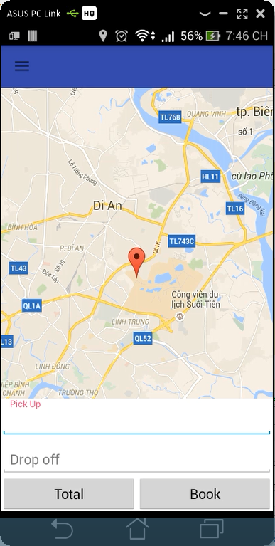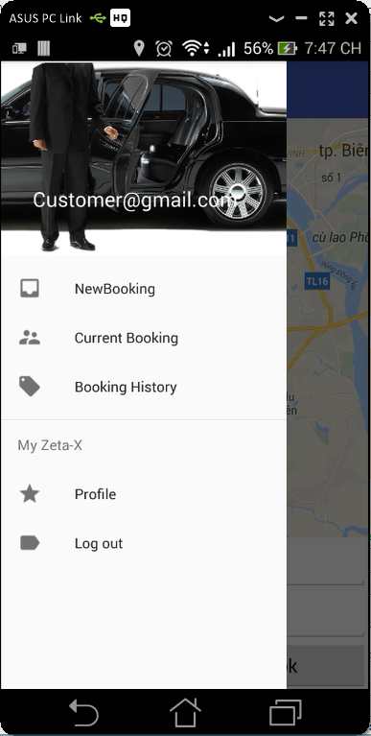

2 . Pick up and drop off

Tapping on pickup and drop-off textboxes should take the customers to the screen below :

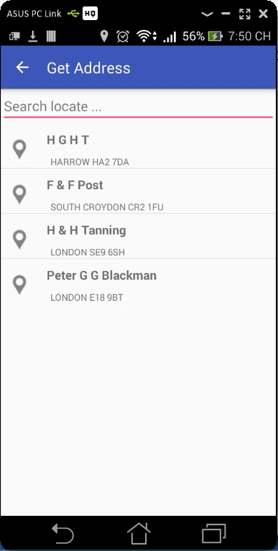

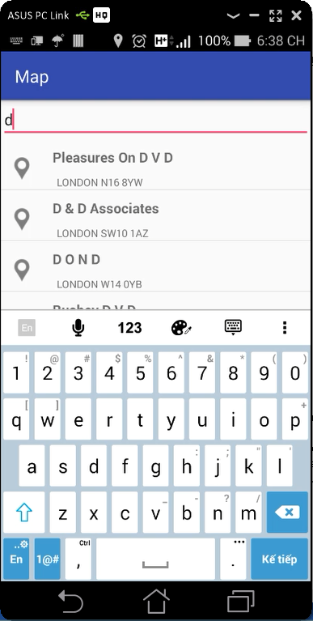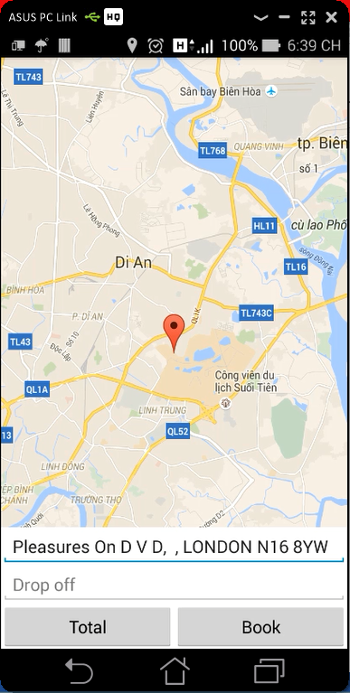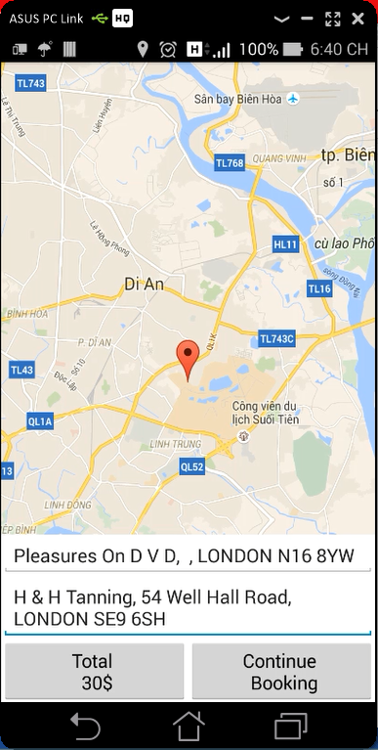

4 . On continue

The design not good but I’ll fix it soon.

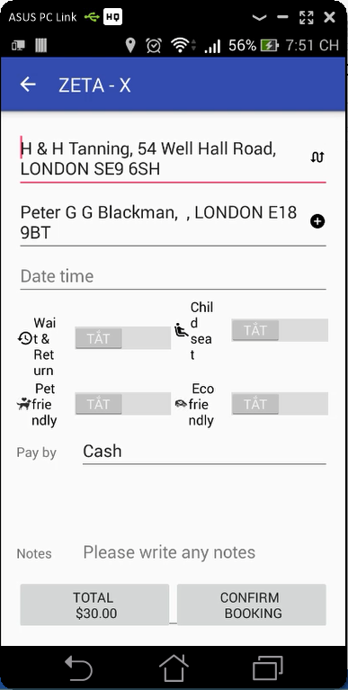

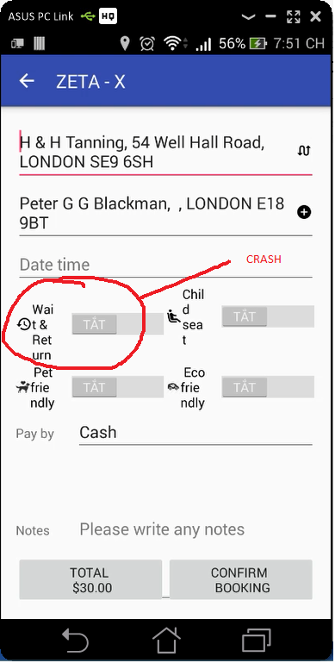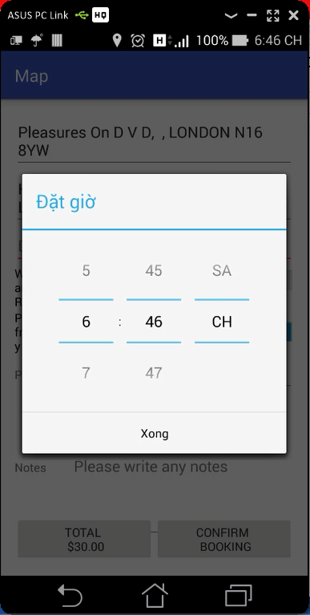

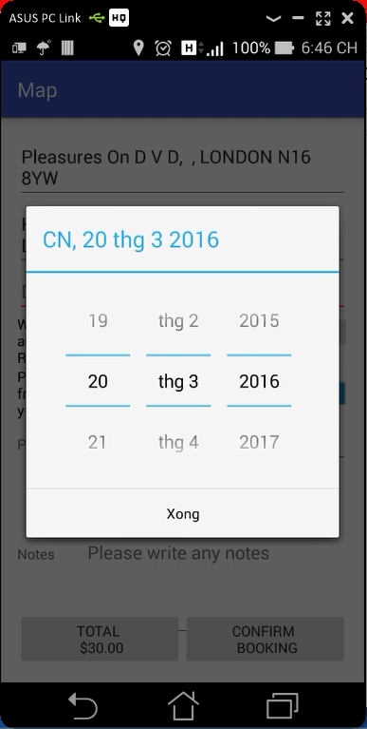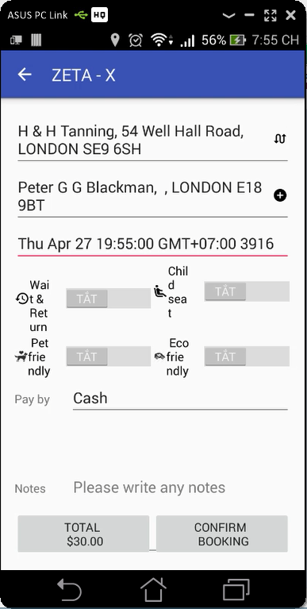

5 . Payment method

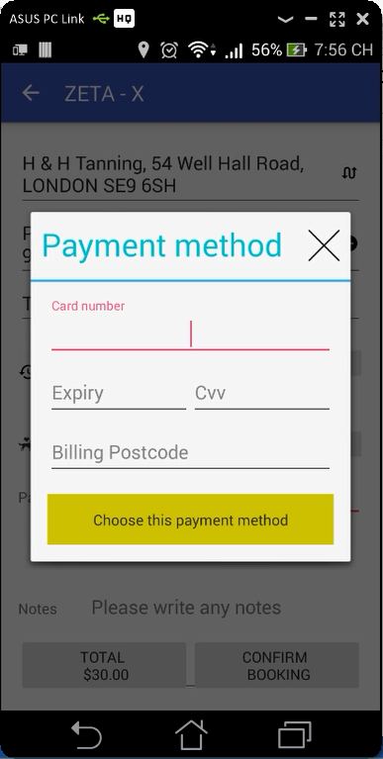

6 . Sign In

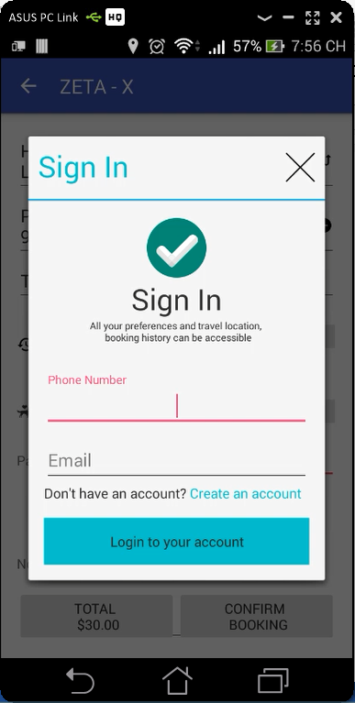

7 . Sign Up

I can’t make an account. When i send data : {"deviceId":"d3aa9cbe70c2f75c","email":"phuquy.uit@gmail.com","mobile":"123456789","name":"quy"} and recieve response : {"CustID":0,"message":"Name, Mobile number and Email are required","FormattedMobileNo":null,"code":2}

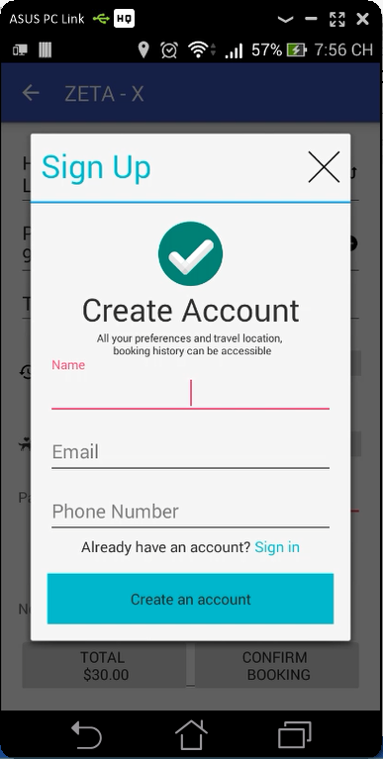

7 . Booking Success

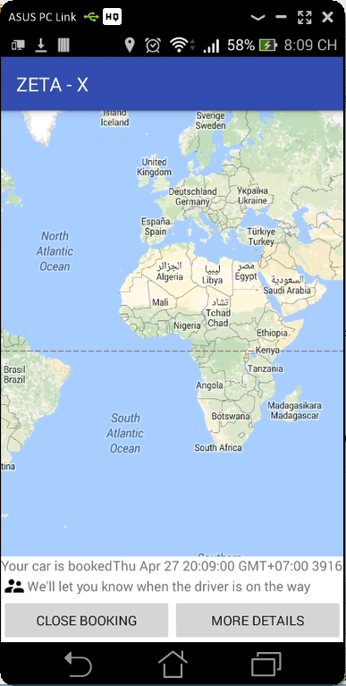

7 . Booking Summary

Can’t login so I can take the current booking

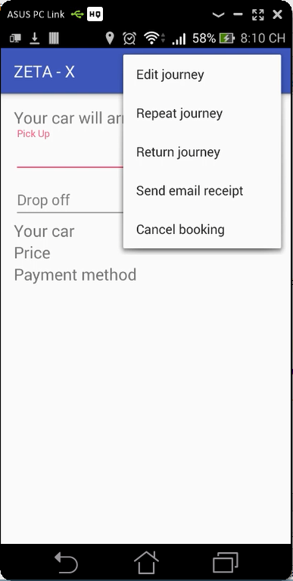

8 . Booking History

No booking history is available but it could display well.