weekly Report

Sunday, April 10, 2016

This is weekly report for the “ZETA – X” project from Atraversa company.

Atraversa

7 Forthgill Close, London E13 0LI

**Tel** [Telephone]

**Fax** [Fax]

http:/atravesar.co.uk

Contents

Start-up screen 1

Get address screen 8

Get home address screen 10

Booking screen 12

Current booking 16

Profile screen 17

Booking history screen 18

## Start-up screen

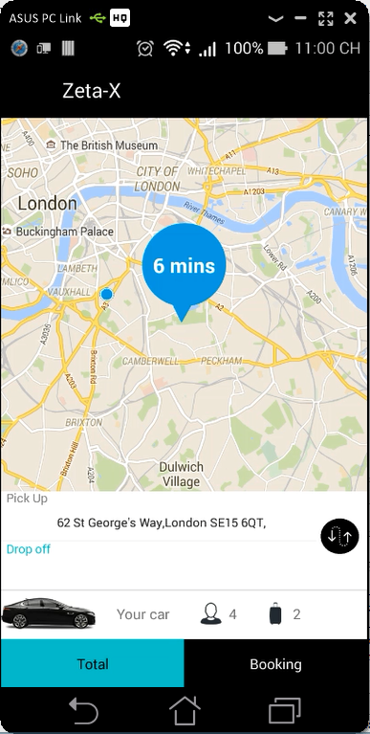 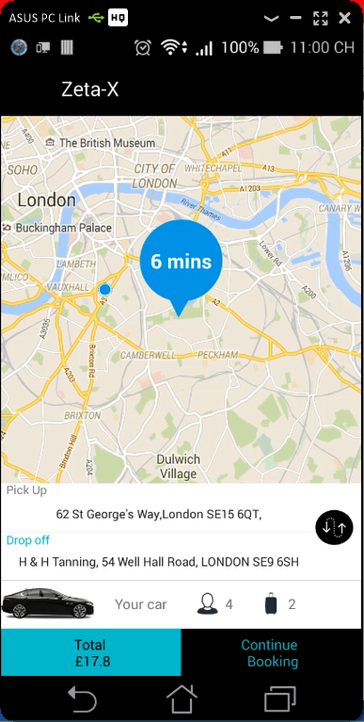

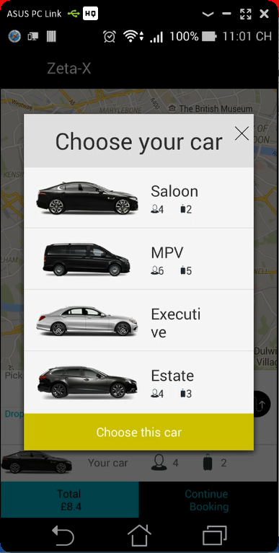 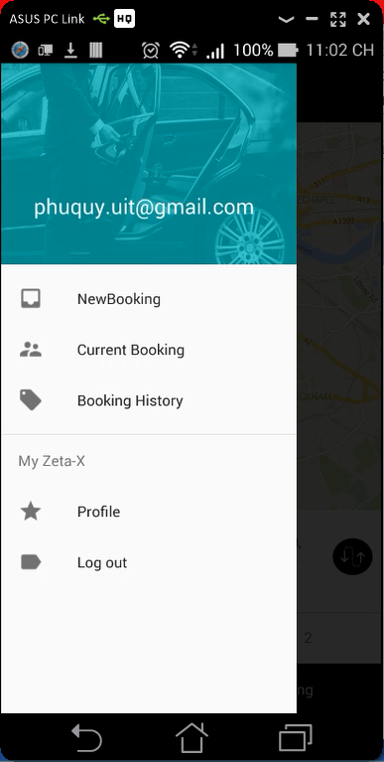

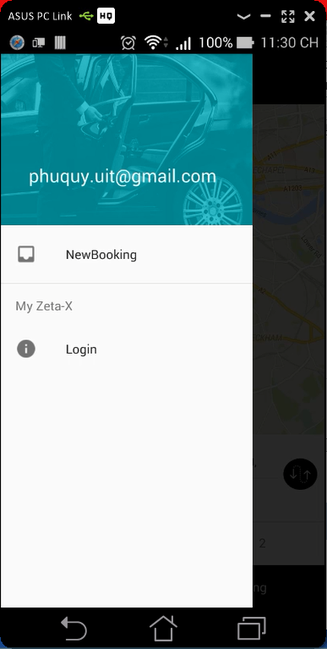 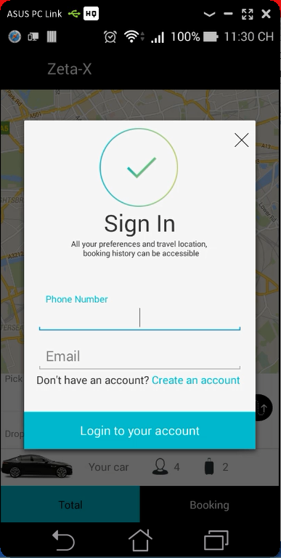

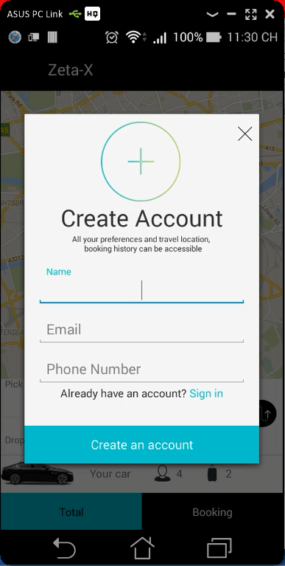

## Get address screen

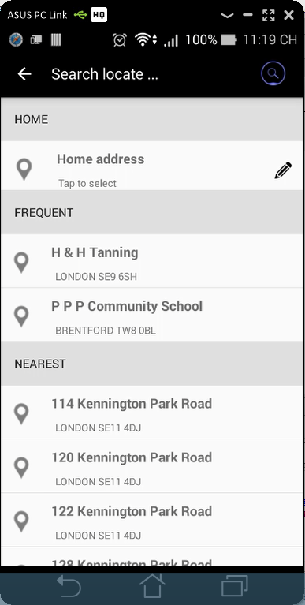 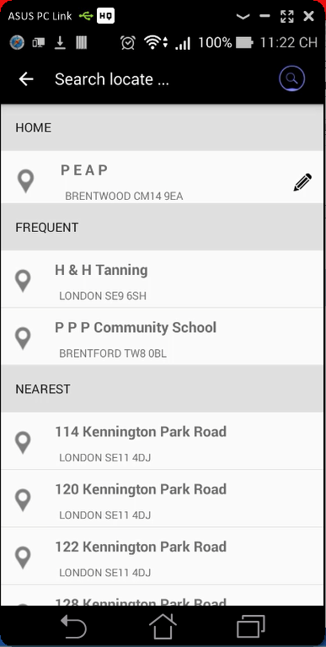

## Get home address screen

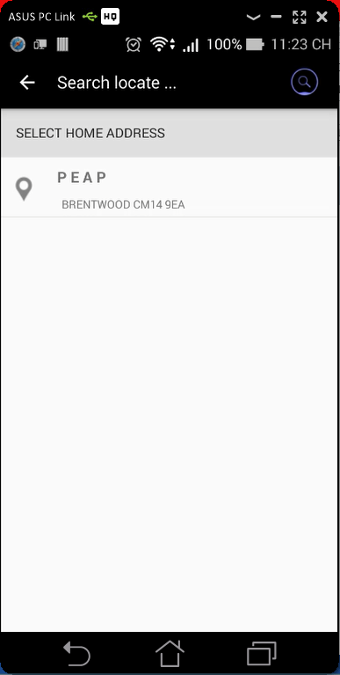 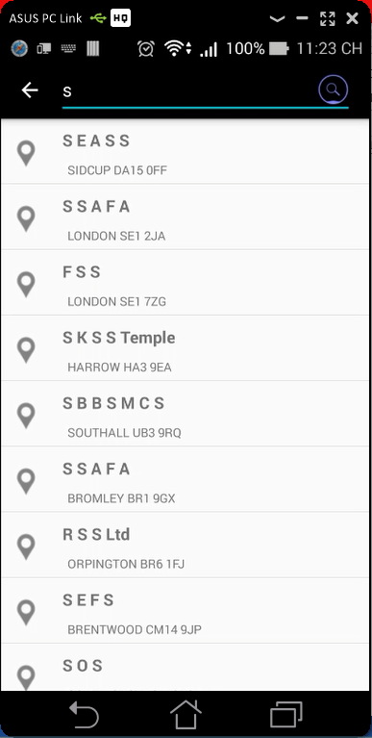

## Booking screen

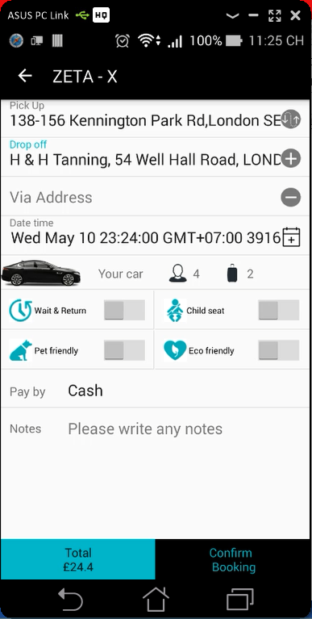 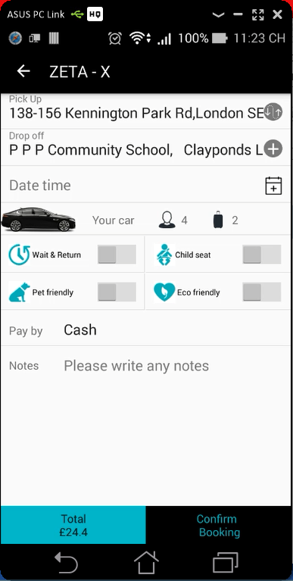

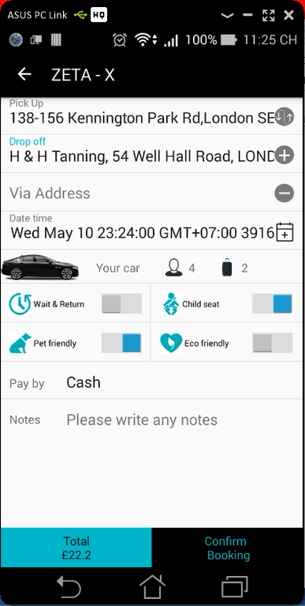 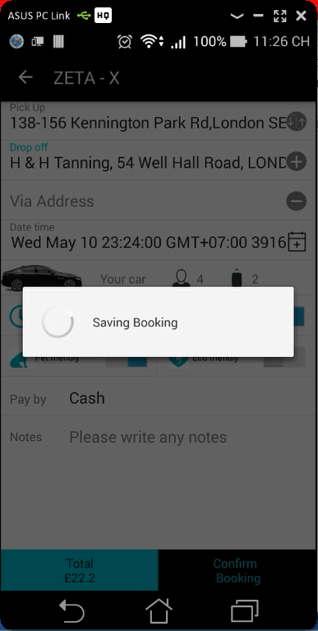

## Current booking

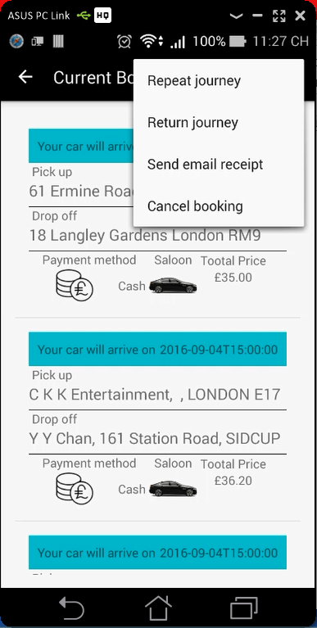

## Profile screen

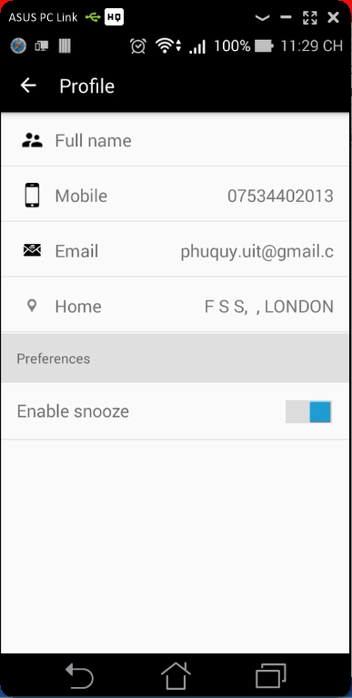

## Booking history screen

