weekly Report

Friday, April 1, 2016

This is weekly report for the “ZETA – X” project from Atraversa company.

Atraversa

7 Forthgill Close, London E13 0LI

**Tel** [Telephone]

**Fax** [Fax]

http:/atravesar.co.uk

Contents

The webservice returns driver’s driving distance from the pickup location in minutes 1

Status 1

Result 1

Issues 1

The time needs to be displayed inside the marker as per design. 2

Status 2

Result 2

Issues 2

When you request ‘nearest driver’ you need to reverse geocode the new location again at the same time and display the new pickup address in the pickup textbox. 3

Status 3

Result 3

Issues 3

The pickup and dropoff address textbox both need two taps before the keypad opens up. 4

Status 4

Result 4

Issues 4

Limit the frequently used address to maximum 5. 5

Status 5

Result 5

Issues 5

As soon as both addresses are available quotation needs to requested and displayed. 6

Status 6

Result 6

Issues 7

The quotation needs to be invalidated as soon as any of the address changes. 8

Status 8

Result 8

Issues 9

If the customer clicks the ‘+’ button next to the dropoff address then a new textbox needs to be appended below it. It will be called ‘via address’. 9

Status 9

Result 10

Issues 10

With any address/datetime changes the quotation needs to be recalled. 10

Status 10

Result 11

Issues 12

On ‘confirm booking’ button click the app crashes. 12

Status 12

Result 12

Issues 13

## The webservice returns driver’s driving distance from the pickup location in minutes

## Status

Active

## Result

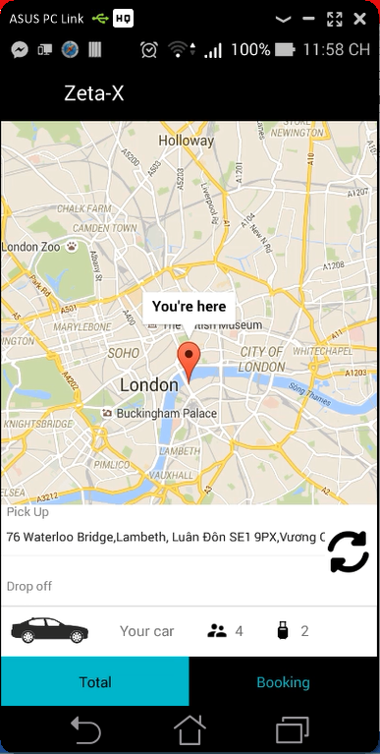

## Issues

I was check Add Lee app. But I still can not understand it well. Please explain it.

## The time needs to be displayed inside the marker as per design.

## Status

Complete

## Result

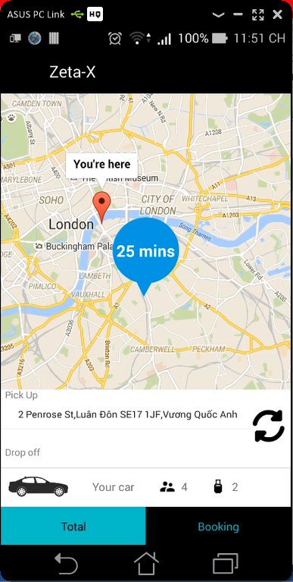

## Issues

The full address take from geocode convert to vietnamese automaticaly. It’s will be crash when we click on confirm booking button.

## When you request ‘nearest driver’ you need to reverse geocode the new location again at the same time and display the new pickup address in the pickup textbox.

## Status

Complete

## Result

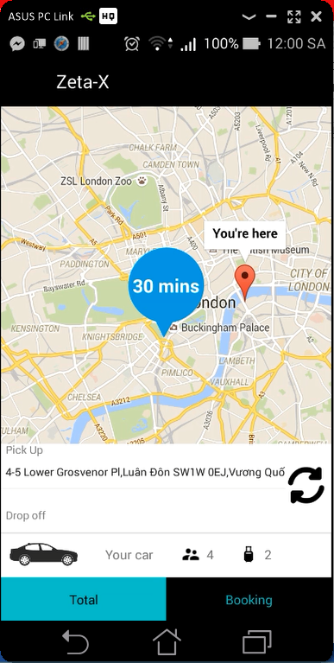

## Issues

I wonder if we should use the address get from “NearByPlace” or use the geocode?

## The pickup and dropoff address textbox both need two taps before the keypad opens up.

## Status

Complete

## Result

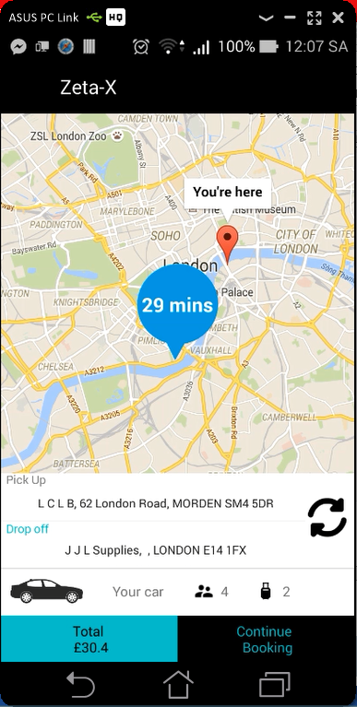

## Issues

Nothing much

## Limit the frequently used address to maximum 5.

## Status

Complete

## Result

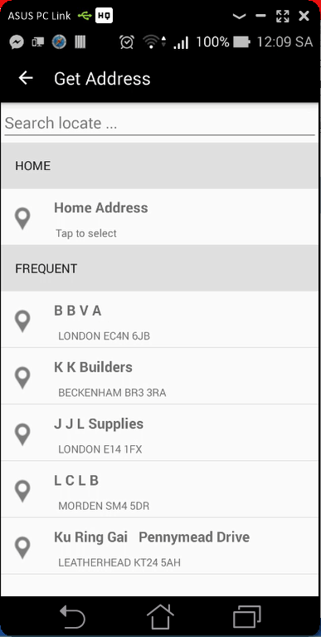

## Issues

Please send me icons from “Icon_Path”

## As soon as both addresses are available quotation needs to requested and displayed.

## Status

Complete

## Result

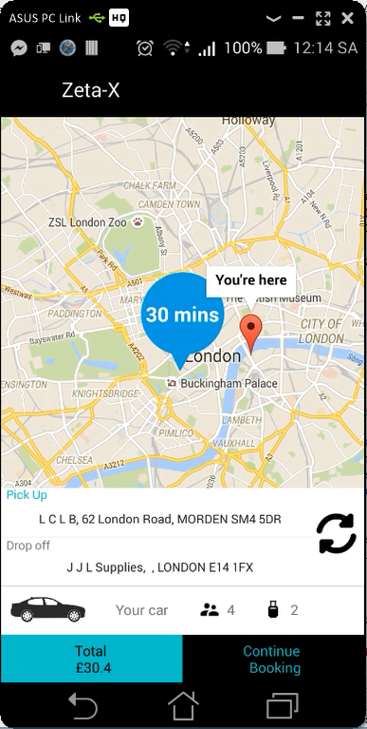

Quotation: {"bags":2,"bookingdate":"2016-04-02 12:13:59","childseat":false,"custid":0,"doff":"J J L Supplies, , LONDON E14 1FX","doffLat":51.513197,"doffLong":-0.028302,"droppostcode":"E14 1FX","executive":false,"note":null,"paq":4,"petfriendly":false,"pick":"L C L B, 62 London Road, MORDEN SM4 5DR","pickLat":51.40266,"pickLong":-0.194086,"pickpostcode":"SM4 5DR","returndate":null,"rtnType":null,"via":null,"viaLat":null,"viaLong":null,"viapostcode":null}

Response_quotation: {"RoutePath":[],"AdditionalInfo":"4/1/2016 5:11:48 PM: String parsed.\r\n4/1/2016 5:11:48 PM: Checking Fixed Price.\r\n4/1/2016 5:11:48 PM: Veh Type.1\r\n4/1/2016 5:11:48 PM: Checking surcharge.\r\n4/1/2016 5:11:48 PM: Calculating route distance.\r\n4/1/2016 5:11:48 PM: Calculating fare.\r\n4/1/2016 5:11:49 PM: Returning result.\r\n","code":1,"message":"success","vehTypeID":1,"rtn_routedistance":0.0,"routedistance":12.61694205356,"rtn_traveltime":0.0,"traveltime":25.0,"vehType":"Saloon","totalfare":"30.4","fare":"30.4","returnfare":null,"viaLat":0.0,"viaLong":0.0,"doLat":0.0,"doLong":0.0,"pkLat":0.0,"pkLong":0.0,"bookingRef":null,"InServiceArea":true}

## Issues

Nothing much

## The quotation needs to be invalidated as soon as any of the address changes.

## Status

Complete

## Result

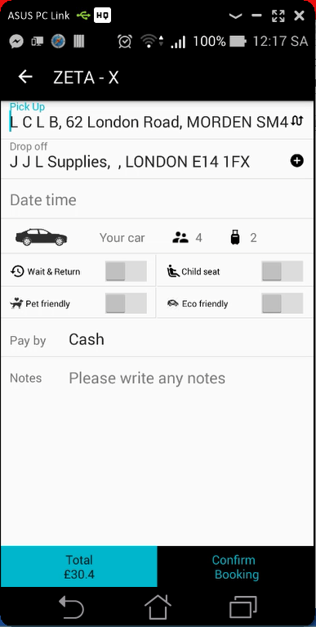 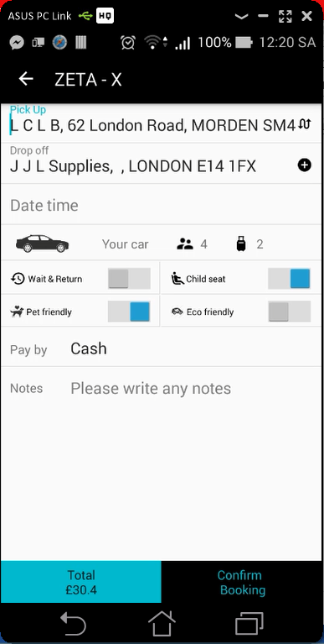

Quotation: {"bags":2,"bookingdate":"2016-04-02 12:13:59","childseat":true,"custid":0,"doff":"J J L Supplies, , LONDON E14 1FX","doffLat":51.513197,"doffLong":-0.028302,"droppostcode":"E14 1FX","executive":false,"note":null,"paq":4,"petfriendly":true,"pick":"L C L B, 62 London Road, MORDEN SM4 5DR","pickLat":51.40266,"pickLong":-0.194086,"pickpostcode":"SM4 5DR","returndate":null,"rtnType":null,"via":null,"viaLat":null,"viaLong":null,"viapostcode":null}

Response_quotation: {vehTypeID=1, rtn_routedistance=0, routedistance=12.61694205356, rtn_traveltime=0, traveltime=25.0, vehType='Saloon', totalfare='30.4', fare='30.4', returnfare='null', viaLat=0.0, viaLong=0.0, doLat=0.0, doLong=0.0, pkLat=0.0, pkLong=0.0, bookingRef='null', InServiceArea=true}

## Issues

Nothing much

## If the customer clicks the ‘+’ button next to the dropoff address then a new textbox needs to be appended below it. It will be called ‘via address’.

## Status

Complete

## Result

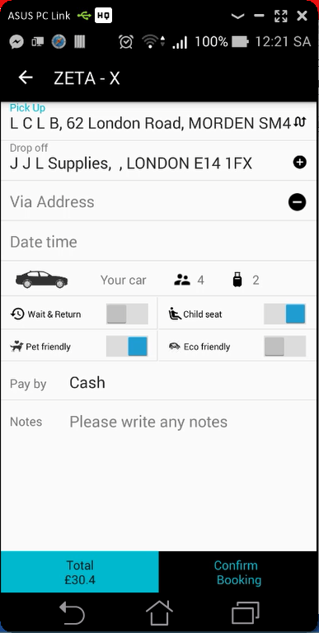

## Issues

Wrong icon. Please send me to fix it.

## With any address/datetime changes the quotation needs to be recalled.

## Status

Complete

## Result

 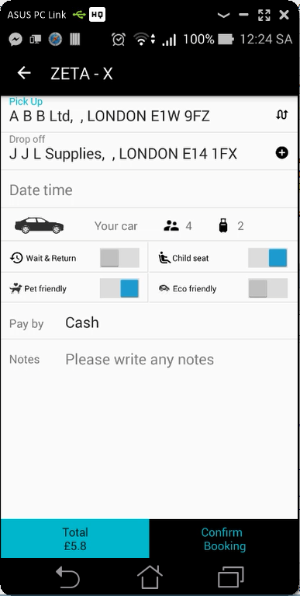

Quotation: {"bags":2,"bookingdate":"2016-04-02 12:24:05","childseat":true,"custid":0,"doff":"J J L Supplies, , LONDON E14 1FX","doffLat":51.513197,"doffLong":-0.028302,"droppostcode":"E14 1FX","executive":false,"note":null,"paq":4,"petfriendly":true,"pick":"A B B Ltd, , LONDON E1W 9FZ","pickLat":51.519026,"pickLong":-0.058075,"pickpostcode":"E1W 9FZ","returndate":null,"rtnType":null,"via":null,"viaLat":null,"viaLong":null,"viapostcode":null}

Response_quotation: {vehTypeID=1, rtn_routedistance=0, routedistance=1.67148850648, rtn_traveltime=0, traveltime=3.0, vehType='Saloon', totalfare='5.8', fare='5.8', returnfare='null', viaLat=0.0, viaLong=0.0, doLat=0.0, doLong=0.0, pkLat=0.0, pkLong=0.0, bookingRef='null', InServiceArea=true}

## Issues

Nothing much.

## On ‘confirm booking’ button click the app crashes.

## Status

Complete

## Result

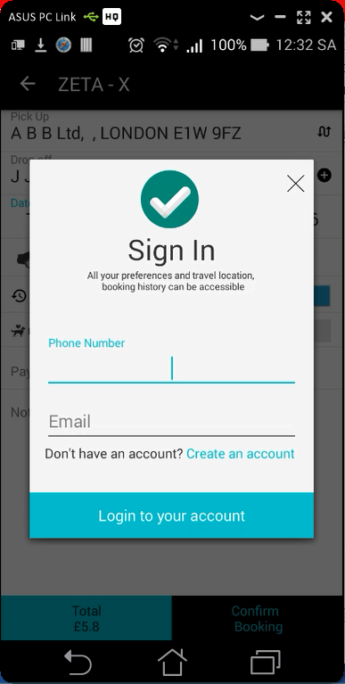 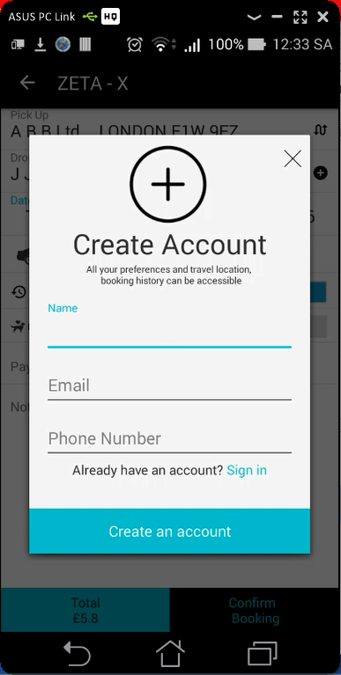

## Issues

Icons