weekly Report

Friday, April 1, 2016

This is weekly report for the “ZETA – X” project from Atraversa company.

Atraversa

7 Forthgill Close, London E13 0LI

**Tel** [Telephone]

**Fax** [Fax]

http:/atravesar.co.uk

Contents

The webservice returns driver’s driving distance from the pickup location in minutes 1

Status 1

Result 1

Issues 1

The time needs to be displayed inside the marker as per design. 2

Status 2

Result 2

Issues 2

When you request ‘nearest driver’ you need to reverse geocode the new location again at the same time and display the new pickup address in the pickup textbox. 3

Status 3

Result 3

Issues 3

The pickup and dropoff address textbox both need two taps before the keypad opens up. 4

Status 4

Result 4

Issues 4

Limit the frequently used address to maximum 5. 5

Status 5

Result 5

Issues 5

As soon as both addresses are available quotation needs to requested and displayed. 6

Status 6

Result 6

Issues 7

The quotation needs to be invalidated as soon as any of the address changes. 8

Status 8

Result 8

Issues 9

If the customer clicks the ‘+’ button next to the dropoff address then a new textbox needs to be appended below it. It will be called ‘via address’. 9

Status 9

Result 10

Issues 10

With any address/datetime changes the quotation needs to be recalled. 10

Status 10

Result 11

Issues 12

On ‘confirm booking’ button click the app crashes. 12

Status 12

Result 12

Issues 13

## The webservice returns driver’s driving distance from the pickup location in minutes

## Status

Active

## Result

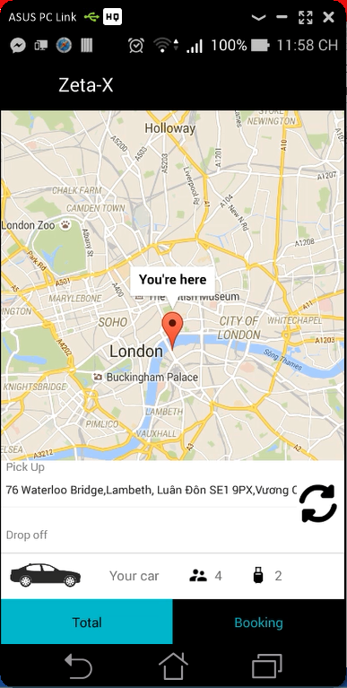

## Issues

I was check Add Lee app. But I still can not understand it well. Please explain it.

On start get the last known location from location provider (if GPS location is available otherwise network location whichever is new and more accurate). Then subscribe to GPS location provider with 0 second and 0 meter settings so that you get the GPS location straight away. As soon as you get the location unsubscribe from GPS location provider as we will not be tracking user’s location.

The map needs to be draggable. If you check Addison Lee app you can tap and hold the map and drag, but the marker is always in center. What it means is that the marker should be set in user’s location on start but when the user moves the map it does not need to be in user’s current location. As the marker is always in center, when you drag the map marker location will change. Whatever the marker’s new location is, we will need to consider that as user’s pickup location.

If the pickup location changes you need to request nearest driver again. If either pickup or dropoff location changes then you need to request new quote.

There should be no refresh button next to pickup textbox. The pickup address will change when the customer drag the map.

The marker position is not user’s current location. It is set in the user’s current location on start. But then user can drag the map and set the pickup location with the help of the marker.

## The time needs to be displayed inside the marker as per design.

## Status

Complete

## Result

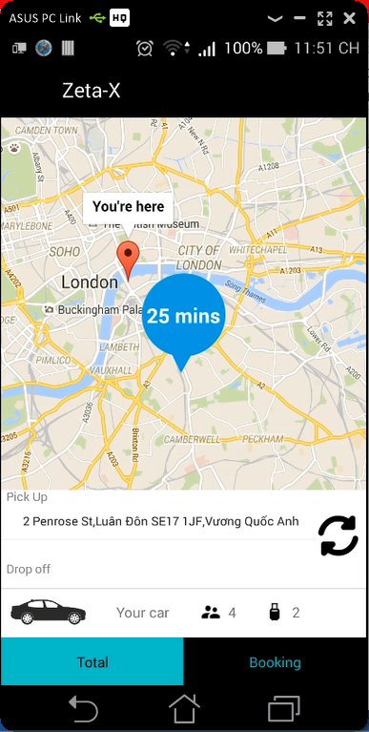

## Issues

The full address take from geocode convert to vietnamese automaticaly. It’s will be crash when we click on confirm booking button.

There should be always one marker. The customer moves the map and place the marker in pickup location.

## When you request ‘nearest driver’ you need to reverse geocode the new location again at the same time and display the new pickup address in the pickup textbox.

## Status

Complete

## Result

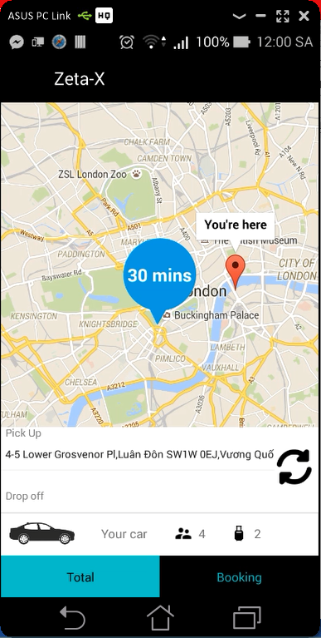

## Issues

I wonder if we should use the address get from “NearByPlace” or use the geocode?

We do not want nearby location. We need specific location with reverse geocode.

## The pickup and dropoff address textbox both need two taps before the keypad opens up.

## Status

Complete

## Result

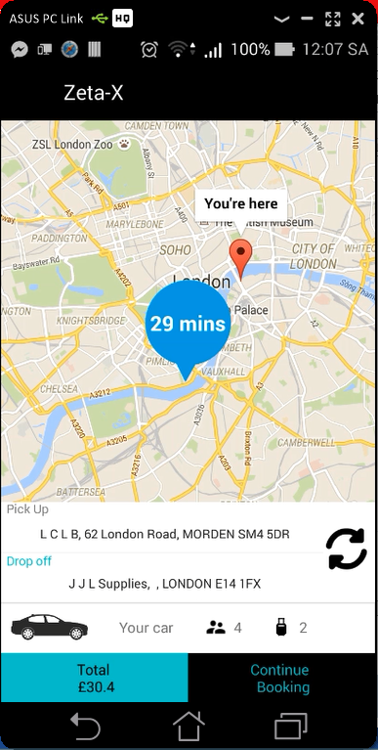

## Issues

Nothing much

## Limit the frequently used address to maximum 5.

Add another section called ‘nearby addresses’. There is a webservice endpoint for that.

## Status

Complete

## Result

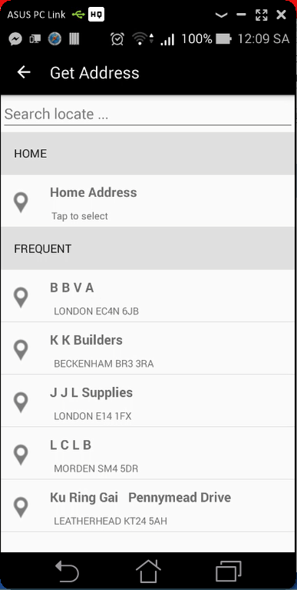

## Issues

Please send me icons from “Icon_Path”

## As soon as both addresses are available quotation needs to requested and displayed.

## Status

Complete

## Result

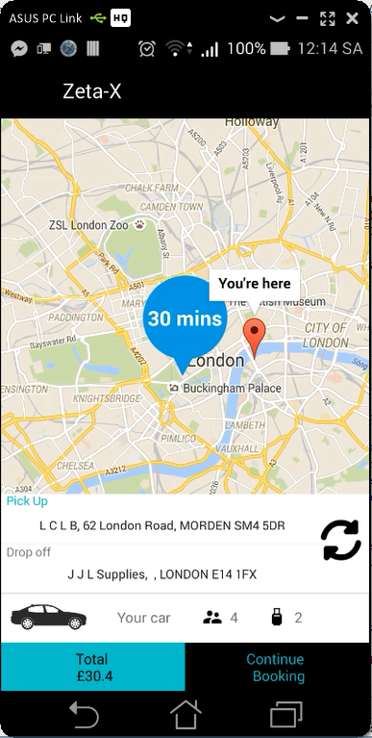

Quotation: {"bags":2,"bookingdate":"2016-04-02 12:13:59","childseat":false,"custid":0,"doff":"J J L Supplies, , LONDON E14 1FX","doffLat":51.513197,"doffLong":-0.028302,"droppostcode":"E14 1FX","executive":false,"note":null,"paq":4,"petfriendly":false,"pick":"L C L B, 62 London Road, MORDEN SM4 5DR","pickLat":51.40266,"pickLong":-0.194086,"pickpostcode":"SM4 5DR","returndate":null,"rtnType":null,"via":null,"viaLat":null,"viaLong":null,"viapostcode":null}

Response_quotation: {"RoutePath":[],"AdditionalInfo":"4/1/2016 5:11:48 PM: String parsed.\r\n4/1/2016 5:11:48 PM: Checking Fixed Price.\r\n4/1/2016 5:11:48 PM: Veh Type.1\r\n4/1/2016 5:11:48 PM: Checking surcharge.\r\n4/1/2016 5:11:48 PM: Calculating route distance.\r\n4/1/2016 5:11:48 PM: Calculating fare.\r\n4/1/2016 5:11:49 PM: Returning result.\r\n","code":1,"message":"success","vehTypeID":1,"rtn_routedistance":0.0,"routedistance":12.61694205356,"rtn_traveltime":0.0,"traveltime":25.0,"vehType":"Saloon","totalfare":"30.4","fare":"30.4","returnfare":null,"viaLat":0.0,"viaLong":0.0,"doLat":0.0,"doLong":0.0,"pkLat":0.0,"pkLong":0.0,"bookingRef":null,"InServiceArea":true}

## Issues

Nothing much

## The quotation needs to be invalidated as soon as any of the address changes.

## Status

Complete

## Result

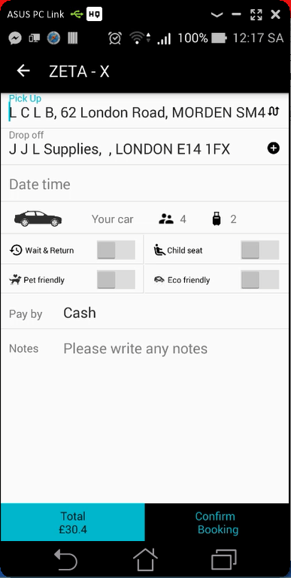 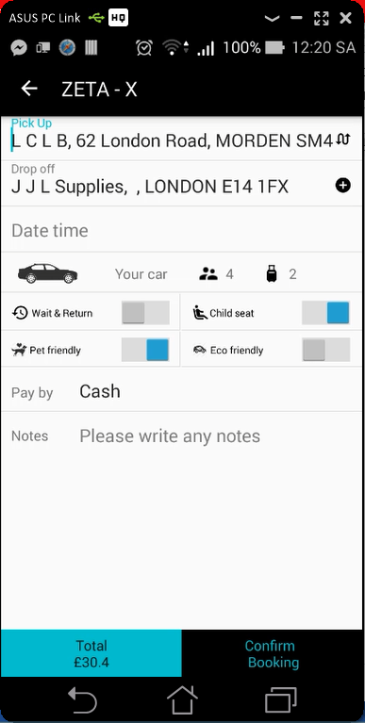

Quotation: {"bags":2,"bookingdate":"2016-04-02 12:13:59","childseat":true,"custid":0,"doff":"J J L Supplies, , LONDON E14 1FX","doffLat":51.513197,"doffLong":-0.028302,"droppostcode":"E14 1FX","executive":false,"note":null,"paq":4,"petfriendly":true,"pick":"L C L B, 62 London Road, MORDEN SM4 5DR","pickLat":51.40266,"pickLong":-0.194086,"pickpostcode":"SM4 5DR","returndate":null,"rtnType":null,"via":null,"viaLat":null,"viaLong":null,"viapostcode":null}

Response_quotation: {vehTypeID=1, rtn_routedistance=0, routedistance=12.61694205356, rtn_traveltime=0, traveltime=25.0, vehType='Saloon', totalfare='30.4', fare='30.4', returnfare='null', viaLat=0.0, viaLong=0.0, doLat=0.0, doLong=0.0, pkLat=0.0, pkLong=0.0, bookingRef='null', InServiceArea=true}

## Issues

Nothing much

## If the customer clicks the ‘+’ button next to the dropoff address then a new textbox needs to be appended below it. It will be called ‘via address’.

## Status

Complete

## Result

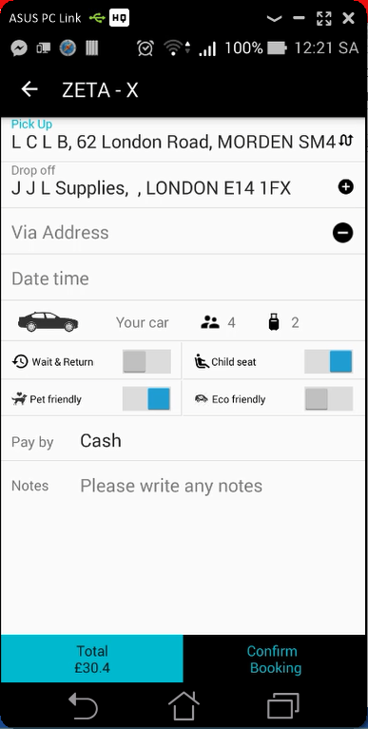

## Issues

Wrong icon. Please send me to fix it.

## With any address/datetime changes the quotation needs to be recalled.

## Status

Complete

## Result

 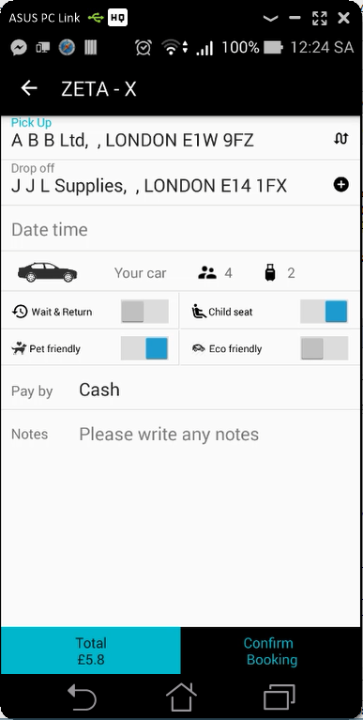

Quotation: {"bags":2,"bookingdate":"2016-04-02 12:24:05","childseat":true,"custid":0,"doff":"J J L Supplies, , LONDON E14 1FX","doffLat":51.513197,"doffLong":-0.028302,"droppostcode":"E14 1FX","executive":false,"note":null,"paq":4,"petfriendly":true,"pick":"A B B Ltd, , LONDON E1W 9FZ","pickLat":51.519026,"pickLong":-0.058075,"pickpostcode":"E1W 9FZ","returndate":null,"rtnType":null,"via":null,"viaLat":null,"viaLong":null,"viapostcode":null}

Response_quotation: {vehTypeID=1, rtn_routedistance=0, routedistance=1.67148850648, rtn_traveltime=0, traveltime=3.0, vehType='Saloon', totalfare='5.8', fare='5.8', returnfare='null', viaLat=0.0, viaLong=0.0, doLat=0.0, doLong=0.0, pkLat=0.0, pkLong=0.0, bookingRef='null', InServiceArea=true}

## Issues

Nothing much.

## On ‘confirm booking’ button click the app crashes.

## Status

Complete

## Result

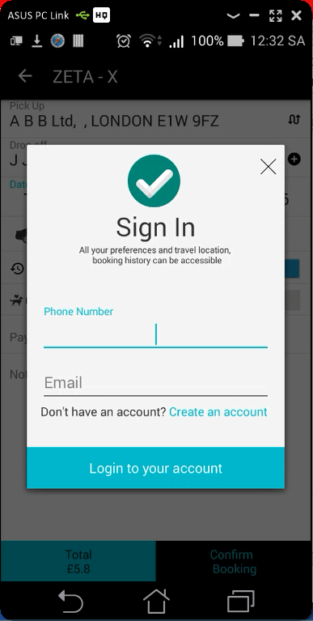 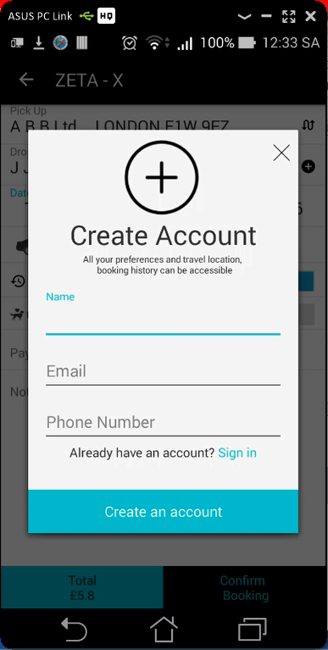

## Issues

Icons