Task 0 - Check your environments
Jupyter Notebook
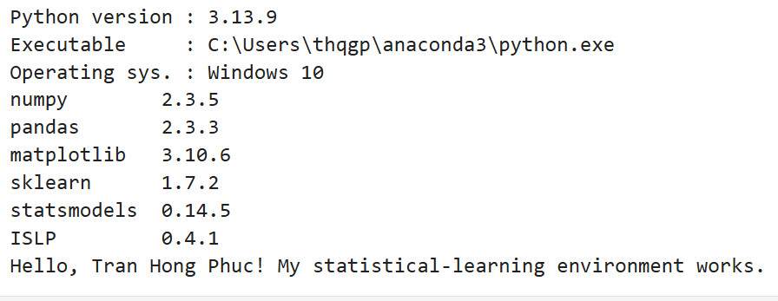
Colab
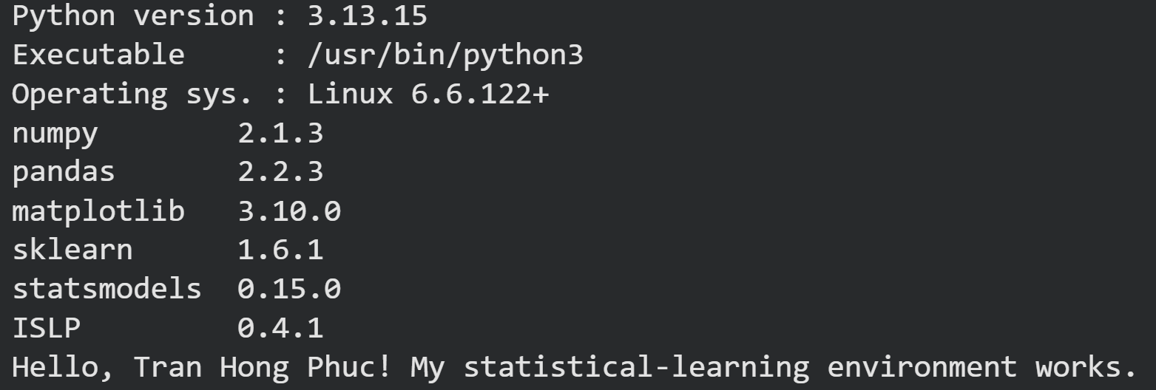

Exercise 1 – NumPy warm-up
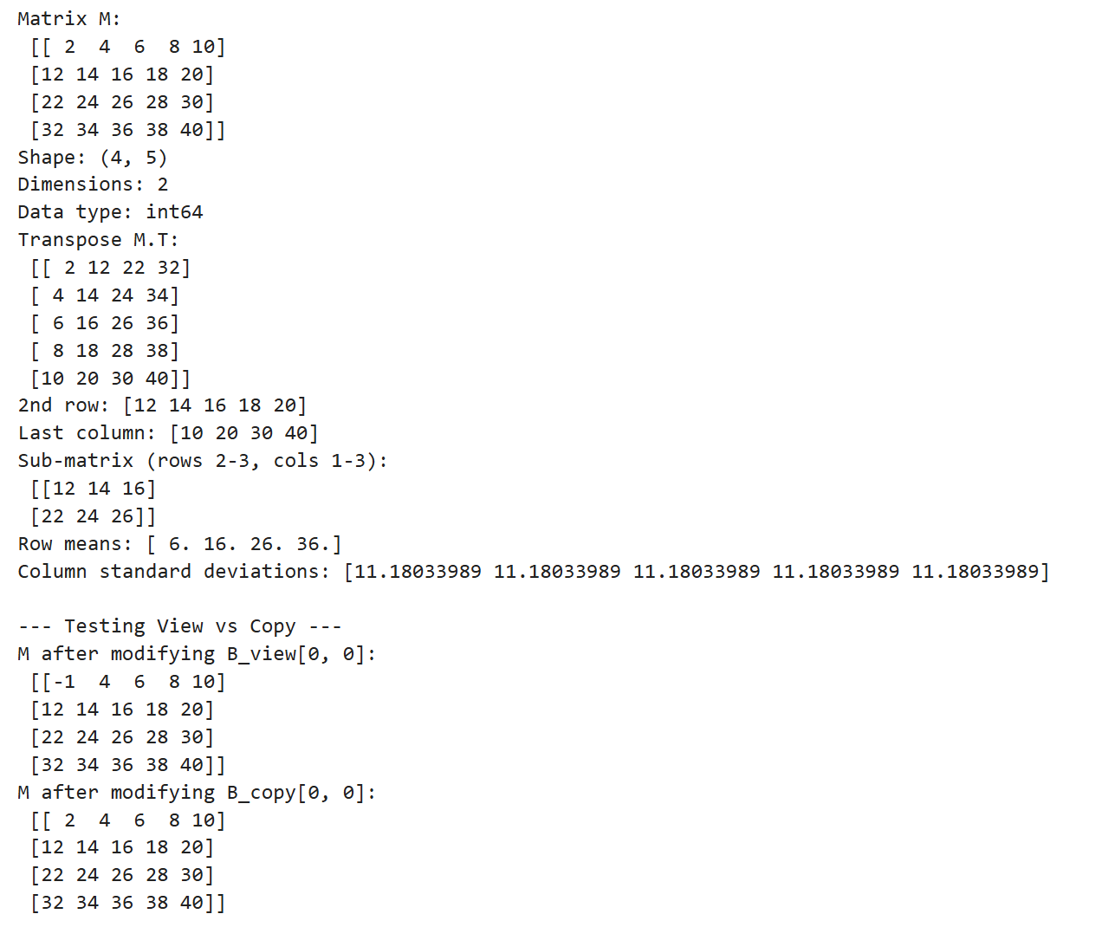
Modifying the view slice (B = M[:2, :2]) directly alters the original matrix M because both objects share the same memory. When using the .copy() method, a separate memory area is created, so operations on B_copy do not affect matrix M.

Exercise 2 – Random numbers, correlation and a saved figure
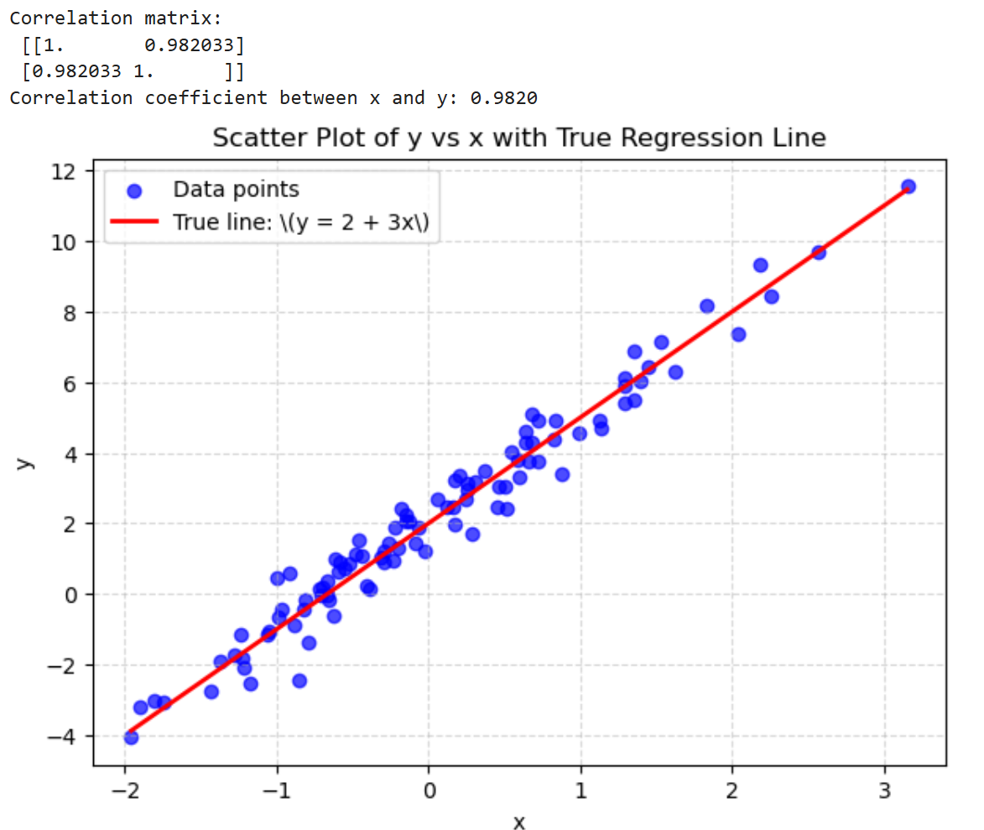
The correlation coefficient between x and y is very high (approx 0.98) because y is generated from a strong linear relationship with x. The data points lie close to the theoretical red line, exhibiting slight fluctuations due to the noise component \varepsilon \sim N(0, 0.5^2).

Exercise 3 – Cleaning the Auto data
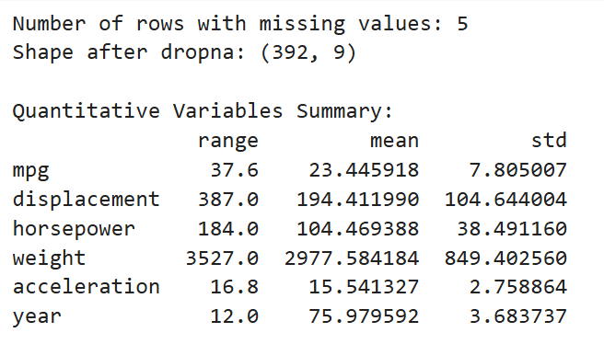 The initial data contained 5 rows with missing values. After their removal, the cleaned dataset retained 392 observations. The 'origin' variable was converted into a categorical format with three corresponding labels representing automotive manufacturing markets.

Exercise 4 – Subsetting rows with iloc[]
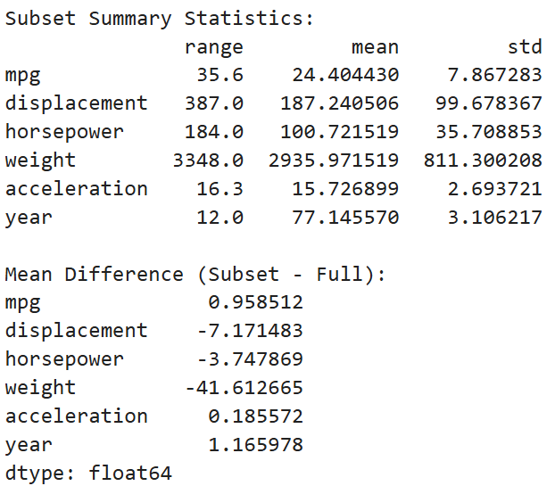 Removing rows 10 through 85 significantly alters the mean and standard deviation of variables such as displacement, horsepower, and weight. This occurs because the removed observations are located at the beginning of the dataset—a section containing many older vehicle models characterized by heavy weight and high engine power.
Exercise 5 – Graphical exploration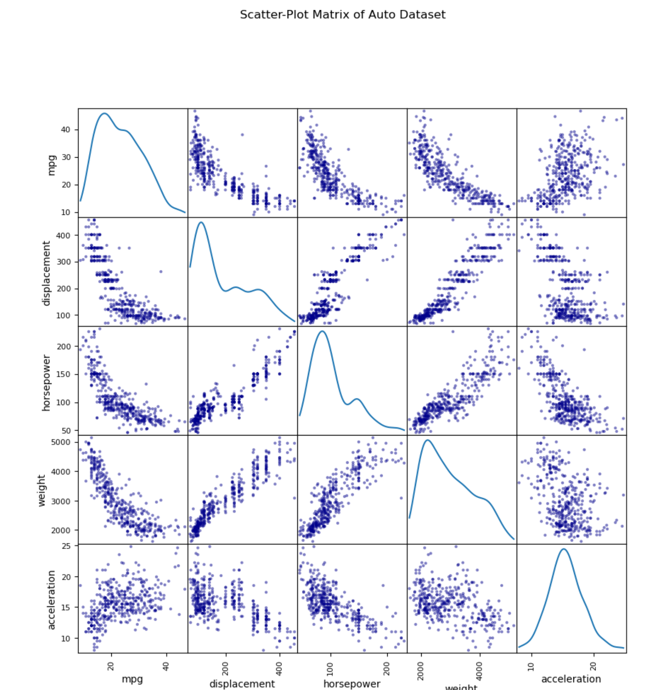 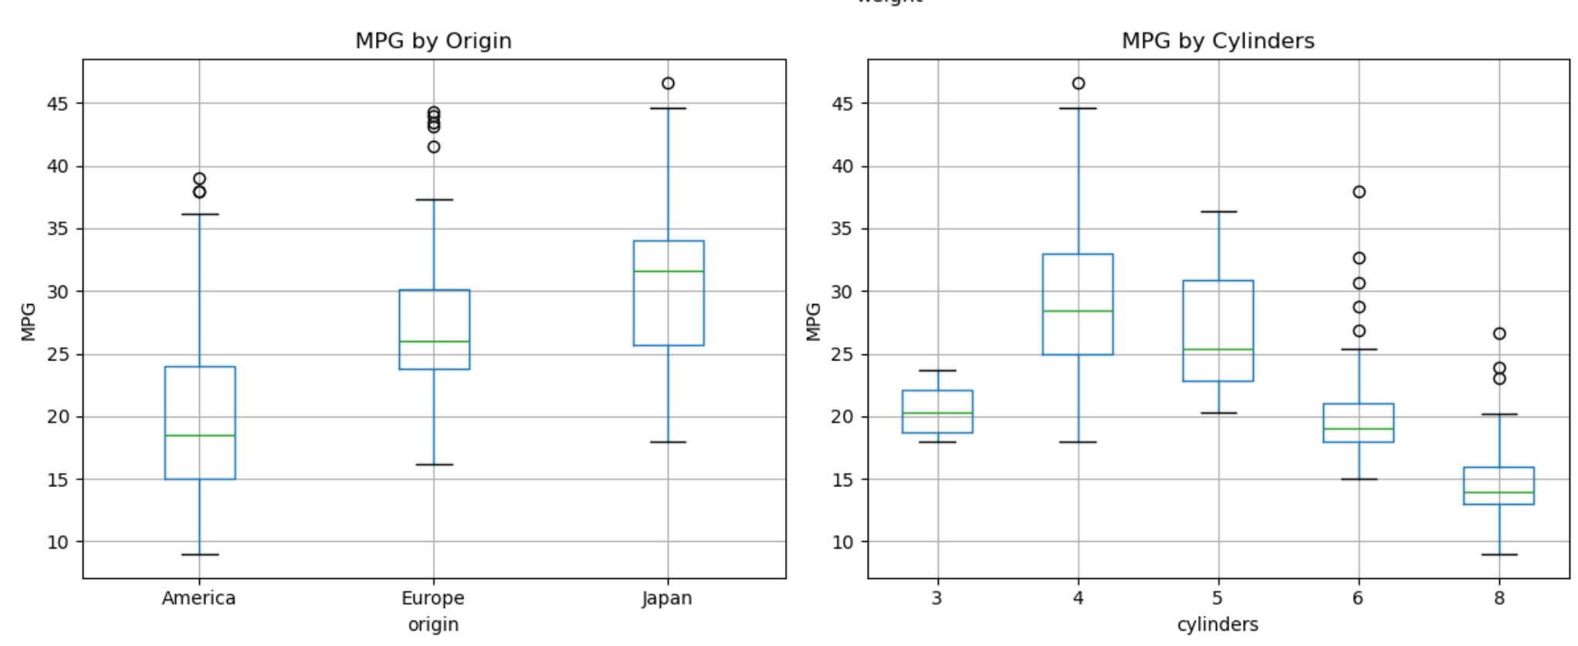
The variables displacement, horsepower, and weight exhibit a clear non-linear (curvilinear) inverse relationship with mpg.

Vehicles manufactured in Asia (Japan) and Europe demonstrate significantly better fuel efficiency (mpg) than those from America.

As the number of cylinders increases, the average mpg decreases markedly.

Exercise 6 – The College data set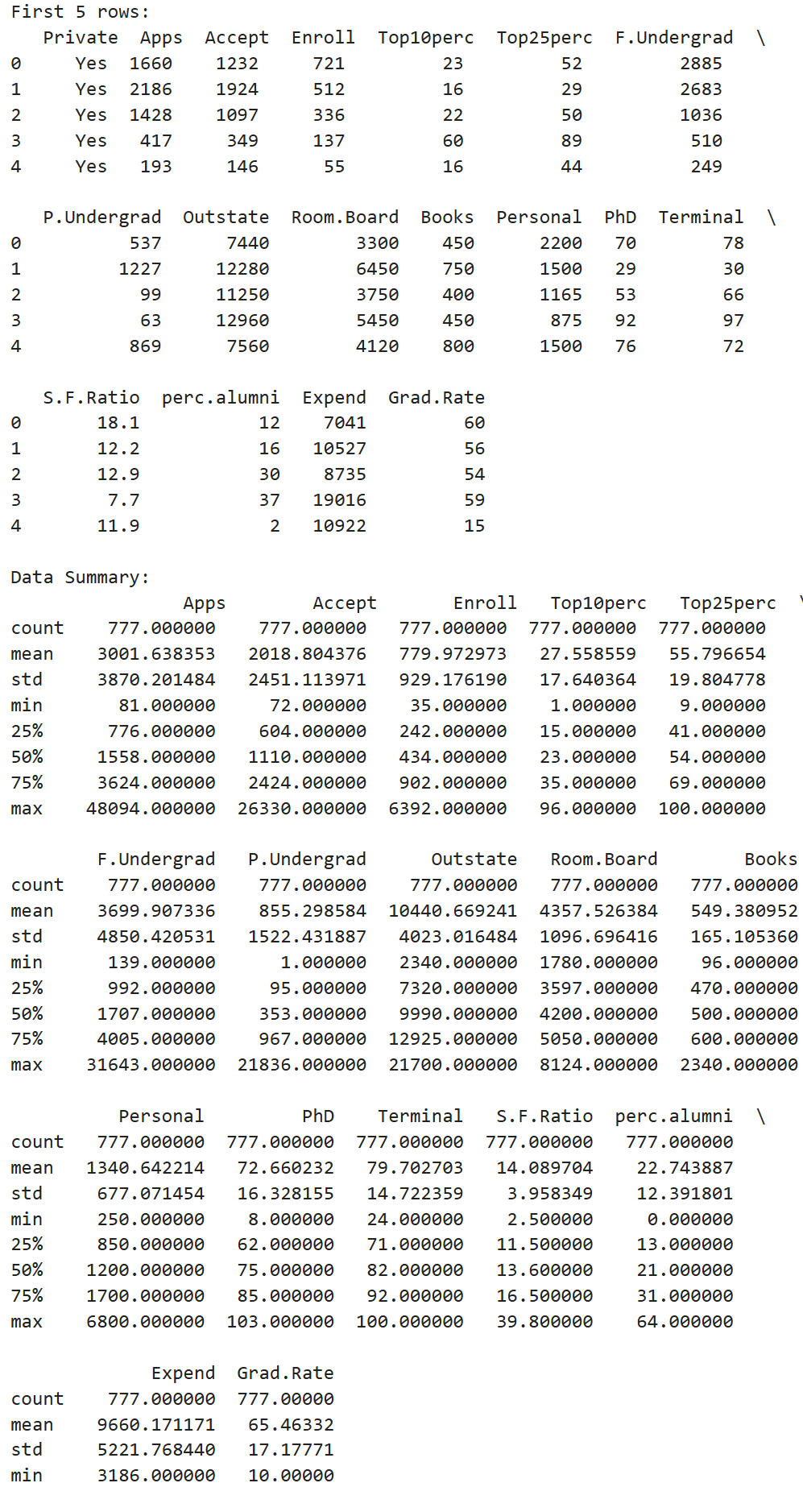
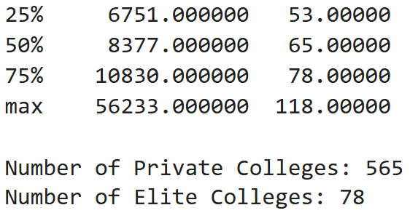
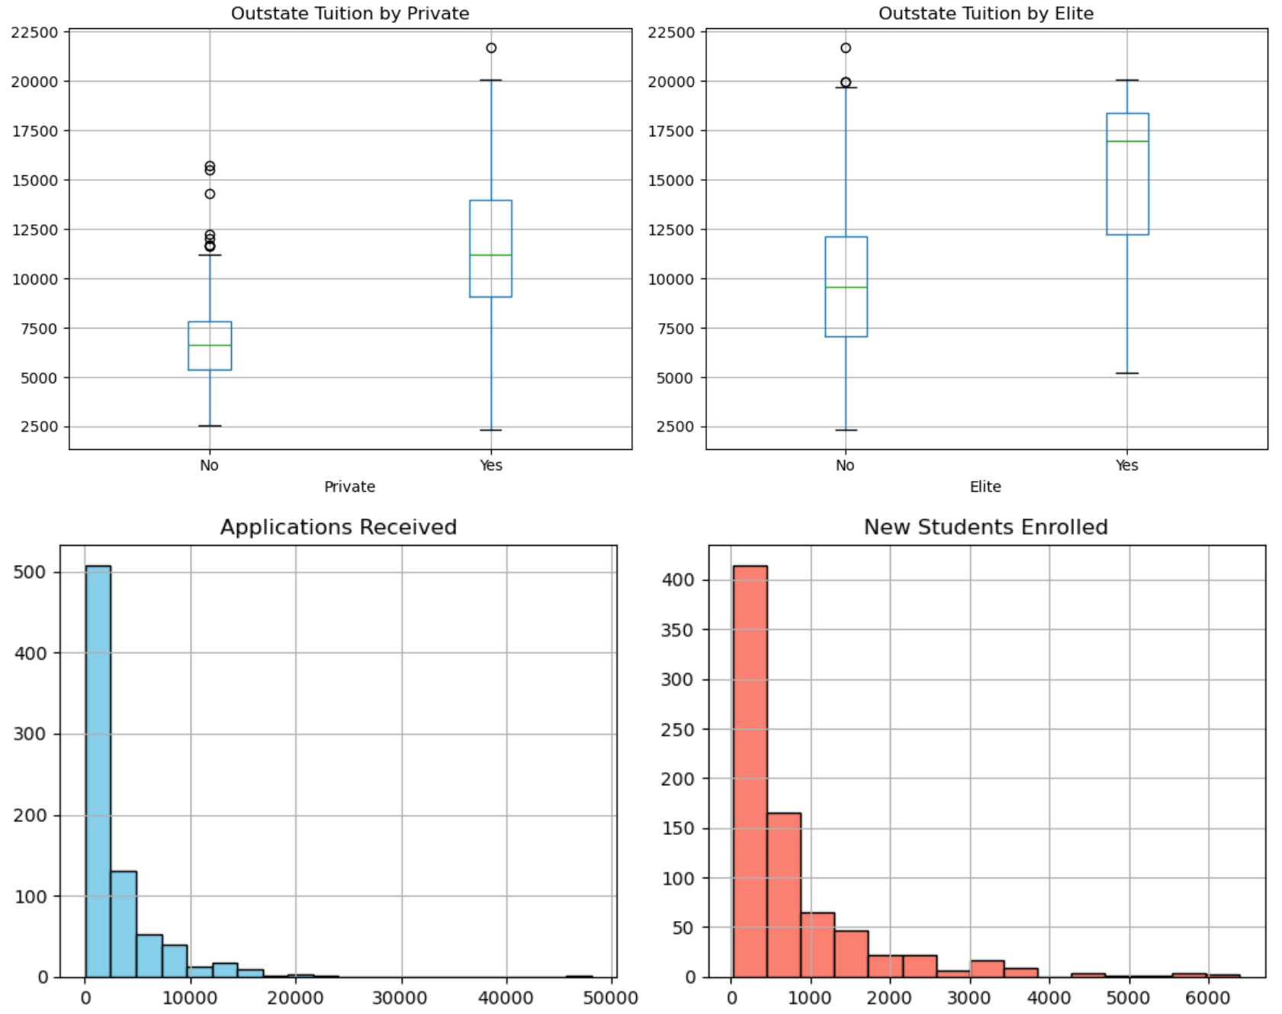
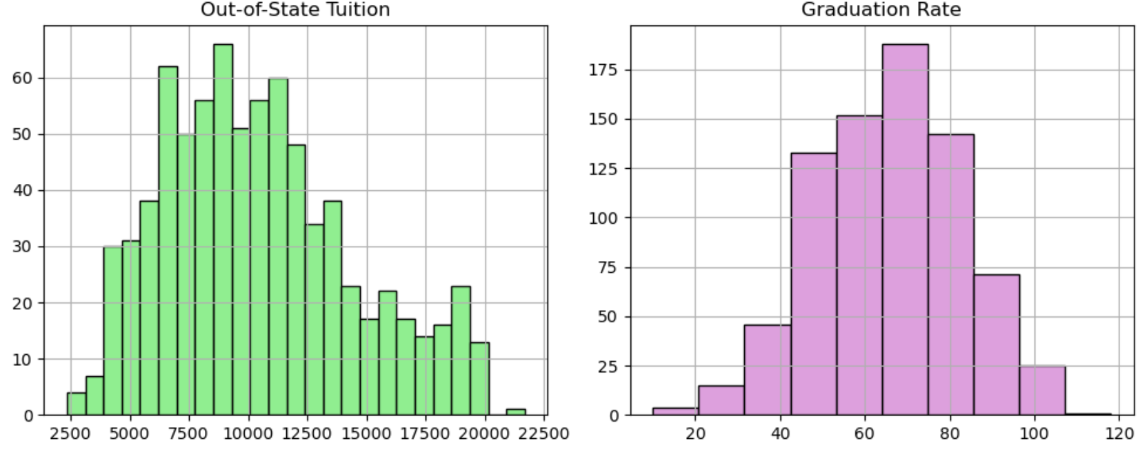 Of the 777 schools, 565 are private and 78 belong to the "Elite" group. Out-of-state tuition at private and Elite schools is significantly higher than at public or non-Elite schools.

Exercise 7 – Loops and string formatting
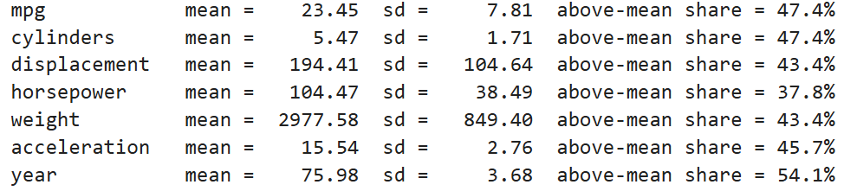
The loop for formatting strings facilitates a quick summary of variable distributions. For both the *weight* and *horsepower* variables, the proportion of vehicles with values ​​above the mean is less than 50%, indicating that these distributions are right-skewed.

Exercise 8 – Estimating bias and variance by simulation (Optional)
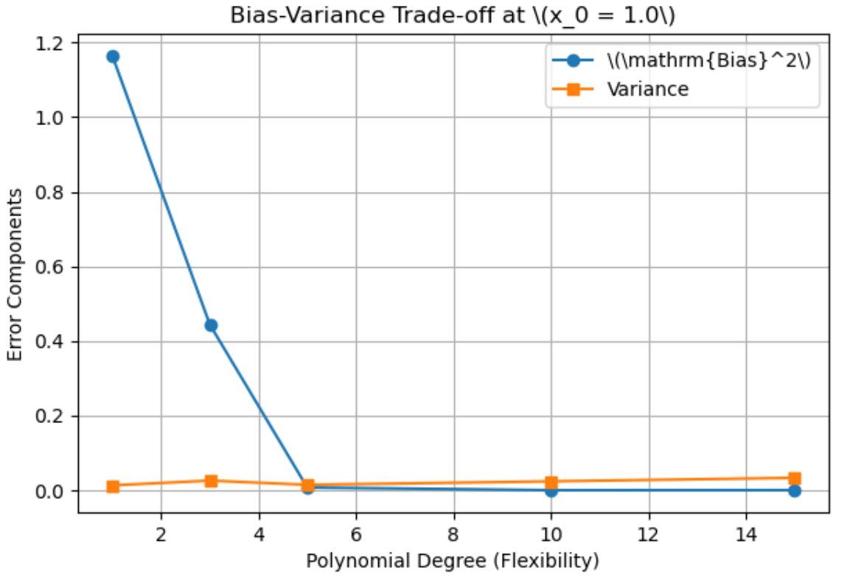
The simulation results clearly demonstrate the bias-variance trade-off: as the polynomial degree d increases, the squared bias decreases rapidly due to the model's increased flexibility, whereas the variance rises sharply.

Exercise 9 – Choosing K for KNN (Optional)
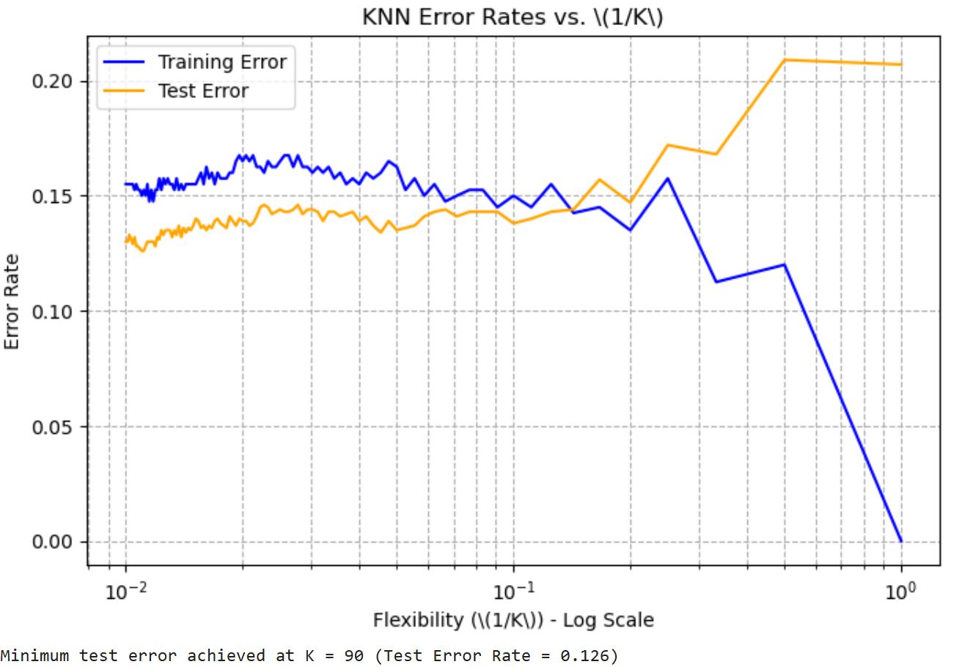
The graph illustrates a relationship similar to Figure 2.17 in the textbook: the training error rate decreases toward zero as 1/K increases (K -> 1, representing maximum flexibility). However, the test error rate follows a U-shaped curve, reaching a minimum in the range of K approx 15–30 before succumbing to overfitting as K approaches 1.

