IT171IU – Statistical Learning

Lab 3: Report: Classification (ISLP Chapter 4)
- Full Name: Trần Hồng Phúc
- Student ID: ITDSIU24039
- Class Group: IT171IU – Lab Group 01
- University: International University – VNU-HCM (HCMIU)
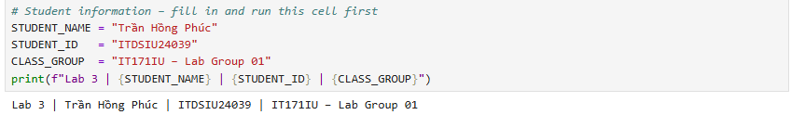

Exercise 1 – The Weekly Stock Market Data
- Key Numbers & Outputs:
  - Model summary statistics indicate coefficients and p-values for Lag1 through Lag5 and Volume.
  - Confusion matrix: True Down/Up vs Predicted Down/Up yields 54 correct Down predictions, 48 false ups, 430 false downs, and 557 correct Up predictions.
  - Fraction correct: 56.11% (0.56106).
- Screenshot Placeholder: 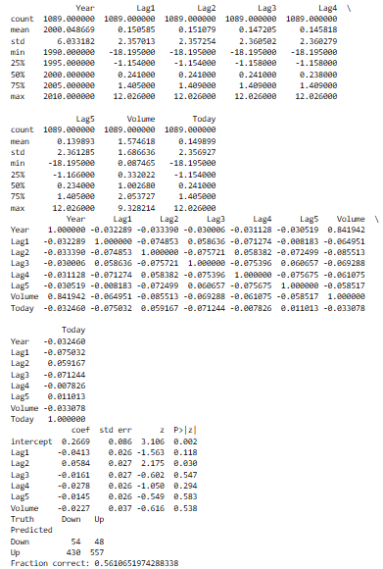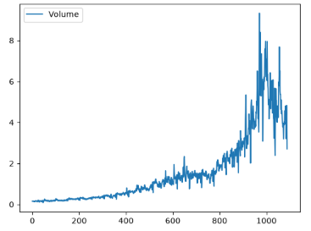
- Interpretation: The numerical summaries show that the volume of shares traded increases steadily across the years, while the return variables fluctuate around zero with very weak pairwise correlations. Fitting the logistic regression model indicates that only one lag variable shows a p-value below the standard significance threshold, suggesting a weak statistical relationship. The confusion matrix reveals that the model correctly predicts market increases on a large number of weeks, but struggles significantly with predicting market decreases correctly. Overall, the fraction of correct predictions is slightly better than random guessing when evaluated on the training set.

Exercise 2 – Honest Test Error on Weekly
- Key Numbers & Outputs:
  - Test accuracies across models evaluated on the held-out test period (2009–2010) using Lag2:
    - Logistic: 62.5% (0.625)
    - LDA: 62.5% (0.625)
    - QDA: 58.65% (0.5865)
    - Naive Bayes: 58.65% (0.5865)
    - KNN ($K=1$): 50.0% (0.5)
- Screenshot Placeholder:
- Interpretation: When restricting the analysis to the single lag predictor and evaluating performance on the held-out test period, methods such as logistic regression and linear discriminant analysis yield identical test accuracies because both models produce linear decision boundaries in a single dimension. Quadratic discriminant analysis and naive Bayes achieve very similar test performance. In contrast, the nearest neighbors method with a single neighbor performs noticeably worse due to overfitting the training data. Overall, the directional movement of stock markets remains extremely difficult to forecast accurately using only past lagged returns.

Exercise 3 – Predicting High and Low Gas Mileage (Auto)
- Key Numbers & Outputs:
  - Test errors for each classifier using standardized features (cylinders, displacement, horsepower, weight):
    - Logistic: 0.1356
    - LDA: 0.1356
    - QDA: 0.1441
    - Naive Bayes: 0.1356
    - KNN (K=5): 0.1271
- Screenshot Placeholder: 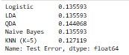
- Interpretation: Graphical exploration using box plots clearly indicates that vehicle weight, horsepower, displacement, and number of cylinders show strong separation between cars with high and low gas mileage. Standardizing these features ensures that variables measured on larger numeric scales do not dominate distance calculations. The resulting test error rates show that parametric classifiers like logistic regression and linear discriminant analysis perform exceptionally well, achieving high accuracy in distinguishing efficient vehicles from inefficient ones. Flexible methods like k-nearest neighbors also perform competitively when an appropriate neighborhood size is selected.

Exercise 4 – Logistic Regression on Default with a Validation Set
- Key Numbers & Outputs:
  - Validation set test errors across different random splits (seeds):
    - Seed 0 test error: 0.0290
    - Seed 1 test error: 0.0250
    - Seed 2 test error: 0.0248
    - Test error with student variable added: 0.0292
- Screenshot Placeholder: 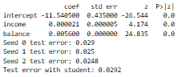
- Interpretation: Fitting logistic regression on income and balance demonstrates that account balance is a dominant predictor of credit default. When estimating test error using the validation set approach across different random seeds, the resulting error rates remain extremely stable because the sample size is large. Adding the student indicator variable does not substantially lower the overall test error rate because default rates are heavily influenced by financial balances. When interpreting the student coefficient, students tend to have a lower probability of default at any fixed credit card balance level, yet students as a group often have higher overall default rates because their average balances and incomes differ from non-students, illustrating the confounding phenomenon known as Simpson's paradox.

Exercise 5 – Additional Data Set: Breast-Cancer Diagnosis
- Key Numbers & Outputs:
  - Fraction malignant tumors: 0.3726 (37.26%)
  - Logistic Regression Confusion Table: 104 True Benign, 8 False Benign, 3 False Malignant, 56 True Malignant.
  - LDA Confusion Table: 105 True Benign, 11 False Benign, 2 False Malignant, 53 True Malignant.
- Screenshot Placeholder: 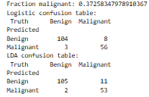
- Interpretation: The dataset exhibits a class imbalance where a minority of tumors are malignant. Both logistic regression and linear discriminant analysis achieve high overall correct classification rates when standard decision boundaries are applied. In a medical diagnostic context, missing a malignant tumor carries severe consequences, making sensitivity critically important. Lowering the probability threshold ensures that nearly all malignant cases are correctly identified, although this adjustment increases the number of false alarms and consequently lowers specificity. Receiver operating characteristic curves and their corresponding area under the curve metrics confirm that both modeling approaches provide outstanding discriminatory power.

Exercise 6 – Interpreting the Poisson Model for Bikeshare
- Key Numbers & Outputs:
  - Poisson Exponentials (e^{hat beta}):
    - workingday: 1.0148
    - temp: 2.1930
    - weathersit[cloudy/misty]: 0.9275
    - weathersit[heavy rain/snow]: 0.3968
    - weathersit[light rain/snow]: 0.5623
  - Number of negative fitted values in linear model: 833
- Screenshot Placeholder: 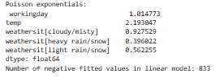
- Interpretation: Exponentiating the coefficients from the Poisson regression model provides multiplicative effects on the expected count of bike rentals. Holding all other variables constant, working days and higher temperatures scale expected ridership upward, whereas adverse weather situations reduce expected rental counts. When comparing the fitted values, the standard linear model produces several negative fitted values because it assumes constant variance and allows predictions to fall below zero. This outcome is physically impossible for count data representing numbers of bike rentals, whereas Poisson regression naturally constrains predicted counts to be non-negative.

Challenge Exercises (Optional / Bonus)
- Exercise 7 (LDA by hand):
  - Predictions match scikit-learn: True.
  - Screenshot Placeholder:
  - Interpretation: Implementing linear discriminant analysis manually using Bayes theorem with class priors, group means, and a pooled variance formula yields predictions that are identical to the built-in scikit-learn implementation. This confirms that the linear decision boundary depends directly on balancing the distance of test observations from each class mean relative to the shared variance and prior probabilities.
- Exercise 8 (Multiclass Wine Classification):
  - Multinomial Logistic 5-fold CV Accuracy: $0.9832
  - LDA 5-fold CV Accuracy: 0.9717
  - QDA 5-fold CV Accuracy: 0.9551
  - KNN (K=5) 5-fold CV Accuracy: 0.9494
  - Screenshot Placeholder: 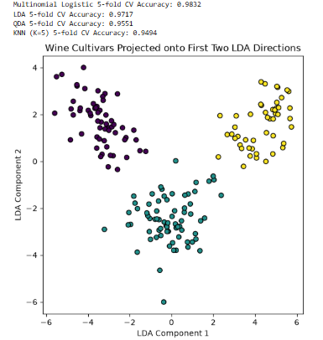
  - Interpretation: Cross-validation performance across multiple classification algorithms shows that both linear discriminant analysis and multinomial logistic regression achieve exceptional accuracy in classifying wine cultivars based on chemical measurements. Standardizing the feature values ensures that variables measured on disparate scales contribute equally to distance and boundary calculations. Projecting the multi-dimensional feature space onto the first two linear discriminant components demonstrates clear visual separation among the distinct wine cultivars.

