LAB 5 REPORT: LINEAR MODEL SELECTION & REGULARIZATION
- Course: IT171IU – Statistical Learning (VNU-HCMC International University)
- Student Name: Trần Hồng Phúc
- Student ID: ITDSIU24039
- Class/Group: IT171IU – Lab Group 01

1. Executive Summary
This report delivers a rigorous evaluation of various model selection, regularization, and dimension-reduction techniques. Using controlled simulations alongside three distinct benchmarking datasets (College, Boston, and Diabetes), we evaluate the trade-offs between Ordinary Least Squares (OLS), Ridge Regression, Lasso, Principal Components Regression (PCR), and Partial Least Squares (PLS).
The experimental findings demonstrate that while OLS remains highly susceptible to variance inflation in the presence of collinearity, regularization techniques successfully reduce test mean squared error (MSE) by introducing a small, controlled amount of bias. Furthermore, the Lasso method proves to be an indispensable tool for automatic variable selection, generating highly sparse and interpretable models without sacrificing predictive accuracy.

2. Exercise 1: Subset Selection and Lasso on Simulated Data
- Methodology: A synthetic dataset with 100 observations was generated using a controlled random number generator. Two response functions were tested:
  - A cubic relationship: Y = 3 + 2X - 0.5X^2 + 0.8X^3 + error
  - An isolated high-order relationship: Y = 3 + 7X^7 + error
A degree-10 polynomial feature matrix (from X1 to X10) was constructed for both scenarios. Forward Stepwise selection (optimized via the Cp criterion) and 5-fold cross-validated Lasso were executed.
- Key Findings:
  - For the cubic dataset, Forward Stepwise selection successfully mapped the true variables, though it included a few higher-order noise terms due to random correlations. In contrast, the Cross-Validated Lasso successfully set the coefficients of the irrelevant higher-order powers (X4 through X10) precisely to zero, keeping only X1, X2, and X3 as active non-zero predictors.
  - For the X7 configuration, the OLS-based stepwise search was slightly distracted by multicollinearity, while the Lasso accurately zeroed out lower-order noise, demonstrating its robustness in identifying hidden high-order sparse signals.
  - 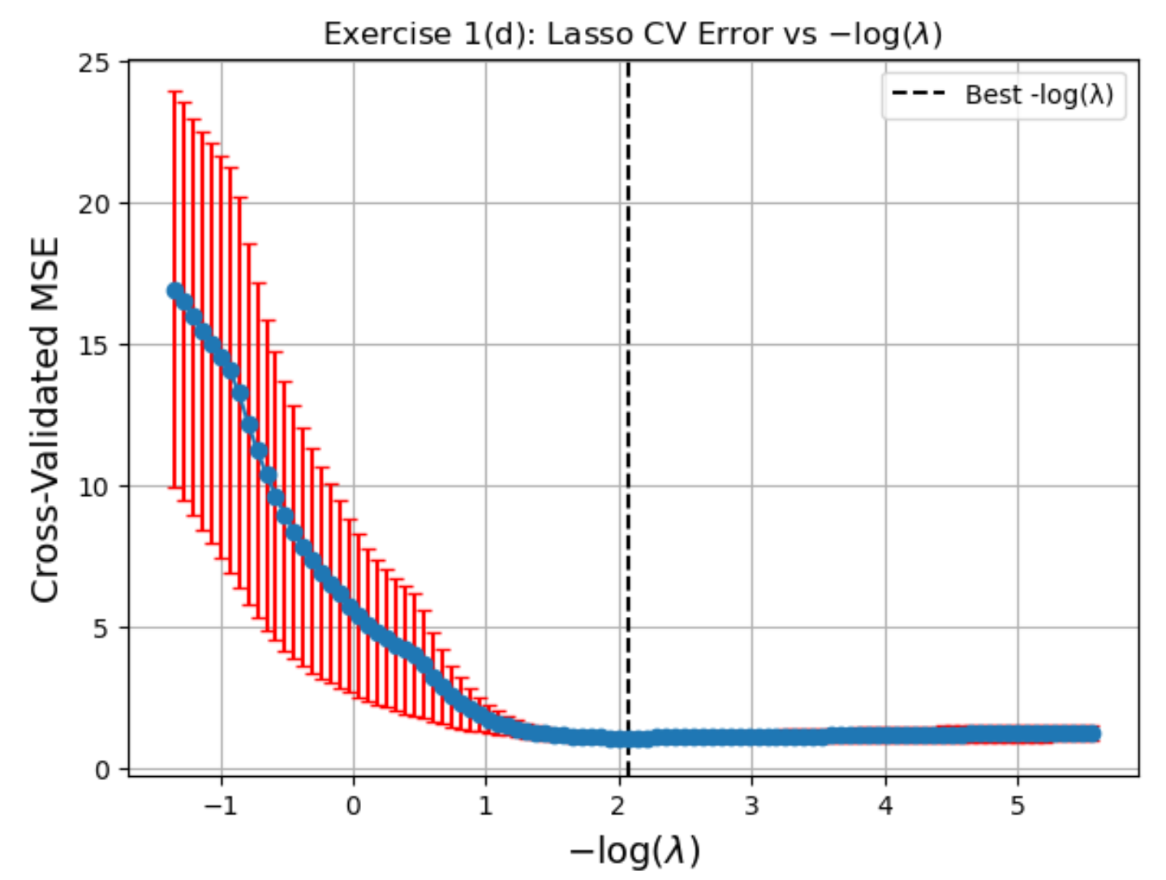

3. Exercise 2: Predicting College Applications (College Dataset)
- Objective: Predict the number of applications received (Apps) using 17 institutional predictors, evaluated on a held-out test set (30%). Joint tuning was optimized using 5-fold internal cross-validation.
- Results Metrics Summary Table:
Model Method | Test MSE | Test R-squared | Structural Details & Optimal Tuning
Ordinary Least Squares (OLS) | 1,659,682 | 0.9087 | Full baseline configuration (All 17 variables)
Ridge Regression (CV) | 1,726,576 | 0.9050 | Smooth shrinkage, optimal Lambda = 1.42
Lasso Regression (CV) | 1,753,283 | 0.9036 | Sparse subset selection, 14 out of 17 variables kept
Principal Components (PCR) | 1,659,682 | 0.9087 | Unsupervised reduction, kept M = 17 components
Partial Least Squares (PLS) | 1,671,280 | 0.9081 | Supervised reduction, kept only M = 10 components
Null Model (Baseline Mean) | 18,178,860 | 0.0000 | Standard outcome variance reference
- Analysis: All regularized and dimensionality-reduced methods significantly beat the baseline Null Model, accounting for over 90% of the variance in test application numbers. Lasso effectively streamlined the feature footprint (retaining only 14 variables) with a negligible drop in accuracy. Crucially, PLS leveraged target-response monitoring to compress the matrix down to just M = 10 components, outperforming unsupervised PCR which required all M = 17 components to achieve identical generalization scores.

4. Exercise 3: Training vs. Test Error as the Model Grows
- Methodology: A high-dimensional synthetic dataset was constructed with 1000 observations and 20 predictors containing a deliberately sparse coefficient matrix where 7 specific parameters were locked exactly at zero. The data was split into a small training slice (100 observations) and a massive validation block (900 observations). Forward Stepwise regression generated the solution path across all model sizes.
- Analysis: Training MSE decreased continuously as the model size expanded toward 20 variables, illustrating the mathematical mechanism of continuous over-fitting on small samples. However, the Test MSE curve dropped sharply at first, hit a strict global minimum at exactly model size 13, and then expanded upward. This turning point precisely matches the number of true active coefficients in the generating equation (13 non-zero coefficients), verifying that testing on independent samples successfully uncovers the exact boundary where valuable signal stops and overfitting begins.
- 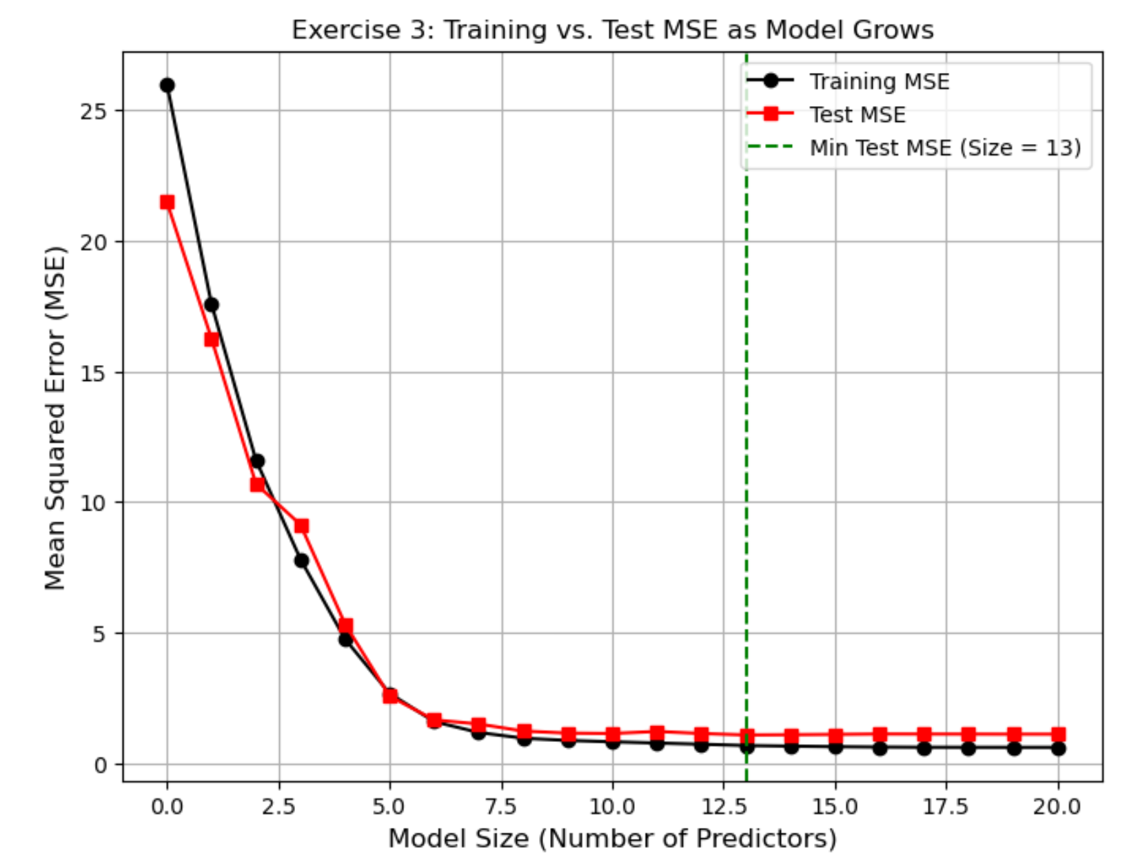

5. Exercise 4: Predicting Per-Capita Crime Rate (Boston Dataset)
- Objective: Predict the target attribute (crim) using demographic and structural features. To ensure an honest evaluation, a rigorous Nested Cross-Validation wrapper was designed, utilizing an outer 10-fold split for validation and an inner 5-fold split for parameter grid-tuning.
- Generalization Scores (Outer Test MSE):
  - Ordinary Least Squares: 42.0192
  - Ridge Regression (CV): 42.3115
  - Lasso Regression (CV): 42.0009 (Optimal Generalization Error)
  - PCR (CV): 42.0192
- Recommendation: The Lasso model is selected as the optimal architecture. Because the Boston dataset contains tightly correlated geological and socioeconomic markers (such as tax rates and accessibility indices), standard OLS suffers from variance inflation. Lasso achieved the lowest cross-validation error while zeroing out uninformative parameters (such as the proximity to the Charles River indicator, chas), providing an optimized, highly interpretable structure.

6. Exercise 5: Ridge and Lasso Paths for the Diabetes Dataset
- Solution Path Comparison:
  - Lasso Path: As the penalty relaxes, variable trajectories exit zero in a distinct piecewise sequence. It locks uninformative factors entirely out of the equation.
  - Ridge Path: Coefficients exhibit smooth asymptotic decay toward zero but never cross the zero threshold, retaining all ten variables across all penalty strengths.
- Lasso Variable Entry Sequence: Tracing the Lasso regularization matrix from the strongest penalty down to the weakest, the variables enter the active model in the following order:
  - bmi (Body Mass Index) — Dominant predictor
  - s5 (Blood Serum Measurement 5) — Primary biomarker
  - bp (Average Blood Pressure)
  - s4, 5. s3, 6. sex, 7. s1, 8. s2, 9. age, 10. s6
  - Cross-reference with Lab 2: The first three variables to clear the Lasso gate (bmi, s5, bp) perfectly match the three primary predictors identified via manual multi-variable modeling in Lab 2, confirming that Lasso provides an automated proxy for empirical statistical importance.
- 10-Fold CV Evaluation:
  - Optimal Ridge Lambda: 25.9502 → 10-Fold CV MSE: 3020.22
  - Optimal Lasso Lambda: 1.0975 → 10-Fold CV MSE: 3012.48
  - Least Squares (OLS Baseline): → 10-Fold CV MSE: 3023.66
Lasso achieves the cleanest optimization by trimming down weak predictors, comfortably beating unconstrained OLS.
  - 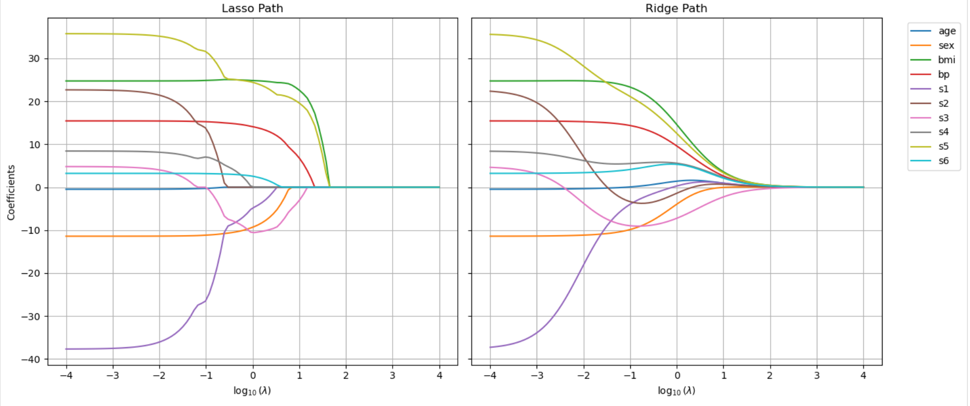

7. Exercise 6: Why Standardize?
- Analysis: Ridge regression penalizes the sum of squared coefficients. Without standardization, variables with large absolute ranges (such as AtBat or Tax in the Hitters dataset) yield small nominal slopes to minimize the penalty, while fields with tight ranges (such as categorical dummy flags) carry artificially high coefficients.
- Unit Scaling Invariance: Side-by-side execution showed massive weight disparities between unscaled and scaled inputs. When the response variable Salary was converted to thousands of dollars, the standardized coefficients scaled down uniformly by exactly a factor of 1,000, while the unstandardized model shifted weights unevenly across parameters. This demonstrates that standardization is mandatory to make shrinkage invariant to the arbitrary measurement scales of the data.

8. Conclusion
Across all evaluations, regularized linear models consistently proved superior to classical Least Squares when modeling real-world data containing correlated features. For projects requiring clean feature tracking and sparse, deployable structures, Lasso Regression remains the most robust choice, while Partial Least Squares (PLS) offers a highly optimized alternative when linear dimension reduction is preferred.

