Booking Core: 8 Domains vs Current Implementation
Oct 13, 2026 · @Theon

Summary
Of the 22 building blocks in the 8 core domains, 5 are done, 7 are partly built and 10 are missing. The base that every booking needs is in place: resource types with a field schema, resources, the booking life cycle and role-based access. What is missing is everything around the booking: time slots and schedules, booking rules, pricing and payment, notification delivery, and audit.
The code also has three supporting modules that are not among the 8 domains: master data (status lists), file storage, and comments. Checked against core/models.py and the service code on 13 Oct 2026.

Comparison table
The resource and booking basics are done; rules, money, delivery and audit are not.
Domain | Block | Status | What exists today | What is missing
1. Booking lifecycle | Booking | Done | Booking model; create for self, guest or by staff; update, delete, my bookings, all bookings with filters | Booking reference code for customers
1. Booking lifecycle | Status | Done | BOOKING_STATUS in master data (Pending, Confirmed, Cancelled, Completed); allowed changes in BOOKING_TRANSITIONS | Transitions are fixed in code, not set per resource type
1. Booking lifecycle | Event | Missing | Nothing records who changed a booking and when | Booking history: created, confirmed, rescheduled, cancelled, by whom
2. Availability & scheduling | TimeSlot | Partial | Free start and end times; overlap check on save; calendar API per resource per day | No slot model: fixed lengths, buffer time, capacity per slot
2. Availability & scheduling | Lock | Partial | Database row lock on the resource while a booking is saved | No temporary hold while a customer fills a form or pays
2. Availability & scheduling | Schedule | Missing | Not built | Opening hours, closed days, holidays, recurring availability
3. Resource management | Type | Done | ResourceType with a field schema (configuration.fields); CRUD API | Nothing major
3. Resource management | Resource | Done | Resource with status from master data; details checked against the type schema; CRUD API | Delete of a resource with bookings returns a server error instead of a clear message
3. Resource management | Group | Missing | Not built | Groups or locations (branch, floor, room); book any resource in a group
4. Booking rules | Policy | Partial | BookingPolicy model per resource type (priority, default, rules in configuration) | No API, and no rule is checked when booking (min/max length, lead time, max per user)
4. Booking rules | Eligibility | Missing | Only role checks: logged in, staff, admin | Who may book which resource type (membership, user group)
5. Pricing & payment | Quote | Missing | A price can only be stored as a free field in resource details | Price rules and a quote shown before booking
5. Pricing & payment | Transaction | Missing | Not built | Payment record and payment gateway
5. Pricing & payment | Refund | Missing | Not built | Refund on cancel, refund policy
6. Identity & access | Actor | Partial | User with soft delete; a guest is saved as name, email and phone on the booking | No guest or contact record, no organisation (tenant)
6. Identity & access | Role | Done | Role, Permission, UserRole, RolePermission; ADMIN, STAFF, CUSTOMER seeded; admin APIs | The API checks role codes only; permission codes are stored but not enforced
6. Identity & access | Credential | Partial | Password + JWT (access, refresh, logout blacklist, token version); email OTP task in Celery | No OTP or 2FA flow in the user API; no SSO or API keys
7. Notification | Event | Partial | Notification model + list API; type from master data | No booking action creates a notification
7. Notification | Template | Missing | Not built | Message templates per event and language
7. Notification | Channel | Partial | Socket.IO service and Celery email tasks exist | Not connected to booking events; no SMS or push; no user preferences
8. Audit & analytics | AuditLog | Missing | django-simple-history is installed, but no model uses it | Change history for bookings, resources, users and roles
8. Audit & analytics | Metrics | Missing | Not built | Occupancy and usage reports, booking counts, cancellation rate

Why the gaps matter
The biggest risk today is that bookings can be made on any time at any hour, with no rule and no trace. That is fine for a demo, not for a real customer.
- Booking lifecycle: without booking history we cannot answer "who cancelled this and when", which support and disputes need.
- Availability & scheduling: without opening hours, a customer can book a room at 3 a.m. or on a holiday. Without a hold, two people paying at the same moment can both think they got the slot.
- Resource management: without groups, a business with several branches cannot show "rooms in branch A" or let a customer book any free room.
- Booking rules: the policy table exists but nothing reads it, so limits like "max 2 hours" or "book at least 1 day ahead" cannot be set per business.
- Pricing & payment: paid industries (sports courts, salons, clinics) cannot use the system until we have prices, payment and refunds.
- Identity & access: roles work, but custom roles like Cashier have no effect, because the API does not check permission codes yet.
- Notification: customers get no confirmation or reminder, even though the socket and email services are already running.
- Audit & analytics: no change history for compliance, and no occupancy numbers for managers.

Plan
Close the gaps in four phases: first make the current core safe to pilot, then add rules, then money, then delivery and reports.
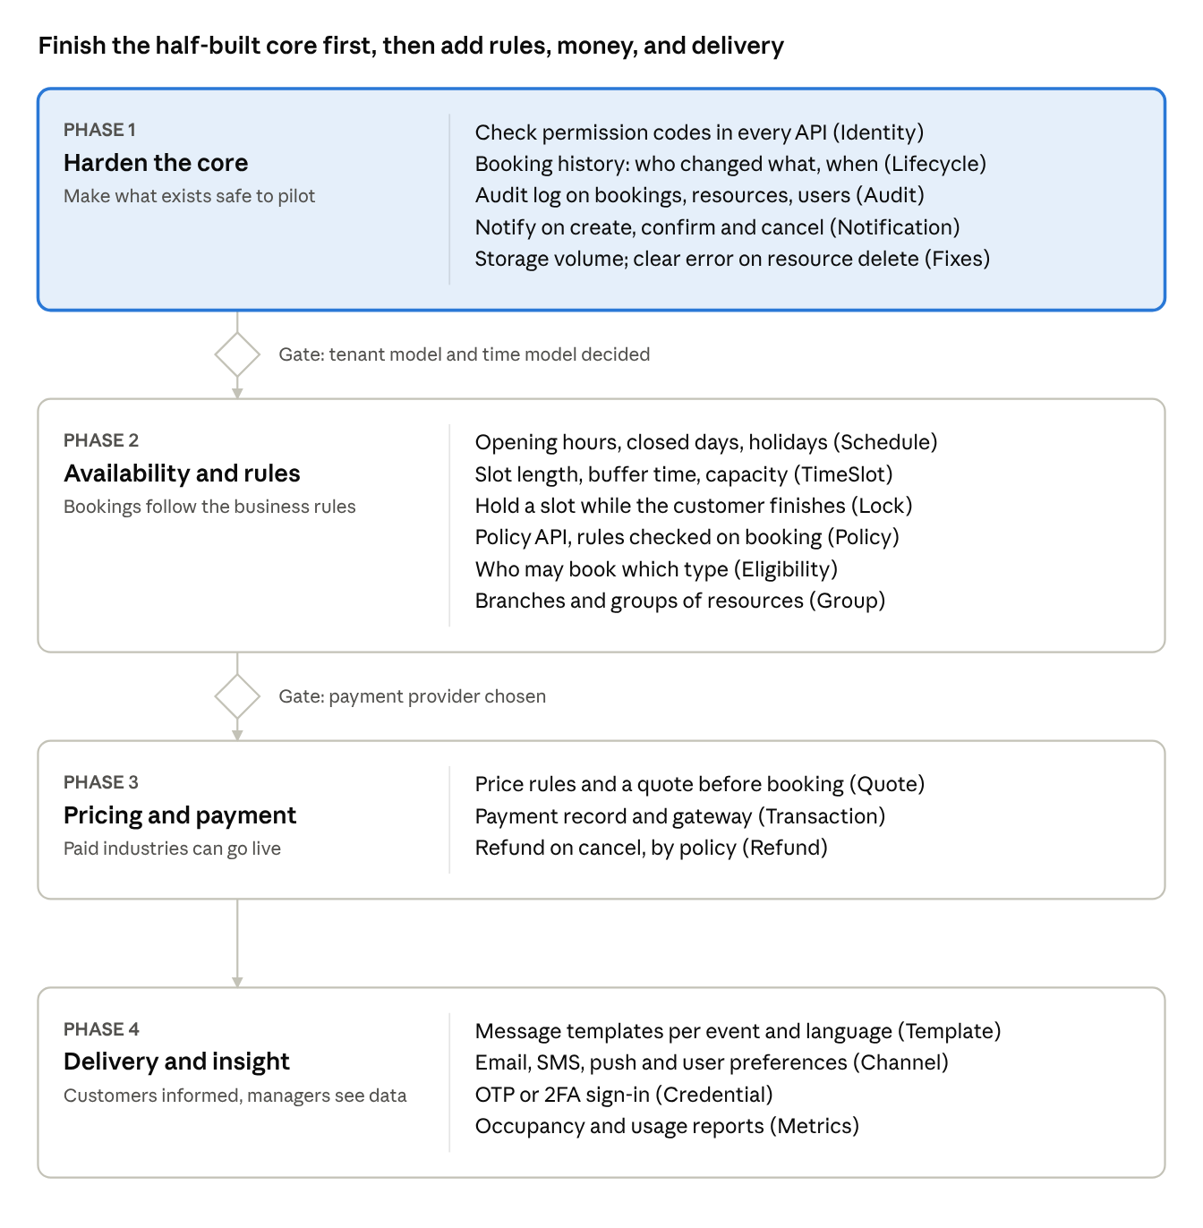
roadmap · 4 phases, 2 gates
Phase 1 adds no new domain; it finishes what is half-built so a pilot can start. Each later phase adds one group of domains, and the two gates are the decisions in the next section.

Decisions needed and risks
Four decisions shape the plan; the first two should be made before phase 2 starts.
Decision | Options | Why it matters
Multi-tenant (organisation) or one business per install? | Add an organisation to every table / keep one business per deployment | Adding it later touches every table and API
How time is booked | Free start and end times / fixed slots per resource type / both, set in the booking policy | Decides the TimeSlot and Schedule design
Payment provider | A local gateway (e.g. VNPay, MoMo) / an international one (e.g. Stripe) / offline payment only at first | Decides phase 3 scope and contracts
First pilot industry | Coworking / clinic / sports / salon / education | Sets which rules and price models we build first
Risks:
- All services share one database, so a schema change in the core reaches every service at once; changes need one coordinated release.
- The storage service keeps files inside its container with no volume, so recreating the container deletes all uploaded files. This must be fixed before any real use.
- Custom roles look active in the admin screens but have no effect until permission checks are built (phase 1).

