|  |  |  |  |  |
| --- | --- | --- | --- | --- |
| **Class** | **SE18xx** | **Group** | **01** | **Contribution** |
| **#** | **Student ID** | **Student Name** | **Task** | **(0-100%)** |
| 1 | SE171325 | Nguyễn Đức Hùng | Tham gia lắp mạch, Phân tích yêu cầu | 100% |
| 2 | SE171259 | Nguyễn Bá Đạt | Thiết kế tinkercad, code | 100% |
| 3 | SE171328 | Nguyễn Phúc Lộc | Tham gia lắp mạch, vẽ flowchart | 100% |
| 4 | SE171330 | Hà Gia Khánh | Tham gia lắp mạch, block diagram | 100% |
| 5 |  |  |  |  |

**IOT 102: PROGRESS TEST 1**

**DO NOT COPY**

**Components**: ultrasonic rangefinder, servo motor, Arduino Uno, LCD, LED (red-green)

**Task**: Design a system to open the barrier when a car approaches.

**Description**:

* Use the ultrasonic rangefinder to estimate the distance *dis* between the car and the barrier.
* 03 pre-defined values: *red_dis < yellow_dis < green_dis*

|  |  |  |
| --- | --- | --- |
| *yellow_dis <= dis < green_dis* | Only GREEN LED blinks | Blink rate depends on the value of *dis: shorter distance, higher blink rate*  and in the range of [01, 100] Hz |
| *red_dis <= dis < yellow_dis* | Only YELLOW LED blinks |
| *dis < red_dis* | Only RED LED blinks |

* When the distance is less than *red_dis*, the servo motor controls the barrier **up**, and the LCD displays “**Barrier opened**” and the buzzer is on.
* When the distance is greater than *yellow_dis*, the servo motor controls the barrier **down** (90 degrees), and the LCD displays “**Barrier closed**”.
* User can change the value of *red_dis, yellow_dis* or *green_dis.*
* *Hint:*

*int red_dis = 30;*

*int yellow_dis = 50;*

*int green_dis = 70;*



**Answer**

1. **Block diagram:**

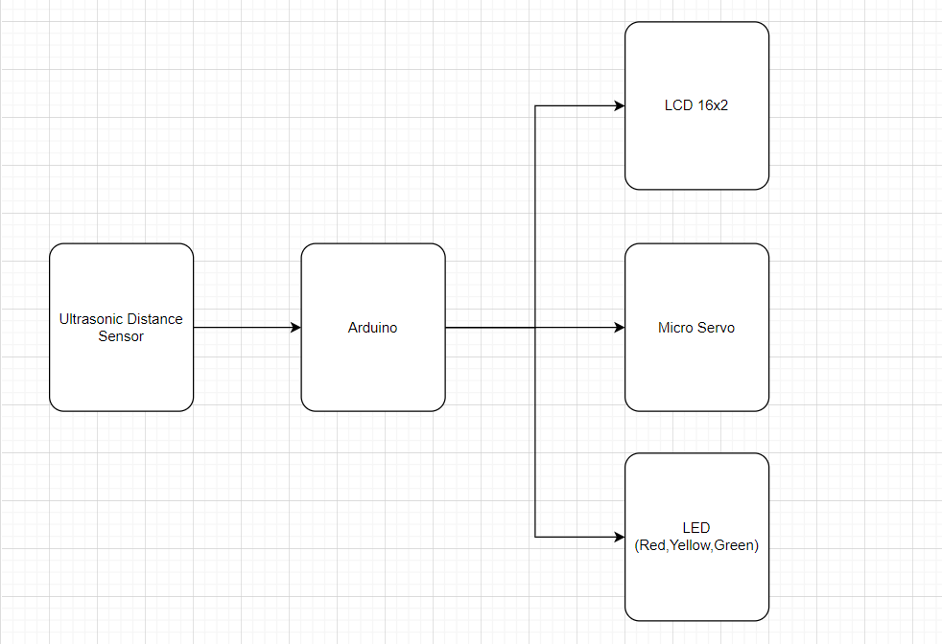

1. **Picture of your design:** 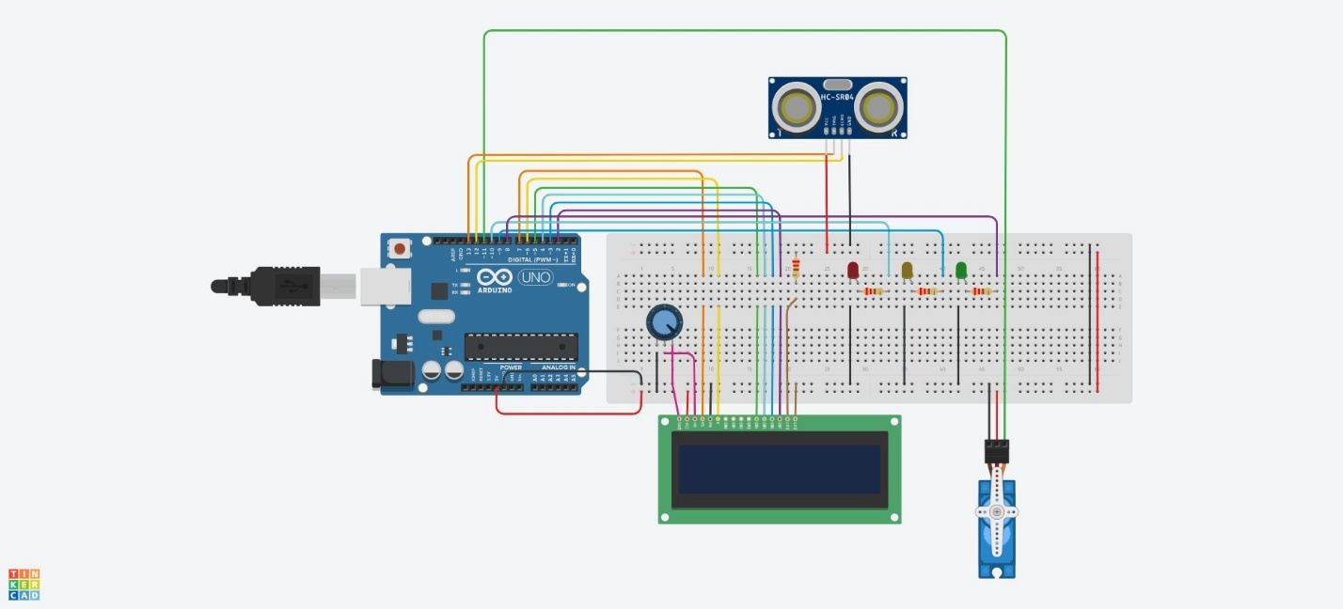
2. **Flowchart (algorithm)**

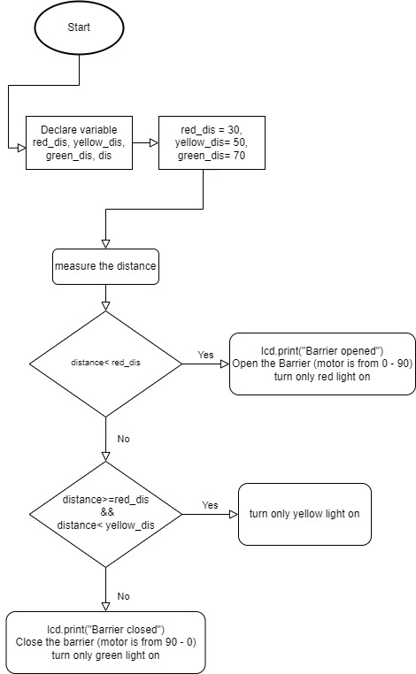

1. **Code:**

**#include <LiquidCrystal.h>**

**#include <Servo.h>**

**Servo myservo;**

**const unsigned int TRIG_PIN=13;**

**const unsigned int ECHO_PIN=12;**

**LiquidCrystal lcd(7, 6, 5, 4, 3, 2);**

**const int red_led = 10;**

**const int yellow_led = 9;**

**const int green_led = 8;**

**const int red_dis = 30;**

**const int yellow_dis = 50;**

**const int green_dis = 70;**

**int pos = 0;**

**void setup()**

**{**

**pinMode(TRIG_PIN, OUTPUT);**

**pinMode(ECHO_PIN, INPUT);**

**lcd.begin(16, 2);**

**myservo.attach(11);**

**pinMode(red_led,OUTPUT);**

**pinMode(yellow_led,OUTPUT);**

**pinMode(green_led,OUTPUT);**

**}**

**void loop()**

**{**

**lcd.setCursor(0, 1);**

**digitalWrite(TRIG_PIN, LOW);**

**delayMicroseconds(2);**

**digitalWrite(TRIG_PIN, HIGH);**

**delayMicroseconds(10);**

**digitalWrite(TRIG_PIN, LOW);**

**const unsigned long duration= pulseIn(ECHO_PIN, HIGH);**

**int distance= duration/29/2;**

**if(distance< red_dis){**

**short_distance();**

**if(pos ==90) myservo.write(pos);**

**else{**

**for(;pos<=90;pos+=1){**

**myservo.write(pos);**

**delay(5);**

**}**

**}**

**lcd.print("Barrier opened");**

**}else if(distance>=red_dis && distance< yellow_dis){**

**average_distance();**

**}else if(distance>=yellow_dis){**

**long_distance();**

**if(pos ==0) myservo.write(pos);**

**else{**

**for(;pos>=0;pos-=1){**

**myservo.write(pos);**

**delay(5);**

**}**

**}**

**lcd.print("Barrier closed");**

**}**

**}**

**void long_distance(){**

**digitalWrite(red_led, LOW);**

**digitalWrite(yellow_led, LOW);**

**digitalWrite(green_led, HIGH);**

**}**

**void average_distance(){**

**digitalWrite(red_led, LOW);**

**digitalWrite(yellow_led, HIGH);**

**digitalWrite(green_led, LOW);**

**}**

**void short_distance(){**

**digitalWrite(red_led, HIGH);**

**digitalWrite(yellow_led, LOW);**

**digitalWrite(green_led, LOW);**

**}**

1. **Tinkercad link:**

[**https://www.tinkercad.com/things/5prUb35CCLS-project-iot-pt1-/editel?sharecode=PE18sr1P5a5JZhXCF2VUnhSfLOC0rpn_XkaAbp3w2uE**](https://www.tinkercad.com/things/5prUb35CCLS-project-iot-pt1-/editel?sharecode=PE18sr1P5a5JZhXCF2VUnhSfLOC0rpn_XkaAbp3w2uE)

1. **Video clip (Google Drive):**

[**https://drive.google.com/file/d/1mDZcUC_pyUc_FTj0WGPrpk2cj7ScJQWL/view?usp=sharing**](https://drive.google.com/file/d/1mDZcUC_pyUc_FTj0WGPrpk2cj7ScJQWL/view?usp=sharing)