Assignment
Subject: Electrical Electronic Circuits (CO2038)
Module: Computer Hardware Design
Semester: 231 (Academic year 2023 – 2024)

Students design any electronic device that uses all the electronic components learned in the course and consists of three main blocks:
- Power Supply: Provides power for all the components in the device.
- Function: Generates output signals according to the inputs and the operating contexts or states (for shot: the logic).
- Interface:
  - Human interface (e.g. switches, buttons, LED indicators, LCD, etc.)
  - Communication interface (e.g. pins, terminals, sockets, etc. for the inputs and outputs)

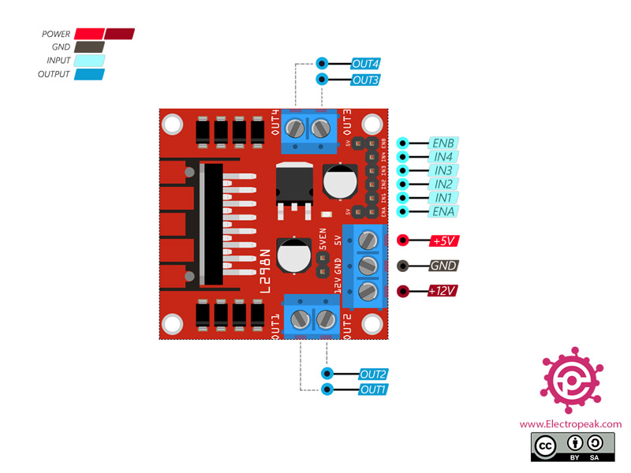
Figure 1. Example of an electronic device that meets the assignment’s requirements.

In this assignment, students are expected to do a full engineering process to design and implement an electronic device. Students have to exactly define it in general and details, then, analyze, design, and implement it in a systematical step-by-step process.

Outcome: Project proposal & docs, CAD design, rendered images, and a working device.

Scoring rubrics

Before scoring, students are given 10 points.
During the scoring progress, their score will be adjusted according to the good or bad things they do in the assignment, as follow:

Categories |  |  | Adjust
Process | Requirement Engineering | There is no (or bad) general description | (-) up to 0.5 point
Process | Requirement Engineering | There is no (or bad) requirements specifications | (-) up to 1 point
Process | Conceptual Design | There is no (or bad) conceptual design | (-) up to 1 point
Process | Schematic Design and Validation | Doesn’t draw a schematic diagram or just draw an incomplete one. (e.g. lack of required block(s); doesn’t meet specified requirements, violate some designing rule(s) or electrical laws, etc.) | (-) up to 1 point | (-) up to 3 points
Process | Schematic Design and Validation | Do the schematic design without a checklist or skip some important step(s). For example, electrical analyses, or schematic validation. | (-) up to 1 point | (-) up to 3 points
Process | Schematic Design and Validation | Do the schematic design without appopriate components selection | (-) up to 1 point | (-) up to 3 points
Process | PCB Design | Doesn’t well define and describe the components’ footprints. | (-) 0.5 point
Process | PCB Design | Doesn’t use any design rules | (-) 0.5 point | (-) up to 1 point
Process | PCB Design | Specify design rule(s) without any reasonable calculation | (-) 0.5 point | (-) up to 1 point
Result |  | Can’t design a complete PCB layout |  | (-) up to 2.5 points
 |  | Doesn’t produce a rendered device image where all the components have 3D bodies. |  | (-) 0.5 point
Bonus |  | Good idea & possible | (+) up to 1 point
 |  | Complicated electronics device | (+) up to 1 point
 |  | Good component placement & routing | (+) up to 1 point
 |  | Device with good appearance | (+) up to 1 point
 |  | Good finishes (e.g. copper polygon pouring, mounting holes, etc.) | (+) up to 1 point

