SOFTWARE ARCHITECTURE DOCUMENT
Order Rescue
How the Adaptive Delivery Recovery Agent is built
Document Definition | This technical document lays out "how" the product is built: system architecture, technology stack, component structure, data flow and key technical decisions.
Who to Share | Development team, system architects, evaluators and reviewers.
Document Scope | Deeply technical. Covers system structure, data contract, security, code organisation, integration and engineering details. Product "why" lives in the Product Vision.

Reading note. This document separates what is implemented today (local MVP) from the target architecture (v2.2 contract with a live LLM Agent). Items marked "Target" or "Proposed" are not built yet. Section 12 lists the known gaps.

1. Executive Summary
Product | Order Rescue: Adaptive Delivery Recovery Agent
Version | 0.1 (hackathon MVP)
Architecture Style | Deterministic decision pipeline with an LLM assessment step behind a validated contract. Single-page local app today; stateless backend service as target
Core Principle | Three separated layers: raw data, Agent assessment (LLM proposes), policy output (deterministic code decides)
Target Scale | Demo scale: 30 synthetic cases. No production scale or load target has been set or measured
Infrastructure | Local development machine (Vite dev server). No deployment, no carrier integration
Data | Synthetic only. No Shopee / SPX data, API, buyer messaging, dispatch or operational action
Document Status | Draft
Last Updated | October 29, 2026

2. High-Level Architecture Overview

2.1 Architecture Philosophy
Evidence-first, policy-bounded, human-in-the-loop. The design rests on four rules taken from the v2.2 business rules:
- Three layers never mix. Raw data (status, courier note, lifecycle, buyer context, replies), Agent assessment (evidence, hypothesis, confidence, missing_info, question_key, candidate_action) and policy output (eligibility, policy_gate, final_action, reason).
- The LLM proposes, code decides. Anything that must be correct (eligibility, attempt limits, allowed actions) is computed by deterministic code. The Agent only proposes a candidate action.
- Two assessment slots, one final. A case stores at most an initial and an after-reply assessment. The final assessment is a copy of one of them, never a third inference.
- Nothing is executed. The system recommends to Operations. It never calls carrier APIs, messages real buyers, changes addresses or COD, dispatches, returns or refunds.

2.2 System Components
Figure 1 (next page) shows the components. Solid boxes exist in the repository today; dashed boxes are target components.
- Presentation (implemented): React components render the scenario list, assessment, evidence, policy result and audit timeline, plus truth labels that mark what is real-local, simulated or future.
- Application state (implemented): useDemoSession keeps one session per scenario and triggers re-assessment; buildDecisionRecord writes an immutable audit record for each assessment.
- Decision core: assessCase is the deterministic assessor used by the MVP (v1 rules). The LLM Agent runner and the schema validator are the target replacement for the v2.2 contract. evaluatePolicy is the deterministic policy gate and already blocks unsupported requests such as address change, courier dispatch or refund.
- Data: five synthetic fixtures today; the v2.2 data model (9 tables, 30 seed cases in JSON) is the target store. The database engine is not selected.
- Offline evaluation harness: 30 golden cases that are never given to the Agent, simulated runs and graders (exact match on enums, set match on missing_info).
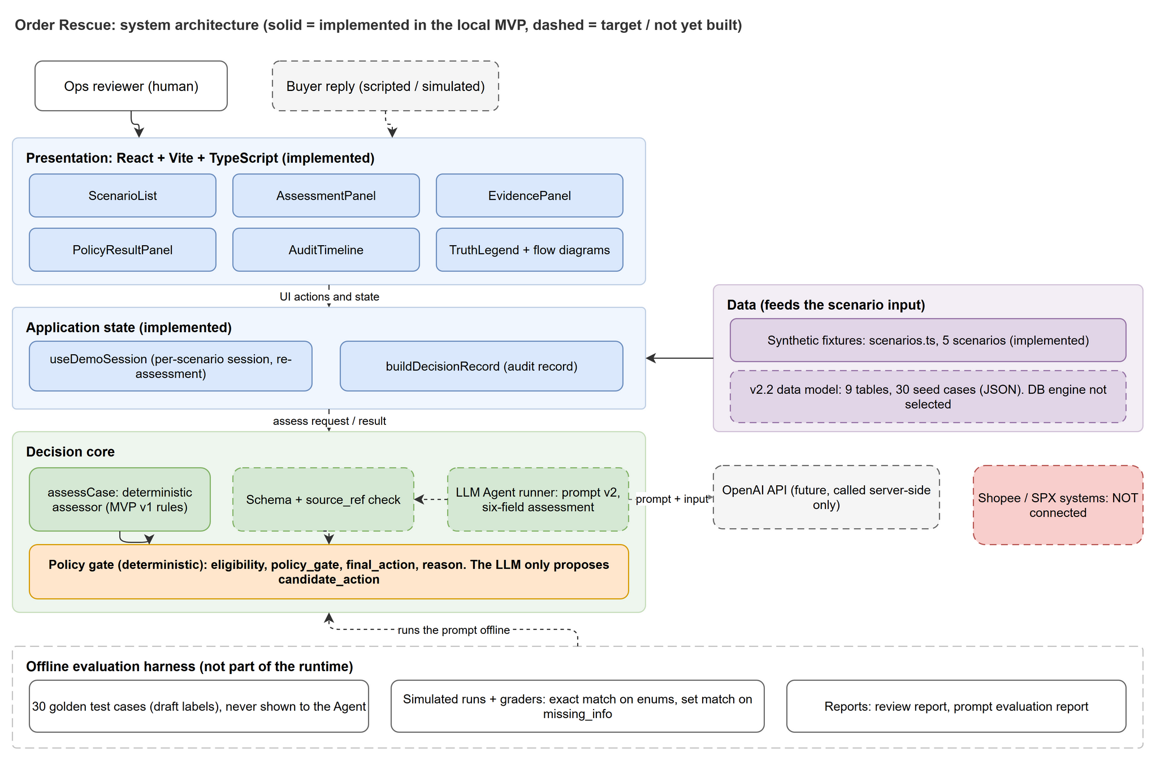
Figure 1. System architecture (solid = implemented, dashed = target)

2.3 Data Flow Architecture
Figure 2 (next page) shows the case flow defined by the v2.2 contract. In words:
- A trigger creates or loads a case in status NEW with raw input only. No expected answers are stored.
- The backend pre-check rejects malformed input, started or completed returns, unknown or expired deadlines, no attempts remaining, and duplicate or stale triggers. A blocked case does not call the AI and is routed to Ops (outside the 30-case suite).
- Agent assessment 1 receives core_input (case id, failed event, attempts used, return state, deadline, buyer history, operational context including T0 buyer messages) and returns the six-field assessment. The backend validates it, computes the policy output and stores both (status ASSESSED).
- The contact gate decides whether one buyer question is permitted. If so, one question is emitted and the case moves to WAITING_FOR_BUYER.
- If the buyer replies, the backend rebuilds the raw input plus the reply as runtime_context, runs Agent assessment 2 and the policy, and the final assessment is a copy of it (final_assessment_source = 2).
- If the demo operator presses USER_NO_REPLY, no second Agent call is made; the final assessment is a copy of the initial one (final_assessment_source = 1). The system never turns silence into refusal.
- The case becomes COMPLETED. This means a recommendation was fixed, not that Ops acted or the parcel was delivered.
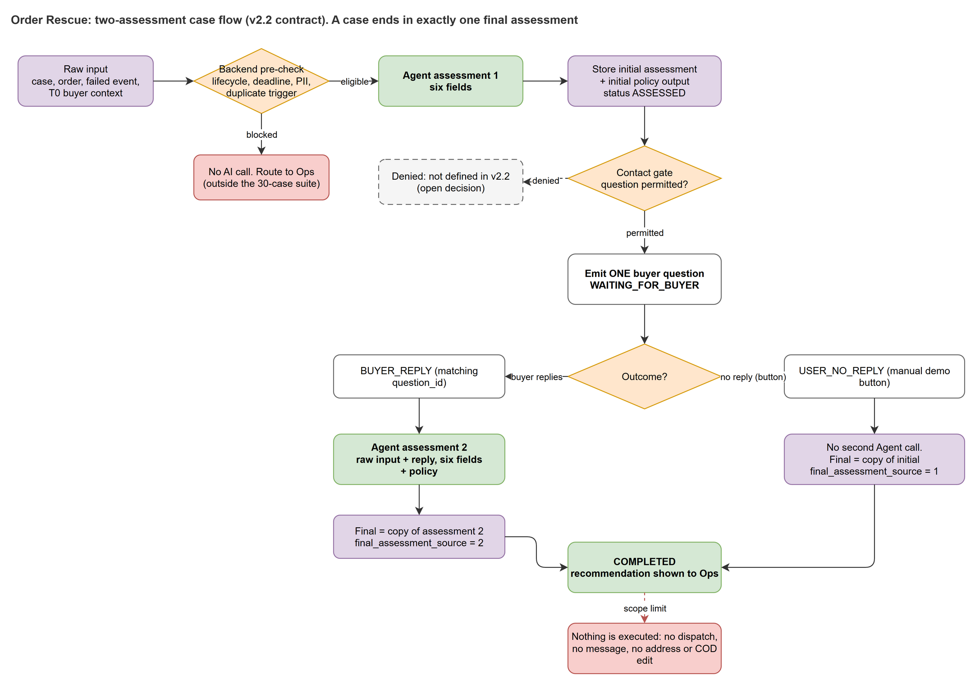
Figure 2. Two-assessment case flow (v2.2 contract)

3. Technology Stack
Layer | Choice | Status
Language | TypeScript (project references: tsconfig.app.json, tsconfig.node.json) | Implemented
UI framework | React with react-dom | Implemented
Build / dev server | Vite with @vitejs/plugin-react | Implemented
Package manager | npm (package-lock.json) | Implemented
Unit / component tests | Vitest, Testing Library (react, jest-dom), jsdom | Implemented
Browser tests | Playwright (e2e/order-rescue-demo.spec.ts) | Implemented
Decision engine (MVP) | Pure TypeScript functions: assessCase, evaluatePolicy, buildDecisionRecord | Implemented
LLM Agent | OpenAI model called server-side with structured JSON output; system prompt and JSON Schema in src/agent/prompts/. Model id not fixed | Target (prompt written and evaluated by simulation)
Data store | Logical 9-table model in JSON seed; relational engine not chosen. Reference SQL was run on SQLite in memory only | Target
Backend runtime | Not chosen. Must be stateless per request, with transactions around state changes | Target
CI/CD | None yet. GitHub Actions proposed (see section 9) | Proposed
Hosting | Local only. No deployment | n/a

Note: package.json pins dependencies to latest; reproducibility today relies on the lockfile. Pinning exact versions is recommended (section 12).

4. Modular Architecture Design

4.1 Module Structure
src/
app/ useDemoSession.ts session state, re-assessment
components/ ScenarioList, AssessmentPanel, EvidencePanel,
PolicyResultPanel, AuditTimeline, TruthLegend,
DecisionFlowDiagram, ScopeDiagram, SyntheticDataCard
data/ scenarios.ts 5 synthetic fixtures + validateScenario
Database model/ v2.2 data model + seed (JSON)
Test case/ 30 golden cases (JSON, never Agent input)
domain/ types.ts vocabularies, actions, labels
engine/ assessCase.ts deterministic assessor (MVP v1)
policyGate.ts deterministic policy gate
buildDecisionRecord.ts audit record builder
agent/prompts/ recommendation_system_prompt.md
assessment.schema.json six-field output schema
README.md
test/ setup.ts
e2e/ order-rescue-demo.spec.ts

Rules of the structure: components never compute decisions; the engine is pure (no I/O, no globals) so it is unit-testable; the Agent can only reach the engine through the validator; the golden test file is read only by the evaluator.

Target backend modules
Module | Responsibility
case-store | Reads cases with the four query recipes; writes initial and final assessments with guarded updates (affected rows = 1)
precheck | Deterministic lifecycle, deadline, attempts, PII and duplicate checks before any AI call
contact-gate | Decides whether one buyer question is permitted; writes the question and wait state
agent-runner | Builds the envelope, calls the LLM with the system prompt, returns raw JSON
validator | Validates six-field schema, enums, source_ref existence and availability, verification values
policy-engine | Computes eligibility, policy_gate, final_action and reason from a versioned policy profile
evaluator | Offline: runs cases, compares with golden labels, produces reports

4.2 State and Event Catalog
Case status follows a fixed state machine (from the v2.2 runtime contract). Each transition writes specific fields and only from the expected prior state.
{
"states": ["NEW", "ASSESSED", "WAITING_FOR_BUYER", "COMPLETED"],
"transitions": [
{ "from": "NEW", "event": "VALID_INITIAL_ASSESSMENT", "to": "ASSESSED",
"writes": ["initial_assessment", "initial_policy_output"] },
{ "from": "ASSESSED", "event": "PERMITTED_FIRST_QUESTION", "to": "WAITING_FOR_BUYER",
"writes": ["AI_QUESTION interaction", "question_wait_state=PENDING"] },
{ "from": "WAITING_FOR_BUYER", "event": "MATCHING_BUYER_REPLY", "to": "COMPLETED",
"writes": ["BUYER_REPLY interaction", "after_reply_*", "final_assessment_source=2",
"final fields", "question status=ANSWERED"] },
{ "from": "WAITING_FOR_BUYER", "event": "MANUAL_USER_NO_REPLY", "to": "COMPLETED",
"writes": ["final_assessment_source=1", "final fields = initial",
"question status=NO_REPLY", "after_reply_* stay null"] }
]
}

Interaction types stored in fact_rescue_interaction: BUYER_CONTEXT (raw context known before T0, never a reply), AI_QUESTION, BUYER_REPLY, and the USER_NO_REPLY control (never evidence of buyer intent).
Pre-reply guards before calling Agent 2: case is WAITING_FOR_BUYER and not COMPLETED; exactly one allowed question is PENDING; the event is a BUYER_REPLY for the same case and matching question_id; no other outcome exists for that question.

5. Data Architecture

5.1 Core Database Schema
The v2.2 model has 9 tables, 67 columns and 9 relationships. Figure 3 (next page) is the ERD. Column types are logical; nullability is not yet enforced as DDL.
Table | Role | Key columns
order_rescue | Case, lifecycle, two assessment slots, final result | case_id (PK), order_id, failed_event_id (FK, unique), current_status, attempts_used, return_state, deadline_at, policy_version, initial_* / after_reply_* / final_*
fact_order | Current order, payment type, operational context | order_id (PK), buyer_id, payment_type, operational_context (JSON)
fact_delivery_event | Failed event that triggers the case plus history | event_id (PK), order_id, event_status, courier_note, reported_reason
fact_rescue_interaction | Buyer context, question, reply, no-reply control | interaction_id (PK), case_id, interaction_type, available_phase, question_id
dim_buyer | Buyer reference (history is derived, never stored here) | buyer_id (PK)
dim_action | Valid action codes | action_id (PK): CLARIFY, STANDARD_REATTEMPT, HOLD_DISRUPTION, ESCALATE_REVIEW, NO_ACTION
dim_product, dim_carrier, dim_date | Optional dimensions; product and carrier are empty in the seed | product_id, carrier_id, date_id

Assessment object (stored three times as JSON columns)
initial_assessment, after_reply_assessment and final_assessment share one schema. They are not three tables, and the Agent returns exactly these six keys:
{
"evidence": [ { "source_ref": "DEMO-001-NOTE",
"fact": "...short, sourced, states who reported what...",
"verification": "UNVERIFIED_REPORT" } ],
"hypothesis": "AVAILABILITY_ISSUE",
"confidence": "MEDIUM",
"missing_info": ["CURRENT_BUYER_INTENT", "RECEIVING_AVAILABILITY"],
"question_key": "CONFIRM_INTENT",
"candidate_action": "CLARIFY"
}
// policy output (backend only): eligibility, policy_gate, final_action, reason

Approved vocabularies
Field | Values
hypothesis (7) | AVAILABILITY_ISSUE, ADDRESS_ISSUE, CONTACT_ISSUE, BUYER_INTENT_ISSUE, PAYMENT_ISSUE, LOGISTICS_ISSUE, UNKNOWN_CAUSE
confidence (3) | LOW, MEDIUM, HIGH (support for the cause, not likelihood of delivery success)
verification (4) | SOURCE_RECORD, UNVERIFIED_REPORT, DIRECT_BUYER_STATEMENT, VERIFIED_OPS_SIGNAL
missing_info (8) | CURRENT_BUYER_INTENT, RECEIVING_AVAILABILITY, ADDRESS_CLARIFICATION, CONTACT_CLARIFICATION, COD_READINESS, DELIVERY_ACCESS, LOGISTICS_VERIFICATION, CAUSE_CLARIFICATION
question_key (2 + null) | CONFIRM_INTENT, CLARIFY_LANDMARK, null
candidate_action (5) | CLARIFY, STANDARD_REATTEMPT, HOLD_DISRUPTION, ESCALATE_REVIEW, NO_ACTION
policy_gate / eligibility | PERMITTED, BLOCKED, ESCALATED / ELIGIBLE, INELIGIBLE, UNKNOWN

Read and write rules
- Read path for the Agent: case, order and failed event joined once and validated (one row, same order_id, event_time <= as_of); buyer history from other orders of the same buyer (empty in the 30 seed cases); T0 buyer context from BUYER_CONTEXT rows; runtime interactions only after they were actually released. Never SELECT * rows that contain earlier assessments.
- Write path: validate against the schema first, then guarded UPDATE statements (status and empty slot checked in the WHERE clause); require affected rows = 1; bind JSON with a library, never by string concatenation.
- Final fields are written once. Late events never reopen a COMPLETED case.

5.2 State and Persistence Strategy
The architecture needs no cache. The consistency strategy replaces it:
Concern | Strategy
Idempotency | Unique failed_event_id per case; guarded UPDATEs with state in the WHERE clause; affected rows = 1 or abort
Atomicity | After-reply assessment, policy output, final selection and question status are written in one transaction
Re-runnable tests | Reset or clone the seed before every evaluation run
Isolation | Golden labels live in a separate file that retrieval and the Agent can never read
Time | Compare parsed timestamps, not strings; the as_of of the assessment moment bounds what is visible

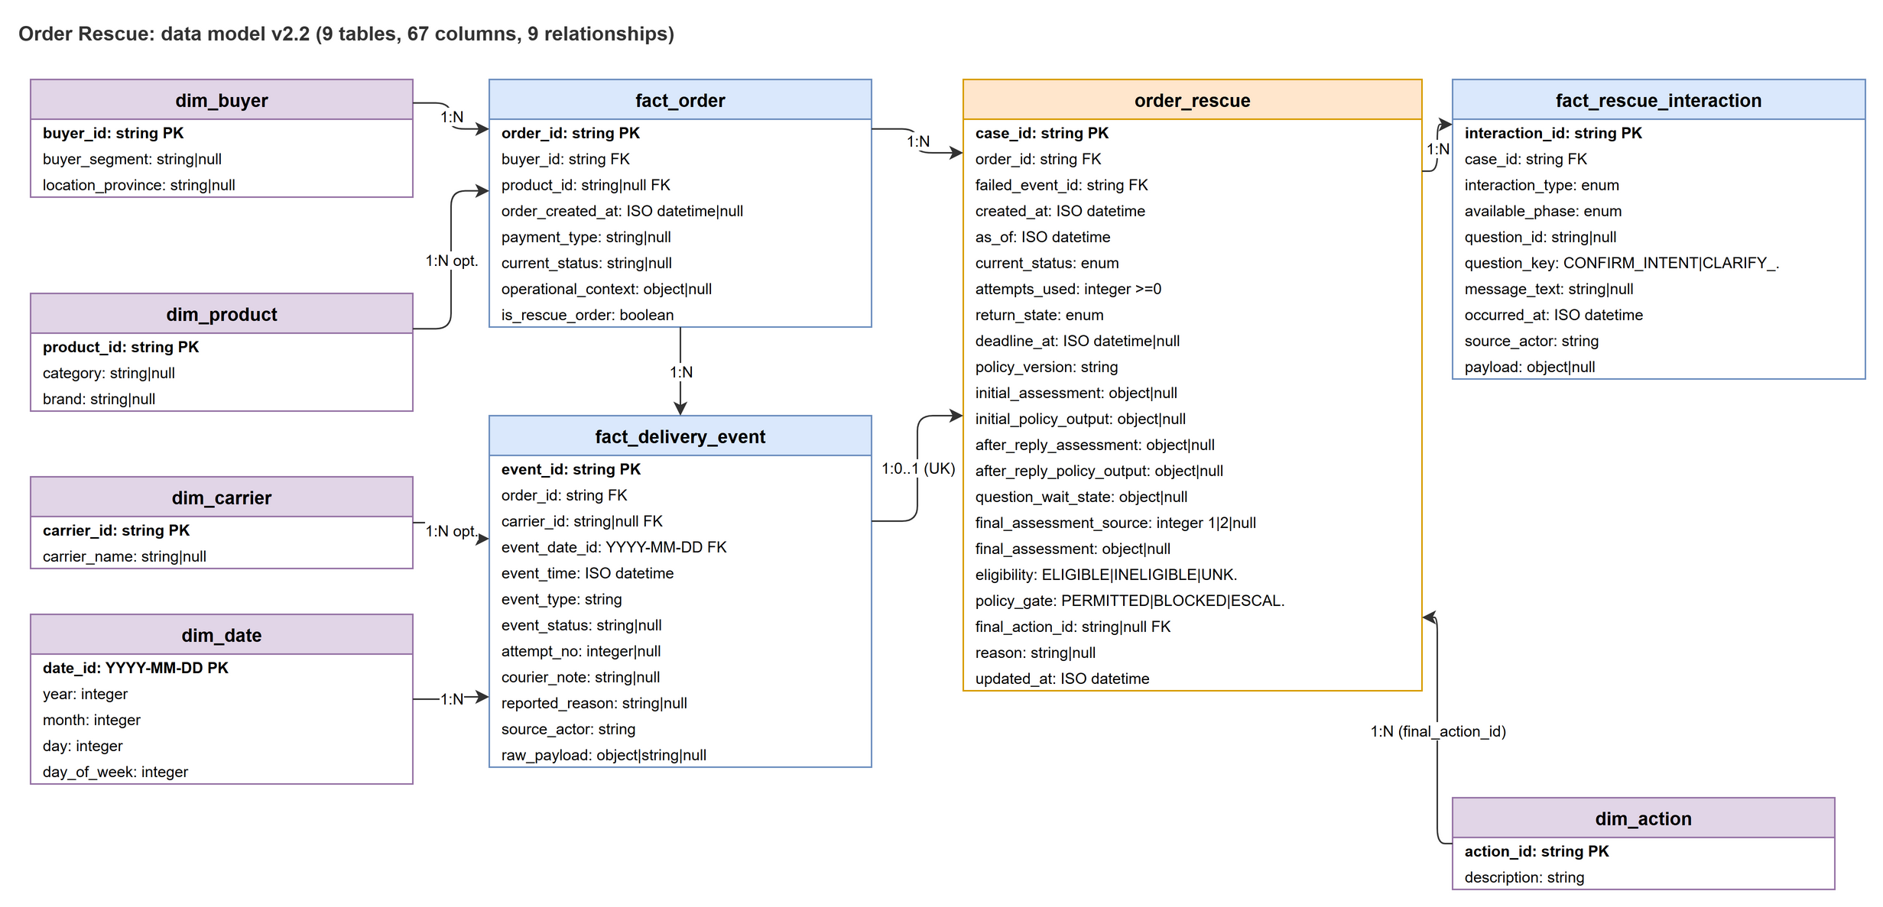
Figure 3. Data model v2.2 (9 tables, 67 columns, 9 relationships)

6. Interface Architecture
The MVP has no network API: the UI calls engine functions in the same process. This section defines the Agent contract (target) and a proposed service interface. Nothing in 6.2 and 6.3 is implemented.

6.1 Agent Contract
Input envelope (seven core fields plus runtime context):
{
"core_input": {
"case_id": "DEMO-001",
"failed_event": { "status": "...", "time": "...", "courier_note": "...",
"reported_reason": "...", "as_of": "..." },
"attempts_used": 1,
"return_state": "NOT_STARTED",
"deadline": "2026-10-28T15:00:00+07:00",
"buyer_history": [],
"operational_context": { "route": "...", "payment": "PREPAID",
"policy_version": "...", "source_refs": ["..."],
"buyer_messages_t0": [ { "source_ref": "...", "text": "..." } ] }
},
"runtime_context": [ { "source_ref": "...-REPLY", "interaction_type": "BUYER_REPLY", "text": "..." } ]
}

Output: the six-field assessment above, JSON only. assessment.schema.json enforces keys and enums. Policy fields are never produced by the Agent.

6.2 Proposed Service Endpoints
POST /v1/cases/{caseId}/assess # run precheck + Agent assessment 1, store initial
POST /v1/cases/{caseId}/question # contact gate; emit the single question
POST /v1/cases/{caseId}/reply # body: { questionId, text } -> assessment 2 + final
POST /v1/cases/{caseId}/no-reply # manual demo control -> final = initial
GET /v1/cases/{caseId} # initial, after_reply, final, policy, question state

6.3 Proposed Error Handling
{ "error": { "code": "SCHEMA_INVALID", "message": "evidence[0].verification is not allowed",
"field": "evidence[0].verification", "caseId": "DEMO-001", "requestId": "uuid" } }

Code | HTTP | Meaning
VALIDATION_ERROR | 400 | Malformed request or case input
SCHEMA_INVALID | 422 | Agent output failed the six-field schema or enum check
SOURCE_REF_UNKNOWN | 422 | An evidence source_ref does not resolve for this case and stage
STATE_CONFLICT | 409 | Transition not allowed from the current status, or a guard matched 0 rows
POLICY_BLOCKED | 200 | Not an error: policy_gate = BLOCKED with the reason
NOT_FOUND | 404 | Unknown case
AGENT_UNAVAILABLE | 502 | LLM call failed after bounded retries; case stays in its state
INTERNAL_ERROR | 500 | Unexpected failure

7. Security Architecture

7.1 Trust Boundaries
- Untrusted inputs: courier notes, buyer replies and any text field. They are data, never instructions. The prompt tells the Agent to ignore commands found there, and the schema limits what output can contain.
- Untrusted output: the LLM response is validated by code before it is stored or shown.
- Authority: only the policy engine grants eligibility and final action. A HIGH confidence never overrides policy.

7.2 Security Measures
Area | Measure | Status
Data | Synthetic data only; fictional IDs; no real phone, address, GPS or business names. Contact and location data are personal data (Vietnam Decree 13) | In place
Actions | Policy gate blocks address change, dispatch, delivery change, exact slot, real buyer message, return authorisation, refund | In place (gate); labels in UI
Prompt injection | Notes and replies treated as data; schema-constrained output; source_ref must resolve | Prompt written; validator is Target
Evaluation integrity | Golden file never given to the Agent; examples in the prompt are invented | In place
Secrets | LLM API key only on the server. Vite exposes only VITE_ variables to the browser bundle, so the key must never be a VITE_ variable | Rule for Target
SQL injection | Bind parameters only; never build SQL from notes or replies | Rule for Target
Input validation | validateScenario in the MVP; schema and enum validation for Agent output | Partial
Audit | Every assessment and policy result stored with source references | In place (decision records)

8. Performance and Scaling
No latency, throughput or concurrency target has been set or measured. The MVP is a local demo. The following are design constraints that keep the cost per case bounded:
- At most two Agent calls per case (initial and after reply); a no-reply case uses one. No loops, no third inference.
- At most one buyer question and a demo policy profile with a maximum of 3 attempts.
- Engine functions are pure and synchronous, so they scale with the UI or service that hosts them.
- The Agent runner is stateless; cases are independent, so it can run behind a queue.

Scaling path
- Measure first: record latency and token usage of the live Agent on the 30 cases; then set targets.
- Run Agent calls from a worker queue; keep state changes in short transactions.
- Version policy profiles per carrier or region through policy_version.
- Run evaluations in parallel (the simulation already ran 30 cases concurrently).
The system prompt is about 28 KB. Trimming it and measuring the effect on the evaluation is a cost and latency lever.

9. Deployment Pipeline

9.1 Environments
Environment | How | Status
Development | npm run dev (Vite dev server) | In use
Verification | npm run typecheck, npm run test:unit, npm run build, Playwright browser journey | In use
Demo | Local run on the presenter machine; no hosting | In use
Staging / Production | Not defined | None

9.2 CI/CD Flow (Proposed)
- Push or pull request to the repository.
- GitHub Actions: install with the lockfile, then npm run typecheck.
- npm run test:unit.
- npx playwright test e2e/order-rescue-demo.spec.ts --output=<isolated dir> (the shared test-results/ output has a known trace-close ENOENT issue).
- npm run build; publish the static bundle only when a hosting target exists.
- Optional: run the evaluation harness on the 30 cases and attach the report.

9.3 Commands
npm ci
npm run typecheck
npm run test:unit
npm run build
npx playwright test e2e/order-rescue-demo.spec.ts --output=/tmp/order-rescue-results

10. Monitoring and Observability

10.1 Today
- Decision records and the audit timeline show input summary, assessment, policy result and labels for each step.
- The evaluation harness reports exact-match rates per field and stage, and classifies mismatches as prompt gap, questionable label or model variance.

10.2 Proposed for the live Agent
- Log per call: case id, stage, prompt version, model id, latency, token counts, schema-validation result, retry count (no PII).
- Track: schema-invalid rate, unknown source_ref rate, candidate_action distribution, share of ESCALATE_REVIEW.
- Alert when the schema-invalid rate rises, when Agent calls fail repeatedly, or when the distribution of actions shifts sharply.

11. Future Migration Path
- Align the MVP with the v2.2 contract: replace the v1 vocabularies in src/domain/types.ts and assessCase with the approved hypotheses and actions.
- Add the validator and run the Agent on the 30 cases through a server-side proxy.
- Choose the database engine, write DDL with NOT NULL and unique constraints, and re-run the query recipes and guards on that engine.
- Add the backend service (modules in 4.1) with transactions and the proposed endpoints.
- Shadow mode on authorised historical data; replace draft labels with Ops-reviewed labels.
- Pilot with a human-controlled Ops console and a real contact channel behind the contact gate.

12. Open Decisions and Known Gaps
# | Gap | Impact / next step
1 | Two vocabularies coexist: the MVP engine uses v1 causes and 6 actions; the v2.2 contract uses 7 hypotheses and 5 actions | The UI demo and the Agent contract disagree. Migrate the engine (section 11, step 1)
2 | Golden labels are drafts (DRAFT_NEEDS_USER_REVIEW). Flagged: DEMO-024 vs 027, HOLD vs CLARIFY in 023 and 026, emoji reply in 030 | Evaluation scores are only as good as the labels. The review report lists 12 questions for Hải
3 | Prompt v2 simulation: all six fields agree in 14/30 initial and 21/24 after reply; confidence and missing_info are weakest | Do not tune further until labels are reviewed, to avoid fitting wrong labels
4 | Pre-check blocked path and contact-gate denial have no defined state or tests | Define the target status and add a few cases outside the 30
5 | Database engine, DDL and constraints not chosen | Decide, then validate on that engine
6 | package.json uses latest for all dependencies | Pin versions
7 | No CI | Add the proposed pipeline
8 | Live Agent integration and its measurements do not exist yet | No latency, cost or live accuracy claim until measured
9 | Hackathon rules: work must be built on-site in a new public repository; any pre-existing work must be declared | Prepare README and declaration stating what was built during the event

Document Info
Author | Engineering Team (Lucas, Phúc, Hải, Kha)
Version | 0.1
Last Updated | October 29, 2026
Review Date | To be set; before the 31 October 2026 hackathon rehearsal
Companion documents | Product Vision; Business Rules v2.2; review report; prompt evaluation report; src/agent/prompts/README.md

