Object-Oriented Language and Theory
Mini-Project Team 4
Class code: 122156

*Members of groups:

Nguyen Trong Nghia – 20184297 - nghia.nt184297@sis.hust.edu.vn
Tran Thai Phuc – 20184300 - phuc.tt184300@sis.hust.edu.vn
Nguyen Trinh Vu – 20184332 - vu.nt184332@sis.hust.edu.vn

1. Assignment of members

*Note: all the source code is designed by own members, no copy with modifying the idea of any source.

- Tran Thai Phuc - 20184300
- Task:
+ Designing class diagram
+ Designing slides
+ Writing source code:
→ pakage oop.globalict.project.gui: ChoosingScreen, ChoosingScreenController, MainScreen, MainScreenController.
+ Investigating virus-structure

- Evaluaion : Completing on time

- Nguyen Trinh Vu - 20184332
- Task:
+ Designing class diagram
+ Designing slides
+ Writing source code:
→ pakage oop.globalict.project.gui: StructureController, InfectionController, DemonstrationScreenController, DemonstrationScreen.
+Taking demo video

- Evaluaion : Completing on time

- Nguyen Trong Nghia - 20184297
- Task:
+Designing use-case diagram
+Writing report
+Writing source code:
→ pakage oop.globalict.project.virus: WithEnvelop, WithoutEnvelop, Stage, Virus
→ pakage oop.globalict.project.storage: VirusStorage
→ pakage oop.globalict.project.gui: Helpscreen
+ Investigating virus - infection progress
- Evaluaion : Completing on time

2. Miniproject description

2.1. Requirement
Topic: Demonstration of type if viruses and its mechanism.

Overview: COVID-19 has been spreading all over the world and there is the need of understanding different type of viruses, as well as the way they infect in order to have the basic knowledge to prevent them.

Basic knowledge: in general, viruses are divided into 2 categories, remark that different viruses may have additional component and different infection progress
+ virus without envelope
+ Structure: acid nucleic, capsid
+ Infection progress: injection, attachment, duplication.
+ virus with envelope
+ Structure: acid nucleic, capsid, envelope, glycoproteins
+ Infection progress: approach cell, enter cell, duplication.

Designs: create an applications that satisfies these following requirements

+ Main screen:

+ Interfaces: title application, choosing options of virus types, help, menu, quit.
+ After choosing the desired type, the application will show a variety of viruses in order for user to select.
+ The help button shows basic usage and aim of the application
+ The quit button exits the application. Be sure to ask for confirmation
+ There is always return button for user to get back to the main menu at any time

+ Demonstration:

+ Display the structure of the virus. Note that each virus has different structure, you should clearly display and explain them.
+ Demonstrating the progress of virus infecting the host cell. Different
viruses have the same basic mechanism of spreading with minor difference - remember
to show that.

2.2. Usecase diagram and explanation

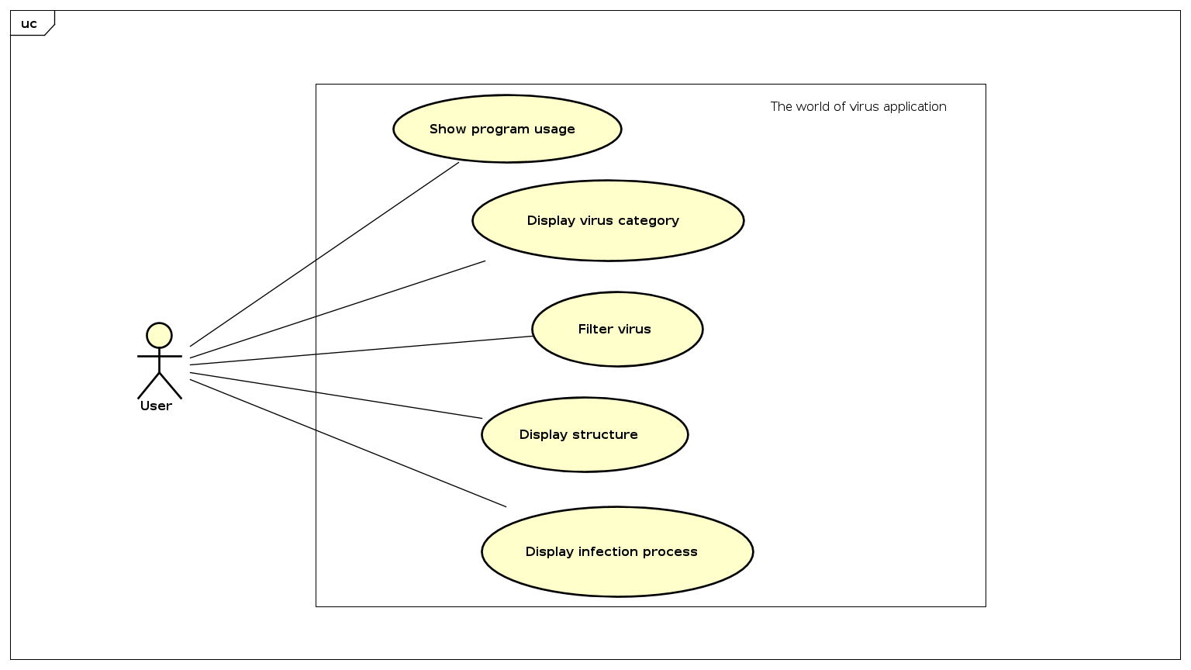

* Show program usage
In this use-case, people interact with the software by buttons. This use-case is performed by software, give the result value – is another interface to actors basing on specific buttons the user choose, for example
+ If the user choose “Help” button, the software will bring user to list of instructions how to use this application.
+ If the user choose “Option” , then choose “Home”, the software will bring user to the home screen.
+ If the user choose “Quit”, the application will be shutting down.

* Display virus category
For this use-case, at first, the software will show two types of virus for the user: with and without envelope. The user interact with the software by choosing one of them.
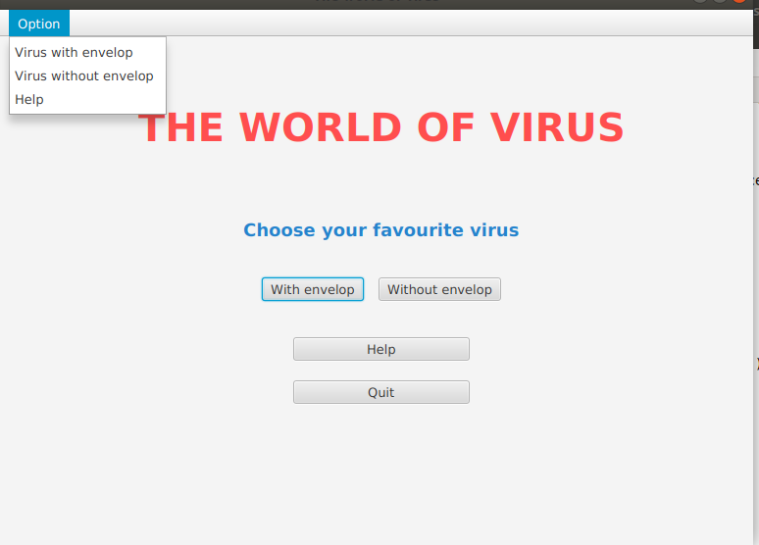

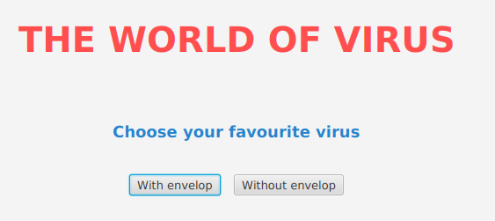
Next, the software will continue showing different examples of each type, and the user can choose one of these example to investigate.

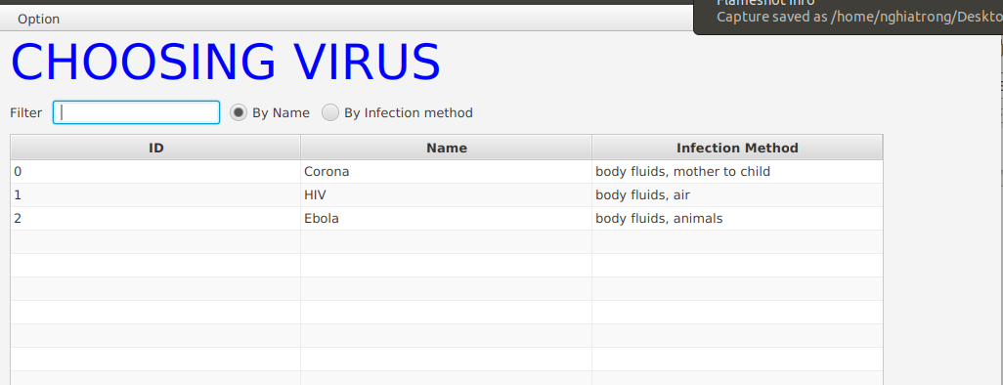

* Filter virus
For filter virus, people can choose one of two type of filter:
+ filter by name: user interact with the software by entering name and the software will show the name of virus properly.

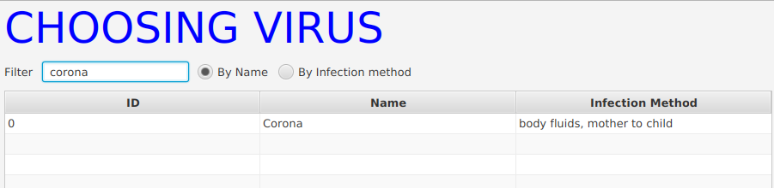

+ filter by transmission: user type name of transmission of virus that user think the virus can have, and the software will return the corresponding virus.

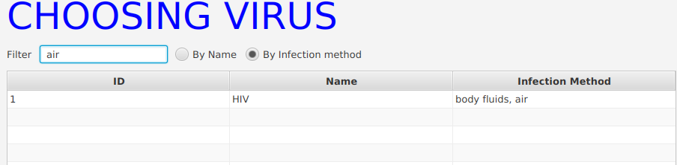

* Display structure
After getting virus to investigate from user, the software will bring user to a new interface, then show many components of the chosen virus. The user then will click “Start” to see the components.

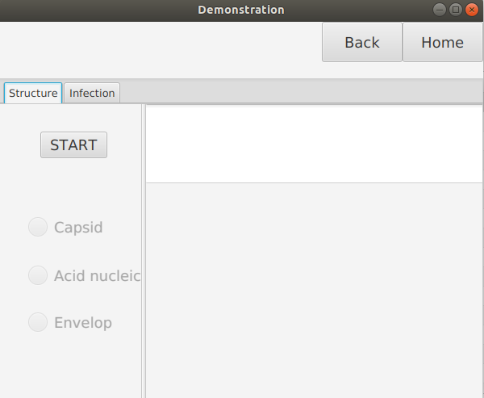
Then the user can move on another component, the software will return the detail of that component by text and image.

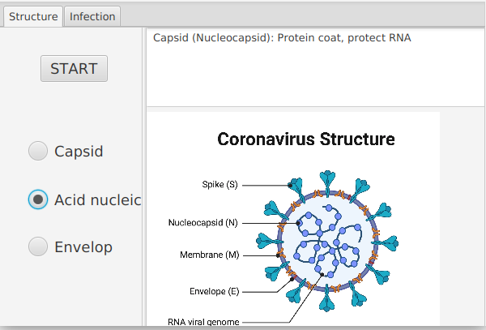
* Display infection process

Similarly with structure, the user can move on “infection” , then click start to see the infection progress of given virus. Denote that there are many stages in infection progress,then the user can interact with the software by choosing arbitrary stage, and the software will return the result by corresponding text and image:

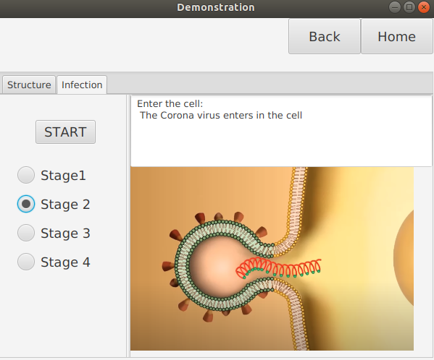

*Note: all of those are considered as use cases because:
- They contain sequence of actions.
- They are performed by the program.
- They all give observable result to actor.

3. Design

3.1. General class diagram

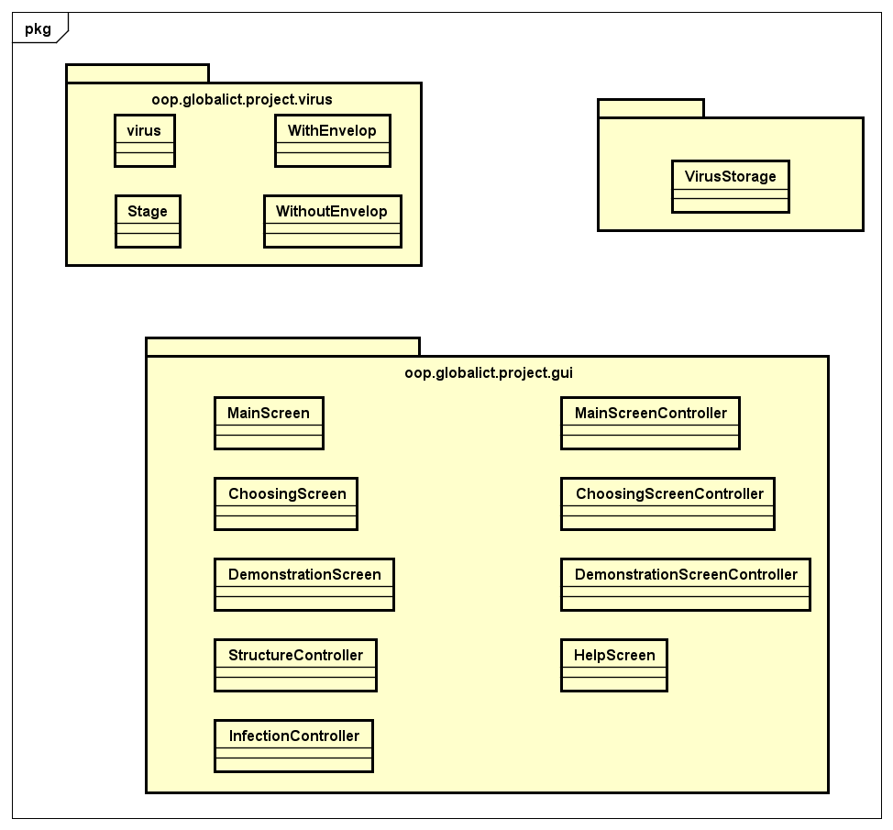

3.2. Some detail class diagrams

- Package oop.globalict.project.storage

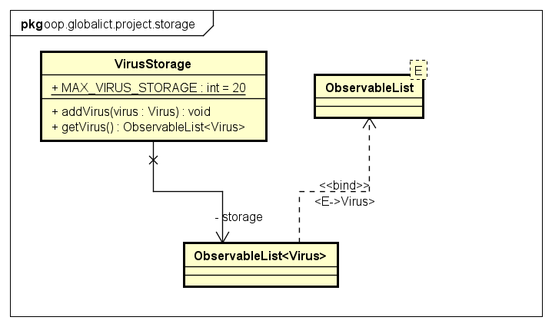

- Package oop.globalict.project.virus

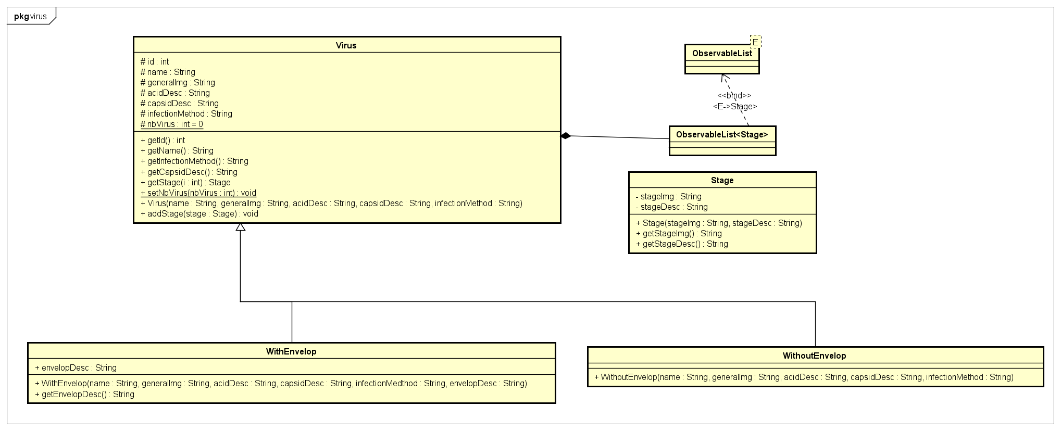

- Package oop.globalict.project.gui

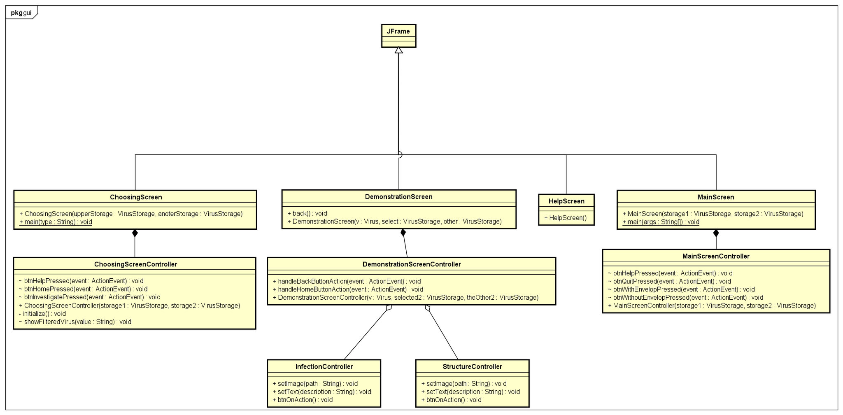

3.3. Design explanation

3.3.1.virus package
- 2 Classes WithEnvelop and WithoutEnvelop are inherited from class Virus.
- Class Virus contains an observable list of Stage (Composition)

3.3.2. storage package
- There is only 1 package VirusStorage, it is a list to contains several typical viruses.

3.3.3. gui package
- 4 classes: MainScreen, DemonstrationScreen, HelpScreen, Choosing Screen are inherited from JFrame.
- MainScreenController is a part of MainScreen (Composition)
- DemonstrationScreenController is a part of DemonstrationScreen (Composition) is a part of ChoosingScreen (Composition)
- DemonstrationController has a StructureController and an InfectionController (Aggregation).

3.4. Implementations of some important methods

Most of methods implemented are about handling event to get fields of Virus objects and display information on screen components.

In Stage class: getStageImg and getStageDesc method to get information about transmission process of viruses.

In Virus class which is inherited by WithEnvelop and WithoutEnvelop: Get methods to get description, image of Virus objects. addStage method to add stage to Virus object.

In VirusStorage class: addVirus method to add Virus objects to the Storage.

