Trên Router:
Switch – Router: 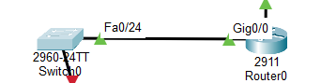
Router – Cloud: 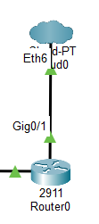
Switch – PC1: 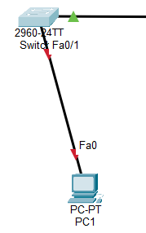
Router (1,123):
management network from the above interface summary: GigabitEthernet0/0
IP address for this interface: 192.168.1.1
Subnet mask for this interface [255.255.255.0] :
[0] Go to the IOS command prompt without saving this config.
[1] Return back to the setup without saving this config.
[2] Save this configuration to nvram and exit.

Enter your selection [2]: 2
configure terminal
Enter configuration commands, one per line. End with CNTL/Z.
Router(config)#interface g0/0
Router(config-if)#description Gateway cho mang noi bo
Router(config-if)#ip address 192.168.1.1 255.255.255.0
Router(config-if)#no shutdown
Router(config-if)#exit
Router(config)#interface g0/1
Router(config-if)#description Noi len Cloud
Router(config-if)#ip address 10.0.0.1 255.255.255.0
Router(config-if)#no shutdown
Router(config-if)#exit
Router#write memory
Router#show ip interface brief
Trên Switch:
Switch>enable
Switch#configure terminal
Enter configuration commands, one per line. End with CNTL/Z.
Switch(config)#interface fa0/1
Switch(config-if)#switchport mode access
Switch(config-if)#switchport port-security
Switch(config-if)#switchport port-security maximum 1
Switch(config-if)#switchport port-security mac-address sticky
Switch(config-if)#switchport port-security violation shutdown
Switch(config-if)#exit
Switch(config)#exit
Switch#
Switch#show port-security address
Switch#show port-security interface fa0/1
IP:
PC0: 192.168.1.2 255.255.255.0, subnet mask: 192.168.1.1
PC1: 192.168.1.3 255.255.255.0, subnet mask: 192.168.1.1

