Deep Learning-Based Classification of Peeled Garlic Cloves for Smart Food Processing
Phuc Hoang, Tuong Le,*
Faculty of Information Technology, HUTECH University, Ho Chi Minh City, Vietnam
giaphuc757@gmail.com, lc.tuong@hutech.edu.vn

Abstract. Accurate classification of peeled garlic cloves is crucial for ensuring consistency, safety, and efficiency in automated food processing workflows. In this context, we develop a deep learning-based machine vision framework for classifying peeled garlic cloves into three categories: fully peeled, partially peeled, and spoiled. This three-class design is intended to support industrial sorting pipelines, enabling direct processing, reprocessing, and rejection streams within automated garlic sorting machines. This study develops the Deep Learning-Based Classification of Peeled Garlic Cloves (CPGC) framework to support automatic and reliable garlic clove classification in industrial processing environments. Firstly, a dataset comprising 2,134 high-resolution images of peeled garlic cloves was collected from real garlic processing environments under diverse lighting conditions. Next, five pre-trained convolutional neural networks including NASNetMobile, InceptionV3, EfficientNetB4, MobileNetV2, and DenseNet121 were fine-tuned using transfer learning on the collected dataset and evaluated using accuracy, precision, recall, and F1-score. Experimental evaluation demonstrates that the proposed EfficientNetB4-F234-wA model outperforms the other models, obtaining an accuracy of 93.73% and an F1-score of 93.75%. In addition to classification accuracy, computational efficiency and model characteristics were examined to assess the feasibility of deploying the framework in real-time processing systems. The results indicate that the proposed approach can be employed as a vision-based classification module for automated garlic sorting.
Keywords. Garlic clove classification, Deep learning, Convolutional neural networks, Machine vision.
1. Introduction
Garlic is a widely cultivated agricultural product in Vietnam, long recognized not only for its culinary applications but also for its traditional medicinal uses in daily healthcare practices. Garlic is further processed into products such as garlic powder, garlic oil, and black garlic (a high-value fermented product gaining popularity for its antioxidant-rich profile and health benefits). In industrial processing, harvested garlic is typically processed by an automatic peeling machine, after which the output consists of three types of cloves: fully peeled and intact garlic cloves, spoiled or defective cloves, and cloves that remain partially covered with skin. At this stage, these three types of cloves are typically separated manually. Such manual inspection, especially when distinguishing fully peeled, partially peeled, and spoiled cloves, is labor-intensive and can lead to inconsistent decisions due to operator fatigue and subjective judgment. With the growing demand for high-quality garlic-derived products, practical automated solutions are increasingly needed to improve the consistency and efficiency of quality classification in large-scale processing environments.
In recent years, computer vision and deep learning techniques have been increasingly applied to image-based classification tasks, with demonstrated effectiveness in domains such as healthcare [1–4] and agriculture [5–7]. In the healthcare sector, deep learning has enabled accurate diagnosis of diseases from medical imaging modalities such as chest X-rays [1–3] and MRI scans [4]. In agriculture, deep learning has been widely used for tasks such as crop disease detection, fruit quality grading, and weed identification. Among these approaches, Convolutional Neural Networks (CNNs) and pre-trained models [8-12] stand out for their ability to extract hierarchical features and deliver strong performance across various visual recognition tasks.
Accurate quality assessment of peeled garlic cloves remains a challenging task in automated processing systems due to the subtle visual differences among quality categories. Although deep learning–based vision approaches have been widely adopted for agricultural product inspection, relatively few studies have focused on the fine-grained classification of peeled garlic cloves under practical processing conditions. This study presents a deep learning–based machine vision framework, named CPGC framework, for the automatic classification of garlic cloves into fully peeled, partially peeled, and spoiled categories. The three-class design (fully peeled, partially peeled, and spoiled) was selected because it reflects the primary quality categories used in industrial garlic sorting processes, where cloves can be directly processed, reprocessed, or rejected. A custom image dataset namely Garlic Clove Dataset comprising 2,134 high-resolution images of peeled garlic cloves was collected from a commercial processing facility under naturally varying lighting conditions and viewing angles to reflect real inspection environments. The proposed system incorporates a practical data preprocessing pipeline that includes image standardization, resizing, dataset partitioning, and data augmentation. Five representative convolutional neural network architectures including NASNetMobile [8], InceptionV3 [9], EfficientNetB4 [10], MobileNetV2 [11], and DenseNet121 [12], are then evaluated for the garlic classification task, as they represent different CNN design strategies and provide a balance between classification performance and computational efficiency. Model performance is compared using standard metrics, including accuracy, precision, recall, and F1-score, to identify the most suitable architecture for practical use. The results indicate that the proposed approach can effectively support automated agricultural processing systems and contribute to improved quality control in food supply chains. The main contributions of this study can be summarized as follows. First, a deep learning-based machine vision framework is developed for the automatic classification of peeled garlic cloves using high-resolution image data. Second, a labeled dataset consisting of 2,134 garlic clove images is constructed under practical processing conditions with variations in lighting and viewing angles, aiming to reflect real inspection scenarios. Third, five representative convolutional neural network architectures are fine-tuned through transfer learning and evaluated for the garlic quality classification. Finally, comprehensive experimental evaluations are carried out using standard performance metrics to determine the most suitable model for practical deployment in industrial agricultural quality control.
The remainder of this manuscript is organized as follows. Section 2 provides the related works on deep learning applications in agriculture. Then, Section 3 describes the proposed methodology, including the overall system architecture, data preparation techniques, and model adaptation strategies. Next, Section 4 presents the experimental setup, performance evaluation metrics, and comparative results among different pre-trained models. Finally, Section 5 summarizes the conclusion of the study and discusses directions for future work.

2. Related Works
In recent years, deep learning and machine vision have become transformative tools for automating quality inspection in both industrial manufacturing and agricultural production. Compared to traditional manual or sensor-based approaches, these technologies provide notable improvements in speed, consistency, and scalability.
In the industrial domain, Cardellicchio et al. (2024) [13] introduced an advanced quality control system for aluminum welds that integrates 3D data with machine learning techniques. By extracting structural features from 3D profiles and feeding them into lightweight classifiers, their approach achieved near-perfect accuracy, demonstrating the strong potential of combining spatial information with artificial intelligence for real-time inspection in complex manufacturing environments. Likewise, Supriya and Ashwini (2021) [14] developed a computer vision–based optical inspection system for automotive wiring harnesses, emphasizing the importance of precise visual feedback in identifying structural inconsistencies. In the textile industry, Caldas et al. (2022) [15] proposed an automated image analysis framework for assessing yarn quality, showing that traditional 2D imaging, when paired with well-designed processing workflows, continues to be highly effective for industrial-grade defect detection.
In agricultural applications, convolutional neural networks (CNNs) have been widely adopted for crop monitoring and quality assessment. Wonggasem et al. (2024) [16] utilized EfficientNet-B5 to develop a deep learning framework for automated baby corn grading, achieving over 99% accuracy in identifying visual defects. Razavi et al. (2024) [17] employed ResNet models in combination with transfer learning to classify rice cultivars and evaluate grain quality, demonstrating the suitability of pre-trained CNNs for problems characterized by subtle intra-class variations. Building on these advances, El Sakka et al. (2024) [18] offered a comprehensive survey of CNN-based techniques in smart agriculture, spanning tasks such as crop disease detection, weed recognition, and growth monitoring. Their review highlighted the advantages of integrating RGB and multispectral imagery within CNN pipelines to enhance classification robustness across varying field conditions—an observation that is particularly relevant to applications involving complex visual textures, such as garlic clove quality assessment.
More broadly, recent advances in computer vision and machine learning have significantly enhanced food quality inspection across diverse application areas. Meenu et al. (2021) [19] reviewed digital image processing techniques for evaluating food quality, emphasizing visual attributes such as texture, color, and shape. Hemamalini et al. (2022) [20] introduced a machine learning–based grading system that leverages efficient image segmentation to accurately detect surface-level irregularities in fruits and vegetables. Zhang et al. (2021) [21] explored the combined use of spectroscopy and deep learning for agro-product assessment, while Lin et al. (2023) [22] provided a comprehensive survey of machine learning approaches for non-destructive food quality and safety monitoring, underscoring the scalability and adaptability of these methods across a wide range of food categories.
Peeled garlic sorting systems have received limited academic attention, despite significant advancements in computer vision-based food inspection. To the best of our knowledge, there are currently no studies specifically addressing the automatic classification of peeled garlic cloves using deep learning–based vision systems. To address this gap, this study presents a deep learning–based framework for automated peeled garlic quality sorting, integrating high-resolution imaging, tailored preprocessing steps, and a convolutional neural network (CNN) architecture optimized for real-time performance. Building on advances in both industrial and agricultural vision applications, the proposed approach provides a practical solution for deployment in automated peeled garlic sorting machines, thereby enhancing labor productivity in commercial garlic processing.
3. Materials and Methods
Section 3.1 focuses on the Garlic Clove Dataset, describing how the data were collected and prepared for training. Section 3.2 then explains the overall architecture of the proposed CPGC framework.
3.1. Garlic Clove Dataset
The Garlic Clove Dataset consists of 2,134 high-resolution images of peeled garlic cloves. All images were collected in February 2025 at a commercial garlic processing facility in Ho Chi Minh City, Vietnam, and were captured using a smartphone camera (iPhone 14). All images in this dataset were manually cropped into square patches and annotated using the LabelImg tool according to predefined visual quality criteria, with the annotations verified through visual inspection during dataset preparation. Table 1 summarizes the definitions and visual examples of the three garlic clove categories included in the Garlic Clove Dataset. Each image corresponds to a different garlic clove captured during the processing workflow. The dataset was split into training, validation, and test subsets at the image acquisition stage to ensure that no duplicated or near-duplicate samples appear across different subsets.
Table 1. Three Class Definitions in the Garlic Clove Dataset.
No | Class name | Description | Visualization
1 | Fully Peeled Garlic | Fully peeled garlic cloves exhibit a smooth and uniform surface without residual skin or visible defects, making them suitable for packaging, industrial processing, and immediate use. | 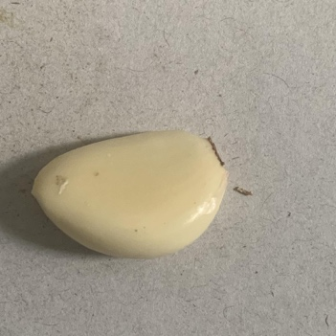
2 | Partially Peeled Garlic | Partially Peeled Garlic cloves still have some outer skin remaining on the surface. These cloves are usually set aside for further cleaning before being classified as fully peeled. | 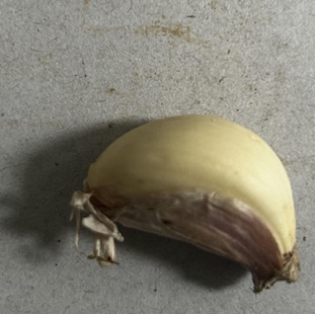
3 | Spoiled Garlic | Spoiled garlic cloves show visible defects such as discoloration, mold, softening, or surface damage. These cloves are removed from the processing line and have no further use due to food safety concerns. | 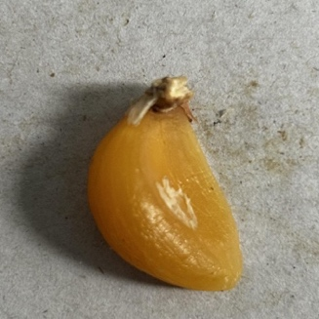
The Garlic Clove Dataset is distributed across three quality categories: Fully Peeled Garlic (690 images), Partially Peeled Garlic (438 images), and Spoiled Garlic (1,006 images). The dataset is further divided into training (1,492 images), validation (318 images), and test (324 images) subsets. The training set includes 482 Fully Peeled Garlic, 306 Partially Peeled Garlic, and 704 Spoiled Garlic images. The validation set contains 103, 65, and 150 images, respectively. The test set consists of 105, 67, and 152 images. Figure 1 shows the distribution of the Garlic Clove Dataset across the three quality categories and the corresponding training, validation, and test splits. Although the dataset size is relatively limited, the images were collected from real garlic processing environments under varying lighting conditions, which helps reflect practical inspection scenarios.
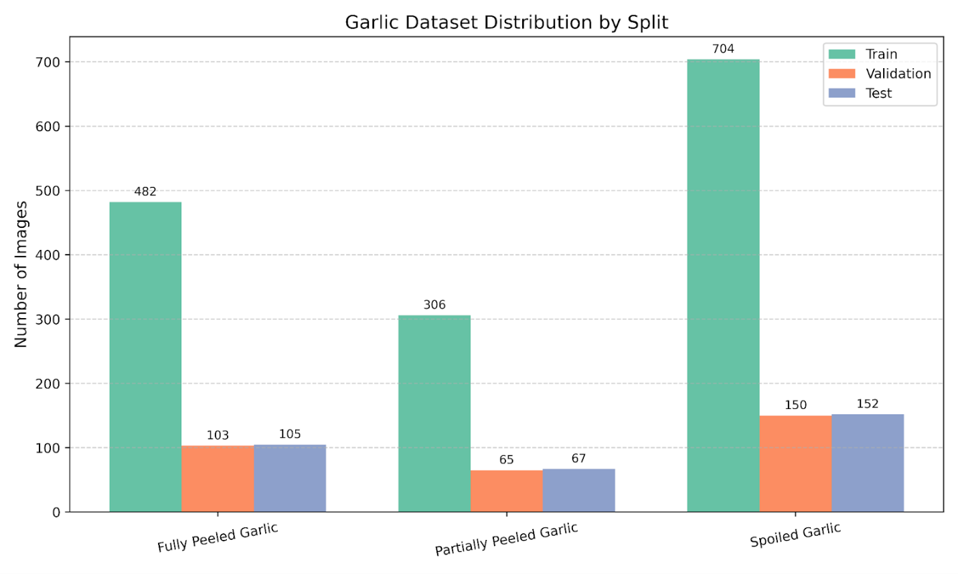
Fig. 1. Distribution of garlic quality classes in the training, validation, and test sets.
3.2. System Architecture
Figure 2 illustrates the overall pipeline of the proposed CPGC framework. The data flow proceeds sequentially from image acquisition, preprocessing, feature extraction by the CNN backbone, and final classification through the output layer. The proposed CPGC framework has two core modules including the Data Preprocessing module and the Model Adaptation module (see Figure 2). In the preprocessing step, the images are first standardized in format, resized to a fixed resolution, and normalized before data augmentation is applied to increase data diversity. In the model adaptation phase, several state-of-the-art convolutional neural networks, including NASNetMobile, InceptionV3, EfficientNetB4, MobileNetV2, and DenseNet121, are fine-tuned on the preprocessed dataset. During the training stage, these models learn from the labeled dataset using transfer learning, while in the inference stage the trained model predicts the quality category of unseen garlic clove images. This module evaluates different architectures to determine the most effective model for peeled garlic clove classification.
Data Preparation Module. A preprocessing pipeline was applied to the Garlic Clove Dataset to ensure consistency in the input data. Images were first resized to a unified resolution of 380 × 380 pixels to standardize the input format across the dataset. Subsequently, model-specific preprocessing functions associated with each pretrained backbone were applied to ensure compatibility with the respective architectures.
The dataset was fixed and partitioned at the beginning of the study into training (70%), validation (15%), and test (15%) subsets, and this split was kept unchanged throughout all experiments to ensure fair evaluation and avoid data leakage. Data augmentation was used exclusively on the training set to increase diversity and support better model generalization. The applied augmentations included random rotations (±20°), translations (±20%), zooming (±20%), horizontal and vertical flipping, and brightness adjustments within a range of 0.7–1.3, affecting approximately 10% of each image. Note that the probability of applying each augmentation followed the default settings of the employed augmentation library. By contrast, only resizing and normalization were applied to the validation and test sets, with no augmentation, to maintain the integrity of the evaluation process. Overall, the preprocessing strategy supports reliable training and evaluation of the proposed models.
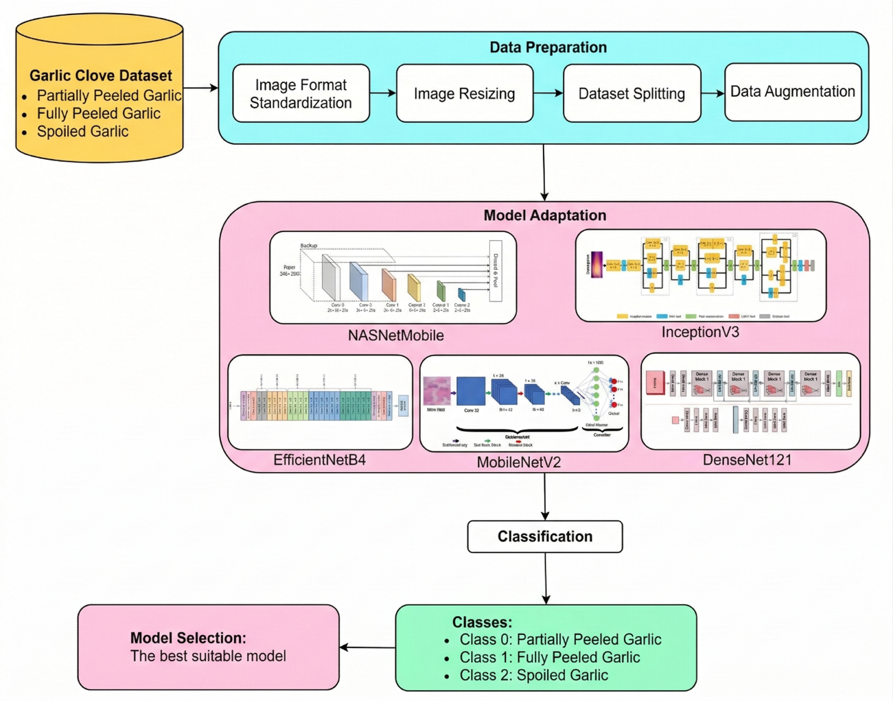
Fig. 2. System Architecture of CPGC framework.
Model Adaptation Module. To accurately classify the quality of peeled garlic cloves, several state-of-the-art pretrained convolutional neural networks (CNNs) were employed for transfer learning. These include NASNetMobile, InceptionV3, EfficientNetB4, MobileNetV2, and DenseNet121—each selected for its demonstrated effectiveness and strong feature extraction capability in image classification tasks. This transfer learning strategy helps improve model performance, particularly given the limited size of the garlic dataset, and facilitates efficient convergence during training. For fairness in comparison, the input resolution and preprocessing pipeline for each backbone follow the recommended configurations associated with the respective pretrained models.
4. Experiments
4.1. Experiment Settings
A transfer learning approach was adopted in the proposed CPGC framework using five pre-trained CNN backbones: NASNetMobile, InceptionV3, EfficientNetB4, MobileNetV2, and DenseNet121. Initially, the backbone layers were frozen and only the classification head was trained to establish a baseline model. Subsequently, an ablation study was conducted to investigate the effect of progressively fine-tuning deeper convolutional blocks. This decision was based on the relatively small size of the dataset (2,134 images), as fully fine-tuning deep backbones could increase the risk of overfitting. Keeping the backbone frozen allows the model to preserve general visual features learned from ImageNet while lowering training complexity for practical industrial applications. This head comprises a global average pooling layer, batch normalization, a fully connected layer with 128 units and ReLU activation with L2 regularization, a dropout layer with a rate of 0.5, and a final softmax layer. Training was conducted for up to 30 epochs with a batch size of 32, using the Adam optimizer and a categorical cross-entropy loss function with label smoothing. The learning rate was scheduled using CosineDecay for EfficientNetB4 and ExponentialDecay for the remaining models, with an initial value of 1e-5. To limit overfitting and reduce unnecessary computation, early stopping was applied with a patience of 10 epochs based on validation loss.
All experiments were conducted on the Kaggle cloud platform using an NVIDIA Tesla P100 GPU. This hardware configuration enabled efficient training, particularly for deeper CNN architectures, by reducing training time while maintaining stable computational performance. Final model performance was evaluated on the test set using standard metrics, including accuracy, precision, recall, and F1-score. The detailed evaluation results are presented in the following subsection.
4.2. Evaluation Metrics
Model performance was evaluated using four standard classification metrics, as described below.
- Accuracy (Acc): The ratio of correctly classified samples to the total number of samples.
$$Accuracy =\frac{TP + TN}{TP + TN + FP + FN}$$
- Precision (P): The ratio of correctly predicted positive samples to the total number of predicted positive samples, reflecting the model’s ability to avoid false positives.
$$precision =\frac{TP }{TP + FP }$$
- Recall (R): The ratio of correctly predicted positive samples to the total number of actual positive samples, indicating the model’s ability to identify relevant cases.
$$Recall=\frac{TP }{TP + FN}$$
- F1-Score: The harmonic mean of precision and recall, providing a single measure that balances both metrics.
$$F1-Score=2 ⋅\frac{precision ⋅ recall}{precision + recall}$$
In these definitions, TP and TN indicate correctly classified positive and negative samples, whereas FP and FN denote misclassified cases. Although the spoiled class is larger, data augmentation was applied during training to reduce imbalance effects. Weighted-average metrics were used to evaluate model performance while accounting for the class distribution.
4.3. Experimental Results
Figures 3 and 4 present the training and validation performance of NASNetMobile and InceptionV3 over 30 epochs. While both models show steady accuracy improvements, InceptionV3 converges faster and consistently achieves higher accuracy, particularly from the mid-training stage. This trend is also reflected in the loss curves, where InceptionV3 exhibits lower and more stable loss values.
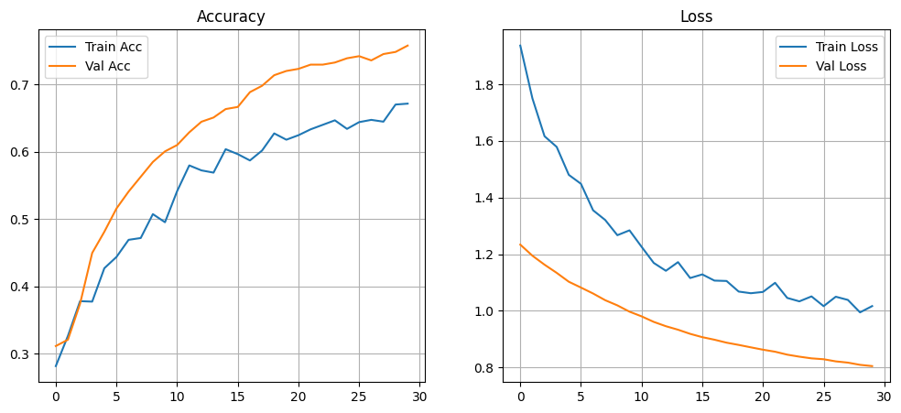
Fig. 3. Training and validation performance of NASNetMobile: (Left) Accuracy, (Right) Loss.
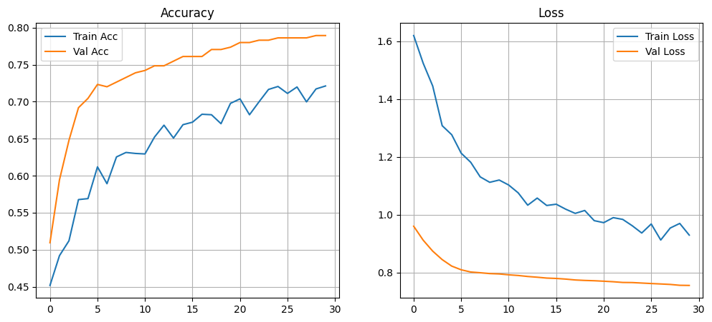
Fig. 4. Training and validation performance of InceptionV3: (Left) Accuracy, (Right) Loss.
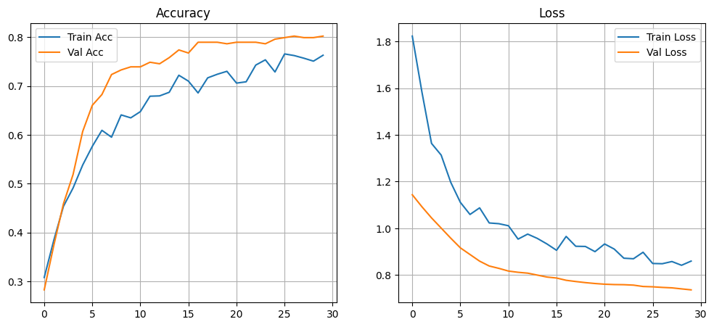
Fig. 5. Training and validation performance of EfficientNetB4: (Left) Accuracy, (Right) Loss.
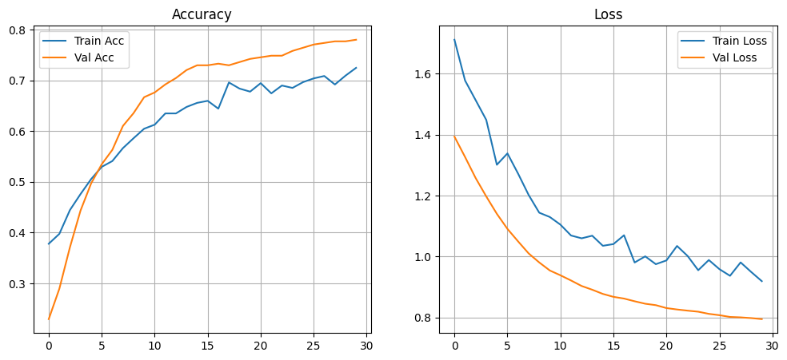
Fig. 6. Training and validation performance of MobileNetV2: (Left) Accuracy, (Right) Loss.
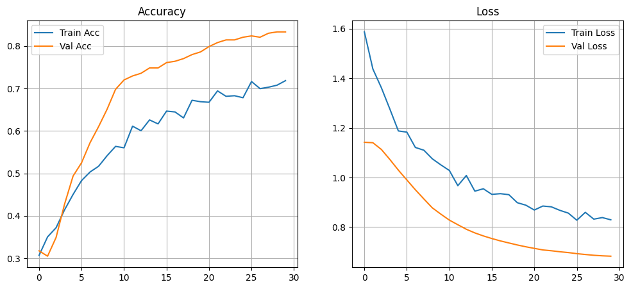
Fig. 7. Training and validation performance of DenseNet121: (Left) Accuracy, (Right) Loss.
Figures 5 and 6 show the training and validation performance of EfficientNetB4 and MobileNetV2 over 30 epochs. EfficientNetB4 converges quickly in the early stages and maintains stable validation accuracy, suggesting effective learning and good generalization. In contrast, MobileNetV2 improves more gradually and exhibits a clearer gap between training and validation accuracy, which may indicate underfitting or the effect of stronger regularization. Both models, however, display smoothly decreasing loss curves, reflecting stable optimization. Figure 7 presents the performance of DenseNet121, which shows closely aligned training and validation accuracy throughout training, along with relatively low validation loss. This behavior indicates strong generalization, although its final classification performance is lower than that of EfficientNetB4 on the Garlic Clove Dataset.
Table 2. Performance of pre-trained CNN models on the test set of the Garlic Clove Dataset.
No | Model | Accuracy (%) | F1-score (%) | Precision (%) | Recall (%)
1 | NASNetMobile | 76.95 ± 1.52 | 77.13 ± 1.32 | 78.89 ± 0.12 | 76.95 ± 1.52
2 | InceptionV3 | 79.94 ± 1.57 | 79.88 ± 1.54 | 80.01 ± 1.57 | 79.94 ± 1.57
3 | EfficientNetB4 | 84.36 ± 1.14 | 84.44 ± 1.09 | 85.34 ± 0.66 | 84.36 ± 1.14
4 | MobileNetV2 | 78.91 ± 0.38 | 79.10 ± 0.15 | 80.86 ± 0.80 | 78.91 ± 0.38
5 | DenseNet121 | 78.70 ± 0.44 | 78.63 ± 0.41 | 79.66 ± 0.33 | 78.70 ± 0.44
Table 2 presents the classification performance of five pre-trained convolutional neural network (CNN) models evaluated on the Garlic Clove Dataset. Among the evaluated architectures, NASNetMobile achieves the lowest performance, with an accuracy of 76.95% ± 1.52%, indicating that its lightweight architecture may limit its ability to capture the subtle visual characteristics required for this classification task. InceptionV3 improves the performance to 79.94% ± 1.57%, demonstrating more stable results due to its deeper architecture and multi-scale feature extraction capability. EfficientNetB4 achieves the best performance among the evaluated models, obtaining an accuracy of 84.36% ± 1.14% and an F1-score of 84.44% ± 1.09%, suggesting that its compound scaling strategy enables more effective feature representation for garlic quality classification. MobileNetV2 attains an accuracy of 78.91% ± 0.38%, indicating that lightweight architectures can still provide reasonable performance while maintaining computational efficiency. DenseNet121 achieves an accuracy of 78.70% ± 0.44%, showing comparable performance to MobileNetV2 but slightly lower than EfficientNetB4 on this dataset.
Overall, EfficientNetB4 achieves the best performance among the evaluated models, obtaining the highest accuracy of 84.36% ± 1.14% on the Garlic Clove Dataset. This result indicates that the compound scaling strategy of EfficientNet enables more effective feature representation for the garlic clove classification task.
Table 3. Computational Complexity and Inference Speed (FPS and ms per image) of Pre-trained Models on the Garlic Clove Dataset
No | Model | Number of Parameters (Millions) | Model Size (MB) | Inference Speed (FPS / ms per image)
1 | NASNetMobile | 4,409,623 | 20.47 MB | 14.51 FPS / 68.90 ms
2 | InceptionV3 | 22,073,635 | 87.28 MB | 31.75 FPS / 31.49 ms
3 | EfficientNetB4 | 17,910,882 | 71.68 MB | 18.78 FPS / 53.25 ms
4 | MobileNetV2 | 2,427,459 | 11.10 MB | 59.91 FPS / 16.69 ms
5 | DenseNet121 | 7,173,187 | 29.82 MB | 20.23 FPS / 49.42 ms
Table 3 presents the computational complexity and inference efficiency of the evaluated pre-trained models on the Garlic Clove Dataset. MobileNetV2 has the smallest architecture with only 2.43 million parameters and a model size of 11.10 MB, making it suitable for deployment in resource-constrained environments. NASNetMobile also maintains a relatively compact design with 4.41 million parameters, although its inference speed is slower compared with other lightweight models. In contrast, InceptionV3 has the largest architecture with 22.07 million parameters and a model size of 87.28 MB, while achieving relatively fast inference performance. EfficientNetB4 provides a favorable balance between model complexity and classification performance, with 17.91 million parameters, a model size of 71.68 MB, and an inference speed of 18.78 FPS, making it suitable for practical deployment in automated garlic sorting systems. DenseNet121 offers moderate model size and stable inference efficiency but does not achieve the same level of classification performance as EfficientNetB4. Overall, these results indicate that EfficientNetB4 offers a good trade-off between computational cost and classification accuracy and is therefore selected as the final model for the proposed framework.
4.4. Ablation study
Head-only Training vs. Fine-tuning the Last N Layers. To investigate the contribution of layer-wise fine-tuning in EfficientNetB4, we conducted an ablation study comparing head-only training with progressively unfreezing deeper convolutional blocks. Specifically, five configurations were evaluated: (1) training only the classification head (EfficientNetB4-H), (2) fine-tuning the last block of the backbone network (EfficientNetB4-F2), (3) fine-tuning the last two blocks (EfficientNetB4-F23), (4) fine-tuning the last three blocks (EfficientNetB4-F234), and (5) unfreezing all convolutional layers (EfficientNetB4-All). This design allows us to analyze how different levels of feature adaptation influence model performance and determine the optimal fine-tuning strategy for the proposed framework. The models were evaluated using four standard classification metrics: Accuracy, F1-score, Precision, and Recall.
Table 4 presents the performance of EfficientNetB4 under different fine-tuning strategies. When only the classification head is trained (EfficientNetB4-H), the model achieves an accuracy of 84.36% ± 1.14%, indicating that pre-trained features provide a reasonable baseline for the garlic clove classification task. Fine-tuning deeper convolutional blocks gradually improves the performance, with EfficientNetB4-F2 achieving 88.37% ± 1.48% and EfficientNetB4-F23 reaching 88.48% ± 0.81% accuracy. The best performance is obtained with EfficientNetB4-F234, which fine-tunes Blocks 2+3+4 simultaneously, achieving 93.73% ± 0.66% accuracy and 93.75% ± 0.66% F1-score. This result suggests that adapting deeper layers enables the network to learn more discriminative representations for garlic quality classification. However, fully unfreezing all layers (EfficientNetB4-All) results in reduced performance (85.08% ± 4.97%), likely due to overfitting caused by updating too many parameters on the relatively limited dataset. Overall, these results indicate that EfficientNetB4-F234 provides the best balance between feature adaptation and generalization performance.
Table 4. Comparative Performance of EfficientNetB4 Under Head-Only Training and Incremental Unfreezing of Convolutional Blocks.
No | Training Strategy | Accuracy (%) | F1-score (%) | Precision (%) | Recall (%)
1 | EfficientNetB4-H | 84.36 ± 1.14 | 84.44 ± 1.09 | 85.34 ± 0.66 | 84.36 ± 1.14
2 | EfficientNetB4-F2 | 88.37 ± 1.48 | 88.44 ± 1.46 | 89.01 ± 1.32 | 88.37 ± 1.48
3 | EfficientNetB4-F23 | 88.48 ± 0.81 | 88.56 ± 0.76 | 89.05 ± 0.59 | 88.48 ± 0.80
4 | EfficientNetB4-F234 | 93.73 ± 0.66 | 93.75 ± 0.66 | 93.82 ± 0.64 | 93.73 ± 0.66
5 | EfficientNetB4-All | 85.08 ± 4.97 | 85.09 ± 5.08 | 86.44 ± 3.62 | 85.08 ± 4.97
Augmentation ablation (with vs without). To further evaluate the impact of data augmentation on model generalization, we conducted an ablation study comparing the EfficientNetB4-F234-woA and EfficientNetB4-F234-wA configurations. Here, wA denotes the configuration trained with data augmentation, while woA represents the configuration trained without data augmentation. The objective is to quantify the contribution of augmentation strategies to classification performance and assess whether synthetic data variability leads to measurable improvements across evaluation metrics.
The results demonstrate that data augmentation significantly improves classification performance across all evaluation metrics. As shown in Table 5, the EfficientNetB4-F234-woA model achieves an accuracy of 86.63% ± 3.91% and an F1-score of 86.60% ± 3.90%. When data augmentation is applied, the EfficientNetB4-F234-wA model achieves substantially better performance, reaching 93.73% ± 0.66% accuracy and 93.75% ± 0.66% F1-score. These results indicate that augmented samples help the model learn more robust visual representations. In addition, the reduced standard deviation suggests more stable training behavior. Overall, the EfficientNetB4-F234-wA configuration provides the best performance and is selected as the final model for the proposed framework.
Table 5. Impact of Data Augmentation on the Performance of the EfficientNetB4-F234 Model.
No | Data Augmentation | Accuracy (%) | F1-score (%) | Precision (%) | Recall (%)
1 | EfficientNetB4-F234-woA | 86.63 ± 3.91 | 86.60 ± 3.90 | 86.85 ± 3.65 | 86.63 ± 3.91
2 | EfficientNetB4-F234-wA | 93.73 ± 0.66 | 93.75 ± 0.66 | 93.82 ± 0.64 | 93.73 ± 0.66
Overall, the ablation results indicate that the EfficientNetB4-F234-wA configuration provides the most effective performance. This strategy significantly improves classification accuracy while maintaining a reasonable computational cost. In particular, the EfficientNetB4-F234-wA model achieves higher accuracy and more stable results compared with the EfficientNetB4-F234-woA configuration. Therefore, EfficientNetB4-F234-wA is selected as the final training configuration for subsequent experiments.
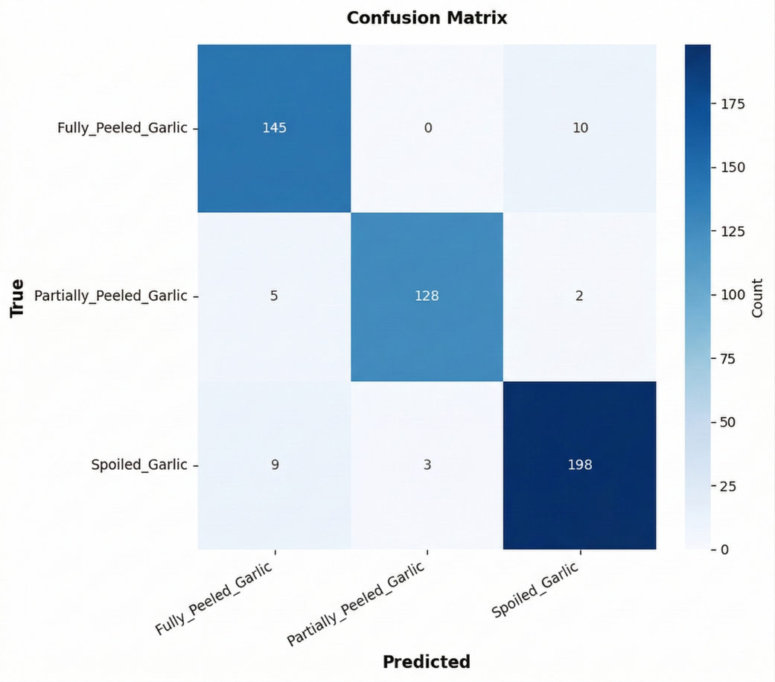
Fig. 8. Confusion matrix of the EfficientNetB4-F234-wA model on the Garlic Clove test dataset.
4.5. Error Analysis
To further analyze classification performance and misclassification patterns, the confusion matrix of the EfficientNetB4-F234-wA model on the Garlic Clove test dataset is shown in Fig. 8. The matrix illustrates the classification outcomes across the three categories: Fully Peeled Garlic, Partially Peeled Garlic, and Spoiled Garlic. The model correctly classifies the majority of samples, including 145 Fully Peeled Garlic, 128 Partially Peeled Garlic, and 198 Spoiled Garlic instances. Most misclassifications occur between visually similar categories, particularly between Fully Peeled Garlic and Spoiled Garlic, where 10 samples are incorrectly predicted as spoiled. A smaller number of errors are also observed between Partially Peeled Garlic and the other categories. Table 6 provides representative examples of these misclassified samples, with two visualization examples for each error case to illustrate the typical error patterns observed in the model predictions. Overall, the confusion matrix indicates that the EfficientNetB4-F234-wA model achieves strong classification performance with relatively few misclassification cases.
Table 6. Error analysis of representative misclassified samples produced by the EfficientNetB4-F234-wA model.
No | Ground Truth | Predicted | Explanation of Error Mechanism | Visualization
1 | Fully Peeled Garlic | Spoiled Garlic | The brown region at the tip of the garlic clove is actually the stem attachment area, a naturally hardened tissue where the clove separates from the bulb. It is not a spoiled region. | 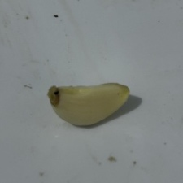 | 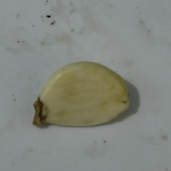
2 | Partially Peeled Garlic | Spoiled Garlic | The brown region is actually a naturally dried garlic skin layer with a small cut formed during the peeling process. It is not a damaged or rotten area. | 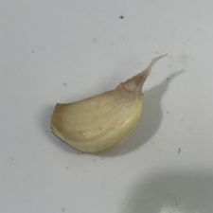 | 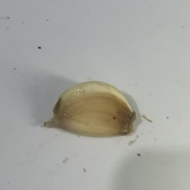
3 | Partially Peeled Garlic | Fully Peeled Garlic | A small portion of the brown outer skin remains attached to the garlic clove and has not been fully removed. Therefore, it is not Fully Peeled Garlic. | 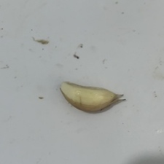 | 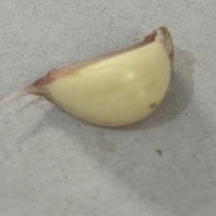
4 | Spoiled Garlic | Partially Peeled Garlic | This garlic clove contains a dark brown damaged region, which was mistakenly interpreted as remaining garlic skin. It is not Partially Peeled Garlic. | 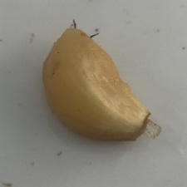 | 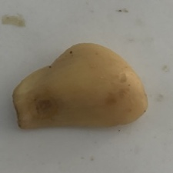
5 | Spoiled Garlic | Fully Peeled Garlic | This sample contains two small black spots and slight dark discoloration, which are signs of spoilage. It is not Fully Peeled Garlic. | 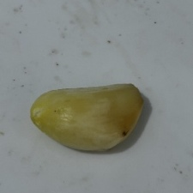 | 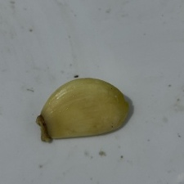
5. Conclusion
This study presented a deep learning–based machine vision framework, namely CPGC, for the automatic classification of peeled garlic cloves. A labeled dataset covering three quality categories including Fully Peeled Garlic, Partially Peeled Garlic, and Spoiled Garlic, was collected to support model training and evaluation. Five pre-trained convolutional neural network architectures were fine-tuned using transfer learning, and experimental results showed that the proposed EfficientNetB4-F234-wA model consistently outperformed the other models in terms of accuracy, F1-score, precision, and recall, achieving approximately 93.73% accuracy and 93.75% F1-score. These findings indicate that EfficientNetB4-F234-wA is effective in capturing fine-grained visual differences and is suitable for garlic quality classification tasks. The results also demonstrate the usefulness of transfer learning for domain-specific image classification problems with limited training data and highlight the potential of the proposed framework to reduce reliance on manual inspection in post-harvest garlic processing, while maintaining computational requirements suitable for practical deployment in real-time vision systems.
One limitation of this study is that the dataset consists only of RGB images captured using a smartphone camera, which may limit the model’s generalization under different imaging devices or environmental conditions. Future work will explore more diverse imaging conditions to improve robustness.
Furthermore, future research will investigate deploying the proposed model in real-time settings, such as edge or embedded vision systems, to support on-site quality inspection. In particular, the classification model will be integrated into an automated peeled garlic sorting machine, where visual predictions can be directly linked to mechanical actuators for separating different types of garlic cloves on a processing line. In addition, the dataset will be expanded to include more garlic varieties, storage conditions, and defect types in order to improve model robustness and generalization across diverse production environments.
Authors Contribution Statement
Phuc Hoang led the conceptualization, methodology development, experimental investigation, and drafting of the manuscript. Tuong Le contributed to methodology, writing-review and editing, supervision, and served as the corresponding author.
Data Availability
The Garlic Clove Dataset used in this study is available from the corresponding author upon reasonable request.
Competing Interests
The authors have no conflicts of interest to declare that are relevant to the content of this article.
Reference
- Mallick, D., Singh, A., Ng, E. Y. K., & Arora, V. (2025). Classifying chest x-rays for COVID-19 through transfer learning: a systematic review. Multimedia Tools and Applications, 84(2), 689-748, doi: 10.1007/s11042-024-18924-3.
- Vo, M. T., Vo, A. H., & Le, T. (2021). A robust framework for shoulder implant X-ray image classification. Data Technologies and Applications, 56(3), 447-460, doi: 10.1108/DTA-08-2021-0210.
- Singh, S., Kumar, M., Kumar, A., Verma, B. K., Abhishek, K., & Selvarajan, S. (2024). Efficient pneumonia detection using Vision Transformers on chest X-rays. Scientific reports, 14(1), 2487, doi: 10.1038/s41598-024-52703-2.
- Dayarathna, S., Islam, K. T., Uribe, S., Yang, G., Hayat, M., & Chen, Z. (2024). Deep learning based synthesis of MRI, CT and PET: Review and analysis. Medical image analysis, 92, 103046, doi: 10.1016/j.media.2023.103046.
- Lei, L., Yang, Q., Yang, L., Shen, T., Wang, R., & Fu, C. (2024). Deep learning implementation of image segmentation in agricultural applications: A comprehensive review. Artificial Intelligence Review, 57(6), 149, doi: 10.1007/s10462-024-10775-6.
- Akbar, J. U. M., Kamarulzaman, S. F., Muzahid, A. J. M., Rahman, M. A., & Uddin, M. (2024). A comprehensive review on deep learning assisted computer vision techniques for smart greenhouse agriculture. IEEE Access, 12, 4485-4522, doi: 10.1109/ACCESS.2024.3349418.
- Charisis, C., & Argyropoulos, D. (2024). Deep learning-based instance segmentation architectures in agriculture: A review of the scopes and challenges. Smart Agricultural Technology, 8, 100448, doi: 10.1016/j.atech.2024.100448.
- Zoph, B., Vasudevan, V., Shlens, J., & Le, Q. V. (2018). Learning transferable architectures for scalable image recognition. In Proceedings of the IEEE Conference on Computer Vision and Pattern Recognition (pp. 8697–8710), doi: 10.48550/arXiv.1707.07012.
- Szegedy, C., Vanhoucke, V., Ioffe, S., Shlens, J., & Wojna, Z. (2016). Rethinking the inception architecture for computer vision. In Proceedings of the IEEE Conference on Computer Vision and Pattern Recognition (pp. 2818–2826), doi: 10.48550/arXiv.1512.00567.
- Tan, M., & Le, Q. V. (2019). EfficientNet: Rethinking model scaling for convolutional neural networks. In Proceedings of the 36th International Conference on Machine Learning (pp. 6105–6114), doi: 10.48550/arXiv.1905.11946.
- Sandler, M., Howard, A., Zhu, M., Zhmoginov, A., & Chen, L. C. (2018). MobileNetV2: Inverted residuals and linear bottlenecks. In Proceedings of the IEEE Conference on Computer Vision and Pattern Recognition (pp. 4510–4520), doi: 10.48550/arXiv.1801.04381.
- Huang, G., Liu, Z., Van Der Maaten, L., & Weinberger, K. Q. (2017). Densely connected convolutional networks. In Proceedings of the IEEE Conference on Computer Vision and Pattern Recognition (pp. 4700–4708), doi: 10.48550/arXiv.1608.06993.
- Cardellicchio, A., Nitti, M., Patruno, C., Mosca, N., Di Summa, M., Stella, E., & Renò, V. (2024). Automatic quality control of aluminium parts welds based on 3D data and artificial intelligence. Journal of Intelligent Manufacturing, 35(4), 1629-1648, doi: 10.1007/s10845-023-02124-1.
- Supriya, S. K., & Ashwini, A. K. (2021). Automatic optical inspection system for wiring harness using computer vision. In Proceedings of the 2021 IEEE International Conference on Electronics, Computing and Communication Technologies (CONECCT) (pp. 1–5). IEEE, doi: 10.1109/CONECCT52877.2021.9622654.
- Caldas, P., Sousa, F., Pereira, F., Lopes, H., & Machado, J. (2022). Automatic system for yarn quality analysis by image processing. In Proceedings of the Journal of the Brazilian Society of Mechanical Sciences and Engineering, 44(11), 565, doi: 10.1007/s40430-022-03875-3.
- Wonggasem, K., Chakranon, P., & Wongchaisuwat, P. (2024). Automated quality inspection of baby corn using image processing and deep learning. Artificial Intelligence in Agriculture, 11, 61-69, doi: 10.1016/j.aiia.2024.01.001.
- Razavi, M., Mavaddati, S., & Koohi, H. (2024). ResNet deep models and transfer learning technique for classification and quality detection of rice cultivars. Expert Systems with Applications, 247, 123276, doi: 10.1016/j.eswa.2024.123276.
- El Sakka, M., Mothe, J., & Ivanovici, M. (2024). Images and CNN applications in smart agriculture. European Journal of Remote Sensing, 57(1), 2352386, doi: 10.1080/22797254.2024.2352386.
- Meenu, M., Kurade, C., Neelapu, B. C., Kalra, S., Ramaswamy, H. S., & Yu, Y. (2021). A concise review on food quality assessment using digital image processing. Trends in Food Science & Technology, 118, 106-124, doi: 10.1016/j.tifs.2021.09.014.
- Hemamalini, V., Rajarajeswari, S., Nachiyappan, S., Sambath, M., Devi, T., Singh, B. K., & Raghuvanshi, A. (2022). Food quality inspection and grading using efficient image segmentation and machine learning‐based system. Journal of Food Quality, 2022(1), 5262294, doi: 10.1155/2022/5262294.
- Zhang, X., Yang, J., Lin, T., & Ying, Y. (2021). Food and agro-product quality evaluation based on spectroscopy and deep learning: A review. Trends in Food Science & Technology, 112, 431-441, doi: 10.1016/j.tifs.2021.04.008.
- Lin, Y., Ma, J., Wang, Q., & Sun, D. W. (2023). Applications of machine learning techniques for enhancing nondestructive food quality and safety detection. Critical Reviews in Food Science and Nutrition, 63(12), 1649-1669, doi: 10.1080/10408398.2022.2131725.

