

**HOstel management**

**Software Requirement Specification**

– Ho Chi Minh, May 2022 –

**Table of Contents**

I. Overview 3

1. Introduction 3

2. System Functions 4

3. Common Requirements 5

II. Functional Requirements 6

1. <<Feature Name 1>> 6

a. <<Function Name 1>> 6

b. <<Function Name 2>> 6

2. <<Feature Name 2>> 6

# I. Overview

## 1. Introduction

In our present age of automated systems with it being software or hardware, manual systems should not be used. Hostel without a management system are usually done manually. For example: Currently, the number of students and workers is increasing, and the number of local people moving to the city is also increasing, the number of motel rooms also increases with the manual management of the accommodation, which also encounters many problems, making it difficult for the owners. Hosteller needs hostel management system. The limitations of current systems lead to the design of a computerized system that greatly reduces manual input. With this system, we were able to improve the efficiency of the system, thereby overcoming the limitations of the existing manual system.

This system is designed to benefit the hostel management, helping the innkeeper to easily manage the rooms, staff and monthly/yearly revenue of the hostel. It saves them from manual work from which it is difficult to find messy customer bills, and information about people who left the hostel many years ago. This system gives an idea of ​​how to maintain a customer and clutter fee, room, spending details in a better way. The hostel management system will also include special features such as the number of customers staying in a room, the customer id, and the available rooms or spaces. The admin panel has a separate identity for each member as well as customer details.

Hostel management system is web-based software to provide accommodation for university students and workers, locals to the city at the hostel more efficiently. This project also keeps detailed information about hostels and Monthly/Yearly Revenue and customer information. The system is intended to reduce human work and make hostel allocation easier for residents by providing an online hostel application, automatically selecting customers from a waiting list, and counting. mess math, complaint registration, bulletin board, etc. Customers will receive approval notices in their mail. Guests can view bulletin boards, accommodation fees and messy details by logging into the online system.

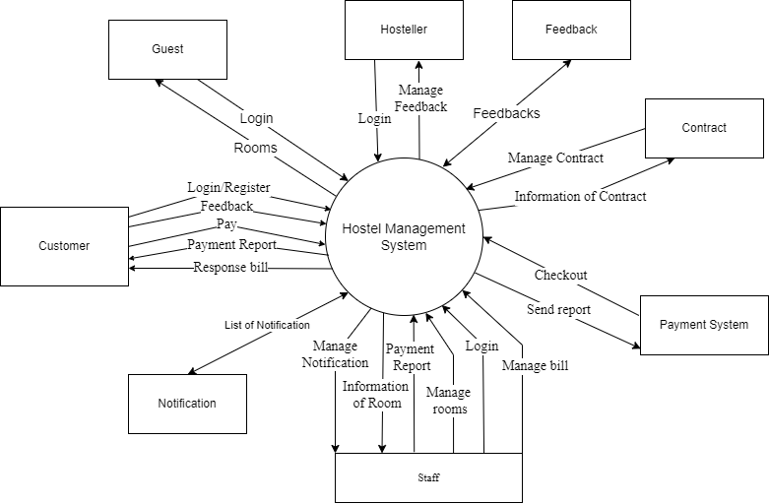

## 2. System Functions

#### a. Screen Flow

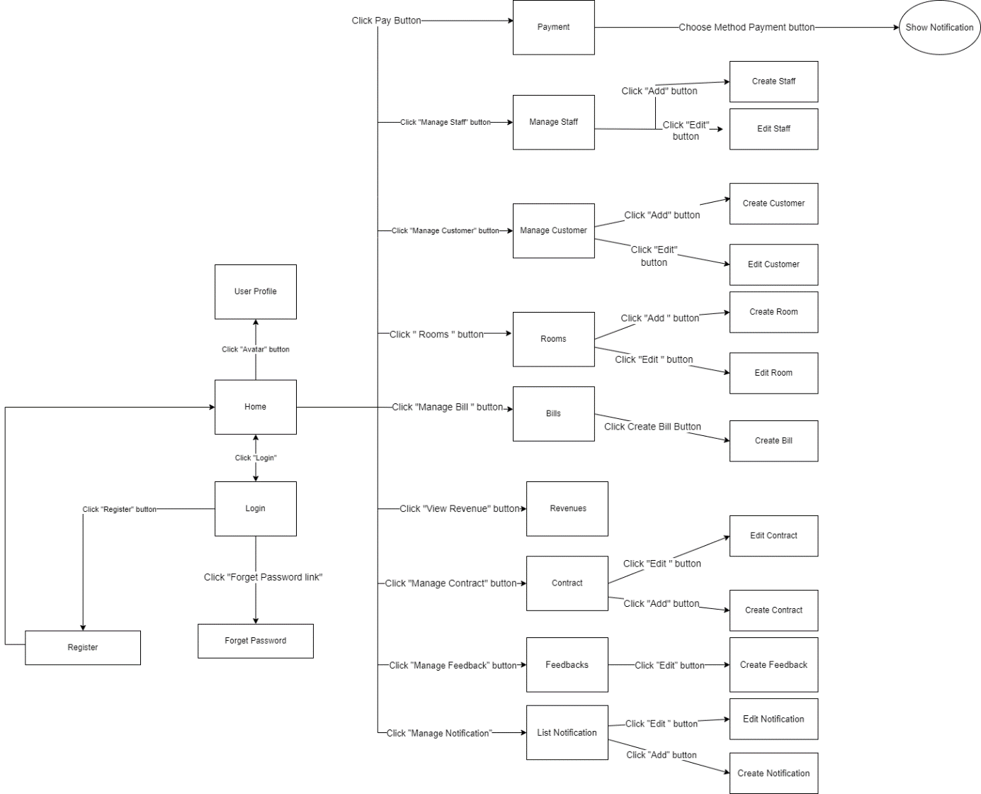

#### b. Screen Details

|  |  |  |  |
| --- | --- | --- | --- |
| **#** | **Feature** | **Screen** | **Description** |
| 1 | Authentication | Login | Check login for staff , hosteller or guest |
| 2 | Authentication | Forget Password | Ask the user to enter the email, the system will send the password via email |
| 3 | Notification | ShowNotification | Pay with Momo |
| 4 | Authentication | Register | Enter information to register |
| 5 | Authentication | Create Account | Hosteller/Staff create for guest or staff to login into system |
| 6 | ManageRevenue | Revenues | Hosteller Manage total profit per month |
| 7 | ManageBill | Bills | Show list of bills |
| 8 | ManageBill | Create Bill | Staff will create a new bill |
| 9 | ViewRevenue | Revenues | Hosteller can watch revenues of his/her hostel |
| 11 | ManageRoom | Rooms | Show list of rooms |
| 12 | ManageRoom | Create Room | Staff will add a new room |
| 13 | ManageRoom | Edit Room | The staff will correct the room information |
| 14 | ManageFeedbacks | Feedback | Customer view feedback |
| 15 | Manage Feedbacks | Create Feedback | Customer send feedback |
| 16 | Manage Payment | Pay | Staff/Customer pay for consumption per month |
| 17 | ManageRegulation | Regulation | All role can manipulate regulation |
| 19 | ViewRevenue | Revenues | Hosteller can watch revenues of his/her hostel |
| 20 | ManageContract | Contracts | Show list of contract |
| 21 | ManageContract | Add Contract | Create new contract |
| 22 | ManageContract | Edit Contract | Update/Delete contract |
| 23 | ManageCustomer | Customers | Staff can view list customer |
| 24 | ManageCustomer | Create Customer | Add new customer |
| 25 | ManageCustomer | Edit Customer | Update/Delete customer out of room |
| 26 | ManageStaff | Staffs | View list of Staff |
| 27 | ManageStaff | Create Staff | Create new Staff |
| 28 | ManageStaff | Edit Staff | Update/Detele staff out of hostel |
| 29 | Notification | List Notification | View list of notification |
| 30 | Notification | Create Notification | Create new notifications for customers |
| 31 | Notification | Edit Notification | Update/Delete notifications |

#### c. User Authorization

|  |  |  |  |  |
| --- | --- | --- | --- | --- |
| **Screen** | **Role1** | **Role2** | **Role3** | **Role4** |
| 1. Authentication |  |  |  |  |
| 1.1 Login | X | X | X | X |
| 1.2 Register |  | X | X | X |
| 1.3 Forget Password | X | X | X | X |
| 1.4 View Profile | X | X | X | X |
| 1.5 Edit Profile | X | X | X | X |
|  |  |  |  |  |
| 2. Manage Rooms |  |  |  |  |
| 2.1 View list of room |  | X | X | X |
| 2.2 Search room |  | X | X | X |
| 2.3 Sort list of rooms |  | X | X | X |
| 2.4 Add room |  | X |  |  |
| 2.5 Update room |  | X |  |  |
| 2.6 Delete room |  | X |  |  |
|  |  |  |  |  |
| 3. Manage Customer |  |  |  |  |
| 3.1 View list of customers | X | X |  |  |
| 3.2 Search customer | X | X |  |  |
| 3.3 Sort list of customers | X | X |  |  |
| 3.4 Update customer | X | X |  |  |
| 3.5 Add customer | X | X |  |  |
| 3.6 Delete customer | X | X |  |  |
|  |  |  |  |  |
| 4. Manage Staff | X |  |  |  |
| 4.1. View list of staff | X |  |  |  |
| 4.2 Search staff | X |  |  |  |
| 4.3 Sort list of staffs | X |  |  |  |
| 4.3 Update staff | X |  |  |  |
| 4.4 Add staff | X |  |  |  |
| 4.5 Delete staff |  |  |  |  |
|  |  |  |  |  |
| 5. Manage Feedback |  | X |  |  |
| 5.1 Send Feedback |  | X | X |  |
| 5.2 View Feedback |  | X | X |  |
| 5.3 Search Feedback |  | X | X |  |
| 5.4 Sort Feedback |  | X | X |  |
|  |  |  |  |  |
| 6. Manage Bill |  | X |  |  |
| 6.1. View list of bill |  | X | X |  |
| 6.2 Update bill |  |  |  |  |
| 6.3 Search Bill |  |  |  |  |
| 6.4 Sort Bill |  |  |  |  |
| 7. Payment |  |  | X |  |
|  |  |  |  |  |
| 8. Manage Revenue | X |  |  |  |
| 8.1 View Revenue | X |  |  |  |
| 8.2 Compute Revenue Statistic | X |  |  |  |
|  |  |  |  |  |
| 9. Manage Regulation |  | X |  |  |
| 9.1 Show Regulation | X | X | X | X |
| 9.2 Create Regulation | X | X |  |  |
| 9.3 Update Regulation | X | X |  |  |
| 9.4 Delete Regulation | X | X |  |  |
|  |  |  |  |  |
| 10 Manage Notification |  |  |  |  |
| 10.1 Show Notification | X | X | X | X |
| 10.2 Update Notification | X | X |  |  |

In which:

* Role1: Hosteller
* Role2: Staff
* Role3: Customer
* Role4: Guest

#### d. Non-Screen Functions

|  |  |  |  |
| --- | --- | --- | --- |
| **#** | **Feature** | **System Function** | **Description** |
| 1 | Payment | Payment | Pay with Momo |
|  |  |  |  |

## 3. Common Requirements

# II. Functional Requirements

## 1. Manage Customer

## 

