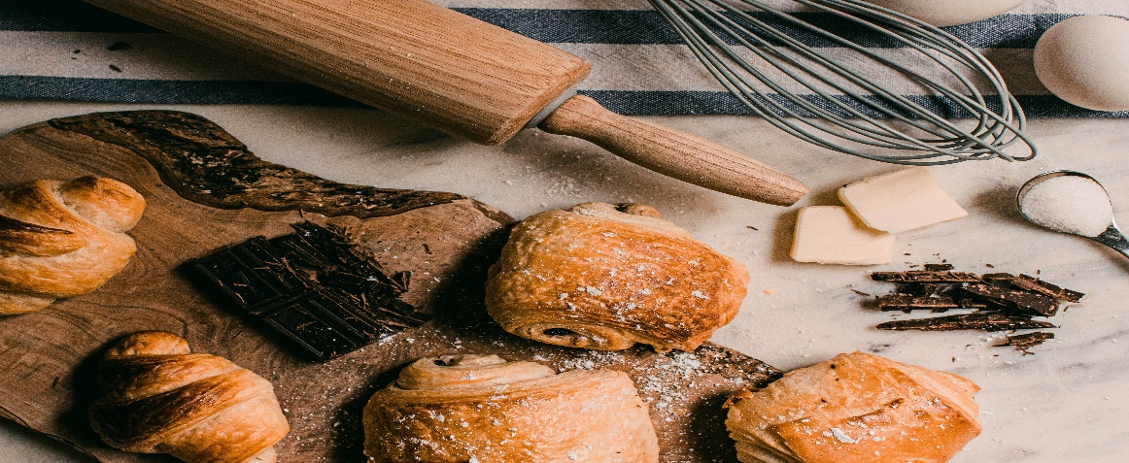

WEDE5020 – Web Development (introduction)

Website Project Proposal

Thandeka's Kitchen

Phuluso Kone
ST10462787
Group 5

14/08/26

Table Of Contents
Contents
1. Organisation Overview 3
2. Website Goals and Objectives 4
3. Current Website Analysis 5
4. Proposed Website Features and Functionality 6
5. Design and User Experience 7
6. Technical Requirements 9
7. Timeline and Milestones 9
8. Budget 10
9. References 10

1. Organisation Overview
Thandeka's Kitchen is a Johannesburg-based artisan bakery and catering business founded in 2021 by Thandeka Mokoena, growing from a home-bakery side hustle into a small commercial operation supplying custom cakes, pastries, and event catering.
- Mission: To bring handcrafted, locally-sourced baked goods to every table, celebration, and workplace in Johannesburg.
- Vision: To become Gauteng's most trusted independent bakery for personalised celebration cakes and corporate catering.
- Target audience: Working professionals (25–45) planning events; small businesses ordering corporate catering; families seeking custom celebration cakes.

2. Website Goals and Objectives
- Generate catering and custom-order leads via an enquiry form
- Showcase products visually to build trust before customers order
- Reduce repetitive WhatsApp/phone queries through clear online information
- KPIs: 20+ enquiry submissions/month within 3 months; average session duration >90 seconds; 15% month-on-month traffic growth

3. Current Website Analysis
Thandeka's Kitchen currently has no website — only an Instagram page and WhatsApp Business account. Weaknesses: no centralised menu/pricing, no way to browse past work, missed leads outside business hours, no SEO presence.

4. Proposed Website Features and Functionality
- Homepage: hero image, tagline, featured products, CTA to enquiry page
- About Us: founder story, mission/vision, kitchen photos
- Products/Services: cake categories, catering packages, pricing guide
- Gallery: photo showcase of past cakes, pastries, and catered events, to build visual trust ahead of enquiry
- Enquiry: custom order/catering request form
- Contact: location map, hours, phone/email, social links

5. Design and User Experience
- Colour Scheme: soft blush pink (#FBEAEA) for header/footer, warm off-white (#FFF8F6) content background, dusty rose (#D98C8C) accent for buttons/links — a gentle, inviting palette suited to a home-grown bakery
- Typography: Playfair Display (headings) paired with Lato (body) for a warm-but-professional feel
- Layout: clean single-column mobile-first grid with generous white space; Gallery page uses a responsive photo grid
- Navigation kept to 6 items; low-fidelity wireframes to be attached showing homepage hero-to-CTA flow, products grid, and gallery grid layout
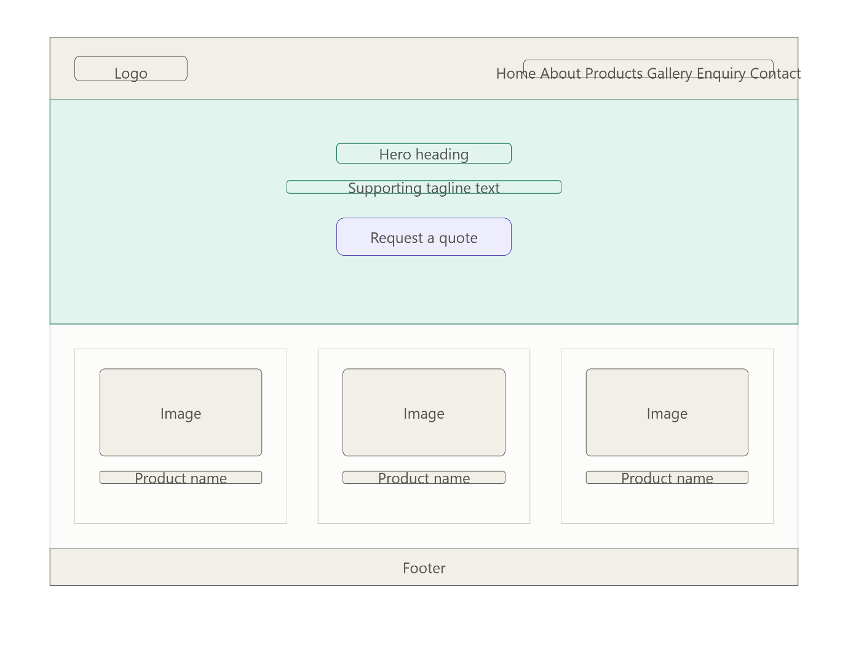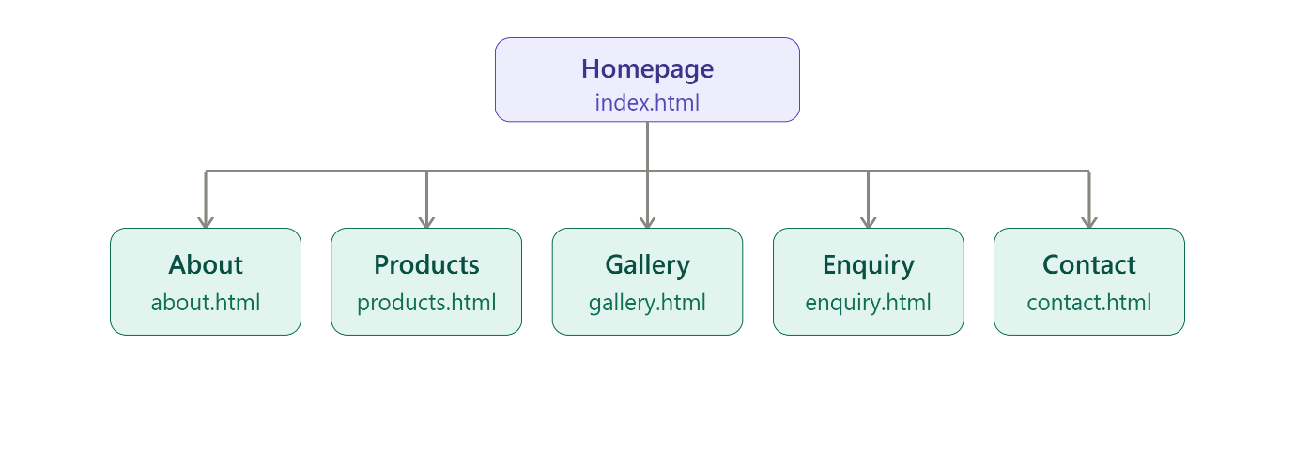

6. Technical Requirements
HTML5, CSS3, vanilla JavaScript for the site; hosting via a shared hosting provider (e.g. Afrihost or Xneelo); domain registration through a local .co.za registrar; no CMS/database required for Part 1 scope.

7. Timeline and Milestones
- Weeks 1–2: Proposal approval, research, sitemap
- Weeks 3–5: HTML structure and content integration across 6 pages
- Weeks 6–8: Styling and responsive design
- Weeks 9–10: Interactivity, testing, final submission

8. Budget
Domain (R150/year), shared hosting (R900/year), stock imagery/licensing (R500 once-off), maintenance allowance (R300/month) — total first-year estimate: ~R5,150.
9. References
Afrihost, 2026. Web hosting plans. Available at: https://www.afrihost.com [Accessed 14 August 2026].
Xneelo, 2026. Domain registration. Available at: https://www.xneelo.co.za [Accessed 14 August 2026].
Unsplash, 2026. Free stock photography. Available at: https://unsplash.com [Accessed 14 August 2026].

