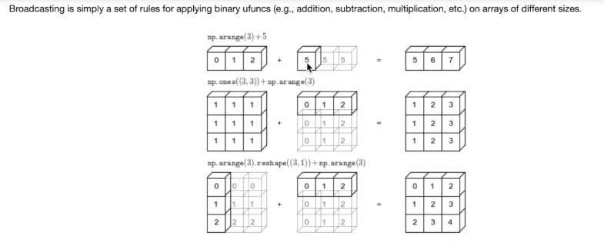

**Standard Deviation and Variance**

**Standard Deviation**

* Standard Deviation is a measure of how spread out numbers are.

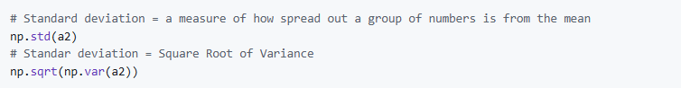

**Variance**

* The average of the squared differences from the Mean.

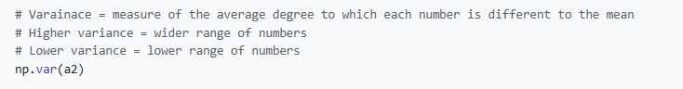

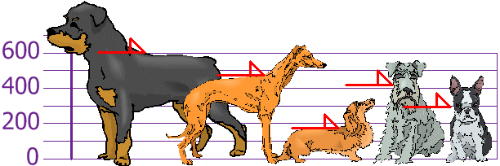

* **The heights (at the shoulders) are: 600mm, 470mm, 170mm, 430mm and 300mm**
* **Mean = (600 + 470 + 170 + 430 + 300)/5 = 394mm**

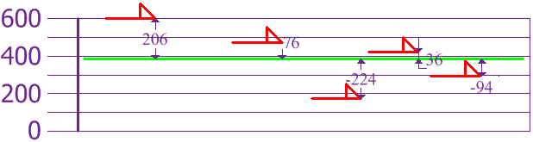

* **Variance = 21704**
* **Standard Deviation = sqrt(variance) = 147 mm**

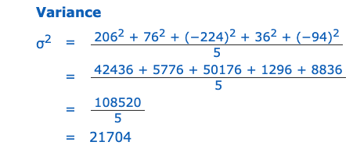

* we can show which heights are within one Standard Deviation (147mm) of the Mean:
* Standard Deviation we have a "standard" way of knowing what is normal, and what is extra large or extra small

