Ministry of Education and Training
Nguyen Tat Thanh University
NTT Institute of International Education


GRADUATION PROJECT
TITLE:
VISUAL IMAGE-BASED FOREIGN LANGUAGE
LEARNING APPLICATION FOR
YOUNG CHILDREN

PROJECT SUPERVISOR: MSC. MA NGAN GIANG
NO. | NAME | STUDENT ID
1 | PHUNG GIA DAT | 2200001492
Ho Chi Minh City, [09] [2026]

Ministry of Education and Training
Nguyen Tat Thanh University
NTT Institute of International Education

GRADUATION PROJECT
TITLE:
VISUAL IMAGE-BASED FOREIGN LANGUAGE
LEARNING APPLICATION FOR
YOUNG CHILDREN

PROJECT SUPERVISOR: MSC. MA NGAN GIANG
NO. | NAME | STUDENT ID
1 | PHUNG GIA DAT | 2200001492
Ho Chi Minh City, [09] [2026]
STUDENT DECLARATION
Student Name and Student ID: PHUNG GIA DAT - 2200001492
Supervisor Name: MSc. Ma Ngan Giang
STUDENT DECLARATION
I affirm that this project, "Visual Image-Based Foreign Language Learning Application for Young Children," is the result of my own independent research efforts and has been entirely produced by me.

Ho Chi Minh City, Date ...... Month ...... Year ......

Supervisor  (Name and Signature) | Student  (Name and Signature)

ACKNOWLEDGMENTS
I would like to sincerely thank my supervisor, MSc. Ma Ngan Giang, for her guidance and support throughout this graduation project. Her feedback helped me identify weaknesses in both the system and the thesis, and encouraged me to improve the way I analysed, implemented, and presented my work. I am especially grateful for her patience and the time she spent reviewing my progress and giving practical suggestions during the development and revision of this project.

TABLE OF CONTENTS
CHAPTER 1: INTRODUCTION 1
1.1 Rationale for topic selection 1
1.1.2 Educational Benefits of the Proposed Application 3
1.1.3 Rationale for Using Augmented Reality with Young Children 5
1.2 Problem Statement 5
1.3 Objectives 6
1.4 Scope 7
1.5 Research and Development Methods 7
1.6 Thesis Structure 8
CHAPTER 2: THEORETICAL FRAMEWORK AND RELATED WORK 9
2.1 Introduction 9
2.2 Visual and Multimedia Vocabulary Learning 9
2.2.1 Design implications for Edu-platform 10
2.3 Augmented Reality in Vocabulary Learning 11
2.3.1 Web AR and mobile access 12
2.3.2 Tracking and interaction model 12
2.3.3 AR limitations relevant to young learners 12
2.4 Game-Based Learning and Gamification 13
2.5 Pronunciation Practice and Automatic Assessment 13
2.6 Mobile-Assisted Language Learning and Child-Oriented Usability 14
2.7 Screen-Time Management and Parent Awareness 14
2.8 Related Work Comparison 15
2.9 Research and Development Gap 16
2.11 Development Methodology 16
2.12 Chapter Summary 17
CHAPTER 3: APPLICATION ANALYSIS AND DESIGN 18
3.1 Introduction 18
3.2 User Roles and Application Scope 19
3.3 System Requirements Analysis 19
3.3.1 Functional Requirements 19
3.3.2 Requirements Traceability Matrix 20
3.4 UML Use Case Modelling 22
3.4.1 Use Case: Login 23
3.4.2 Use Case: Courses and Lessons 24
3.4.3 Use Case: Flashcards 25
3.4.4 Use Case: Pronunciation Practice 26
3.4.5 Use Case: Games 27
3.4.6 Use Case: Gamification 28
3.4.7 Use Case: Parent and Session Tracking 29
3.4.8 Use Case: QR Scanning 30
3.4.9 Use Case: One-card AR 31
3.4.10 Use Case: Chatbot Assistance 32
3.4.11 Use Case: Learning Path 33
3.4.12 Use Case: Leaderboard 34
3.4.13 Use Case: Daily Challenge 35
3.4.14 Use Case: Pet Companion 36
3.4.15 Use Case: Word Check 37
3.4.16 Use Case: Dictionary (Notebook) 38
3.4.17 Use Case: Translate 39
3.4.18 Use Case: Multi-card AR 40
3.4.19 Use Case Relationships 40
3.4.20 Administrative Content and Learner Management 42
3.5 Sequence Analysis 43
3.5.1 Login 43
3.5.2 Courses and Lessons 44
3.5.3 Flashcards 45
3.5.4 Pronunciation Practice 46
3.5.5 Games 47
3.5.7 Parent and Session Tracking 48
3.5.8 QR Scanning 49
3.5.9 One-card AR 50
3.5.10 Chatbot Assistance 51
3.5.11 Learning Path 52
3.5.12 Leaderboard 53
3.5.13 Daily Challenge 54
3.5.14 Pet Companion 55
3.5.15 Word Check 56
3.5.16 Dictionary (Notebook) 57
3.5.17 Translate 58
3.5.18 Multi-card AR 59
3.5.19 Registration and Protected Learner Access 60
3.5.20 Administrative Learning-Content Management 62
3.6 Activity Diagram Analysis 62
3.6.1 Learner Learning, Reward and Progress Flow 62
3.6.2 QR-Based AR Learning Flow 63
3.6.3 Child Session and Parent-Controlled Break Flow 65
3.6.4 Administrative Learning-Content Lifecycle 65
3.6.5 Account Registration and Protected Access 65
3.6.6 Course, Lesson and Flashcard Learning Flow 66
3.6.7 Pronunciation Capture and Feedback Flow 67
3.6.8 Game Completion and Authoritative Reward Flow 67
3.6.9 Learning Path, Daily Challenge and Progress Views 68
3.6.10 Dictionary, Notebook, Translation and Chat Support 68
3.6.11 Profile and Notification Preference Flow 69
3.6.12 Administrative Learner Review, Goals, Analytics and Monitoring 69
3.7 Data-Flow Analysis 70
3.7.1 Context Diagram 70
3.7.2 DFD Level 0 71
3.7.3 DFD Level 1 – Cor[-e Learning Data Flow 72
3.7.4 DFD Level 1 - AR Data Flow 72
3.8 Application Architecture 73
3.8.1 Implemented Technology Stack 73
3.8.2 Event-Driven WebAR Architecture 74
3.8.3 Agentic RAG Learning-Support Architecture 75
3.9 Data Design 76
3.9.1 Conceptual Data Model (CDM) 77
3.9.2 Entity-Relationship Diagram (ERD) 77
3.9.3 Physical Data Model (PDM) 79
3.9.4 AR Identity and Asset Mapping 81
3.10 Chapter Summary 81
CHAPTER 4: SYSTEM TESTING AND EVALUATION 83
4.1 Introduction 83
4.2 Test Setup and Result Criteria 83
4.3 Core Learning and Practice Testing 84
4.4 Progress, Motivation and Parent-Monitoring Tests 85
4.5 Learning-Support Service Tests 86
4.6 AR Interaction Tests 87
4.7 Automated Regression and Build Validation 89
4.8 Responsive Interface Evidence 90
4.8.1 Production Mobile-Web Runtime Evidence 94
4.8.2 Additional Production Mobile-Web Runtime Evidence 99
4.9 Recovery and Negative-path Checks 115
4.10 Observed Issues and Evidence Gaps 116
4.11 Evaluation 116
4.12 Chapter Summary 116
CHAPTER 5: CONCLUSION AND FUTURE WORK 118
5.1 Summary of the work 118
5.2 Contributions 118
5.3 Limitations and future work 119
5.4 Conclusion 120
REFERENCES 121
APPENDIX A: CONFIRMED FEATURE TRACEABILITY 123
APPENDIX B: DATA-MODEL REFERENCE TABLES 124
APPENDIX C: DEMONSTRATION AND SOURCE CODE 127
LIST OF TABLES, FIGURES
TABLES
Table 2.1. Flashcard design implications for Edu-platform. 10
Table 2.2. Comparison of related learning approaches. 15
Table 3.1. Implemented technology stack of Edu-platform. 72
Table 3.2. Requirements traceability for the implemented prototype. 19
Table 4.1. Test environment, technology stack and result interpretation. 81
Table 4.2. Core learning and practice test results. 82
Table 4.3. Progress, motivation and parent-monitoring test results. 83
Table 4.4. Learning-support service test results. 84
Table 4.5. AR-specific interaction test cases. 85
Table 4.6. Recorded automated regression and build evidence. 87
Table B.1. Conceptual entity groups represented in the CDM. 122
Table B.2. Selected physical-table reference from the PDM. 122
Table B.3. AR identity and asset-mapping reference. 123
Table C.1. Project demonstration and source access. 124
FIGURES
Figure 3.1. Overall use-case model of the Edu-platform web application. 21
Figure 3.2. Learner-oriented use-case model of Edu-platform. 22
Figure 3.3. Use Case: Login. 22
Figure 3.4. Use Case: Courses and Lessons. 23
Figure 3.5. Use Case: Flashcards. 24
Figure 3.6. Use Case: Pronunciation Practice. 25
Figure 3.7. Use Case: Games. 26
Figure 3.8. Use Case: Gamification. 27
Figure 3.9. Use Case: Parent and Session Tracking. 28
Figure 3.10. Use Case: QR Scanning. 29
Figure 3.11. Use Case: One-card AR. 30
Figure 3.12. Use Case: Chatbot Assistance. 31
Figure 3.13. Use Case: Learning Path. 32
Figure 3.14. Use Case: Leaderboard. 33
Figure 3.15. Use Case: Daily Challenge. 34
Figure 3.16. Use Case: Pet Companion. 35
Figure 3.17. Use Case: Word Check. 36
Figure 3.18. Use Case: Dictionary (Notebook). 37
Figure 3.19. Use Case: Translate. 38
Figure 3.20. Use Case: Multi-card AR. 39
Figure 3.21. Core learning use cases. 40
Figure 3.22. Engagement and support use cases. 40
Figure 3.23. AR use cases and multi-card interaction. 41
Figure 3.24. Use-case model for administrative content and learner management. 42
Figure 3.25. Login. 43
Figure 3.26. Courses and Lessons. 44
Figure 3.27. Flashcards. 45
Figure 3.28. Pronunciation Practice. 46
Figure 3.29. Games. 47
Figure 3.31. Parent and Session Tracking. 48
Figure 3.32. QR Scanning. 49
Figure 3.33. One-card AR. 50
Figure 3.34. Chatbot Assistance. 51
Figure 3.35. Learning Path. 52
Figure 3.36. Leaderboard. 53
Figure 3.37. Daily Challenge. 54
Figure 3.38. Pet Companion. 55
Figure 3.39. Word Check. 56
Figure 3.40. Dictionary (Notebook). 57
Figure 3.41. Translate. 58
Figure 3.42. Multi-card AR. 59
Figure 3.43. Sequence for registration or authenticated learner access. 60
Figure 3.44. Sequence for administrative learning-content management. 61
Figure 3.46. Activity flow for learner interaction, semantic reward processing and progress refresh. 62
Figure 3.47. Activity flow for QR-based AR learning. 63
Figure 3.48. Activity flow for child-session and parent-controlled break handling. 64
Figure 3.49. Activity flow for administrative learning-content management. 64
Figure 3.50. Activity flow for account registration, authentication and protected route access. 65
Figure 3.51. Activity flow for course selection, lesson work and flashcard review. 65
Figure 3.52. Activity flow for pronunciation recording, assessment request and feedback. 66
Figure 3.53. Activity flow for game completion and backend-authoritative reward processing. 67
Figure 3.54. Activity flow for learning-path selection, challenge completion and progress views. 67
Figure 3.55. Activity flow for dictionary, notebook, translation and chat support. 68
Figure 3.56. Activity flow for profile changes and notification preferences. 68
Figure 3.57. Activity flow for administrative learner review, goal management, analytics and monitoring. 69
Figure 3.58. Context Diagram. 70
Figure 3.59. DFD Level 0. 70
Figure 3.60. DFD Level 1 - Core Learning Flow. 71
Figure 3.61. DFD Level 1 - AR Data Flow. 71
Figure 3.62. Layered application architecture with optional WebAR and learning-support services. 73
Figure 3.63. Event-driven WebAR architecture for the React host and MindAR viewer. 74
Figure 3.64. Agentic RAG architecture for authenticated learning-support chat. 75
Figure 3.65. Conceptual data model of Edu-platform. 76
Figure 3.66. ERD for core learning and session data. 77
Figure 3.67. ERD for progress, practice and learner-support data. 77
Figure 3.68. ERD for AR tracking and combination data. Solid links are declared foreign keys; dashed links are application-level mappings. 78
Figure 3.69. Selected physical data model for users, courses, lessons, learner progress and learning sessions. 79
Figure 3.70. Selected physical data model for the current AR path and combination rules. 79
Figure 3.71. Identity separation across flashcard, 8th Wall target, AR object and combination data. 80
Figure 4.1. Home route at a desktop-sized viewport. 89
Figure 4.2. Home route at a narrow portrait viewport. 90
Figure 4.3. Login route at a desktop-sized viewport. 91
Figure 4.4. Login route at a narrow portrait viewport. 92
Figure 4.5. Active-pet view showing the Giraffe state, displayed meters and the feed action. 94
Figure 4.6. Pet collection view showing rarity, active status, a locked item and available feed/play actions. 95
Figure 4.7. Legendary sticker collection view showing recorded collected states. 96
Figure 4.8. Epic and Rare sticker collection view showing recorded collection progress. 97
Figure 4.9. Memory matching game view showing recognized vocabulary pairs during gameplay. 98
Figure 4.10. Leaderboard view showing the ranked learners and displayed XP values. 99
Figure 4.11. Daily Challenge view showing the current lesson goal, streak, reward and progress state. 100
Figure 4.12. Learner profile view showing level, total XP, progress toward the next level and the protected account area entry. 101
Figure 4.13. Learning Path view showing the selected school topic, route count and next learning card. 102
Figure 4.14. Course catalogue card showing the available course, learning topic, displayed XP and start action. 103
Figure 4.15. Topic selection view showing the animal and family course categories with their visible progress states. 104
Figure 4.16. Lexi chat view showing a response to a learner question about the English word cat. 105
Figure 4.17. Lexi chat view after the learner starts a new conversation. 106
Figure 4.18. Word Check result for Cat showing the entered word, pronunciation, part of speech, Vietnamese meaning, explanation and example. 107
Figure 4.19. Continued Word Check result showing the source field and the available action to save Cat to the notebook. 108
Figure 4.20. Second captured Word Check result state for Cat, retaining the displayed source and save action. 109
Figure 4.21. Vocabulary notebook view showing saved-word and review counts together with filter controls. 110
Figure 4.22. Vocabulary notebook detail view for Cat showing stored meaning, source, review count and the delete action. 111
Figure 4.23. Deployed AR viewer with configured animal study cards visible and rendered 3D animal assets. 112
Figure 4.24. Deployed AR viewer reporting the scanned cat001 target while preparing the AR experience. 113
Figure 4.25. Cat and Fish rendered together in the deployed AR viewer during the captured cat001 target interaction. 114
ABBREVIATIONS LIST
ABBREVIATION | EXPLANATION
8th Wall | WebAR engine used for image-target tracking and AR rendering
FastAPI | Python web framework used for the application service API
PostgreSQL | Relational database used for structured application data
API | Application Programming Interface
AR | Augmented Reality
ASR | Automatic Speech Recognition
GLB | Binary glTF 3D model format
PWA | Progressive Web Application
QR | Quick Response code
SRS | Spaced Repetition System
TTS | Text-to-Speech
UI | User Interface
UX | User Experience
XP | Experience Points
XR | Extended Reality

ABSTRACT
Edu-platform is a browser-based English learning system for young learners. It combines visual flashcards, pronunciation practice, short games, progress tracking, a virtual pet companion, and optional augmented-reality activities. The engineering work focuses on a practical problem: several services must cooperate without turning a camera or asset failure into a complete learning failure. The implementation therefore separates course data, learner progress, QR identity, AR target identity, model delivery, and gamification events. React and TypeScript provide the learner interface; FastAPI exposes the service layer; PostgreSQL and Supabase support persistence and media delivery. The current prototype uses the 8th Wall Engine for the AR path alongside the conventional web learning routes. Repository tests and interface artifacts support functional claims, but they do not yet prove learning gains or stable AR performance across a broad device sample. The thesis reports those limits directly and identifies the physical-device and learner studies required next.

CHAPTER 1:
INTRODUCTION

1.1 Rationale for topic selection
Children, especially younger students in primary school, are increasingly exposed to English through electronic devices such as phones, tablets, and computers. The content they encounter can come from videos, images, games, or simple learning apps. From this approach, web and mobile applications can be used to bring vocabulary images, audio, short exercises, and information about learning progress into the same environment [19]–[21], [25]. However, the goal of the app is not just to include images, questions, or exercises in a familiar and easily boring presentation. Instead, the system leverages modern visualization technologies to present content from 2D images to 3D models and AR. This approach aims to make the learning process more vivid, create more excitement, and pique children's curiosity when exposed to new vocabulary. Therefore, technological elements should not be used only to create effects, but need to be associated with a specific learning activity and support children to observe, listen, interact and remember content more easily. EduAR is a web app learning system built to support young children in learning English through visual images. In this system, children can familiarize themselves with vocabulary through visual flashcards, practice pronunciation, participate in games and short questions, and track their learning progress. In addition, the system also integrates reward mechanisms such as stickers and unlocking pets, thereby creating more motivation for children to maintain learning. A highlight of EduAR is the augmented reality (AR) function, which allows children to scan flashcards to observe 3D models, such as images of animals, right on the device. These functions are not designed as separate parts, but are organized into a short series of learning activities, helping children recognize new words, practice, receive feedback, and review the content they have learned in a more vivid way. AR technology is incorporated into the system to support young children's learning through visual content and the ability to interact with 3D objects. In ARbis Pictus, vocabulary labels are combined with enhanced visual content [1], while Che Dalim et al. investigate the use of AR in combination with voice input for children learning a non-native language [2]. These studies show that AR can be applied in vocabulary learning activities for children. In EduAR, AR is integrated as part and a function of the system, allowing children to access learning content in a more intuitive way in addition to activities such as listening, practicing, receiving feedback, and reviewing learned words. Pronunciation-assisted technology is also used and constructed with caution so as not to pressure or bind young children to the system's recognition results. Differences in voice, microphone quality, environmental noise, and acoustic characteristics in a child's voice can all affect the accuracy of the recognition results [3]. Therefore, in EduAR, the speech recognition function is used primarily to assist children in practicing and giving feedback after each pronunciation. This result is for reference during the learning process, rather than being used as an absolute assessment of the child's pronunciation. The design of the system also references studies on multimedia learning and game-based learning. When a child learns a new word in EduAR, the vocabulary is accompanied by illustrations and pronunciation sounds so that the child can both see and hear and associate the word with the object from which the word describes [4], [5]. Animations are used when necessary, such as to make the object more lively or to respond to a child's action [6], [7]. In addition to the learning content, EduAR also uses rewards such as stickers and unlocking pets after learning or completing an activity [10]–[13]. These elements are used to create more excitement for the child, rather than just turning the lesson into a series of questions and static images. The main target of the system is children who begin learning English between the ages of five and eight. At this age, children should not have to handle interfaces that are too multi-step or too complex. Therefore, the children's interface prioritizes the use of images, voice instructions, short actions, and clear feedback. The system also provides information and reminders for parents to support the use of the app in a purposeful and supervised manner, rather than encouraging children to use the device for long periods of time [14]–[16]. This thesis focuses on the process of designing and implementing a visual language learning application for young children. The main contribution of the project lies in building a complete software system and providing functional evidence for that design. The study does not aim to draw large-scale conclusions about how children learn foreign languages.

1.1.2 Educational Benefits of the Proposed Application
The value of EduAR lies not in an individual function but in the way the activities are connected to each other during the learning process. When starting with a new vocabulary, children first see the image of the object or animal on the flashcard. Children can tap on the card to hear the pronunciation of the word and listen to it again as many times as needed. Seeing the same picture and listening to the reading again helps children gradually remember vocabulary through both images and sounds, instead of just learning with writing. Once they are familiar with the word, they can continue to practice through short activities in EduAR such as games, matching words with pictures, choosing answers, coloring, or practicing pronunciation. A word can therefore appear many times in different activities. For example, children may encounter an image of an animal on a flashcard, hear its name, and then meet the animal itself again in a game or word matching exercise. The system also gives feedback after each activity so that children know if they have answered correctly or need to try again. Thanks to this organization, children don't just see one word once and then move on to another. The same word can reappear in many activities such as word matching, games, pronunciation practice, or review later. After each activity, EduAR gives a simple feedback to let children know if they have done it correctly or need to try again. Learned words can also reappear in later lessons or review sections, helping children continue to memorize and repractice vocabulary over and over again [4]–[9]. In addition to the main learning activities, EduAR also adds some game elements to make learning more fun and less boring for children. In addition to the main learning activities, EduAR uses a number of game elements to create more excitement for children during the use of the system. Children can receive stickers, badges, level up, or unlock virtual pets for completing certain activities. However, these rewards are not considered the main goal of the lesson. They are placed after activities such as completing an exercise, trying to pronounce a word, or going back to review the content they have learned [10]–[13], [28]. This means that children need to actually participate in a learning activity before receiving a reward, rather than just opening a screen, tapping a button, or scanning an AR card. This way of organizing helps gamification elements play a role in supporting learning, while also giving children a sense of progress in their use of the app. For younger users, visual feedback such as stickers, pets, or small rewards can also make learning less difficult than just constantly answering questions. In addition, the EduAR system is also designed so that children can continue learning when some functions do not work as expected. Features such as AR, cameras, or 3D models depend quite a lot on the device and the environment used. For example, when learning in a low-light place, the image from the camera may be dark or blurry, making it difficult for the system to recognize the card. Some devices may also not fully support AR, or the 3D model may load slowly when the network connection is unstable. In such situations, children do not necessarily have to stop the lesson. EduAR still provides other activities such as learning with regular flashcards, listening to the pronunciation of words, doing quizzes, playing short games, or continuing the basic lessons in the course. As a result, AR is seen as an addition to the learning experience instead of becoming a mandatory function that every lesson depends on. If the camera or AR is temporarily unusable, children still have other content to continue learning and reviewing the vocabulary they have encountered before. With this construction, the thesis mainly focuses on checking whether EduAR works properly with the functions that have been designed. Sections such as flashcards, games, pronunciation practice, AR, progress tracking, and other supporting functions will be considered based on how they work and connect to each other in the system. In addition, the topic is also interested in how the application handles when a function fails or is temporarily unusable, such as when the camera does not recognize the card or the 3D model fails to load. However, the scope of the current thesis is still mainly on building and testing the system. The project has not carried out a long-term study with young children to accurately measure the level of vocabulary improvement after using EduAR. To evaluate this, it is necessary to have a separate testing process with real learners, monitor for a long enough period of time, and have an appropriate way to measure learning outcomes.

1.1.3 Rationale for Using Augmented Reality with Young Children
AR places digital information over a view of the physical environment [1], [2], [19], [20], [25], [30]. In Edu-platform, a printed card can act as a target for a digital model or related visual content. This suits concrete vocabulary because the child can link the printed word and image with another visible representation.
AR can make a short vocabulary activity more memorable, but it is still only one part of the activity. The child still needs to listen, repeat, match, or answer a question. Studies on AR, speech practice, and pedagogical guidance support the combination of visual context, spoken activity, and structured feedback [2], [31], [32].
Lighting, camera movement, target quality, device performance, or asset loading can interrupt a mobile AR activity. AR is still optional, and the interface gives child-facing instructions while keeping a flashcard-based fallback when tracking or content delivery is unavailable. Within the scope of the project, the evaluation is mainly based on what has been developed and implemented in EduAR. The results from previous AR studies are only used as a reference for the design process, and cannot be considered as a direct result of EduAR users. Therefore, the thesis does not conclude that children will improve their vocabulary after using the system. To evaluate that, it is necessary to have a separate study with young children using EduAR in practice and monitor their learning outcomes for an appropriate period of time. The relevant studies and their limitations will be explained more clearly in Chapter 2.

1.2 Problem Statement
EduAR is built primarily to assist young children in learning English in a way that is easier to see and use. Since children are young, the content in the system should not be too long or have too many steps. Instead, children can learn with pictures, listen to pronunciation, do some short exercises, play games, or repractice the words they have learned. The system also has a progress tracker, rewards, learning paths, and some functions for parents to be able to see what their children have learned. The difficulty of EduAR is not necessarily in each individual function, but in how those functions can be used together in a learning process. For example, children can start with a flashcard, look at a picture, click to listen to the reading, and then move on to a game or short exercise to review from there. When completed, children can receive stickers, bonus points, or unlock another content. After a while, parents can also review their child's learning progress. AR is included as an additional function in this process. Children can use it when needed, but if they don't use AR, other parts of the system will still work normally.

1.3 Objectives
The goal of the project is to build EduAR into an English learning app for young children. The main part of learning is still vocabulary. Children can open a flashcard, look at the image of the animal or object on it, and then click to listen to the reading. If they want, they can listen to it again and again. Some content has additional movement or 3D models so that the image doesn't just stand still on the screen. AR is added in some lessons. When using this function, children use the camera to scan flashcards and view the corresponding 3D model. Some lessons only need one card, and there may be lessons that use two cards or multiple cards at the same time. However, AR is not mandatory. If the device does not support it or the camera does not recognize the card, the child can still return to learning with a normal flashcard. After the new word learning part, there are activities for children to practice what they have just learned. EduAR has forms such as word matching with pictures, memory games, coloring, short questions, vocabulary games, and pronunciation practice. In the pronunciation part, children listen to the words first and then read them again. The system uses speech recognition on the browser to record the child's speech. Audio is available and TTS is still used for children to listen to the reading again when needed. While learning, children can also get XP, stickers, badges, level up, or unlock pets. I included this section because if you just learn flashcards and answer questions continuously, it's quite boring, especially for young children. Rewards are tied to activities that children have completed, not separated into a separate section. EduAR also has a section for parents. Parents can see what topics their children have learned, their current progress, and some achievements along the way. There are also learning goals for the day, priority topics, and time limits. The time of each lesson is also recorded so that the system can remind when the child has been using the app for too long.

1.4 Scope
EduAR is designed for young children between the ages of five and eight who are starting to learn English. The most done part of the topic is learning vocabulary with pictures. When entering a lesson, children can look at flashcards, click on pictures to hear how to read them, and then practice words with other activities. Some lessons add AR or 3D models, but this is not a mandatory part of the entire system. During the projecting process, most of the time is spent building functions and testing them as they run together. Flashcards need to display the correct words and images. The pronunciation part needs to receive the child's voice. With AR, the camera must receive the card before the 3D model can appear. The games also need to save the results after the child has finished. The learning progress is then retained so that the child or parent can review it. The topic currently stops at building and testing the system. I have not conducted a long-term experiment with a group of children who are large enough to measure how many more words they learn after using EduAR. Therefore, the results in the thesis mainly show what the system does and how the functions work. If you want to more accurately assess whether EduAR helps children learn vocabulary better, it is necessary to let children use the system in practice and monitor the results for a longer period of time.

1.5 Research and Development Methods
To implement EduAR, I first read documents that are directly related to what I am doing in the system. In the AR section, I look for research on AR and vocabulary learning. For flashcards and images, I look for studies on multimedia learning. For games, rewards, pronunciation practice, or screen time. These materials mainly help me to have a basis when choosing how to do each function, especially since EduAR users are young children. Then I went back to the EduAR system itself and checked the source code that was already there. At this point, it was important to know which parts were actually running, which parts were still working, and which parts were new to the design. I looked at the main modules, databases, APIs, and data flows between the frontend and the backend. As a result, the content written in the thesis can stick to what has been implemented in the system instead of just describing it according to the original idea. The rest is testing. The tests are written based on the scenarios that might occur when using EduAR. There are tests that check the data after the child has completed an activity. There are tests to see what a function returns when the input is correct or when an error occurs. For parts like AR or pronunciation, I also check for cases where the function can't continue normally. The purpose of this section is quite simple: to see if what has been built works as expected.

1.6 Thesis Structure
Chapter 1 introduces the topic, research problem, objectives, scope and methodology. Chapter 2 provides an overview of the relevant research. Chapter 3 describes the process of analyzing and designing the application that has been implemented. Chapter 4 presents the results of testing and evaluating the system through screenshots and other demonstrations. The final chapter summarizes the project, clearly stating the limitations and future development orientation.

CHAPTER 2:
THEORETICAL FRAMEWORK AND RELATED WORK

2.1 Introduction
Chapter 2 outlines the concepts and technical foundations of the Edu-platform, a web-based interactive English vocabulary learning tool for young children. The application integrates various elements: visual flashcards, audio pronunciation samples, simple animations, short practice games, gamification mechanisms, progress tracking for parents, and an optional marker-based augmented reality (AR) feature. Subsequent sections will revisit these choices from a practical perspective. Together, these features create a streamlined learning process: flashcards introduce new words, audio provides pronunciation models, short activities facilitate word recall and feedback, and progress data records completion results. While AR can add visual context, practice, feedback, and repetition remain essential components. In this context, technology serves to support the learning process rather than acting as the ultimate goal.
The discussion covers visual and multimedia vocabulary learning, AR, game-based learning and gamification, pronunciation practice, mobile usability, and screen-time management. It also compares related work, sets out the development gap, and explains the rationale behind the Edu-platform design.

2.2 Visual and Multimedia Vocabulary Learning
A vocabulary unit is the connection between word form and specific meanings, pronunciations, and reference objects [4], [5], [8], [9]. For young learners, images can make it easier to understand a new word. A flashcard for the word "cat" can simultaneously display English words, recognizable images, translations, and sample sounds. This eliminates the need for children to search for information in different places on the screen. Dual Coding Theory describes linguistic and non-verbal information as interconnected systems. Placing textual vocabulary next to sample images and sounds can aid memorization, as learners have multiple cues that remind them of the same vocabulary unit [8], [9]. This educational platform integrates those signals on the same card instead of forcing learners to switch to separate screens.
Multimedia learning research also suggests that we should not add communication elements just because they are available. The way information is combined by learners is affected by factors like modality and contiguity; when related materials are separated, it can cause students to lose focus and become distracted [4], [5]. Adding too many words, images, or effects can increase the effort needed to process information without improving the understanding of the material. The coherence principle addresses this issue [7]. For young learners, these extra elements can make a simple vocabulary exercise harder to follow. In the prototype, words, images, translations, and sound controls are all placed together. Short, clear animation clips have a specific purpose: they can show an action, explain an object's features, or give feedback without distracting or competing with the text labels. That way, learners can move from understanding knowledge to applying it in practice without needing to know how the system's technology works.
Animation can help highlight an action or a related change [6]. It doesn't show that the learner knows the meaning of the word. The learner needs to use the vocabulary in some way, like remembering what it means, pairing words with images, repeating how it sounds, or answering a quick question.

2.2.1 Design implications for Edu-platform
Table 2.1. Flashcard design implications for Edu-platform.
The literature leads to the following flashcard design implications [4]–[9]:  Design principle | Application in Edu-platform
Coordinate verbal and visual representations | Present the English word, picture, translation, and audio pronunciation in one focused view.
Reduce split attention | Keep the word, image, and audio control together rather than scattering them across unrelated panels.
Use animation selectively | Trigger movement only when it demonstrates an object or confirms an interaction.
Support active retrieval | Follow presentation with matching, memory, pronunciation, or quiz activities.
Keep content age-appropriate | Use short text, recognisable images, simple instructions, and immediate feedback.
These choices keep the flashcard from showing more media than the task needs. The learner gets a few related representations, then has a chance to retrieve the word again.

2.3 Augmented Reality in Vocabulary Learning
Augmented reality combines a view of the physical environment with computer-generated information [1], [2], [19], [20], [25], [30]. Unlike fully immersive virtual reality, AR leaves the surroundings visible. Digital content is aligned with the user’s view of them [19]. On a mobile device, camera input, tracking, a coordinate system, and a rendering layer all have to work together before the learner can see stable AR content. Printed cards give marker-based AR a simple learning surface. The card can act as a visual target, while the web application connects it to a digital image, sound, or 3D model. The child still sees the card and the surrounding space while the added content is displayed. This arrangement fits a short, supervised activity at home or in a classroom.
Several studies provide a reason to include AR in a vocabulary activity. ARbis Pictus examined vocabulary learning with augmented visual context [1], while Che Dalim et al. examined AR with speech input for non-native children [2]. Other work has reported benefits related to vocabulary, motivation, or technology perception when AR is paired with pedagogical guidance for primary learners [20], [30], [32]. Taken together, these studies support using AR as a learning cue rather than as decoration. They do not remove the need to design the task around what the learner must do with the AR view. Seeing an AR object is not an instructional outcome. Scanning a card may create curiosity, but it does not show vocabulary acquisition. The AR activity still needs a follow-up action, such as listening, repeating, matching, or answering a question. Young learners also need clear prompts, demonstrations, feedback, and a structured task [2], [32].

2.3.1 Web AR and mobile access
Web AR lets the learner open an AR experience in a browser instead of installing a separate native application. This reduces the entry step and allows centrally deployed content updates. In Edu-platform, a QR code or web link can open the activity on a mobile browser, so the learner does not need to navigate through a separate installation. That route has limits. Camera permission, network latency, image-target quality, device performance, and asset size can all affect the experience. The child-facing interface should hide these details behind clear instructions and fallback content. If a 3D model fails to load, the learner should still be able to view the flashcard, hear the pronunciation model, and continue with a non-AR activity. The actual conditions can differ between phones, networks, rooms, and printed materials.

2.3.2 Tracking and interaction model
In the implementation, four responsibilities stay separate:
1. The QR or card-identification step determines which flashcard data should be requested.
2. The server returns the flashcard and AR metadata.
3. The 8th Wall target configuration and target metadata define which image targets can be tracked.
4. The AR viewer attaches a corresponding GLB model to the detected target anchor.
These are separate operations, not one success state. A valid QR response does not guarantee image tracking, and successful tracking does not guarantee that a 3D model will load. This separation makes diagnosis clearer and leaves a fallback learning path available when AR cannot be used.

2.3.3 AR limitations relevant to young learners
In EduAR, AR uses the image tracking of the 8th Wall to identify the image on the card and display the 3D model. This part when used in actual use still depends quite a lot on the environment. Low light, unclear images on the card, reflections, or the camera difficult to focus can all make tracking unstable. Sometimes the camera receives the image but then loses tracking, so the 3D model is also lost. The device used also affects this part. With machines that are too old, the camera is often weaker and the hardware is also difficult to handle AR continuously. Some devices also use old browsers, so the ability to support WebAR or XR is incomplete. Therefore, the same AR function can run normally on one device and run poorly on another. This is a limitation that EduAR still encounters when used on many types of devices.

2.4 Game-Based Learning and Gamification
Learning through games involves organizing an activity that centers around goals, rules, challenges, actions, feedback, and progress [10]–[13], [28], [29]. These factors can help improve understanding and motivation when they are connected to the learning material [12]. The effectiveness of our education still depends on the purpose and design of the activity [13]. Adding more game elements into non-game activities. A common example includes points, levels, badges, progress indicators, challenges, and rewards [10]. Its effect can vary depending on the implementation context, the learners' characteristics, and the connection between game elements and the intended learning activities [11], [28].
An education platform uses gamification as a gentle form of reinforcement. It helps with studying instead of replacing it. Virtual XP, levels, badges, labels, and pet companions are connected to completed exercises, pronunciation efforts, and review activities. Opening a vocabulary section or simply scanning cards is not considered evidence of learning. A learning cycle is short: the learner looks at the flashcard, listens, repeats, does a short practice activity, gets feedback, and then sees progress or receives a reward. The reward is connected to learning actions, not just based on how much time you spend using the screen or the camera.

2.5 Pronunciation Practice and Automatic Assessment
Pronunciation practice needs chances to hear how people speak, speak themselves, get feedback, and then try again [3], [18], [24]. Pronunciation technology can help people practice on their own, but automated pronunciation evaluation also has some key limitations [3], [18].
For applications aimed at children, automated assessment should serve a supportive role. Background noise, microphone quality, tonal variations, short utterances, children's voices, and browser limitations can affect speech recognition [3], [24]. Consequently, automated results serve as formative feedback for practice rather than a definitive assessment of a child's ability. A child might need to retry for practical reasons, without this necessarily indicating a lack of effort.
The interaction is designed to be simple: the application plays a pronunciation model, the learner repeats the word, and the browser or backend attempts to recognize the pronunciation. The interface then provides encouraging feedback and an opportunity to try again. A failure in recognition does not prevent the rest of the lesson from proceeding.

2.6 Mobile-Assisted Language Learning and Child-Oriented Usability
EduAR is a web app, but from the beginning the interface was made in a mobile-first direction. The reason is quite simple, the AR part is mainly used on phones because children need to open the camera to scan images. If the interface only makes the screen large, it will be quite inconvenient to switch to the phone. Therefore, the main screens are kept neat, the buttons are large enough and the number of operation steps is not too much. Children can learn flashcards and then switch to AR scanning right on the same device, no need to change to another application. A lesson session in EduAR should also not be too long. Children can learn a few words, listen to pronunciation, do a short game, or try AR and then stop. When they come back later, they can still continue the part they are learning. This way of dividing lessons into short sections is more suitable for learning on the phone and for the attention span of young children[17], [21]–[23], [29].

2.7 Screen-Time Management and Parent Awareness
Screen-time management is part of the design for young children. Research has reported links between screen exposure and developmental or health-related outcomes; context, timing, content quality, and supervision also matter [14]–[16]. This does not mean that every educational screen activity is harmful. The evidence supports short sessions, breaks, parent awareness, and avoiding incentives that reward long periods of use.
Edu-platform includes session tracking, time-limit reminders, break states, and parent-oriented progress information. The purpose is to support deliberate practice instead of maximising duration of use. AR is one optional activity in a session, not an unrestricted camera mode.

2.8 Related Work Comparison
Table 2.2. Comparison of related learning approaches.
The related work can be grouped by its main learning contribution instead of by technology alone.  Related work | Main contribution | Limitation or gap relevant to Edu-platform
ARbis Pictus [1] | Connects vocabulary learning with augmented visual context. | Does not cover the integrated workflow of flashcards, games, rewards, and parent-oriented progress information.
AR with speech input for children [2] | Combines AR interaction and spoken-language learning. | The proposed system broadens the workflow with games, progress tracking, and gamification.
Multimedia learning principles [4]–[8] | Explain how verbal, visual, auditory, and animated information should be coordinated. | The principles must be translated into a practical child-oriented web interface.
Gamification studies [10], [11] | Explain the role and variability of points, badges, progression, and rewards. | Edu-platform links rewards to specified learning activities rather than scanning alone.
Game-based learning research [12], [13] | Supports challenge, feedback, and goal-oriented educational activities. | The system integrates games with flashcard and optional AR practice.
Pronunciation research [3], [18] | Identifies opportunities and limitations of automatic speech assessment. | The feedback must remain tolerant and non-punitive for young learners.
Screen-time research [14]–[16] | Supports short sessions, monitoring, and careful mobile design. | Edu-platform combines these considerations with AR and parent-facing information.

2.9 Research and Development Gap
﻿The reviewed literature supports the separate parts of the proposed application, but the main development gap is how they are combined. Existing work may focus on AR vocabulary interaction, multimedia learning, pronunciation practice, game-based learning, or mobile usability separately [1]–[3], [10]–[13], [17], [20], [30]–[32]. Edu-platform brings these parts together in one browser-based workflow for young learners. The practical gap is the work of connecting these parts into one understandable learning flow. The contribution is stated carefully. This thesis does not claim, through a large controlled study, that the application leads to better vocabulary learning.

2.11 Development Methodology
In EduAR, each flashcard has its own QR code. This code is used to let the system know exactly which card the child is holding, for example, an elephant card or a tiger card. After scanning the QR, the system will take the correct data of that card and select the corresponding 3D model to display. The image tracking part of 8th Wall does something else. After knowing what card it is, the camera will continue to track the image of the card when it is in the frame. If the child moves the card or changes the camera angle, the position of the model is also updated. Sometimes the QR can read very quickly, but the tracking is not stable, especially when the light is low or the camera is shaking. Therefore, these two parts are processed separately, one part to know the correct content of the card, the other part to keep the 3D model according to the position of the card when AR is running.

2.12 Chapter Summary
Vocabulary, visuals, and audio are still the two most used components. AR, games, and pronunciation practice are added to aid in the learning process, but not all functions are suitable in all cases.
In the process of looking at previous studies, it is quite clear that AR and speech recognition are both highly dependent on the device and the conditions of use. Therefore, in EduAR, these parts are not considered mandatory so that children can continue the lesson. If the AR or pronunciation part has problems, the child still has flashcards, games, and other activities to continue learning.
Chapter 3 will go into how these parts are incorporated into the design and organization of the EduAR system.

CHAPTER 3:
APPLICATION ANALYSIS AND DESIGN

3.1 Introduction
This chapter goes into the actual EduAR system that has been built. The main content includes the functions for children, the services behind it, how the data is stored, and the AR part that is working in the system. Rather than continuing to talk about what the future functions are planned, this chapter focuses only on what the current prototype already has and how those parts connect to each other. On the interface side, EduAR uses React and TypeScript. The backend of the system is built using FastAPI, and the data is stored in PostgreSQL through Supabase. Images, media, and some assets, videos, and 3D models used for AR and the system are stored on Supabase Storage. The AR section uses 8th Wall technology and libraries and is separated into a separate viewer to handle image tracking and display the 3D model. Therefore, the parts in this chapter are all attached to the current version of the system, not described in an unimplemented design. The analysis starts with the use case to describe the main actions that users can perform in EduAR. Some of the key flows are then represented by sequence diagrams and data-flow diagrams to make it easier to see how the frontend, backend, and data work together. The detailed testing section will be moved on to the next chapter. With multi-tag AR, the current prototype can hold multiple supported targets at the same time. The system also checks pre-configured rules to know when a tag combination is contextually valid and then runs the corresponding interaction. Just because a function is present in the system does not mean that it will work the same on every device. Therefore, issues related to performance, cameras, or AR support on each device will be considered separately in the evaluation section. The diagrams in this chapter are only used to describe the flow of activity and how the components in EduAR connect to each other, not to assess children's learning outcomes.

3.2 User Roles and Application Scope
In EduAR, the two main groups of users are children and parents. Children are the ones who directly use the learning functions, while parents mainly access the system to see the progress and time of learning. In addition to these two groups, there is also a section for content management and techniques. These accounts are used to update vocabulary, images, AR configurations, test the system, or handle some problems when deploying. These functions do not appear in the child's learning interface. For young children, the functionality section is broader because most of the activities in EduAR revolve around the learner. After logging in, children can choose a course, open the lesson, learn with flashcards, and then switch to games or practice pronunciation. AR and QR are also part of this learning stream. There are also learning paths, daily challenges, leaderboards, pets, rewards, and some tools such as Word Check, Dictionary/Notebook, or Translate. The chatbot is only an additional support if needed, not a mandatory function of the lesson. Parents do not need to use all of the above functions. Their section is simpler, mainly to see what the child has learned, the current progress, and the information of the sessions. The sections related to content, system configuration, or techniques are reserved for the admin account.maintain learning content, media, target configuration, and deployment, but these tasks sit outside the child-facing learning flow.

3.3 System Requirements Analysis
These functional requirements describe observable learner, parent, and administrative responsibilities in the implemented prototype. They establish the boundary used by the UML models that follow. They do not claim measured educational effectiveness, device performance, or a complete security evaluation.

3.3.1 Functional Requirements
Learner-facing requirements cover account access, courses and lessons, flashcards, pronunciation practice, short games, notebook and language-support tools, progress and reward views, child-session controls, and QR-based AR. Parent or supervisor requirements allow review of available progress and session information. The protected administrative area covers learning-content management, learner information, learning goals, analytics, and monitoring views. The following traceability matrix groups these responsibilities as requirements that can be checked against Chapter 3 design evidence and Chapter 4 test evidence.

3.3.2 Requirements Traceability Matrix
The use cases above describe the implemented features in detail. Table 3.2 consolidates the functional requirements so that the scope can be traced from application behaviour to the checks reported in Chapter 4. The table records the current prototype boundary; it does not add requirements that have not been implemented or tested.
Table 3.2. Requirements traceability for the implemented prototype.
ID | Requirement represented by the prototype | Chapter 3 evidence | Chapter 4 evidence
FR-01 | Learner access is provided through authentication or the supported guest path, with protected learner state kept separate. | Login use case and sequence | TC-01
FR-02 | Courses, lessons and flashcards provide an ordered vocabulary-learning context with text, visual media and pronunciation controls linked to one item. | Courses/Lessons and Flashcards | TC-02, TC-03
FR-03 | Practice is available through pronunciation, games, Word Check, Dictionary/Notebook and Translate without creating unrelated vocabulary identities. | Practice and support use cases | TC-04, TC-05, TC-15–TC-17
FR-04 | Progress, rewards, challenges, ranking, pet state and parent/session views use learner activity and stored state where available. | Gamification and supervisory use cases | TC-06, TC-07, TC-11–TC-14
FR-05 | QR resolution and one-card or multi-card AR connect a learning item to configured 8th Wall targets and renderable assets. | QR and AR use cases; AR identity mapping | TC-08, TC-09, TC-18; AR-01-AR-07
The functional rows make the learner-facing and administrative scope explicit. The matrix is limited to implemented responsibilities and the corresponding Chapter 3 design evidence and Chapter 4 checks.

3.4 UML Use Case Modelling
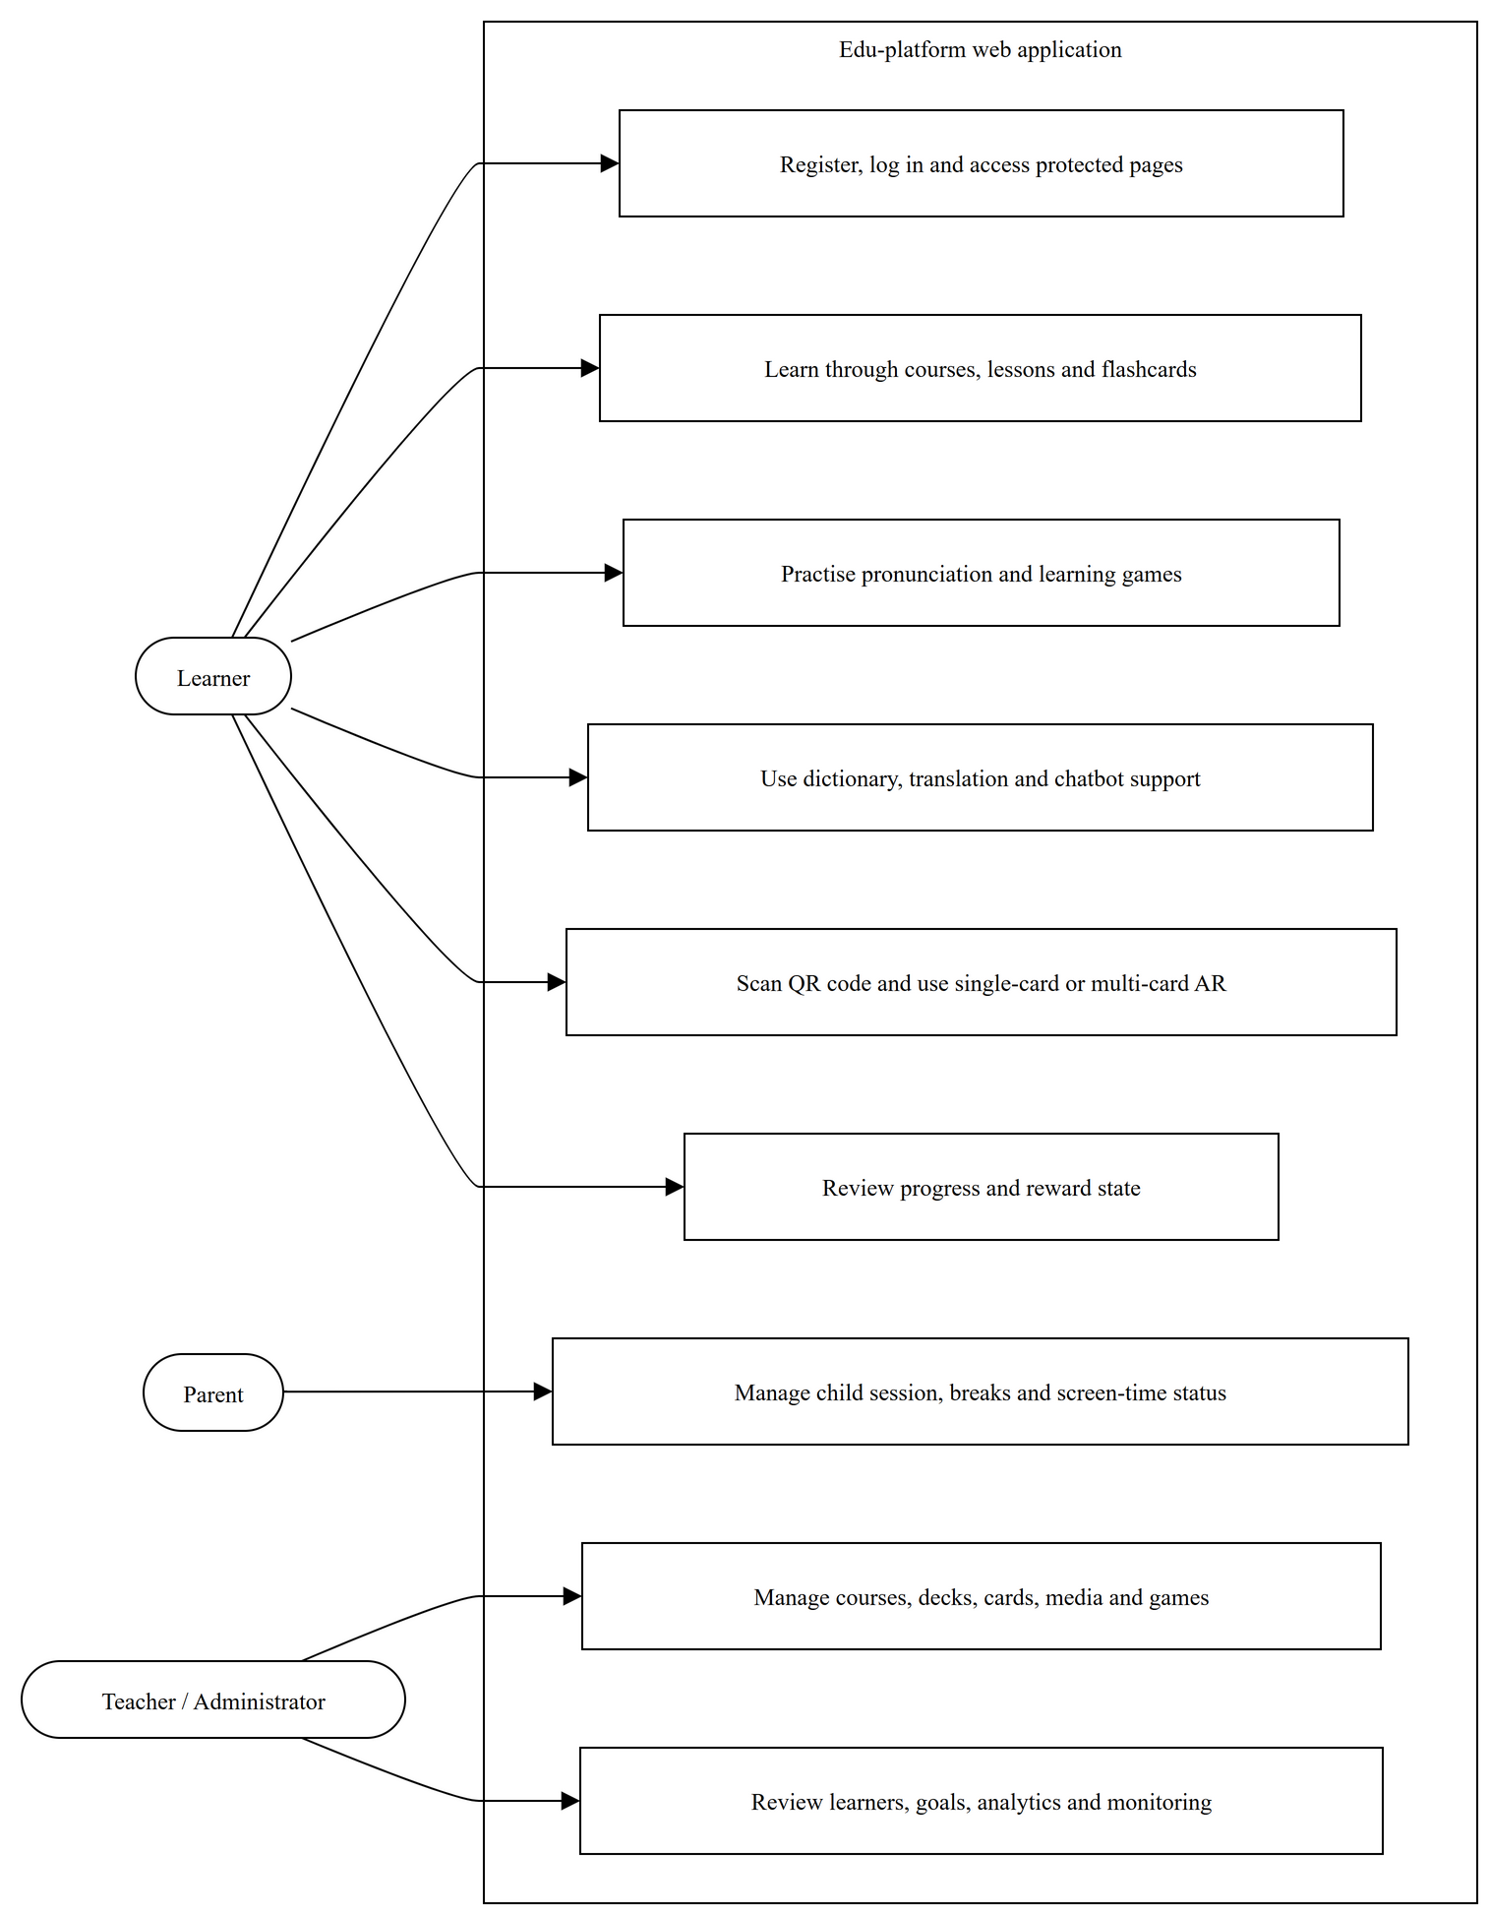
Figure 3.1. Overall use-case model of the Edu-platform web application.
The UML use-case model shows the learner, parent or supervisor, and protected administrative responsibilities that are implemented in the web application. The detailed learner use cases retain the current prototype boundary. Administrative content and learner-management responsibilities are shown as grouped models, so the analysis includes protected routes implemented in the frontend without creating a separate diagram for every page.
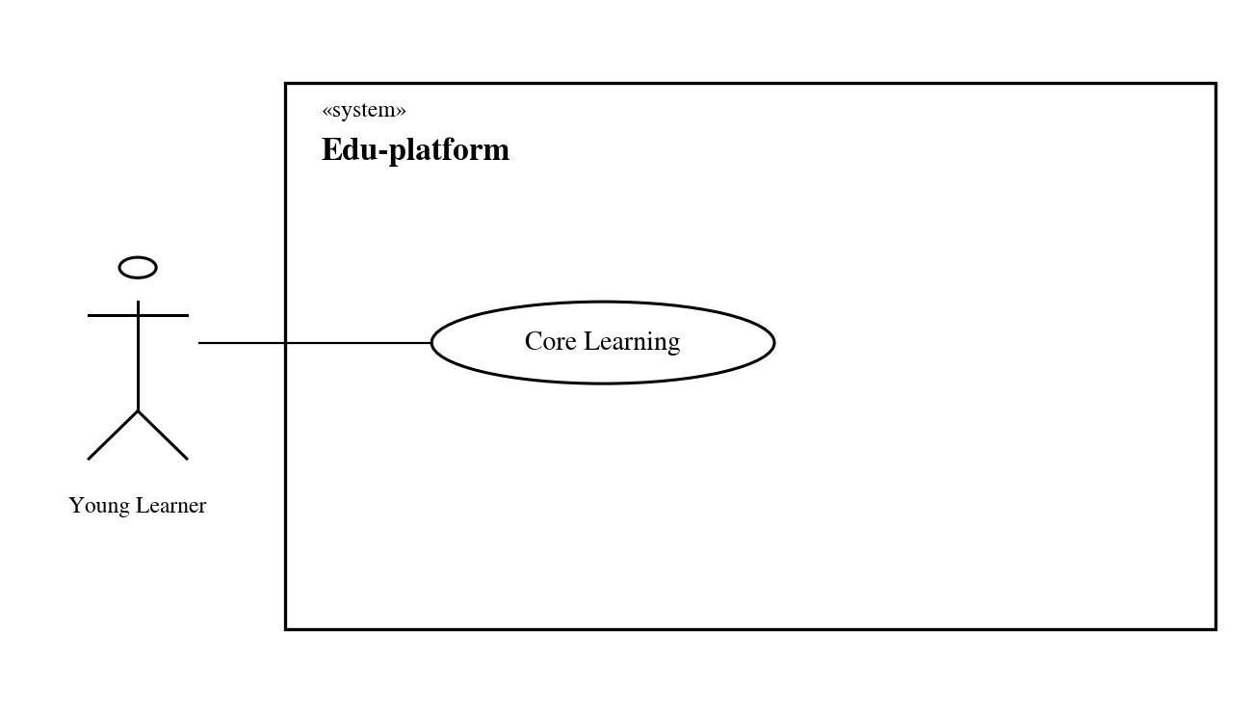
Figure 3.2. Learner-oriented use-case model of Edu-platform.

3.4.1 Use Case: Login
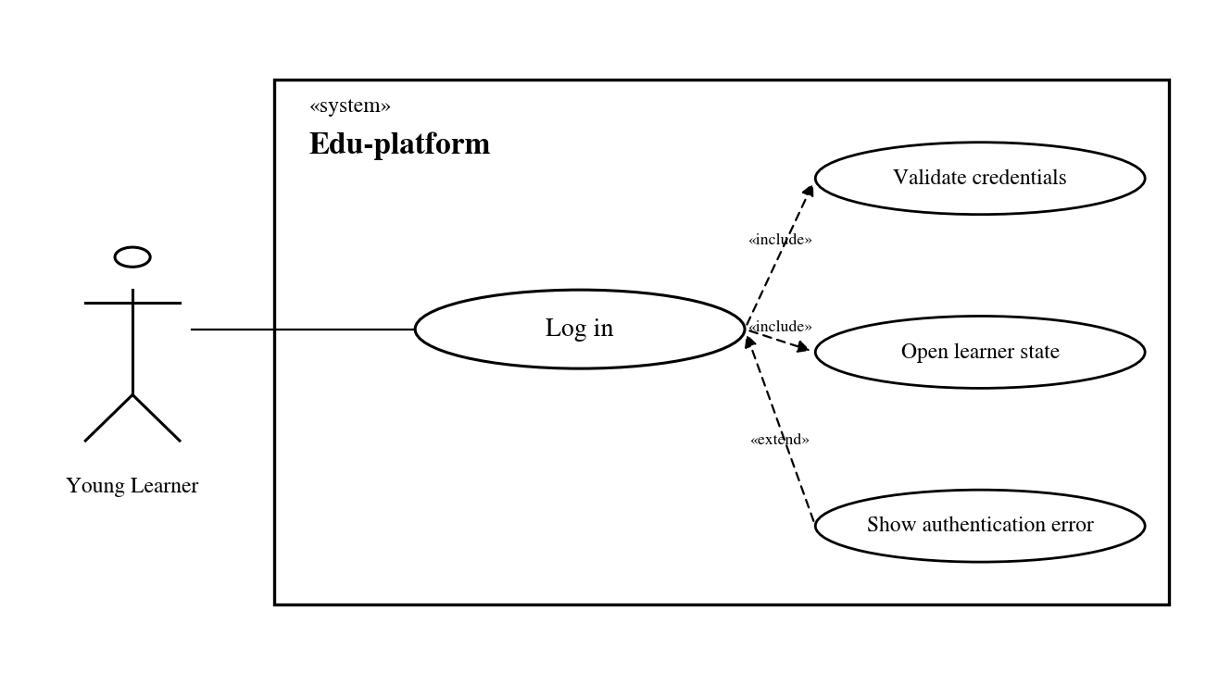
Figure 3.3. Use Case: Login
A young learner begins through the supported authentication path. Valid credentials open the protected learner state used by later activities. Invalid or unavailable authentication returns a controlled error and does not expose protected content. After authentication succeeds, the course, progress, and reward flows use the same learner identity for all later learner interactions in the application. That identity is authenticated before any protected content is accessed.

3.4.2 Use Case: Courses and Lessons
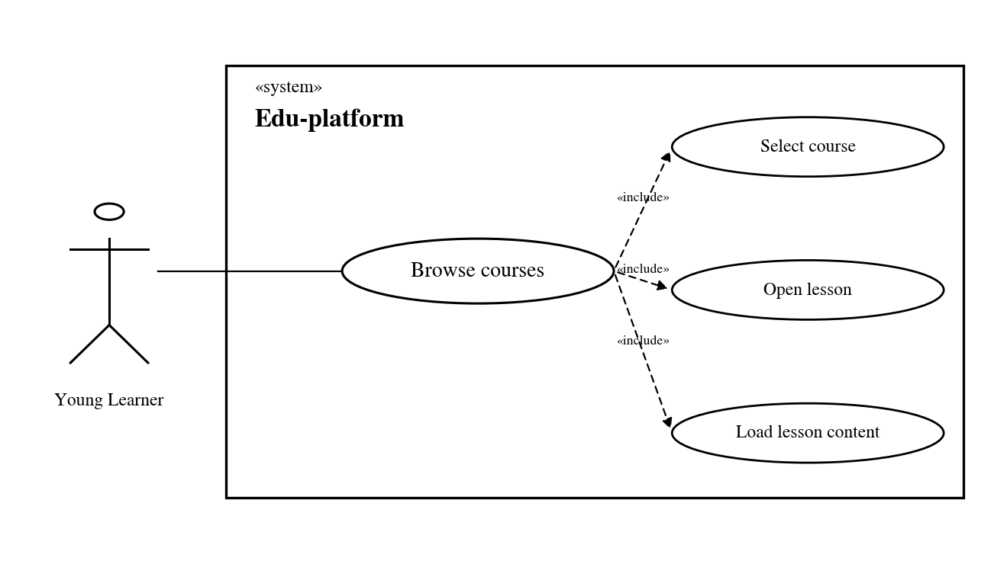
Figure 3.4. Use Case: Courses and Lessons.
The course and lesson sections are quite simple. Children go to the course list, select the course they are learning, and then open the lesson inside. When a lesson is opened, the system takes the data of that lesson to display the appropriate content. Some lessons are flashcards, some are games or other activities. If the loading process fails, the lesson will not be counted as completed. When returning later, children can still continue from the previous section.

3.4.3 Use Case: Flashcards
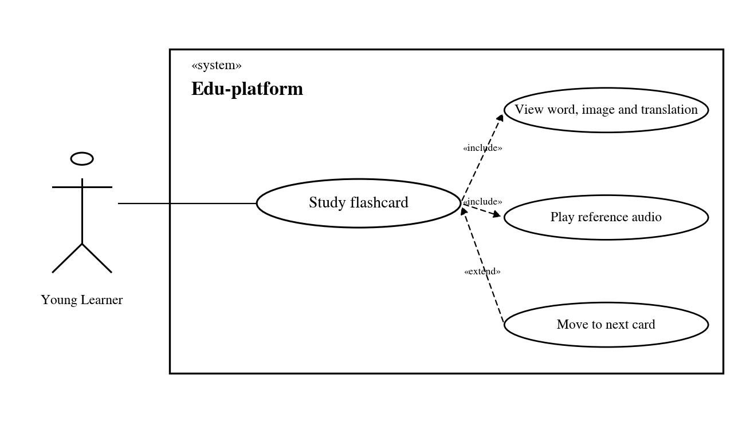
Figure 3.5. Use Case: Flashcards. Source: Author's design based on the implemented prototype.
Flashcards are opened from the lesson that the child is learning. On one card, there will be vocabulary, images, the meaning of the word and the pronunciation listening part. This information all uses the same data of the word, so when the child switches to games, pronunciation practice or AR, the system still knows that they are working with the same word. There are cases where an image or audio file has not been loaded, but the rest of the flashcard can still be used. This method also avoids the fact that the same word but the flashcard has different content than the game or AR part.

3.4.4 Use Case: Pronunciation Practice
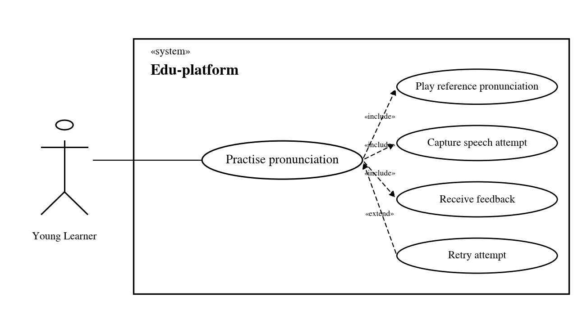
Figure 3.6. Use Case: Pronunciation Practice.
The pronunciation practice section is opened from the flashcard of the word the child is learning. The child can listen to the reading from the system first, then click the microphone button and try to read the word again. If the browser receives the voice, EduAR will return a response so that the child knows how the last reading went. Sometimes the microphone is denied permissions or speech recognition does not work. At that time, the lesson will continue normally, the child can still listen to the pronunciation again and try again later. The results of each speech are only used to support practice, not considered as an official score of the child's pronunciation. After this section, the child can return to the flashcard function or move on to another activity in the lesson.

3.4.5 Use Case: Games
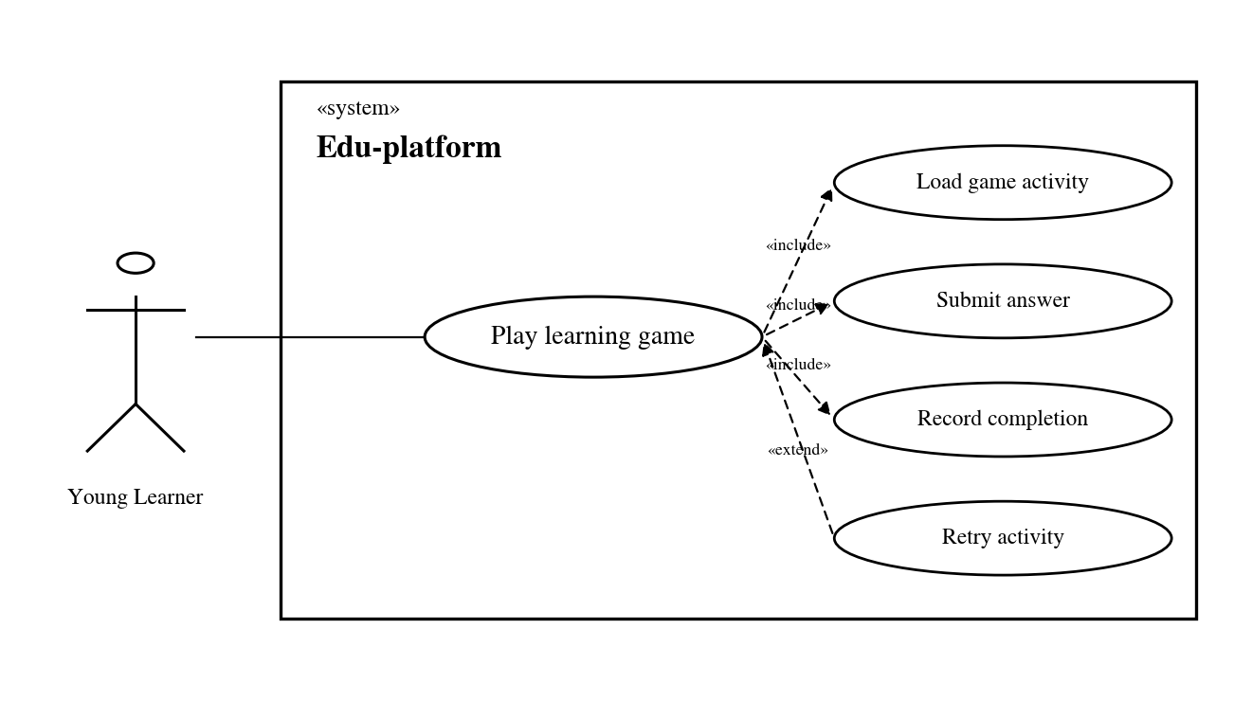
Figure 3.7. Use Case: Games
The games use the active learning context for a short practice task. A valid completion gives feedback and can be sent to progress handling, while an incorrect or incomplete interaction can be retried. This stops an unfinished activity from being counted as a successful learning event. The result is sent only after the needed learning action has actually occurred.

3.4.6 Use Case: Gamification
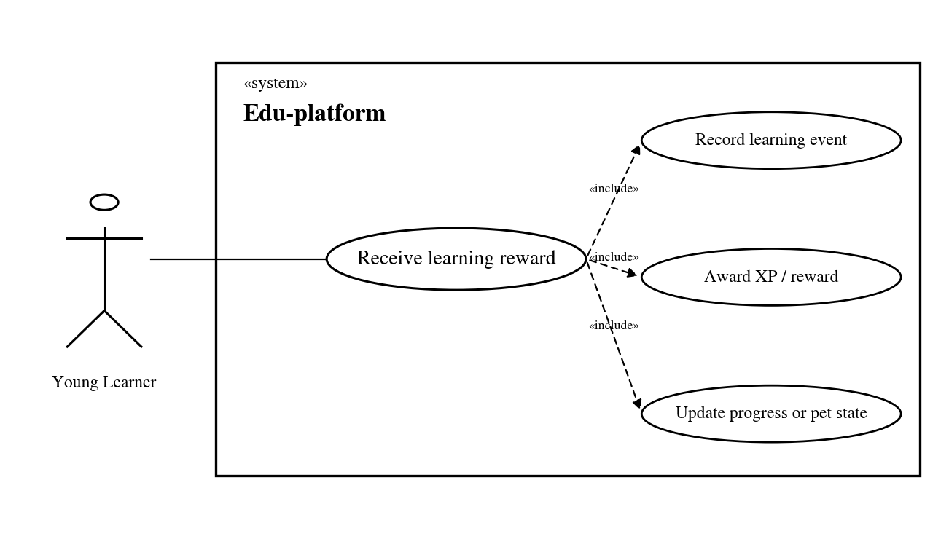
Figure 3.8. Use Case: Gamification.
Gamification handles meaningful learning events. It is not a separate lesson flow. A completed practice activity can update XP, rewards, badges, or pet-related progress, and the learner sees the new state in the interface. Before a reward is shown, the system checks the event and returns the updated reward state to the learner. Duplicate or unsupported conditions do not create a second successful event for the same learning action.

3.4.7 Use Case: Parent and Session Tracking
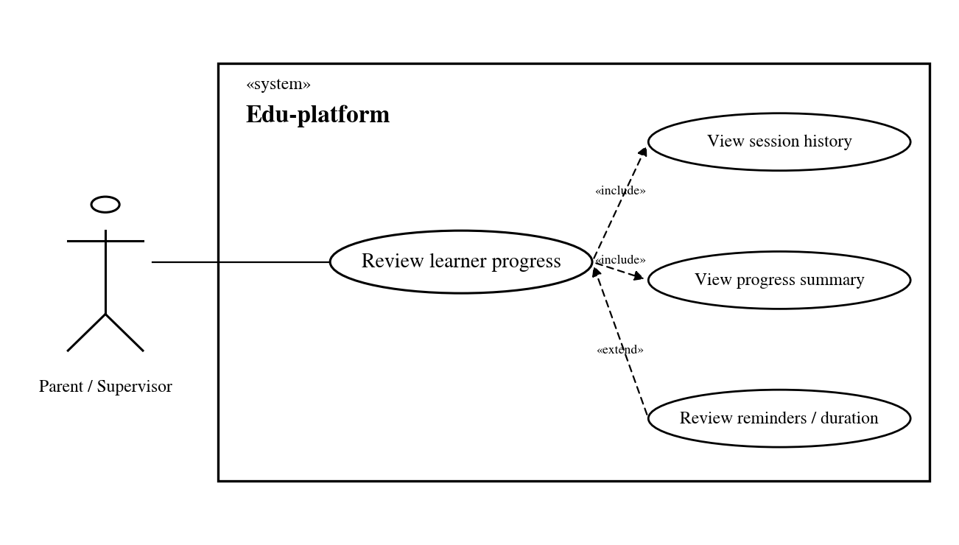
Figure 3.9. Use Case: Parent and Session Tracking.
The parent or supervisor view reads progress and session records that learner activity has already produced. It can show available summaries such as learning progress, session duration, or reminders without creating activity when records are missing. This role observes and supervises rather than taking part in the child-facing lesson sequence.

3.4.8 Use Case: QR Scanning
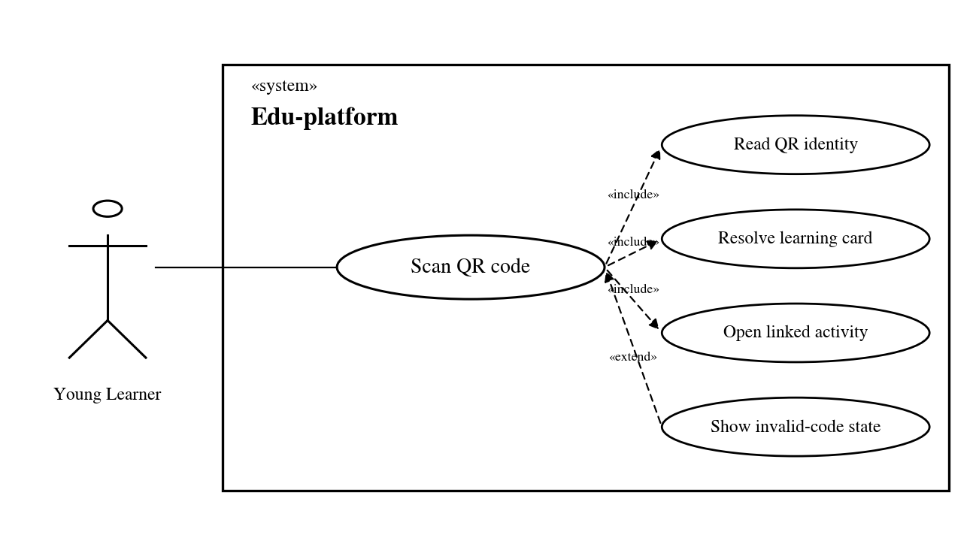
Figure 3.10. Use Case: QR Scanning.
QR scanning links a physical or printed identifier to its learning item. A successful lookup opens the normal learning view and, where AR metadata is available, supplies the information needed for the AR path. Unknown or invalid identifiers remain unresolved. The interface does not create a false card or target match.

3.4.9 Use Case: One-card AR
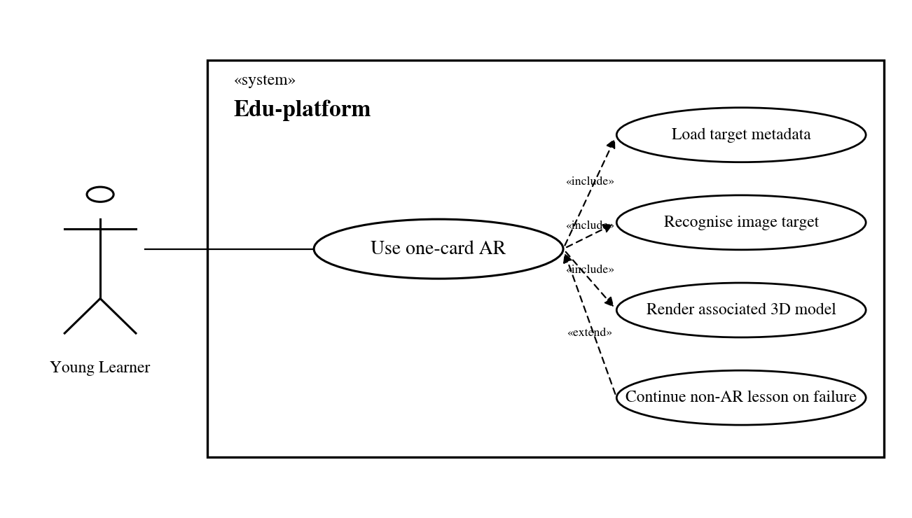
Figure 3.11. Use Case: One-card AR.
For one-card AR, the learner first opens an AR-enabled vocabulary item. The application passes target configuration, target identity, and model metadata to the isolated 8th Wall viewer. After camera permission is available, the viewer registers the image target, listens for target events, and renders the related GLB when recognition and asset loading succeed. Camera denial, target loss, and model-loading failure stay separate states, and the normal flashcard is still available outside the AR view. The viewer does not treat a QR lookup result as an image-tracking result.

3.4.10 Use Case: Chatbot Assistance
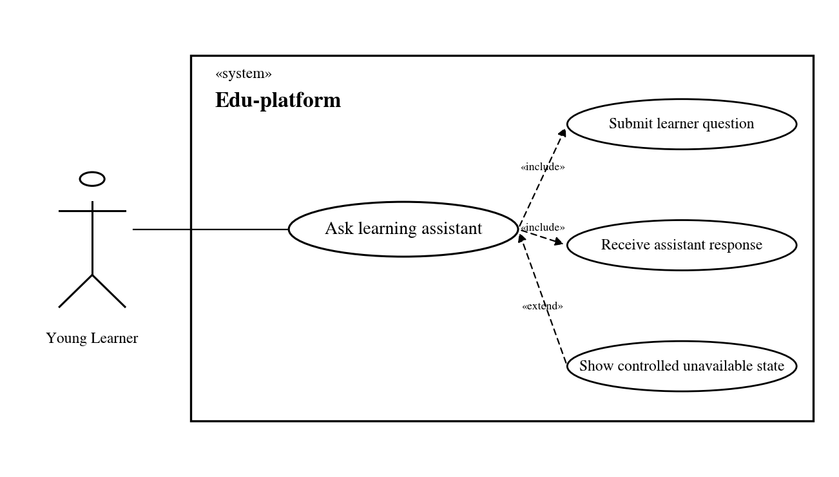
Figure 3.12. Use Case: Chatbot Assistance.
Phần luyện phát âm được mở từ flashcard của từ mà trẻ đang học. Trẻ em có thể nghe cách đọc trước Chatbot trong EduAR chỉ là một chức năng hỗ trợ thêm cho trẻ trong lúc học. Khi có câu hỏi, trẻ có thể gửi trực tiếp trong giao diện và nhận câu trả lời từ chatbot nếu dịch vụ đang hoạt động. Phần chức năng này không bắt buộc trong lesson, nên nếu chatbot bị lỗi hoặc tạm thời không sử dụng được thì trẻ vẫn có thể quay lại course, flashcard hoặc tiếp tục những hoạt động khác như bình thường.
Lịch sử trò chuyện cũng không được xem là dữ liệu chính của quá trình học nếu hệ thống chưa có phần lưu riêng cho nó. Mục đích của chatbot chủ yếu là hỗ trợ nhanh và giải đáp trong lúc trẻ đang học, chứ không để việc học phụ thuộc vào chatbot.

3.4.11 Use Case: Learning Path
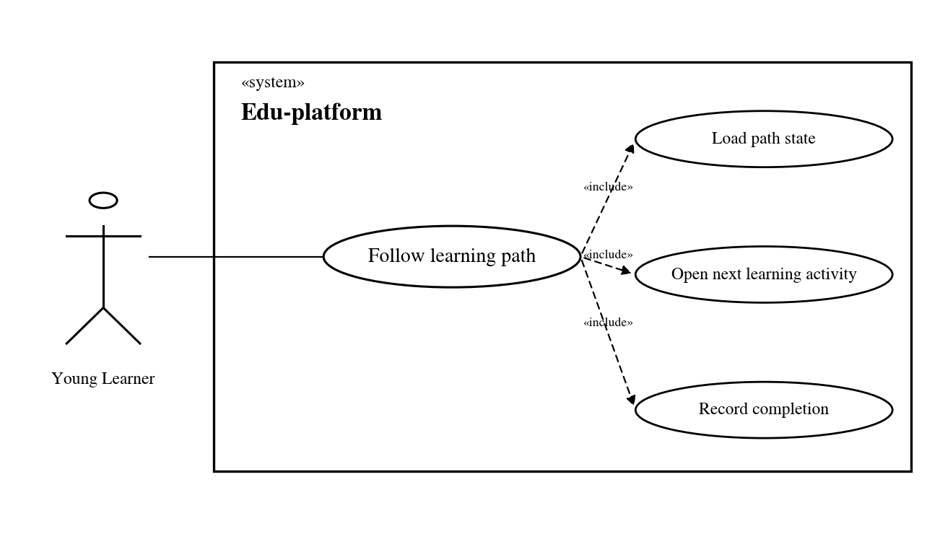
Figure 3.13. Use Case: Learning Path.
The Learning Path function in EduAR is a function used to help children know which part they should learn next. When children open this page, the system will read the current progress and display the lessons in the appropriate order like the way Doulingo builds. The lessons that have been completed, the lessons that are being studied, and the lessons that have not been opened will have different states for children to easily see. If the child has enrolled in a course, the learning path can follow that order and open the next lesson right on the interface. The learning path mainly makes it easier to track progress, rather than changing the actual content of the lessons.

3.4.12 Use Case: Leaderboard
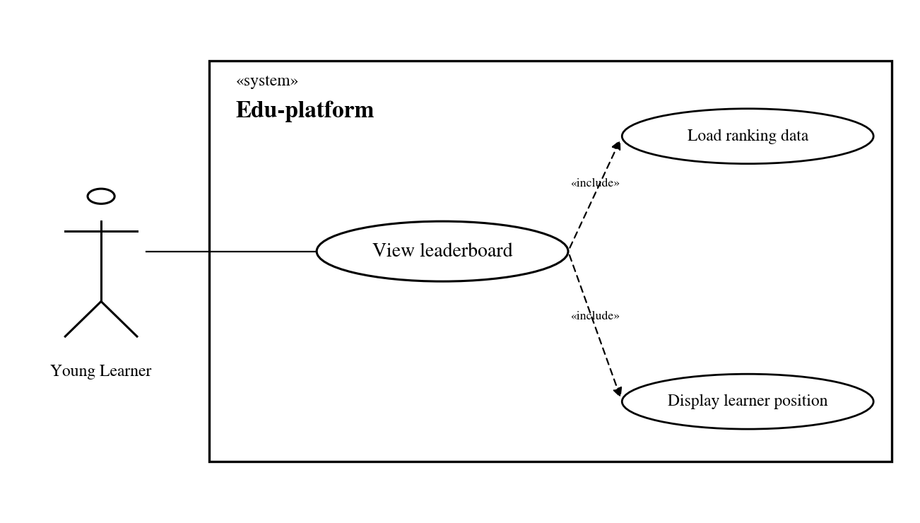
Figure 3.14. Use Case: Leaderboard
The leaderboard section in EduAR takes the learner's existing progress data to sort the ranking. When the leaderboard system is opened, children will see their current position and that of others in the same range allowed by the system to be displayed. If the data is not available or cannot be loaded, the leaderboard will only leave it blank or report that there is no information, not create the ranking itself. The leaderboard only reuses the progress data that has been saved from learning activities.

3.4.13 Use Case: Daily Challenge
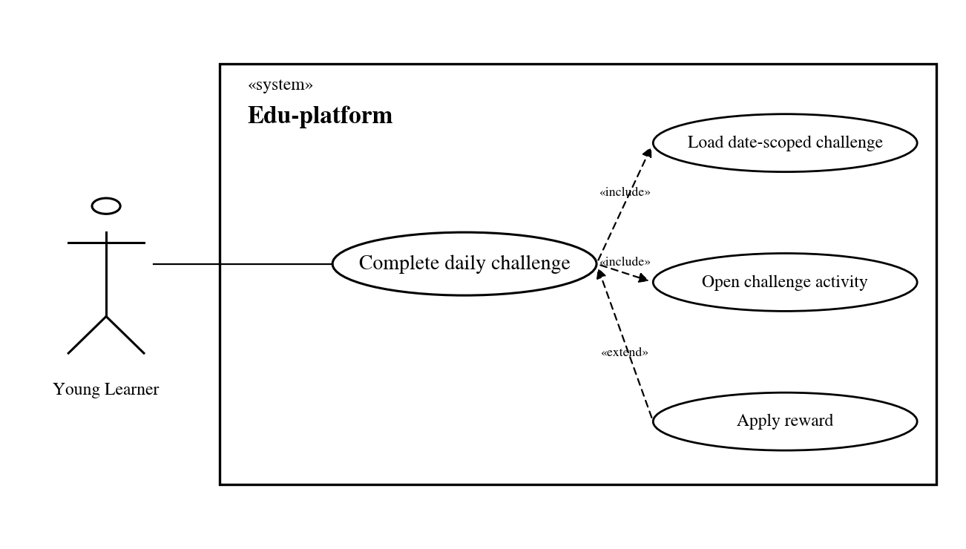
Figure 3.15. Use Case: Daily Challenge
The daily challenge shows a date-scoped practice goal using the same learning and progress mechanisms as the rest of the application. Completing an eligible activity updates the challenge state and can contribute to normal progress or reward handling. Completed or unavailable challenge states are shown clearly so that the same action is not counted twice.

3.4.14 Use Case: Pet Companion
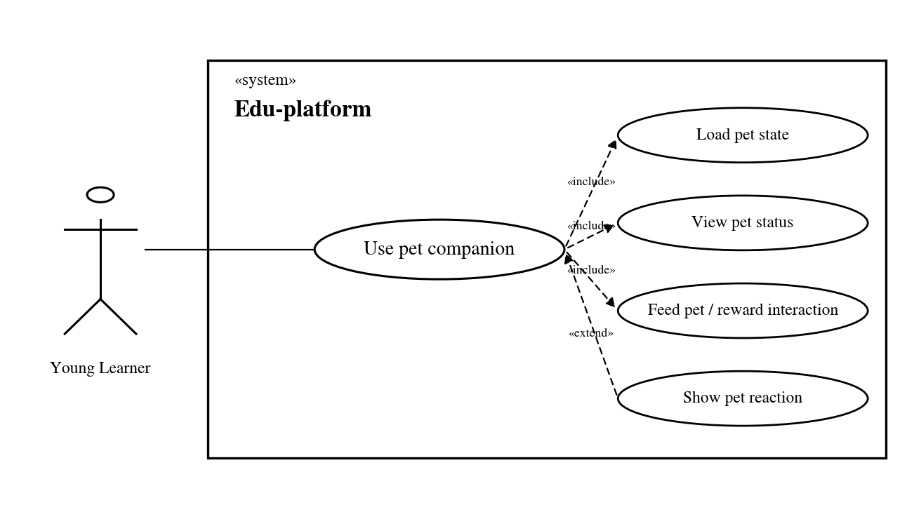
Figure 3.16. Use Case: Pet Companion.
The virtual pet is a learner-facing companion linked to the gamification state. The learner can open the pet view to see the current pet, its progression, and the available reward state. Eligible learning or reward events update the stored pet state, and the interface shows the new progression. If pet data is temporarily unavailable, the lesson and reward history remain independent of the pet view.

3.4.15 Use Case: Word Check
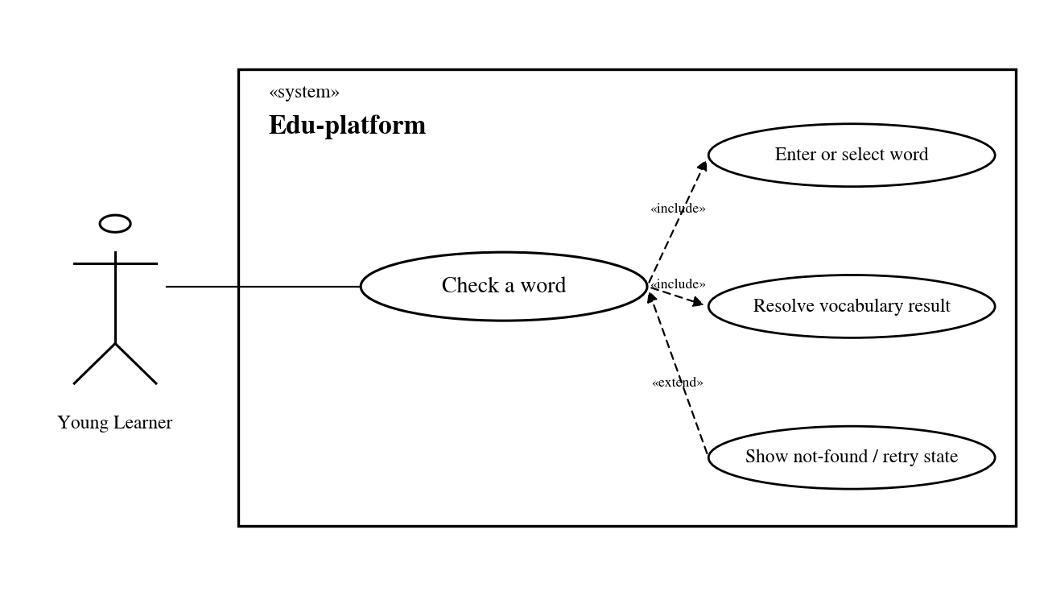
Figure 3.17. Use Case: Word Check.
The detailed learner use cases are grouped into three views to keep their relationships readable: core learning, engagement and support, and AR learning. The overview and administrative use-case diagrams complement these views. The feature-specific diagrams in Section 3.4 contain the detailed included and alternative behaviour.

3.4.16 Use Case: Dictionary (Notebook)
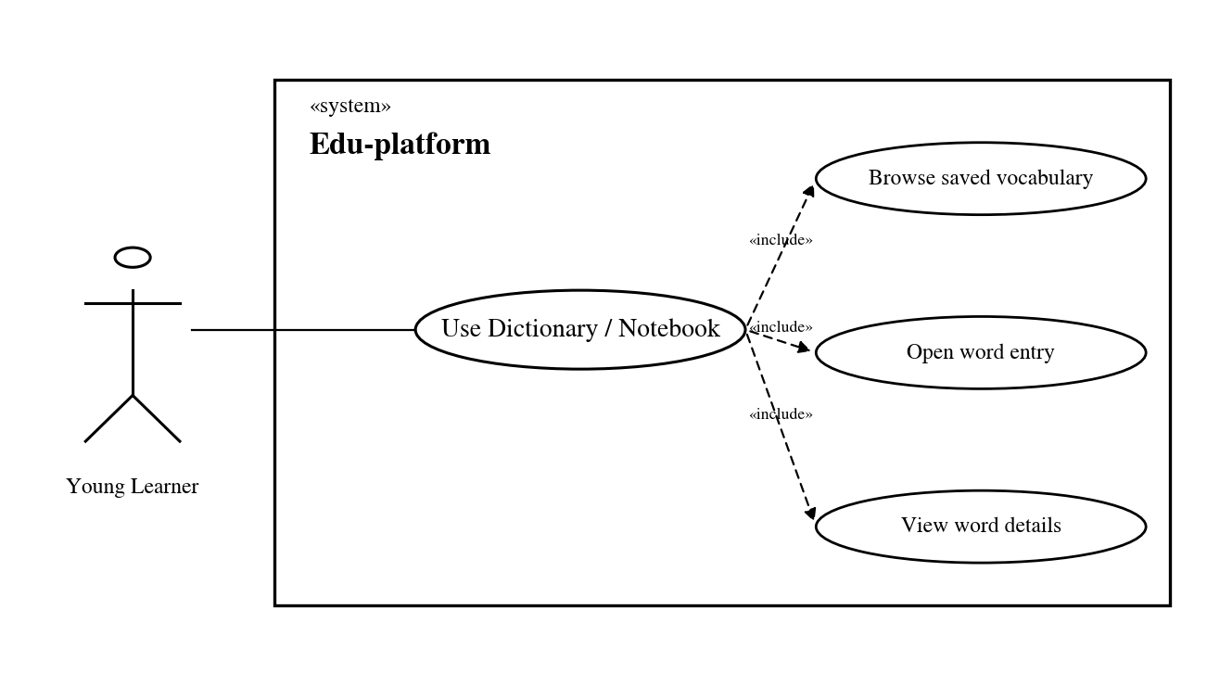
Figure 3.18. Use Case: Dictionary (Notebook).
The Dictionary, shown as a learner notebook, gives the learner a place to browse vocabulary outside the immediate lesson. A learner can open the notebook, select a stored vocabulary entry, and review its available meaning, translation, and related learning media. The notebook supports review and recall while using the same vocabulary identity as flashcards and other activities.

3.4.17 Use Case: Translate
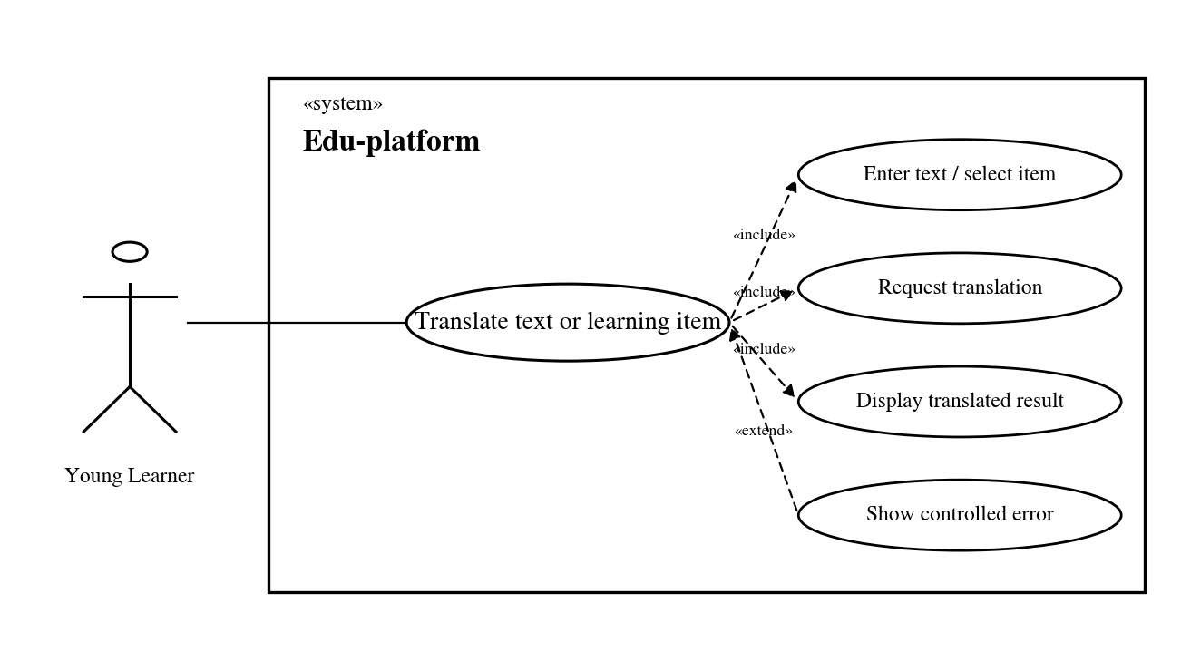
Figure 3.19. Use Case: Translate.
Translate is added so that children can quickly look up words or sentences they don't understand. Children need to enter the content they need to translate and see the results right in EduAR. This part is not related to the grades. If the translation service is faulty, children just need to go back to the lesson and continue learning.

3.4.18 Use Case: Multi-card AR
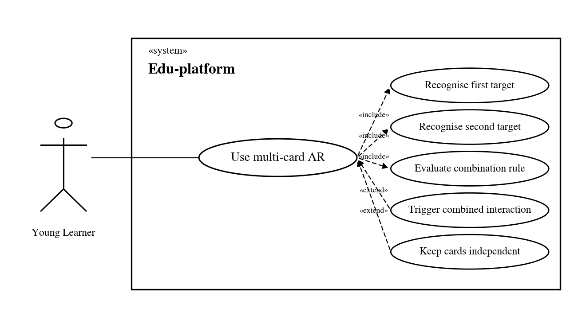
Figure 3.20. Use Case: Multi-card AR.
The multi-card path extends the one-card viewer by keeping two supported targets active at the same time. Their semantic identities are checked against configured combination rules, and the related interaction is triggered when a valid rule and interaction condition are met..Unsupported pairs remain independent. This path is implemented in the current prototype. Broader physical-device testing is still an evaluation issue rather than a reason to label it as provisional.

3.4.19 Use Case Relationships
The detailed learner use cases are grouped into three views to keep their relationships readable: core learning, engagement and support, and AR learning. The overview and administrative use-case diagrams complement these views. The feature-specific diagrams in Section 3.4 contain the detailed included and alternative behaviour.
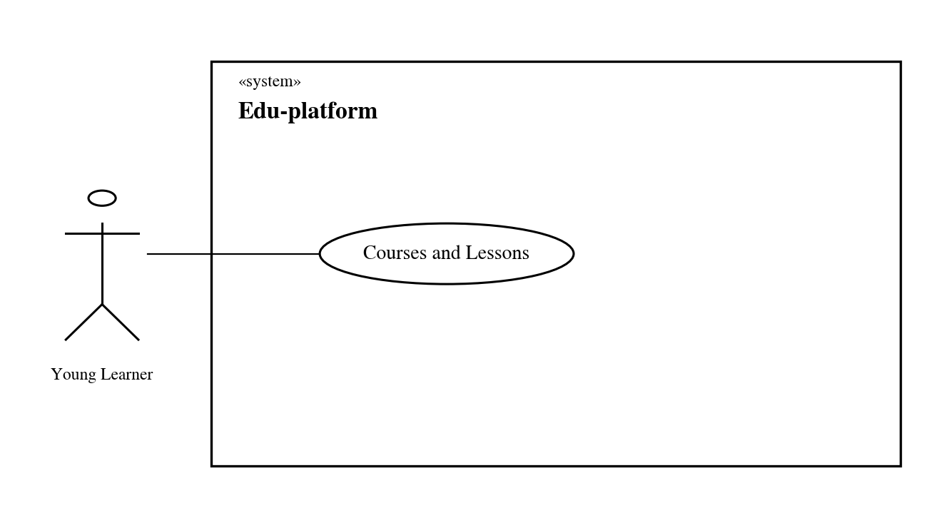
Figure 3.21. Core learning use cases. Source: Author's design.
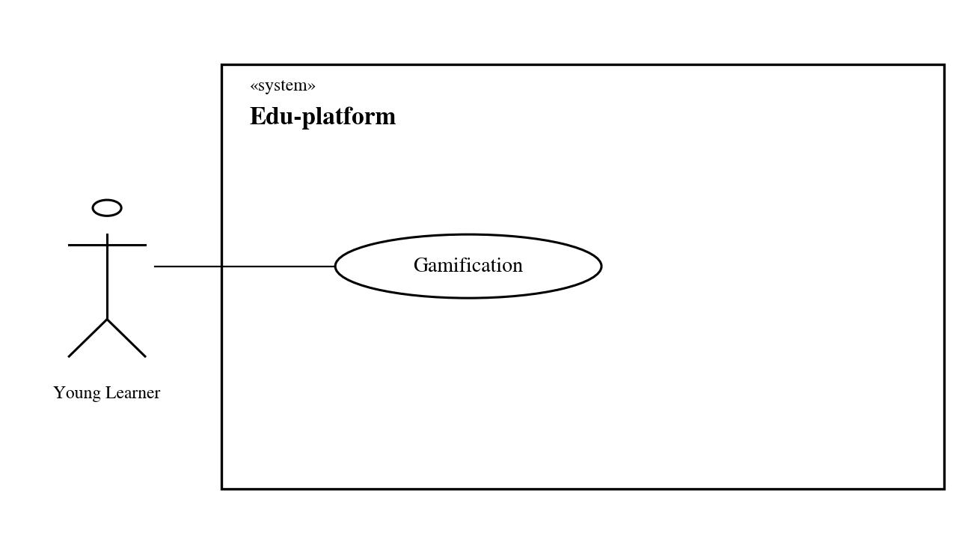
Figure 3.22. Engagement and support use cases. Source: Author's design.
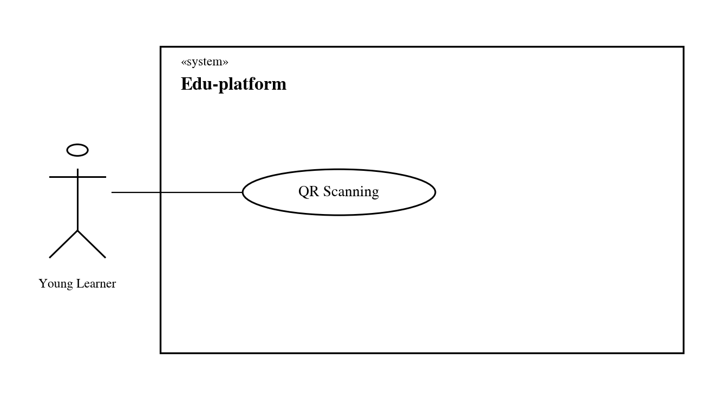
Figure 3.23. AR use cases and multi-card interaction.

3.4.20 Administrative Content and Learner Management
The protected administration area supports two related responsibilities. A teacher or administrator can maintain courses, decks, flashcards, related media, and game content. The same role can review learner information, learning goals, engagement data, and monitoring views. These are grouped in one use case because they share the same role-protected web area and backend boundary, while still remaining separate from the child-facing lesson flow.
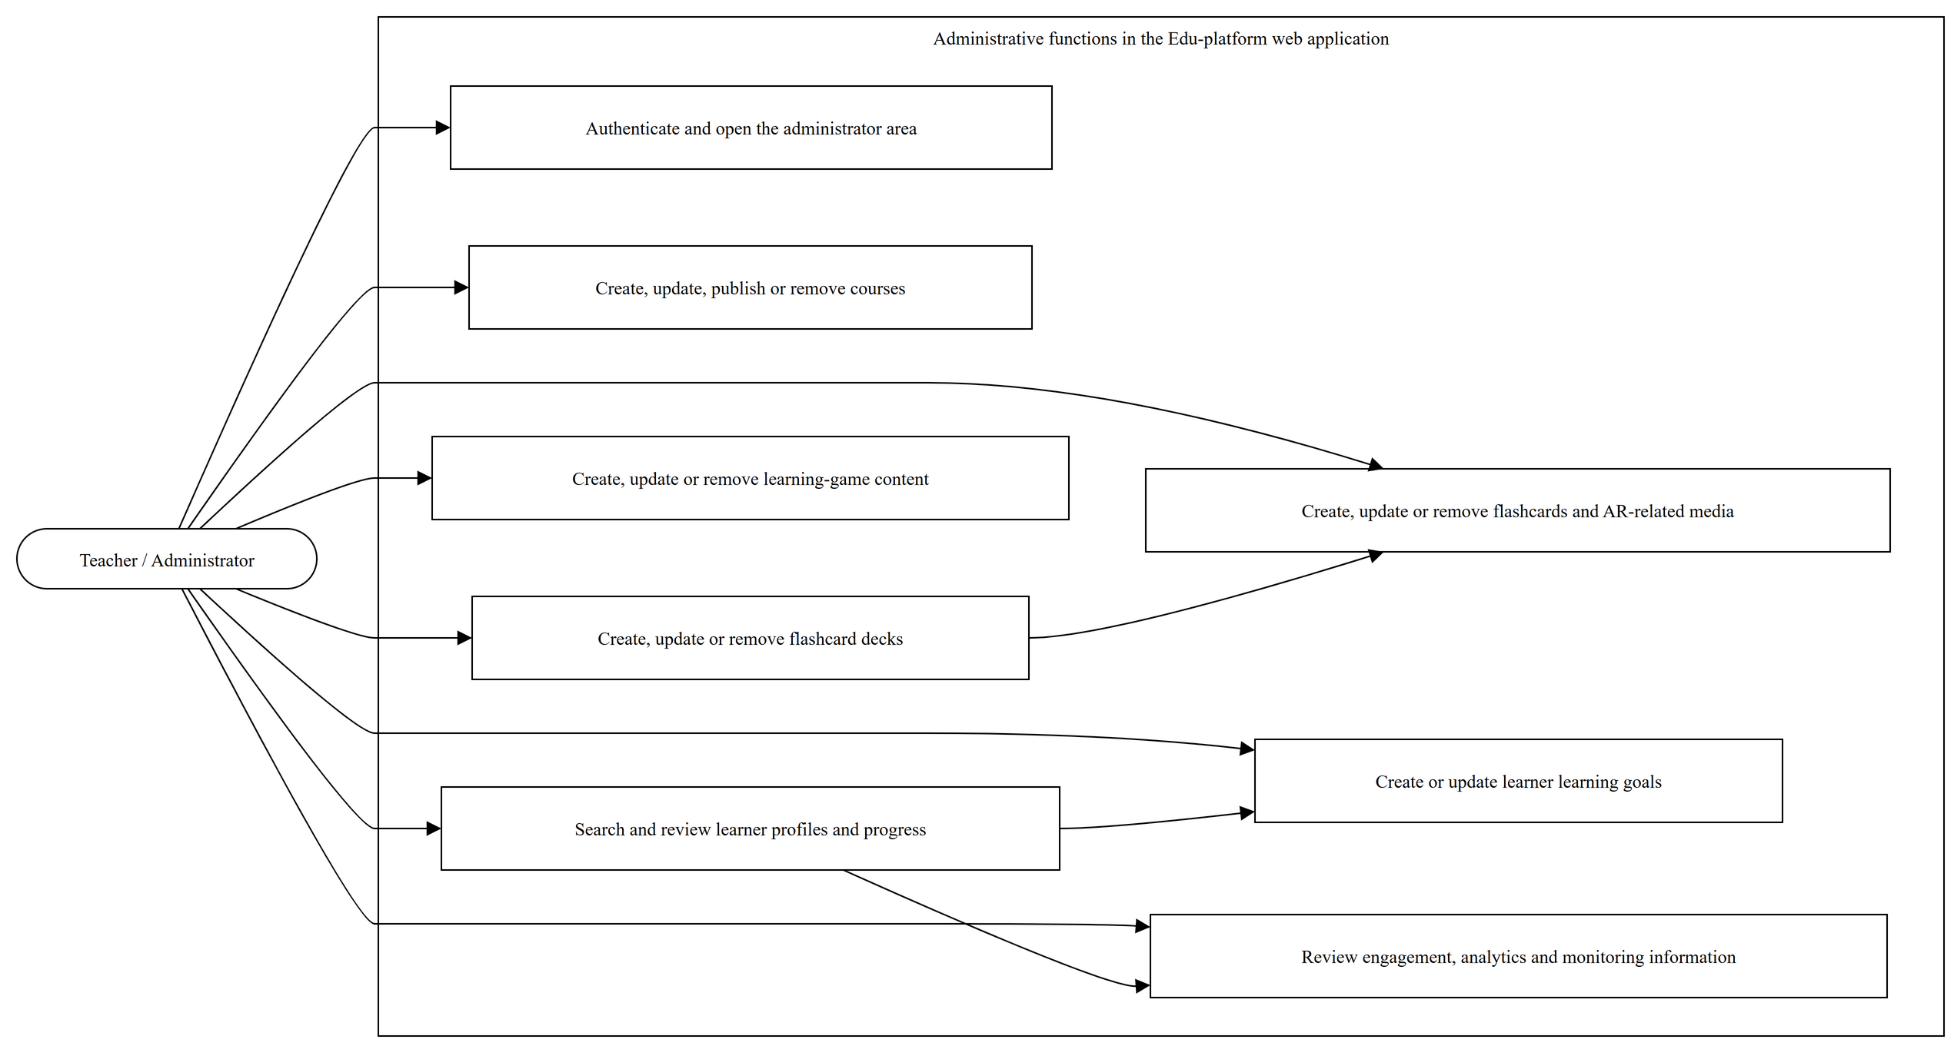
Figure 3.24. Use-case model for administrative content and learner management.

3.5 Sequence Analysis
The course screen requests the available course list first. After a learner chooses a course, the client requests its lessons and then the selected lesson content. The exact records come from the backend data layer, while the React side mainly keeps the selected course and lesson as the active learning context.

3.5.1 Login
React authentication context handles login in the current flow. The client first sends credentials to the login endpoint, then requests the authenticated user profile before storing the session data in browser storage. If authentication fails, the flow normally stops before protected learner pages open.
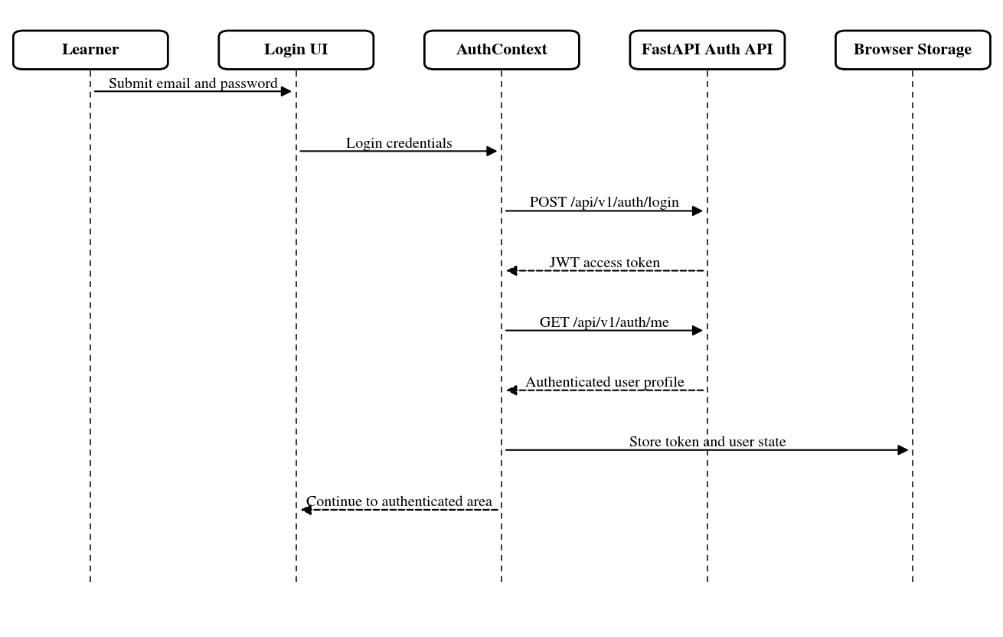
Figure 3.25. Login sequence

3.5.2 Courses and Lessons
In the course section, the system will load a list of courses first for children to choose from. When a course is opened, the EduAR system will take the list of lessons inside, and then load the content of the lessons that the child chooses. The main data is still taken from the backend, while React mainly keeps the status of the course and the lesson is open to know where the child is currently learning in the system.

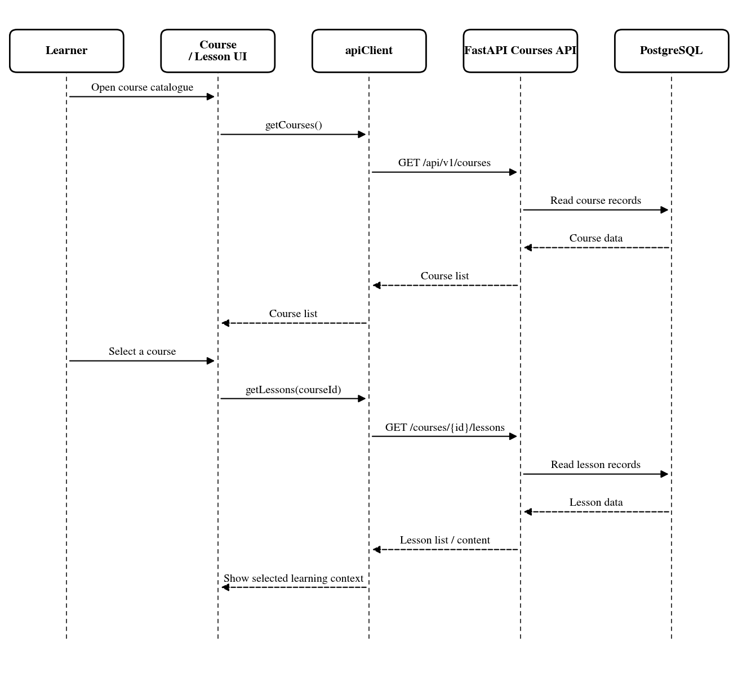
Figure 3.26. Courses and Lessons.

3.5.3 Flashcards
A flashcard is one learning item with several related assets. The page gets vocabulary metadata from the learning API, while images or audio can load from storage through the returned URLs. This separation means that the text part of a card may still be available when one media asset is slow or unavailable.

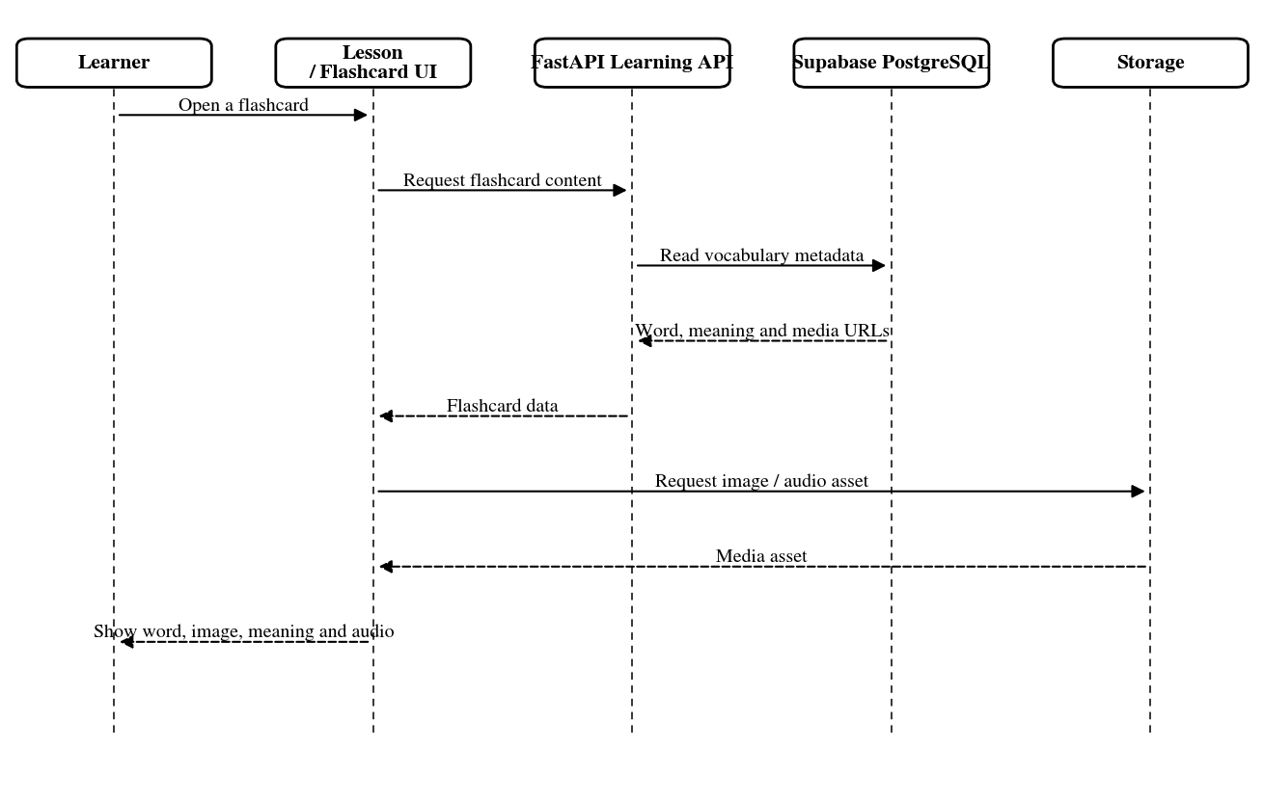
Figure 3.27. Flashcards sequence

3.5.4 Pronunciation Practice
Pronunciation practice has more than one path. The service uses browser speech recognition when available; otherwise, it can record audio and send it to the server transcription endpoint. The recognised text is compared with the target word on the client, and a feedback request may be used before the result appears for the learner. Because this depends on browser and microphone behaviour, the sequence describes the implemented path rather than guaranteeing the same result on every device.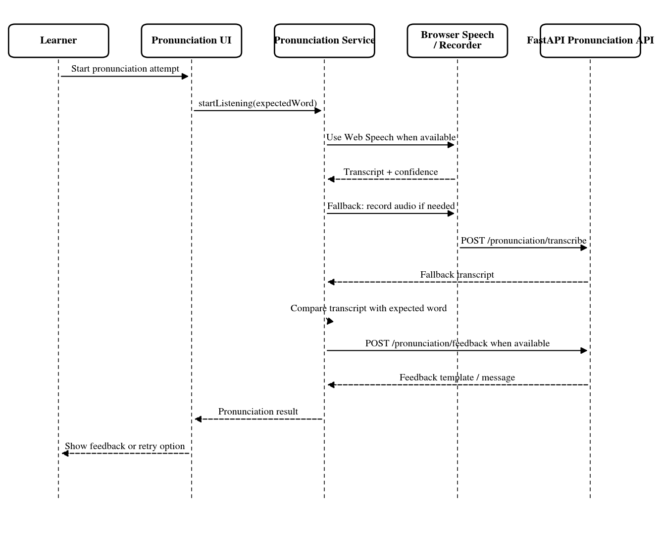
Figure 3.28. Pronunciation Practice Sequence

3.5.5 Games
The game is loaded based on the QR item that the child is learning, the type of game and the level of difficulty chosen. EduAR can use the cache data in the browser first to make the screen open faster, and then check the data again with the game API. Parts such as checking answers, moving on to the next challenge, and temporary stars are mainly handled in the game hook. As for the reward function that is stored for a long time, it goes through a separate gamification flow, not processed in the game.
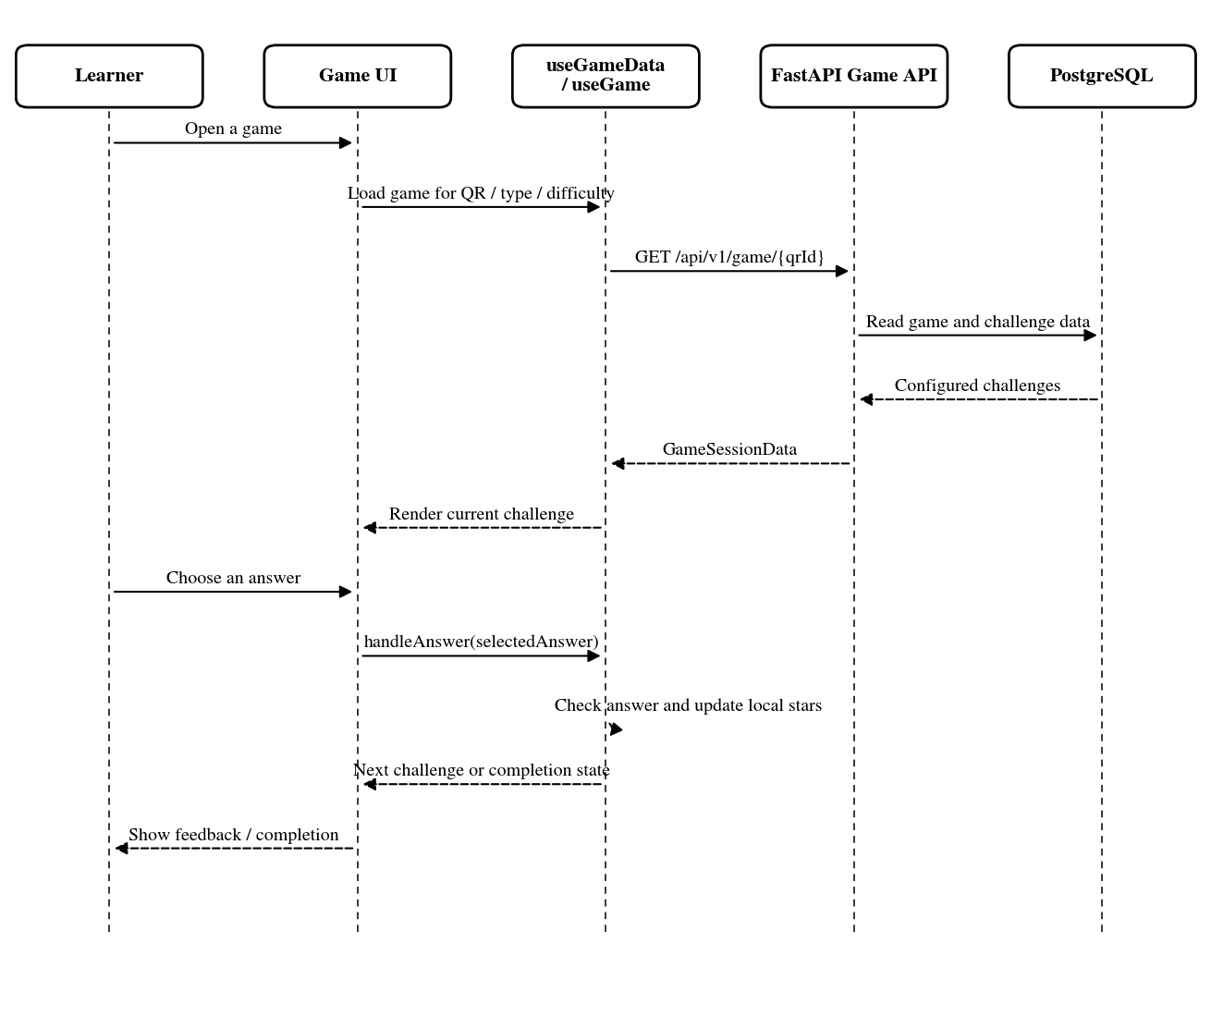
Figure 3.29. Game Sequence

3.5.7 Parent and Session Tracking
In the current version, the timer of the session runs on the frontend. The SessionContext keeps the learning time and states such as pause and break, and the browser storage is used to retain this state. When the session ends, the frontend sends a request to the backend to close the record of the session. The report for parents does not use this timer but pulls the data from its own report API.
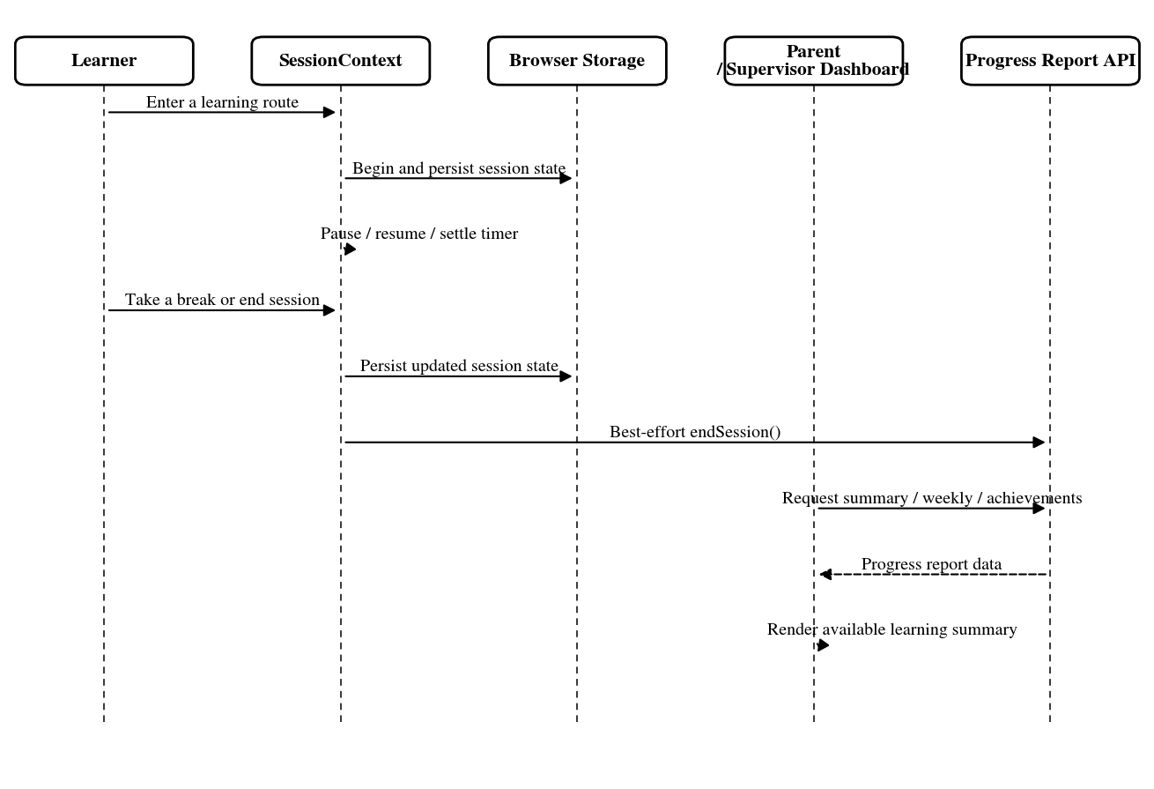
Figure 3.31. Parent and Session Tracking.

3.5.8 QR Scanning
The QR is processed before opening the 8th Wall. The camera is first used to scan the QR right on the browser. When the code is read, the QR scanning stops and the identifier of the card is transferred to LearnAR8thWall. From this identifier, EduAR calls the backend to get the XR information corresponding to the flashcard. After obtaining the necessary data, the system moves to the AR part of the 8th Wall.

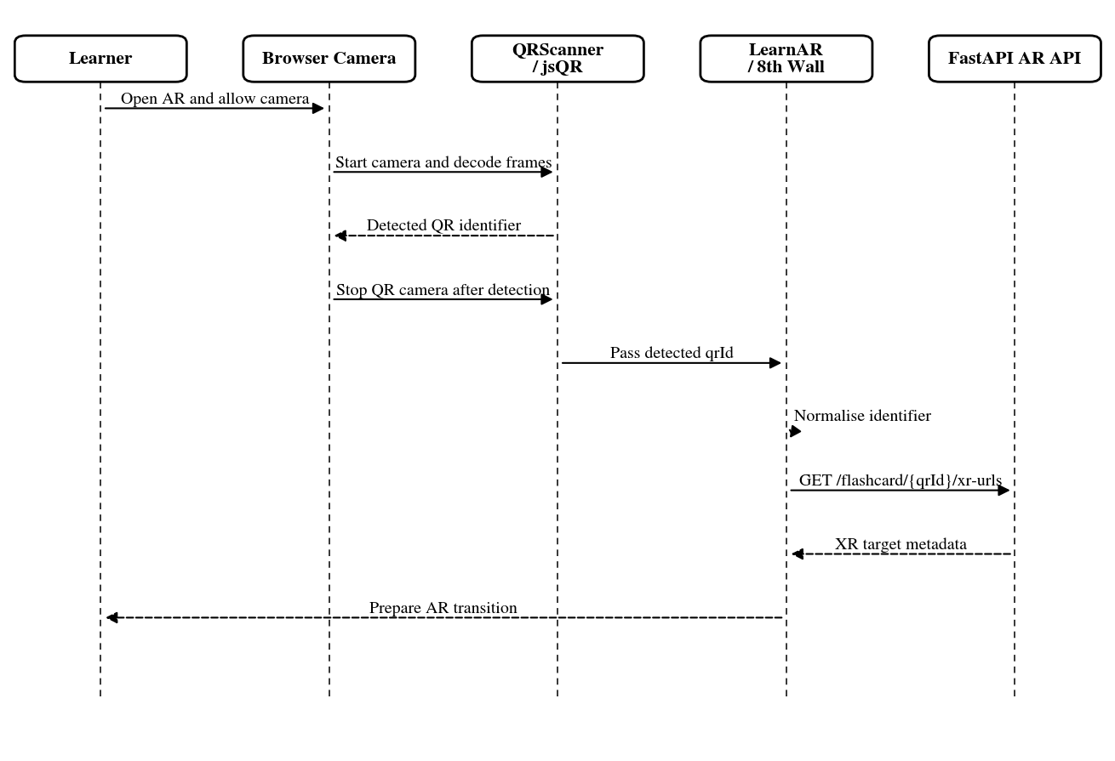
Figure 3.32. QR Scanning

3.5.9 One-card AR
EduAR's one-card AR flow starts after the QR scanning step. When the QR decode system has read the code, the camera in the scanner is stopped and then switched to the 8th Wall. Before the viewer runs, the page takes the target information of the deck and selects the target that matches the scanned card. The target images needed for that AR are also prepared in this step. To the viewer, the target data and the new 3D model are loaded. The 3D model of AR does not appear immediately when the camera is opened. The 8th Wall must recognize the correct image on the flashcard first. When testing this part, there are times when the target is captured quite quickly, but changing the light, the angle of holding the card or the device can be slower or take a while.
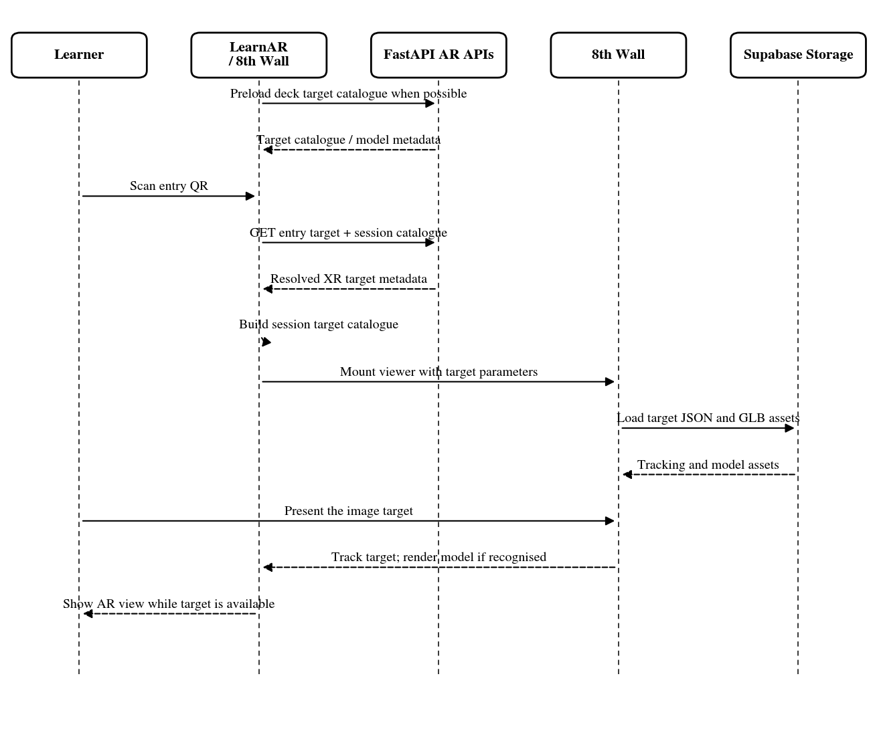
Figure 3.33. One-card AR

3.5.10 Chatbot Assistance
In the chatbot part, questions from the interface are sent through ChatService and then sent to the RAG endpoint. The main processing part is in the backend system. It finds relevant data first and then generates an answer to send back to the frontend. The current response has the content of the reply, the source if any, and the session id of the chat. While running, there are also cases where the request does not reach the backend or is stopped in the middle, such as a network loss, a login session expires, or a waiting time for too long. It does not add an answer to the conversation if the request has not actually been successful.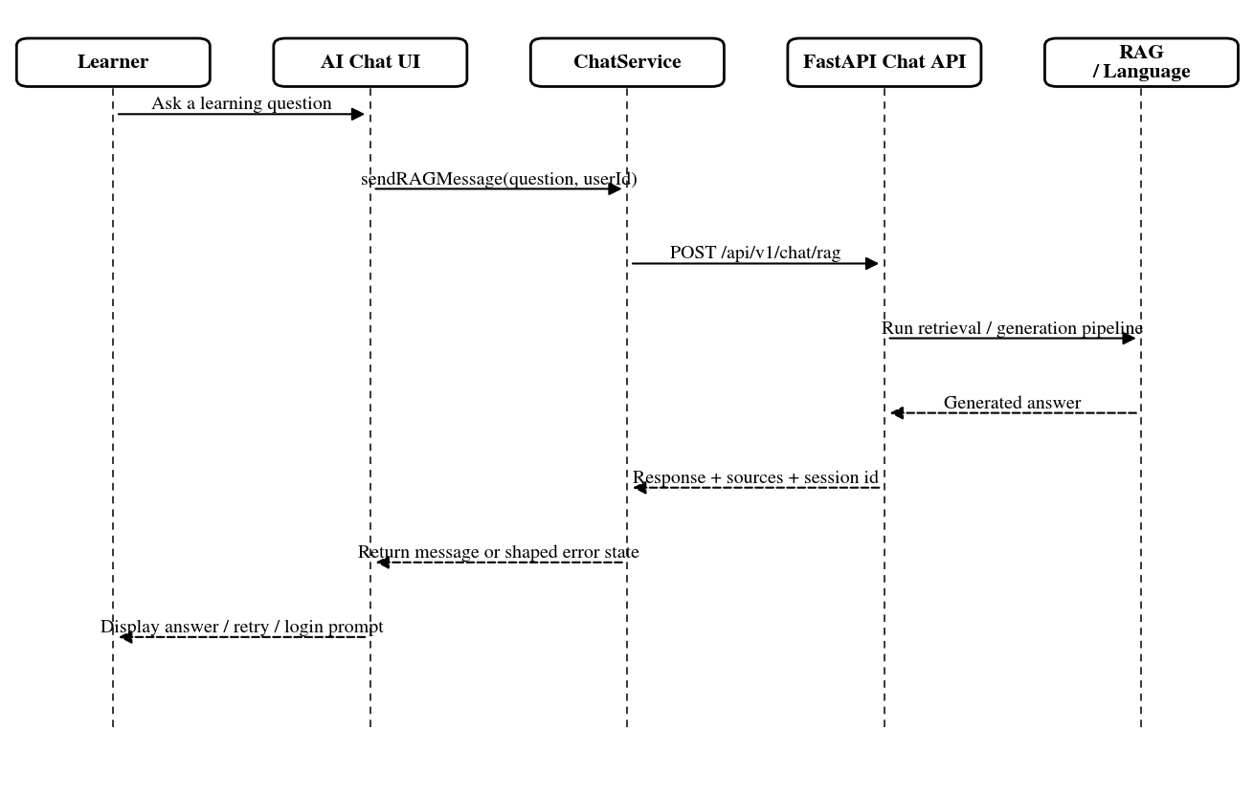
Figure 3.34. Chatbot Assistance

3.5.11 Learning Path
The Learning Path section takes the settings that the child has previously selected along with the day's progress and displays them again on the page. If the child changes their preferred topic or changes the learning objective, the frontend sends the new values to the learning-path API for saving. This section is mainly used to save the learning direction and goals that the child is following. It is not the type of system that analyzes itself and then changes the entire learning path according to each user.

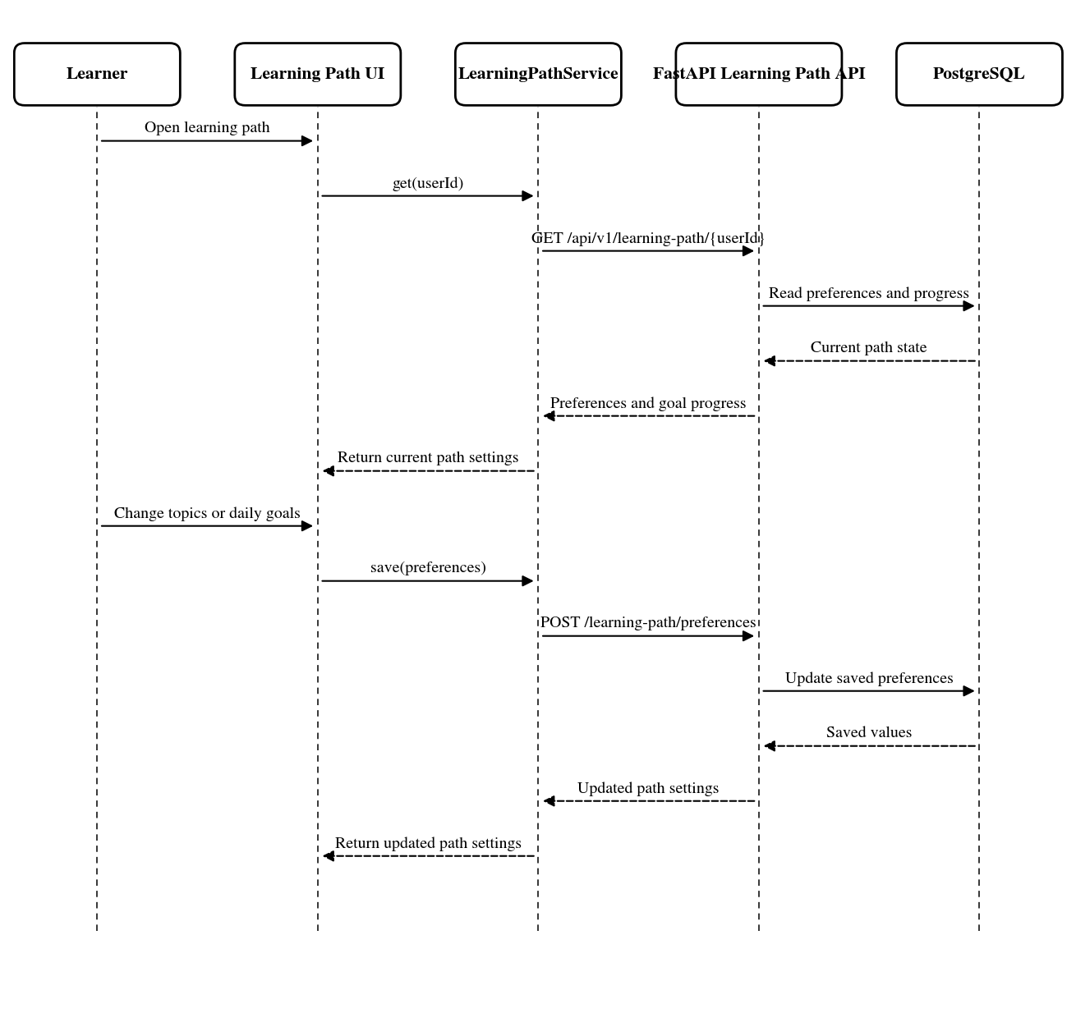
Figure 3.35. Learning Path

3.5.12 Leaderboard
In the Leaderboard, the page does not add points and then rank itself. It calls the gamification section and receives a list that has been arranged by the backend. Requests can be taken for a period of time or a limit on the number of people that need to be displayed. The frontend receives the list and renders it to the screen. The part of how the backend calculates rankings is not part of this sequence, because the page only needs the results returned to be displayed.
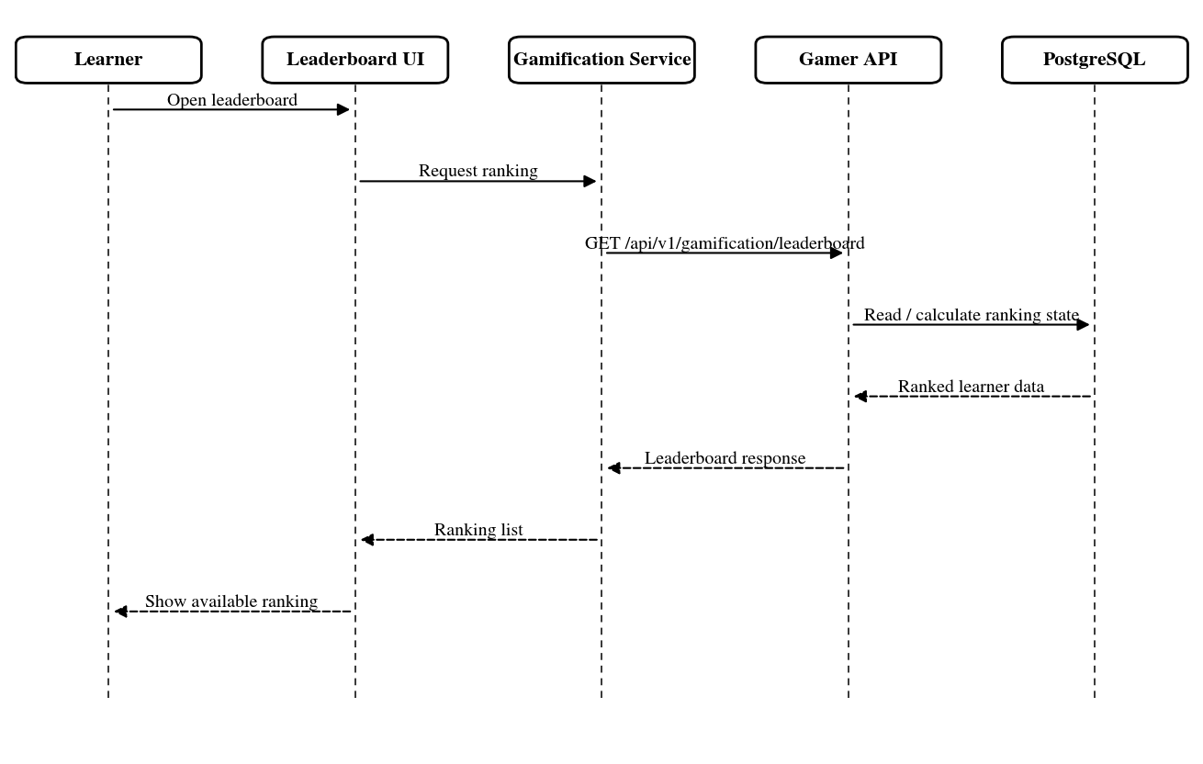
Figure 3.36. Leaderboard.

3.5.13 Daily Challenge
The daily challenge page currently gets its visible challenge state from the composed user profile. The page derives the displayed percentage from returned progress and target values. Learning actions elsewhere in the application can change that progress, so reopening or refreshing the page may show a different state.
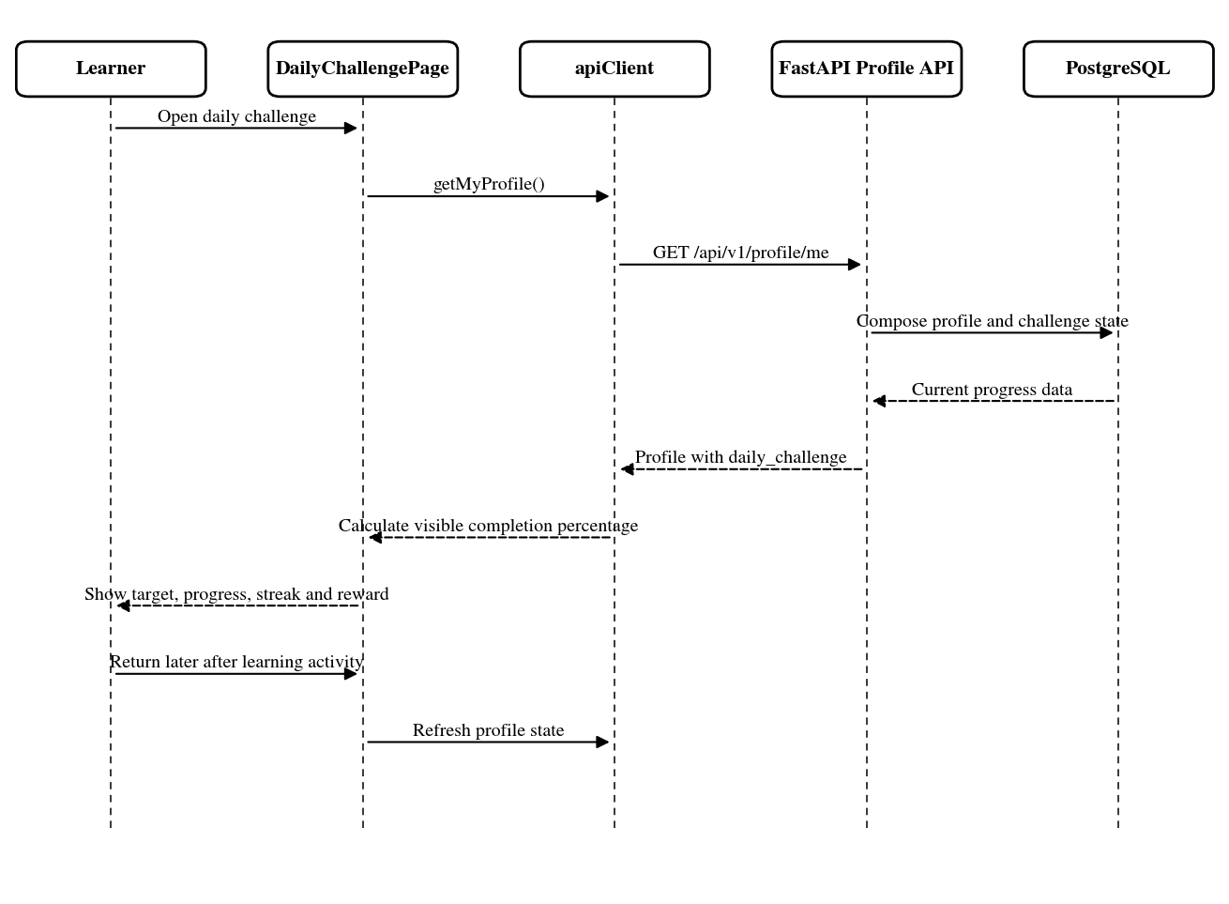
Figure 3.37. Daily Challenge.

3.5.14 Pet Companion
Pet Companion takes a list of pets from the pets API and displays the ones that they have opened. They can also select a pet as their pet. Actions such as feeding or playing with pets go through the gamification API rather than being processed directly on the page. After the backend returns the new state, the frontend can run more pet animations or AR animations. Which animations are run depends on the pet's data and what clips the model currently has.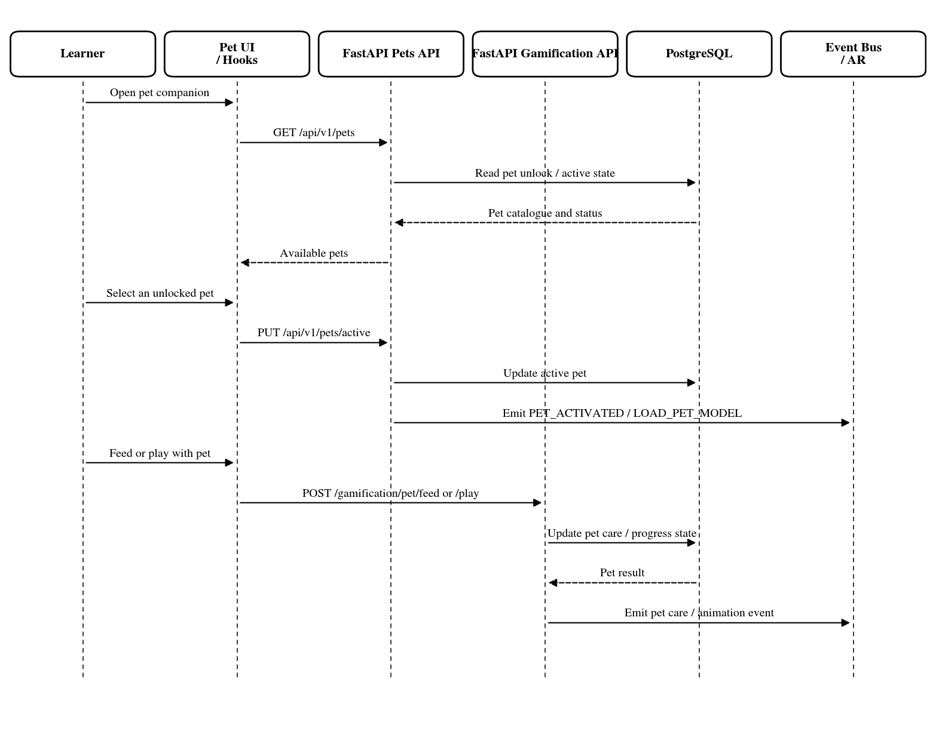
Figure 3.38. Pet Companion

3.5.15 Word Check
In Word Check, the page only processes one English word at a time. The word selected by the child is sent to the dictionary API, then the frontend takes the results to show the meaning, reading, and some information of the word. The backend can also reject if the input is not suitable. If the child wants to keep the word, another request will be made to the notebook API. Word lookup and word saving are separated.
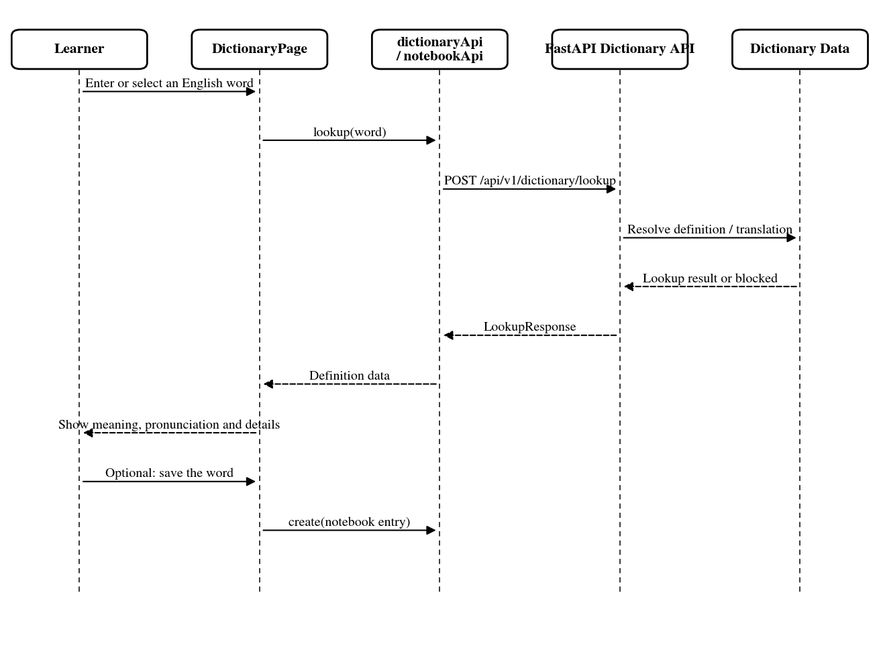
Figure 3.39. Word Check

3.5.16 Dictionary (Notebook)
In the Notebook, the page takes the words that the child has saved along with the words that are in the process of reviewing. If the search or filter section is changed, the list can be recalled from the API. When a child reviews a word, the frontend sends the entry id, the evaluation level of the review, and the event id to the notebook review endpoint. The backend returns the new results and the page updates the review schedule or reward information that is displayed.
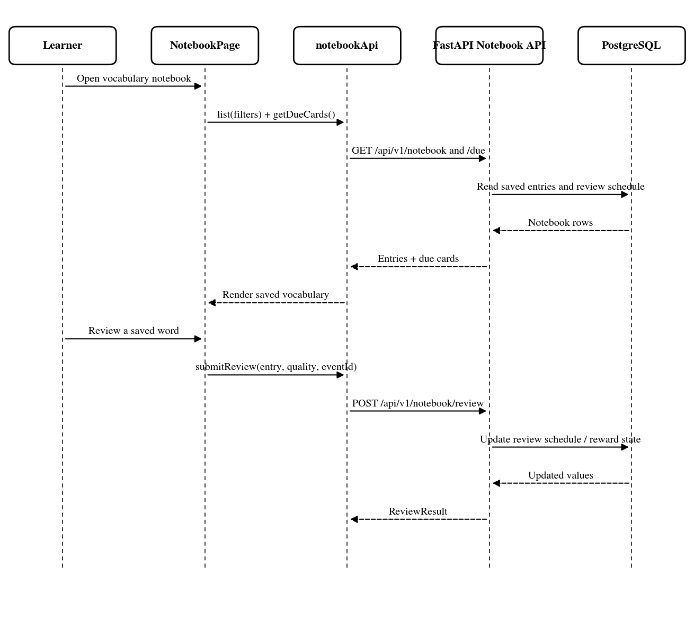
Figure 3.40. Dictionary (Notebook)

3.5.17 Translate
In Dictionary, there is an additional part to translate the whole sentence, not just look up each word. The child enters the sentence to be translated, and the context can be added if necessary. This request goes to the translation API. The result usually returns a Vietnamese sentence and the separation of some words inside. If the child clicks on a word there, EduAR does not open a new type of translation. It just switches from there to Word Check for further lookup.

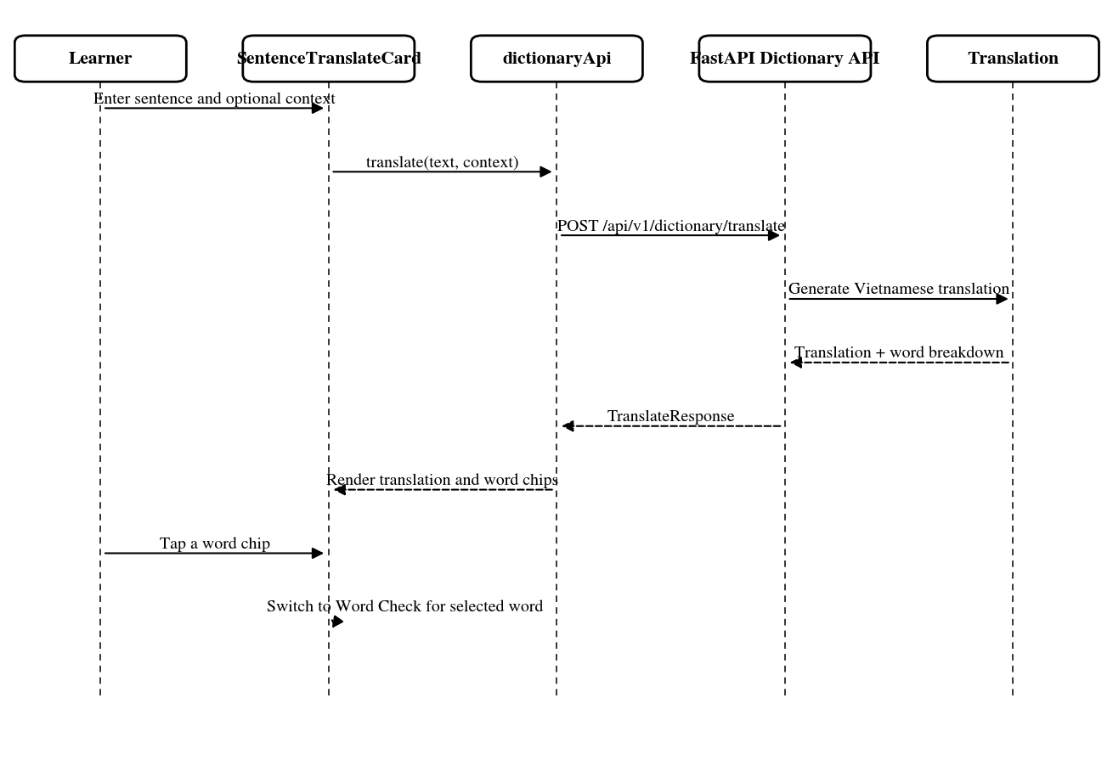
Figure 3.41. Translate sequence

3.5.18 Multi-card AR
Multi-card AR uses the same LearnAR8thWall page and 8th Wall viewer as the one-card path, but the session can register more than one valid image target. The React page prepares the session target catalogue and passes it to the viewer. The viewer then loads configured interaction rules for the deck and tracks the targets independently. When recognised targets match a configured rule, the related interaction can run. Otherwise, the targets remain visible as separate AR objects.

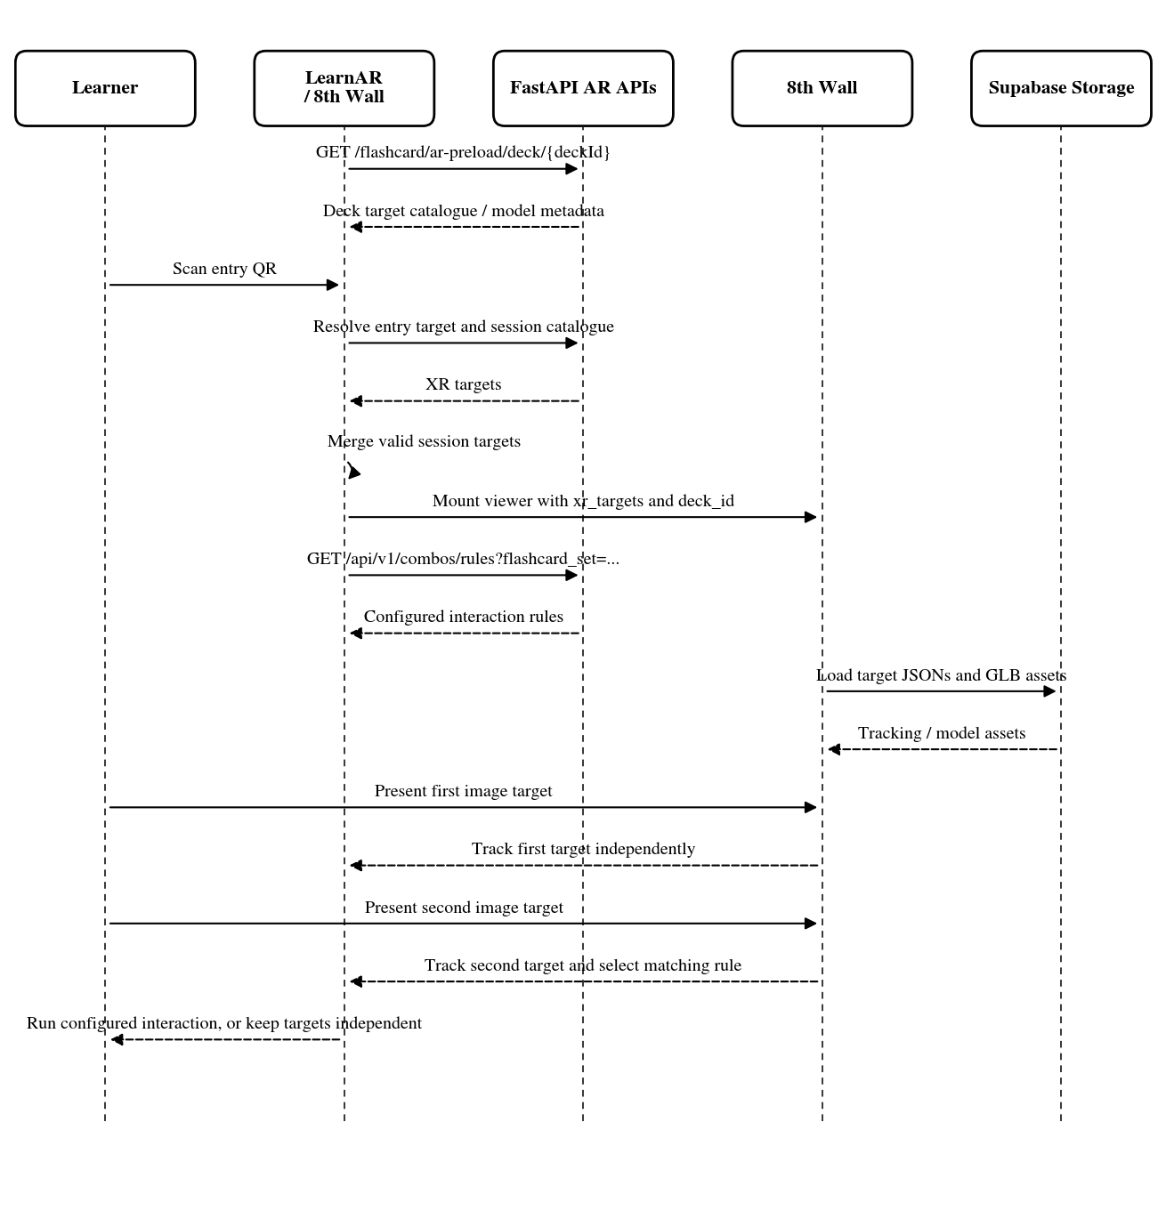
Figure 3.42. Multi-card AR sequence

3.5.19 Registration and Protected Learner Access
On the frontend, there are both register and login. Those who do not have an account can create a new one first, while the old account only needs to log in. The information from these two screens is sent to FastAPI and then checked by the auth service. If it is valid, React lets the user enter the learner section. This sequence is added because the old diagram shows the login, there is no account creation step.
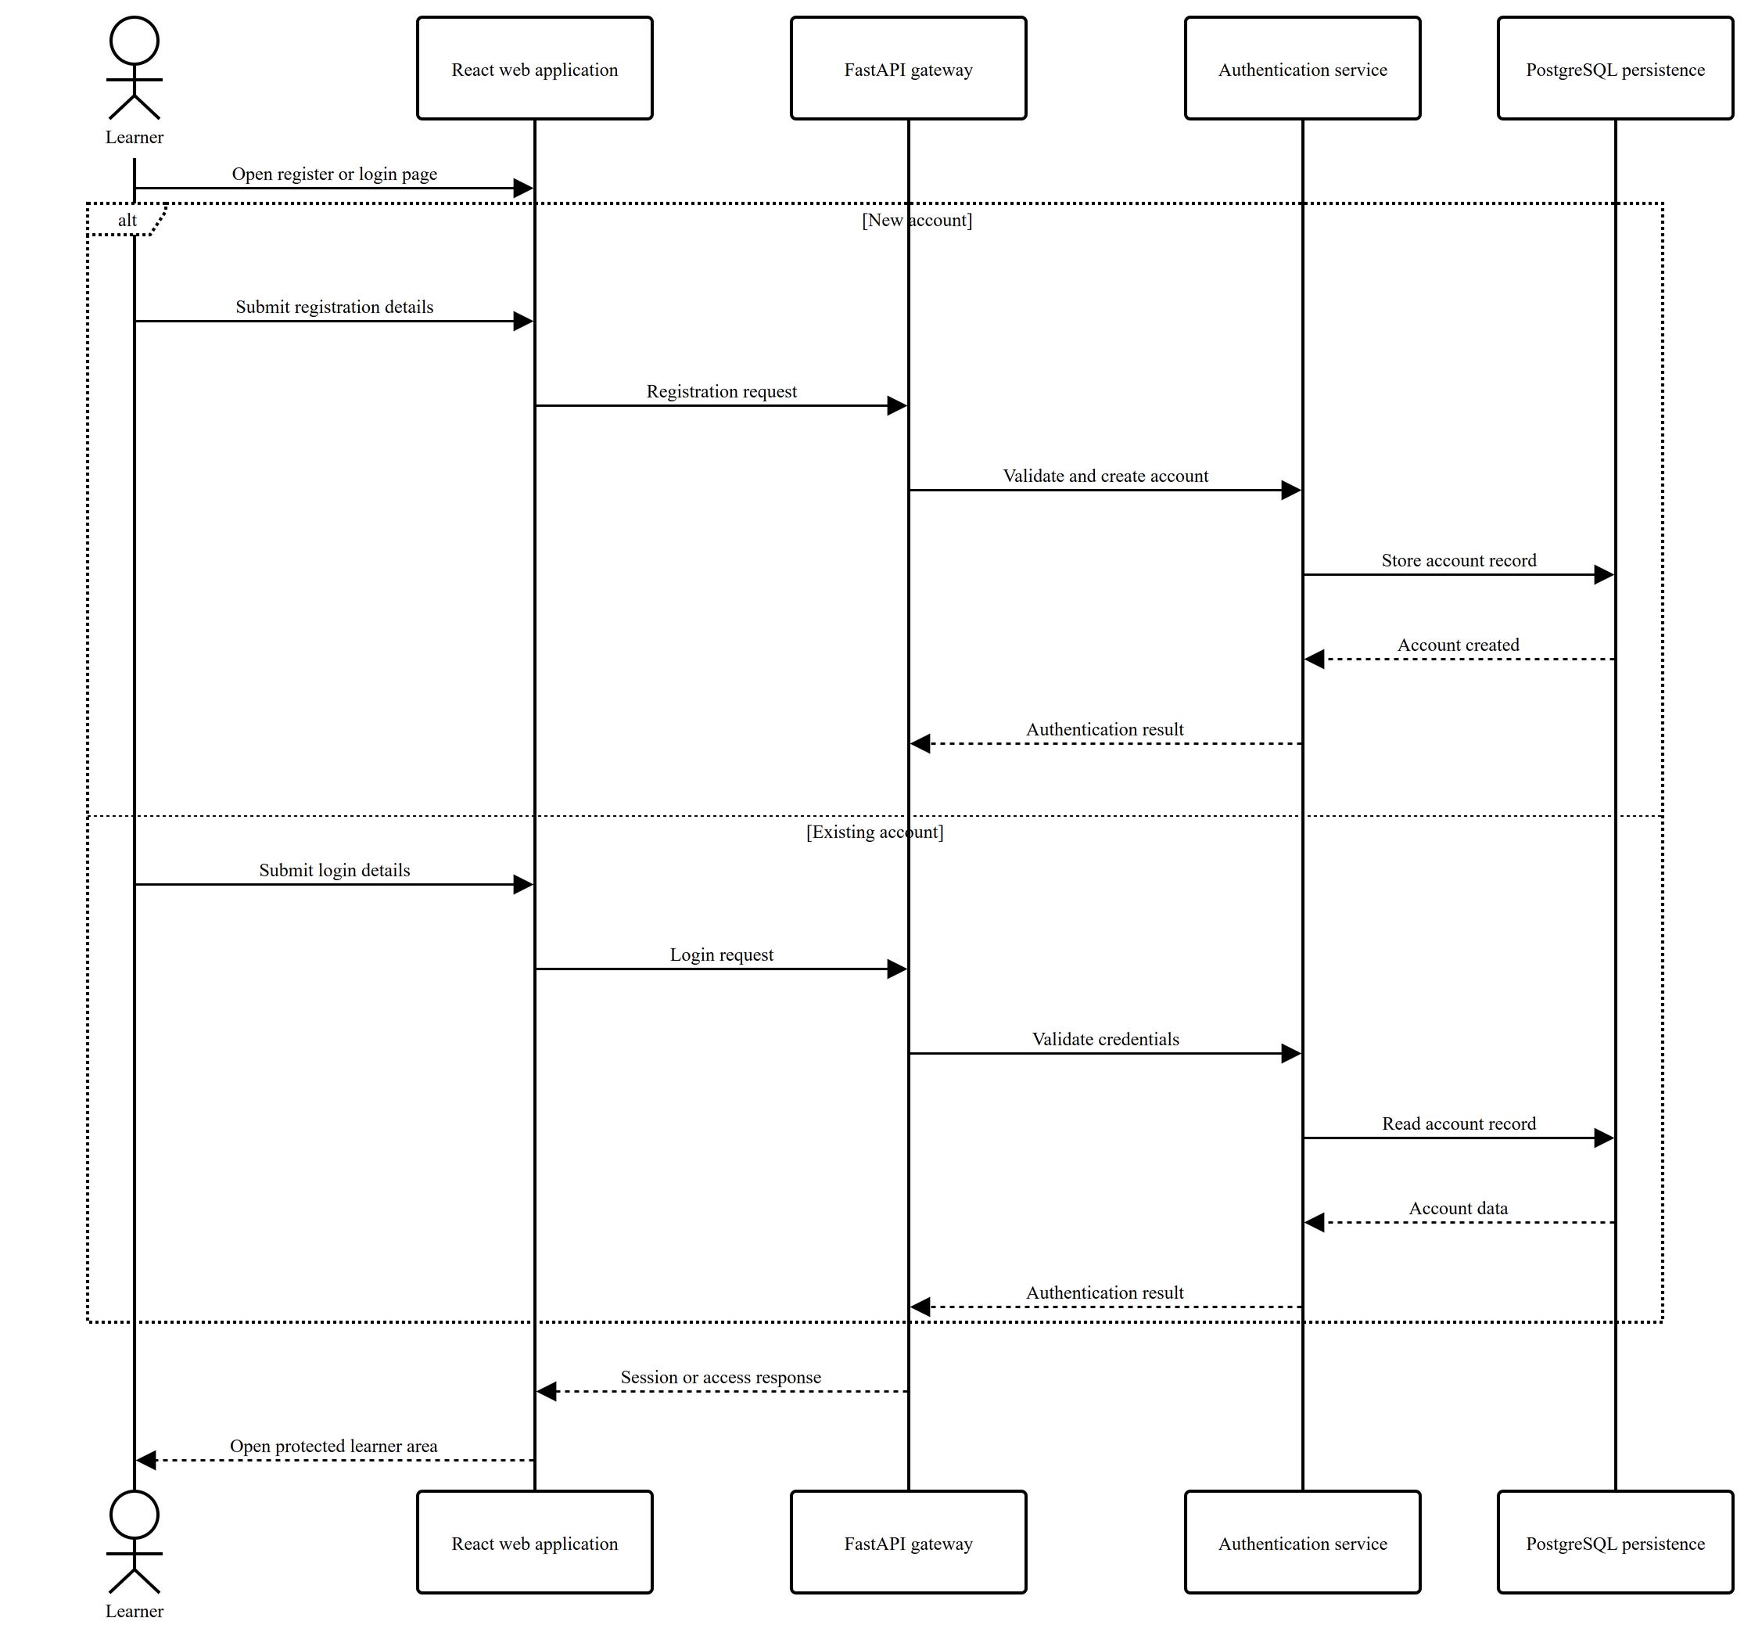
Figure 3.43. registration or authenticated learner access Sequence

3.5.20 Administrative Learning-Content Management
The admin section is now separated into a separate screen. Before editing courses, decks, cards or games, the backend still checks the role of the account. The data is then sent to FastAPI to be saved. Photos and 3D models are not stored together in the record, the file is in storage and the record only keeps the reference. The learner side does not do these steps. It only calls the API to retrieve the content that has been created or edited by the admin before. 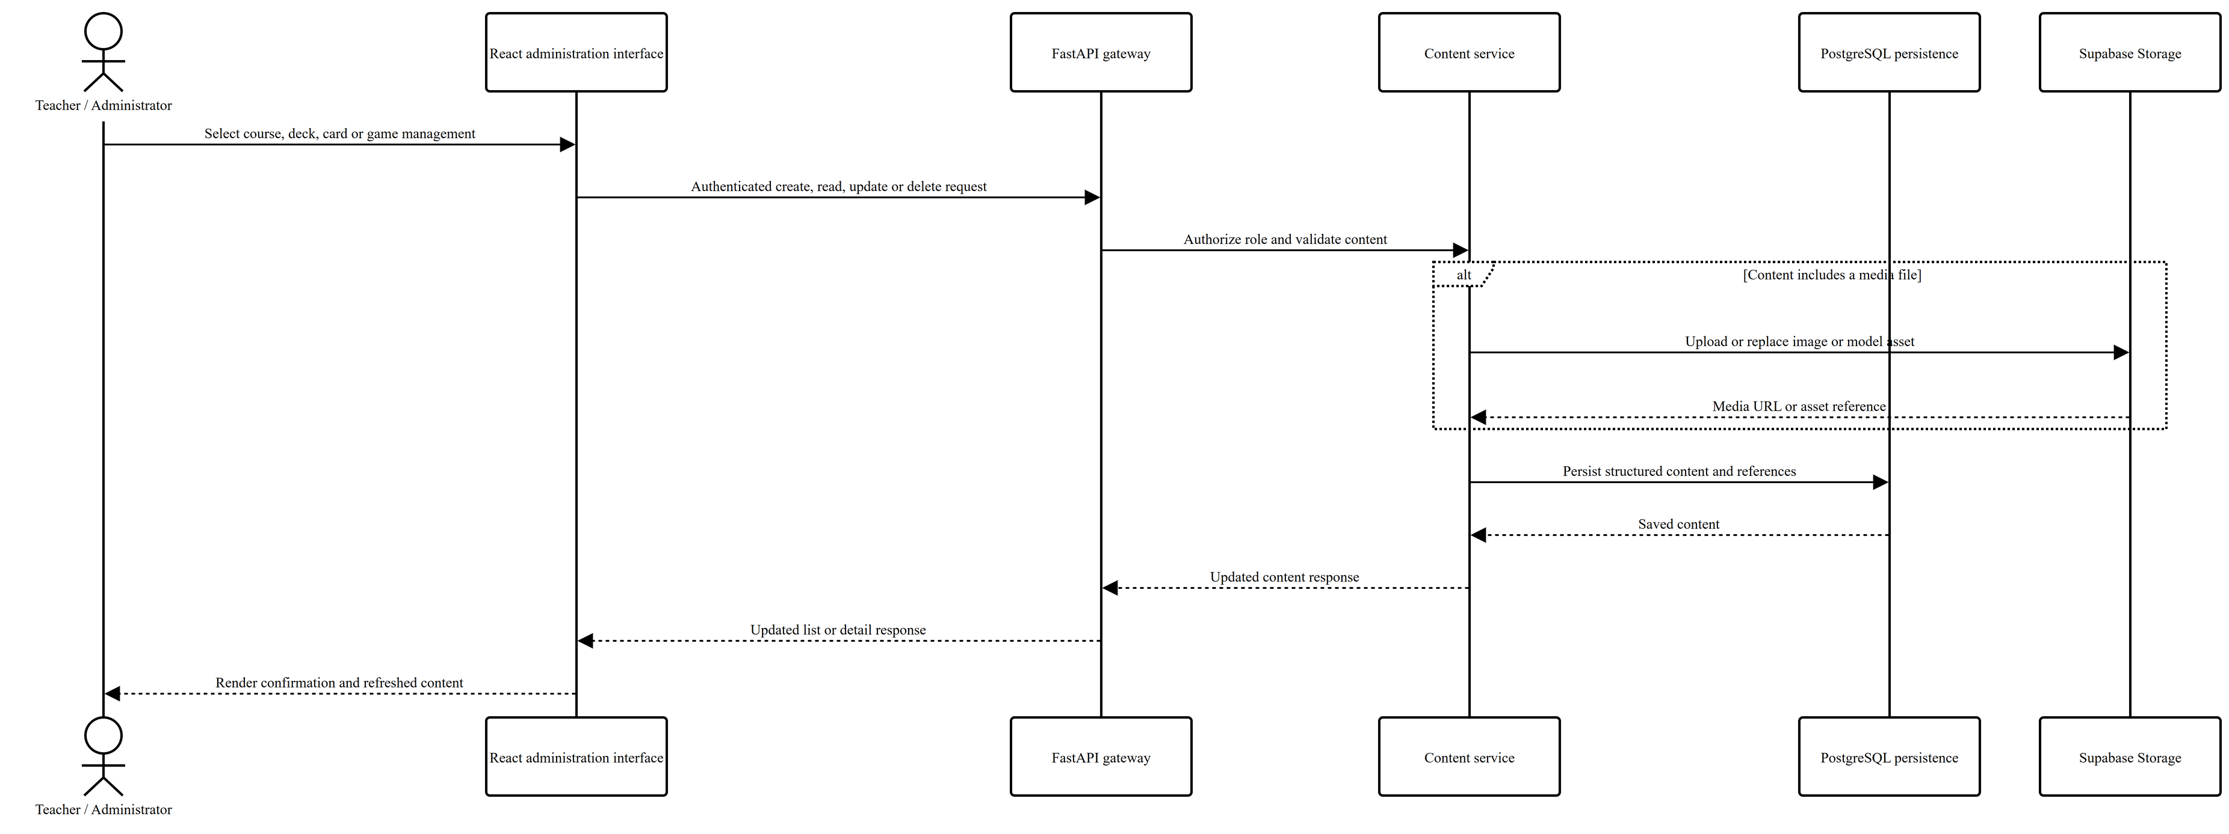
Figure 3.44. administrative learning-content Sequence

3.6 Activity Diagram Analysis
The activity diagram is used to better see the branches or repeatable segments in a function. There are a total of 12 diagrams, mainly going through the existing sections in EduAR such as learning and receiving rewards, QR/AR, children's sessions, courses, flashcards, pronunciation, games, progress, language support tools, and some sections for admins. Not every screen is plotted into a separate activity diagram. Screens that are processed close to each other are grouped in the main flow so that the number of diagrams is not too much. Each diagram only holds the steps and decisions necessary to see how the function is running.

3.6.1 Learner Learning, Reward and Progress Flow
The flow starts from the lesson or flashcard that the child is already using. From there, only some actions are counted for progress. This can be finishing a game, trying a pronunciation task, or reviewing a word. EduAR does not give XP for every tap. FastAPI receives the event and updates the progress or current reward status.XP is not awarded every time the child taps the screen. This diagram illustrates the point where the system validates a learning activity; progress is refreshed only after this validation occurs.

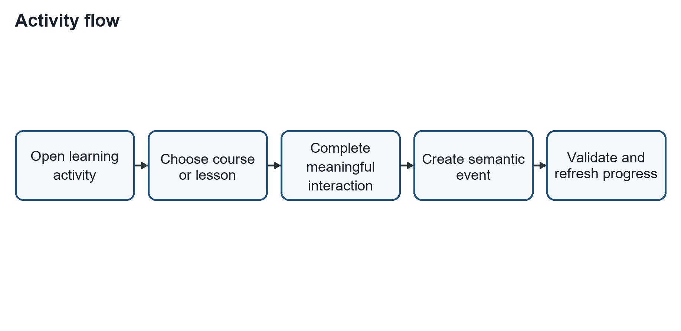
Figure 3.46. learner interaction, semantic reward processing and progress refresh Activity flow

3.6.2 QR-Based AR Learning Flow
The QR code is used first to find the learning item and its deck. From that information, the AR page gets the image targets that belong to the deck. Depending on the activity, there may be one target or several targets in the same session. The model comes later, after EduAR has found a target to use.

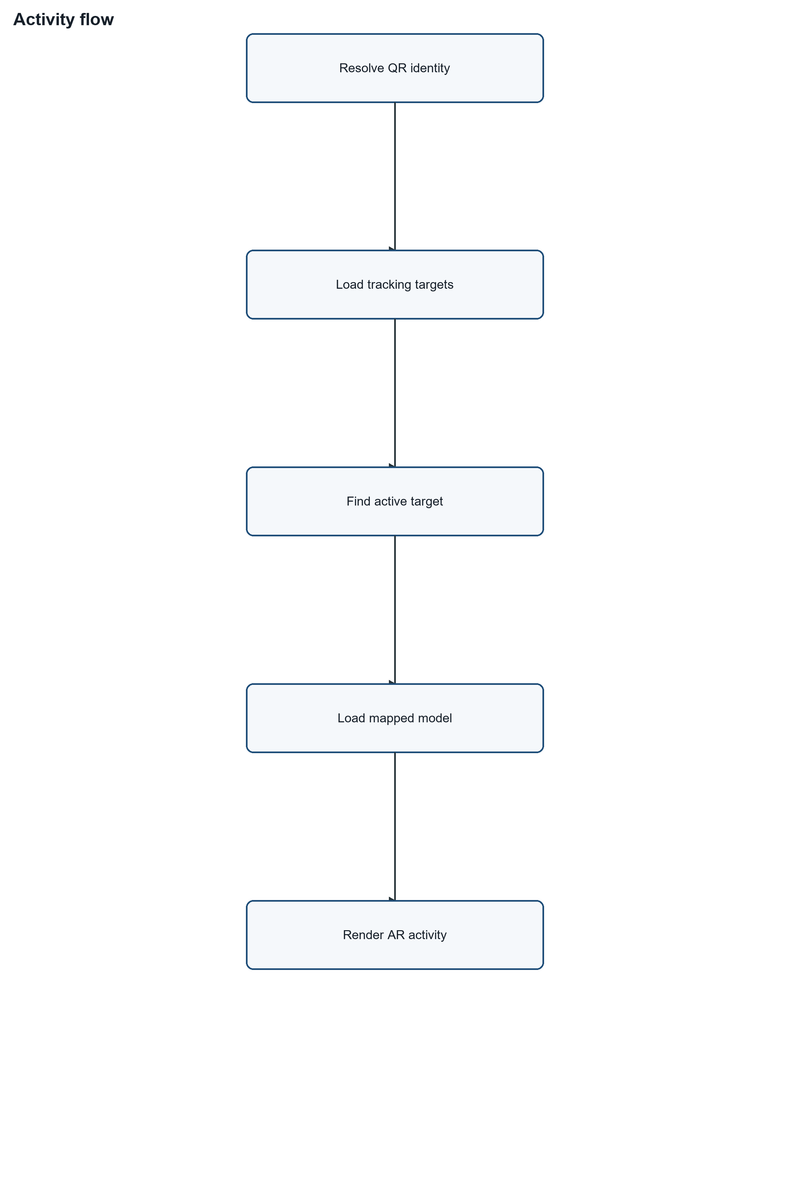
Figure 3.47. Activity flow QR-based AR learning Activity flow

3.6.3 Child Session and Parent-Controlled Break Flow
A supervised session can either start from the beginning or continue from an earlier one. While the child is learning, EduAR keeps track of the active session time. When the break limit is reached, EduAR pauses the current activity and displays the break screen. The session can resume through a resume action or a parent unlock. If the session is not resumed, it closes and saves the last usage state. 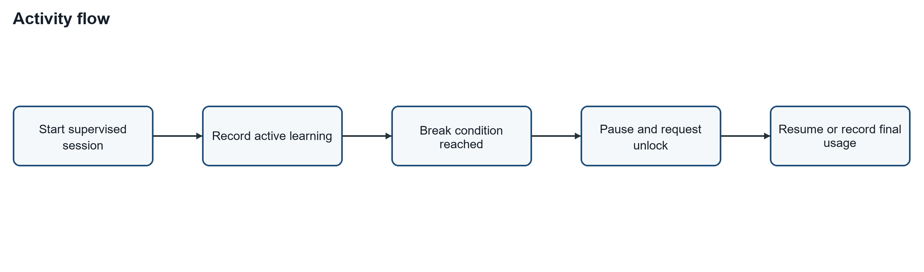
Figure 3.48. child-session and parent-controlled break handling Activity flow

3.6.4 Administrative Learning-Content Lifecycle
The admin flow starts after the teacher or administrator opens the content management area. From there, they can add new material, change existing content, publish it, remove it, or replace an image or other media file.
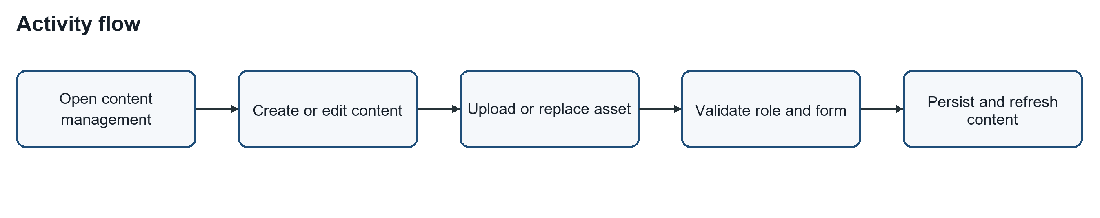
Figure 3.49. administrative learning-content management Activity flow

3.6.5 Account Registration and Protected Access
The account activity starts at the public application entry. A new user follows registration, while an existing user sends login credentials. FastAPI validates the access request before the frontend opens a protected learner route or a teacher and administrator area. If validation or role checking fails, the user receives feedback instead of reaching the protected function

.
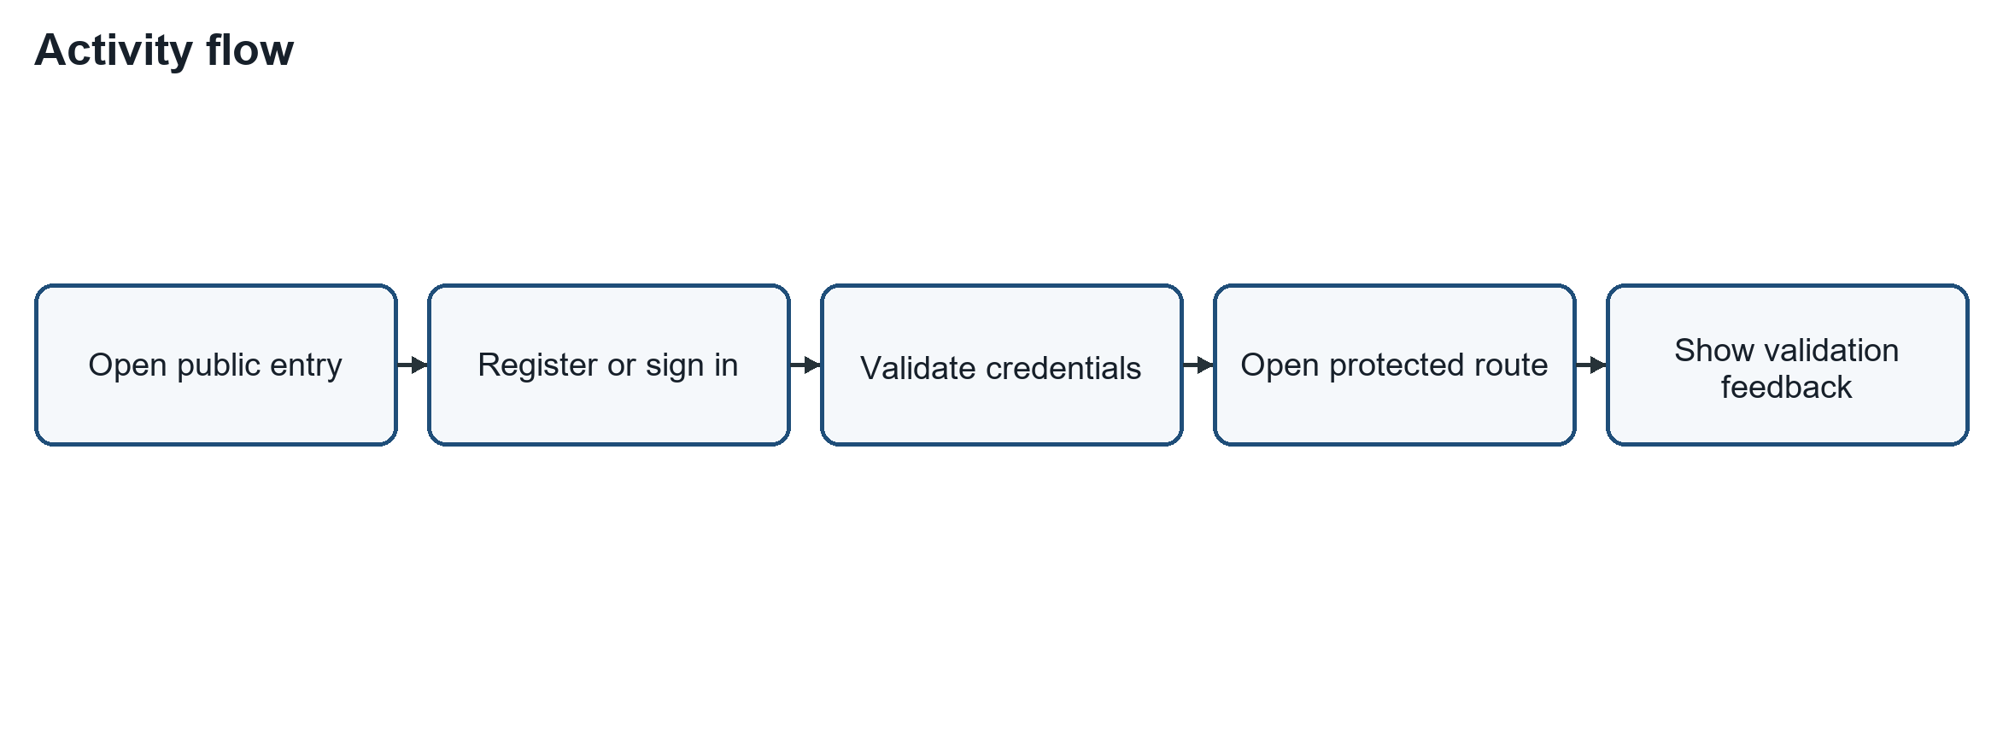
Figure 3.50. account registration, authentication and protected route access Activity flow

3.6.6 Course, Lesson and Flashcard Learning Flow
This activity describes the normal study path used by the course, lesson and flashcard views. The learner loads available courses, selects a lesson or vocabulary step, and completes or saves an item for later review. The application records available lesson or review progress before the learner continues or returns to the course. The diagram separates ordinary progress storage from the semantic reward event shown in the broader learning-and-reward flow.
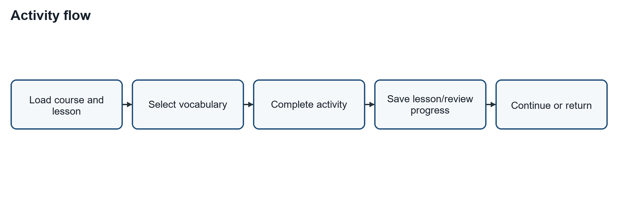
Figure 3.51. course selection, lesson work and flashcard review Activity flow

3.6.7 Pronunciation Capture and Feedback Flow
The pronunciation activity begins when the learner selects a target word in a pronunciation course. The browser must provide microphone permission before a recording can be captured. The selected audio and target word are sent for available assessment, and the learner receives recognised output and practice feedback. A learner can retry recording or continue after the result; the flow does not claim that automatic feedback is equivalent to a teacher assessment.
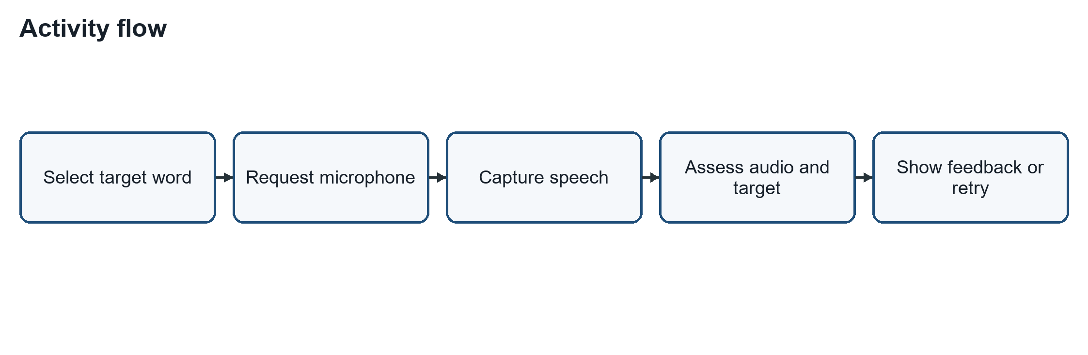
Figure 3.52. pronunciation recording, assessment request and feedback

3.6.8 Game Completion and Authoritative Reward Flow
A game starts only after the learner opens an authenticated game route and the configured vocabulary is available. The learner performs matching, memory, colouring or word actions until the game reaches its completion condition. A completed activity creates one stable semantic event for the backend to check. FastAPI decides whether the event is eligible and returns the resulting completion and progress state, so a client retry is not treated as a separate reward.
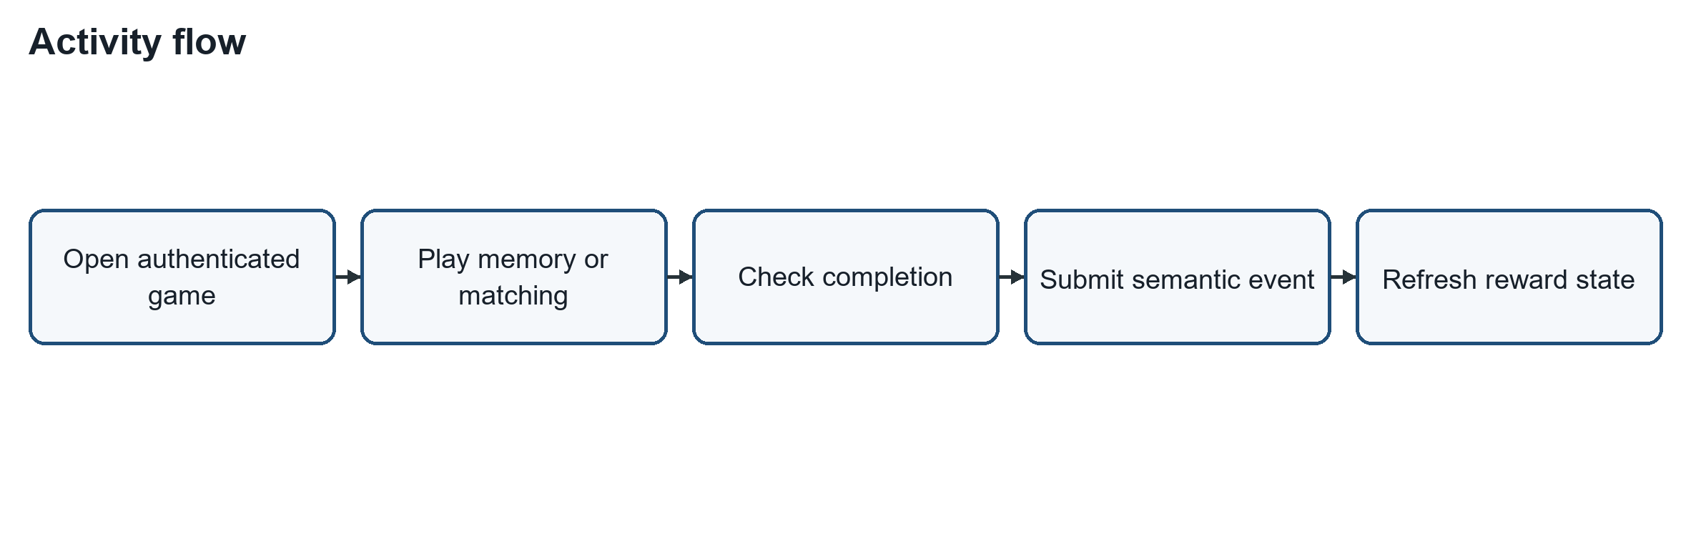
Figure 3.53. game completion and backend-authoritative reward processing Activity flow

3.6.9 Learning Path, Daily Challenge and Progress Views
The learner can enter the learning path, daily challenge, leaderboard or pet view from the protected navigation. The interface first loads the current progress state and available targets. A path or challenge opens a linked learning activity, while leaderboard and pet views present the available state. After a learning outcome is returned, the progress and possible unlock state are refreshed without allowing the client to set an authoritative XP total.
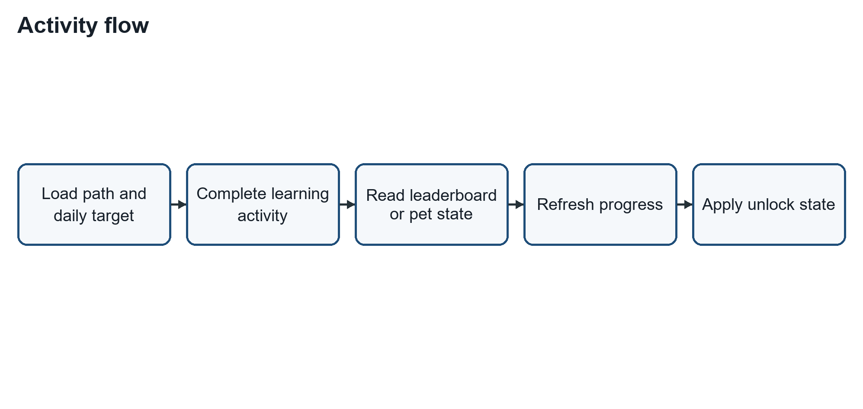
Figure 3.54. learning-path selection, challenge completion and progress views Activity flow

3.6.10 Dictionary, Notebook, Translation and Chat Support
Language-support functions begin when the learner selects a dictionary, notebook, translation, or chat request. The selected word, sentence, or question goes to the relevant service, which returns a response or retry feedback. A useful returned item can be saved as a learner-owned notebook entry for later review by the learner.
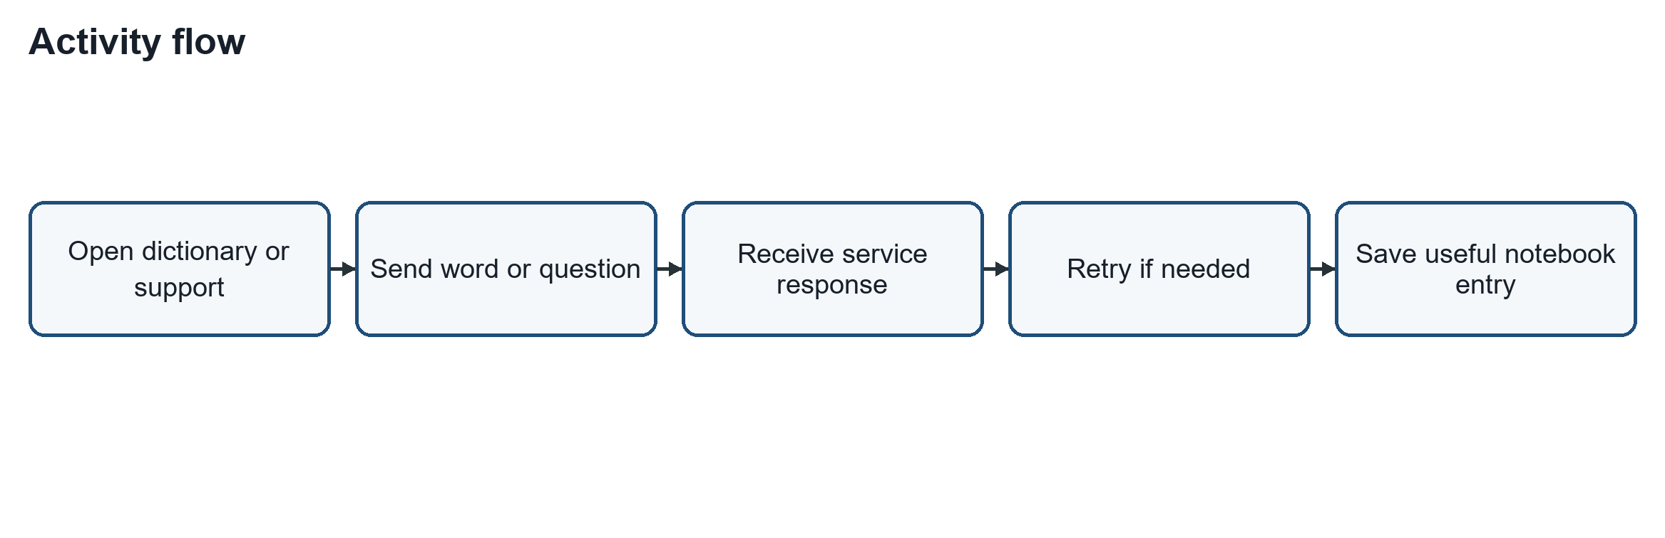
Figure 3.55. dictionary, notebook, translation and chat support Activity flow

3.6.11 Profile and Notification Preference Flow
An authenticated user can open the profile or notification-settings route to read current account and reminder information. When the user changes an allowed value, the frontend submits it through the authenticated API boundary. The backend validates the request before it saves the allowed preference and the view refreshes. A rejected request returns validation or permission feedback and does not update the displayed setting.
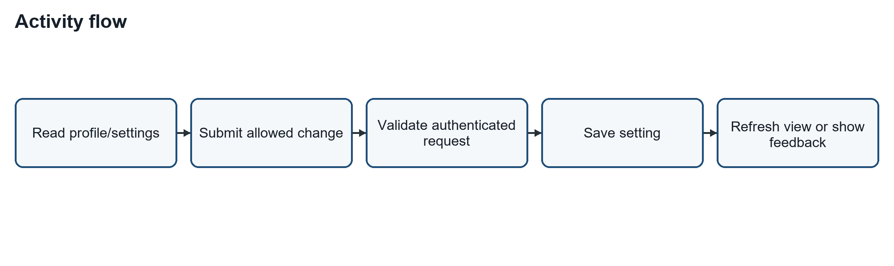
Figure 3.56.profile changes and notification preferences Activity flow

3.6.12 Administrative Learner Review, Goals, Analytics and Monitoring
This activity records the administrative responsibilities not covered by the content-lifecycle diagram. After role protection succeeds, a teacher or administrator can open student, goal, analytics or monitoring views and request the available information. A learning-goal change is validated and persisted before the learner information is refreshed. The flow does not allow an administrative view to alter a learner's earned progress without a separate supported action.
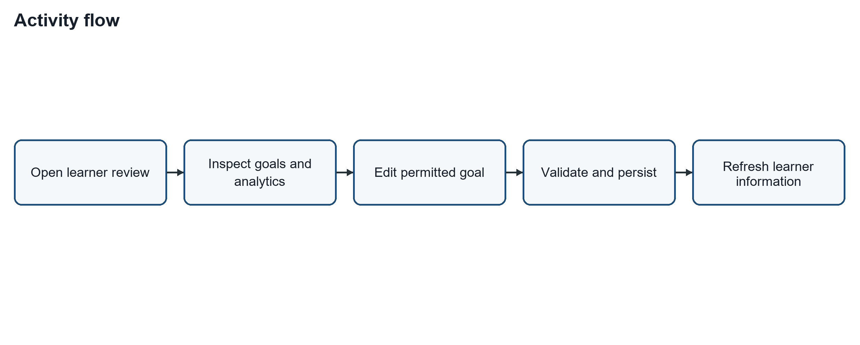
Figure 3.57. administrative learner review, goal management, analytics and monitoring activity flow

3.7 Data-Flow Analysis
The data flow section focuses on where the data is going when EduAR is running. For example, the content of the lesson is taken from the backend, the images and models go from the storage, and the progress or session is sent back to be saved. This section does not delve into the structure of each table in the database because the main purpose is to see the path of data between parts of the system.

3.7.1 Context Diagram
In the context diagram, EduAR is placed in the middle and has not been broken down into frontend, backend or database. This diagram only shows who is exchanging data with the system. The learner sends the learning operations and receives the content, progress, or results of the activity. The parent/supervisor is mainly able to view information related to the learning process. In addition, EduAR also calls some external services when the function needs them
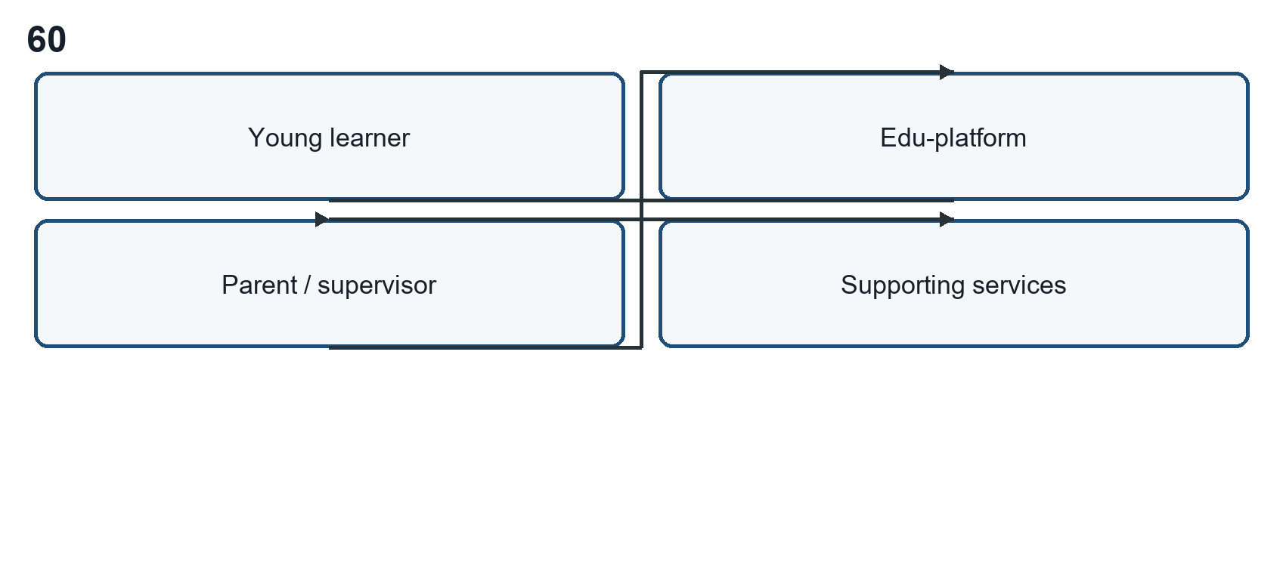
Figure 3.58. Context Diagram

3.7.2 DFD Level 0
In the Level 0 diagram, the main parts of EduAR are shown separately. These include the learning interface, backend services, AR, progress and rewards, and the places where the system keeps its data.
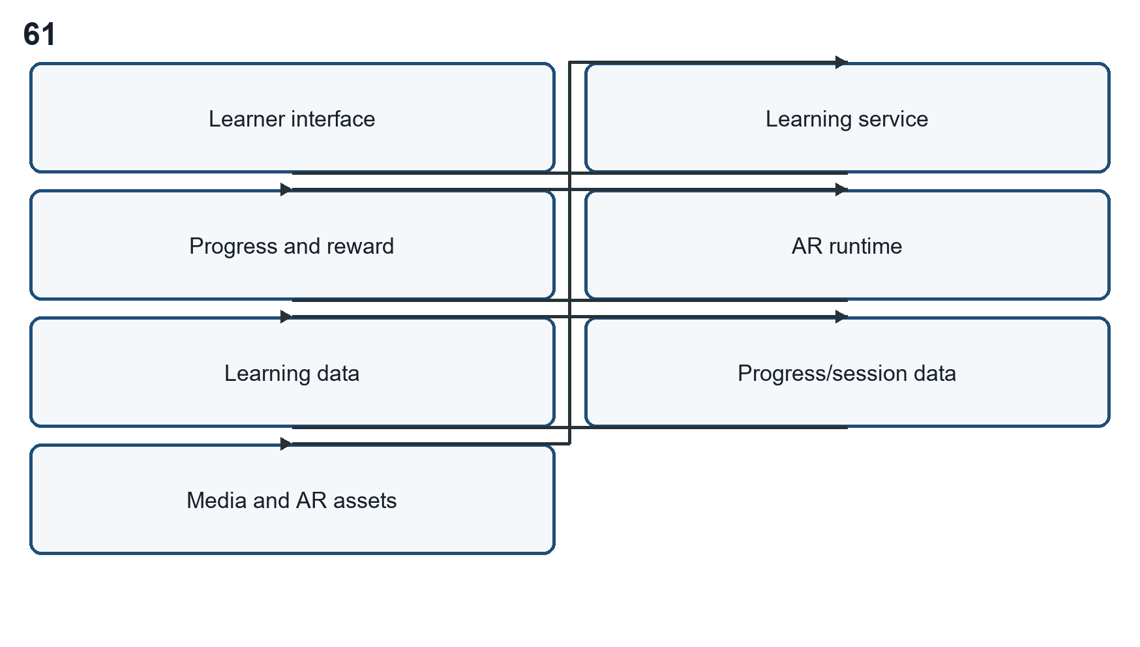
Figure 3.59. DFD Level 0

3.7.3 DFD Level 1 - Core Learning Data Flow
The core learning DFD follows course and lesson selection, flashcard retrieval, practice, and progress recording.
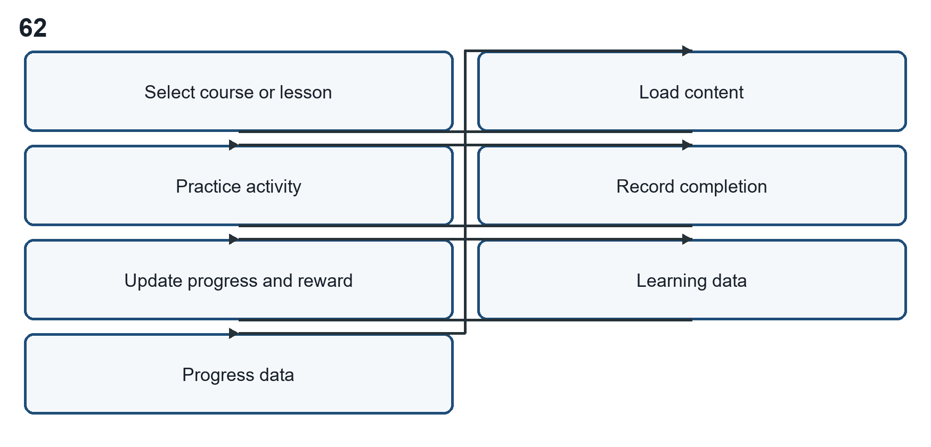
Figure 3.60. DFD Level 1 - Core Learning Flow Chart

3.7.4 DFD Level 1 - AR Data Flow
The AR DFD treats QR/card identity, target metadata, target recognition, and asset rendering as separate data transitions.
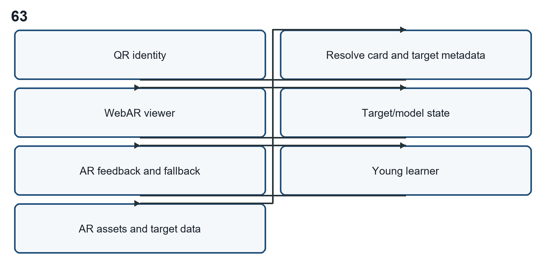
Figure 3.61. DFD Level 1 - AR Data Flow

3.8 Application Architecture
The implemented browser architecture is layered. React and TypeScript provide the learner, parent and administration views. FastAPI forms the authenticated service boundary. PostgreSQL through Supabase stores structured data, while Supabase Storage serves media, target data and GLB assets. The current WebAR viewer uses a MindAR and A-Frame iframe. The engine adapter also keeps an additive XR or 8th Wall path. Speech feedback and agentic RAG are optional learning-support capabilities, so the normal flashcard route does not depend on them.

3.8.1 Implemented Technology Stack
Table 3.1 lists the technologies used in the implemented prototype and their practical roles.
Table 3.1. Implemented technology stack of Edu-platform.
Layer | Technology | Implemented role
Web client | React, TypeScript, Vite | Learner and parent interface, routes, forms and visible learning states.
Service layer | FastAPI | Application API for learning, progress, session and supporting-service requests.
Structured data | PostgreSQL via Supabase | Persistent course, lesson, learner, progress, practice and gamification records.
Media storage | Supabase Storage | Images, audio, 8th Wall target data and GLB model assets.
AR runtime | 8th Wall Engine viewer | Image-target tracking and AR scene execution in an isolated viewer.
Optional services | Speech and chatbot services | Pronunciation and assistance paths; these do not block the ordinary flashcard path.
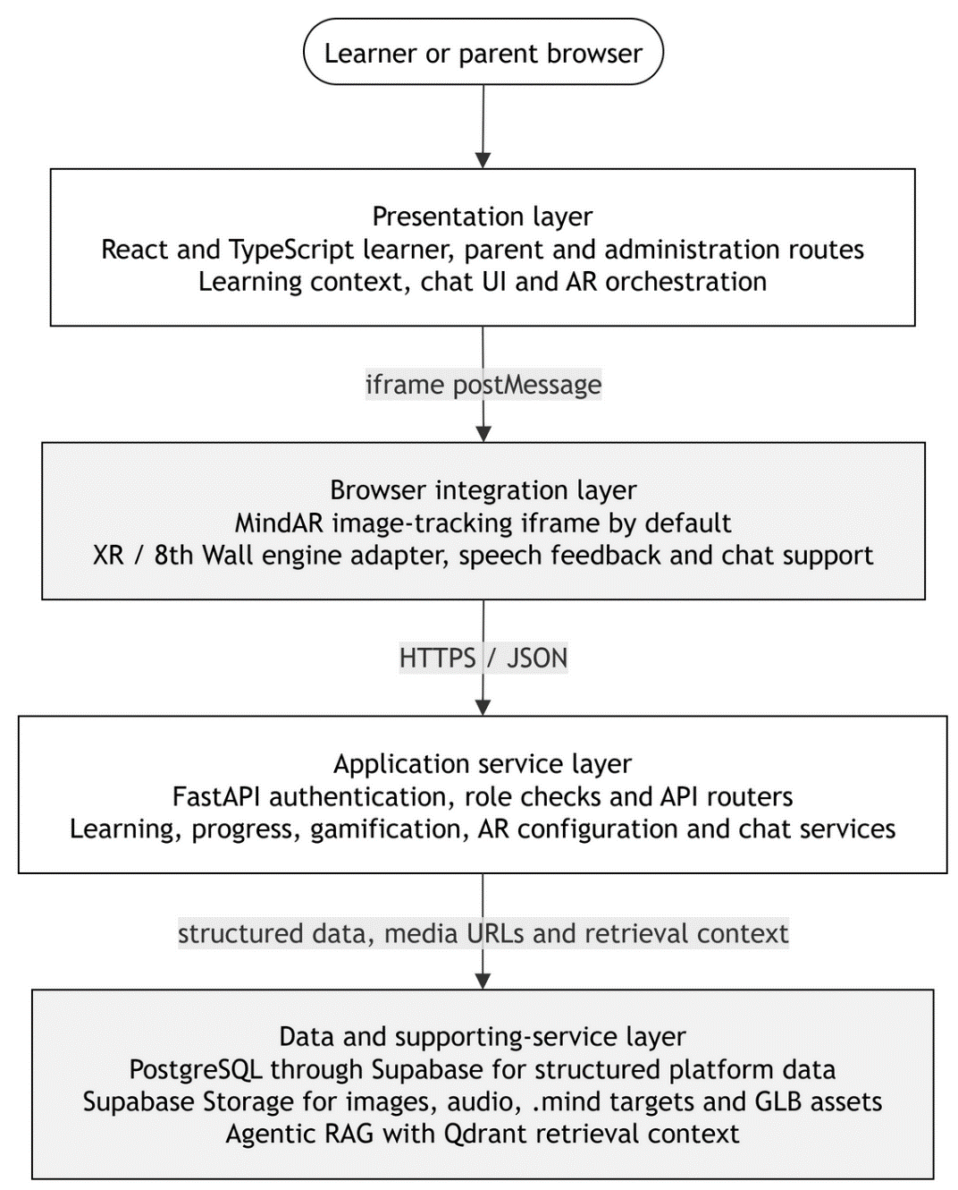
Figure 3.62. Layered application architecture with optional WebAR and learning-support services. Source: Author's design based on the implemented prototype.

3.8.2 Event-Driven WebAR Architecture
The active WebAR route is event driven. ARContainerV2 receives the selected catalog and sends a revisioned SET_ACTIVE_TARGETS message to the isolated viewer. The viewer reports readiness and whether the target revision was applied. It then sends target, model, and combination events back to the React host. The event bus turns these messages into learner-interface callbacks. An asset problem can remain inside the AR path, while a system error or timeout moves only that interaction to a controlled failure state. The normal lesson page is not treated as failed.
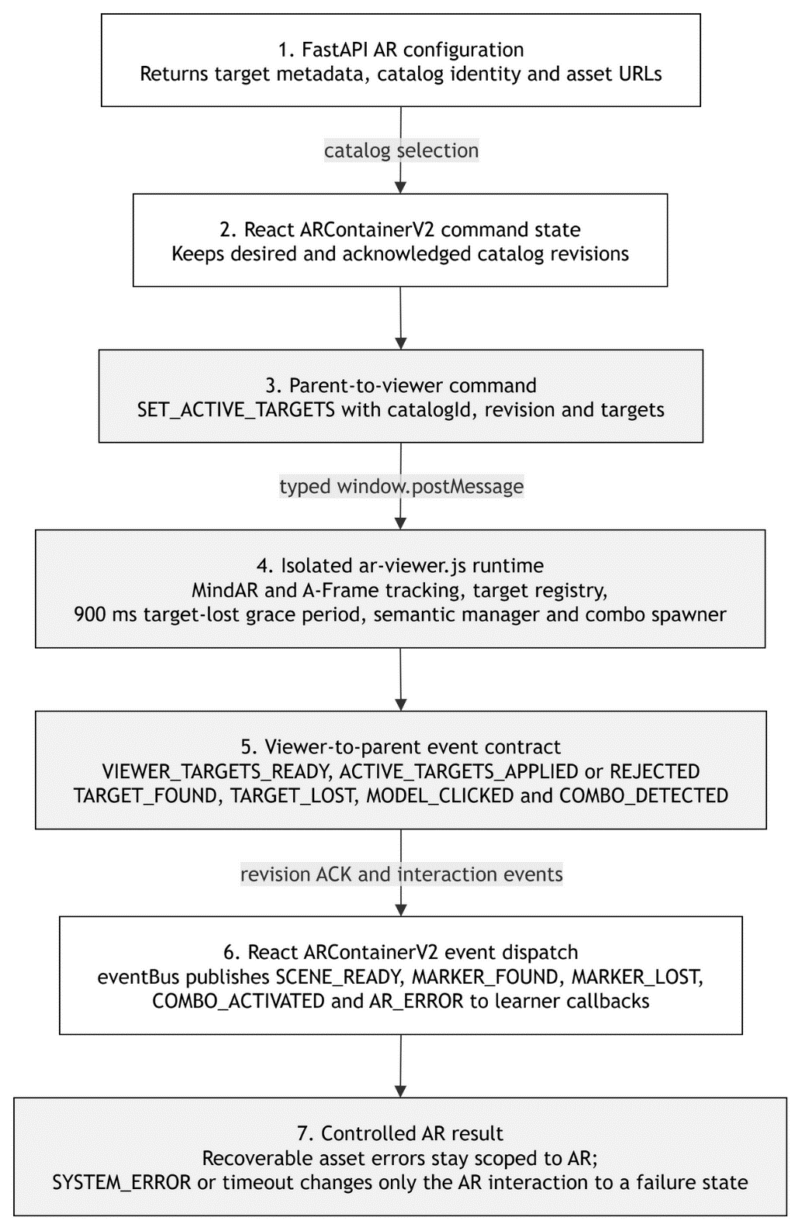
Figure 3.63. Event-driven WebAR architecture for the React host and MindAR viewer. Source: Author's design based on the implemented frontend contract.

3.8.3 Agentic RAG Learning-Support Architecture
The chat section is an additional support function in EduAR, it does not change the child's progress or reward. When there is a question. sent by the user to the system, the system will check the cache first to see if there is a suitable response. If not, Planner will use the learner's progress and the context of the lesson, if any, to prepare the data search section. The Generator then takes the context from Qdrant and sends it through the router model to generate a draft answer. The Validator will check the content with a number of fixed rules and also recent responses such as profanity, curse words. Only when needed will it call more models to check. The final result can return both the source and the trace. The logging or saving of traces is run separately so as not to slow down the chatbot's response.

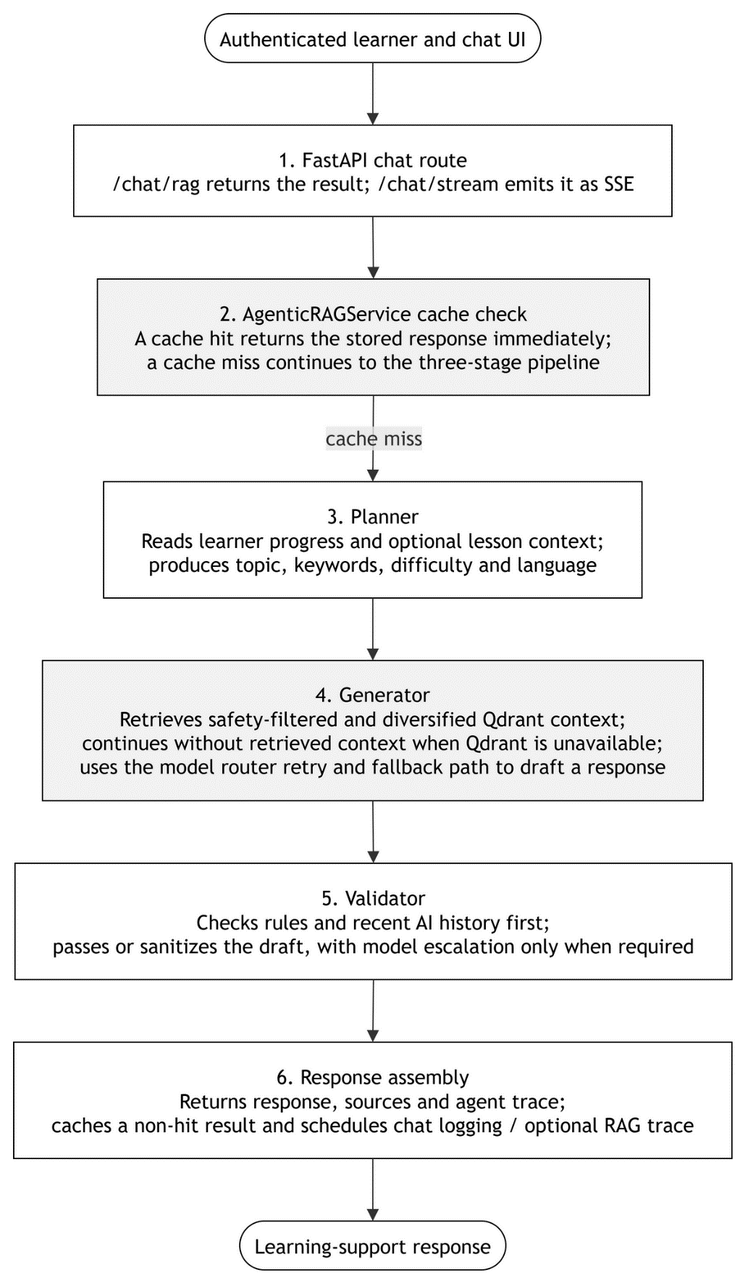
Figure 3.64. Agentic RAG architecture

3.9 Data Design
PostgreSQL is used through Supabase to store EduAR's structured data. In the database section of this chapter, the schema in use includes groups of tables related to learning, session, progress, practice, gamification, review, and AR. Diagrams are taken from the exported database schema. Relationships with primary and foreign keys are directly represented as relationships between tables. Some parts that are not connected by foreign keys but share the same identifier, for example ar_tag, are noted separately to avoid misunderstanding that they are direct database relationships tiếp.

3.9.1 Conceptual Data Model (CDM)
In the conceptual model, I don't divide the database by screen. The tables are placed close together based on the functionality they serve. Courses and lessons are related to vocabulary, while sessions and practices hold the data generated while the child learns. Progress and gamification use this data in the next sections. AR is still associated with vocabulary, but there are additional targets, 3D models, and rules for multi-card cases. Reviews and chatbots are separate because they serve other functions.
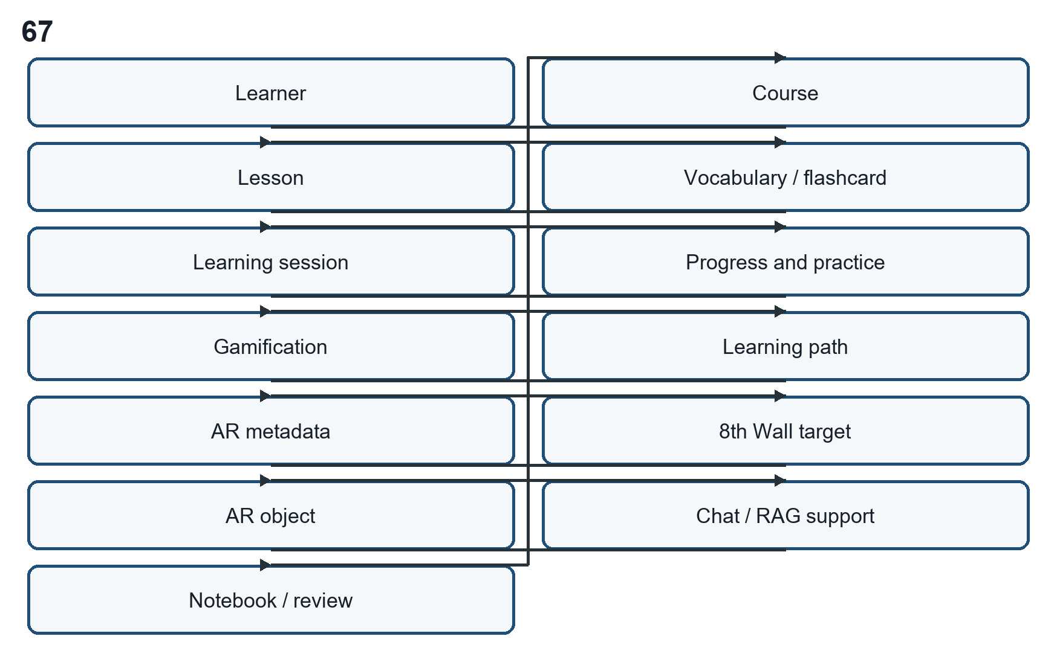
Figure 3.65. Data model of Edu-platform.

3.9.2 Entity-Relationship Diagram (ERD)
The logical ERD is divided into three views so declared relationships remain readable. The first covers course, lesson, learner progress, and lesson-session records. The second focuses on progress, practice, gamification, learning-path, and review data. AR tables form the third view because tracking identity and renderable assets use identifiers that differ from the normal learning records.
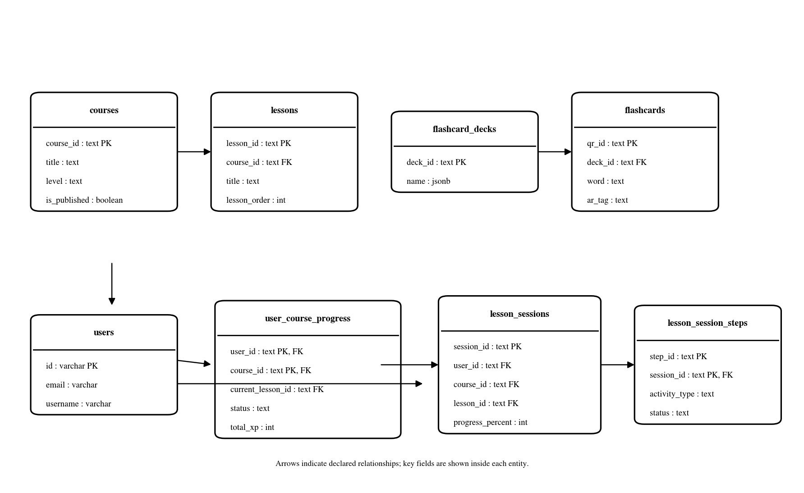
Figure 3.66. core learning and session data ERD
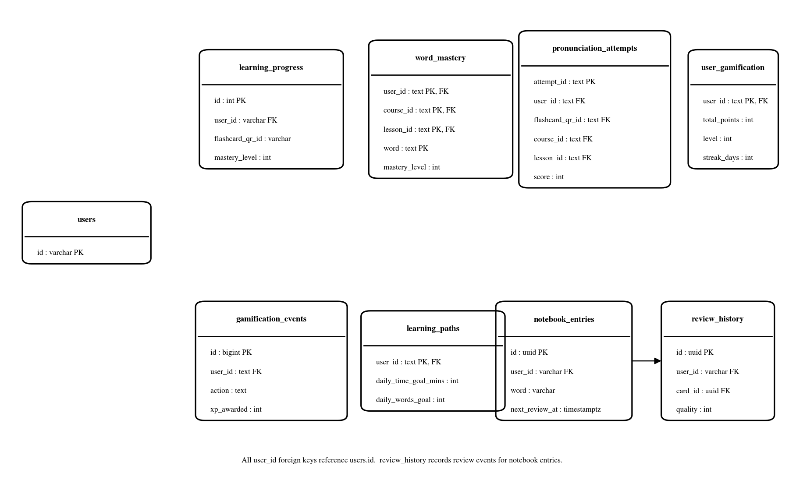
Figure 3.67. progress, practice and learner-support data ERD
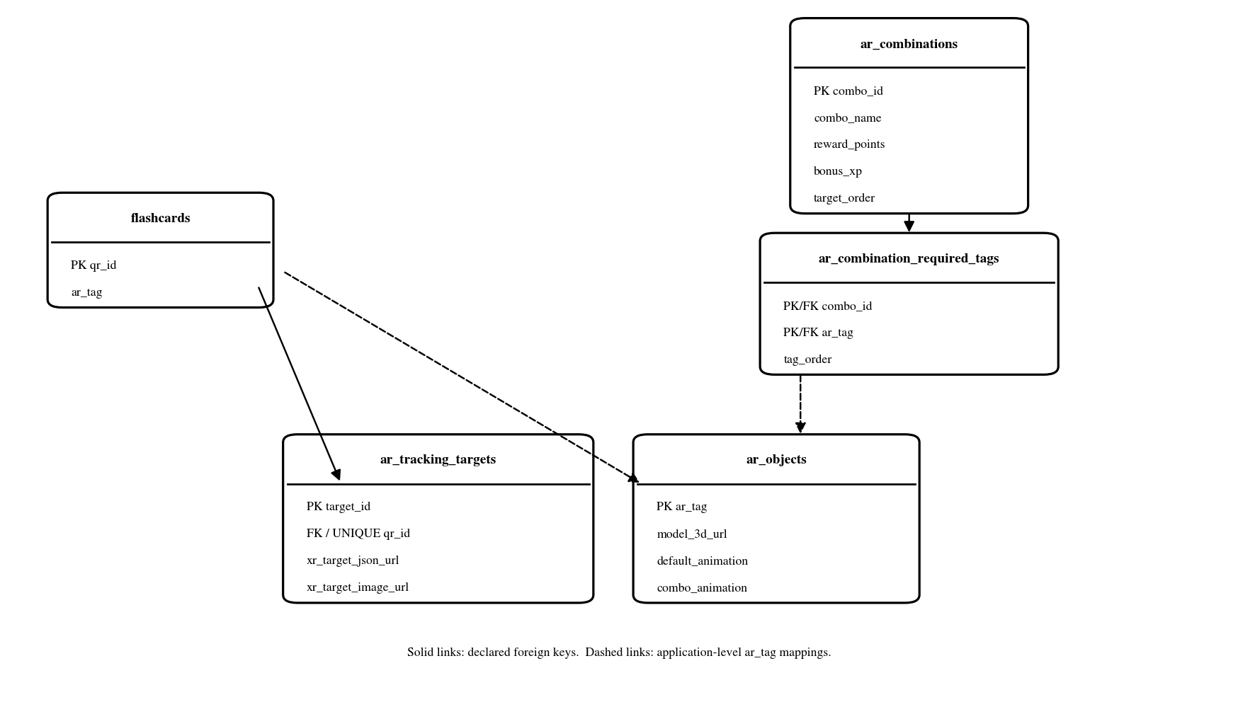
Figure 3.68. AR tracking and combination data ERD

3.9.3 Physical Data Model (PDM)
The physical model uses the correct table and column names that are in PostgreSQL. This diagram doesn't try to include all the fields of the database. I only keep the columns that are directly related to the learning flow and AR so that the image doesn't get too thick. The tables used for notifications, migration, tracing, and some admin functions also do not appear in this PDM. They still exist in the database, just not needed for the part being explained. The keys and data types related to the main relationships remain the same.
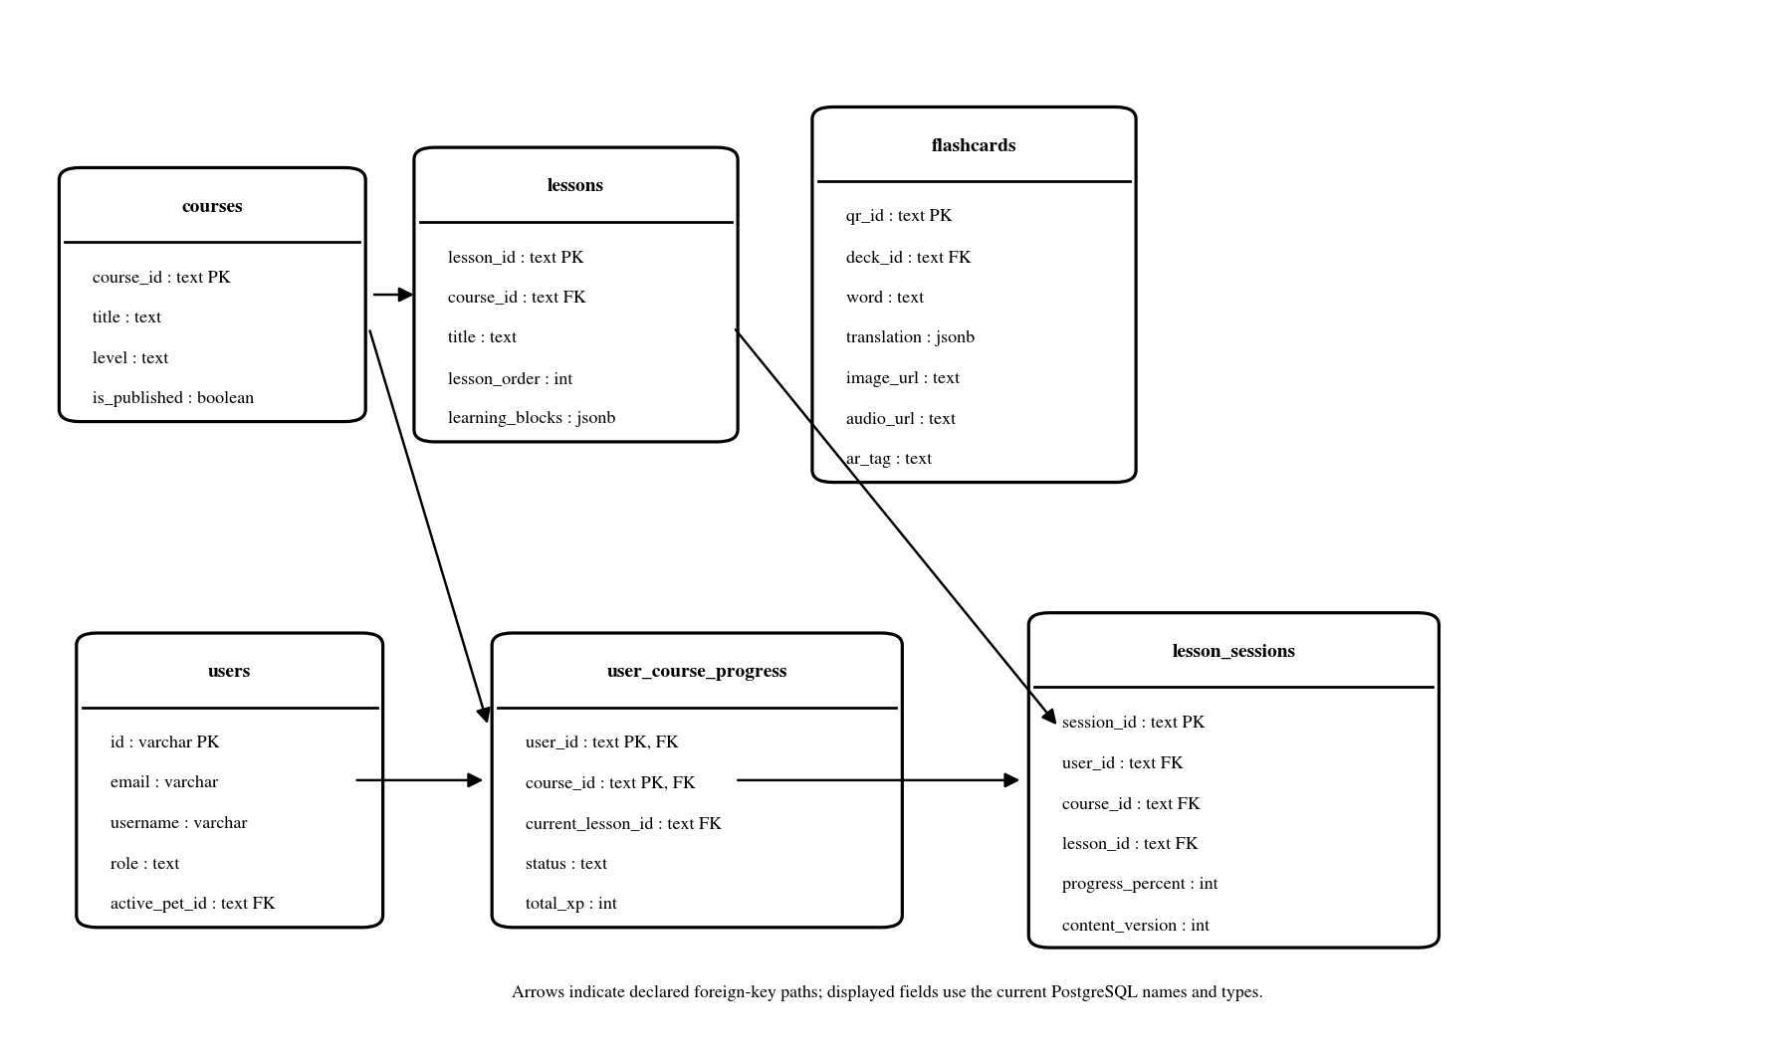
Figure 3.69. Selected physical data model for users, courses, lessons, learner progress and learning sessions.
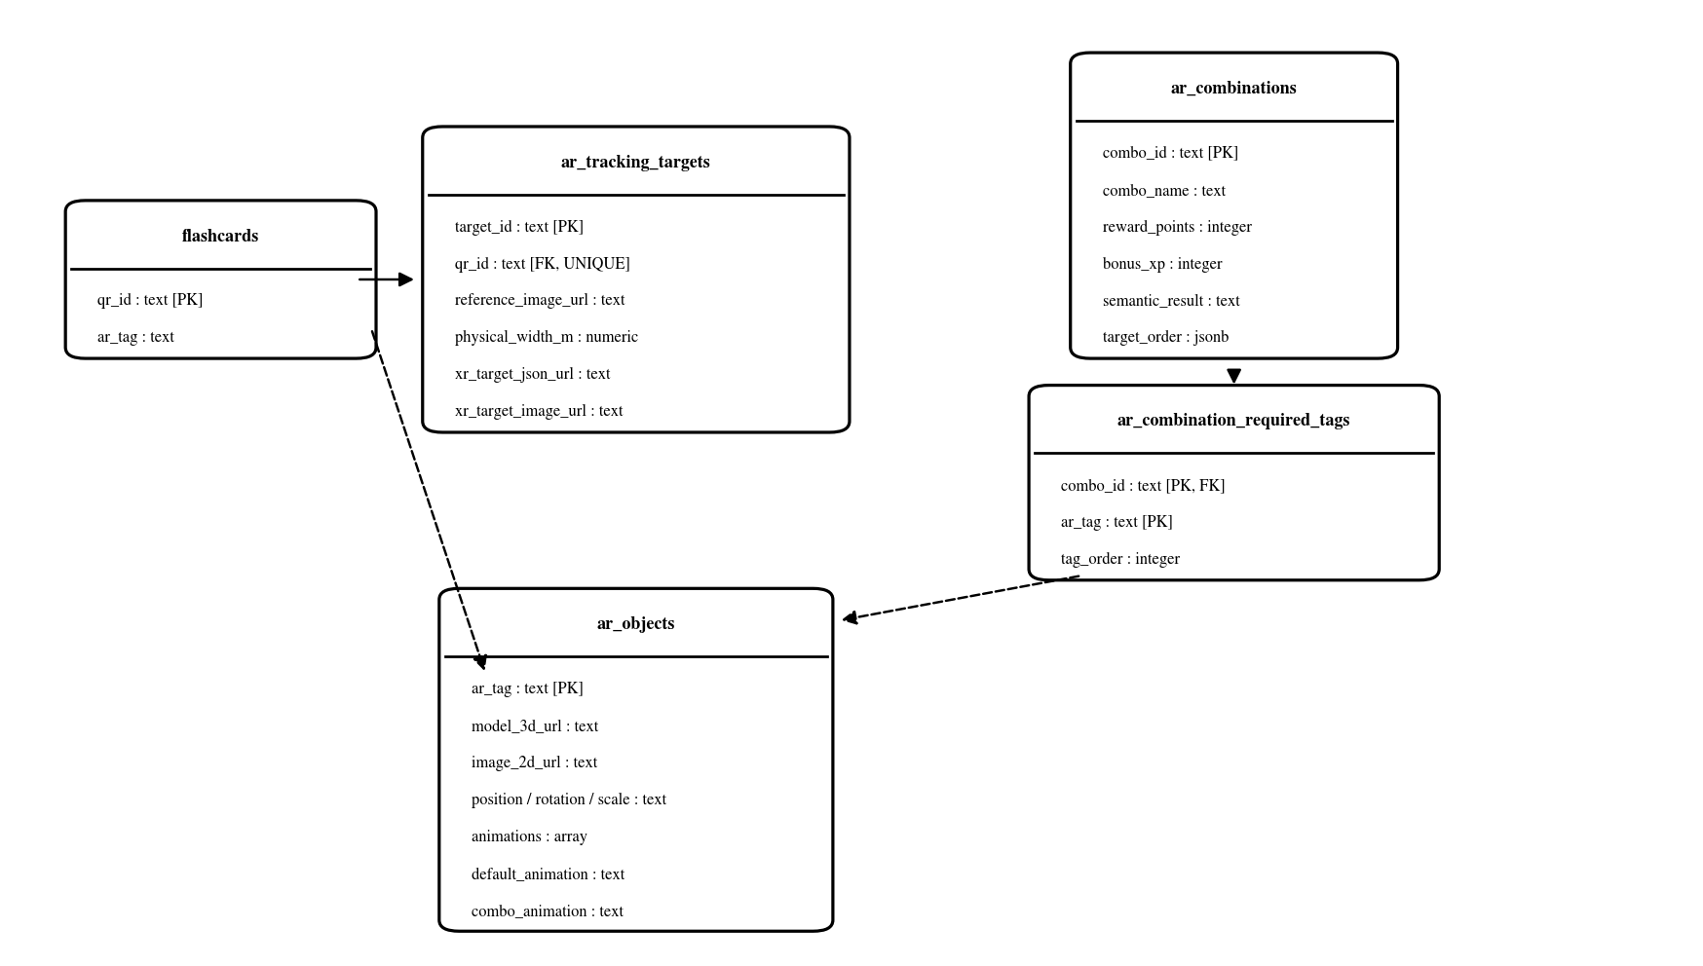
Figure 3.70. Selected physical data model for the current AR path and combination rules.
The physical schema has a small number of legacy compatibility columns, but they are not part of the active AR path described in this chapter. In the current design, the important fields are the target identifiers, xr_target_json_url and xr_target_image_url in ar_tracking_targets, together with model and animation metadata stored for AR objects. The conceptual and interaction views therefore focus on these current 8th Wall fields instead of older compatibility columns.

3.9.4 AR Identity and Asset Mapping
AR data separates learning identity, physical tracking identity, and the renderable asset. The flashcard qr_id identifies the learning item, ar_tracking_targets maps that item to the 8th Wall target data, and ar_objects selects model and animation metadata through ar_tag. Combination rules use semantic AR tags, so the application can decide whether two recognised items form a supported interaction without treating target recognition and model rendering as the same state.
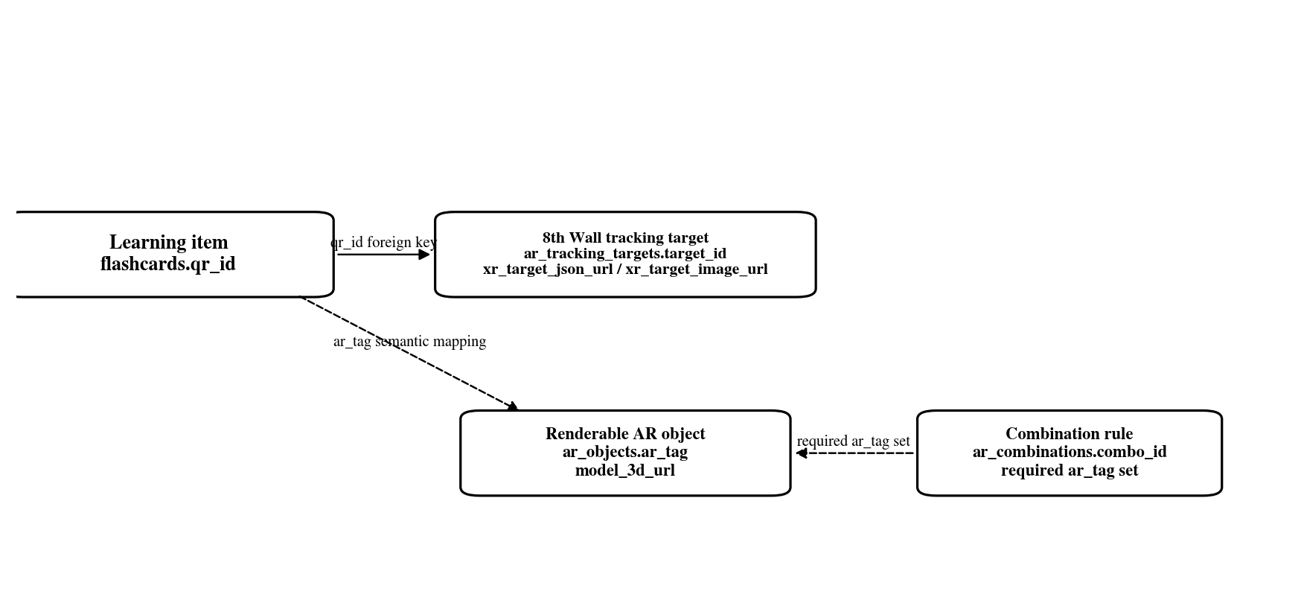
Figure 3.71. Identity separation across flashcard, 8th Wall target, AR object and combination data. Source: Author's design.

3.10 Chapter Summary
This chapter describes Edu-platform as an implemented application rather than a list of desired requirements. Eighteen capabilities are documented as use cases, including the virtual pet, Word Check, the Dictionary/Notebook, Translate, and multi-card AR. The sequence models show how the user interface, FastAPI services, Supabase data, and the 8th Wall runtime work together in representative interactions.
The data-flow, architecture, CDM, ERD, and selected PDM views show the system boundaries. Normal web learning stays available independently of optional AR and external services, while the database design keeps learner activity, progress, practice state, and gamification separate from media assets. For AR, flashcard identity, 8th Wall target identity, and renderable model identity stay separate so that resolution, tracking, and rendering failures can be analysed independently.

CHAPTER 4:
SYSTEM TESTING AND EVALUATION

4.1 Introduction
Chapter 3 described how the application is organised. This chapter checks the prototype from a testing point of view. The main question is whether a learner can reach a feature, carry out its main action and obtain a visible or recorded result without breaking the rest of the learning flow. Camera, microphone and external-service features are interpreted more carefully because the same path can behave differently under another browser, device or network condition.
Source inspection is used to explain a test path, but it is not treated as a pass result by itself. A stronger result comes from an observed browser state, a stored result, or a development run of the feature. If that evidence is incomplete, the result is kept as partial rather than being reported as fully verified.

4.2 Test Setup and Result Criteria
The current evidence comes from the working web prototype, retained browser screenshots, repository test paths and the application data contracts. The older screenshots do not consistently record every browser version or physical-device condition, so they are used only for the state that is directly visible.
Table 4.1. Test environment, technology stack and result interpretation.
Item | Current setup / evidence | Use in this chapter
Web application | Current React/TypeScript frontend with FastAPI service layer. | Route, form, content and visible-state checks.
Persistence | PostgreSQL through Supabase; Supabase Storage for media and AR assets. | Progress, reward, session and asset metadata where relevant.
AR runtime | 8th Wall Engine viewer used by the current AR route. | QR resolution, one-card tracking, multi-card tracking and configured interactions.
Browser evidence | Desktop and narrow portrait screenshots retained from the prototype. | Responsive state only; not a device benchmark.
Test automation | Playwright paths and retained browser artefacts. | Reproducible responsive and regression checks.

4.3 Core Learning and Practice Testing
The first group of checks covers the learner's ordinary path through the application: entering the platform, opening course content, using a flashcard, attempting pronunciation and completing a short activity. These checks are kept separate from AR so that the web learning core can be evaluated on its own evidence.
Table 4.2. Core learning and practice test results.
ID | Feature | Test action | Observed result / current evidence | Status
TC-01 | Login | Submit valid and invalid credentials; use guest entry. | Login state is visible in desktop and portrait evidence. Invalid credentials do not enter protected learner state. | PASS
TC-02 | Courses and lessons | Open a course and continue to a lesson. | Captured production views show the course catalogue and topic selection. A clean final capture of course-to-lesson continuation is not retained. | PARTIAL
TC-03 | Flashcards | Open a vocabulary item and move through the card content. | Word, media and pronunciation controls remain under the same learning item. Dedicated browser evidence is limited. | PARTIAL
TC-04 | Pronunciation practice | Start an attempt and receive feedback. | Web Speech and recorded-audio fallback paths are implemented. The observed result depends on browser support and microphone permission. | PARTIAL
TC-05 | Games | Load a game, submit an answer and complete or retry. | Game state supports answer, retry and completion. A complete final screenshot set is not retained yet. | PARTIAL

4.4 Progress, Motivation and Parent-Monitoring Tests
The results distinguish a visible completed state from a path that still needs a retained browser artefact or authenticated learner data.
Table 4.3. Progress, motivation and parent-monitoring test results.
ID | Feature | Test action | Observed result / current evidence | Status
TC-06 | Gamification | Complete a rewarded learning action. | XP and reward state are connected to learner actions and persisted state. Duplicate-event behaviour is mainly a backend/data check. | PARTIAL
TC-07 | Parent/session tracking | Run a learning session and open the progress report. | Session state and report paths exist. The global reminder presentation is temporarily bypassed in the inspected branch. | PARTIAL
TC-11 | Learning path | Load and save learner goals or preferences. | A captured production view shows the learning-path route, selected topic and route count. The capture does not separately prove a save action. | PARTIAL
TC-12 | Leaderboard | Open the ranking view. | Captured production run shows the All Time ranking view with named positions and displayed XP values. | PASS in captured production run
TC-13 | Daily challenge | Open the challenge and inspect progress or reward state. | Captured production run shows the daily challenge goal, progress state, streak and displayed XP reward. | PASS in captured production run
TC-14 | Pet Companion | Open the pet view and interact with an available pet. | Pet catalogue, activation and care actions are implemented. The visible state depends on authenticated progression data. | PARTIAL

4.5 Learning-Support Service Tests
Chatbot assistance, Word Check, Dictionary/Notebook and Translate are tested as optional learning-support services. Their functional paths are recorded separately because service availability and authenticated account data can affect the observable result.
Table 4.4. Learning-support service test results.
ID | Feature | Test action | Observed result / current evidence | Status
TC-10 | Chatbot assistance | Submit a learner question; use New to start another conversation. | Captured production run shows a reply to a Vietnamese cat question and the New-conversation reset state. The capture does not assess response accuracy or safety. | PASS in captured production run
TC-15 | Word Check | Submit a known or unknown word. | Captured production run shows a known Cat lookup with IPA, Vietnamese meaning, explanation, example and displayed source. The unknown-word branch is not retained. | PARTIAL
TC-16 | Dictionary (Notebook) | Open saved vocabulary and review an entry. | Captured production run shows a three-word notebook list and a Cat detail entry. Other create, update, delete and search operations are not separately retained. | PARTIAL
TC-17 | Translate | Submit text and retry an error state. | Translation result and error/retry states are implemented. Service availability can affect the run. | PARTIAL

4.6 AR Interaction Tests
AR is tested as an optional interaction layer. QR identity, image-target tracking and model rendering are separate stages, so a defect in one stage is not reported as a failure of the ordinary vocabulary path. The multi-card cases also check whether a second registered target remains active and whether a configured rule is selected only under the intended condition.
Table 4.5. AR-specific interaction test cases.
ID | Case | Procedure | Expected / observed behaviour | Status
AR-01 | Known QR | Scan a configured QR value. | The entry item and XR metadata are resolved for the scanned card. | PASS / device-sensitive
AR-02 | One-card target | Present the configured image target. | The viewer recognises the target and associates its model when the asset is available. | PASS in development run
AR-03 | Second target | Present another registered target in the same session. | The second target can be tracked without replacing the semantic identity of the entry card. | PASS in multi-card flow
AR-04 | Supported combination | Present a configured pair under the interaction condition. | A matching rule can activate the configured interaction or animation after the condition is met. | PASS in current flow
AR-05 | Unsupported / out-of-condition pair | Present a pair without a matching active rule, or keep it outside the required condition. | The targets should remain independent and no combination should be recorded. | PARTIAL - negative-path artefact limited
AR-06 | Model / asset failure | Resolve a valid card while the model asset fails to load. | The AR asset can fail separately while the ordinary learning item remains available. | PARTIAL - recovery path source-backed
AR-07 | Cat-Fish interactive scene | Scan the configured cat001 target in the deployed AR viewer and present the configured Cat-Fish interaction scene. | The captured production run reports cat001 and shows Cat and Fish rendered in the AR viewer. It does not by itself prove a reward, a completed combination event, or cross-device reliability. | PASS in captured production run
These results are enough to keep multi-card AR as an implemented feature rather than an experimental one. They are not a performance benchmark. Recognition time, frame rate, thermal behaviour and long-session stability would need a controlled device matrix before being reported as measured results.

4.7 Automated Regression and Build Validation
Browser screenshots show visible states, but they cannot cover every transition or regression path. The recorded automated run therefore complements the manual evidence. It verifies the current learner-mode gating, selected AR lifecycle paths and the production build. These checks are engineering evidence; they do not measure recognition accuracy, educational benefit or cross-device performance.
Table 4.6. Recorded automated regression and build evidence.
Evidence ID | Recorded check | Result | Interpretation in this thesis
E-01 | LearnAR8thWall transition suite | 18 tests passed | Checks learner-mode presentation, authorised debug mode, diagnostic-query handling, loading-state contract and reduced-motion support.
E-02 | Focused AR regression suite | 6 test files; 131 tests passed | Covers AR lifecycle, target registry, target configuration and camera-handoff diagnostic paths in the recorded run.
E-03 | Production build | tsc -b and vite build completed with exit code 0 | Confirms that the tested source compiled into the production build at the recorded point in time.
E-04 | Source diff check | git diff --check completed with exit code 0 | Checks whitespace integrity only; it is not used as a feature-quality result.
The automation result is deliberately reported separately from the feature table. A passing automated test reduces the chance of a regression in its covered path, whereas a learner-facing PASS in Table 4.2 or Table 4.3 still requires an observed outcome appropriate to that feature.

4.8 Responsive Interface Evidence
The retained browser artefacts are strongest for the public home and login routes. The same routes are shown at a wide desktop viewport and a narrow portrait viewport. The figures are used only to check layout continuity and reachable controls; they do not prove backend correctness or AR tracking.
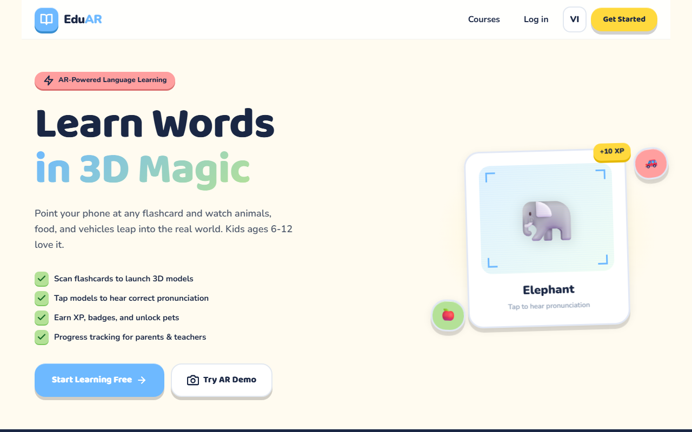
Figure 4.1. Home route at a desktop-sized viewport.
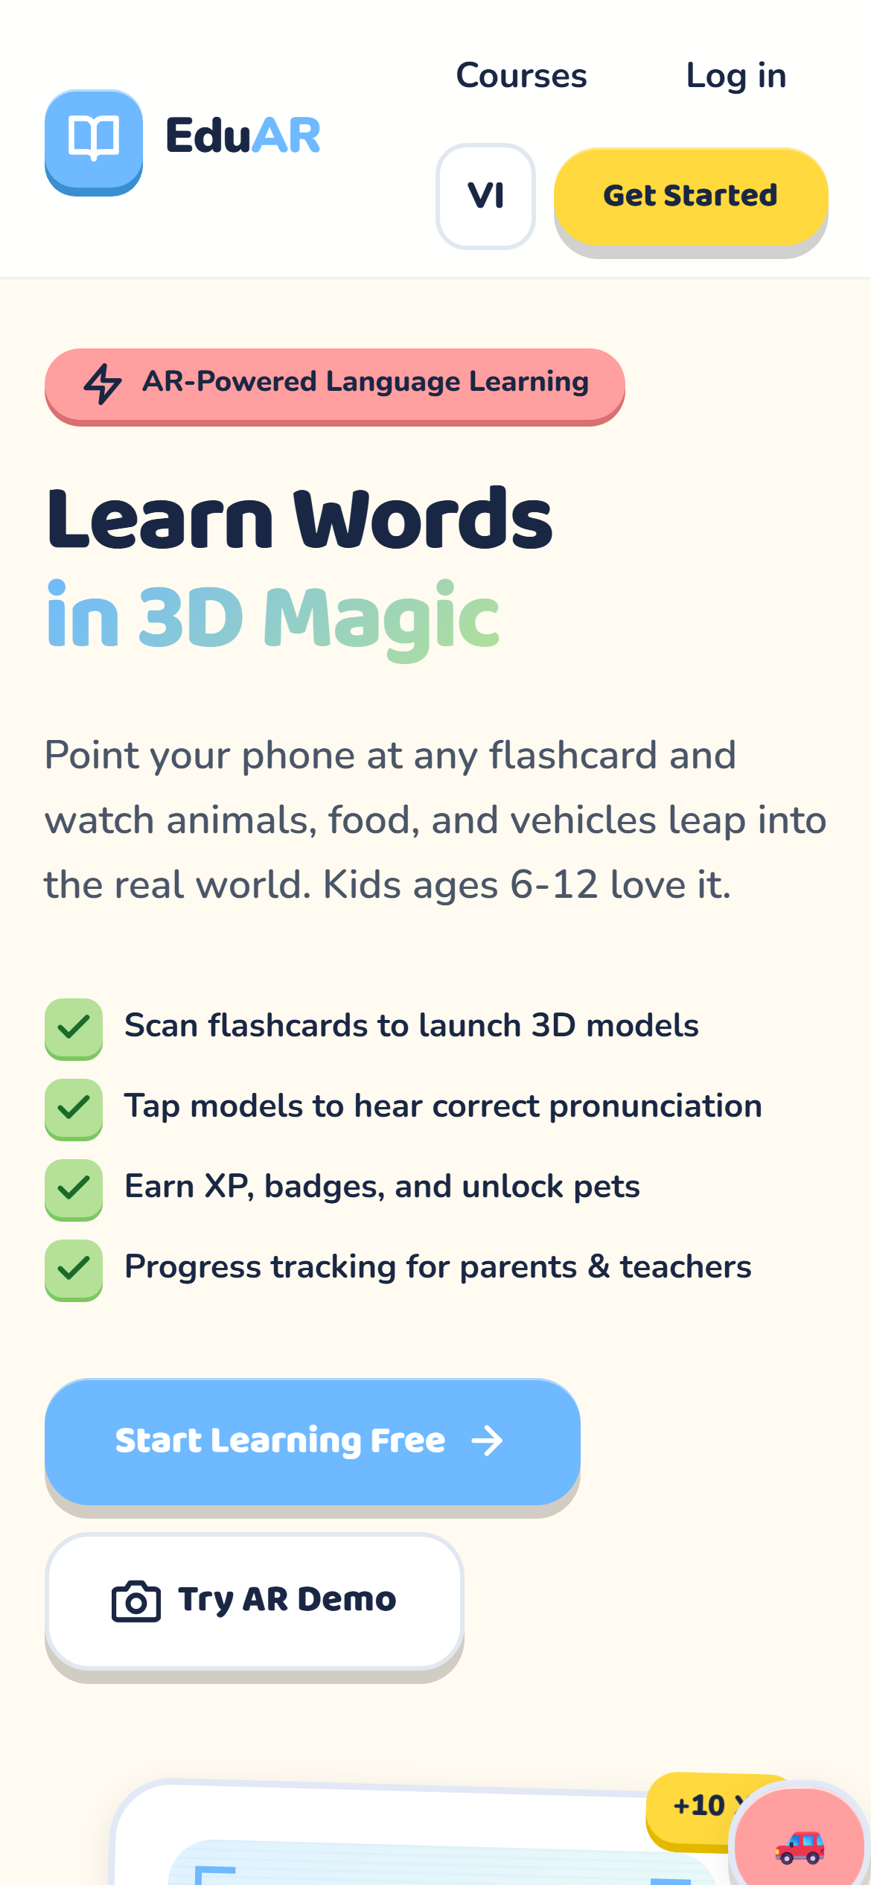
Figure 4.2. Home route at a narrow portrait viewport.
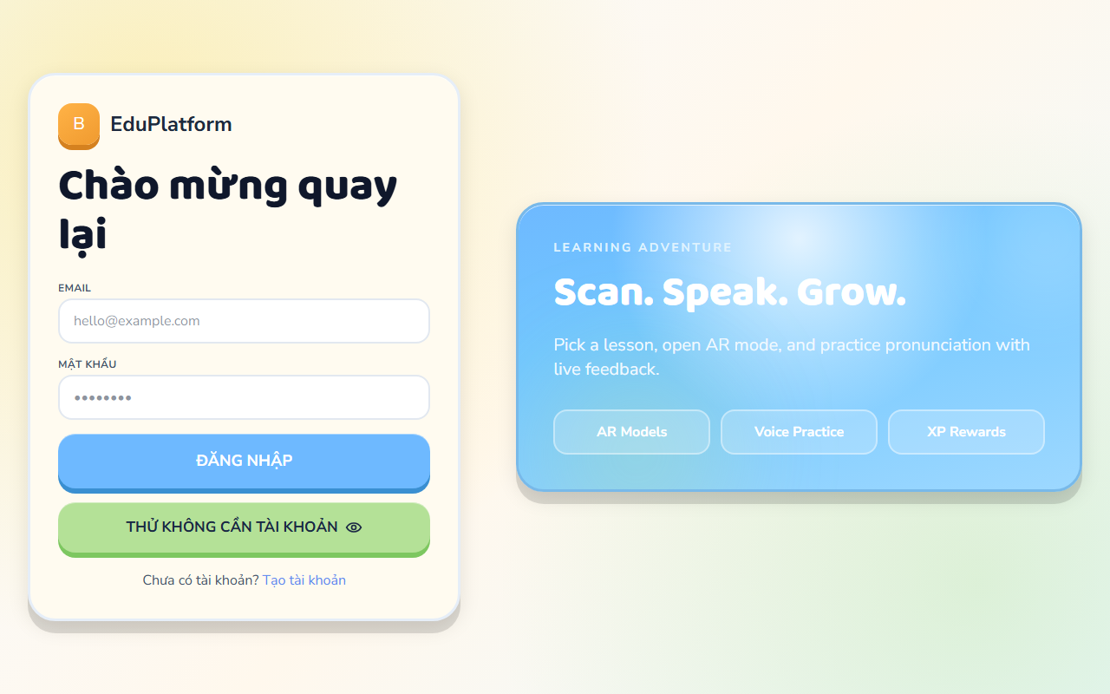
Figure 4.3. Login route at a desktop-sized viewport.
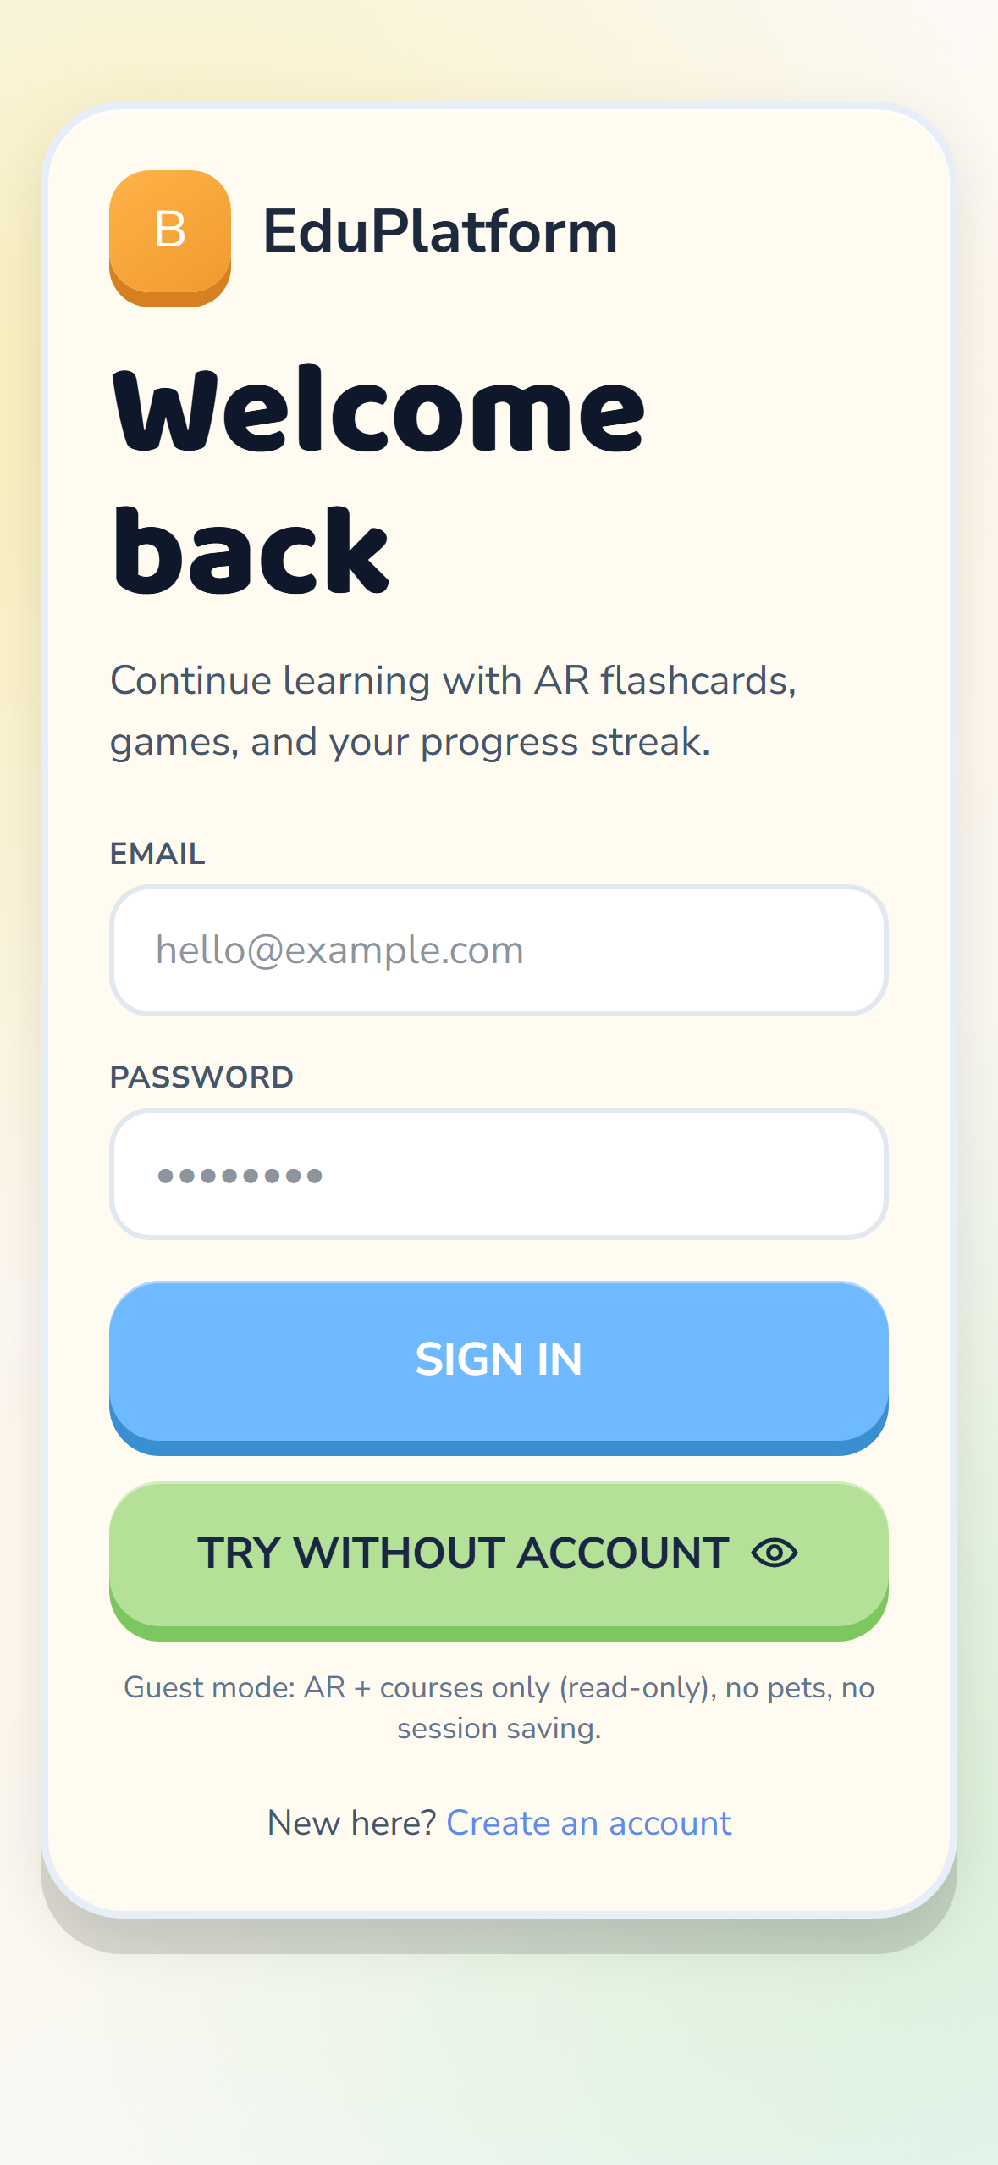
Figure 4.4. Login route at a narrow portrait viewport.
Across these captured states, the main content remains readable and the primary actions are not visibly clipped. The evidence is limited to the routes shown here and should not be extended into a claim that every game, report, notebook or AR screen has already been tested at the same viewport sizes.

4.8.1 Production Mobile-Web Runtime Evidence
The following screenshots were captured during functional testing on the deployed production mobile-web application. They show that the stated views were rendered and that the visible interactions were available in the tested run. The screenshots do not measure vocabulary-learning outcomes or establish usability for a larger child population.
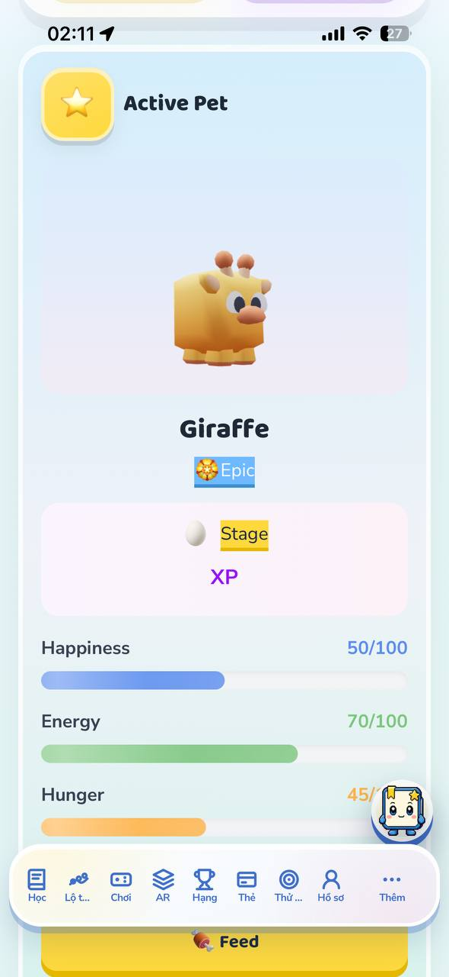
Figure 4.5. Active-pet view showing the Giraffe state, displayed meters and the feed action. Source: Runtime screenshot captured by the author during functional testing on the deployed production mobile-web application.
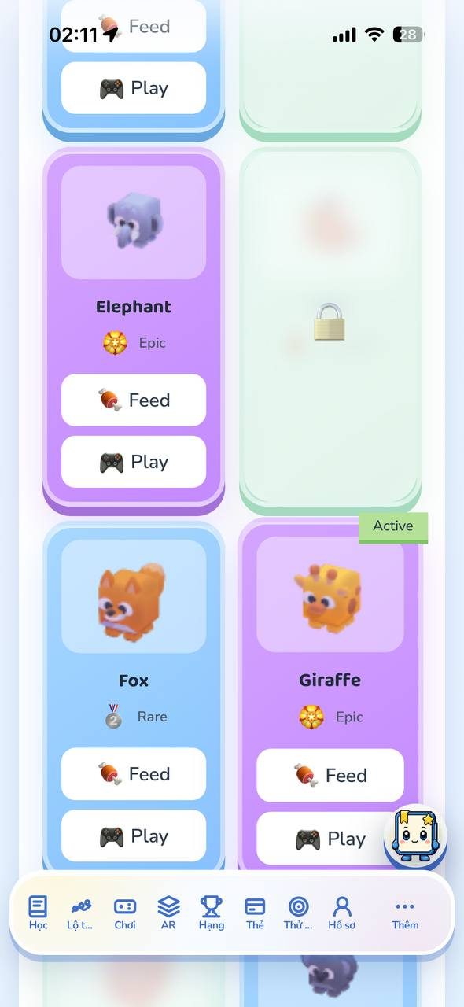
Figure 4.6. Pet collection view showing rarity, active status, a locked item and available feed/play actions. Source: Runtime screenshot captured by the author during functional testing on the deployed production mobile-web application.
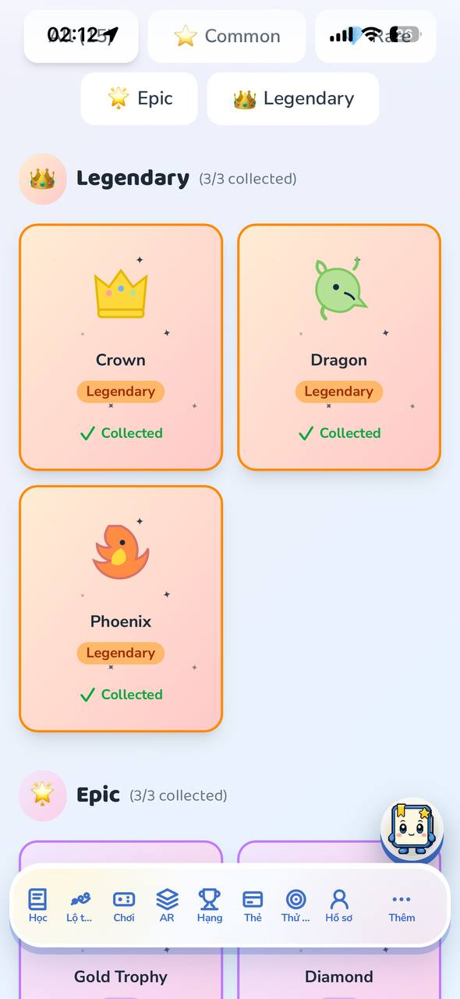
Figure 4.7. Legendary sticker collection view showing recorded collected states. Source: Runtime screenshot captured by the author during functional testing on the deployed production mobile-web application.
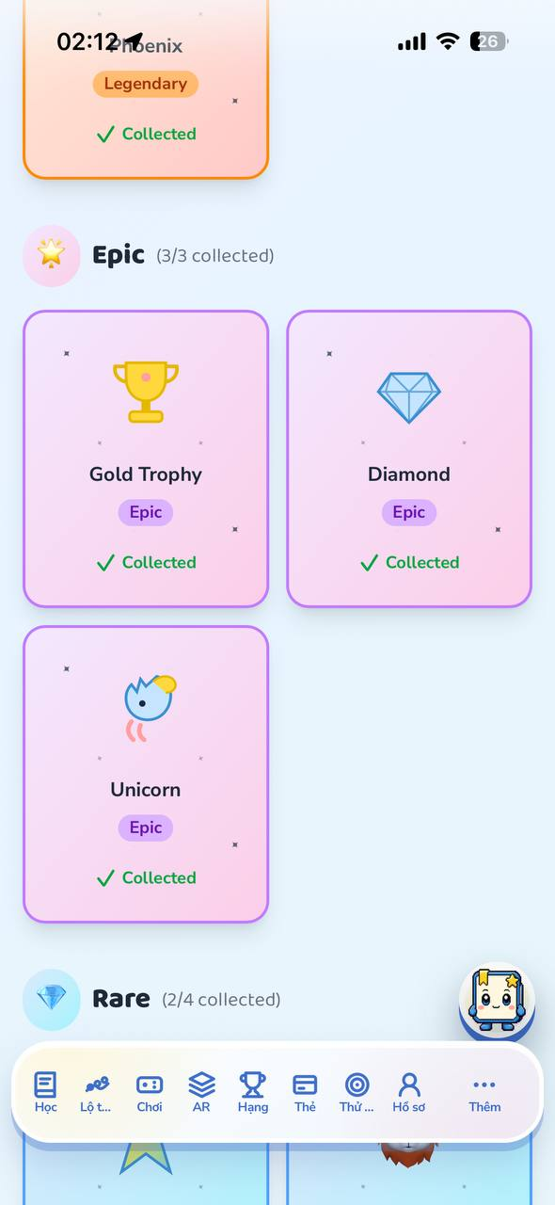
Figure 4.8. Epic and Rare sticker collection view showing recorded collection progress. Source: Runtime screenshot captured by the author during functional testing on the deployed production mobile-web application.
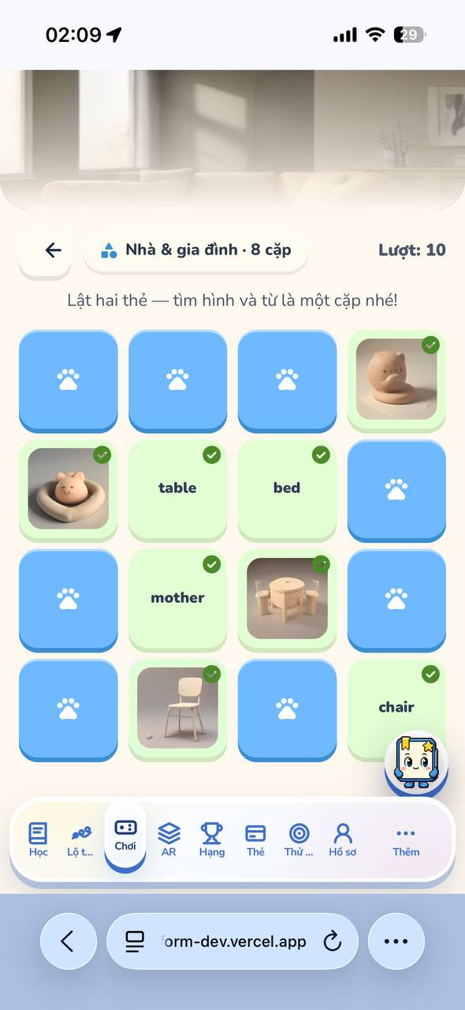
Figure 4.9. Memory matching game view showing recognized vocabulary pairs during gameplay. Source: Runtime screenshot captured by the author during functional testing on the deployed production mobile-web application.

4.8.2 Additional Production Mobile-Web Runtime Evidence
The following screenshots expand the captured production-run evidence for course discovery, progress and gamification, learning support, and the AR route. Each figure confirms the screen or interaction directly visible in the recorded browser session. The screenshots do not measure response correctness, cross-device reliability, or educational effectiveness.
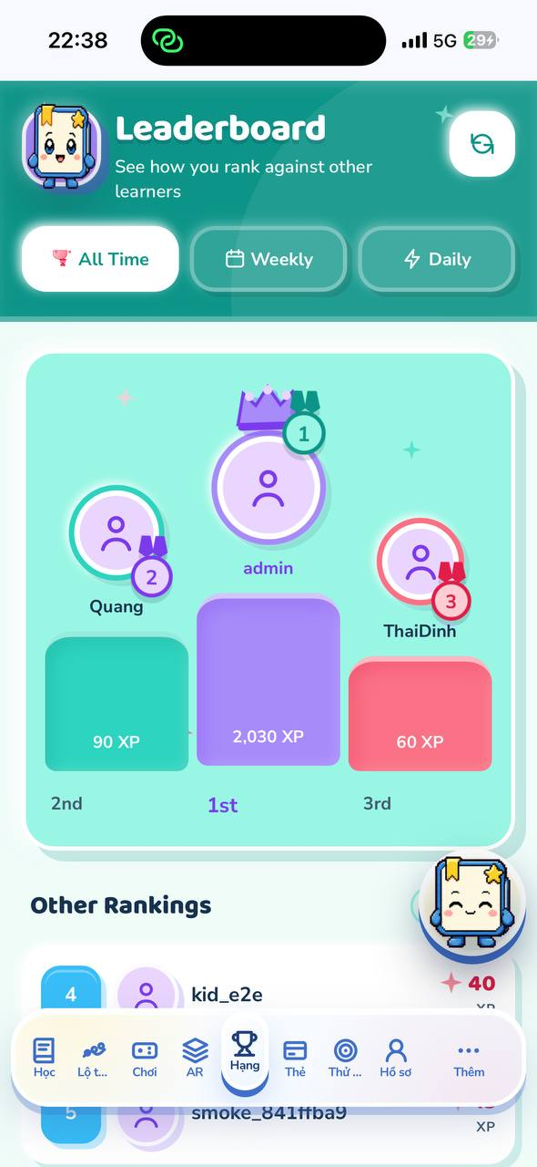
Figure 4.10. Leaderboard view showing the ranked learners and displayed XP values. Source: Runtime screenshot captured by the author on the deployed production mobile-web application.
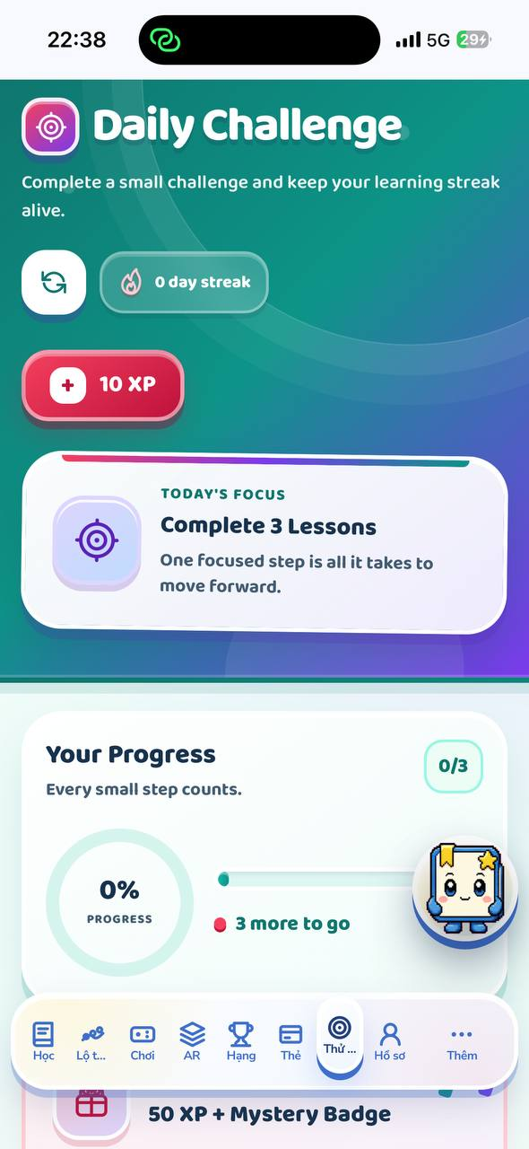
Figure 4.11. Daily Challenge view showing the current lesson goal, streak, reward and progress state. Source: Runtime screenshot captured by the author on the deployed production mobile-web application.
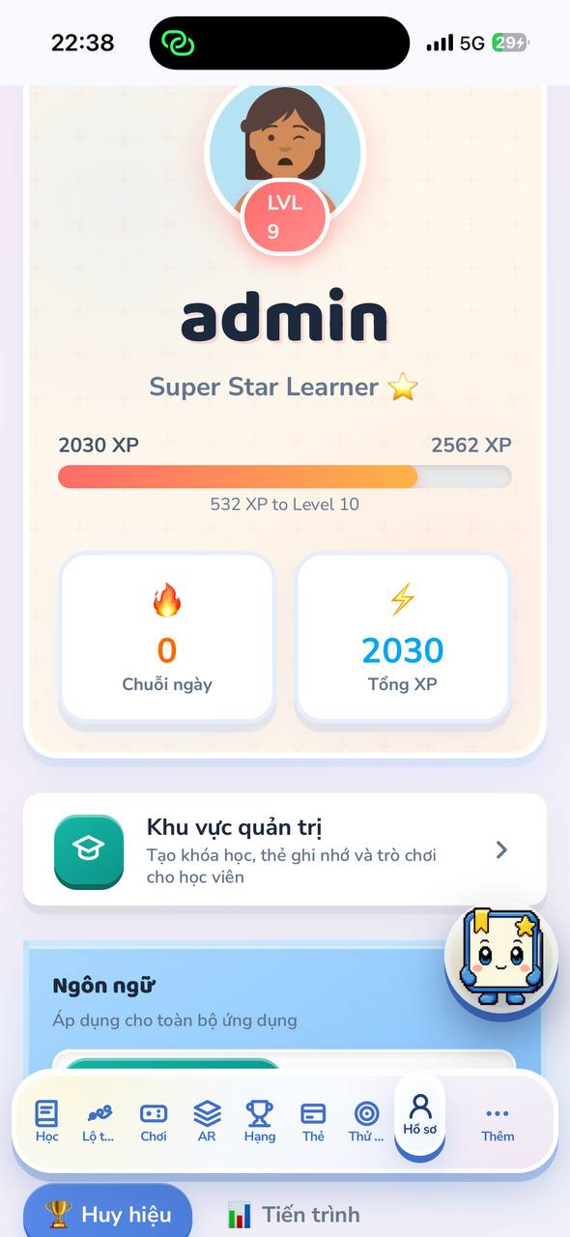
Figure 4.12. Learner profile view showing level, total XP, progress toward the next level and the protected account area entry. Source: Runtime screenshot captured by the author on the deployed production mobile-web application.
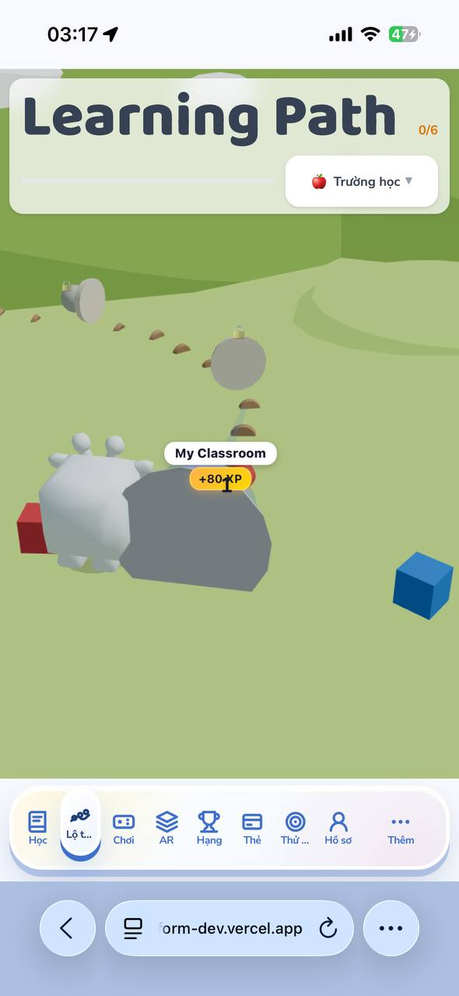
Figure 4.13. Learning Path view showing the selected school topic, route count and next learning card. Source: Runtime screenshot captured by the author on the deployed production mobile-web application.
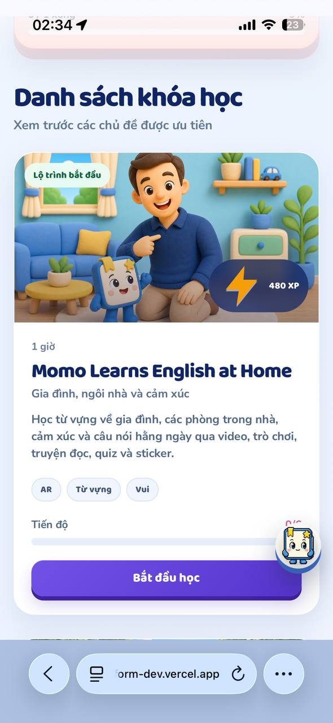
Figure 4.14. Course catalogue card showing the available course, learning topic, displayed XP and start action. Source: Runtime screenshot captured by the author on the deployed production mobile-web application.
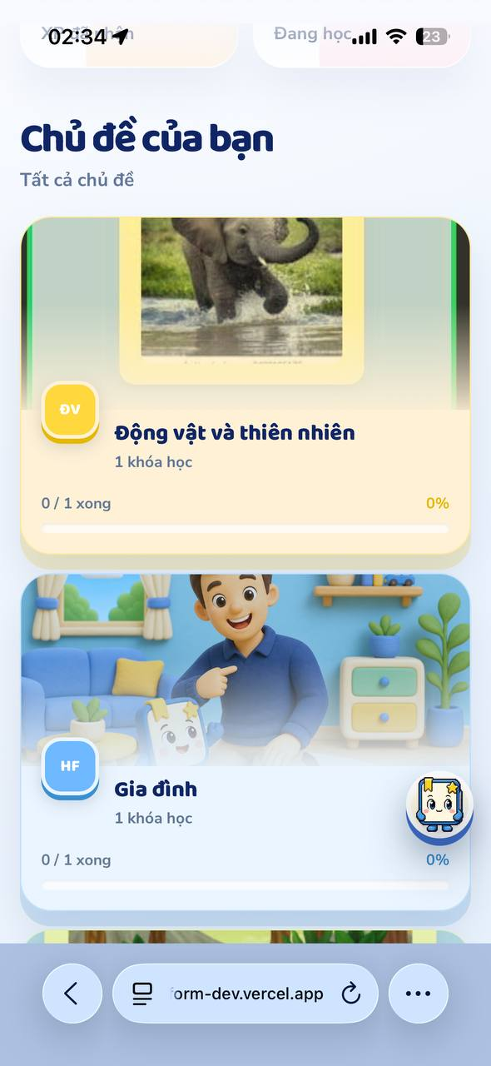
Figure 4.15. Topic selection view showing the animal and family course categories with their visible progress states. Source: Runtime screenshot captured by the author on the deployed production mobile-web application.
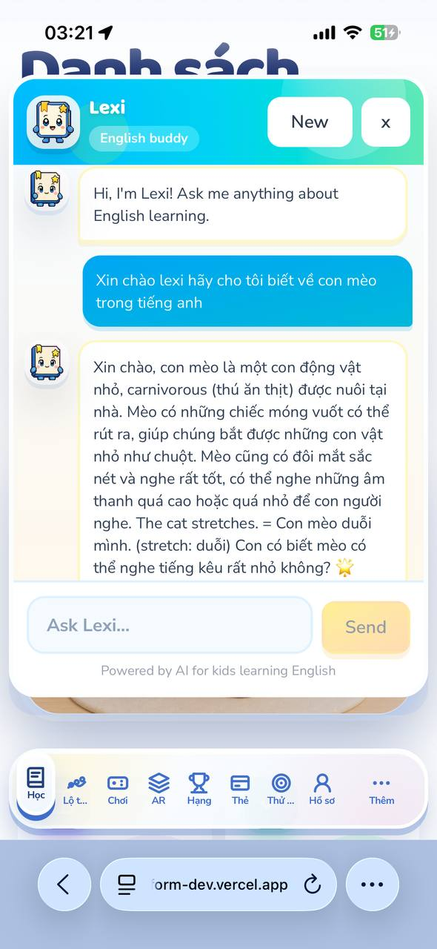
Figure 4.16. Lexi chat view showing a response to a learner question about the English word cat. Source: Runtime screenshot captured by the author on the deployed production mobile-web application.
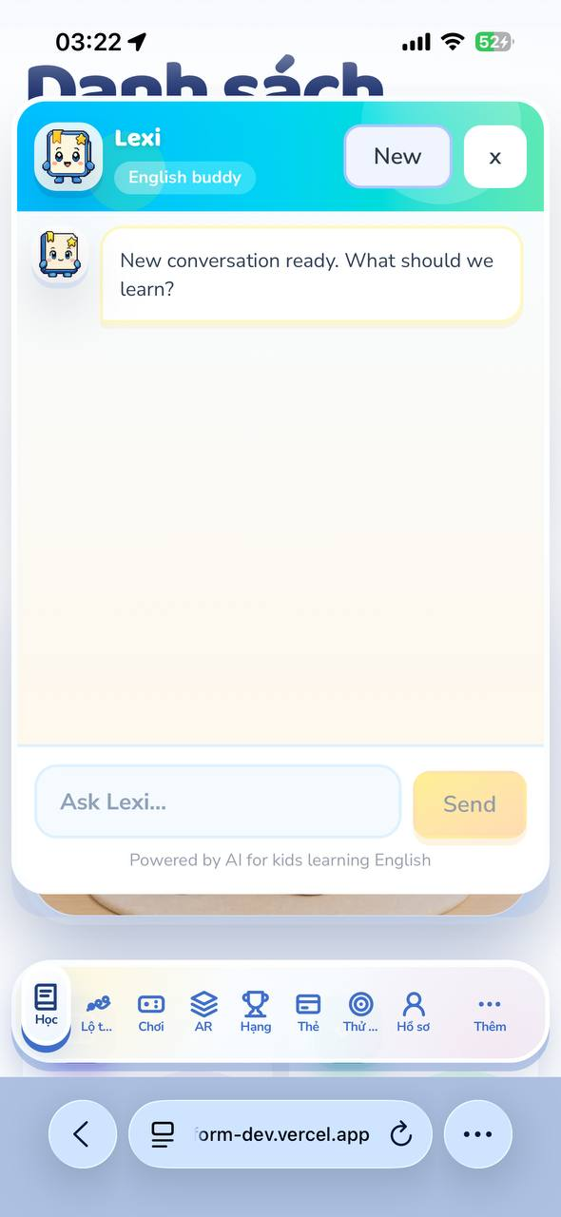
Figure 4.17. Lexi chat view after the learner starts a new conversation. Source: Runtime screenshot captured by the author on the deployed production mobile-web application.
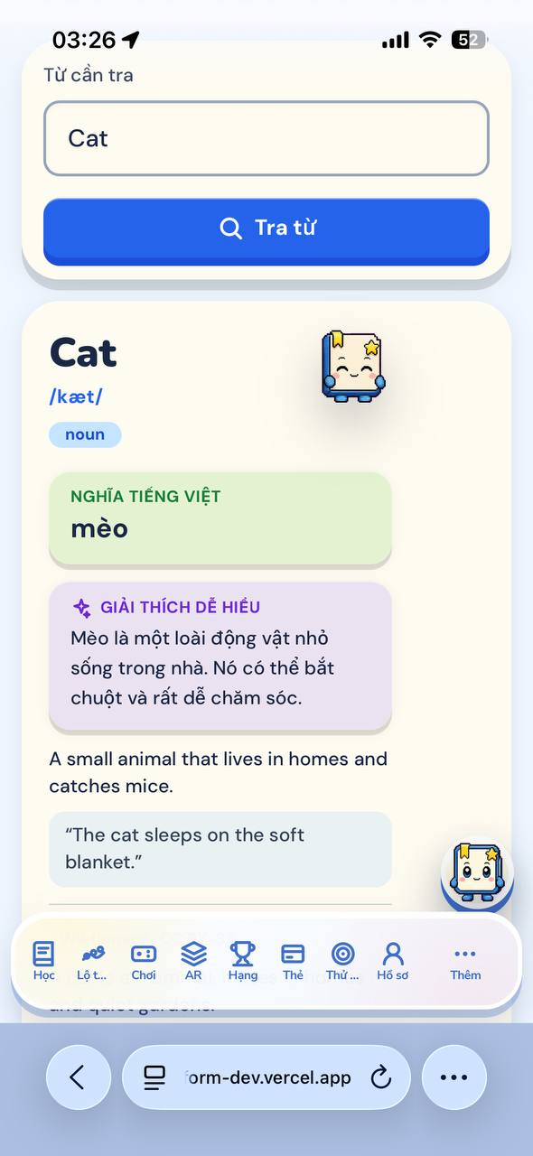
Figure 4.18. Word Check result for Cat showing the entered word, pronunciation, part of speech, Vietnamese meaning, explanation and example. Source: Runtime screenshot captured by the author on the deployed production mobile-web application.
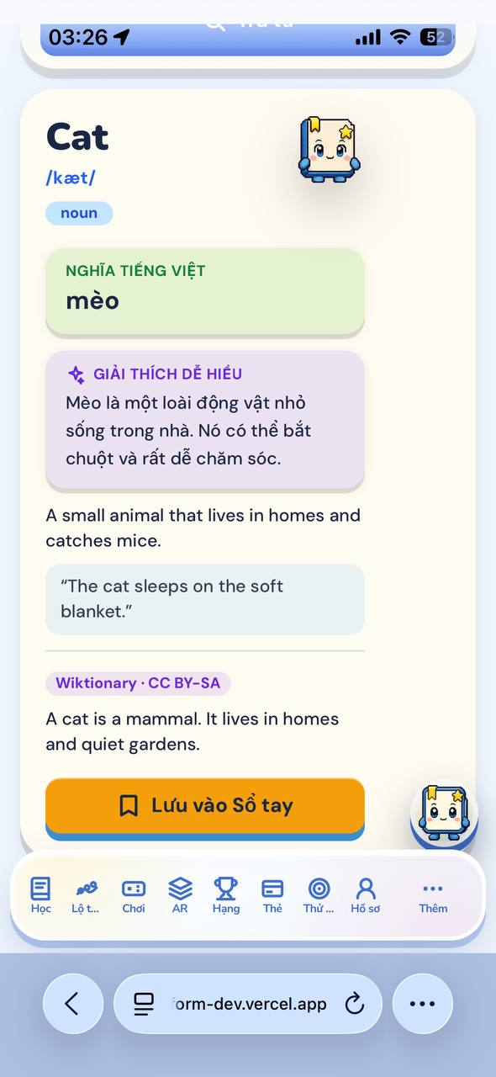
Figure 4.19. Continued Word Check result showing the source field and the available action to save Cat to the notebook. Source: Runtime screenshot captured by the author on the deployed production mobile-web application.
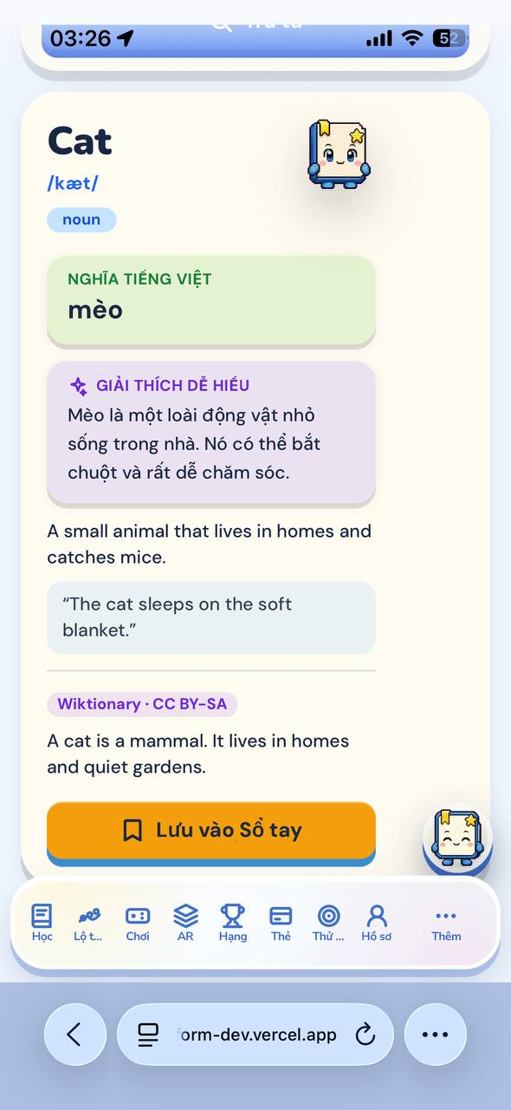
Figure 4.20. Second captured Word Check result state for Cat, retaining the displayed source and save action. Source: Runtime screenshot captured by the author on the deployed production mobile-web application.
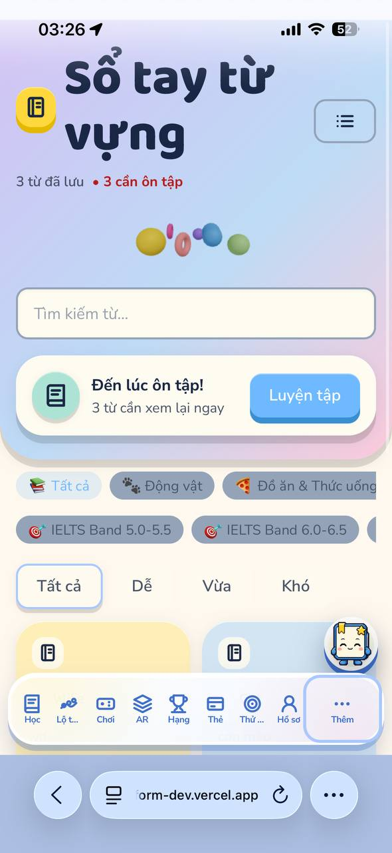
Figure 4.21. Vocabulary notebook view showing saved-word and review counts together with filter controls. Source: Runtime screenshot captured by the author on the deployed production mobile-web application.
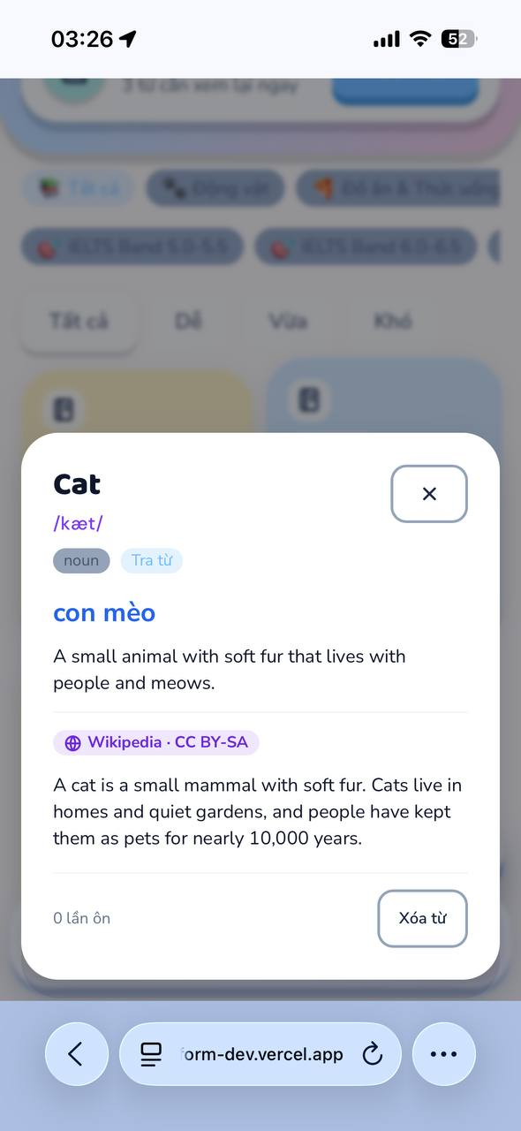
Figure 4.22. Vocabulary notebook detail view for Cat showing stored meaning, source, review count and the delete action. Source: Runtime screenshot captured by the author on the deployed production mobile-web application.
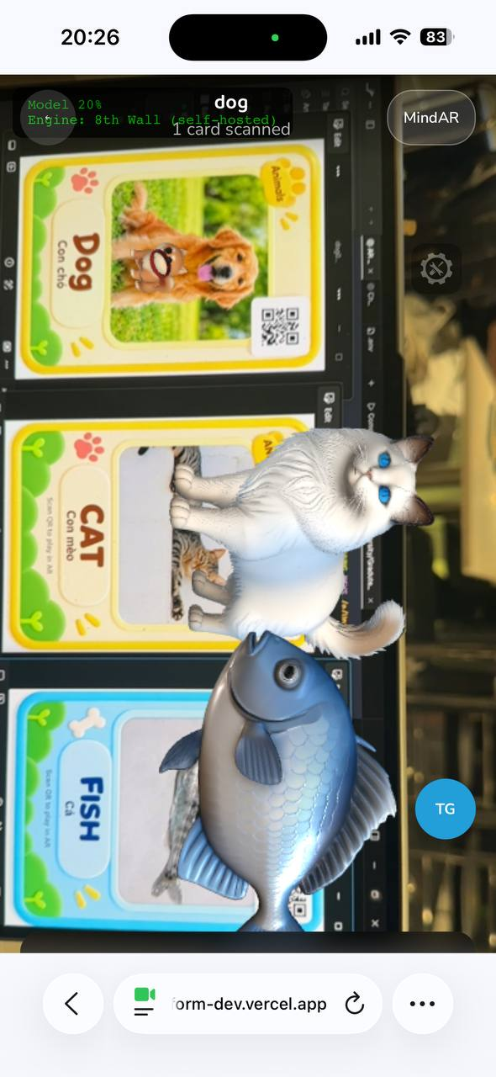
Figure 4.23. Deployed AR viewer with configured animal study cards visible and rendered 3D animal assets. Source: Runtime screenshot captured by the author on the deployed production mobile-web application.
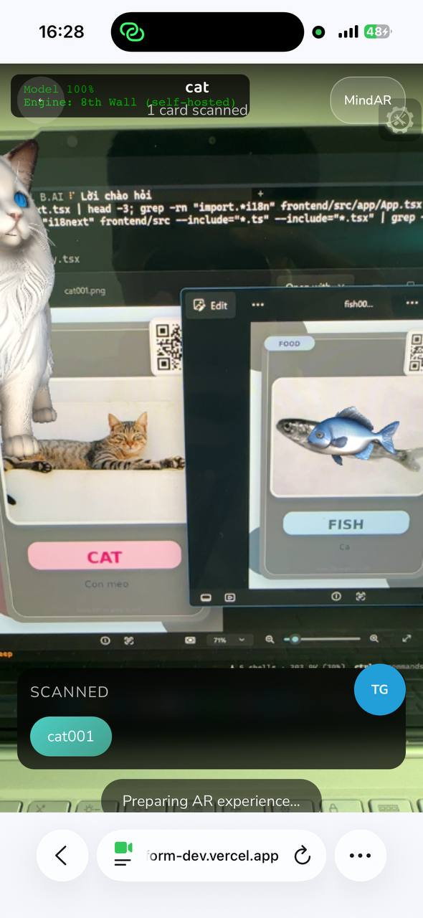
Figure 4.24. Deployed AR viewer reporting the scanned cat001 target while preparing the AR experience. Source: Runtime screenshot captured by the author on the deployed production mobile-web application.
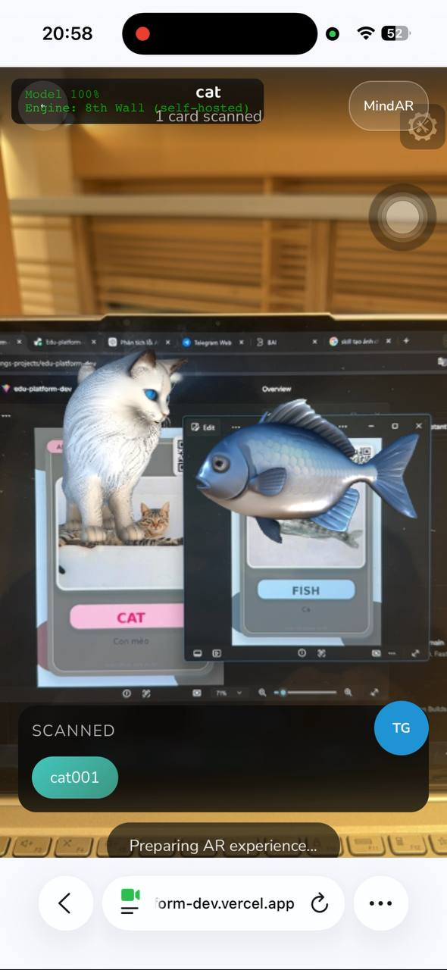
Figure 4.25. Cat and Fish rendered together in the deployed AR viewer during the captured cat001 target interaction. Source: Runtime screenshot captured by the author on the deployed production mobile-web application.

4.9 Recovery and Negative-path Checks
Recovery behaviour is checked as part of the feature flow. Pronunciation can move from browser speech recognition to recorded-audio transcription when required. Chatbot requests distinguish authentication, timeout, server and offline failures. Translate keeps an error and retry state. In AR, a camera, target or model problem remains separate from the underlying vocabulary item so the learner can return to the ordinary lesson path.
One current exception is the session reminder presentation. The session state model still exists, but the global reminder component is temporarily bypassed while AR work is being tested. Since the warning is not currently presented to the learner, this visible behaviour is not marked as passed in this chapter.

4.10 Observed Issues and Evidence Gaps
The main gap is uneven retained evidence. Login and the public responsive routes have clear screenshots. One-card and multi-card AR have development-run evidence, but not a broad device benchmark. Pet Companion, Word Check, Notebook, Translate and Daily Challenge still need clean final browser artefacts if they are to be presented as fully reproduced tests in the submitted thesis.

4.11 Evaluation
The strongest result is functional integration rather than educational effectiveness. The current evidence does not support claims about vocabulary retention, pronunciation improvement or stable AR performance across different phones.
Most partial results are caused by missing final artefacts or environment-dependent behaviour, rather than evidence that the feature is absent. A final regression pass should therefore focus on reproducing and retaining those states instead of adding more implementation description.

4.12 Chapter Summary
This chapter tested the current Edu-platform prototype across the ordinary learning path, practice features, progress and parent-facing functions, optional learning-support services, AR interaction, and technical recovery paths. The results distinguish observed runs from source-backed or environment-limited paths. AR is reported as one tested module rather than as the whole application. Login, one-card AR and multi-card AR currently have stronger run evidence, while several browser and service-dependent features still need final artefacts before they are described as fully reproduced tests.
The remaining work is mainly verification work: retain screenshots for missing learner routes, repeat the negative AR cases on the target device, and remove or clearly isolate temporary placeholder or bypass behaviour before final submission.

CHAPTER 5:
CONCLUSION AND FUTURE WORK

5.1 Summary of the work
This thesis presented the analysis, design, implementation, and evaluation boundary of Edu-platform, a mobile-oriented English learning system for children. The system combines structured courses and lessons with flashcards, pronunciation practice, games, gamification, parent/session tracking, learning-path configuration, leaderboard and daily challenge mechanisms. QR scanning and one-card AR add a physical interaction layer, while the chatbot provides optional assistance. The implementation uses a FastAPI backend, PostgreSQL persistence through Supabase, Supabase Storage for media and AR assets, a React frontend, Playwright evidence, and an isolated 8th Wall Engine viewer. The database model is treated as a durable source of truth. Optional services and AR assets are deliberately prevented from blocking the basic vocabulary path.

5.2 Contributions
Phần đóng góp của EduAR không nằm ở một chức năng riêng lẻ mà chủ yếu ở cách các phần của hệ thống được tách và nối với nhau. Flow học thông thường như course, lesson, flashcard, game hay pronunciation vẫn chạy độc lập với AR và chatbot. Vì vậy hai phần này có thể được bật, sửa hoặc tạm thời không dùng mà không làm mất progress hay chặn lesson của trẻ.
Ở phần dữ liệu, learning event, practice attempt, progress và reward được nối với nhau theo quá trình học thay vì tạo database theo từng screen. Với AR thì ba phần này không dùng chung một nhiệm vụ. QR chỉ giúp EduAR biết trẻ vừa quét thẻ nào. Image target là phần 8th Wall dùng để bám theo hình trên thẻ, còn model 3D là nội dung được đưa lên camera sau khi target đã được nhận ra.. Cách tách này giúp việc xử lý lỗi dễ hơn, vì một lỗi nhìn giống nhau trên màn hình chưa chắc đến từ cùng một chỗ.
Trong lúc test AR có trường hợp model vẫn hiện nhưng diagnostic cũ lại báo URL không dùng được. Cũng có lúc model nhìn quá nhỏ nhưng nguyên nhân lại nằm ở target origin chứ không phải scale. ì vậy khi AR có lỗi, tôi kiểm tra từng phần riêng chứ không chỉ nhìn model trên camera rồi đoán nguyên nhân. Playwright được dùng cho những flow có thể chạy và kiểm tra trên giao diện web. Còn tốc độ AR trên nhiều loại máy và việc trẻ học tốt hơn bao nhiêu thì thesis này chưa kiểm tra tới.
Về implementation, một learning action có thể được lần từ route ở frontend, request API, record được lưu và tới AR target hoặc model nếu activity đó có dùng AR. Điều này giúp phần web learning và phần AR không bị phụ thuộc quá chặt vào nhau.

5.3 Limitations and future work
The current evaluation is limited by the available Playwright artifacts and source audit. It does not include a controlled learner study, a large physical-device benchmark, or an independent pronunciation validation set. The AR experience remains sensitive to target authoring, camera conditions, asset delivery, and browser behaviour. These limitations do not invalidate the engineering design, but they restrict the strength of claims that can be made.
Future work should add a target-authoring validation tool, a device telemetry study, offline-friendly asset caching, richer parent analytics, and an evaluation of delayed vocabulary recall. A future AR engine comparison could be conducted only after defining identical targets, models, devices, lighting, and interaction tasks. The comparison should measure reliability and maintenance cost rather than relying on a single successful demonstration.
Future work should prioritise evidence and asset tooling before adding more visible features. A manifest validator, physical-device test harness and event inspection tooling would make AR failures easier to classify and would provide a stronger basis for later comparisons between one-card AR, multi-card AR and an equivalent non-AR learning path across several devices.

5.4 Conclusion
Edu-platform demonstrates a practical way to combine child-oriented language practice with optional marker-based AR while retaining a stable web learning core. Its value lies in the boundaries between features: identity is separated from progress, QR identity from tracking identity, target tracking from model rendering, and reward display from reward persistence.

REFERENCES

[1] A. Ibrahim, B. Huynh, J. Downey, T. Hollerer, D. Chun, and J. O'Donovan, "ARbis Pictus: A Study of Vocabulary Learning with Augmented Reality," IEEE Transactions on Visualization and Computer Graphics, vol. 24, no. 11, pp. 2867-2874, 2018, doi: 10.1109/TVCG.2018.2868568.
[2] C. S. Che Dalim, M. S. Sunar, A. Dey, and M. Billinghurst, "Using Augmented Reality with Speech Input for Non-native Children's Language Learning," International Journal of Human-Computer Studies, vol. 134, pp. 44-64, 2020, doi: 10.1016/j.ijhcs.2019.10.002.
[3] Y. Kheir, A. Ali, and S. Chowdhury, "Automatic Pronunciation Assessment - A Review," Findings of the Association for Computational Linguistics: EMNLP 2023, pp. 8304-8324, 2023, doi: 10.18653/v1/2023.findings-emnlp.557.
[4] R. Moreno and R. E. Mayer, "Cognitive Principles of Multimedia Learning: The Role of Modality and Contiguity," Journal of Educational Psychology, vol. 91, no. 2, pp. 358-368, 1999, doi: 10.1037/0022-0663.91.2.358.
[5] R. E. Mayer and R. Moreno, "A Split-attention Effect in Multimedia Learning: Evidence for Dual Processing Systems in Working Memory," Journal of Educational Psychology, vol. 90, no. 2, pp. 312-320, 1998, doi: 10.1037/0022-0663.90.2.312.
[6] R. E. Mayer and R. Moreno, "Animation as an Aid to Multimedia Learning," Educational Psychology Review, vol. 14, no. 1, pp. 87-99, 2002, doi: 10.1023/A:1013184611077.
[7] R. Moreno and R. E. Mayer, "A Coherence Effect in Multimedia Learning," Journal of Educational Psychology, vol. 92, no. 1, pp. 117-125, 2000, doi: 10.1037/0022-0663.92.1.117.
[8] J. M. Clark and A. Paivio, "Dual Coding Theory and Education," Educational Psychology Review, vol. 3, no. 3, pp. 149-210, 1991, doi: 10.1007/BF01320076.
[9] C. Andra, B. Mathias, A. Schwager, M. Macedonia, and K. von Kriegstein, "Learning Foreign Language Vocabulary with Gestures and Pictures Enhances Vocabulary Memory for Several Months Post-Learning in Eight-Year-Old School Children," Educational Psychology Review, vol. 32, no. 3, pp. 815-850, 2020, doi: 10.1007/s10648-020-09527-z.
[10] A. M. Toda et al., "Analysing Gamification Elements in Educational Environments Using an Existing Gamification Taxonomy," Smart Learning Environments, vol. 6, no. 1, 2019, doi: 10.1186/s40561-019-0106-1.
[11] J. Hamari, J. Koivisto, and H. Sarsa, "Does Gamification Work? A Literature Review of Empirical Studies on Gamification," 47th Hawaii International Conference on System Sciences, pp. 3025-3034, 2014, doi: 10.1109/HICSS.2014.377.
[12] J. L. Plass, B. D. Homer, and C. K. Kinzer, "Foundations of Game-Based Learning," Educational Psychologist, vol. 50, no. 4, pp. 258-283, 2015, doi: 10.1080/00461520.2015.1122533.
[13] T. M. Connolly, E. A. Boyle, E. MacArthur, T. Hainey, and J. M. Boyle, "A Systematic Literature Review of Empirical Evidence on Computer Games and Serious Games," Computers & Education, vol. 59, no. 2, pp. 661-686, 2012, doi: 10.1016/j.compedu.2012.03.004.
[14] S. Madigan, D. Browne, N. Racine, C. Mori, and S. Tough, "Association Between Screen Time and Children's Performance on a Developmental Screening Test," JAMA Pediatrics, vol. 173, no. 3, p. 244, 2019, doi: 10.1001/jamapediatrics.2018.5056.
[15] J. S. Hutton, J. Dudley, T. Horowitz-Kraus, T. DeWitt, and S. K. Holland, "Associations Between Screen-Based Media Use and Brain White Matter Integrity in Preschool-Aged Children," JAMA Pediatrics, vol. 174, no. 1, p. e193869, 2020, doi: 10.1001/jamapediatrics.2019.3869.
[16] N. Stiglic and R. M. Viner, "Effects of Screentime on the Health and Well-being of Children and Adolescents: A Systematic Review of Reviews," BMJ Open, vol. 9, no. 1, p. e023191, 2019, doi: 10.1136/bmjopen-2018-023191.[17] M. Mihaylova, S. Gorin, T. P. Reber, and N. Rothen, "A Meta-Analysis on Mobile-Assisted Language Learning Applications: Benefits and Risks," Psychologica Belgica, vol. 62, no. 1, p. 252, 2022, doi: 10.5334/pb.1146.
[18] F. Ehsani and E. Knodt, "Speech Technology in Computer-Aided Language Learning: Strengths and Limitations of a New CALL Paradigm," Language Learning & Technology, vol. 2, no. 1, pp. 54-73, 1998, doi: 10.64152/10125/25032.
[19] T.-C. Hsu, "Learning English with Augmented Reality: Do Learning Styles Matter?" Computers & Education, vol. 106, pp. 137-149, 2017, doi: 10.1016/j.compedu.2016.12.007.
[20] E. Korosidou, "The Effects of Augmented Reality on Very Young Learners' Motivation and Learning of the Alphabet and Vocabulary," Digital, vol. 4, no. 1, pp. 195-214, 2024, doi: 10.3390/digital4010010.
[21] K. Okumus Dagdeler, "A Systematic Review of Mobile-Assisted Vocabulary Learning Research," Smart Learning Environments, vol. 10, art. no. 19, 2023, doi: 10.1186/s40561-023-00235-z.
[22] A. E. S. Hanson and C. M. Brown, "Enhancing L2 Learning through a Mobile-Assisted Spaced-Repetition Tool: An Effective but Bitter Pill?" Computer Assisted Language Learning, vol. 33, nos. 1-2, pp. 133-155, 2020, doi: 10.1080/09588221.2018.1552975.
[23] C.-M. Chen, H. Liu, and H.-B. Huang, "Effects of a Mobile Game-Based English Vocabulary Learning App on Learners' Perceptions and Learning Performance: A Case Study of Taiwanese EFL Learners," ReCALL, vol. 31, no. 2, pp. 170-188, 2019, doi: 10.1017/S0958344018000228.
[24] J. Michot, M. Hurlimann, J. Deriu, L. Sauer, K. Mlynchyk, and M. Cieliebak, "Error-Preserving Automatic Speech Recognition of Young English Learners' Language," in Proc. 62nd Annual Meeting of the Association for Computational Linguistics, vol. 1, pp. 6444-6454, 2024, doi: 10.18653/v1/2024.acl-long.348.
[25] M. M. Zhang, H. Hashim, and M. M. Yunus, "Analyzing and Comparing Augmented Reality and Virtual Reality Assisted Vocabulary Learning: A Systematic Review," Frontiers in Virtual Reality, vol. 6, art. 1522380, 2025, doi: 10.3389/frvir.2025.1522380.
[26] C. C. Y. Liao, Z.-H. Chen, and T.-W. Chan, "Designing the Game-Based Environment to Facilitate Learners' Interaction in Performance-Based Learning by Virtual Pets," in Proc. 9th International Conference on Computer Supported Collaborative Learning, pp. 429-433, 2009, doi: 10.3115/1600053.1600116.
[27] C. Lin, T. Faas, L. Dombrowski, and E. Brady, "Beyond Cute: Exploring User Types and Design Opportunities of Virtual Reality Pet Games," in Proc. 23rd ACM Symposium on Virtual Reality Software and Technology, pp. 1-10, 2017, doi: 10.1145/3139131.3139132.
[28] M. Sailer and L. Homner, "The Gamification of Learning: A Meta-Analysis," Educational Psychology Review, vol. 32, no. 1, pp. 77-112, 2020, doi: 10.1007/s10648-019-09498-w.
[29] J. Sandberg, M. Maris, and P. Hoogendoorn, "The Added Value of a Gaming Context and Intelligent Adaptation for a Mobile Learning Application for Vocabulary Learning," Computers & Education, vol. 76, pp. 119-130, 2014, doi: 10.1016/j.compedu.2014.03.006.
[30] R. M. Yilmaz, F. B. Topu, and A. Takkac Tulgar, "An Examination of Vocabulary Learning and Retention Levels of Pre-School Children Using Augmented Reality Technology in English Language Learning," Education and Information Technologies, vol. 27, no. 5, pp. 6989-7017, 2022, doi: 10.1007/s10639-022-10916-w.
[31] R. Cerezo, V. Calderón, and C. Romero, "A Holographic Mobile-Based Application for Practicing Pronunciation of Basic English Vocabulary for Spanish-Speaking Children," International Journal of Human-Computer Studies, vol. 124, pp. 13-25, 2019, doi: 10.1016/j.ijhcs.2018.11.009.
[32] C. Chen, N. Jamiat, S. N. A. Rabu, and S. Du, "Effects of Augmented Reality with Pedagogical Agent on EFL Primary Students' Vocabulary Acquisition, Motivation, and Technology Perceptions," International Journal of Human-Computer Interaction, 2025, doi: 10.1080/10447318.2024.2443534.

APPENDIX A: CONFIRMED FEATURE TRACEABILITY

- Login: Identity and protected user state
- Courses/Lessons: courses, lessons, and progress tables
- Flashcards: flashcard decks and QR vocabulary records
- Pronunciation: pronunciation attempts and audio storage
- Games: quiz and mini-game content
- Gamification: points, levels, streaks, badges, and idempotent events
- Parent/Session Tracking: course progress, lesson progress, sessions, steps, and attempts
- QR Scanning: QR-to-flashcard resolution
- One-card AR: tracking target to model mapping
- Chatbot: service interaction; no dedicated persistence table evidenced
- Learning Path: user priority topics and daily goals
- Leaderboard: derived view over gamification points
- Daily Challenge: daily learning progress plus learning-path goals
- Pet Companion: virtual-pet state and progression linked to gamification rewards
- Word Check: vocabulary lookup and controlled not-found state
- Dictionary/Notebook: reusable learner vocabulary review and saved word entries
- Translate: translation request and returned learner-facing text state
- Multi-card AR: simultaneous supported targets, semantic combination rules, and configured interaction trigger

APPENDIX B: DATA-MODEL REFERENCE TABLES

This appendix records the entity groups and selected physical tables represented by the Chapter 3 CDM and PDM. It is a compact reference for the implemented PostgreSQL schema, not a second schema specification.
Table B.1. Conceptual entity groups represented in the CDM.
- Domain | - Representative entities | - Relationship covered
- Learning content | - courses; lessons; flashcard_decks; flashcards | - Courses organise lessons; decks organise vocabulary cards.
- Learner state | - users; user_course_progress; user_course_lesson_progress; lesson_sessions; lesson_session_steps | - Learner state is linked to the selected course, lesson and session steps.
- Review and support | - learning_progress; word_mastery; notebook_entries; chat_logs | - Review state belongs to the learner; chat history is session-scoped.
- Engagement | - user_gamification; gamification_events; pets; user_unlocked_pets; learning_paths | - Progress and reward events remain separate from pet ownership and path preferences.
- AR content | - ar_tracking_targets; ar_objects; ar_combinations; ar_combination_required_tags | - Tracking, renderable assets and supported combinations use distinct identifiers.
Table B.2. Selected physical-table reference from the PDM.
- Table | - Primary key | - Key relationship | - Implemented role
- users | - id | - Owns learner state and progress records | - Learner identity and protected role state.
- courses | - course_id | - Referenced by lessons and learner course progress | - Published course metadata and learning context.
- lessons | - lesson_id | - course_id -> courses.course_id | - Ordered learning content inside a course.
- flashcards | - qr_id | - deck_id -> flashcard_decks.deck_id; ar_tag is an application mapping | - Vocabulary identity, media and AR association.
- user_course_progress | - (user_id, course_id) | - user_id -> users.id; course_id -> courses.course_id | - Per-learner course state and accumulated course XP.
- lesson_sessions | - session_id | - References user, course and lesson | - Current lesson step and completion state.
- ar_tracking_targets | - target_id | - qr_id -> flashcards.qr_id | - Physical target metadata and XR target files.
- ar_objects | - ar_tag | - Mapped by application AR tag | - Model URL, animation and render presentation metadata.
- ar_combinations | - combo_id | - Required tags stored in ar_combination_required_tags | - Supported multi-card interaction definition.
Table B.3. AR identity and asset-mapping reference.
- Layer | - Table and identifiers | - Mapping | - Runtime purpose
- Learning identity | - flashcards.qr_id and flashcards.ar_tag | - qr_id identifies the learning card; ar_tag identifies AR semantics. | - Keeps the vocabulary item stable across normal and AR routes.
- Tracking identity | - ar_tracking_targets.target_id and qr_id | - The target record maps a card to xr_target_json_url and xr_target_image_url. | - Registers the physical image target without treating it as the model asset.
- Renderable asset | - ar_objects.ar_tag | - ar_tag selects model_3d_url and animation metadata. | - Loads the model and configured behaviour after target handling.
- Interaction rule | - ar_combinations.combo_id and ar_combination_required_tags | - Configured tag pairs select a supported combination rule. | - Determines whether recognised items can use the configured Cat-Fish or other interaction.

APPENDIX C: DEMONSTRATION AND SOURCE CODE

Table C.1. Project demonstration and source access.
ITEM | LINK
DEMO VIDEO | https://drive.google.com/drive/folders/19AWV3cJ-ju9dkjGySavrCRIM457320qM?usp=sharing
SOURCE CODE | https://github.com/PhungGiaDat/Edu-platform

