**# Project_GPT**

This project is a proposed solution for Maybelline upcoming problem which is developing new product.

This project aiming to support the brand on collecting and utilizing availabel data, and leveraging AI for decision support

**## Below is the installation guide for this project**

1. Clone this repository

2. Open terminal and run the bellow command to install dependencies:

$ pip install -r requirements

3. Run run.web.py to instantiate the backend

4. Navigate to templates folder and run index.html to start the interface

**# Example usage**

**## Charts**

All the chart within the website are interactive and filter are available.

**## GPT usage sample**

There 2 main tasks: Feedback Analysis and Product Improvement Support

**### Feedback Analysis**

The user first choose the sub-task want to perform

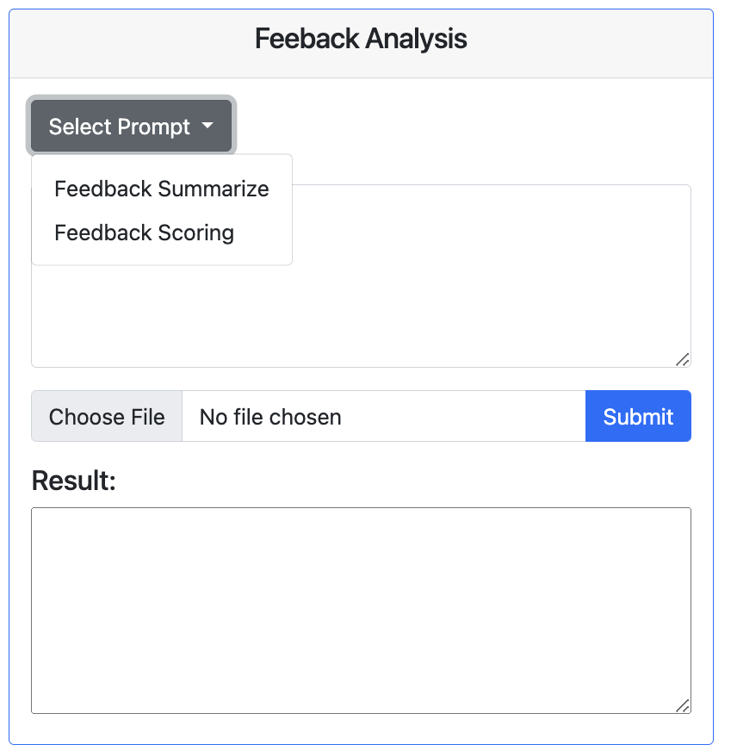

The user can either enter manually or upload a sample file which is provided inside the folder data_for_demo, then click Submit

**### Product Improvement Support**

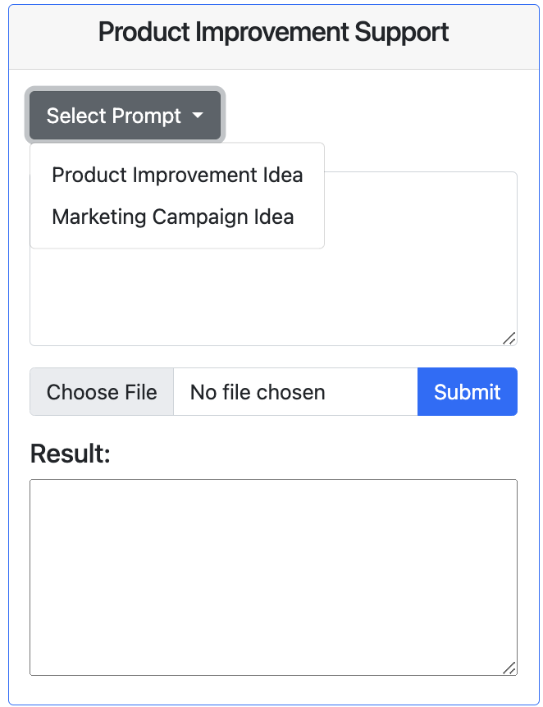

The procedure is the same with this task, user either enter a description of existing product, ask questions relating

to the chosen sub-task or upload a sample description we provided.