Student Enrolment System
Software Requirement Specification

Project Code: <1>
Document Code: <1 >– v<0.0>

HCMC,29/10/2021

Record of change

*A - Added M - Modified D - Deleted
Effective Date | Changed Items | A*  M, D | Change Description | New Version
29/10/2021 | Initial | a | Add project over view
5/11/2021 | Use case define | m | Add use case diagram

SIGNATURE PAGE

ORIGINATOR:

REVIEWERS: Customer

APPROVAL: Nguyen Thi Thanh Truc
Instructor
TABLE OF CONTENTS
1 Introduction 6
1.1 Purpose 6
1.2 Scope 6
1.3 Definitions, Acronyms, and Abbreviations 6
1.4 References 6
1.5 Overview 7
2 Overall Description 8
3 FUNCTIONAL Requirements 9
3.1 <The actors> 9
3.2 <The use cases> 9
3.3 <Use Cases Diagram> 10
3.3.1 <Functional Requirement one> 10
4 NON-FUNCTIONAL Requirements 16
4.1 Usability 16
4.2 Reliability 16
4.3 Performance 17
4.4 Supportability 17
4.5 Design Constraints 17
4.6 On-line User Documentation and Help System Requirements 17
4.7 Purchased Components 18
4.8 Interfaces 18
4.9 Licensing Requirements 18
4.10 Legal, Copyright, and Other Notices 18
4.11 Applicable Standards 19
5 Supporting Information 20

Introduction

Purpose
This SRS describes the functional and non functional requirements for software release of the Student’s Enrolling System. This document is intended to be used by the members of project team who will implement and verify the correct functioning of the system.

Scope
The aim of this project is to develop a software system that would help Vietnam’s education have easier way to manage students/candidates through examinations or tests. SES provides school and teacher tools to control candidates list and separate exam process into three different phases with compatible function. These functions are:
- Login
- Log out
- Set Score
- Set Benchmark
- View Score
- View Result

Definitions, Acronyms, and Abbreviations

References

Overview
The document contains non-functional and functional requirements. Functional Requirements section includes Use Cases specification and Use Cases Diagram.

Overall Description

Product Perspective
The system have some basic function of a student enrolment system. It’s is the minimized version of the SES project in https://github.com/PhungThanhTu/StudentEnrollment which is reduced and refactored for easier designing testcases.

User Classes and Characteristics
Teacher | The Teacher get account from Admin, login into the system to set score of students and set benchmark for passing the exam.
Admin | Admin is who create account for teachers.
Student | Student is the one who take the exam and view their score in this system.  They don’t need account, just need their student ID.

Operating Environment
OE-1: The SES shall operate on a server running the current corporate-approved versions of Windows.
OE-2: The SES shall permit user access from the corporate Intranet, from a VPN Internet connection.

FUNCTIONAL Requirements

<The actors>
[An Actor is someone outside the system that communicates directly with the system]
[List the actors of the system with their permissions, privileges…]
# | Main functions | Teacher | Student | Admin | Database
1 | setScore | x
2 | setBenchmark
3 | login | x |  | x
4 | viewScore |  | x
5 | createTeacherAccount |  |  | x
6 | setResult |  |  |  | x

<The use cases>
[A Use Case is a description of a complete flow of events that results in something of value to an Actor.]

System Functions | Main Use Cases | Use Case #
Basic Exam Management
 | setStudentScore | UC_1.1
 | setBenchmark | UC_1.2
 | login | UC_1.3
 | viewScore | UC_1.4
 | createTeacherAccount | UC_1.5
 | setResult | UC_1.6

<Use Cases Diagram>
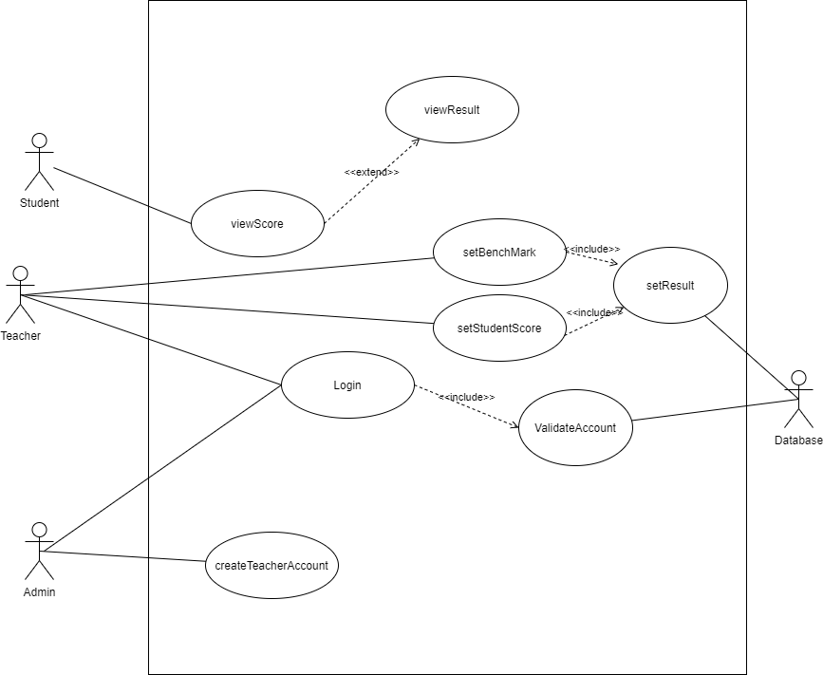

<Functional Requirement one>

setStudentScore

User Case ID | UC_1.1
Name | setStudentScore
Goal | Set score for students
Actors | Teacher
Pre-conditions | Teacher must login
Post-conditions
Main Flow | - Choose student  - Choose subject  - Set score of subjects for student
Exception | If score is invalid, system will require entering score again
Open Issues | N/A

setBenchmark

User Case ID | UC_1.2
Name | setBenchmark
Goal | Set benchmark to decide result for students
Actors | Teacher
Pre-conditions | Teacher must login
Post-conditions
Main Flow | - Choose university  - Choose faculty to set benchmark  - Set benchmark
Exception | If benchmark is invalid, system will require entering score again
Open Issues | N/A

login

User Case ID | UC_1.3
Name | login
Goal | Login to gain access to some function of systme
Actors | Teacher,Admin
Pre-conditions
Post-conditions
Main Flow | - enter username  - enter password  - click on login
Exception | If username or password is invalid, require re-login
Open Issues | N/A

viewScore

User Case ID | UC_1.4
Name | viewScore
Goal | View the score of student
Actors | Student
Pre-conditions | Student must be scored by Teacher
Post-conditions
Main Flow | - enter student ID | 2. Display score
Exception
Open Issues | N/A

createTeacherAccount
User Case ID | UC_1.5
Name | createTeacherAccount
Goal | Admin create teacher account
Actors | Admin
Pre-conditions | Admin must login
Post-conditions
Main Flow | - click on create account  2Enter username  - Enter password  - Click on CreateAccount button
Exception | If the username contain strange character (not latin letter and number), system will require re-enter
Open Issues | N/A

setResult
User Case ID | UC_1.6
Name | setResult
Goal | System set result of the student depend on their score every times setScore and setBenchmark operates to update data
Actors | Database
Pre-conditions | setBenchmark or setScore operated
Post-conditions
Main Flow | - get input as score  - get benchmark  - compare score with benchmark  - return result
Exception
Open Issues | N/A

NON-FUNCTIONAL Requirements

Usability
- A clear user interface to help users access to the system.
- A data validate system which will pop-up message when users input wrong data regulation, requiring them to use correct data.

Reliability

Performance
- Quick Login, must response within 5s under good Internet condition
- View Result and View Score within 2s

Supportability

Design Constraints
- Use WPF as Front-end and SQL as database

Supporting Information
- User and Admin:
- System instruction for use, instruction of customer right.
- Analysist:
- Evaluating System Description.
- Evaluating Use case diagram.
- Analyzing business rules.
- Developer:
- Follow diagrams, model to understand about project.
- Optimize constraints of model and diagram.
- Tester: Have information for unit test and system test

