Processing build dashboard

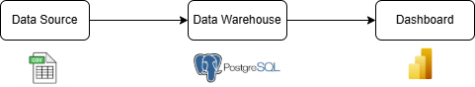

1. **Data Management**
   * Schema Design: using a Star Schema structure, with a Fact Table linked to several Dimension Tables.
   * Difficulty: Store Name was inconsistent; City field was unclear between store and vendor.
   * 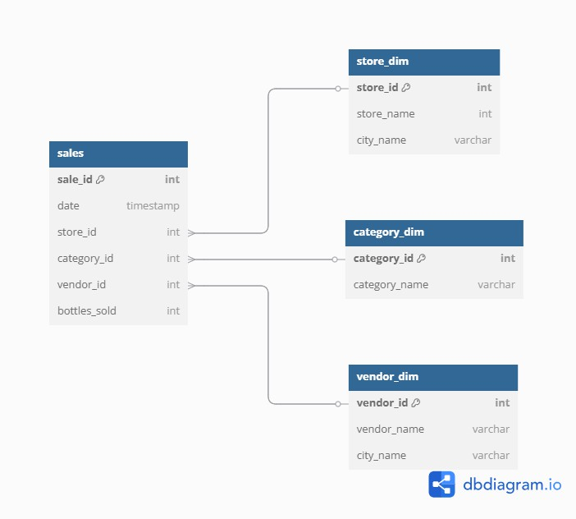Assumption: that the store's city and the vendor's city are different, and used this rule throughout the analysis to avoid confusion.
2. **SQL**

---1.Total Bottles Sold per Year: Calculate the total number of bottles sold each year from 2017 to 2023.

select extract(year from date) as year, sum(bottles_sold) as total_bottles_sold

from sales_data.sales

where bottles_sold > 0

group by 1

order by 1

--- 2.Top 3 Vendors per City: Identify the top three vendors (Vendor Name) with the highest sales (by bottle count) in each city.

with ranked_vendors as (

    select city_name, vendor_name, sum(bottles_sold) as total_bottles_sold,

        row_number() over (partition by city_name order by sum(bottles_sold) desc) as rank

    from sales_data.sales as s

    left join sales_data.vendor_dim as v

        on s.vendor_id = v.vendor_id

    WHERE bottles_sold > 0

    GROUP BY 1,2

)

select city_name, vendor_name, total_bottles_sold,rank

from ranked_vendors

where rank <= 3

-- 3.Sales Analysis by Category: Analyze the sales trends for the top-selling wine categories (Category Name) year by year.

-- top 3

with top_3_cat as (

select category_name, sum(bottles_sold) as total_bottles_sold

from sales_data.sales as sales

left join sales_data.category_dim as cat

on sales.category_id = cat.category_id

where bottles_sold > 0

group by 1

order by 1 desc

limit 3

)

select category_name, EXTRACT(YEAR FROM date) AS year, sum(bottles_sold) as total_bottles_sold

from sales_data.sales as sales left join

sales_data.category_dim as cat

on sales.category_id = cat.category_id

where category_name in (select category_name

                        from top_3_cat)

group by 1,2

order by 1,2

-- 4.Top Stores by Sales per City: Identify the stores (Store Name) with the highest wine sales in each city in the most recent year (2023).

with stores_rank as (

select store_name, city_name, sum(bottles_sold) as total_bottles_sold,

row_number() over(partition by city_name order by sum(bottles_sold) desc) as rank

from sales_data.sales as s

left join sales_data.store_dim as st

on s.store_id = st.store_id

where bottles_sold > 0 and EXTRACT(YEAR FROM date) = 2023

group by 1, 2

order by 1, 2

)

select store_name, city_name, total_bottles_sold

from stores_rank

where rank = 1

-- 5.Vendor Sales Share: Calculate the percentage of total sales for each vendor (Vendor Name) compared to the overall sales of all vendors across the entire time period (2017-2023).

with vendor_sales as (

select vendor_name, sum(bottles_sold) as total_bottles_sold

from sales_data.sales as s

left join sales_data.vendor_dim as v

on s.vendor_id = v.vendor_id

where bottles_sold > 0

group by 1

),

total_sales as

(select sum(total_bottles_sold) as overall_bottles_sold

from vendor_sales

)

select v.vendor_name, v.total_bottles_sold, ROUND((v.total_bottles_sold * 100.0) / t.overall_bottles_sold , 2) AS sales_share_percentage

FROM vendor_sales v, total_sales t

ORDER BY sales_share_percentage desc

1. **Dashboard with Power BI**

