Practice Reading Test 02

Questions 1-6. For each question, choose the correct answer.
1 | 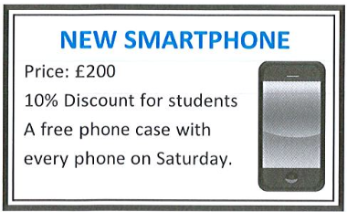 | A. The new smartphone has a special price at the weekend.  B. People studying have to pay less to buy the new smartphone.  C. The free gift is only available on weekdays.

2 | 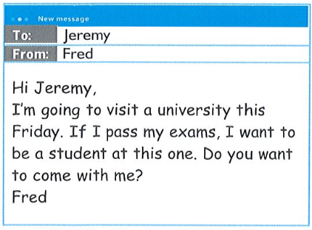 | Why did Fred send his email to Jeremy?  A. to tell Jeremy that he passed his exams  B. to tell Jeremy that he’ll visit a university next week  C. to ask Jeremy to join him when he visits a university

3 | 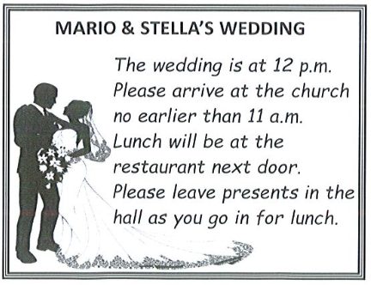 | A. The place guests will have lunch is not far away.  B. Guests can arrive at the church before 11 a.m.  C. Guests should leave the presents at the church.

4 | 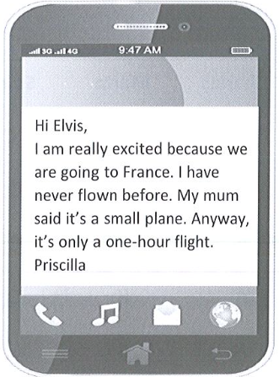 | Priscilla is excited because  A. she has never been on a plane before.  B. the flight is a couple of hours long.  C. she is travelling in a large plane.

5 | VILLAGE SHOP  OPENING HOURS: 7 a.m to 7 p.m.  (from 1st July we will open at 6 a.m.)  Services: Post office, fresh food, newspapers. Sorry, no frozen food. | A. You can’t post letters at the shoo.  B. The shop will open an hour earlier in July.  C. Frozen food is available all day.

6 | 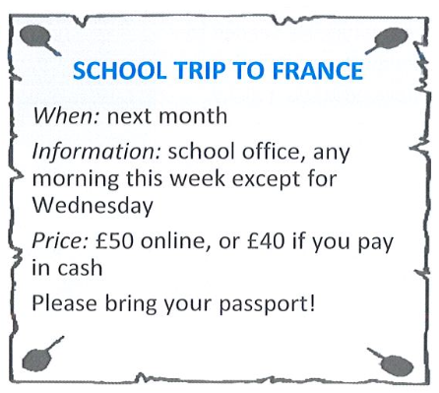 | A. Students can ask about the trip any day this week.  B. All students need to pay at the school office.  C. Some students can pay less for the trip.

Questions 7-13. For each question, choose the correct answer.
 |  | Thomas | Magareth | Spiros
7. | Which person is said to be a beginner at something? | A | B | C
8. | Which person knows what they want to be in the future? | A | B | C
9. | Which person did something different from other people of their age? | A | B | C
10. | Which person used a computer to win a competition? | A | B | C
11. | Which person doesn’t like the internet? | A | B | C
12. | Which person was the best in their country? | A | B | C
13. | Which person will meet someone famous? | A | B | C

Competition winners
Thomas
Thomas is sixteen and is a very good artist. He is so good that he won a competition that was held for students all over the United Kingdom. Each student had to do a painting on the subject of “My country”. Most students painted a famous building or a beautiful landscape. Thomas, however, surprised everyone by painting a traditional Sunday roast dinner! When he was asked why he chose such a strange subject, he said that eating a roast dinner with his family every Sunday was really important to him and this was the thing that he missed most when he visited other countries.
Magareth
Magareth was very happy when she won a competition to bake a birthday cake for the headteacher of her school. It was the first time that she had ever cooked anything. She found out on the internet what she needed to buy and what to do. She was going to ask her grandmother to help her because she makes beautiful cakes but then she decided to do it all by herself. Magareth’s prize was a cooking lesson with a TV chef. She can’t wait to meet him!
Spiros

Spiros won a short story competition. The competition was open to anyone in his city who is under eighteen. Spiros has been writing stories for many years and he loves reading. However, he only reads stories in books and not on the computer or on a tablet. He hates the internet and technology, in general. He has many, many books in his house and never throws them away. Spriros says that he will always write stories and he is sure that he will become a rich and famous writer in the future.

Questions 14-18. For each question, choose the correct answer.
Sophia Capaldi - Young Businesswoman of the Year
Sophia Capaldi has just won the Young Businesswoman of the Year competition. She is the youngest woman to have ever won it. She comes from quite a poor family and when she was a child, her parents couldn’t buy her things that her friends had. That is when Sophia started to look on eBay and in shops that sell used or second-hand things at very low prices.
Sophia soon thought that she could buy things very cheaply and sell them again at a higher price. “It started as a hobby” she said. “But when I quickly started to make money and I spent more time buying and selling things until I started to earn a lot of money.”
She had always planned to go to university but she was making so much money that she soon changed her plans. She preferred not to spend three years studying to get a good job because she was already earning a lot of money. “I think university life would be fun but I believe there will be enough time for me to have fun in the future” she said.
When she won the competition, she couldn’t believe it. She hadn’t even heard of the competition before. She was very happy and she felt that she had done something that none of her friends had ever done.
Now she is planning to find one or two people to work for her in the next few weeks as there is too much for her to do on her own. Also, she thinks it will be good to have some company during the day in the office because it can be a bit boring being her own boss.

14. What problem did Sophia have when she was a child?
A. Her family didn’t have much money.
B. Her parents didn’t want her to have nice things.
C. Her friends laughed at her because she was poor.
15. What does Sophia say about the first time she sold something?
A. It was quite difficult
B. She became rich with the first thing she sold.
C. She did it just for fun.
16. Sophia believes that she will
A. go to university when she is older.
B. be sorry that she didn’t go to university.
C. still enjoy life when she’s a bit older.
17. What did Sophia think about winning the competition?
A. She knew that she was going to win it.
B. She felt very special
C. She didn’t understand why she had won it.
18. What is Sophia planning to do next?
A. find a new boss
B. look for staff
C. move to a new office

Questions 19-24. For each question, choose the correct answer.
Camping
Camping is a great (19) ……….. to spend a holiday. You can enjoy nature and have a (20) ……….. at the same time. If you go camping far from the city, you must remember to bring everything you need with you.
First, you need a tent and a sleeping bag. Also a small backpack in which you can (21) ……….. water, some clothes and something to eat on day trips. Be very careful with things you eat. Don’t eat something if you don’t know what it is! Finally, it’s useful to have a (22) ……….. of the area you are going to. It can help you if you get lost.

When you go camping, there are also some rules you must follow. For example, if you want to make a campfire, make (23) ……….. that you make your fire well away from tents, grasses or trees. Also always remember to throw your rubbish in the bins and not (24) ……….. it behind.

19. A. plan B. path C. way
20. A. stuff B. rest C. tour
21. A. carry B. move C. travel
22. A. menu B. kit C. map
23. A. safe B. sure C. right
24. A. live B. leave C. give

Questions 25-30. For each question, write the correct answer. Write ONE word for each gap.
From: Mark
To: Robert
It is my birthday Saturday, and I am having a funny hat party. I have invited a (25) …………… of my friends. Would you like (26) …………… come, too?
My address is 12, Moor Road, Gateshead and my telephone number is 0113 4743812. Call (27) …………… if you can’t find the road.
Could you bring some music playlists or CDs (28) …………… you? I know that you love listening to music (29) …………… you must have a lot. Also, don’t forget your funny hat!
I (30) …………… you can come.
See you soon,

Mark
25.few | 26.to | 27.me | 28.with | 29.so | 30.hope

