Practice Reading Test 08
Questions 1 – 6: For each question, choose the correct answer
1 | 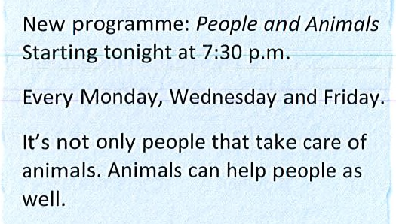 | A. You can watch the TV programme every day.  B. The programme is not on at the weekend.  C. The programme is about people killing animals.
2 | 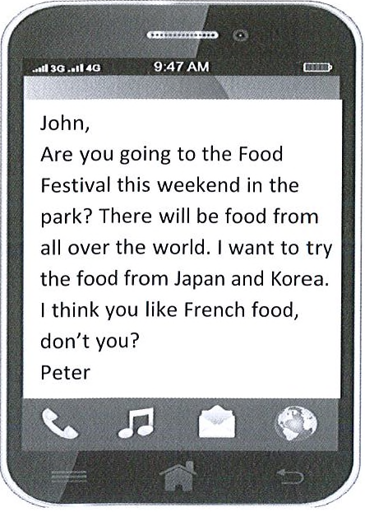 | A. Peter wants to try French food with John.  B. Peter wants John to travel with him to Japan.  C. Peter wants to eat different kinds of food.
3 |  | A. The last tour starts at 3 in the afternoon.  B. The tour is half price for children.  C. There is a tour of the castle every hour.
4 | 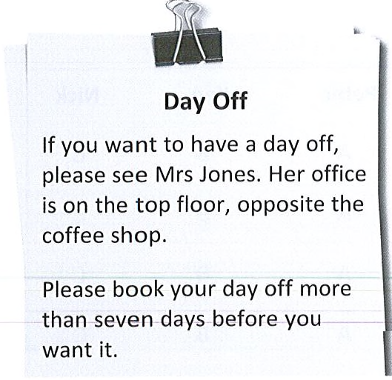 | A. Mrs. Jones’s office is downstairs.  B. Staff must book day off at least a week earlier.  C. The coffee shop is next to Mrs. Jones’ office.
5 | 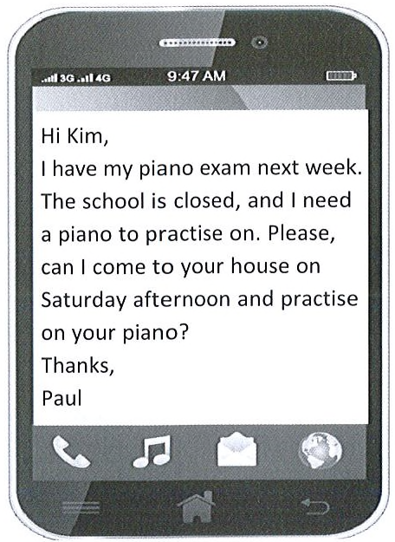 | Why did Paul write this message?  A. to tell Kim that the school piano doesn’t work  B. to invite Kim to come to his home on Saturday  C. to ask Kim to let him practice on her piano
6 |  | - Televisions have the biggest discount.  - The shop will make you pay extra to take the appliance to your home.  - All the appliances cost half price on Saturday.

Questions 7-13. For each question, choose the correct answer
 |  | Peter | Ken | Nick
7. | Which person works at the biggest school? | A | B | C
8. | Which person lives with other people in the same house? | A | B | C
9. | Which person has colleagues from other countries? | A | B | C
10. | Which person works at a school that offers outdoor sports? | A | B | C
11. | Which person goes to school on foot? | A | B | C
12. | Which person stays at school 24 hours a day? | A | B | C
13. | Which person works at an expensive school? | A | B | C
Young teachers
Peter
Peter works at a school in a village. He lives with two other teachers in a guest-house for free. The house is only a five-minute walk to school. The school is very small; only sixty pupils go there. The school has a small library and a small hall which can be used for indoor sports and meetings. There isn't a lot of outdoor space, which means there isn't enough room for students to play sports outside.

Ken
Ken works at a very big school with over eight hundred students and forty teachers. The school is in the middle of a very big city. He rents a house which is far away from school, so he goes there by bus. The school has pupils as well as teachers who have different nationalities. The school has everything the students need. There is another building next to the school where different sports can be played, a large cafeteria and a very big library. There are no outdoor sports.

Nick
Nick works at a school in the countryside, far away from any village or town. During the term, he lives at the school and goes home for the holidays. He sometimes goes home at the weekends, too. He is a very good teacher like most of the teachers who work there. This is why parents have to pay a lot of money to send their children there. His school has a lot of land with three football fields, one rugby field and one cricket field. The school also has two very large swimming pools, one inside the school and the other one outside. The school has about five hundred students.
Questions 14 – 18. For each question, choose the correct answer.
A family who loves animals
Everyone in the Collins family loves animals. These days Anna Collins has stopped working as a doctor and she spends her days selling pet food, toys and just about everything an animal could need. In her free time she walks her dog.
Anna's daughter, Georgia, also loves animals and was very happy when they finally got a dog, two years ago. She had wanted a cat when she was little but they all agreed that a rabbit was a much better pet for a little girl. Now, of course, she has many different animals all around her at home.
The reason for this is that Georgia's father, Jack, owns an animal shelter. This is where animals are brought when they have no home or owner. Jack says, "We never say no if an animal needs our help and they come and go all the time. We always try to find them new homes with kind people."
Georgia understands that the animals they save need a good home and it's a good thing if they don't have too many animals to look after. She still finds it difficult when a new animal that someone has left on the street or hurt in some way comes to them. "I don't understand how anyone could do that." she says.
Georgia wants to work with animals when she leaves school so every weekend, when her friends go shopping, she goes to her Saturday job. She helps collect eggs from the chickens and gives water to the cows. "It's the best job" she says. "I love working outside".
14. What is Anna's job now?
A. doctor
B. dog walker
C. shop assistant
15. What was Georgia's first pet?
A. a dog
B. a rabbit
C. a cat
16. Jack says that
A. there isn't any room left for other animals.
B. they can only have one more animal.
C. they give some animals to other people.
17. What makes Georgia feel sad?
A. when the animals have to leave
B. when they only have a few animals at the shelter
C. when people are unkind to animals
18. Where does Georgia go every Saturday?
A. to the farm
B. to the school
C. to the shops
Questions 19 – 24. For each question, choose the correct answer.
Dogs
Dogs are the (19) ……………. popular pets in many countries. One reason why this is true is that they are easy to live with. They are easy to feed and look (20) ………… and they can also become (21) …………… of the family. They are often called "man's best friend". This is because they can make us laugh, they help us not feel alone, or (23) ……………… make new friends. This is because people with dogs often love to (24) …………….. with other people who have a dog, too.
Dogs are very clever and they can also help people do their work. For example, there are guide dogs that help people (25) ………………. can't see, or police dogs that can find people or things that the police are looking for.
19 | A. best | B. biggest | C. most
20 | A. for | B. after | C. out
21 | A. part | B. type | C. piece
22 | A. still | B. even | C. instead
23 | A. tell | B. say | C. chat
24 | A. which | B. what | C. who

Questions 25 – 30. For each question, write the correct answer. Type ONE word for each gap.
From: From: Artemis
To: Dylan
Hi Dylan,
I am having a great time on my holiday. On Monday, we arrived in Spain - the first time I have been (25) ………… to another country. I was so excited!
First, my dad rented a car and we drove to the beach. A lot of people were there, but I liked it. I found a group of kids (26) ………… age and we became friends. Unfortunately, it wasn't long before I had to (27) …………. goodbye to them for the evening. Then Dad drove us to our hotel. It is very nice!
I'll tell you more (28) ………… my holiday tomorrow. If you have (29) ………….. news, send me an email or text. I can't wait to hear (30) …………. you.
Love,
Artemis
25.ever | 26.my | 27.say | 28.about | 29.any | 30.from

