API:
- doctor.router.ts:


- hospital.rouuter.ts


- mediacalService.router.ts
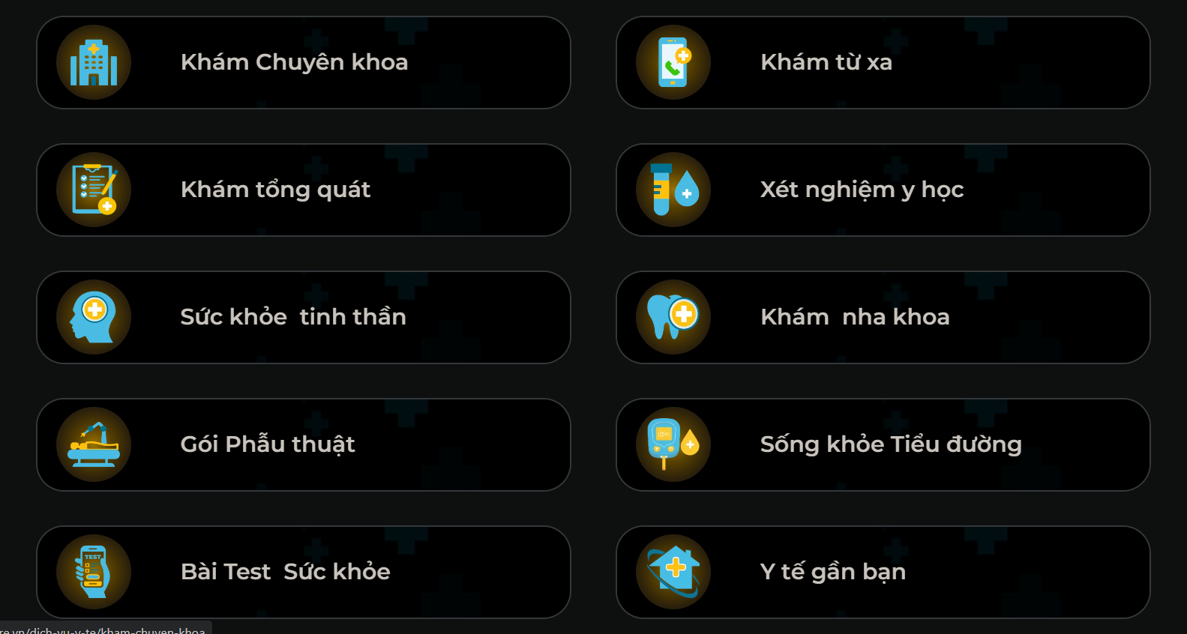

- mediacalSchedule.router.ts


