University of Information Technology – VNU-HCM
Faculty of Computer Engineering
Computer System
LAB 01
Getting to Know MARS: Registers, Arithmetic Instructions and System Calls
Full name | Nguyễn Ngô Bảo Phúc | Student ID | 26560047
Class | ATBC2026 | Practice date | 27/10
Self-assessed score | 100/100 | GitHub link | https://github.com/Phungu12334/ComputerSystemLab.git

1. LAB OVERVIEW
Purpose. In this session you will meet the machine that sits underneath every program you have ever used. Starting from an ordinary arithmetic statement such as a = b + c, you will see how a processor keeps numbers in registers, how one assembly instruction works on three registers, how that instruction is stored as a single 32-bit number, and how a running program talks to the keyboard and the screen through system calls. Every new idea is explained first and then practised.
Situation: the arithmetic inside a smart electricity meter
A household electricity meter keeps a running total of the energy used, measured in kilowatt-hours (kWh). The electricity company notes the meter reading at the start of each month. The energy used in a month is the difference between two consecutive readings, and the energy used over several months is the sum of the monthly differences. The small processor inside a smart meter carries out exactly these subtractions and additions on numbers held in registers, and then reports the results. All readings used in this LAB are fictitious.

After this session, you can:
- open, assemble, run, step through and reset a program in MARS, and find the Registers, Text Segment, Data Segment and Run I/O panes;
- name the main MIPS registers ($zero, $t0–$t9, $s0–$s7, $v0, $a0, pc) and read their contents in decimal and hexadecimal;
- translate simple arithmetic statements such as a = b + c into MIPS instructions that use add, sub and addi, with registers playing the role of variables;
- describe how an assembly instruction is stored as a 32-bit machine-code word and read the register numbers inside it;
- use system calls to print text and integers and to read an integer from the keyboard;
- predict, observe and explain the behaviour of a short assembly program.

Table 1. Structure of the session
Part | Content | Suggested time | Score
0 | Getting started with MARS | 20 min | –
1 | Experiment 1 – Meet the registers | 30 min | 20
2 | Experiment 2 – From a = b + c to $t0 = $t1 + $t2 | 45 min | 30
3 | Experiment 3 – Input, output and system calls | 50 min | 35
4 | Wrap-up and submission | 15 min | 15
– | Debugging, checking and review | 20 min | –
Total |  | 180 min | 100

Working conventions
• A yellow cell is where you write an answer or a value. A dashed frame is where you paste a screenshot.
• Program listings appear in grey frames in a monospaced font. In a listing, everything after # is a comment. A line that starts with # >>> marks a place where you write code.
• Questions are labelled with the type of thinking they ask for: Understand, Apply, Analyze or Evaluate.
• Many activities follow the cycle PREDICT → OBSERVE → EXPLAIN. First write down what you expect (PREDICT), then run the program and record what really happens (OBSERVE), and finally explain any difference (EXPLAIN). A wrong prediction is never penalised; the explanation is what earns the marks.
• Tick the box ☐ in a checklist when you have completed the item.
PART 0. GETTING STARTED WITH MARS (20 minutes)
MARS (MIPS Assembler and Runtime Simulator, version 4.5) is a Java program that imitates a MIPS processor. It lets you run assembly programs and watch registers and memory change one instruction at a time, without any real MIPS hardware.
Table 2. Skills checklist
☐ | Skill | Hint
☐ | Start MARS and create a new file | Double-click Mars4_5.jar (or run java -jar Mars4_5.jar), then File → New.
☐ | Check the settings used in this LAB | In the Settings menu: Permit extended (pseudo) instructions and formats ticked; Initialize Program Counter to global ‘main’ if defined ticked; Delayed branching unticked; Popup dialog for input syscalls unticked.
☐ | Assemble a program | Run → Assemble (or the toolbar icon). MARS switches from the Edit tab to the Execute tab.
☐ | Run the whole program | Run → Go. Text printed by the program appears in the Run I/O pane at the bottom.
☐ | Execute one instruction at a time | Run → Step runs the next instruction; Run → Backstep undoes one; Run → Reset returns to the start. Shortcut keys are shown next to each command.
☐ | Identify the panes of the Execute tab | Registers (right), Text Segment (upper left), Data Segment (below it), Messages and Run I/O (bottom).
☐ | Switch values between decimal and hexadecimal | Settings → Values displayed in hexadecimal.
☐ | Save your work | File → Save as… and use the file-name rule given below.

Note
MARS has two views of a program: the Edit tab, where you type, and the Execute tab, where you run it. After every change in the editor you must assemble again. Assembling also resets all registers and memory to their initial state.
Step 0 – Quick check
Type the program in Listing 0 into a new file (use the exact text), save it, assemble it and run it. You will learn what each line means in Experiment 3; for now, only confirm that your installation works.
Listing 0
# Listing 0 - quick check
.data
msg: .asciiz "Hello, MARS!\n"

.text
.globl main
main:
li $v0, 4
la $a0, msg
syscall
li $v0, 10
syscall

Text that appears in the Run I/O pane:
Hello, MARS!

File-name rule
Every program you submit is saved as Lab01_<StudentID>_<Part>.asm, for example Lab01_22520001_TN3.asm. Use TN2 or TN3 for the part. Start every file with a comment block containing your name, student ID and a one-line purpose.
EXPERIMENT 1. MEET THE REGISTERS (30 minutes – 20 points)
Situation
The processor in a smart meter does not calculate on numbers stored far away in memory. It first brings the numbers into a small set of very fast storage cells called registers and calculates there. Before programming the meter, you need to know the registers.

Background: registers and the program counter
A processor executes instructions one after another. MIPS has 32 registers, each 32 bits wide (one word). Every register has a number from 0 to 31 and a name that starts with $. Table 3 lists the registers used in this LAB.
The processor also has a special register, the program counter (pc), which holds the address of the next instruction to execute. MARS shows register contents as hexadecimal numbers such as 0x0000002A: each hexadecimal digit stands for 4 bits, so 8 digits make 32 bits.

Table 3. Registers used in this LAB
Name | Number | Conventional use
$zero | 0 | The constant 0. It always holds 0.
$v0–$v1 | 2–3 | Results; $v0 also carries the service number of a system call (Experiment 3).
$a0–$a3 | 4–7 | Arguments; $a0 also carries the value given to a system call (Experiment 3).
$t0–$t9 | 8–15, 24–25 | Temporary values.
$s0–$s7 | 16–23 | Variables whose values are kept for a longer time.
$sp | 29 | Stack pointer (used in a later LAB).
$ra | 31 | Return address (used in a later LAB).

Step 1.1 – Find the registers (8 min)
Assemble Listing 0 but do not run it. Look at the Registers pane and complete Table 4 with the register number and its initial value (hexadecimal).
Table 4. Initial register contents
Register | Number | Initial value (hex)
$zero | 0 | 0x00000000
$v0 | 2 | 0x00000000
$a0 | 4 | 0x00000000
$t0 | 8 | 0x00000000
$t9 | 25 | 0x00000000
$s0 | 16 | 0x00000000
$sp | 29 | 0x7fffeffc
pc | – | 0x00400000

Question 1.1 (Understand) Compare the initial value of pc with the Address column of the first row of the Text Segment. What do you notice, and what does this tell you about the job of the program counter?
The initial value of pc (0x00400000) is identical to the address of the first instruction of the Text segment.
The job of the program counter is to store the address of the next instruction so that it can be fetched and executed by the CPU.

Step 1.2 – Predict, observe, explain (15 min)
Open a new file, type Listing 1, save it and assemble it. Before you run anything, fill the PREDICT column of Table 5 with the decimal value that the destination register should hold after each instruction.
Listing 1
# Listing 1 - first steps with registers
.text
.globl main
main:
addi $t0, $zero, 12 # $t0 = $zero + 12
addi $t1, $zero, 30 # $t1 = $zero + 30
add $t2, $t0, $t1 # $t2 = $t0 + $t1
addi $zero, $zero, 5 # try to put $zero + 5 into $zero
add $t3, $zero, $t2 # $t3 = $zero + $t2
li $v0, 10 # end of program (see Experiment 3)
syscall

Now use Run → Step to execute the first five instructions one at a time. After each Step, MARS highlights the register that has just changed. Record the observed value of the destination register and the value of pc after the instruction. Use Backstep at least once to see an instruction being undone.
Table 5. Predict and observe (decimal values for registers, hexadecimal for pc)
Instruction | Destination register | PREDICT value | OBSERVE value | OBSERVE pc after the instruction
addi $t0, $zero, 12 | $t0 | 12 | 12 | 0x00400004
addi $t1, $zero, 30 | $t1 | 30 | 30 | 0x00400008
add $t2, $t0, $t1 | $t2 | 42 | 42 | 0x0040000c
addi $zero, $zero, 5 | $zero | 5 | 0 | 0x00400010
add $t3, $zero, $t2 | $t3 | 42 | 42 | 0x00400014

Question 1.2 (Apply) Switch the display to hexadecimal. $t2 now shows 0x0000002a. Convert this number to decimal by hand and show your calculation.
0x0000002a = 2 * 16^1 + 10 * 16^0 = 32 + 10 = 42
a in hexadecimal equals 10

Question 1.3 (Analyze) One of your predictions did not match what MARS showed. Which instruction was it? Give your explanation of what happened and what this says about $zero.
The instruction that don’t match is: addi $zero, $zero, 5.
In what I have studied, $zero is guaranteed to be 0 and it cant be overwritten. So when we tried to overwrite $zero with an operation, the output will always be 0.

Question 1.4 (Analyze) By how many does pc increase after each instruction? Every MIPS instruction occupies one 32-bit word in memory. Use this fact to explain the number you observed.
PC increased by 4 after each instruction, the reason why this happen is because 1 instruction needs 4 bytes = 32 bits to store, so after the first instruction, the address of the pc has to plus 4 to store the next instruction

Screenshot of the Registers pane after the fifth instruction:
Paste screenshot he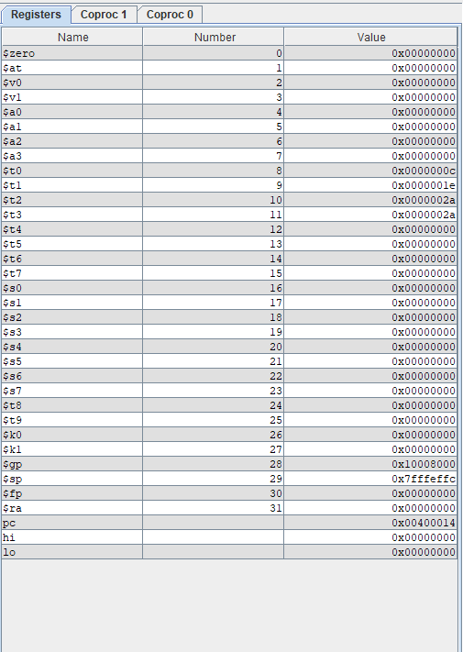re

EXPERIMENT 2. FROM a = b + c TO $t0 = $t1 + $t2 (45 minutes – 30 points)
Situation
The firmware of the meter must compute the energy used between two readings. In a high-level language the programmer writes usage = reading2 - reading1. The processor, however, executes only instructions that name exactly three registers. This experiment shows how a statement is translated step by step, down to the number that the machine really executes.

Background: from a statement to machine code
The same operation can be written at three levels (Table 6). The program that translates assembly into machine code is called the assembler; MARS contains one.

Table 6. Three levels of the same operation
Level | Example | Written by
High-level statement | a = b + c | the programmer
Assembly instruction | add $t0, $t1, $t2 | the programmer (or a compiler)
Machine code | one 32-bit number, shown as 8 hexadecimal digits | the assembler

Variables become registers
A processor has no named variables. We decide which register stands for which variable, for example a → $t0, b → $t1, c → $t2. The instruction add has the form
add destination, source1, source2
so a = b + c becomes add $t0, $t1, $t2. One instruction performs one operation on three registers; a longer expression needs several instructions. For example, x = p + q - r with x→$t0, p→$t1, q→$t2, r→$t3 needs two instructions:
add $t0, $t1, $t2 # x = p + q
sub $t0, $t0, $t3 # x = x - r

To put a constant into a register, add it to $zero: addi $t1, $zero, 7 sets $t1 to 7. To copy a register, add $zero to it: add $t2, $t1, $zero copies $t1 into $t2.

Step 2.1 – Your first addition (8 min)
Type Listing 2, save it and assemble it. PREDICT the final value of $t0 before you run it.
Listing 2
# Listing 2 - a = b + c
.text
.globl main
main:
addi $t1, $zero, 7 # b = 7
addi $t2, $zero, 5 # c = 5
add $t0, $t1, $t2 # a = b + c
li $v0, 10
syscall

PREDICT – final value of $t0 (decimal):
12

OBSERVE – execute the three instructions with Step and write down the three registers after each one.
Table 7. Registers after each instruction of Listing 2
After executing | $t0 | $t1 | $t2
addi $t1, $zero, 7 | 0 | 7 | 0
addi $t2, $zero, 5 | 0 | 7 | 5
add $t0, $t1, $t2 | 12 | 7 | 5

Step 2.2 – Look at the machine code (12 min)
Select the Execute tab and look at the Text Segment. Each row has the columns Address, Code, Basic and Source: Source is the text you typed, Basic is the real instruction the processor executes, and Code is the 32-bit machine word in hexadecimal. Find the row of add $t0, $t1, $t2 and note its address and code.
Background: the R-type instruction format
Instructions such as add and sub use the R format, in which the 32 bits are divided into six fields:
| op | rs | rt | rd | shamt | funct |
| 6 bits | 5 bits | 5 bits | 5 bits | 5 bits | 6 bits |

op is the operation code; rs and rt are the numbers of the first and second source registers; rd is the number of the destination register; shamt is a shift amount (0 for add); funct selects the exact operation. To read a hexadecimal code, replace every digit by 4 bits: 0=0000, 1=0001, 2=0010, 3=0011, 4=0100, 5=0101, 6=0110, 7=0111, 8=1000, 9=1001, A=1010, B=1011, C=1100, D=1101, E=1110, F=1111.

Address of the row:
0x00400008

Code of the row (hexadecimal):
0x012a4020

Table 8. Fields of the instruction add $t0, $t1, $t2
 | op | rs | rt | rd | shamt | funct
Binary | 000000 | 01001 | 01010 | 01000 | 00000 | 100000
Decimal | 0 | 9 | 10 | 8 | 0 | 32

Question 2.1 (Analyze) Compare the decimal values of rs, rt and rd with the register numbers in Table 3. Which operand of the assembly text does each field hold? In which order are the three registers written in the assembly text, and in which order do their fields appear in the machine word?
- The decimal values of rs, rt, and rd are: 9 ($t1), 10 ($t2), and 8 ($t0), respectively.
- The rd field holds the destination operand, while the rs and rt fields hold the first and second operands.
- In the assembly text, the registers are ordered as destination first, and then the sources. (rd, rs, rt -> $t0, $t1, $t2). However, in the machine word, the source registers appear first and the destination register comes last (rs, rt, rd -> $t1, $t2, $t0 )

Question 2.2 (Understand) Look at the row of li $v0, 10. Compare its Source and Basic columns. Is li an instruction that the hardware executes itself? What does the assembler do with it?
- li is not an instruction that the hardware can execute by itself. In the Basic columns, we can see that assembler has compiled it to “ addiu $2, $0, 0x0000000a” so that the hardware is able to execute the instruction.

Screenshot of the Text Segment showing the row of add $t0, $t1, $t2:
Paste screenshot here

Step 2.3 – Energy used by a household (12 min)
Listing 3 loads four meter readings (in kWh) taken at the start of month 1, the start of month 2, the start of month 3 and the end of month 3. Complete the program so that $t0, $t1 and $t2 hold the energy used in months 1, 2 and 3, and $t3 holds the total. Use only add and sub.
Listing 3
# Listing 3 - energy used by a household (fictitious readings, kWh)
# Variable Register
# reading0 $s0 start of month 1
# reading1 $s1 start of month 2
# reading2 $s2 start of month 3
# reading3 $s3 end of month 3
# usage1 $t0 energy used in month 1
# usage2 $t1 energy used in month 2
# usage3 $t2 energy used in month 3
# total $t3 usage1 + usage2 + usage3
.text
.globl main
main:
addi $s0, $zero, 1200
addi $s1, $zero, 1350
addi $s2, $zero, 1475
addi $s3, $zero, 1640

# >>> usage1 = reading1 - reading0
# >>> usage2 = reading2 - reading1
# >>> usage3 = reading3 - reading2
# >>> total = usage1 + usage2 + usage3 (two add instructions)

li $v0, 10
syscall

Check your result
With these readings, after the program has run, $t0, $t1, $t2 and $t3 must contain 150, 125, 165 and 440.

Screenshot of the Registers pane after the program has run:
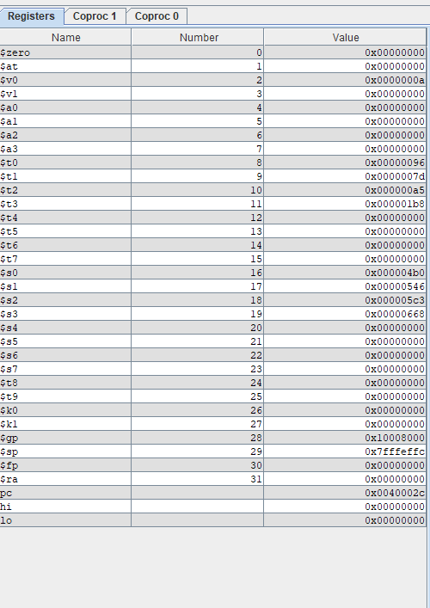Paste screenshot here

Question 2.3 (Analyze) Calculate reading3 - reading0 by hand and compare it with total. Why must the two numbers be equal? Explain in terms of what the meter readings represent.
- reading3 - reading0 = 1640 - 1200 = 440 | total = 150 + 125 + 165 = 440
In terms of the electricity meter, the sum of energy used in each individual month over a 3-month period must equal the total change in the meter reading from the beginning of month 1 (reading0) to the end of month 3 (reading3)

Step 2.4 – Translate statements into instructions (13 min)
Table 9 lists four statements. In each of them the variables y, z and w live in $s0, $s1 and $s2 and start with the values 8, 5 and 3. Write the MIPS instructions for each statement in the yellow cells, using the destination register shown. Where an intermediate result is needed, use $t5 as a temporary register. PREDICT the result of each statement by hand before you test it.
Table 9. Statements to translate
Statement | Destination | Your MIPS instructions | PREDICT (decimal) | OBSERVE (decimal)
x1 = y + z + w | $t0 | add $t0, $s0, $s1  add $t0, $t0, $s2 | 16 | 16
x2 = (y + z) - (w + 5) | $t1 | add $t1, $s0, $s1  addi $t5, $s2, 5  sub $t1, $t1, $t5 | 5 | 5
x3 = y (copy) | $t2 | add $t2, $s0, $zero | 8 | 8
x4 = z - y | $t3 | sub $t3, $s1, $s0 | -3 | -3

To test your answers, start a new file with the lines below, add your instructions at the marker, run the program and read $t0–$t3.
Listing 4
# Listing 4 - translating statements
.text
.globl main
main:
addi $s0, $zero, 8 # y = 8
addi $s1, $zero, 5 # z = 5
addi $s2, $zero, 3 # w = 3

# >>> instructions for x1, x2, x3 and x4

li $v0, 10
syscall

Question 2.4 (Analyze) The value of x4 is negative. Show $t3 in hexadecimal and in decimal. What do the leading hexadecimal digits of a negative number look like, and what does this suggest about how the processor stores negative numbers?
- Decimal and hexadecimal value of $t3 are: -3 and 0xfffffffd
- The leading hexadecimal digits of the negative number is fff… ( value in hexa is 15 ), in binary it means 1111.., and this is a way to represent a negative number.
- This indicates that the most significant bits are all 1s due to sign extension, which demonstrates that the processor represents and stores negative integers using the two's complement system.

EXPERIMENT 3. INPUT, OUTPUT AND SYSTEM CALLS (50 minutes – 35 points)
Situation
A technician types the readings into the smart meter, and the meter shows the energy used to the customer. A program running on a processor has no screen or keyboard of its own: it must ask the system to read and print on its behalf. This request is called a system call.

Background: program memory and text
A MIPS program has two parts. The .text part holds the instructions. The .data part holds the data that the program uses, such as messages. In MARS the data part starts at address 0x10010000.
A label is a name for an address. The directive .asciiz "text" stores the characters of a message followed by one extra byte of value 0, which marks the end of the message. The pseudo-instruction la $a0, label puts the address of the label into $a0.

Background: how to make a system call
1. Put the service number in $v0. 2. Put the argument, if any, in $a0. 3. Execute syscall. 4. If the service returns a result, read it from $v0.
In MARS, the simulator plays the role of the operating system and performs the service. Table 10 lists the four services used in this LAB.

Table 10. System-call services used in this LAB
Service | $v0 | Argument | Result
Print integer | 1 | $a0 = integer to print | –
Print string | 4 | $a0 = address of a string that ends with 0 | –
Read integer | 5 | – | the integer typed by the user, in $v0
Exit program | 10 | – | –

Step 3.1 – Print text and a number (12 min)
Type Listing 5, save it and assemble it. PREDICT exactly what will appear in the Run I/O pane.
Listing 5
# Listing 5 - print a message and an integer
.data
msg: .asciiz "Usage (kWh): "
nl: .asciiz "\n"

.text
.globl main
main:
addi $t0, $zero, 150
li $v0, 4 # service 4: print string
la $a0, msg # argument: address of msg
syscall
li $v0, 1 # service 1: print integer
add $a0, $t0, $zero # argument: the number to print
syscall
li $v0, 4 # print a new line
la $a0, nl
syscall
li $v0, 10 # service 10: exit
syscall

PREDICT – text in the Run I/O pane:
Usage (kWh): 150

OBSERVE – run the program. Then open Settings → Show Labels Window (symbol table) and read the addresses of the two labels.
Table 11. Label addresses
Label | Address (hex)
msg | 0x10010000
nl | 0x1001000e

Screenshot of the Run I/O pane after the program has run:
Paste sc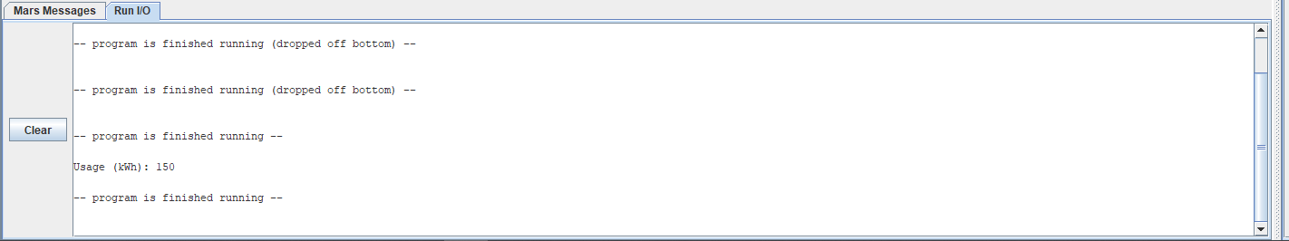reenshot here

Question 3.1 (Understand) Which register told the system which service was wanted, and which register carried what to print? What would happen to the meaning of $a0 if you changed the service number?
Register $v0 told the system which service was wanted (holding the service number), and register $a0 carried the argument (what to print: either the memory address of the string for service 4, or the integer value itself for service 1). If you changed the service number in $v0, the system would interpret the contents of $a0 differently according to the new service.
For example: Changing service 1 to service 4 would make the system treat the integer in $a0 as a memory address of a string rather than a number value.

Question 3.2 (Apply) Subtract the address of msg from the address of nl. Count the characters of the message Usage (kWh): (including spaces) and compare with your result. How do you explain the difference between the two numbers?
nl – msg = 0x1001000e – 0x10010000 = 0x0e
The string “Usage (kWh): “ has 13 characters ( including spaces )
The difference of 2 numbers exists because the .asciiz directive automatically appends an extra null-terminator byte (0x00) at the end of the string to mark where the message finishes in memory
(13 characters + 1 null byte = 14 bytes )

Step 3.2 – Read two numbers and compute the usage (15 min)
Listing 6 reads the previous meter reading from the keyboard and stores it in $s0. Complete the program so that it also reads the current reading into $s1, computes usage = current - previous in $t0, and prints the result in the form shown below the listing.
Listing 6
# Listing 6 - energy used between two readings
.data
prompt1: .asciiz "Enter previous reading (kWh): "
prompt2: .asciiz "Enter current reading (kWh): "
label: .asciiz "Usage (kWh): "
newline: .asciiz "\n"

.text
.globl main
main:
# --- read the previous reading into $s0 ---
li $v0, 4
la $a0, prompt1
syscall
li $v0, 5 # service 5: read integer, result in $v0
syscall
add $s0, $v0, $zero # keep the value in $s0

# >>> read the current reading into $s1 (print prompt2, then service 5)

# >>> usage = current - previous, into $t0

# >>> print label, then the usage (service 1), then newline

li $v0, 10
syscall

Check your result
Run the program and type 1200 and 1350 when asked. The last line in the Run I/O pane must be Usage (kWh): 150. Type each number in the Run I/O pane and press Enter.

Screenshot of the Run I/O pane for this test:
Paste s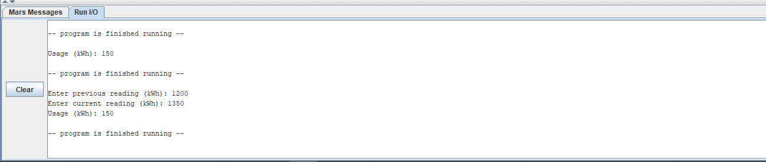 Screenshot here

Step 3.3 – Three-month summary with your own data (15 min)
Extend your program so that it reads four readings in order (reading0 to reading3) and then prints the usage of each month and the total. Start from the .data section below and keep the register plan of Listing 3 ($s0–$s3 for the readings, $t0–$t3 for the results). The output must have this form:
Month 1: <usage1>
Month 2: <usage2>
Month 3: <usage3>
Total: <total>

Listing 7 (data section)
.data
prompt: .asciiz "Enter reading (kWh): "
m1: .asciiz "Month 1: "
m2: .asciiz "Month 2: "
m3: .asciiz "Month 3: "
tot: .asciiz "Total: "
nl: .asciiz "\n"

First test the program with the readings 1200, 1350, 1475 and 1640; the four results must be 150, 125, 165 and 440. Then take D, the last digit of your student ID, and look up your own readings in Table 12. PREDICT the four results by hand, run the program with your readings, and record what you observe.
Table 12. Personal readings (D = last digit of the student ID)
D | reading0 | reading1 | reading2 | reading3
0 | 1000 | 1120 | 1220 | 1360
1 | 1020 | 1143 | 1248 | 1390
2 | 1040 | 1166 | 1276 | 1420
3 | 1060 | 1189 | 1304 | 1450
4 | 1080 | 1212 | 1332 | 1480
5 | 1100 | 1235 | 1360 | 1510
6 | 1120 | 1258 | 1388 | 1540
7 | 1140 | 1281 | 1416 | 1570
8 | 1160 | 1304 | 1444 | 1600
9 | 1180 | 1327 | 1472 | 1630

Table 13. Results for your own readings
My D | Result | Month 1 | Month 2 | Month 3 | Total
7 | PREDICT | 141 | 135 | 154 | 430
7 | OBSERVE | 141 | 135 | 154 | 430

Screenshot of the Run I/O pane with your own readings:
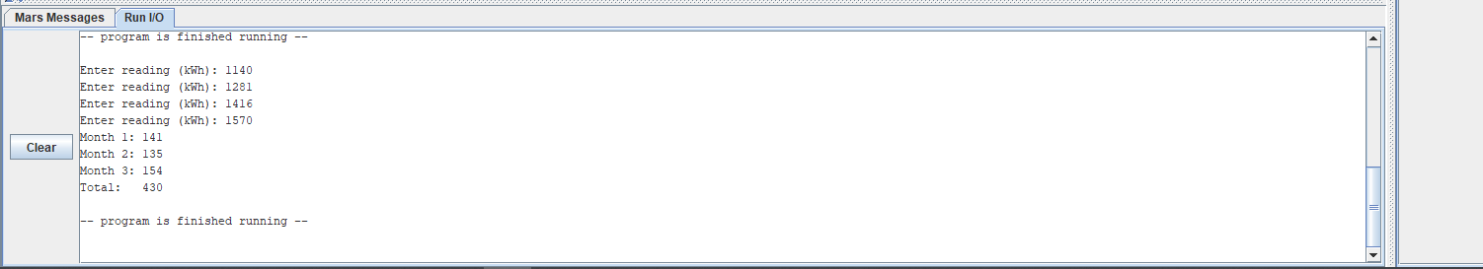 Paste screenshot here

Step 3.4 – Break it on purpose (8 min)
Programmers learn a great deal from errors. For each experiment in Table 14, PREDICT what will happen, make the change, run the program and OBSERVE the result. Restore the program afterwards.
Table 14. Controlled experiments
Experiment | PREDICT | OBSERVE
(a) Run your Step 3.2 program and enter the readings in the wrong order: 1350 first, then 1200. | The program will calculate 1200 – 1350 and print a negative usage:  Usage (kWh): -150 | The program prints -150 without any error, although the negative energy usage makes no sense
(b) In Listing 5, delete the last two instructions (li $v0, 10 and syscall) and run it. | The program will print: Usage (kWh): 150 normally, then stop because there are no more instructions | The program prints  Usage (kWh): 150 and terminates with a message: “ -- program is finished running (dropped off bottom) --" instead of normal system exit
(c) In Listing 5, change the service number before printing the integer from 1 to 4, and run it. | The program will fail or crash because service 4 expects a string memory address in $a0, not number 150 | It prints Usage (kWh): and then crashes with a runtime exception: “Runtime exception at 0x0040001c: address out of range 0x00000096”.

Question 3.3 (Analyze) Explain your observation in experiment (c). What did the system try to treat as an address, and why did the program fail?
-In experiment (c), changing $v0 to 4 requested the "print string" service instead of "print integer".As a result, the system treated the value inside $a0 ( 150 in decimal or 0x00000096 in hexadecimal ) as a memory address pointing to the start of a character string.
-Because 0x00000096 lies outside the valid user data memory region (which starts at 0x10010000 in MARS) and is in a restricted memory segment, the processor triggered an "address out of range" runtime exception and stop the program.

PART 4. WRAP-UP AND SUBMISSION (15 minutes – 15 points)
Question 4.1 (Understand) In your own words, describe how the statement a = b + c becomes something the processor can execute. Use the terms register, assembly instruction, assembler and machine code.
To execute a high-level language like a = b + c, the variables are first mapped to specific register ($t0, $t1 and $t2). The compiler then compiled the statement to assembly instruction (add $t0, $t1, $t2). Next, the assembler translate this instruction into the machine code so that the computer can understand what to execute.

Question 4.2 (Apply) Write the instructions that print the integer held in $t5 followed by a new line, assuming that a string labelled nl exists in the .data section.
li $v0, 1 # service 1: print integer
add $a0, $t5, $zero # copy integer from $t5 into $a0
syscall
li $v0, 4 # service 4: print string
la $a0, nl # load address of newline string
syscall

Question 4.3 (Evaluate) Your Step 3.3 program contains several almost identical blocks of instructions. In two or three sentences, suggest a feature that would make such a program shorter, and say what the processor would need to be able to do to support it.
The program could be made shorter using loops instead of copying and pasting the same block of instructions. To support this, the processor need the branch and jump instructions to jump backward or forward a specific instruction address based on the conditions

Table 15. Submission checklist
☐ | Item
X | Files Lab01_<StudentID>_TN2.asm and Lab01_<StudentID>_TN3.asm are saved with the correct names.
X | Every file begins with a comment block (name, student ID, purpose) and every program assembles without errors.
X | Every # >>> marker has been replaced by your own code and the register plan is documented in comments.
X | This document is complete: all yellow cells are filled and every dashed frame contains a screenshot.
X | The .asm files are pushed to your GitHub repository, and the repository link is written in the information table on the first page.
x | The document and the repository link are submitted in the way announced by your instructor.

APPENDIX. INSTRUCTION REFERENCE
Table 16. Instructions used in this LAB
Instruction | Example | Meaning
add | add $t0, $t1, $t2 | $t0 = $t1 + $t2
sub | sub $t0, $t1, $t2 | $t0 = $t1 - $t2
addi | addi $t0, $t1, 20 | $t0 = $t1 + 20
syscall | syscall | ask the system to perform the service whose number is in $v0
li (pseudo) | li $t0, 7 | $t0 = 7; the assembler turns it into a real instruction
la (pseudo) | la $a0, label | $a0 = address of label; the assembler turns it into real instructions

