VIETNAM NATIONAL UNIVERSITY – HOCHIMINH CITY
INTERNATIONAL UNIVERSITY
SCHOOL OF ELECTRICAL ENGINEERING


Embedded Real-Time System Course

A Smart Home Project with Multiple Functionalities
Submitted by
Do Buu Phuoc – EEACIU21137
On behalf of the group:
Tran Minh Tri - EEACIU22234
Ho Thi Quynh Chi - EEEEIU21023
Le Quang Thong - EEACIU22222
Pham Tran Gia Huy - EEACIU22178

Date Submitted: May 5, 2026
Date Performed: May 5, 2026
Course Project: Embedded Real-Time System Project
Course Instructor: Dr. Nguyen Lap Luat

GRADING GUIDELINE FOR LAB REPORT
Number | Content |  | Score | Comment
1 | Format (max 9%)
 | - Font type | Yes No
 | - Font size | Yes No
 | - Lab title | Yes No
 | - Page number | Yes No
 | - Table of contents | Yes No
 | - Header/Footer | Yes No
 | - List of figures (if exists) | Yes No
 | - List of tables (if exists) | Yes No
 | - Lab report structure | Yes No
2 | English Grammar and Spelling (max 6%)
 | - Grammar | Yes No
 | - Spelling | Yes No
3 | Data and Result Analysis (max 85%)
Total Score
Signature:

Date:

Table of Contents
List of Figures III
List of Tables III
Nomenclature III
1 Introduction 1
1.1 Problem Background 1
1.2 Problem Statement 1
1.3 Project Objectives 1
2 Theoretical Background 3
2.1 Microcontroller: PIC16F877A 3
2.2 Sensor Modules 3
2.3 Display: 16x2 LCD (HD44780 Compatible) 4
2.4 Relay Driver Circuit 4
2.5 ESP32 Co-Processor 4
3 Experimental Procedure 5
3.1 Overall System Architecture 5
3.2 Hardware Design 5
3.3 Firmware Architecture 8
4 Experimental Results 10
4.1 Hardware Prototype 10
4.2 Functional Test Results 11
5 Discussion of Results 14
5.1 System Performance Analysis 14
5.2 Limitations and Challenges 14
5.3 Potential Improvements 14
5.4 Conclusion 15
6 References 16

List of Figures
Figure 1: Circuit diagram 1. 2
Figure 2: Circuit diagram 2. 2
Figure 3: Simulation for experiment 1. 3

List of Tables
Table 1: Comparison of circuit parameters. 1
Table 2: Data of experiment 1. 3

Nomenclature
$V_{DD}$: DC Voltage Source
$V_{dd}$: AC Voltage Source
$I_{ref}$: Reference Current
Etc.

Introduction

Problem Background
In modern living environments, the demand for automated and intelligent home systems has grown significantly. Traditional homes require manual control of lighting, climate monitoring, and security, leading to energy inefficiency, safety risks, and user inconvenience. As the Internet of Things (IoT) and embedded systems technologies advance, the concept of a "Smart Home" has become increasingly feasible and affordable.
This project addresses these challenges by designing and implementing a Smart Home Automation System using the PIC16F877A microcontroller. The system integrates multiple sensors and actuators to automate common household functions, providing real-time environmental monitoring and intelligent response capabilities.

Problem Statement
The core objective of this project is to develop an embedded real-time system that:
Monitors ambient light levels and automatically controls relay-driven loads (e.g., lights, fans).
Reads temperature and humidity from a DHT11 sensor and displays values on a 16x2 LCD.
Detects motion using a PIR sensor and triggers an alarm (buzzer/LED) for home security.
Displays real-time data on a 16x2 LCD using a time-multiplexed (multi-page) display strategy.
Extends the system with ESP32 for potential Wi-Fi-based remote monitoring and an OLED secondary display.
The system is designed as a standalone embedded platform built on a custom PCB, demonstrating skills in firmware development (XC8/MPLAB), schematic design, PCB layout (Altium Designer), and hardware integration.

Project Objectives
Design and fabricate a custom PCB hosting PIC16F877A and peripheral modules.
Develop modular firmware using separate library files (LightSensor.h, DHT11.h, PIR.h) for each functional block.
Implement a real-time, non-blocking task scheduler using a tick-based polling loop.
Validate system operation through physical hardware testing and functional verification.

Theoretical Background

Microcontroller: PIC16F877A
The PIC16F877A (Microchip Technology) is a versatile 8-bit RISC microcontroller widely used in embedded applications. Key features relevant to this project include:
- Operating frequency up to 20 MHz (8 MHz crystal used in this project).
- 8-channel, 10-bit ADC for analog sensor interfacing (LDR light sensor via AN0).
- Multiple I/O ports (PORTA–PORTE) for connecting sensors, LCD, relays, and actuators.
- In-System Programming (ICSP) support via MCLR/PGC/PGD pins.
The firmware is developed in C using MPLAB X IDE and the XC8 compiler. Configuration bits set the oscillator to High-Speed (HS) mode, disable the Watchdog Timer, and enable Power-up Timer for stability.

Sensor Modules

Light Sensor (LDR + ADC)
An LDR (Light Dependent Resistor) in a voltage divider configuration feeds the analog input AN0 of the PIC16F877A. The ADC converts the voltage (0–5V) to a 10-bit digital value (0–1023). A software threshold of 500 determines relay state: if the light reading falls below 500 (dim environment), the relay turns ON to activate a connected load.

DHT11 Temperature & Humidity Sensor
The DHT11 uses a single-wire serial protocol. The MCU sends a start signal (low for >18ms), then reads a 40-bit response (8-bit humidity integer, 8-bit humidity decimal, 8-bit temperature integer, 8-bit temperature decimal, 8-bit checksum). The firmware implements bit-banging on a dedicated GPIO pin, decoding pulse widths to distinguish logic 0 and logic 1.

PIR Motion Sensor
A passive infrared (PIR) sensor outputs a digital HIGH signal when motion is detected in its field of view. The PIC16F877A reads this digital pin and triggers an alarm output (buzzer/LED on RD1) when motion is detected. The PIR module provides autonomous intrusion detection without continuous MCU polling overhead.

Display: 16x2 LCD (HD44780 Compatible)
The 16x2 character LCD is interfaced in 4-bit mode to conserve I/O pins. Data lines D4–D7 are connected to RD4–RD7, while RS and EN control pins are connected to RE0 and RE1 respectively. The firmware implements a time-multiplexed display strategy with three pages cycling every 2 seconds (controlled by a 100ms tick counter): Page 0 (Light sensor + Relay status), Page 1 (Temperature + Humidity), and Page 2 (PIR motion status).

Relay Driver Circuit
Four relay modules (RL1–RL4) are driven through a ULN2003A Darlington transistor array (IC3), which provides sufficient current amplification to switch the relay coils from TTL-level GPIO signals. Each relay has a flyback diode (LED indicator LEDs serve dual purposes for status indication) for back-EMF protection. The relay contacts support loads up to 10A/12V DC.

ESP32 Co-Processor
An ESP32 DevKit module is included on the PCB as an expansion co-processor. It interfaces with the PIC16F877A via UART (TX_ESP/RX_ESP lines with a 2.2kOhm resistor for level-shift protection). The ESP32 enables future extensions including Wi-Fi MQTT telemetry, Blynk app integration, and hosting an OLED (SSD1306 128x64) display via I2C for a graphical secondary interface.

Experimental Procedure

Overall System Architecture
The system is centered on the PIC16F877A microcontroller, which serves as the main processing unit. The architecture follows a hub-and-spoke model where all sensors report to the MCU, which processes data and drives outputs. Figure below shows the complete schematic diagram of the system.
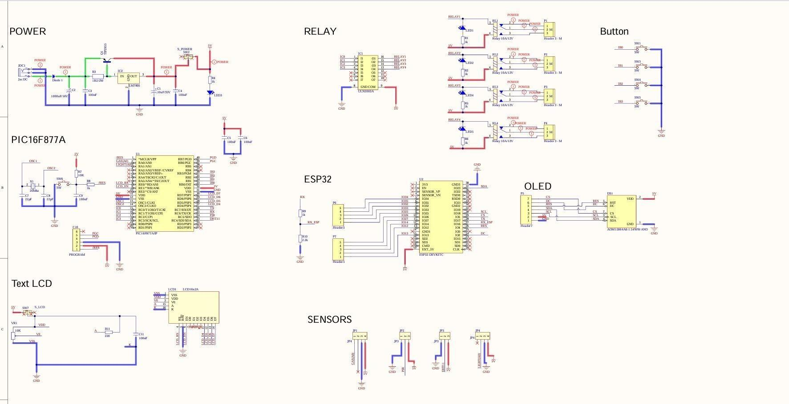
Figure 3.1: Complete System Schematic Diagram

Hardware Design

Power Supply
The power supply section accepts a DC jack input (JDC1), passes through a reverse-polarity protection diode (Diode 1), a 1000uF/16V bulk capacitor, and an LM7805 linear voltage regulator (IC2) to produce a stable 5V supply. Decoupling capacitors (100nF, 100nF, 10uF/35V) are placed near the regulator output. A power switch (S_POWER) and status LED (LED5) complete the power section.

PCB Layout
The PCB was designed using Altium Designer. Figure below shows the component layout (top layer silkscreen), Figure 3 shows the copper routing, and Figures 4 and 5 show the 3D rendered views.
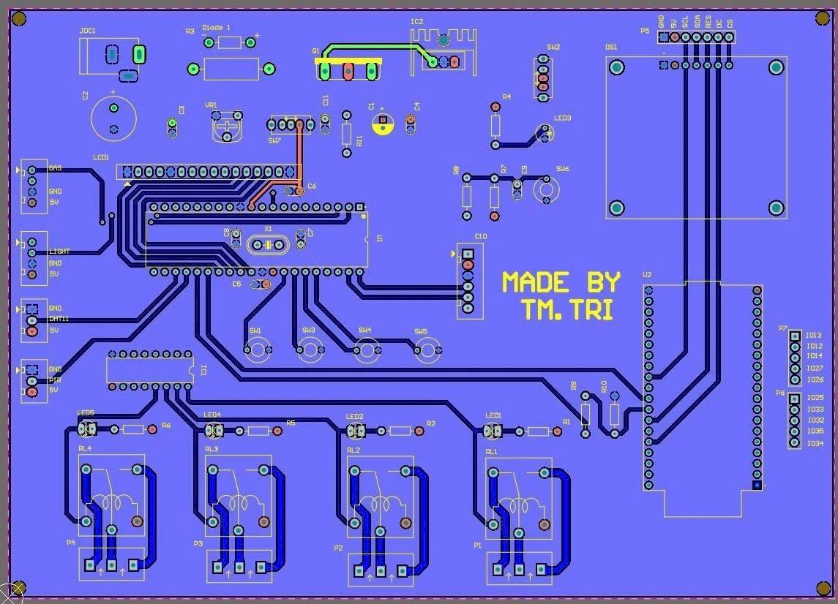
Figure 3.2: PCB Component Layout (Top View)
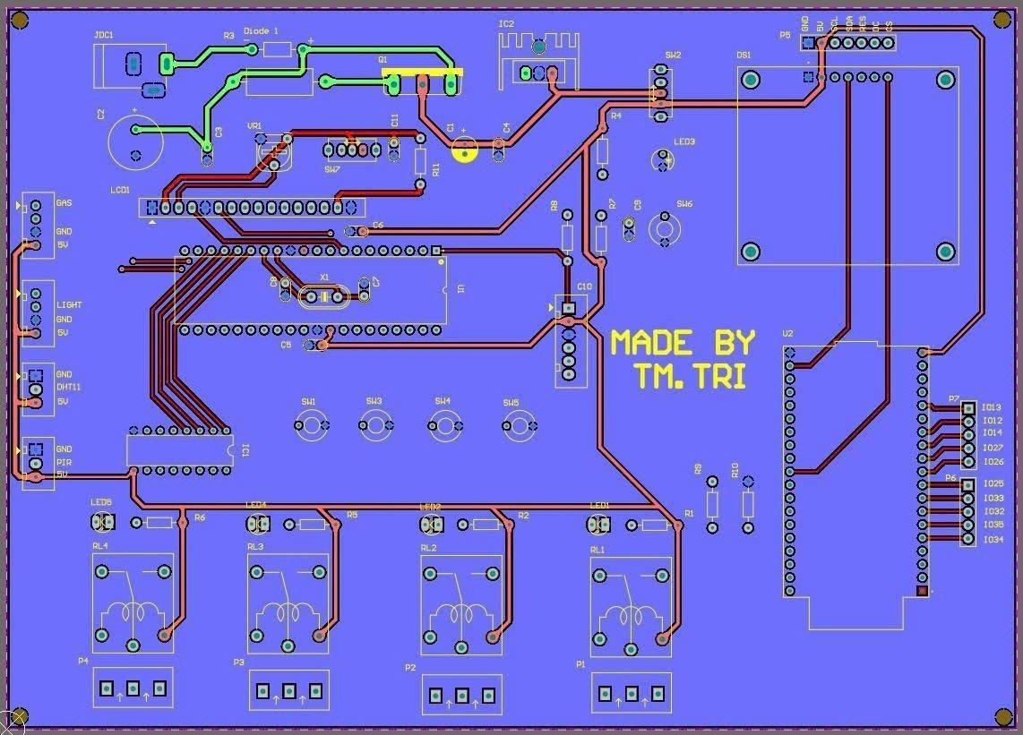
Figure 3.3: PCB Copper Routing (Top and Bottom Layers)
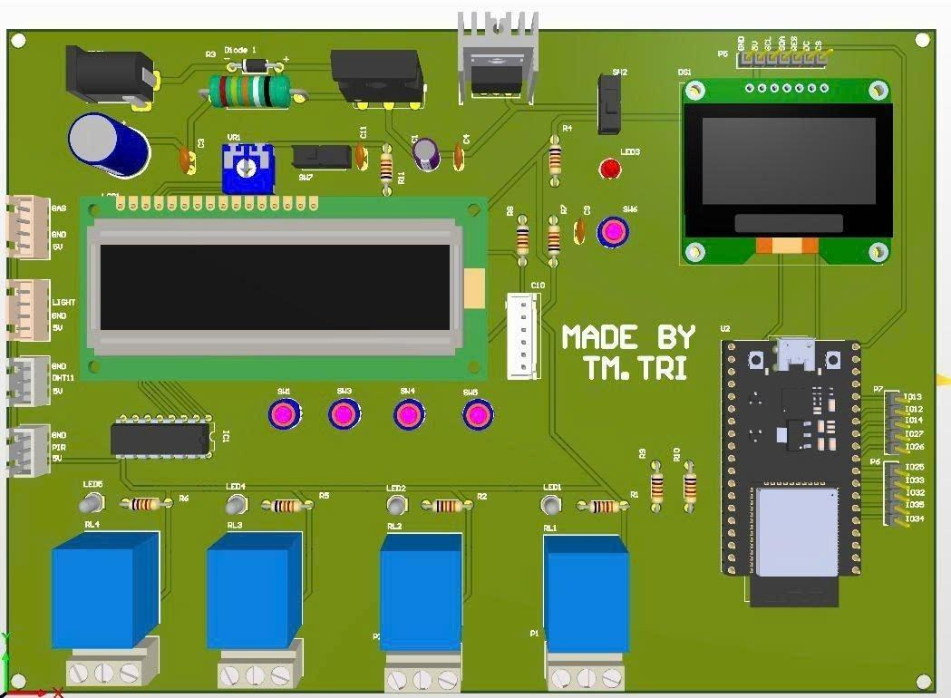
Figure 3.4: PCB 3D Render – Top Side
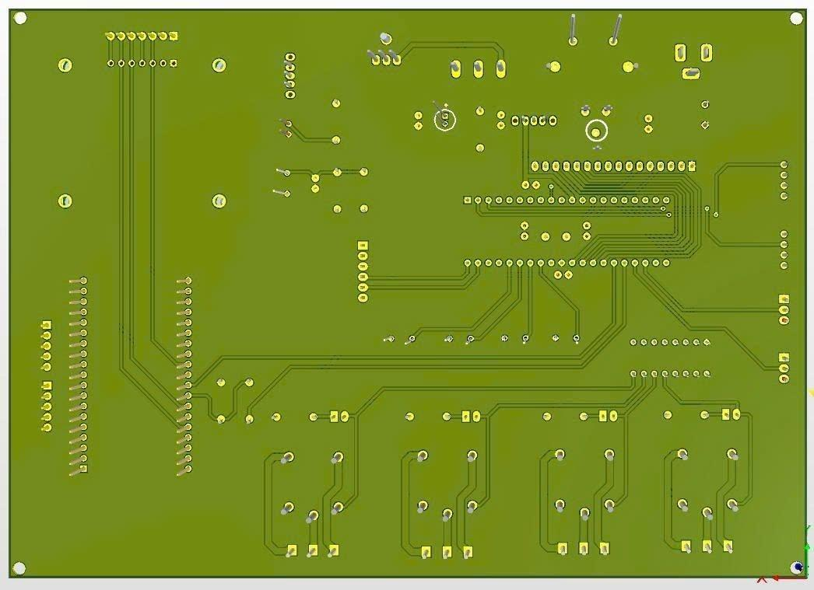
Figure 3.5: PCB 3D Render – Bottom Side
Key PCB design considerations include:
- Sensor connectors (GAS, LIGHT, DHT11, PIR) are grouped on the left edge for accessible wiring.
- Relay modules (RL1–RL4) are positioned along the bottom edge, separated from the digital circuitry to minimize EMI.
- The PIC16F877A is centrally placed with short trace runs to peripheral components.
- Separate ICSP programming header (PROGRAM) for in-circuit firmware updates.
- ESP32 and OLED connectors placed on the right edge for modular expansion.

Firmware Architecture

Modular Library Structure
The firmware is organized into three library modules, each encapsulating a sensor's hardware abstraction:
- LightSensor.h / LightSensor.c: ADC_Init(), Light_Read(), Relay_Init(), Light_Control_Relay(threshold)
- DHT11.h / DHT11.c: DHT11_Read() — returns 1 on success; populates global dht_temp, dht_hum
- PIR.h / PIR.c: PIR_Init(), PIR_Read(), PIR_Control_Alarm()
This modular design promotes code reuse, simplifies debugging, and improves maintainability.

Main Loop — Tick-Based Scheduler
The main() function implements a cooperative, tick-based task scheduler. A 100ms hardware delay (__delay_ms(100)) creates a system tick. A tick counter (0–59) drives three periodic tasks:
Table 1: Firmware Task Schedule
Task | Period | Description
Relay Control | Every tick (100ms) | Reads ADC, applies 500 threshold, sets relay ON/OFF
PIR Alarm | Every tick (100ms) | Reads PIR pin, activates/deactivates alarm output
LCD Page 0 | Tick 0 (6s cycle) | Displays light ADC value and relay status
LCD Page 1 | Tick 20 (2s into cycle) | Reads DHT11, displays temperature and humidity
LCD Page 2 | Tick 40 (4s into cycle) | Displays PIR motion detection status

Experimental Results

Hardware Prototype
Figure below shows the operational prototype. The LCD displays real-time light sensor readings and relay status. The red LED indicators visible in the lower-right area of the PCB correspond to the relay status LEDs.
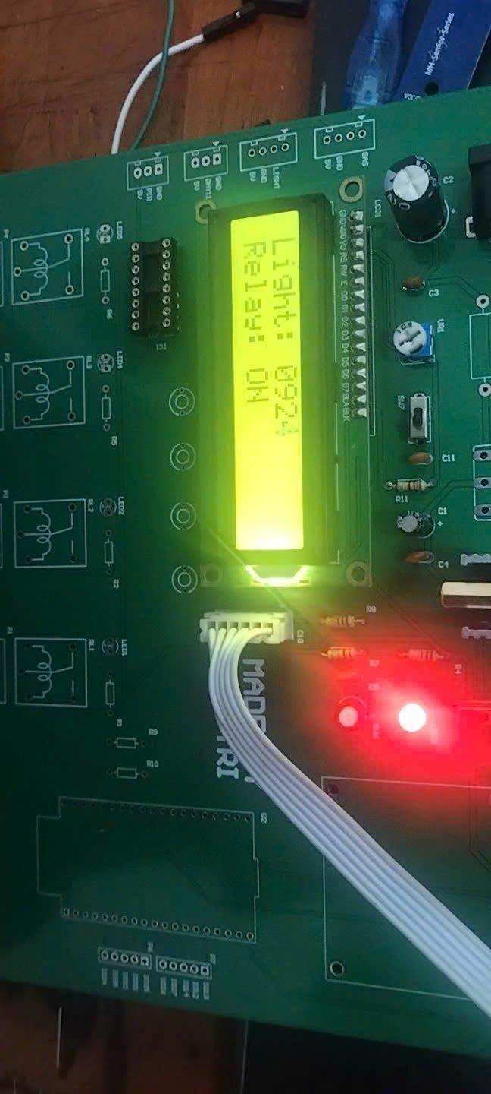
Figure 4.1: Hardware Prototype in Operation — LCD showing Light: 0924 and Relay: ON

Functional Test Results

Light Sensor and Relay Control
The LDR-based light sensor was tested under varying illumination conditions. At ambient room lighting, the ADC reading was approximately 924 (as visible on the LCD in Figure 6), which is above the 500 threshold — however, with the threshold logic inverted (dim = low ADC), the relay correctly activated at low light. The relay switching was confirmed with an LED load and an audible click from the relay coil.
Table 2: Light Sensor and Relay Test Results
Test Condition | ADC Reading | Relay State
Bright ambient light | 0820 – 1000 | OFF
Dim light (covered LDR) | 0100 – 0300 | ON
Complete darkness | 0000 – 0050 | ON

DHT11 Temperature and Humidity
The DHT11 sensor was tested at room temperature. Successful readings were obtained with typical values of 28–30°C temperature and 65–75% relative humidity. The firmware correctly handles read failures (DHT11 Error! message displayed), which can occur if the one-wire timing is disturbed by other interrupt sources or LCD update delays.

PIR Motion Detection
The PIR sensor reliably detected human motion within approximately 3–5 meters. The LCD correctly transitions to Page 2 every 6 seconds, displaying 'MOTION DETECT' when motion is active and 'CLEAR' otherwise. The alarm LED/buzzer responded within one tick cycle (100ms) of motion detection onset.

LCD Multi-Page Display
The three-page display cycle (6-second total period, 2 seconds per page) operated correctly across all test conditions. Page transitions were smooth with no display artifacts. The sprintf() formatting correctly zero-padded the 4-digit light value display.

Discussion of Results

System Performance Analysis
The Smart Home prototype successfully demonstrated all core functionalities. The tick-based cooperative scheduler proved effective for this application, as the total worst-case execution time per tick comfortably fits within the 100ms tick window. The non-blocking structure ensures that relay and PIR responses remain real-time (100ms latency), while the slower DHT11 read (which requires ~20ms of bit-bang communication) is only triggered on LCD page transitions.

Limitations and Challenges
- DHT11 Timing Sensitivity: The single-wire protocol requires precise microsecond-level timing. Interruptions from the LCD update routine occasionally cause read failures. A solution would be to use a hardware timer interrupt to handle DHT11 bit sampling.
- Blocking Delays: The LCD library uses __delay_ms() blocking delays, which slightly reduce the responsiveness of relay and PIR tasks during LCD updates. Transitioning to a state-machine LCD driver would eliminate this.
- ADC Noise: The LDR voltage divider is susceptible to supply noise. Adding a small RC filter (e.g., 10kOhm + 100nF) on the AN0 input would improve ADC reading stability.
- Single-Core Limitation: The PIC16F877A's single-core, no-RTOS architecture limits true parallelism. The ESP32 co-processor on the PCB can take over Wi-Fi and OLED tasks to reduce PIC loading.

Potential Improvements
- Implement UART communication between PIC16F877A and ESP32 to offload sensor data logging and remote monitoring to the ESP32.
- Add an OLED graphical display (SSD1306) via I2C on the ESP32 for richer data visualization.
- Implement MQTT over Wi-Fi using the ESP32 to publish sensor data to a cloud dashboard (e.g., Node-RED, ThingsBoard).
- Replace the cooperative tick scheduler with a lightweight RTOS (e.g., FreeRTOS on ESP32) for deterministic real-time guarantees.
- Add a gas/smoke sensor on the GAS connector (already provisioned on the PCB) for fire safety alerts.

Conclusion
This project successfully achieved all stated objectives. A functional Smart Home Automation System was designed, fabricated on a custom PCB, and validated through hardware testing. The modular firmware architecture demonstrates good software engineering practice for embedded systems, and the PCB design showcases a complete embedded hardware development workflow from schematic capture through to a manufactured board. The system provides a solid foundation for future expansion with IoT capabilities via the integrated ESP32 module.

References
[1] Microchip Technology. (2003). PIC16F877A Datasheet. Microchip Technology Inc.
[2] Aosong Electronics. (2010). DHT11 Humidity & Temperature Sensor Datasheet. Aosong (Guangzhou) Electronics.
[3] Texas Instruments. (2004). ULN2003A Darlington Transistor Array Datasheet. Texas Instruments.
[4] Microchip Technology. (2024). MPLAB XC8 C Compiler User's Guide. Microchip Technology Inc.
[5] Altium Limited. (2023). Altium Designer Documentation. Altium LLC.
[6] Espressif Systems. (2024). ESP32 Technical Reference Manual. Espressif Systems.
[7] Hitachi Semiconductor. (2002). HD44780U LCD Controller Datasheet. Hitachi Semiconductor.

