|  |  |
| --- | --- |
| Me&Be Online Shop  Software Requirements Specification | Author  N3_NET1804  FPT UNIVERSITY  Lô E2a-7, Đường D1, Khu Công Nghệ Cao, P. Long Thạnh Mỹ, TP. Thủ Đức, Thành phố Hồ Chí Minh. |

Contents

1. Introduction 1

1.1 Project information 1

1.2 Project overview 2

1.3 Purpose 2

1.4 Project Scope 2

1.5 Definition, Acronyms and Abbreviations 3

1.6 Member in project 3

2. User requirements 3

2.1 Actor 3

2.2 Use Case List with description 4

3. Specific Requirements 5

3.1 Functional Requirement 5

3.2 Technical Requirements 8

3.3 Feature List 10

4. Database 12

4.1 Data design 12

5. Wireframe 13

5.1 Overview 13

5.1.1 Member wireframe 13

# Introduction

## 1.1 Project information

* Project name: Me&Be Online Shop
* Software type: Web application

## Project overview

  The Me&Be Online Shop project aims to create a comprehensive and user-friendly e-commerce platform dedicated to providing a wide range of products for mothers and babies. Our goal is to become the go-to online destination for parents seeking high-quality milk, diapers, baby essentials, and maternity wear. The website will cater to both registered members and guest shoppers, offering a seamless shopping experience and exceptional customer service.

## 1.3 Purpose

The purpose of the Me&Be Online Shop project is to create an innovative and user-centric e-commerce platform that caters specifically to the needs of mothers and babies. Our mission is to provide a comprehensive, convenient, and trustworthy shopping experience where parents can find a diverse selection of high-quality products including milk, diapers, baby essentials, and maternity wear.

## 1.4 Project Scope

* Design and Development: Creation of the website, including front-end and back-end development, ensuring a responsive and user-friendly interface.
* User Roles and Permissions: Define and implement roles for Admin, Staff, Member, and Guest, with specific permissions for each.
* Payment Integration: Integration with major payment gateways to facilitate secure and efficient transactions.
* Security Features: Implement SSL encryption, secure login mechanisms, and compliance with PCI DSS standards for payment security.
* Customer Engagement Features: Develop features such as personalized product recommendations, member-exclusive deals, and a newsletter subscription.
* Testing and Quality Assurance: Conduct thorough testing, including functional, performance, and security testing, to ensure the website meets all requirements and standards.
* Deployment and Maintenance: Deploy the website on a reliable hosting platform and provide ongoing maintenance and support.

## 1.5 Definition, Acronyms and Abbreviations

* Admin: System administrator with full control over the website.
* Staff: Employees who manage products and orders.
* Member: Registered customers who can make purchases and track orders.
* Guest: Unregistered visitors who can browse products and make purchases.

## 1.6 Member in project

|  |  |  |
| --- | --- | --- |
| Name | Role | Student ID |
| Hứa Đình Thuận | Leader | SE171787 |
| Huỳnh Minh Phước | Member | SE171830 |
| Nguyễn Chí Thành | Member | SE171820 |
| Đặng Lê Hoàng Phúc | Member | SE171826 |
| Nguyễn Trường Phi Vũ | Member |  |
| Lâm Xuân Thái | Member |  |

# User requirements

## 2.1 Actor

|  |  |  |
| --- | --- | --- |
| # | Actors | Description |
| 1 | Administrator | The administrator is the person with the highest rights in the system, able to manage all aspects of the website. They have the authority to add, edit, and delete products, manage users, track orders, manage inventory, and make changes to the site's configuration and security. |
| 2 | Staff | Staff are people who assist administrators in managing the website and are often responsible for handling day-to-day tasks such as product management, order processing, and customer support. |
| 3 | Member | Members are customers who have registered an account on the website. They can view products, add products to their cart, make purchases, and track their order history. Members can also receive special offers and promotions. |
| 4 | Guest | Guests are users who do not have an account or are not logged into the website. They can view products, add products to cart, and make purchases but cannot receive offers and vouchers from the store |

## 2.2 Use Case List with description

|  |  |  |  |  |
| --- | --- | --- | --- | --- |
| ID | Use Case | Actors | Description | Priority |
| AS-UC001 | Product Management | Admin, Staff | Allows admin, staff to add, edit, or delete products from the system. | High |
| AD-UC002 | Account Management | Admin | Allows admin to manage user information and permissions. | High |
| AS-UC003 | Order Management | Admin, Staff | Allows admin, staff to monitor and manage customer orders. | High |
| AS-UC004 | Generate Reports | Admin, Staff | Allows admin, staff to generate reports on sales, products, and users. | Medium |
| AS-UC005 | Voucher Management | Admin, Staff | Allows admin, staff to manage discount codes and promotional offers. | Medium |
| ME-UC001 | Browse Products | Member | Allows users to browse the available product listings on the website. | High |
| ME-UC002 | Manage Account | Member | Allows users to update personal information and change their password. | Medium |
| ME-UC003 | Product Reviews | Member | Allows users to leave reviews and comments on products they have purchased. | Medium |
| MG-UC001 | Add To Cart | Member, Guest | Allows users to add products to their shopping cart for future purchase. | High |
| MG-UC002 | Order History | Member, Guest | Allows users to view the history of their past orders. | Medium |
| MG-UC003 | Track Order Status | Member, Guest | Allows users to track the status of their orders. | Medium |
| GU-UC001 | Checkout | Guest | Allows users to proceed with the payment for products in their shopping cart. | High |
| AU-UC001 | Login | Admin, Member, Staff | Allows users to log in to the system using their registered email and password. | High |
| AU-UC002 | Logout | Admin, Member, Staff | Allows users to log out of the system, terminating their session and returning them to the homepage. | High |
| AU-UC003 | Change Password | Admin, Member, Staff | Allows logged-in users to change their account password. | High |
| AU-004 | Forgot Password | Admin, Member, Staff | Allows users who are not logged in to reset their password by receiving a reset link via email. | High |

# Specific Requirements

## 3.1 Functional Requirement

* **Account Management**
  + **Admin:**
    - Add, edit, delete, and view all user profiles in the system.
    - Assign and manage roles and permissions for each user.
    - Reset passwords and manage account recovery options.
    - Access reports on user activity and metrics.
  + **Staff:**
    - Reset passwords and manage account recovery options.
    - Reset their own passwords and manage account settings.
  + **Member:**
    - Register, login, and logout of their accounts.
    - Edit their own profile information.
    - Reset their own passwords and manage account settings.
    - View their own account details.
  + **Guest:**
    - Register and create a new account.
* **Product Management**
* **Admin & Staff:**
  + - Add new products.
    - Edit existing product details.
    - Delete products
    - Manage categories and subcategories for products.
* **Member & Guest:**
  + - Browse products by categories and subcategories.
    - Use filters and search functionality to find specific products.
    - View detailed product pages with descriptions, images, reviews, and pricing.
    - See related products or recommendations.
* **Order Management**
* **Admin & Staff:**
  + - View all orders with details such as order number, customer information, ordered items, and status.
    - Update order statuses from processing to shipped, delivered, or canceled.).
    - Generate detailed reports on orders, including daily, monthly, and annual sales.
    - Manage voucher and discounts applicable to orders.
* **Member**
  + - Place orders with an option to add or remove items from the cart.
    - View the history and status of their own orders.
    - Apply a voucher at checkout.
    - Choose delivery options and input shipping information.
* **Guest**
  + - Place orders without creating an account.
    - Enter shipping information at checkout for each order.
* **Authentication**
* **Admin, Staff, Member**
  + - Secure login and authentication mechanisms.
    - Passwords are encrypted and securely stored.
    - Sessions are protected with timeout and automatic logouts to prevent unauthorized access.
* **Payment**
* **Admin & Staff**
  + - Process and manage transactions and payments on the website.
    - Set up and manage multiple payment gateways (COD, PayPal, etc.).
* **Member & Guest**
  + - Make payments using various payment options.
    - View payment status and receive confirmations for completed transactions.
* **Cart Management**
* **Admin & Staff**
  + - View cart details and manage cart items for all users.
* **Member & Guest**
  + - Add and remove products from the shopping cart.
    - Adjust quantities of items in the cart.
    - Save items in the cart for future purchases (Members only).
    - Access and retrieve previously saved carts upon logging in (Members only).
    - Option to clear or update the cart before checkout.
    - Review a detailed summary of the cart before proceeding to checkout, including item descriptions, quantities, and total cost.
* **Voucher Management**
* **Admin & Staff**
  + - Create new voucher codes that can apply a fixed discount, a percentage discount, or special offers (e.g., buy one get one free).
    - Set expiration dates and usage limits for each voucher.
    - Manage the activation and deactivation of vouchers.
* **Member & Guest**
  + - Apply voucher codes at checkout to receive discounts.
    - View the terms and conditions of vouchers.
* **Product Review Management**
* **Admin & Staff**
  + - View, edit, and delete product reviews.
* **Member**
  + - Create and submit product reviews.
    - Edit their own product reviews.
* **Guest**
  + - View product reviews.
* **Address Management**
* **Admin & Staff**
  + - View, edit, and delete address details for all users.
* **Member**
  + - Create, view, edit, and delete their own address details.
* **Guest**
  + - Enter shipping information at checkout for each order.
* **Financial Report**
* **Admin & Staff**
  + - Generate and view financial reports including sales, revenue, and other financial metrics.

## 3.2 Technical Requirements

**Log- in**

T1 – Email – Login with valid email

T2 – Email – Email is required

T3 – Password – Login with correct password

T4 – Password – Password is required

**Log out**

T1 – Logout – Logout successfully

**Register**

T1 – First name – First name is required

T2 – Last name – Last name is required

T3.1 - Username – Username is required

T3.2 – Username – Username cannot be duplicated

T4.1 - Email – Email is required

T4.2 – Email – Email must be valid format

T4.3 – Email – Email cannot be duplicated

T5 – Password - Password is required

T6.1 – Confirm password - Confirm password is required

T6.2 - Confirm password - Confirmation password must match the password

T7 – Birthdate - Birthdate is required

T7.2 - Check valid DoB - DoB must be valid date

T8.1 – Phone – Phone is required

T8.2 – Phone – Phone cannot have character

T8.3 – Check validation phone – Phone must be valid format

T8.4 - Check duplicated phone - Phone cannot be duplicated

**Forgot Password**

**Change Password**

**Update Account**

T1 – First name – First name is required

T2 – Last name – Last name is required

T3.1 - Username – Username is required

T3.2 – Username – Username cannot be duplicated

T4.1 - Email – Email is required

T4.2 – Email – Email must be valid format

T4.3 – Email – Email cannot be duplicated

T5 – Password - Password is required

T6.1 – Confirm password - Confirm password is required

T6.2 - Confirm password - Confirmation password must match the password

T7 – Birthdate - Birthdate is required

T7.2 - Check valid DoB - DoB must be valid date

T8.1 – Phone – Phone is required

T8.2 – Phone – Phone cannot have character

T8.3 – Check validation phone – Phone must be valid format

T8.4 - Check duplicated phone - Phone cannot be duplicated

**Delete Account**

**View Account**

**Edit Profile**

**Create Product**

T1 - Create product - Successful Product Creation

T2 – Create product – Duplicate Product Creation

T3 - Create product - Product Creation with Multiple Categories

**Update Product**

**View Product**

**Search Product**

**Sort Product**

**Filter Product**

**Add To Cart**

T1 – Verify Add to Cart - Product added successfully

T2 – Verify Add to Cart – Can not add product out of stock

T3 – Verify Add to Cart - Products being added no more than the quantity in stock

T4 - Verify Add to Cart - Product Already in Cart

**Update Cart**

**Remove Cart**

**View Cart**

**Checkout**

T32 – Customer Name – Customer Name is required

T33.1 – Email – Customer Email is required

T33.2 - Email - Customer Email must valid format   
T34 – Address - Address is required

T35.1 – Phone – Phone is required

T36.2 – Phone - Phone must not have character

T37.3 – Phone – Phone cannot have space

**Payment**

**Tracks Orders**

**View Orders**

**Update Orders**

**Delete Order**

**Return/Refund**

**Apply Voucher**

**Create Voucher**

**Update Voucher**

**Create Review**

**Update Review**

**Delete Review**

**View Reviews**

**Create Address**

T1 – Address – Address is required

T1.2 – Address – Address format must be valid

T2 – Title – Title is required  
T2.2 – Title – Title format must be valid

T3 – Is Default – Checkbox functionality

T4 – Create Address – Address create is successful

**Update Address**T1 – Address – Address is required

T1.2 – Address – Address format must be valid

T2 – Title – Title is required  
T2.2 – Title – Title format must be valid

T3 – Is Default – Checkbox functionality

T4 – Update Address – Address update is successful

**Delete Address**T1 – Delete Address – Address must exist to delete

T2 – Delete Address – Confirmation is required to delete

T3 – Delete Address – Cannot delete the only default address

T4 – Delete Address – Address deletion is successful

T5 – Delete Address – UI reflects address deletion

T6 – Delete Address – Multiple address deletion

**Financial Report**

## 3.3 Feature List

* + 1. **User Account Management**
* Login
* Logout
* Register
* Forgot Password
* Change Password
* Update Account
* Delete Account
* View Account
* Edit Profile
  + 1. **Product Management**
* Create product
* Update product
* View product
* Search product
* Sort product
* Filter product
  + 1. **Cart Management**
* Add to Cart
* Update Cart
* Remove cart
* View Cart
* Checkout
  + 1. **Order Management**
* Payment
* Track orders
* View order
* Update order
* Delete order
* Return/Refund
  + 1. **Voucher management**
* Apply Voucher
* Create voucher
* Update voucher
  + 1. **Product Reviews Management**
* Create reviews
* Update reviews
* Delete review
* View reviews
  + 1. **Address Management**
* Create address
* Update address
* View address
  + 1. **Financial Report**
* Generate financial report

**3.4**

# Database

## Data design

# Wireframe

## Overview

## Member wireframe

* + 1. Login Page

* + 1. Register Page
    2. Home Page



* + 1. Product Detail Page
    2. Cart

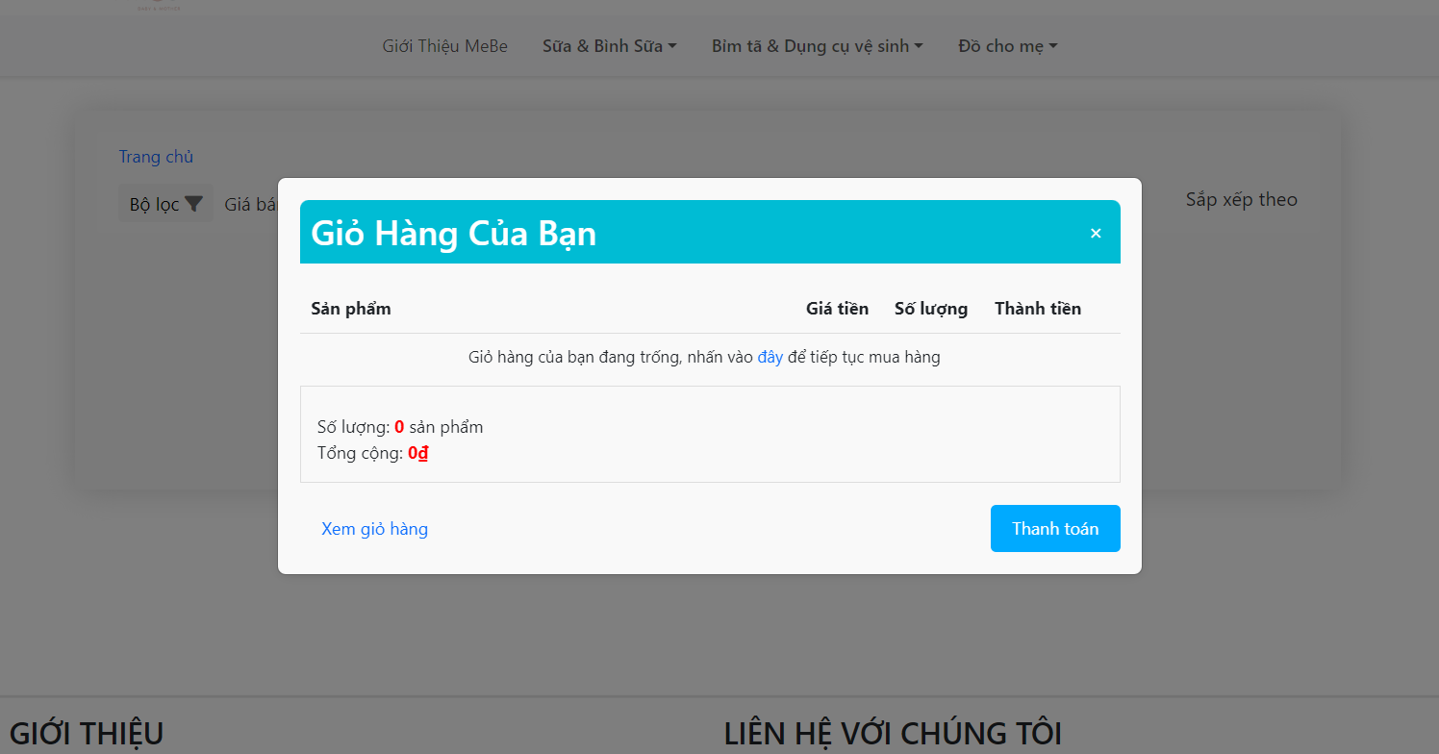

* + 1. Order Page
    2. Order History
    3. Payment
    4. Profile
    5. Edit Profile Page
    6. Change Password Page
    7. Forgot Password Page
    8. Policy
    9. About Us
    10. Pre-order Page

## 