# **Ryan’s Blog**

## Introduction

Blog website shares new of technical, life,... Written in ReactJS, combined with Ant Design and Bootstrap 5

*Website*: https://demo-blog-tvk.herokuapp.com/

## Version

|  |  |
| --- | --- |
| Website Version | 0.1.0 |
| React | 17.0.2 |
| Redux | 4.1.2 |
| Ant Design | 4.18.8 |
| Bootstrap | 5 |
| Axios | 0.21.1 |
| Chart.js | 3.7.1 |
| TypeScript | 4.5.5 |

## Structure of Website

## Browser compatibility

Mozilla Firefox, Apple Safari, Opera, Microsoft Edge, Google Chrome

## The sites

### Home Page

### 

1. Register

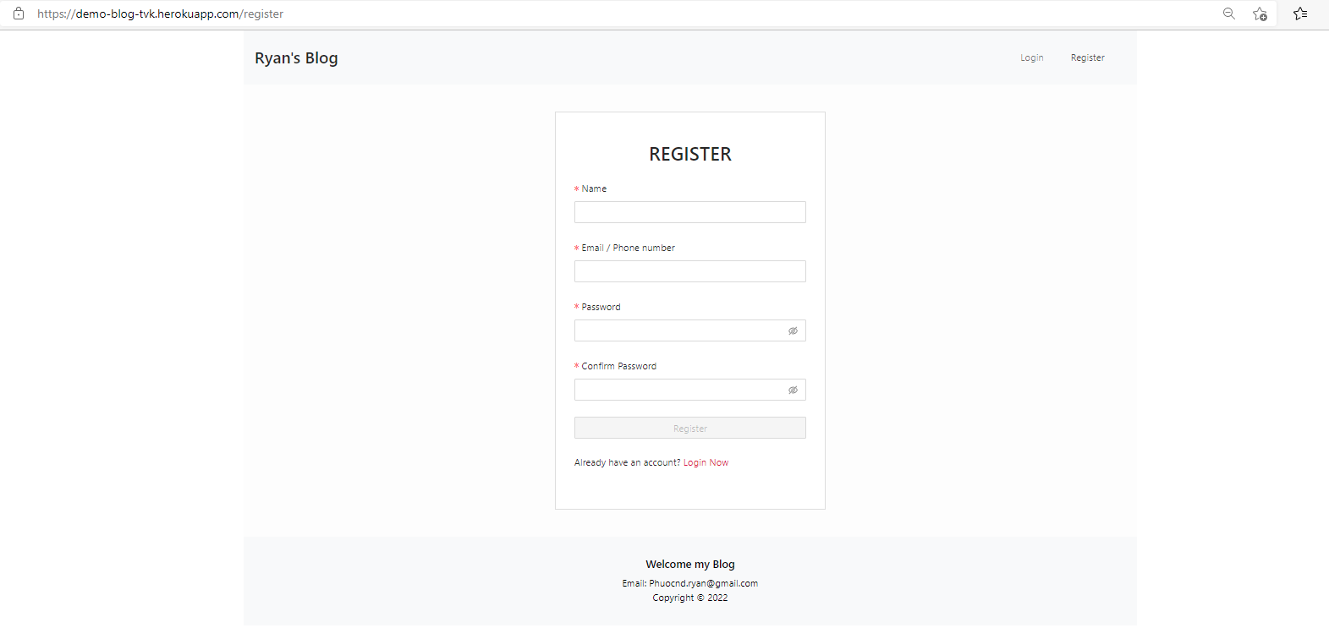

Which input * is require

* Name: Display name
* Email / Phone Number: Input your Account, will use for authentication account and login
* Password: Have length ass less 6 character

After you register successfully, the email/SMS will send to your account(email or SMS).

1. Login  
   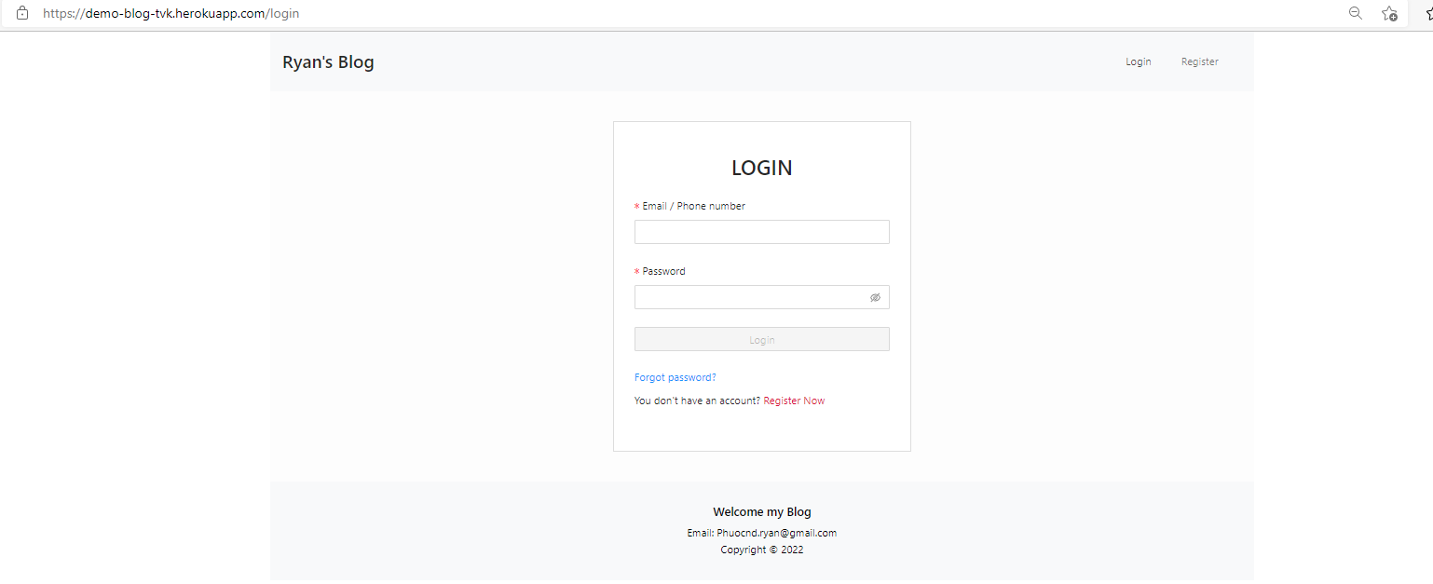
2. Email was sent  
   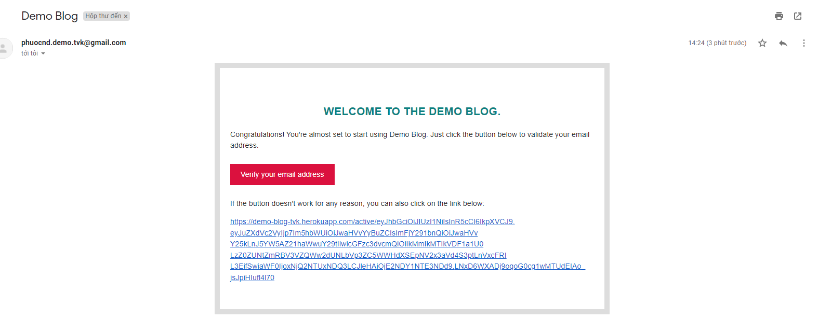
3. Authentication Email  
   Successful:  
   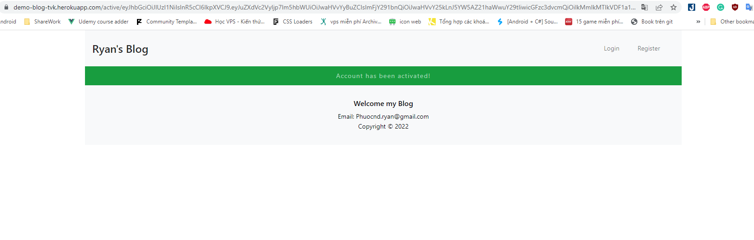  
   Have error with your account:  
   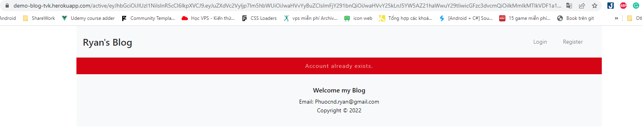
4. Statistics Blog  
   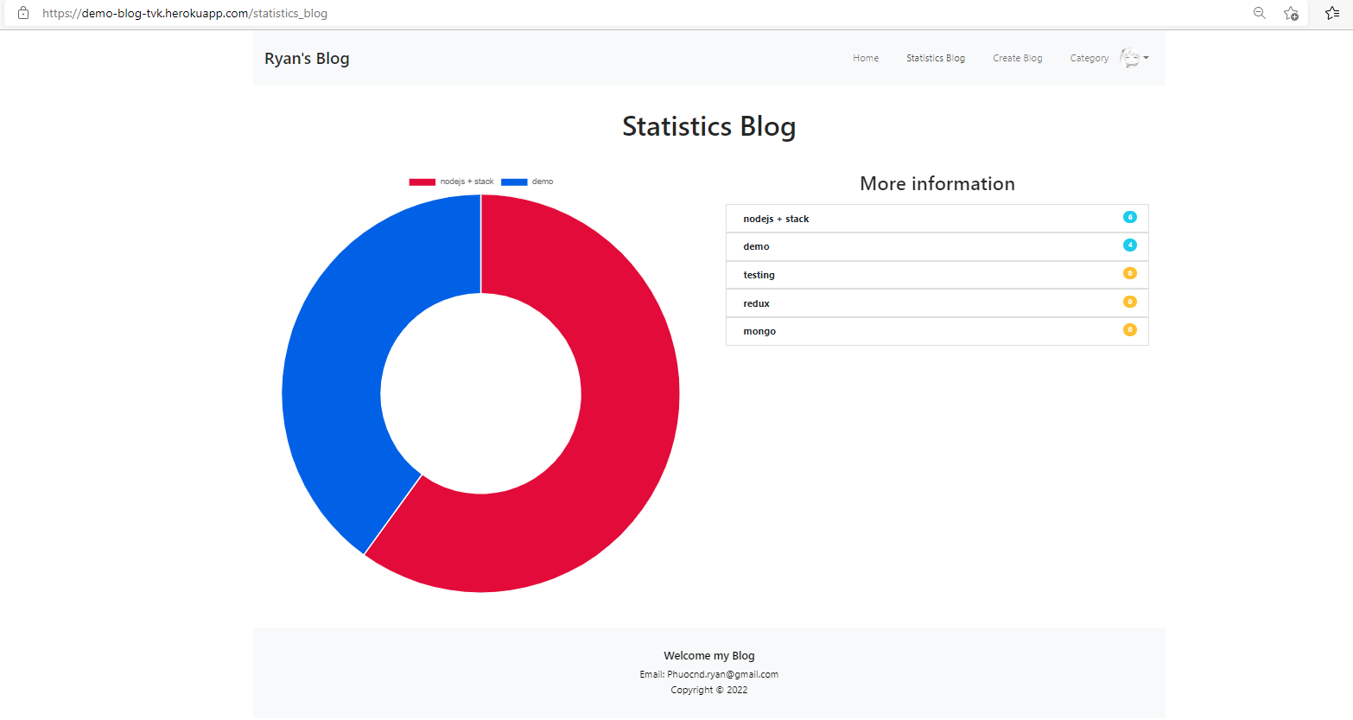  
   Here statistics number of the blog had on our website
5. Profile  
   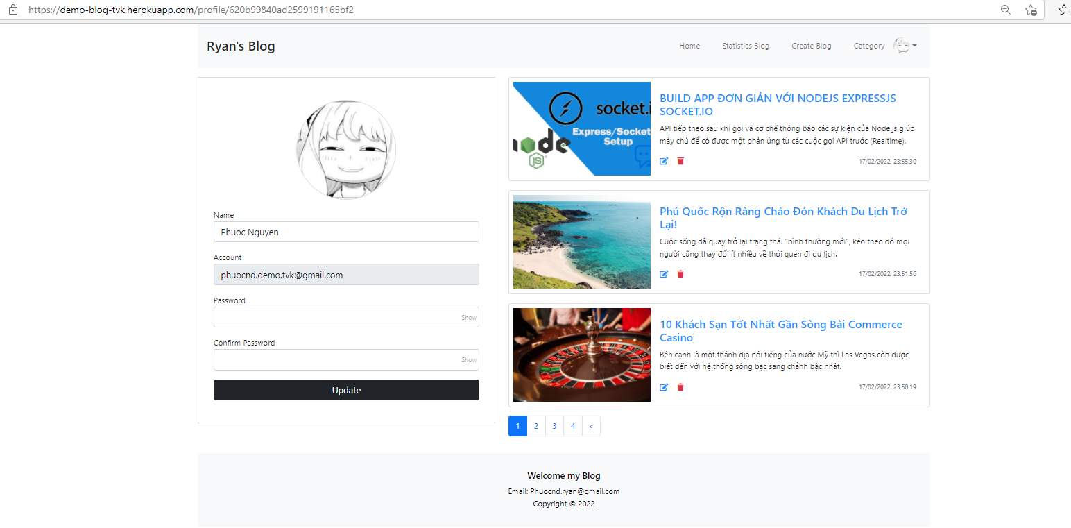  
   Show sort your information, you can change avatar, see all blog you was written in the page
6. Category  
   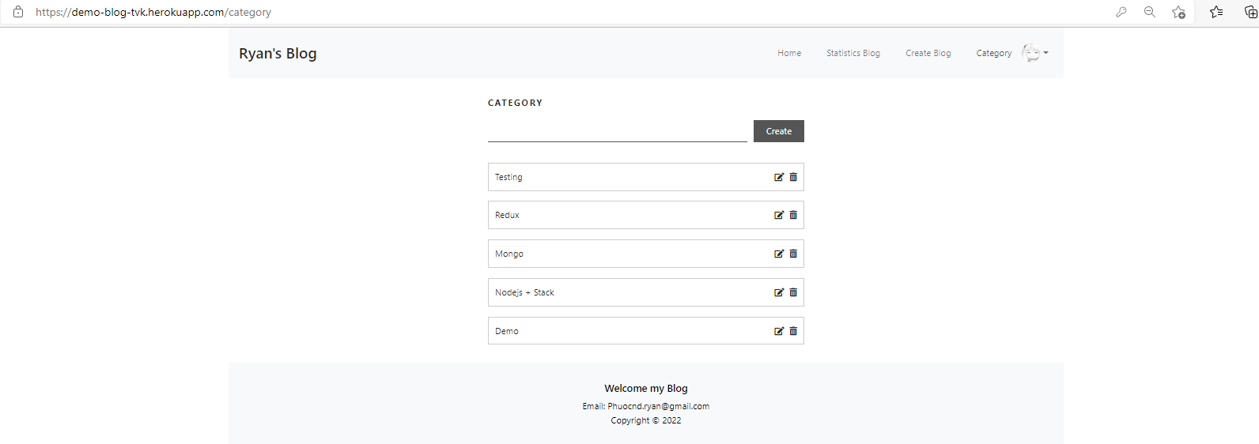  
   On this page, you can create/delete/edit category for the Blog
7. Create Blog  
   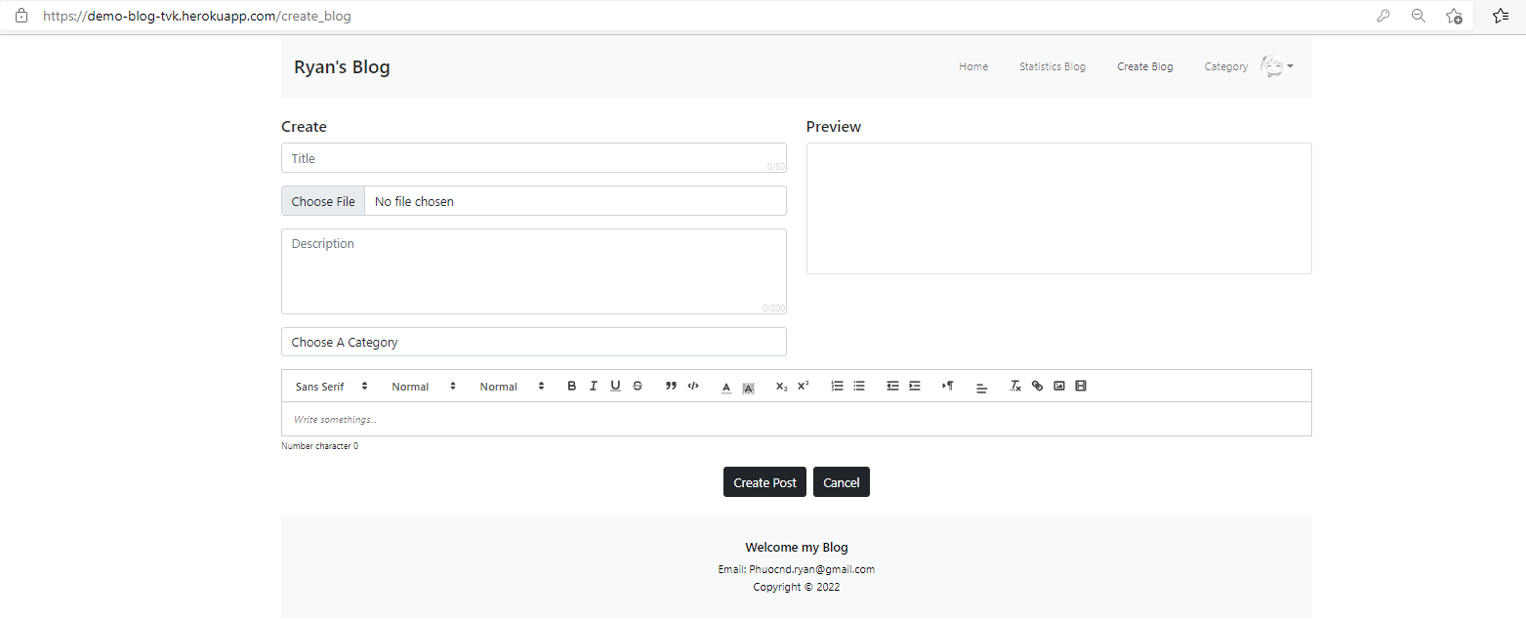  
   You can create a new Blog on this page with the hint in the input and review with a quick view this blog will show on the Home Page.