1.

a)

b)

Y^ = 132 – 22.9x

d)

2.

a)

Pearsonian coefficient of Skewness = 0.05648716 > 0 => skewed slightly to the right (sk is close to 0)



b)



c)

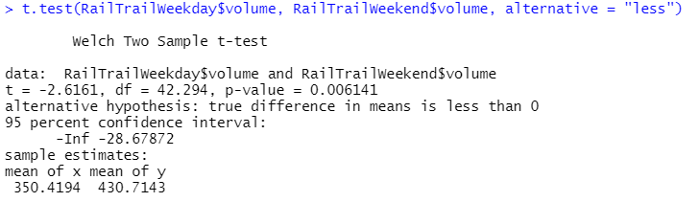

Alternative hypothesis is true means we have enough evidence, at significant level of 5%, that mean trail volume on weekdays is less than the mean trail use volume on weekends.

3.

a) 

b)

51% of male crabs’ frontal lobe is larger than the median frontal lobe size

c)



4)

a)

b)

5.

a)



Rexp(rate=1/50)

Beta = 50

Rate = 1/beta

b)

