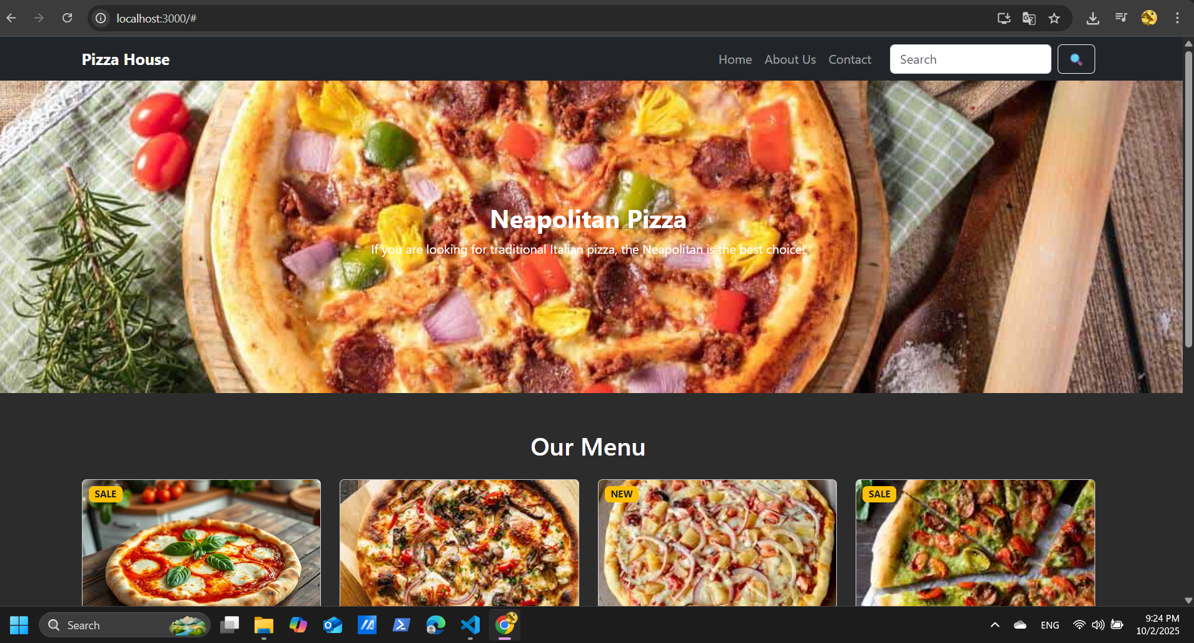
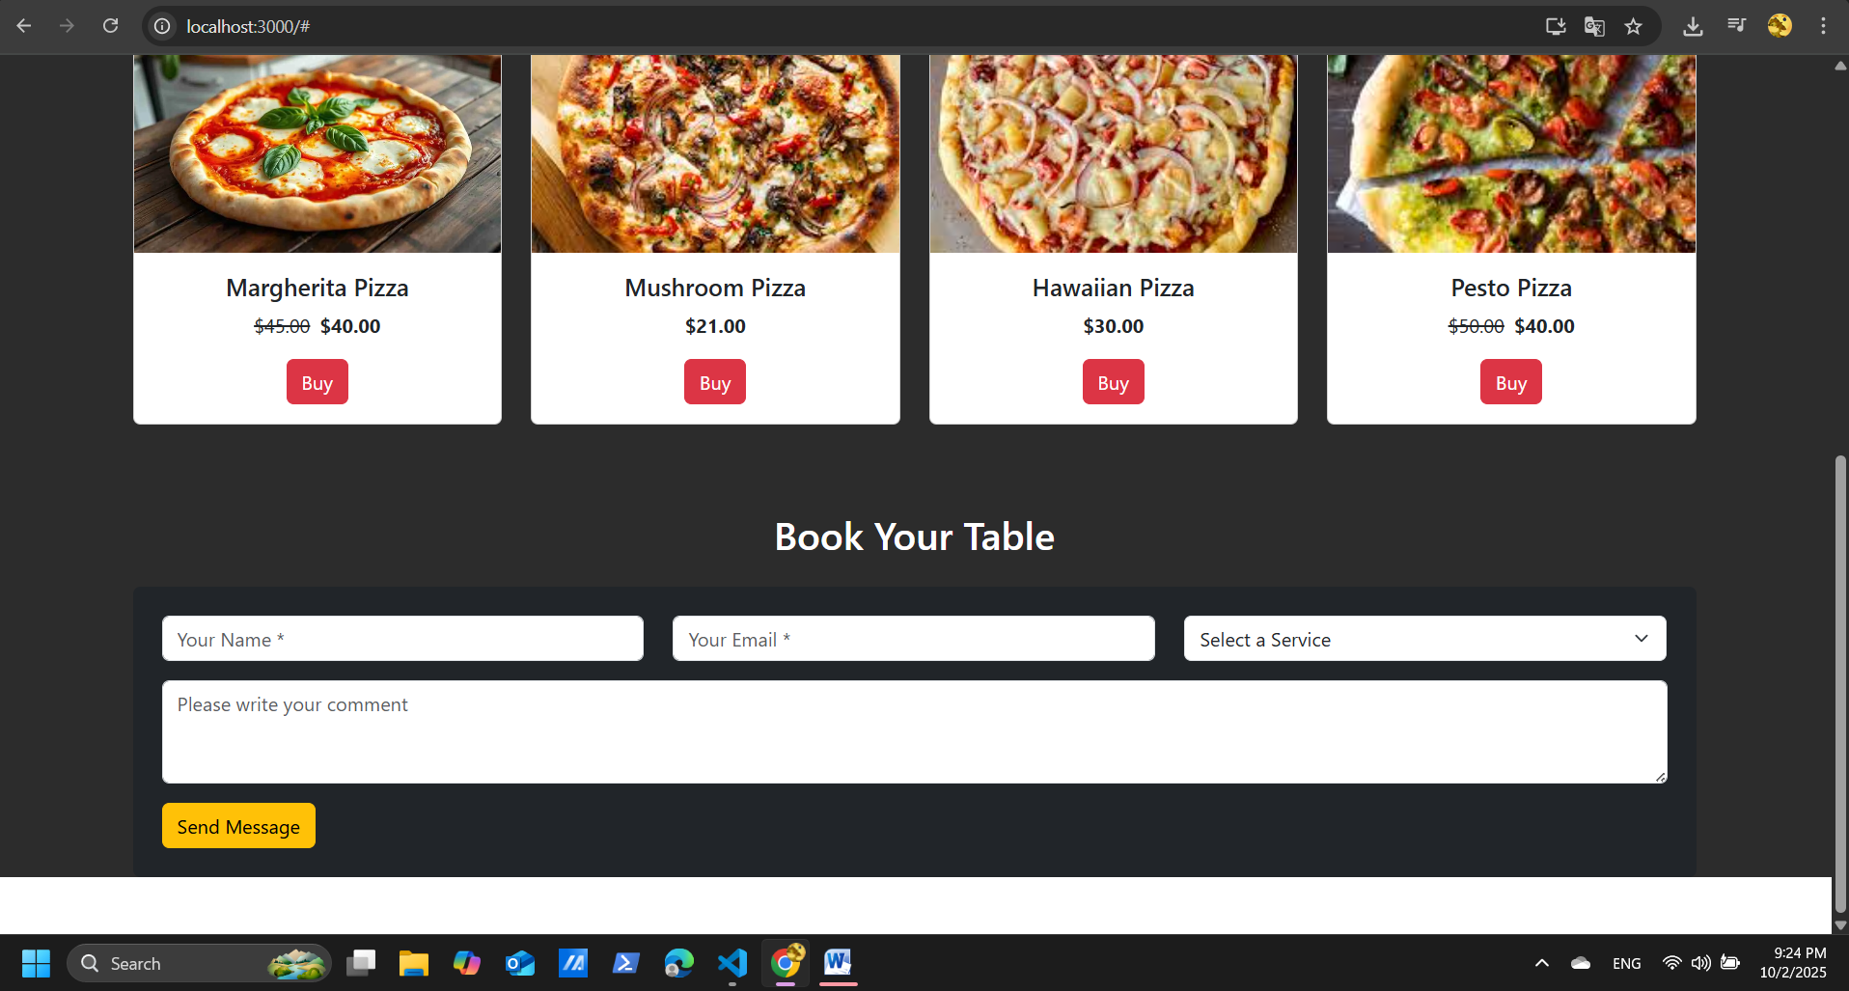
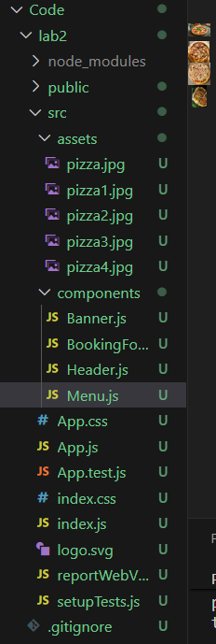
import React from "react";

export default function Header() {
return (
<nav className="navbar navbar-expand-lg navbar-dark bg-dark">
<div className="container">
<a className="navbar-brand fw-bold" href="#">Pizza House</a>
<button className="navbar-toggler" type="button" data-bs-toggle="collapse"
data-bs-target="#navbarNav" aria-controls="navbarNav" aria-expanded="false">
<span className="navbar-toggler-icon"></span>
</button>
<div className="collapse navbar-collapse" id="navbarNav">
<ul className="navbar-nav ms-auto">
<li className="nav-item"><a className="nav-link" href="#">Home</a></li>
<li className="nav-item"><a className="nav-link" href="#">About Us</a></li>
<li className="nav-item"><a className="nav-link" href="#">Contact</a></li>
</ul>
<form className="d-flex ms-3">
<input className="form-control me-2" type="search" placeholder="Search" />
<button className="btn btn-outline-light" type="submit">🔍</button>
</form>
</div>
</div>
</nav>
);
}

import React from "react";
import pizzaBanner from "../assets/pizza.jpg";

export default function Banner() {
return (
<div className="position-relative">
<img src={pizzaBanner} alt="Pizza Banner" className="w-100" style={{height: "400px", objectFit: "cover"}} />
<div className="position-absolute top-50 start-50 translate-middle text-white text-center">
<h2 className="fw-bold">Neapolitan Pizza</h2>
<p>If you are looking for traditional Italian pizza, the Neapolitan is the best choice!</p>
</div>
</div>
);
}

import React from "react";
import "bootstrap/dist/css/bootstrap.min.css";
import Header from "./components/Header";
import Banner from "./components/Banner";
import Menu from "./components/Menu";
import BookingForm from "./components/BookingForm";

function App() {
return (
<div style={{ backgroundColor: "#2c2c2c" }}>
<Header />
<Banner />
<Menu />
<BookingForm />
</div>
);
}

export default App;

import React from "react";
import pizza1 from "../assets/pizza1.jpg";
import pizza2 from "../assets/pizza2.jpg";
import pizza3 from "../assets/pizza3.jpg";
import pizza4 from "../assets/pizza4.jpg";

export default function Menu() {
const pizzas = [
{ id: 1, title: "Margherita Pizza", price: "$40.00", oldPrice: "$45.00", tag: "SALE", img: pizza1 },
{ id: 2, title: "Mushroom Pizza", price: "$21.00", oldPrice: null, tag: null, img: pizza2 },
{ id: 3, title: "Hawaiian Pizza", price: "$30.00", oldPrice: null, tag: "NEW", img: pizza3 },
{ id: 4, title: "Pesto Pizza", price: "$40.00", oldPrice: "$50.00", tag: "SALE", img: pizza4 },
];

return (
<div className="container my-5">
<h2 className="text-white text-center mb-4">Our Menu</h2>
<div className="row">
{pizzas.map((p) => (
<div className="col-md-3 mb-4" key={p.id}>
<div className="card h-100">
<div className="position-relative">
<img src={p.img} className="card-img-top" alt={p.title} style={{ height: "200px", objectFit: "cover" }} />
{p.tag && (
<span className="badge bg-warning text-dark position-absolute top-0 start-0 m-2">
{p.tag}
</span>
)}
</div>
<div className="card-body text-center">
<h5 className="card-title">{p.title}</h5>
<p className="card-text">
{p.oldPrice && <span className="text-decoration-line-through me-2">{p.oldPrice}</span>}
<span className="fw-bold">{p.price}</span>
</p>
<button className="btn btn-danger">Buy</button>
</div>
</div>
</div>
))}
</div>
</div>
);
}

import React from "react";

export default function BookingForm() {
return (
<div className="container my-5">
<h2 className="text-center text-white mb-4">Book Your Table</h2>
<form className="bg-dark p-4 rounded text-white">
<div className="row mb-3">
<div className="col-md-4">
<input type="text" className="form-control" placeholder="Your Name *" />
</div>
<div className="col-md-4">
<input type="email" className="form-control" placeholder="Your Email *" />
</div>
<div className="col-md-4">
<select className="form-select">
<option>Select a Service</option>
<option>Dine In</option>
<option>Take Away</option>
<option>Delivery</option>
</select>
</div>
</div>
<div className="mb-3">
<textarea className="form-control" rows="3" placeholder="Please write your comment"></textarea>
</div>
<button type="submit" className="btn btn-warning">Send Message</button>
</form>
</div>
);
}

