Ex3:
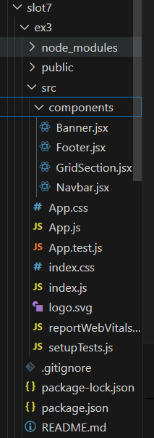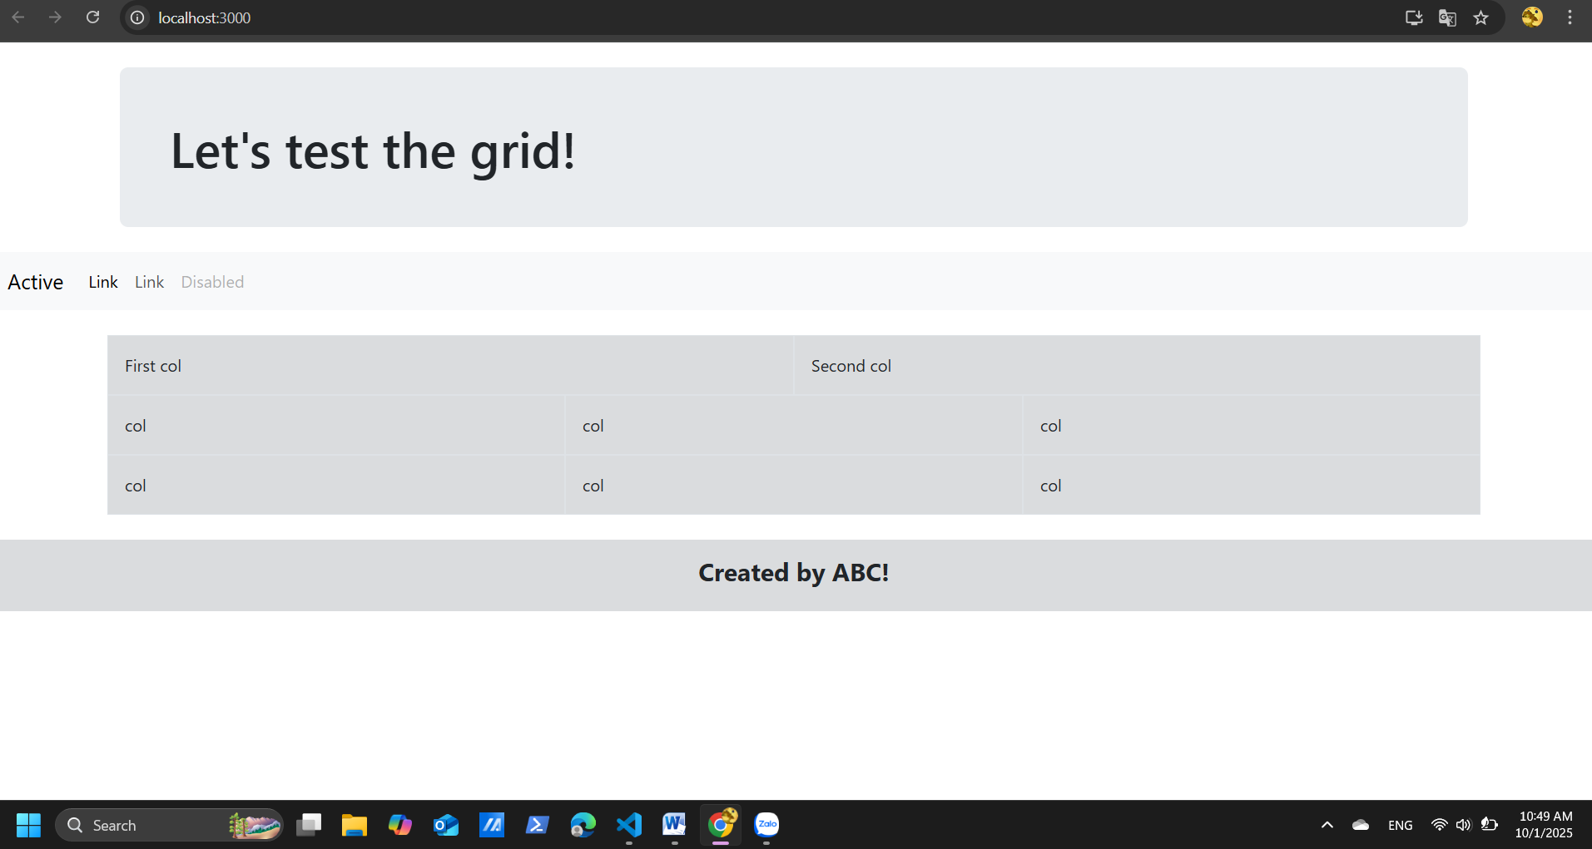
export default function Banner() {
return (
<div className="container my-4">
<div className="p-5 mb-4 bg-body-secondary rounded-3">
<h1 className="display-5 fw-semibold mb-0">Let&apos;s test the grid!</h1>
</div>
</div>
);
}

export default function Footer() {
return (
<footer className="bg-secondary bg-opacity-25 text-center p-3 mt-4">
<h4 className="fw-bold">Created by ABC!</h4>
</footer>
);
}

export default function GridSection() {
return (
<div className="container my-4">
{/* Hàng 1 */}
<div className="row mb-0">
<div className="col bg-secondary bg-opacity-25 border p-3">First col</div>
<div className="col bg-secondary bg-opacity-25 border p-3">Second col</div>
</div>

{/* Hàng 2 */}
<div className="row mb-0">
<div className="col bg-secondary bg-opacity-25 border p-3">col</div>
<div className="col bg-secondary bg-opacity-25 border p-3">col</div>
<div className="col bg-secondary bg-opacity-25 border p-3">col</div>
</div>

{/* Hàng 3 */}
<div className="row mb-0">
<div className="col bg-secondary bg-opacity-25 border p-3">col</div>
<div className="col bg-secondary bg-opacity-25 border p-3">col</div>
<div className="col bg-secondary bg-opacity-25 border p-3">col</div>
</div>
</div>
);
}

export default function Banner() {
return (
<div>
<nav class="navbar navbar-expand-lg bg-body-tertiary">
<div class="container-fluid">
<a class="navbar-brand" href="#">Active</a>
<button class="navbar-toggler" type="button" data-bs-toggle="collapse" data-bs-target="#navbarNav" aria-controls="navbarNav" aria-expanded="false" aria-label="Toggle navigation">
<span class="navbar-toggler-icon"></span>
</button>
<div class="collapse navbar-collapse" id="navbarNav">
<ul class="navbar-nav">
<li class="nav-item">
<a class="nav-link active" aria-current="page" href="#">Link</a>
</li>
<li class="nav-item">
<a class="nav-link" href="#">Link</a>
</li>

<li class="nav-item">
<a class="nav-link disabled" aria-disabled="true">Disabled</a>
</li>
</ul>
</div>
</div>
</nav>
</div>
);}

import './App.css';
import 'bootstrap/dist/css/bootstrap.min.css';
import 'bootstrap/dist/js/bootstrap.bundle.min.js';

import Banner from './components/Banner';
import Navbar from './components/Navbar';
import GridSection from './components/GridSection';
import Footer from './components/Footer';

function App() {
return (
<div>
<Banner />
<Navbar />
<GridSection />
<Footer />
</div>
);
}

export default App;

Ex4:
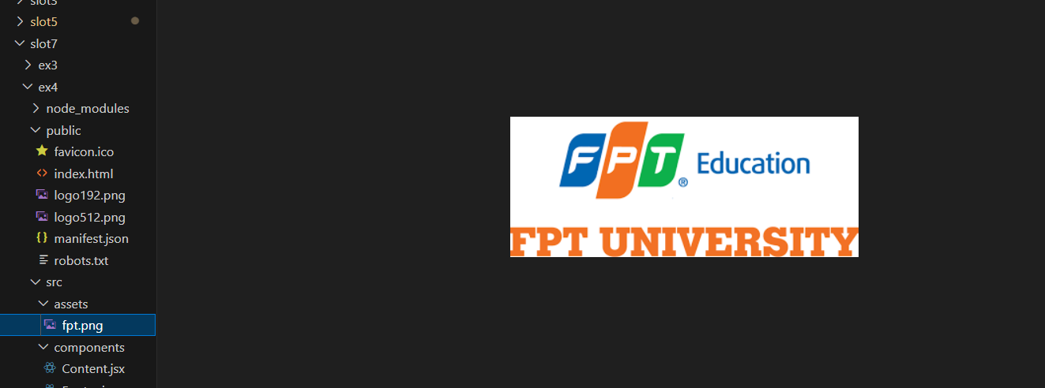
export default function Content() {
return (
<div className="container my-5 text-center">
<section id="about" className="mb-5">
<h3 className="fw-bold">About</h3>
<p>This is the about section of the website.</p>
</section>

<section id="contact">
<h3 className="fw-bold">Contact</h3>
<p>
For any inquiries, please contact us at{" "}
<a href="mailto:example@example.com">example@example.com</a>.
</p>
</section>
</div>
);
}

export default function Footer() {
return (
<footer style={{ backgroundColor: "#FFB347" }} className="text-center py-3">
<small>© 2023 Website. All rights reserved.</small>
</footer>
);
}

import logo from "../assets/fpt.png";

export default function Header() {
return (
<header style={{ backgroundColor: "#f58220" }} className="text-center py-3">
<div style={{ width: "1300px", height: "300px", margin: "0 auto" }}>
<img
src={logo}
alt="FPT University"
style={{ width: "100%", height: "100%", objectFit: "contain" }}
/>
</div>
</header>
);
}

export default function Navbar() {
return (
<nav style={{ backgroundColor: "#f58220" }} className="text-center py-3">
<a href="#home" className="mx-2 text-white text-decoration-none">Home</a>
<a href="#about" className="mx-2 text-white text-decoration-none">About</a>
<a href="#contact" className="mx-2 text-white text-decoration-none">Contact</a>
</nav>
);
}

import 'bootstrap/dist/css/bootstrap.min.css';
import Header from './components/Header';
import Navbar from './components/Navbar';
import Content from './components/Content';
import Footer from './components/Footer';

function App() {
return (
<div>
<Header />
<Navbar />
<Content />
<Footer />
</div>
);
}

export default App;

