# Use case Diagrams and Written use cases

# Admin

### Manage Account Use case Diagrams

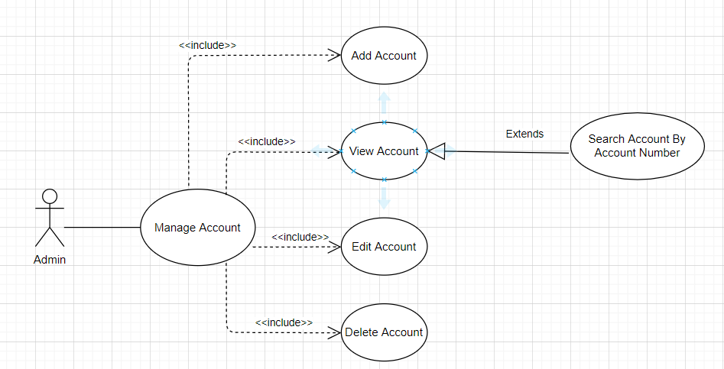

## Add a new account

|  |  |
| --- | --- |
| **Use case’s Name** | **Add new account** |
| **Description** | Process of adding a new account  Admin receives information from a customer who want to sign up and then adds the information to database. |
| **Actors** | Admin |
| **Triggers** | Admin wants to add a new account |
| **Pre-Conditions** | Admin receives request to create a new account from a user |
| **Post-Conditions** | Admin checks the database to ensure the new account is added successfully. |
| **Main Event Flow** | * Admin opens Add an account page * Fill provided information into corresponding field * Click button Add |
| **Alternative Event Flow** | * Any invalid information for required field will cause errors and failed adding. * Admin may click Cancel button in the case to re-check the information |
| **Special Requirements** | * Admin has basic knowledge of manipulating the database. * Some required information likes phone, email especially account number has not existed in the database. |

Activity diagram:

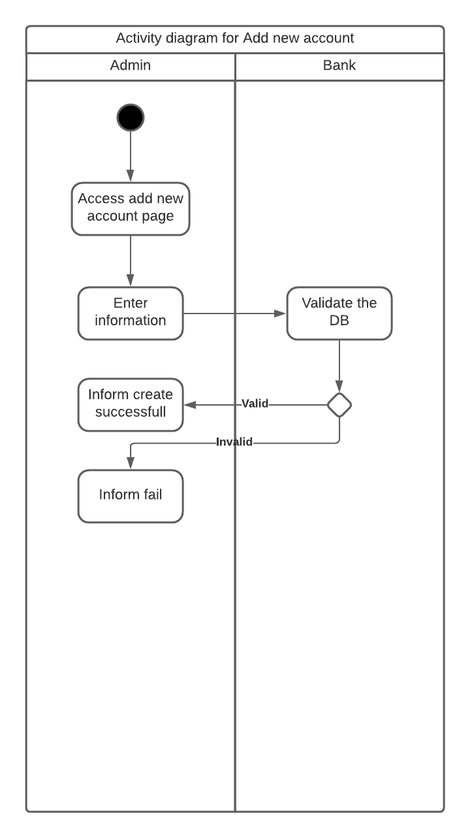

## Edit an account

|  |  |
| --- | --- |
| **Use case’s Name** | **Edit an account** |
| **Description** | Process of editing an account  Admin edits some information of a user and save the edited data in database. |
| **Actors** | Admin |
| **Triggers** | Admin wants to edit an account |
| **Pre-Conditions** | Admin receives request to edit some information from a existing user |
| **Post-Conditions** | Admin checks the database to ensure the edited information is saved |
| **Main Event Flow** | * Admin opens List of Accounts and finds the user who needs editing then clicks Edit button * Finds fields need to edit and update the information * Clicks button Save |
| **Alternative Event Flow** | * Any invalid information for required field will cause errors and failed editing. * Admin may click Cancel button in the case to re-check the information |
| **Special Requirements** | Admin has basic knowledge of manipulating the database. |

Activity diagram:

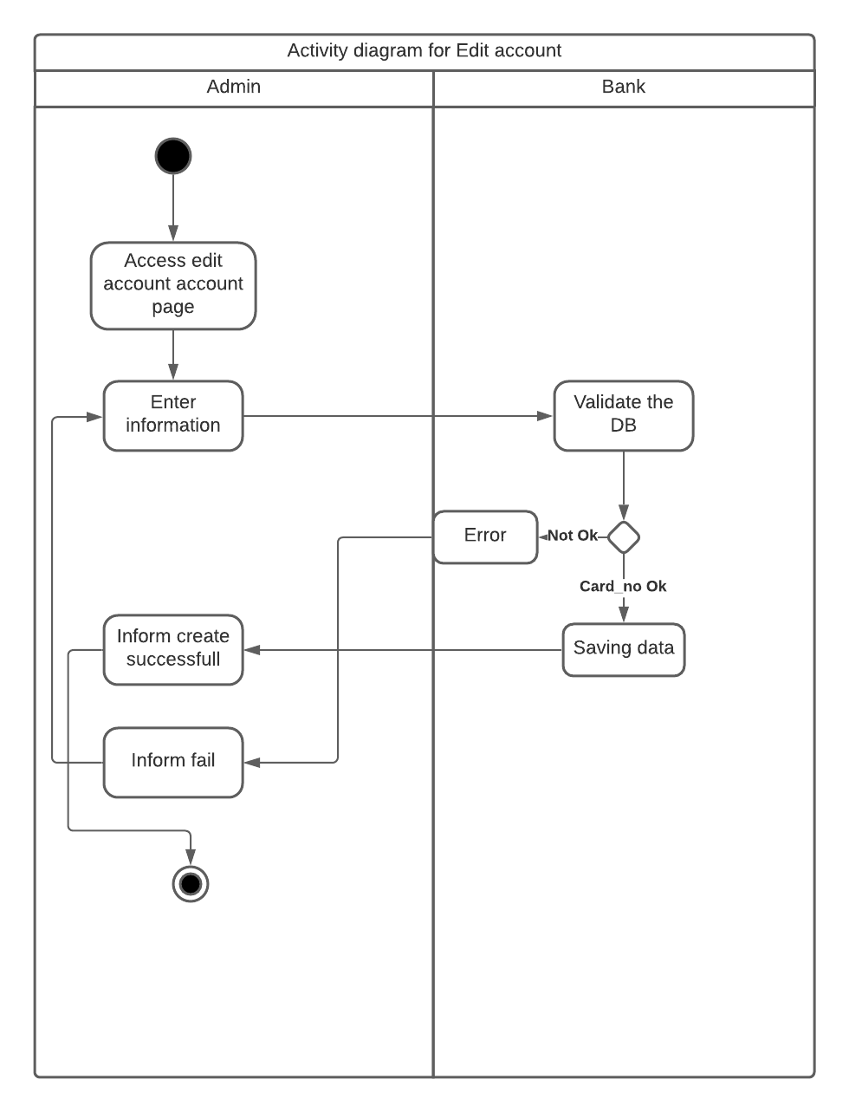

## Delete an account

|  |  |
| --- | --- |
| **Use case’s Name** | **Delete an account** |
| **Description** | Process of deleting an account  Admin deletes an account that no need managing |
| **Actors** | Admin |
| **Triggers** | Admin wants to delete an account |
| **Pre-Conditions** | Admin receives request to delete an account or find that there is no sense to manage this user |
| **Post-Conditions** | Admin checks the database to ensure the user’s information is deleted successfully. |
| **Main Event Flow** | * Admin opens List of Accounts page, find the user who needs to be deleted and clicks Delete button * Confirm deleting |
| **Alternative Event Flow** | * Admin may click Cancel button in the case to re-check the information |
| **Special Requirements** | Admin has basic knowledge of manipulating the database. |

Activity diagram

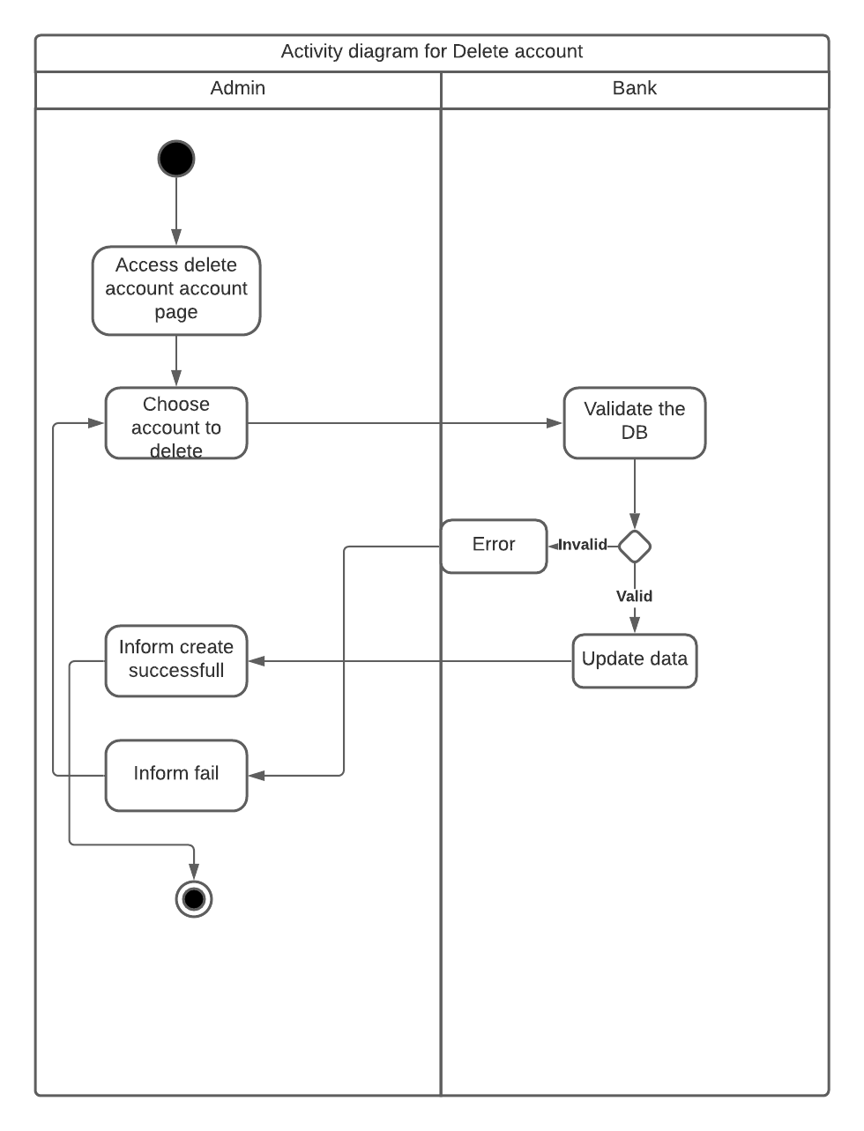

## View all user’s accounts

|  |  |
| --- | --- |
| **Use case’s Name** | **View all accounts in the bank** |
| **Description** | Process of viewing all user’s accounts  Admin views list of accounts in the bank |
| **Actors** | Admin |
| **Triggers** | Admin wants to view all accounts |
| **Pre-Conditions** | Admin wants to check information of users |
| **Post-Conditions** | No post-condition. |
| **Main Event Flow** | * Admin opens List of Accounts page |
| **Alternative Event Flow** | * Admin may click Edit/Delete button |
| **Special Requirements** | No special requirement. |

## Search an account by account number

|  |  |
| --- | --- |
| **Use case’s Name** | **Search an account** |
| **Description** | Process of searching an account  Admin views list of accounts in the bank and searches for specific account by entering account number and click search button |
| **Actors** | Admin |
| **Triggers** | Admin wants to search an account |
| **Pre-Conditions** | Admin wants to view information of a specific account |
| **Post-Conditions** | No post-condition. |
| **Main Event Flow** | * Admin opens List of Accounts page * In the field search, admin enters account number and click Search button to search a for user’s data |
| **Alternative Event Flow** | * Admin may click Edit/Delete button |
| **Special Requirements** | Admin has basic knowledge of manipulating the database. |

### Manage Transaction Use case Diagrams

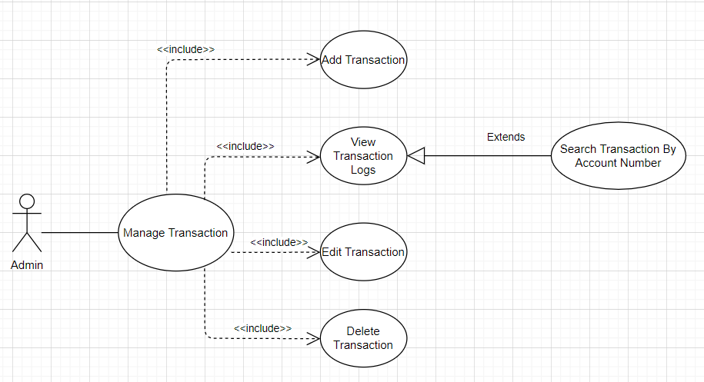

## Add a transaction

|  |  |
| --- | --- |
| **Use case’s Name** | **Add a transaction** |
| **Description** | Process of adding a transaction  Admin receives information from a customer who made a transaction and adds the information to database. |
| **Actors** | Admin |
| **Triggers** | Admin wants to add a transaction |
| **Pre-Conditions** | Admin receives transaction’s information to create a transaction |
| **Post-Conditions** | Admin checks the transaction log to ensure the transaction is added successfully. |
| **Main Event Flow** | * Admin opens Add a transaction page * Fill provided information into corresponding field * Click button Add |
| **Alternative Event Flow** | * Any invalid information for required field will cause errors and failed adding. * Admin may click Cancel button in the case to re-check the information |
| **Special Requirements** | * Admin has basic knowledge of manipulating the database. |

## Edit a transaction

|  |  |
| --- | --- |
| **Use case’s Name** | **Edit a transaction** |
| **Description** | Process of editing a transaction  Admin edits some information of a transaction |
| **Actors** | Admin |
| **Triggers** | Admin wants to edit a transaction |
| **Pre-Conditions** | The transaction has been exited in the transaction logs |
| **Post-Conditions** | Admin checks the transaction log to ensure the transaction is edited successfully. |
| **Main Event Flow** | * Admin opens Edit a transaction page * Fill provided information into corresponding field * Click button Save |
| **Alternative Event Flow** | * Any invalid information for required field will cause errors and failed adding. * Admin may click Cancel button in the case to re-check the information |
| **Special Requirements** | * Admin has basic knowledge of manipulating the database. |

## Delete a transaction

|  |  |
| --- | --- |
| **Use case’s Name** | **Delete a transaction** |
| **Description** | Process of deleting an account  Admin deletes a transaction that no need managing |
| **Actors** | Admin |
| **Triggers** | Admin wants to delete a transaction |
| **Pre-Conditions** | Admin receives request to delete a transaction or find that there is no sense to manage this transaction |
| **Post-Conditions** | Admin checks the database to ensure the transaction log is deleted successfully. |
| **Main Event Flow** | * Admin opens List of Transactions page, find the transaction which needs to be deleted and clicks Delete button * Confirm deleting |
| **Alternative Event Flow** | * Admin may click Cancel button in the case to re-check the information |
| **Special Requirements** | Admin has basic knowledge of manipulating the database. |

## View transaction logs

|  |  |
| --- | --- |
| **Use case’s Name** | **View log of transactions** |
| **Description** | Process of viewing all transaction history  Admin views log of transactions in the bank |
| **Actors** | Admin |
| **Triggers** | Admin wants to all transactions |
| **Pre-Conditions** | Admin wants to check log of transactions |
| **Post-Conditions** | No post-condition. |
| **Main Event Flow** | * Admin opens List of Transactions page |
| **Alternative Event Flow** | * Admin may click Edit/Delete button |
| **Special Requirements** | No special requirement. |

Activity diagram:

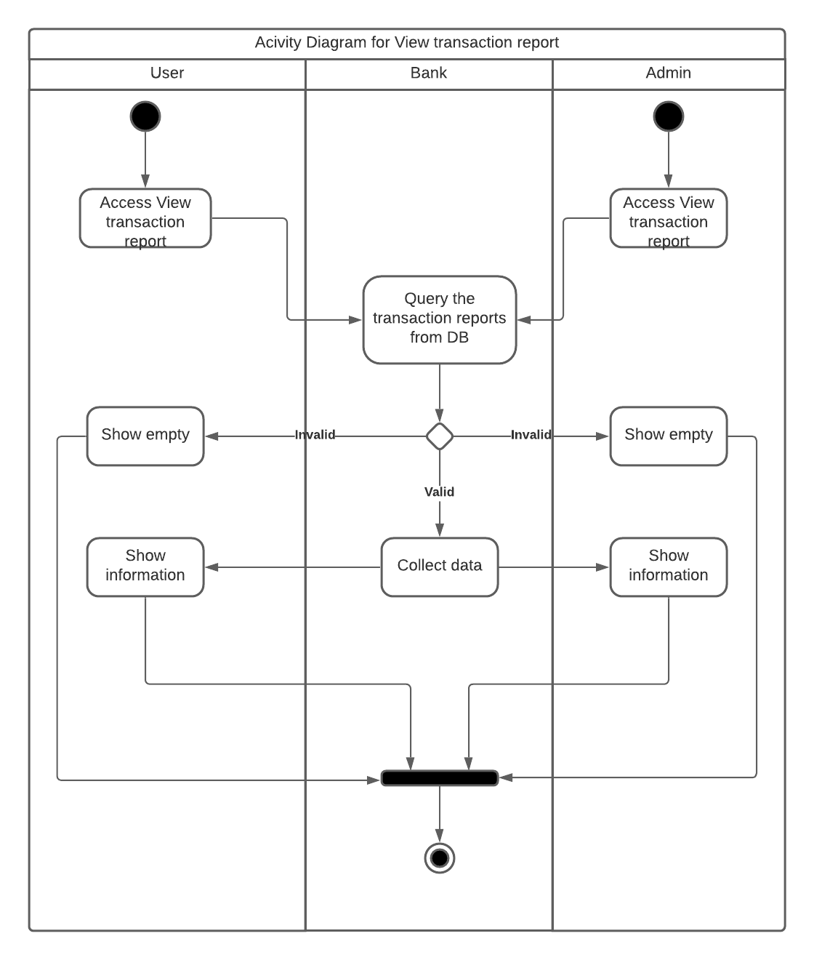

## Search transactions by account number

|  |  |
| --- | --- |
| **Use case’s Name** | **Search transactions based on account number** |
| **Description** | Process of searching a transaction log  Admin views list of transaction in the bank and searches for specific transaction logs by entering account number and click search button |
| **Actors** | Admin |
| **Triggers** | Admin wants to search transaction logs of an account |
| **Pre-Conditions** | Admin wants to view information of a specific account |
| **Post-Conditions** | No post-condition. |
| **Main Event Flow** | * Admin opens List of Transactions page * In the field search, admin enters account number and click Search button to search a for transaction log |
| **Alternative Event Flow** | * Admin may click Edit/Delete button |
| **Special Requirements** | Admin has basic knowledge of manipulating the database. |