



*“Never one… without the other”*

* Dragon Knights Team

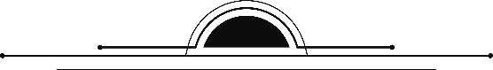

Tên tài liệu

Tên tài liệu

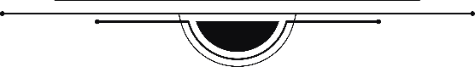

**Version 1.0**

4/4/2018

VERSION HISTORY

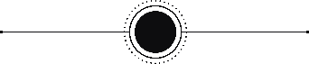

|  |  |  |  |
| --- | --- | --- | --- |
| **VERSION** | **DATE** | **AUTHOR** | **CONTENT** |
| 1.0 | 11/5/2018 | Đổng Kim Vinh |  |
| 1.1 | 4/6/2018 | Đổng Kim Vinh | Fix document |
| 2.0 | 19/6/2018 | Đổng Kim Vinh | Rework document |
| 2.1 | 23/62018 | Đổng Kim Vinh | Fix document |
|  |  |  |  |

MAIN CONTENT

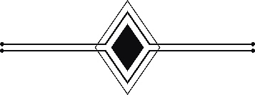

Nội dung

1. Quality attribute 4

1.1. Quality attribute :Scalability 4

1.2. Quality attribute :Performance 4

1.2.1. Client 4

1.2.2. Server 5

2. Physical Perspective 5

3. Dynamic Perspective 6

3.1. Dynamic perspective lv0 6

3.2. Dynamic perspective lv0 by function 7

3.2.1. View Course List 7

3.2.2. Get Student List 8

3.2.3. Add New Student 9

3.2.4. Remove Student 10

3.2.5. Add Session 11

3.2.6. Remove Session 12

3.2.7. Attendance Online 13

3.2.8. Statistics By Students And Courses 14

3.2.9. Statistics By Classes 15

4. Static Perspective 16

4.1. Static Perspective Lv0 16

4.2. Static Perspective Lv1 17

1. Quality attribute
   1. Quality attribute :Scalability

|  |  |
| --- | --- |
| **What It’s For** | When requirement change , the system easy to upgarde (or scale) |

|  |  |
| --- | --- |
| Q.01 | Scalability |
|  | |
| Source of stimulus | Developer |
| Stimulus | Want to scale the system easily when requirement change |
| Environmental conditions | Code time |
| Artifact stimulated | System |
| Response | The system can be extended to many departments |
| Response measure | The system serves 23 departments, when the server and the program upgraded |

* 1. Quality attribute :Performance
     1. Client

|  |  |
| --- | --- |
| Q.02.1 | Performance: Client |
|  | |
| Source of stimulus | Developer |
| Stimulus | Want to increase performance of the system in 2 side Client and Server |
| Environmental conditions | Code time |
| Artifact stimulated | System |
| Response | +Client:  -reduce the time of loading page  -avoid reload the whole page when reloading page |
| Response measure | -Time reduced when loading page: 70%  -Time of loading page: less than 3 second  -Reduce 57% size of the css and script file |

* + 1. Server

|  |  |
| --- | --- |
| **Q.02.2** | Performance: Server |
|  | |
| Source of stimulus | Developer |
| Stimulus | Want to increase performance of the system in 2 side Client and Server |
| Environmental conditions | Code time |
| Artifact stimulated | System |
| Response | +Server:  -handling parallel tasks  -solving the sync problem  -avoid call-back hell situation  -speed up execution |
| Response measure | Average Respone time(ART):5s |

1. Physical Perspective

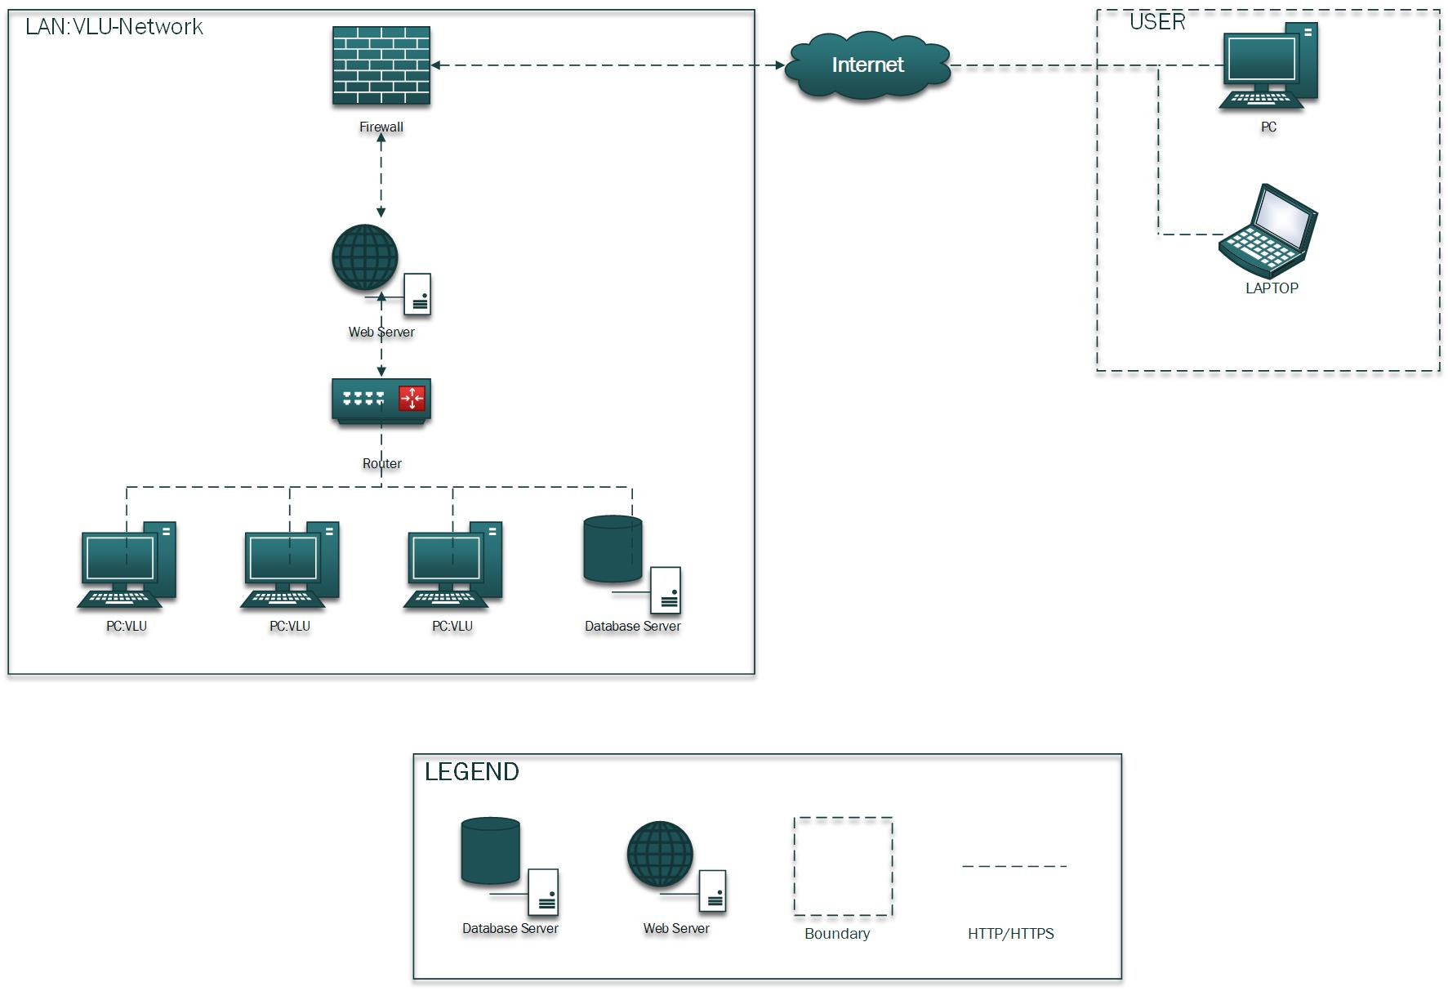

1. Dynamic Perspective
   1. Dynamic perspective lv0

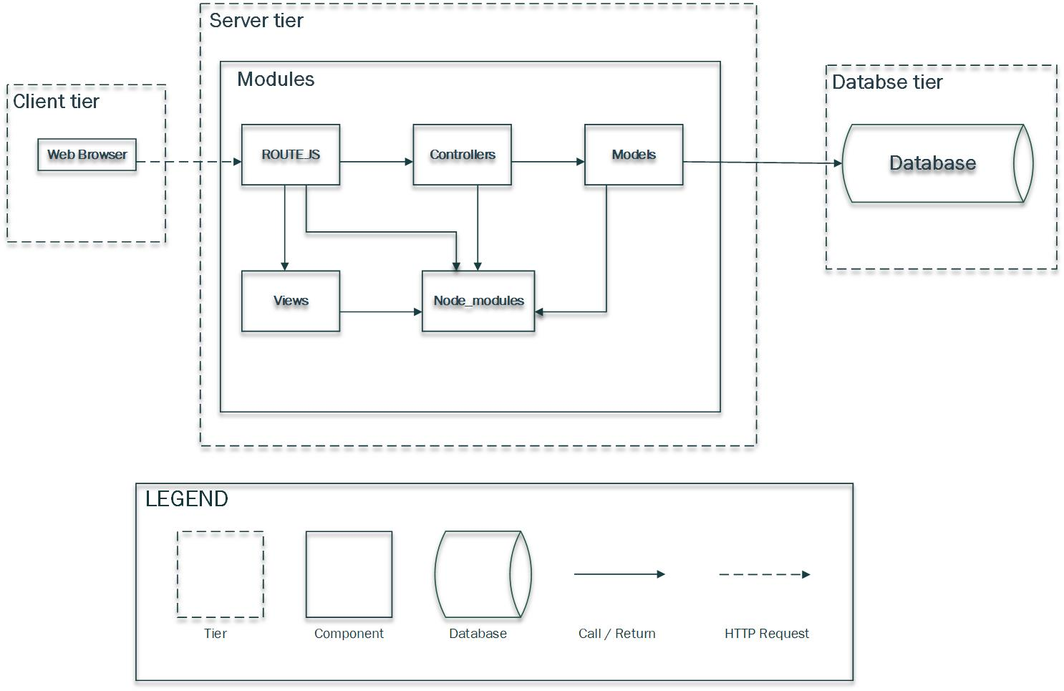

* 1. Dynamic perspective lv0 by function
     1. View Course List

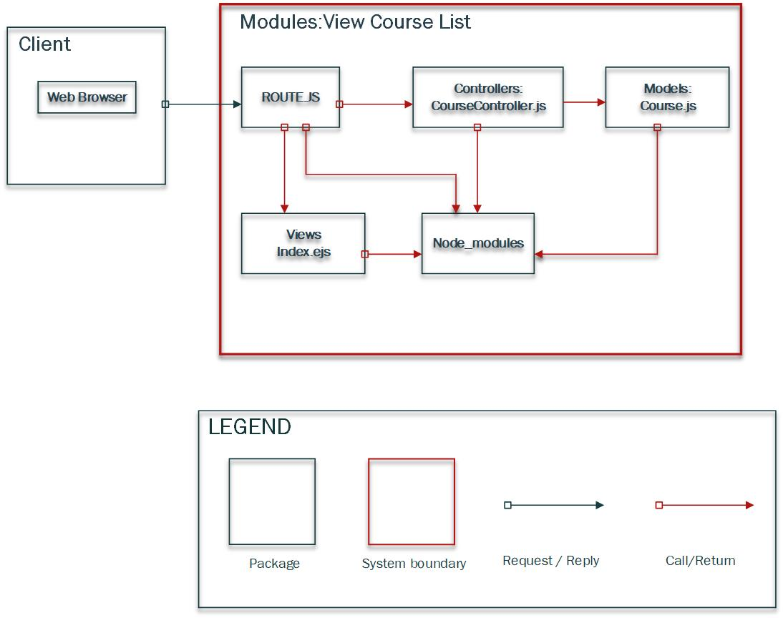

* + 1. Get Student List

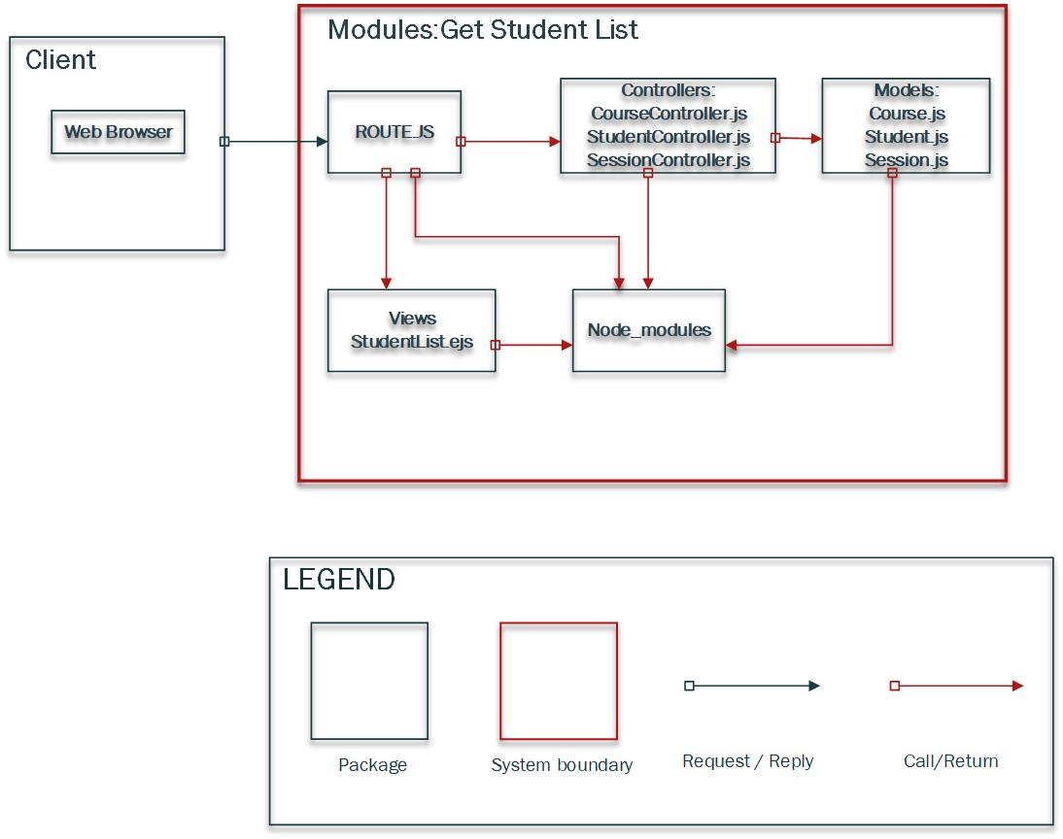

* + 1. Add New Student

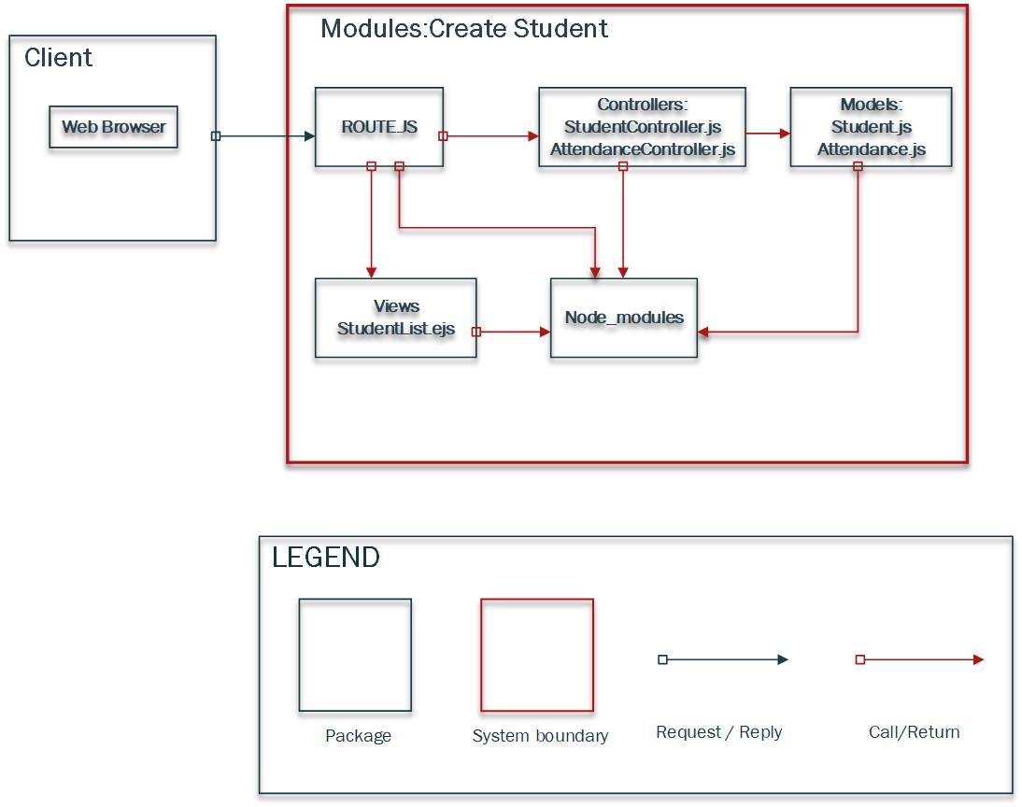

* + 1. Remove Student

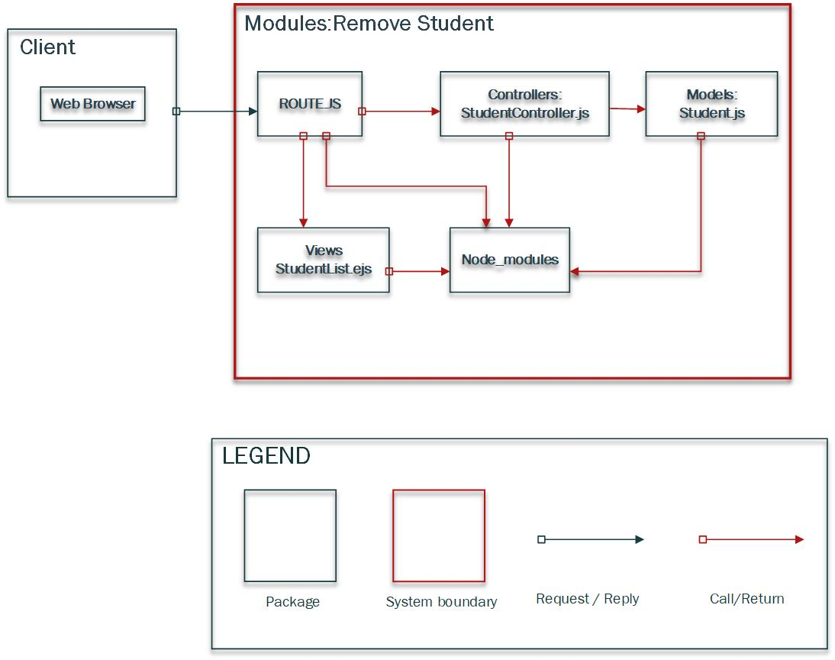

* + 1. Add Session

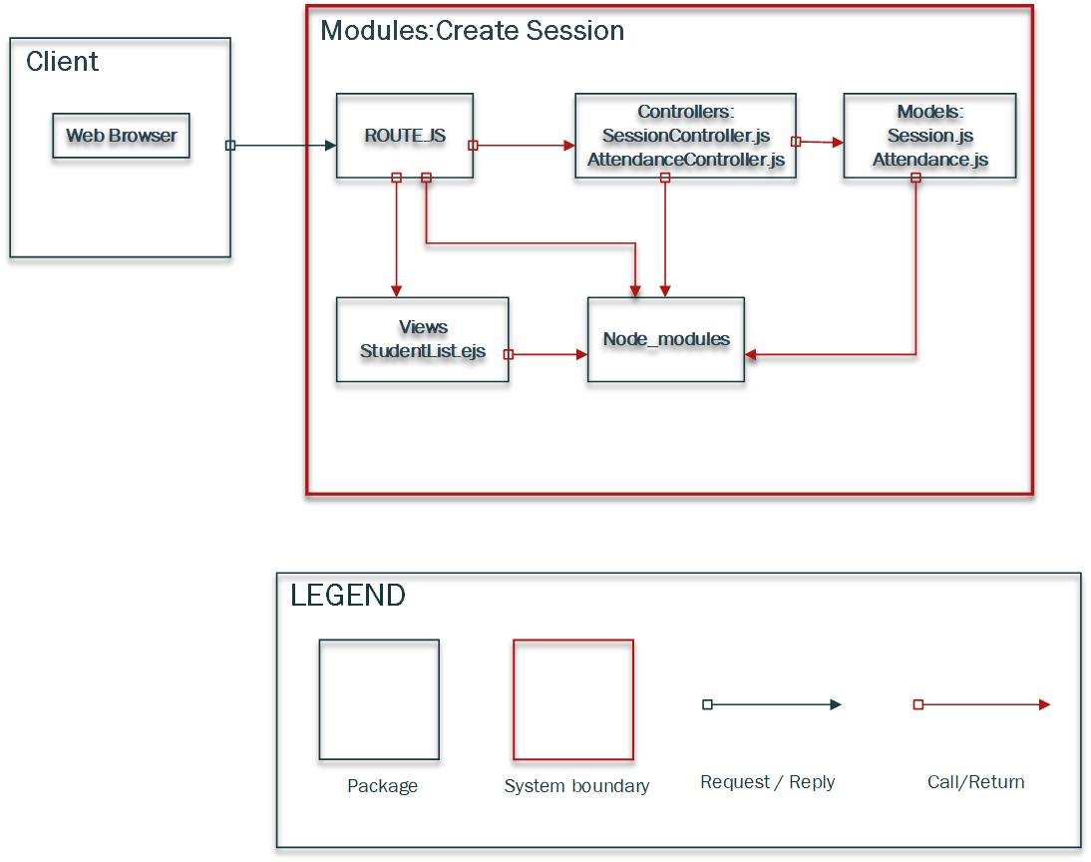

* + 1. Remove Session

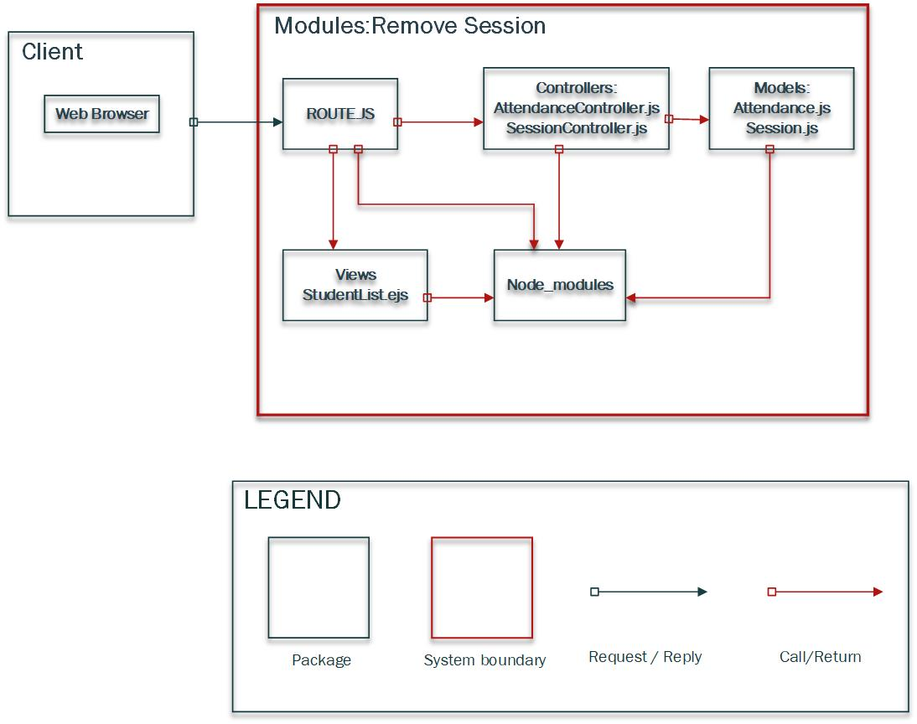

* + 1. Attendance Online

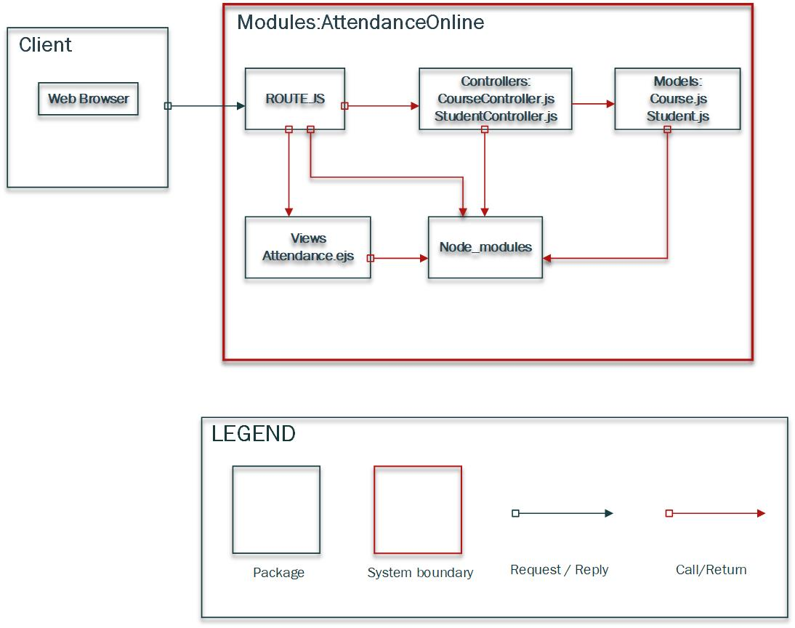

* + 1. Statistics By Students And Courses

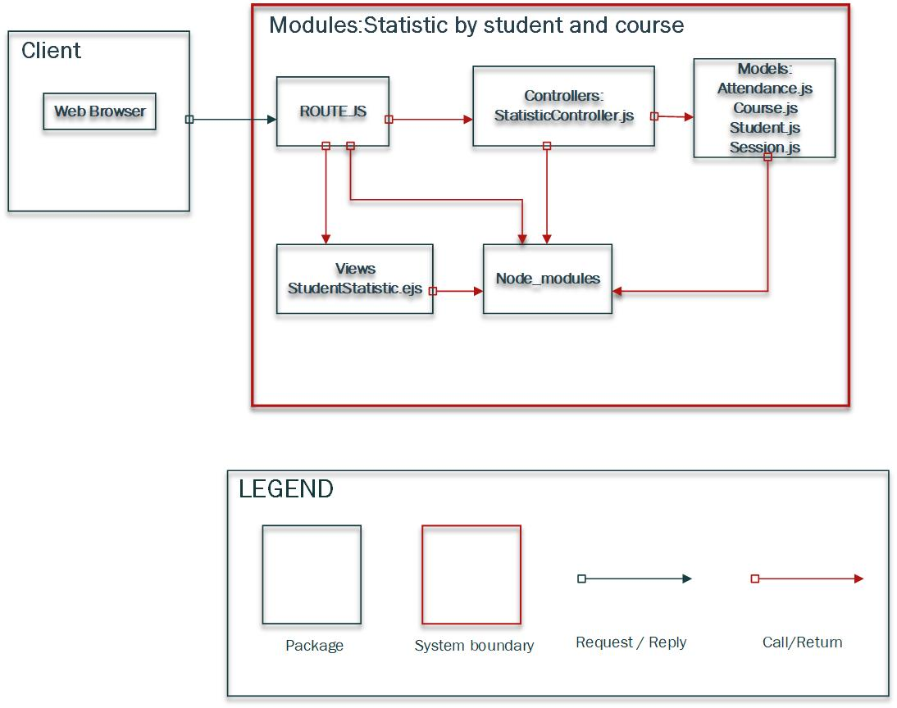

* + 1. Statistics By Classes

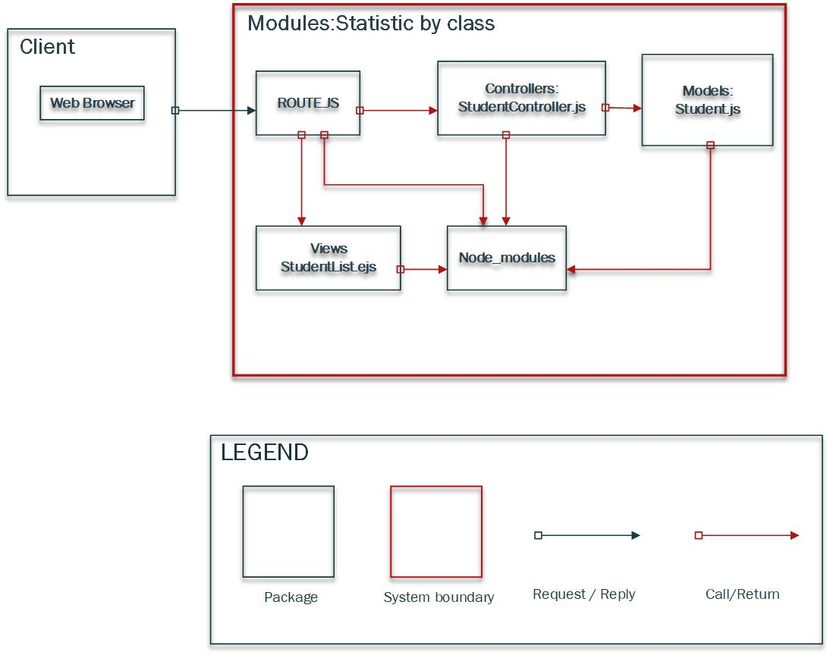

1. Static Perspective
   1. Static Perspective Lv0

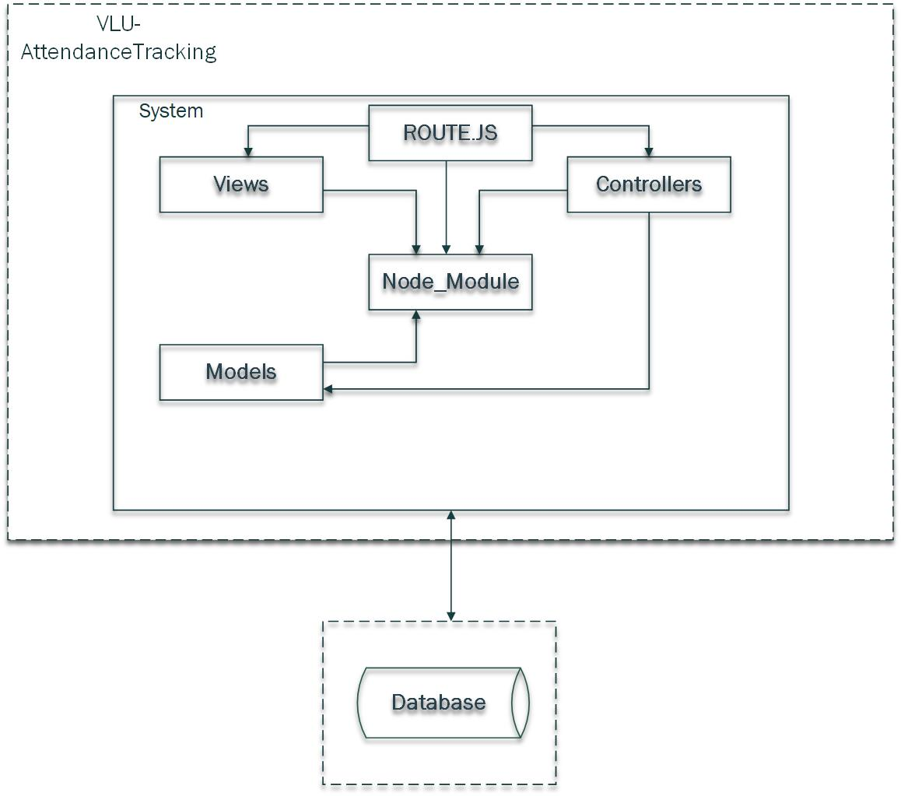

* 1. Static Perspective Lv1

