

**Capstone Project Report**

**Report 3 – Software Requirement Specification**

– Hanoi, August 2023 –

**Table of Contents**

I. Record of Changes 3

II. Software Requirement Specification 4

1. Requirement Overview 4

1.1 Context Diagram 4

1.2 User Requirements 5

1.3 System Functionalities 5

2. Functional Specifications 7

2.1 <<Feature/Workflow Name1>> 7

2.2 Common Feature 10

2.3 Patron Feature 13

3. Non-Functional Requirements 16

3.1 External Interfaces 16

3.2 Quality Attributes 16

4. Requirement Appendix 17

4.1 Business Rules 17

4.2 Common Requirements 17

4.3 Application Messages List 17

4.4 Other Requirements… 18

# I. Record of Changes

|  |  |  |  |
| --- | --- | --- | --- |
| Date | A* M, D | In charge | Change Description |
|  |  |  |  |
|  |  |  |  |
|  |  |  |  |
|  |  |  |  |
|  |  |  |  |
|  |  |  |  |
|  |  |  |  |
|  |  |  |  |
|  |  |  |  |
|  |  |  |  |
|  |  |  |  |
|  |  |  |  |
|  |  |  |  |

*A - Added M - Modified D - Deleted

# II. Software Requirement Specification

## 1. Requirement Overview

### 1.1 Context Diagram

*[Gives the overall description about the product with some introduction and the context diagram. The context diagram presents the boundary and connections between the system you’re developing and everything else in the universe. This identifies external entities (or terminators – software, hardware, human components, and other systems) outside the system that interface to it in some way, as well as data, control, and material flows between the terminators and the system.]*

<<Sample: The Cafeteria Ordering System is a new software system that replaces the current manual and telephone processes for ordering and picking up meals in the Process Impact cafeteria. The context diagram below illustrates the external entities and system interfaces for release 1.0. The system is expected to evolve over several releases, ultimately connecting to the Internet ordering services for several local restaurants and to credit and debit card authorization services.

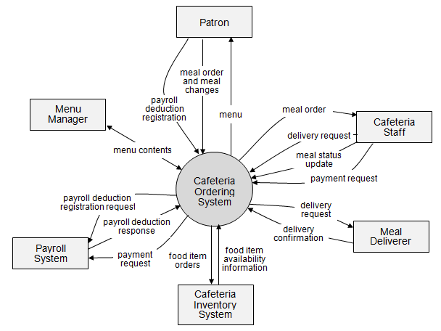

>>

### 1.2 User Requirements

#### 1.2.1 Actors

*[An actor is a person (or sometimes another software system or a hardware device) that interacts with the system to perform a use case. Following are some questions you might ask to help user representatives identify actors*

* *Who (or what) is notified when something occurs within the system?*
* *Who (or what) provides information or services to the system?*
* *Who (or what) helps the system respond to and complete a task?*

*This part gives the description of system actors, you can follow the table form as below]*

|  |  |  |
| --- | --- | --- |
| **#** | **Actor** | **Description** |
| 1 | Administrator |  |
| 2 | Menu Manager |  |
| 3 | … |  |

#### 1.2.2 Use Cases

*[A use case (UC) describes a sequence of interactions between a system and an external actor that results in the actor being able to achieve some outcome of value. The names of use cases are always written in the form of a verb followed by an object. Select strong, descriptive names to make it evident from the name that the use case will deliver something valuable for some user.*

*In this section, you need to provide the UC diagram(s) to show the actor-UCs and UC-UC relationships like the sample below. You can have multiple UC diagrams for the system, each diagram is for one actor or one workflow]*

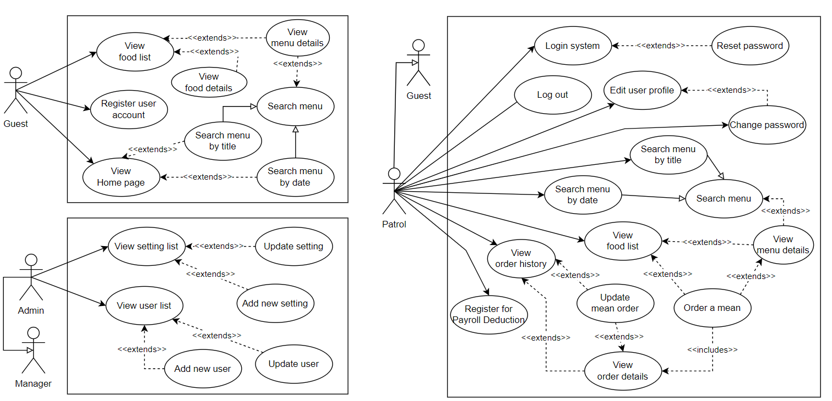

### 1.3 System Functionalities

*[Provide functionality overview of software system: screen flow, screen descriptions, system user roles, screen authorization, non-screen functions, ERD]*

#### 1.3.1 Screens Flow

*[This part shows the system screens and the relationship among screens. You can draw the Screens Flow for the system in the form of diagram as below. Please note that beside the normal flat screen, we might have the oval notation for pop-up screen (Orders Import) or a screen with multiple information tab (Order Update), etc. You may also use text or background format for different visuality purpose]*

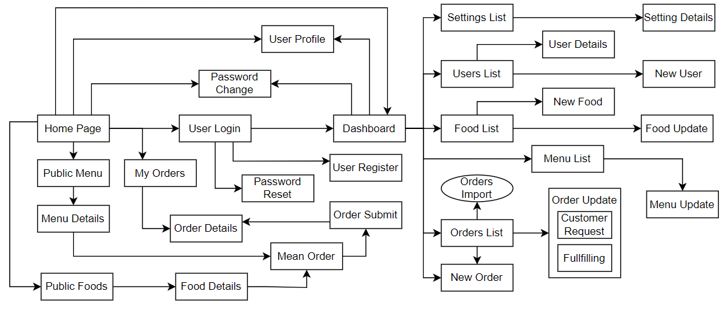

#### 1.3.2 Screen Descriptions

*[Provide the descriptions for the screens in the Screens Flow above]*

|  |  |  |  |
| --- | --- | --- | --- |
| **#** | **Feature** | **Screen** | **Description** |
| 1 | Order Meals | Create Order | <<Screen Brief description>> |
| 2 | Order Meals | Change Order |  |
| 3 | .. |  |  |

#### 1.3.3 Screen Authorization

*[Provide the system roles authorization to the system features (down to screens, and event to the screen activities if applicable) in the table form as below – replace Role1, Role2,… with your specific system user role names]*

|  |  |  |  |  |
| --- | --- | --- | --- | --- |
| **Screen** | **Role-Name1** | **Role-Name2** | **Role-Name3** | **…** |
| <<Screen Name1>> | X |  | X | X |
| <<Screen Activity>> |  |  | X | X |
| <<Screen Name2>> | X |  | X |  |
| Query All Data | X |  |  |  |
| Query Own Data |  |  | X |  |
| Query Managed Data |  |  | X |  |
| Add New Data |  |  | X | X |
| Update All Data |  |  |  | X |
| Update Own Data |  |  |  | X |
| Update Managed Data |  |  |  | X |
| Delete Data |  |  |  |  |
| … |  |  |  |  |

#### 1.3.4 Non-UI Functions

*[Provide the descriptions for the non-screen system functions, i.e batch/cron job, service, API, etc.]*

|  |  |  |  |
| --- | --- | --- | --- |
| **#** | **Feature** | **System Function** | **Description** |
| 1 | <<Feature Name>> | <<Function Name1>> | <<Function Name1 Description>> |
| 2 | … |  |  |

#### 1.3.5 Entity Relationship Diagram

*[Provide the entity relationship diagram and the entity descriptions in the table format as below]*

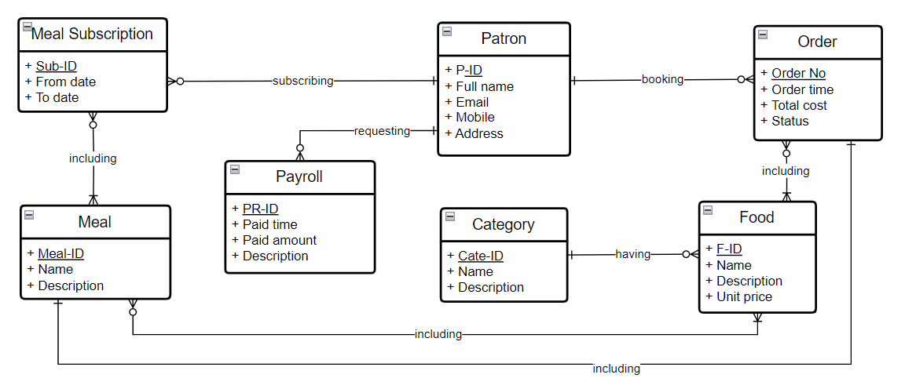

**Entities Description**

|  |  |  |
| --- | --- | --- |
| **#** | **Entity** | **Description** |
| 1 | Patrol | Cafeteria’s customer information |
| 2 | Meal | … |
| 3 | Meal Subscription |  |
| 4 | … |  |

## 2. Functional Specifications

*[Provide the functional specification of the screens/functions (grouped by features or workflows and sub-features if needed), in which you need to provide the UI, UC specifications and the business rules in the form of table as guided]*

### 2.1 <<Feature/Workflow Name1>>

#### 2.1.1 <<SubFeature Name1>>

##### 2.1.1.1 <<Screen/Function Name1>>

###### a. UI Specifications

*[Provide the brief description, the mockup screen(s) and UI description for the screen]*

**<<Screen Name1>>**

*[Specification content 1: brief description of the screen/function]*

*[Specification content 2: the screenshot which is UI layout (Mockup screen) here]*

*[Specification content 3: descriptions/requirements for the components/fields of the screen here]*

|  |  |  |
| --- | --- | --- |
| **Field Name** | **Field Type** | **Description** |
| ***Field Group Name*** | | |
| <<Field-Name>> | <<Field type>> | <<Field description & data initializing design>> |

**<<Screen Name2>>**

*[Specification content 1: brief description of the screen/function]*

*[Specification content 2: the screenshot which is UI layout (Mockup screen) here]*

*[Specification content 3: descriptions/requirements for the components/fields of the screen here]*

###### b. UC Specifications

**<<UseCaseCode1_UC Name1>>**

*[Provide descriptions for the UC(s) that are covered in the Screen/Function. The descriptions include the UC specifications and business rules specific to the UC using the template/guides below]*

|  |  |  |  |
| --- | --- | --- | --- |
| UC ID and Name: |  | | |
| Created By: |  | Date Created: |  |
| Primary Actor: |  | Secondary Actors: |  |
| Trigger: |  | | |
| Description: |  | | |
| Preconditions: |  | | |
| Postconditions: |  | | |
| Normal Flow: |  | | |
| Alternative Flows: |  | | |
| Exceptions: |  | | |
| Priority: | High (Medium, Low), Must Have (Should Have, Could Have),.. | | |
| Frequency of Use: |  | | |
| Business Rules: |  | | |
| Other Information: |  | | |
| Assumptions: |  | | |

**Functional Description Contents**

***Use Case ID and Name***

Give each use case a unique integer sequence number identifier. State a concise name for the use case that indicates the value the use case would provide to some user. Begin with an action verb, followed by an object.

***Author and Date Created***

Enter the name of the person who initially wrote this use case and the date it was written.

***Primary and Secondary Actors***

An actor is a person or other entity external to the software system being specified who interacts with the system and performs use cases to accomplish tasks. Different actors often correspond to different user classes, or roles, identified from the customer community that will use the product. Name the primary actor that will be initiating this use case and any other secondary actors who will participate in completing execution of the use case.

***Trigger***

Identify the business event, system event, or user action that initiates the use case. This trigger alerts the system that it should begin testing the preconditions for the use case so it can judge whether to proceed with execution.

***Description***

Provide a brief description of the reason for and outcome of this use case, or a high-level description of the sequence of actions and the outcome of executing the use case.

***Preconditions***

List any activities that must take place, or any conditions that must be true, before the use case can be started. The system must be able to test each precondition. Number each precondition. Example: PRE-1: User’s identity has been authenticated.

***Postconditions***

Describe the state of the system at the successful conclusion of the use case execution. Label each postcondition in the form POST-X, where X is a sequence number. Example: POST-1: Price of item in the database has been updated with the new value.

***Normal Flow***

Provide a description of the user actions and corresponding system responses that will take place during execution of the use case under normal, expected conditions. This dialog sequence will ultimately lead to accomplishing the goal stated in the use case name and description. Show a numbered list of actions performed by the actor, alternating with responses provided by the system. The normal flow is numbered “X.0”, where “X” is the Use Case ID.

***Alternative Flows***

Document other successful usage scenarios that can take place within this use case. State the alternative flow, and describe any differences in the sequence of steps that take place. Number each alternative flow in the form “X.Y”, where “X” is the Use Case ID and Y is a sequence number for the alternative flow. For example, “5.3” would indicate the third alternative flow for use case number 5. Indicate where each alternative flow would branch off from the normal flow, and if pertinent, where it would rejoin the normal flow.

***Exceptions***

Describe any anticipated error conditions that could occur during execution of the use case and how the system is to respond to those conditions. Number each alternative flow in the form “X.Y.EZ”, where “X” is the Use Case ID, Y indicates the normal (0) or alternative (>0) flow during which this exception could take place, “E” indicates an exception, and “Z” is a sequence number for the exceptions. For example “5.0.E2” would indicate the second exception for the normal flow for use case number 5. Indicate where in the normal (or an alternative) flow each exception could occur.

***Priority***

Indicate the relative priority of implementing the functionality required to allow this use case to be executed. Use the same priority scheme as that used for the functional requirements.

***Frequency of Use***

Estimate the number of times this use case will be performed per some appropriate unit of time. This gives an early indicator of throughput, concurrent usage loads, and transaction capacity.

***Business Rules***

List any business rules that influence this use case. Don’t include the business rule text here, just its identifier so the reader can find it in another repository when needed.

***Other Information***

Identify any additional requirements, such as quality attributes, for the use case that may need to be addressed during design or implementation. Also list any associated functional requirements that aren’t a direct part of the use case flows but which a developer needs to know about. Describe what should happen if the use case execution fails for some unanticipated or systemic reason (e.g., loss of network connectivity, timeout). If the use case results in a durable state change in a database or the outside world, state whether the change is rolled back, completed correctly, partially completed with a known state, or left in an undetermined state as a result of the exception.

***Assumptions***

List any assumptions that were made regarding this use case or how it might execute.

**Business Rules**

<<Provide the business rules those are applied only to the use case>>

|  |  |  |
| --- | --- | --- |
| **ID** | **Business Rule** | **Business Rule Description** |
| FR1 | Password Encoding | User’s password must be encoded with MD5 hashing |

**<<UseCaseCode2_UC Name2>>**

UC specs…

Business Rules..

##### 2.1.1.2 <<Screen/Function Name2>>

###### a. UI Specifications

…

###### b. UC Specifications

…

### 2.2 Common Feature

#### 2.2.1 User Login

##### a. UI Specifications

**User Login**

This screen allows user to be authenticated to the system screens/functionalities.

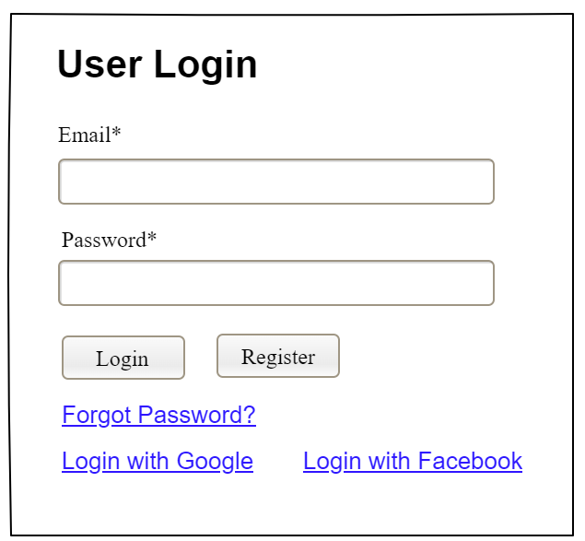

|  |  |  |
| --- | --- | --- |
| **Field Name** | **Field Type** | **Description** |
| Email* | Text Box | This is for user to input valid email address for logging in |
| Password* | Password Box | This is for user to input password for logging in |
| Login | Button | User clicks to authenticate him/herself into the system with provided email & password |
| Register | Button | User clicks to redirect to the User Register page for registering new user account to access the system |
| Forgot Password? | Hyperlink | User clicks to redirect to the Password Reset page for resetting his/her forgot password |
| Login with Google | Hyperlink | Allow user to login with his/her Google account |
| Login with Facebook | Hyperlink | Allow user to login with his/her Facebook account |

##### b. UC Specifications

**UC-2_Login System**

|  |  |  |  |
| --- | --- | --- | --- |
| UC ID and Name: | ***UC-2_Login System*** | | |
| Created By: | MinhNNT | Date Created: | 16/Jun/2023 |
| Primary Actor: | Customer | Secondary Actors: | None |
| Trigger: | User clicks Login button from the page header, or  User accesses an authenticated feature (from a link or type the page URL directly into the address bar) | | |
| Description: | As a user, I want to be able to log into the system so that I can use the system’s authenticated features and access my personalized account. | | |
| Preconditions: | User account has been created & authorized | | |
| Postconditions: | * User logs in the system successfully * The system tracked successful login into the Activity Log | | |
| Normal Flow | **2.0 Login System**  1. User accesses the User Login screen  2. User types in the login details or choo other login options (see 2.1 and 2.2)  3. User clicks the Login button  4. System validates the login details (see 2.0.E1)  5. System allows user to access  6. System tracks user’s success login to the Activity Log  7. System accesses the Home Page (or the previous calling page if any) | | |
| Alternative Flows: | ***2.1 Google Login***  1. User chooses to login system using Google account  2. System redirects the user to the Google’s Login screen  3. User types in the Google account details and chooses to login  4. Google validates user’s login information successfully and redirect him/her back to the system  5. Return to step 5 of normal flow.  ***2.2 Facebook Login***  1. User chooses to login system using Facebook account  2. System redirects the user to the Facebook’s Login screen  3. User types in the Facebook account details and chooses to login  4. Facebook validates user’s login information successfully and redirect him/her back to the system  5. Return to step 5 of normal flow. | | |
| Exceptions: | ***2.0.E1 System can’t authenticate the user***  1. The Error Message screen is shown to the user  2. User cancels the logging in *=> UC stops, change to UC-1_View Home Page*  3. User clicks “Forgot Password?” link *=> change to UC-3_Reset Password*  4. User clicks “Register” link *=> change to UC-4_Register User Account* | | |
| Priority: | Must Have | | |
| Frequency of Use: |  | | |
| Business Rules: | FR1, FR2, FR3 | | |
| Other Information: |  | | |
| Assumptions: |  | | |

**Business Rules for UC-2**

|  |  |  |
| --- | --- | --- |
| **ID** | **Business Rule** | **Business Rule Description** |
| FR1 | Password Encoding | User’s password must be encoded with MD5 hashing |
| FR2 | Invalid Logging In | User can’t be authenticated to login the system if below cases   * His/her logging-in details are incorrect * His/her account has not been verified * His/her account has been locked or blocked |
| FR3 | Account Locking | If user inputs wrong logging-in details 6 times continuously, his/her account would be locked in 30 minutes |

**UC-3_Abc Xyz**

…

### 2.3 Patron Feature

#### 2.3.1 Meal Order

##### a. UI Specifications

…

##### b. UC Specifications

**UC-5_Order a Meal**

|  |  |  |  |
| --- | --- | --- | --- |
| ID and Name: | **UC-5 Order a Meal** | | |
| Created By: | Prithvi Raj | Date Created: | 10/4/13 |
| Primary Actor: | Patron | Secondary Actors: | Cafeteria Inventory System |
| Description: | A Patron accesses the Cafeteria Ordering System from the corporate intranet or from home, views the menu for a specific date if desired, selects food items, and places an order for a meal to be delivered to a specified location within a specified 15-minute time window. | | |
| Trigger: | A Patron indicates that he wants to order a meal | | |
| Preconditions: | PRE-1. Patron is logged into COS.  PRE-2. Patron is registered for meal payments by payroll deduction. | | |
| Postconditions: | POST-1. Meal order is stored in COS with a status of “Accepted”.  POST-2. Inventory of available food items is updated to reflect items in this order.  POST-3. Remaining delivery capacity for the requested time window is updated. | | |
| Normal Flow: | **5.0 Order a Single Meal**   1. Patron asks to view menu for a specific date. (see 5.0.E1, 5.0.E2) 2. COS displays menu of available food items and the daily special. 3. Patron selects one or more food items from menu. (see 5.1) 4. Patron indicates that meal order is complete. (see 5.2) 5. COS displays ordered menu items, individual prices, and total price, including taxes and delivery charge. 6. Patron either confirms meal order (continue normal flow) or requests to modify meal order (return to step 2). 7. COS displays available delivery times for the delivery date. 8. Patron selects a delivery time and specifies the delivery location. 9. Patron specifies payment method. 10. COS confirms acceptance of the order. 11. COS sends Patron an email message confirming order details, price, and delivery instructions. 12. COS stores order, sends food item information to Cafeteria Inventory System, and updates available delivery times. | | |
| Alternative Flows: | **5.1 Order multiple identical meals**   1. Patron requests a specified number of identical meals. (see 5.1.E1) 2. Return to step 4 of normal flow.   **5.2 Order multiple meals**   1. Patron asks to order another meal. 2. Return to step 1 of normal flow. | | |
| Exceptions: | **5.0.E1 Requested date is today and current time is after today’s order cutoff time**  1. COS informs Patron that it’s too late to place an order for today.  2a. If Patron cancels the meal ordering process, then COS terminates use case.  2b. Else if Patron requests another date, then COS restarts use case.  **5.0.E2 No delivery times left**  1. COS informs Patron that no delivery times are available for the meal date.  2a. If Patron cancels the meal ordering process, then COS terminates use case.  2b. Else if Patron requests to pick the order up at the cafeteria, then continue with normal flow, but skip steps 7 and 8.  **5.1.E1 Insufficient inventory to fulfill multiple meal order**  1. COS informs Patron of the maximum number of identical meals he can order, based on current available inventory.  2a. If Patron modifies number of meals ordered, then Return to step 4 of normal flow.  2b. Else if Patron cancels the meal ordering process, then COS terminates use case. | | |
| Priority: | High | | |
| Frequency of Use: | Approximately 300 users, average of one usage per day. Peak usage load for this use case is between 9:00 A.M. and 10:00 A.M. local time. | | |
| Business Rules: | BR-1, BR-2, BR-3, BR-4, BR-11, BR-12, BR-33 | | |
| Other Information: | 1. Patron shall be able to cancel the meal ordering process at any time prior to confirming it. 2. Patron shall be able to view all meals he ordered within the previous six months and repeat one of those meals as the new order, provided that all food items are available on the menu for the requested delivery date. (Priority = M) 3. The default date is the current date if the Patron is using the system before today’s order cutoff time. Otherwise, the default date is the next day that the cafeteria is open. | | |
| Assumptions: | Assume that 15 percent of Patrons will order the daily special (source: previous 6 months of cafeteria data). | | |

#### 2.3.2 Payroll Deduction Registration

##### a. UI Specifications

…

##### b. UC Specifications

**UC-6_Register for Payroll Deduction**

|  |  |  |  |
| --- | --- | --- | --- |
| ID and Name: | **UC-6 Register for Payroll Deduction** | | |
| Created By: | Nancy Anderson | Date Created: | 9/15/13 |
| Primary Actor: | Patron | Secondary Actors: | Payroll System |
| Description: | Cafeteria patrons who use the COS and have meals delivered must be registered for payroll deduction. For noncash purchases made through the COS, the cafeteria will issue a payment request to the Payroll System, which will deduct the meal costs from the next scheduled employee payday direct deposit. | | |
| Trigger: | Patron requests to register for payroll deduction, or Patron says yes when COS asks if he wants to register | | |
| Preconditions: | PRE-1. Patron is logged into COS. | | |
| Postconditions: | POST-2. Patron is registered for payroll deduction. | | |
| Normal Flow: | **6.0 Register for Payroll Deduction**   1. COS asks Payroll System if Patron is eligible to register for payroll deduction. 2. Payroll System confirms that Patron is eligible to register for payroll deduction. 3. COS asks Patron to confirm his desire to register for payroll deduction. 4. If so, COS asks Payroll System to establish payroll deduction for Patron. 5. Payroll System confirms that payroll deduction is established. 6. COS informs Patron that payroll deduction is established. | | |
| Alternative Flows: | None | | |
| Exceptions: | 6.0.E1 Patron is not eligible for payroll deduction  6.0.E2 Patron is already enrolled for payroll deduction | | |
| Priority: | High | | |
| Business Rules: | BR-86 and BR-88 govern an employee’s eligibility to enroll for payroll deduction. | | |
| Other Information: | Expect high frequency of executing this use case within first 2 weeks after system is released. | | |

## 3. Non-Functional Requirements

### 3.1 External Interfaces

*[This section provides information to ensure that the system will communicate properly with users and with external hardware or software/system elements.]*

### 3.2 Quality Attributes

*[List all the required system characteristics (quality attributes) specification. Some of the possible attributes are provided with the guide/descriptions are mentioned here]*

#### 3.2.1 Usability

*[This section includes all those requirements that affect usability. For example, specify the required training time for a normal users and a power user to become productive at particular operations specify measurable task times for typical tasks or base the new system’s usability requirements on other systems that the users know and like specify requirement to conform to common usability standards, such as IBM’s CUA standards Microsoft’s GUI standards]*

#### 3.2.2 Performance

*[The system’s performance characteristics are outlined in this section. Include specific response times. Where applicable, reference related Use Cases by name.*

*Response time for a transaction (average, maximum)*

*Throughput, for example, transactions per second*

*Capacity, for example, the number of customers or transactions the system can accommodate*

*Resource utilization, such as memory, disk, communications, and so forth.]*

#### 3.2.3 …

## 4. Requirement Appendix

*[Provide business rules, common requirements, or other extra requirements information here]*

### 4.1 Business Rules

*[Provide common business rules that you must follow. The information can be provided in the table format as the sample below]*

|  |  |
| --- | --- |
| ID | Rule Definition |
| BR-01 | Delivery time windows are 15 minutes, beginning on each quarter hour. |
| BR-02 | Deliveries must be completed between 10:00 A.M. and 2:00 P.M. local time, inclusive. |
| BR-03 | All meals in a single order must be delivered to the same location. |
| BR-04 | All meals in a single order must be paid for by using the same payment method. |
| BR-11 | If an order is to be delivered, the patron must pay by payroll deduction. |
| BR-12 | Order price is calculated as the sum of each food item price times the quantity of that food item ordered, plus applicable sales tax, plus a delivery charge if a meal is delivered outside the free delivery zone. |
| BR-24 | Only cafeteria employees who are designated as Menu Managers by the Cafeteria Manager can create, modify, or delete cafeteria menus. |
| BR-33 | Network transmissions that involve financial information or personally identifiable information require 256-bit encryption. |
| BR-86 | Only regular employees can register for payroll deduction for any company purchase. |
| BR-88 | An employee can register for payroll deduction payment of cafeteria meals if no more than 40 percent of his gross pay is currently being deducted for other reasons. |

### 4.2 Common Requirements

*[Fill all the common requirements here..]*

### 4.3 Application Messages List

|  |  |  |  |  |
| --- | --- | --- | --- | --- |
| **#** | **Message code** | **Message Type** | **Context** | **Content** |
| 1 | MSG01 | In line | There is not any search result | *No search results.* |
| 2 | MSG02 | In red, under the text box | Input-required fields are empty | *The * field is required.* |
| 3 | MSG03 | Toast message | Updating asset(s) information successfully | *Update asset(s) successfully.* |
| 4 | MSG04 | Toast message | Adding new asset successfully | *Add asset successfully.* |
| 5 | MSG05 | Toast message | Confirming email of asset hand-over is sent successfully | *A confirmation email has been sent to {email_address}.* |
| 6 | MSG06 | Toast message | Resetting asset information successfully | *Return asset(s) successfully.* |
| 7 | MSG07 | Toast message | Deleting asset information successfully | *Delete asset(s) successfully.* |
| 8 | MSG08 | In red, under the text box | Input value length > max length | *Exceed max length of {max_length}.* |
| 9 | MSG09 | In line | Username or password is not correct when clicking sign-in | *Incorrrect user name or password. Please check again.* |

### 4.4 Other Requirements…