

**Capstone Project Report**

**Report 1 – Project Introduction**

– Hanoi, August 2023 –

**Table of Contents**

I. Record of Changes 3

II. Project Introduction 4

1. Overview 4

1.1 Project Information 4

1.2 Project Team 4

2. Product Background 4

3. Existing Solutions 4

3.1 System name1 4

3.2 System name2 4

4. Business Opportunity 4

5. Software Product Vision 5

6. Project Scope & Limitations 5

6.1 Major Features 5

6.2 Limitations & Exclusions 6

# I. Record of Changes

|  |  |  |  |
| --- | --- | --- | --- |
| Date | A* M, D | In charge | Change Description |
|  |  |  |  |
|  |  |  |  |
|  |  |  |  |
|  |  |  |  |
|  |  |  |  |
|  |  |  |  |
|  |  |  |  |
|  |  |  |  |
|  |  |  |  |
|  |  |  |  |
|  |  |  |  |
|  |  |  |  |
|  |  |  |  |

*A - Added M - Modified D - Deleted

# II. Project Introduction

## 1. Overview

### 1.1 Project Information

* Project name: ***Cafeteria Ordering System***
* Vietnamese name: ***Hệ thống đặt hàng quán cà phê***
* Project code: ***COS***
* Group name: ***SEP490-G4***
* Software type: ***Mobile App***

### 1.2 Project Team

|  |  |  |  |
| --- | --- | --- | --- |
| **Full Name** | **Role** | **Email** | **Mobile** |
| Nguyen Trung Kien | Lecturer | abc@fe.edu.vn | 0912345678 |
| Nghiem Thi Thuy Van | Leader |  |  |
| Dam Thi Huyen | Member |  |  |
| Dao Thi Phuong | Member |  |  |
| Vu Thi Thuy | Member |  |  |

## 2. Product Background

*[This section summarizes the rationale for the new product. Provide a general description of the history or situation that leads to the recognition that this product should be built. You should also mention here the information on the customer /the people who raise project idea/request]*

<<Sample: Employees at the company Process Impact presently spend an average of 65 minutes per day going to the cafeteria to select, purchase, and eat lunch. About 20 minutes of this time is spent walking to and from the cafeteria, selecting their meals, and paying by cash or credit card. When employees go out for lunch, they spend an average of 90 minutes off-site. Some employees phone the cafeteria in advance to order a meal to be ready for them to pick up. Employees don’t always get the selections they want because the cafeteria runs out of certain items. The cafeteria wastes a significant quantity of food that is not purchased and must be thrown away. These same issues apply to breakfast and supper, although far fewer employees use the cafeteria for those meals than for lunch.>>

## 3. Existing Solutions

*[Add the system which might help solving the problems you listed above or the systems in which you can learn/refer the features for your system design]*

### 3.1 System name1

*[Write the brief descriptions of the system, the link, the system actors, features, pros, cons, etc.]*

### 3.2 System name2

…

## 4. Business Opportunity

*[Describe the market opportunity that exists or the business problem that is being solved. Describe the market in which a commercial product will be competing or the environment in which an information system will be used. This may include a brief comparative evaluation of existing products and potential solutions, indicating why the proposed product is attractive. Identify the problems that cannot currently be solved without the product, and how the product fits in with market trends or corporate strategic directions]*

<<Sample: Many employees have requested a system that would permit a cafeteria user to order meals (defined as a set of one or more food items selected from the cafeteria menu) on line, to be picked up at the cafeteria or delivered to a company location at a specified time and date. Such a system would save employees time, and it would increase the chance of their getting the items they prefer. Knowing what food items customers want in advance would reduce wastage in the cafeteria and would improve the efficiency of cafeteria staff. The future ability for employees to order meals for delivery from local restaurants would make a wide range of choices available to employees and provide the possibility of cost savings through volume discount agreements with the restaurants.>>

## 5. Software Product Vision

*[Write a concise vision statement that summarizes the purpose and intent of the new product and describes what the world will be like when it includes the product. The vision statement should reflect a balanced view that will satisfy the needs of diverse customers as well as those of the developing organization. It may be somewhat idealistic, but it should be grounded in the realities of existing or anticipated customer markets, enterprise architectures, organizational strategic directions, and cost and resource limitations]*

<<Sample: For employees who want to order meals from the company cafeteria or from local restaurants on-line, the Cafeteria Ordering System is an Internet-based and smartphone-enabled application that will accept individual or group meal orders, process payments, and trigger delivery of the prepared meals to a designated location on the Process Impact campus. Unlike the current telephone and manual ordering processes, employees who use the Cafeteria Ordering System will not have to go to the cafeteria to get their meals, which will save them time and will increase the food choices available to them.>>

## 6. Project Scope & Limitations

*[The project scope defines the concept and range of the proposed solution. It’s also important to define what will not be included in the product. Clarifying the scope and limitations helps to establish realistic expectations of the many stakeholders. It also provides a reference frame against which proposed features and requirements changes can be evaluated. Proposed requirements that are out of scope for the envisioned product must be rejected, unless they are so beneficial that the scope should be enlarged to accommodate them (with accompanying changes in budget, schedule, and/or resources)]*

### 6.1 Major Features

*[Include a numbered list of the major features of the new product, emphasizing those features that distinguish it from previous or competing products. Specific user requirements and functional requirements may be traced back to these features.]*

<<Sample:

FE-01: Order and pay for meals from the cafeteria menu to be picked up or delivered.

FE-02: Order and pay for meals from local restaurants to be delivered.

FE-03: Create, view, modify, and cancel meal subscriptions for standing or recurring meal orders, or for daily special meals.

FE-04: Create, view, modify, delete, and archive cafeteria menus.

FE-05: View ingredient lists and nutritional information for cafeteria menu items.

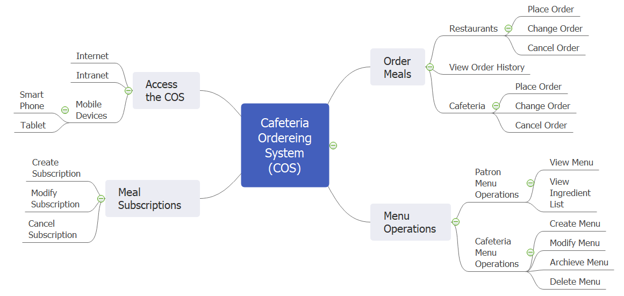

>>

### 6.2 Limitations & Exclusions

*[Identify any product features or characteristics that a stakeholder might anticipate, but which are not planned to be included in the new product.]*

<<Sample:

LI-1: Some food items that are available from the cafeteria will not be suitable for delivery, so the menus available to patrons of the COS must be a subset of the full cafeteria menus.

LI-2: The COS shall be used only for the cafeteria at the Process Impact campus in Clackamas, Oregon.

>>