**TRƯỜNG ĐẠI HỌC NHA TRANG**

**KHOA CÔNG NGHỆ THÔNG TIN**

******o0o******



**BÁO CÁO LẬP TRÌNH NHÚNG**

**Giảng viên học phần: Mai Cường Thọ**

**Sinh viên thực hiện : Đặng Phương Nam**

**Mssv : 61133120**

# **Bài TMP36 đo led**

## 1.Mô tả:

Bài này quan sát nhiệt độ thay đổi trên TMP khi đèn led sáng .

## 2.Sơ đồ thiết kế:

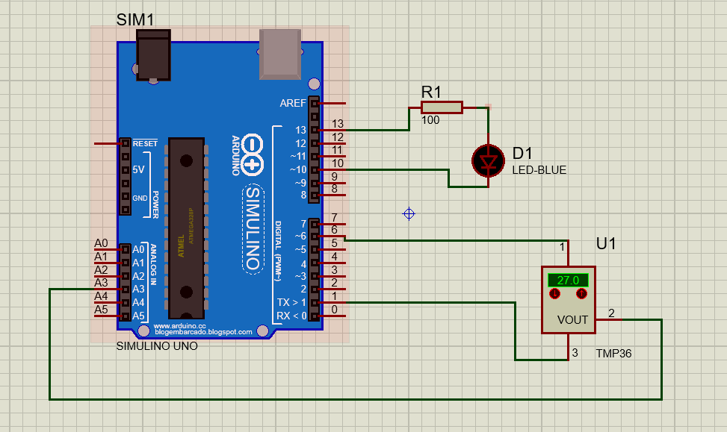

Figure 1 Sơ đồ kết nối

## 3.Đặc điểm linh kiện:

* 1 Arduino UNO
* 1 Led blue
* 1 Điện trở
* 1 TMP361.

## 4.Code:

*Void setup ()*

*{*

*Serial.begin(9600);*

*pinMode(6,1); pinMode(1,1); pinMode(13,1);*

*digitalWrite(6,1); digitalWrite(1,0);*

*digitalWrite(10,1); digitalWrite(10,0);*

*}*

*void loop(){*

*Serial.println(analogRead(A3));*

*if(analogRead(A3)>181){digitalWrite(10,0);};*

*if(analogRead(A3)<181){digitalWrite(13,1);};*

*}*

# **Bài led bật tắt**

## 1.Mô tả:

Thực hiện việc lập trình điều khiển bật tắt bằng nút bấm của đèn led được nối cổng 13 Arduino trong khoảng thời gian xác định.

## 2.Sơ đồ thiết kế:

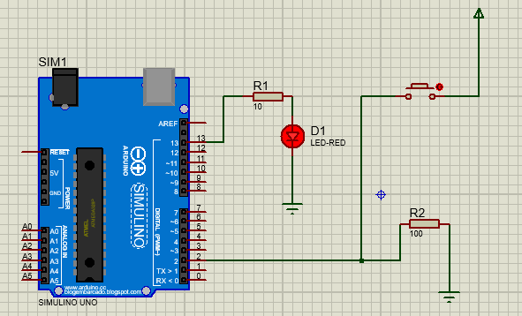

Figure Sơ đồ kết nối

## 3.Đặc điểm linh kiện:

* 1 Arduino UNO
* 1 Led red
* 2 điện trở
* 1 nút bấm

## 4.Code:

*int x = 0;*

*void setup() {*

*// put your setup code here, to run once:*

*pinMode(2, INPUT);*

*pinMode(13, OUTPUT);*

*}*

*void loop() {*

*// put your main code here, to run repeatedly:*

*x = digitalRead(2);*

*if (x== HIGH) {*

*digitalWrite(13, HIGH);*

*} else {*

*digitalWrite(13, LOW);*

*}*

*delay(1000);*

*}*

# **Bài led 7 đoạn**

## 1.Mô tả**:**

Bài này thực hiện việc lập trình điều khiển led 7 đoạn hiện thị các chữ số từ 0 đến 9 qua mạch test-thử IC 4511

## 2.Sơ đồ thiết kế:

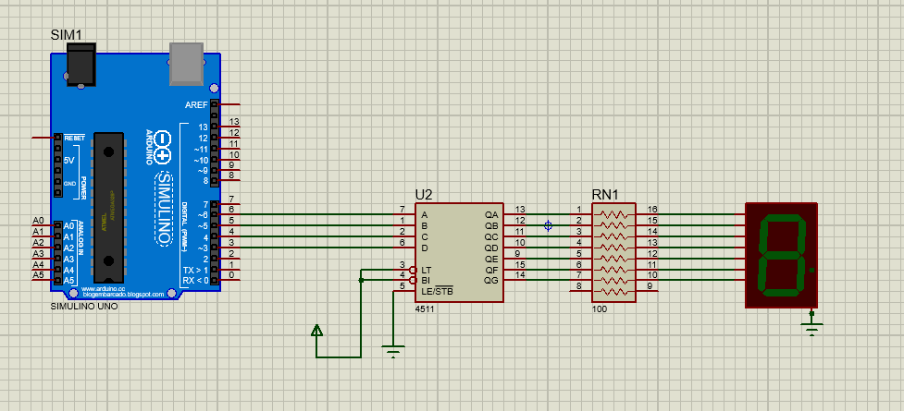

Figure 3 Sơ đồ kết nối

## 3.Đặt điểm linh kiện:

- 1 Mạch Arduino

- 1 Led 7 đoạn

- 1 Điện trở

- 1 4511 IC

- 2 Đất tiếp nối đèn và IC

## 4.Code :

*int a=6, b=5, c=4, d=3;*

*void setup() {*

*pinMode(a, OUTPUT);*

*pinMode(b, OUTPUT);*

*pinMode(c, OUTPUT);*

*pinMode(d, OUTPUT); }*

*void khong(){*

*digitalWrite(a, LOW);*

*digitalWrite(b, LOW);*

*digitalWrite(c, LOW);*

*digitalWrite(d, LOW); }*

*void mot(){*

*digitalWrite(a, HIGH);*

*digitalWrite(b, LOW);*

*digitalWrite(c, LOW);*

*digitalWrite(d, LOW);*

*}*

*void hai(){*

*digitalWrite(a, LOW);*

*digitalWrite(b, HIGH);*

*digitalWrite(c, LOW);*

*digitalWrite(d, LOW);*

*}*

*void ba(){*

*digitalWrite(a, HIGH);*

*digitalWrite(b, HIGH);*

*digitalWrite(c, LOW);*

*digitalWrite(d, LOW);*

*}*

*void bon(){*

*digitalWrite(a, LOW);*

*digitalWrite(b, LOW);*

*digitalWrite(c, HIGH);*

*digitalWrite(d, LOW);*

*}*

*void nam(){*

*digitalWrite(a, HIGH);*

*digitalWrite(b, LOW);*

*digitalWrite(c, HIGH);*

*digitalWrite(d, LOW);*

*}*

*void sau(){*

*digitalWrite(a, LOW);*

*digitalWrite(b, HIGH);*

*digitalWrite(c, HIGH);*

*digitalWrite(d, LOW);*

*}*

*void bay(){*

*digitalWrite(a, HIGH);*

*digitalWrite(b, HIGH);*

*digitalWrite(c, HIGH);*

*digitalWrite(d, LOW);*

*}*

*void tam(){*

*digitalWrite(a, LOW);*

*digitalWrite(b, LOW);*

*digitalWrite(c, LOW);*

*digitalWrite(d, HIGH);*

*}*

*void chin(){*

*digitalWrite(a, HIGH);*

*digitalWrite(b, LOW);*

*digitalWrite(c, LOW);*

*digitalWrite(d, HIGH);*

*}*

*void loop() {*

*khong(); delay(1000);*

*mot(); delay(1000);*

*hai(); delay(1000);*

*ba(); delay(1000);*

*bon(); delay(1000);*

*nam(); delay(1000);*

*sau(); delay(1000);*

*bay(); delay(1000);*

*tam(); delay(1000);*

*chin(); delay(1000);*

*}*

# **Bài 8 led nhấp nháy**

## 1.Mô tả**:**

* Thực hiện điều khiển 8 led sáng tắt theo hệ số nhị phân 10

## 2.Sơ đồ thiết kế:

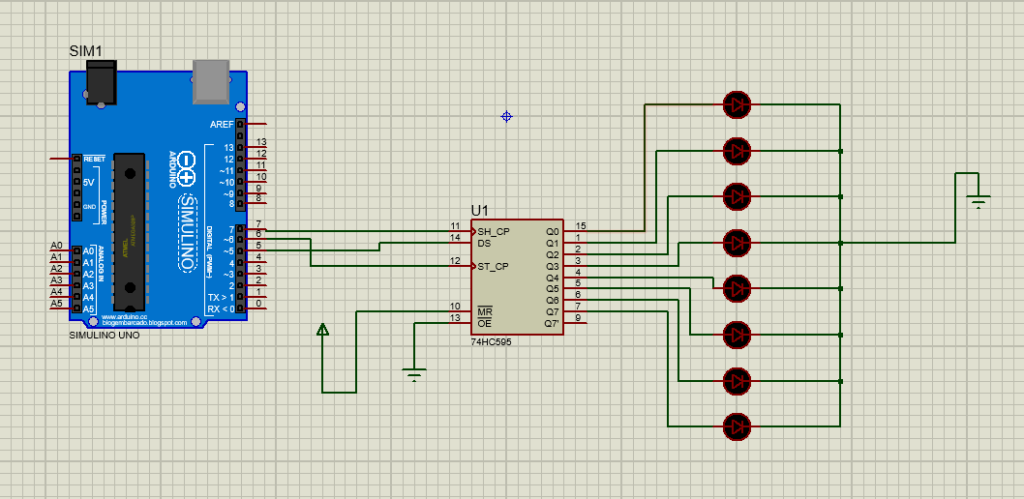

Figure 4 Sơ đồ kết nối

## 3.Đặc điểm linh kiện:

- 8 Led yellow

- 1 IC 74HC 595

- 1 ARDUINO UNO

- 2 Đất tiếp nối đèn và IC

## 4.Code:

|  |
| --- |
| *#define _clock 7*  *#define _latch 6*  *#define _data 5*  *void setup() {*  *// put your setup code here, to run once:*  *pinMode(_latch, OUTPUT);*  *pinMode(_clock, OUTPUT);*  *pinMode(_data, OUTPUT);*  *}*  *void loop() {*  *// put your main code here, to run repeatedly:*  *for (int i=0;i<256;i++){*  *digitalWrite(_latch, LOW);*  *shiftOut(_data, _clock, LSBFIRST, i);*  *digitalWrite(_latch, HIGH);*  *delay(500);}* |

# **Bài led ma trận**

## 1.Môi tả :

Bài này thực hiện nháy đèn LED MATRIX 8x8 qua mạch IC 74HC595.

## 2.Sơ đồ thiết kế :

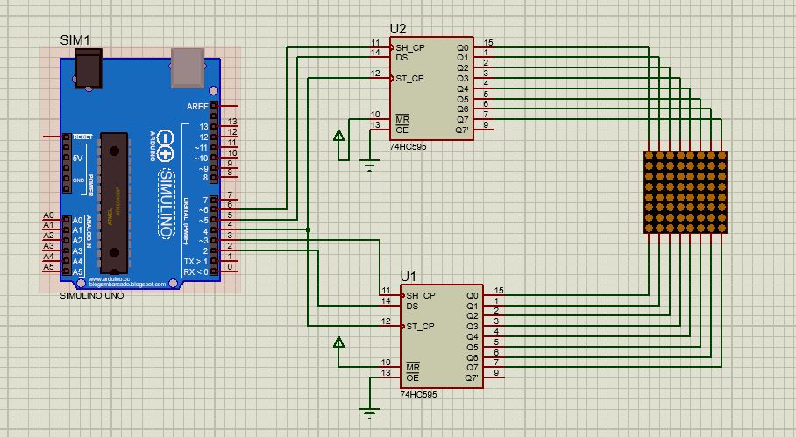

Figure Sơ đồ kết nối

## 3.Đặc điểm linh kiện:

* Arduino UNO R3.
* 1 LED MATRIX 8x8.
* 2 IC 74HC595.
* 2 Đất tiếp nối đèn

## 4.Code :

*#define _data_cot 3*

*#define _data_hang 2*

*#define _clock_hang 6*

*#define _clock_cot 5*

*#define _latch 4*

*byte chu[][8] = {*

*{0x3C,0x66,0x66,0x0C,0x18,0x30,0x7E,0x7E},//2*

*};*

*byte cot = 0b10000000;*

*void setup() {*

*Serial.begin(9600);*

*pinMode(_latch,OUTPUT);//RCLK*

*pinMode(_data_hang,OUTPUT);//SER hang*

*pinMode(_clock_hang,OUTPUT);//SRCLK hang*

*pinMode(_clock_cot,OUTPUT);//SRCLK cot*

*pinMode(_data_cot,OUTPUT);//SER cot*

*}*

*void loop() {*

*for(int i = 0;i<10;i++){*

*digitalWrite(_latch,LOW);*

*shiftOut(_data_hang,_clock_hang,LSBFIRST,cot >> i);// hang 8 - hang 1*

*shiftOut(_data_cot,_clock_cot,LSBFIRST,chu[0][i]);// cot 8 - cot 1*

*digitalWrite(_latch,HIGH);*

*delay(100);*

*}*

# **Bài điều khiển motor bằng IC L1293D**

## 1.Mô tả :

* Thực hiện việc điều khiển làm quay 2 motor
* Chạy theo trình tự bắt đầu quay, đổi chiều quay, tăng tốc, giảm tốc,
* 2 Motor được kết nối vào IC L293D để điều khiển

## 2.Sơ đồ thiết kế:

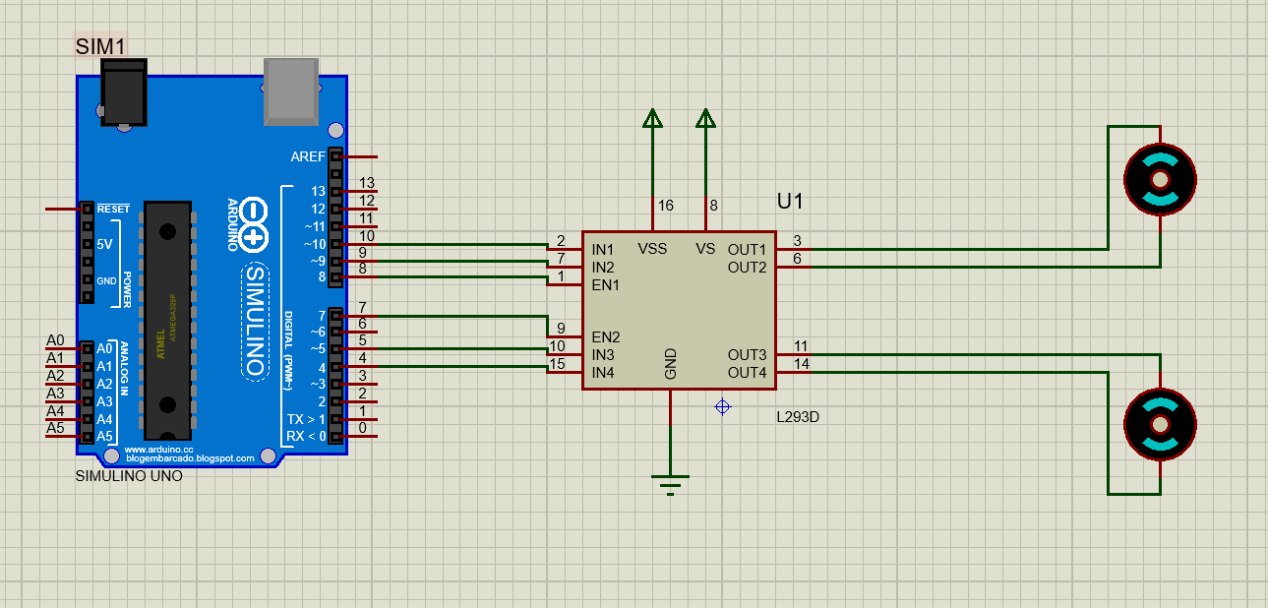

Figure 6 Sơ đồ kết nối

## 3.Đặc điểm linh kiện:

* 1 Arduino UNO
* 1 IC L293D
* 2 Motor

## 4.Code:

*// Kết nối động cơ A*

*int enA = 8;*

*int in1 = 10;*

*int in2 = 9;*

*// Kết nối động cơ B*

*int enB = 7;*

*int in3 = 5;*

*int in4 = 4;*

*void setup()*

*{ // Set tất cả các chân điều khiển động cơ thành output*

*pinMode(enA, OUTPUT);*

*pinMode(enB, OUTPUT);*

*pinMode(in1, OUTPUT);*

*pinMode(in2, OUTPUT);*

*pinMode(in3, OUTPUT);*

*pinMode(in4, OUTPUT);*

*// Tắt tất cả động cơ – Trạng thái ban đầu*

*digitalWrite(in1, LOW);*

*digitalWrite(in2, LOW);*

*digitalWrite(in3, LOW);*

*digitalWrite(in4, LOW);*

*}*

*void loop()*

*{*

*directionControl();*

*delay(1000);*

*speedControl();*

*delay(1000);*

*}*

*// Đoạn chương trình này cho phép bạn điều khiển chiều quay của động cơ*

*void directionControl()*

*{*

*// Cho động cơ quay với tốc độ tối đa*

*// Giá trị của PWM thay đổi từ 0 đến 255*

*analogWrite(enA, 255);*

*analogWrite(enB, 255);*

*// Tắt động cơ A và B*

*digitalWrite(in1, HIGH);*

*digitalWrite(in2, LOW);*

*digitalWrite(in3, HIGH);*

*digitalWrite(in4, LOW);*

*delay(2000);*

*// Thay đổi chiều quay của động cơ*

*digitalWrite(in1, LOW);*

*digitalWrite(in2, HIGH);*

*digitalWrite(in3, LOW);*

*digitalWrite(in4, HIGH);*

*delay(2000);*

*// Tắt tất cả các động cơ*

*digitalWrite(in1, LOW);*

*digitalWrite(in2, LOW);*

*digitalWrite(in3, LOW);*

*digitalWrite(in4, LOW);*

*}*

*// Đoạn chương trình điều khiển tốc độ của động cơ*

*void speedControl()*

*{ // Khởi động các động cơ*

*digitalWrite(in1, LOW);*

*digitalWrite(in2, HIGH);*

*digitalWrite(in3, LOW);*

*digitalWrite(in4, HIGH);*

*// Tăng tốc từ 0 đến tốc độ tối đa*

*for (int i = 0; i < 256; i++)*

*{*

*analogWrite(enA, i);*

*analogWrite(enB, i);*

*delay(20);*

*}*

*// Giảm tốc từ tốc độ tối đa về 0*

*for (int i = 255; i >= 0; i--)*

*{*

*analogWrite(enA, i);*

*analogWrite(enB, i);*

*delay(20);*

*}*

*// Tắt tất cả các động cơ*

*digitalWrite(in1, LOW);*

*digitalWrite(in2, LOW);*

*digitalWrite(in3, LOW);*

*digitalWrite(in4, LOW);}*

# **Bài nháy led 7 đoạn (0.0->9.9)**

## 1.Mô tả:

Bài này thực hiện việc lập trình điều khiển led 7 đoạn hiện thị các chữ số từ 0.0 đến 9.9 qua mạch test-thử IC 4511 , để thực hiện được ta cần dung 2 đèn led 7 đoạn kết nối với 2 IC.

## 2.Sơ đồ kết nối:

( Mô phỏng trên Tinkercard )

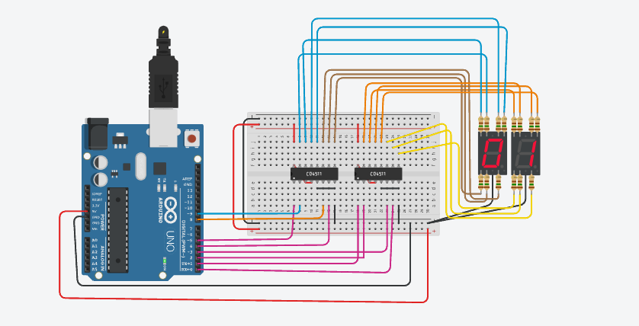

Figure 7 Mô phỏng Tinkercard

## 3.Đặc điểm linh kiện:

* 1 Mạch Arduino
* 2 Led 7 đoạn
* 14 Điện trở
* 2 IC 4511
* 1 Breadboard

## 4. Code:

*{*

*pinMode(0, OUTPUT);*

*pinMode(1, OUTPUT);*

*pinMode(2, OUTPUT);*

*pinMode(3, OUTPUT);*

*pinMode(4, OUTPUT);*

*pinMode(5, OUTPUT);*

*pinMode(6, OUTPUT);*

*pinMode(7, OUTPUT);*

*}*

*void show_so(int so, int led = 0)*

*{*

*if (so == 0)*

*{*

*digitalWrite(0 + led, LOW);*

*digitalWrite(1 + led, LOW);*

*digitalWrite(2 + led, LOW);*

*digitalWrite(3 + led, LOW);*

*}*

*else if (so == 1)*

*{*

*digitalWrite(0 + led, HIGH);*

*digitalWrite(1 + led, LOW);*

*digitalWrite(2 + led, LOW);*

*digitalWrite(3 + led, LOW);*

*}*

*else if (so == 2)*

*{*

*digitalWrite(0 + led, LOW);*

*digitalWrite(1 + led, HIGH);*

*digitalWrite(2 + led, LOW);*

*digitalWrite(3 + led, LOW);*

*}*

*else if (so == 3)*

*{*

*digitalWrite(0 + led, HIGH);*

*digitalWrite(1 + led, HIGH);*

*digitalWrite(2 + led, LOW);*

*digitalWrite(3 + led, LOW);*

*}*

*else if (so == 4)*

*{*

*digitalWrite(0 + led, LOW);*

*digitalWrite(1 + led, LOW);*

*digitalWrite(2 + led, HIGH);*

*digitalWrite(3 + led, LOW);*

*}*

*else if (so == 5)*

*{*

*digitalWrite(0 + led, HIGH);*

*digitalWrite(1 + led, LOW);*

*digitalWrite(2 + led, HIGH);*

*digitalWrite(3 + led, LOW);*

*}*

*else if (so == 6)*

*{*

*digitalWrite(0 + led, LOW);*

*digitalWrite(1 + led, HIGH);*

*digitalWrite(2 + led, HIGH);*

*digitalWrite(3 + led, LOW);*

*}*

*else if (so == 7)*

*{*

*digitalWrite(0 + led, HIGH);*

*digitalWrite(1 + led, HIGH);*

*digitalWrite(2 + led, HIGH);*

*digitalWrite(3 + led, LOW);*

*}*

*else if (so == 8)*

*{*

*digitalWrite(0 + led, LOW);*

*digitalWrite(1 + led, LOW);*

*digitalWrite(2 + led, LOW);*

*digitalWrite(3 + led, HIGH);*

*}*

*else if (so == 9)*

*{*

*digitalWrite(0 + led, HIGH);*

*digitalWrite(1 + led, LOW);*

*digitalWrite(2 + led, LOW);*

*digitalWrite(3 + led, HIGH);*

*}*

*}*

*void loop()*

*{*

*static int num1 = 0;*

*static int num2 = 0;*

*show_so(num1 % 10, 4);*

*show_so(num2 % 10);*

*num2++;*

*if (num2 % 10 == 0)*

*{*

*num2 = 0;*

*num1++;*

*}*

*delay(1000);*

}

# **Bài đọc giá trị độ sáng và hiện ra LCD**

## 1.Mô tả:

Bài này thực hiện việc lập trình điều khiển LCD hiển thị ra độ sáng của đèn điện được gắn quang trở.

## 2.Sơ đồ kết nối:

( Mô phỏng trên Tinkercard )

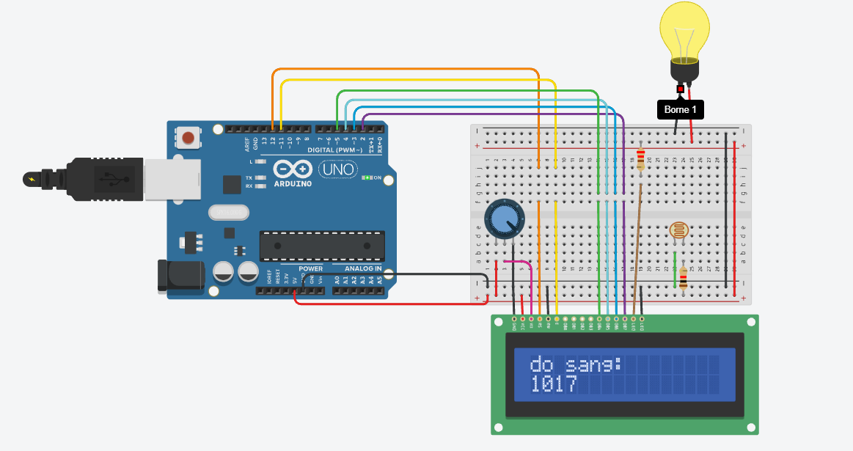

Figure 6 Mô phỏng Tinkercard

## 3.Đặc điểm linh kiện:

* 1 Mạch Arduino
* 1 LDR
* LCD
* 2 điện trở
* 1 Breadboard

## 4. Code:

*#include <LiquidCrystal.h>*

*#define SENSOR_PIN A0*

*// initialize the library with the numbers of the interface pins*

*LiquidCrystal lcd(12, 11, 5, 4, 3, 2);*

*int LIGHT = 0;*

*int val =0;*

*void setup() {*

*// set up the LCD's number of columns and rows:*

*lcd.begin(16, 2);*

*// Print a message to the LCD.*

*Serial.begin(9600);*

*}*

*void loop() {*

*val = analogRead(LIGHT);*

*// set the cursor to column 0, line 1*

*// (note: line 1 is the second row, since counting begins with 0):*

*lcd.setCursor(0, 0);*

*// print the number of seconds since reset:*

*lcd.print("do sang:");*

*lcd.setCursor(0, 1);*

*lcd.print(val);*

*}*

# **Bài chip STM32F401CB nháy 4 led**

## 1.Mô tả:

Bài này thực hiện lập trình điều khiển 4 đèn led sáng nhấp nháy bằng chip STM32F401VB.

## 2.Sơ đồ thiết kế:

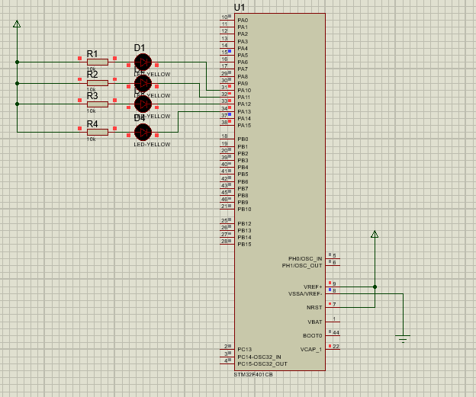

Figure Sơ đồ thiết kế

## 3.Đặc điểm linh kiện:

* 1 Chip STM32F401VB
* 4 điện trở
* 4 đèn led

## 4.Code:

*#include "main.h"void SystemClock_Config(void);*

*static void MX_GPIO_Init(void);*

*int main(void)*

*{HAL_Init();*

*SystemClock_Config();*

*MX_GPIO_Init();*

*while (1)*

*{*

*HAL_GPIO_TogglePin(GPIOA,GPIO_PIN_10);*

*HAL_Delay(1000);*

*HAL_GPIO_TogglePin(GPIOA,GPIO_PIN_11);*

*HAL_Delay(1000);*

*HAL_GPIO_TogglePin(GPIOA,GPIO_PIN_12);*

*HAL_Delay(1000);*

*HAL_GPIO_TogglePin(GPIOA,GPIO_PIN_13);*

*}*

*void SystemClock_Config(void)*

*{*

*RCC_OscInitTypeDef RCC_OscInitStruct = {0};*

*RCC_ClkInitTypeDef RCC_ClkInitStruct = {0};*

*__HAL_RCC_PWR_CLK_ENABLE();*

*__HAL_PWR_VOLTAGESCALING_CONFIG(PWR_REGULATOR_VOLTAGE_SCALE2);*

*RCC_OscInitStruct.OscillatorType = RCC_OSCILLATORTYPE_HSE;*

*RCC_OscInitStruct.HSEState = RCC_HSE_ON;*

*RCC_OscInitStruct.PLL.PLLState = RCC_PLL_NONE;*

*if (HAL_RCC_OscConfig(&RCC_OscInitStruct) != HAL_OK)*

*{*

*Error_Handler();*

*}*

*RCC_ClkInitStruct.ClockType = RCC_CLOCKTYPE_HCLK|RCC_CLOCKTYPE_SYSCLK*

*|RCC_CLOCKTYPE_PCLK1|RCC_CLOCKTYPE_PCLK2;*

*RCC_ClkInitStruct.SYSCLKSource = RCC_SYSCLKSOURCE_HSE;*

*RCC_ClkInitStruct.AHBCLKDivider = RCC_SYSCLK_DIV1;*

*RCC_ClkInitStruct.APB1CLKDivider = RCC_HCLK_DIV1;*

*RCC_ClkInitStruct.APB2CLKDivider = RCC_HCLK_DIV1;*

*if (HAL_RCC_ClockConfig(&RCC_ClkInitStruct, FLASH_LATENCY_0) != HAL_OK)*

*{*

*Error_Handler();*

*}*

*}*

*static void MX_GPIO_Init(void)*

*{*

*GPIO_InitTypeDef GPIO_InitStruct = {0};*

*__HAL_RCC_GPIOH_CLK_ENABLE();*

*__HAL_RCC_GPIOA_CLK_ENABLE();*

*HAL_GPIO_WritePin(GPIOA, Led_OUT_Pin|Led_OUTA11_Pin|GPIO_PIN_12|GPIO_PIN_13, GPIO_PIN_RESET);*

*GPIO_InitStruct.Pin = Led_OUT_Pin|Led_OUTA11_Pin|GPIO_PIN_12|GPIO_PIN_13;*

*GPIO_InitStruct.Mode = GPIO_MODE_OUTPUT_PP;*

*GPIO_InitStruct.Pull = GPIO_NOPULL;*

*GPIO_InitStruct.Speed = GPIO_SPEED_FREQ_LOW;*

*HAL_GPIO_Init(GPIOA, &GPIO_InitStruct);*

*}*

*#ifdef USE_FULL_ASSERT*

*#endif*

# **Bài chip STM32F401VE sáng led trái tim (22led)**

## 1.Mô tả:

Bài này thực hiên điều khiển nháy sáng đèn led hình trái tim 22 led cạnh nhau và các hiệu ứng của nó qua mạch RES16DIPIS kết nối chip STM32F401VE.

## 2.Sơ đồ thiết kế

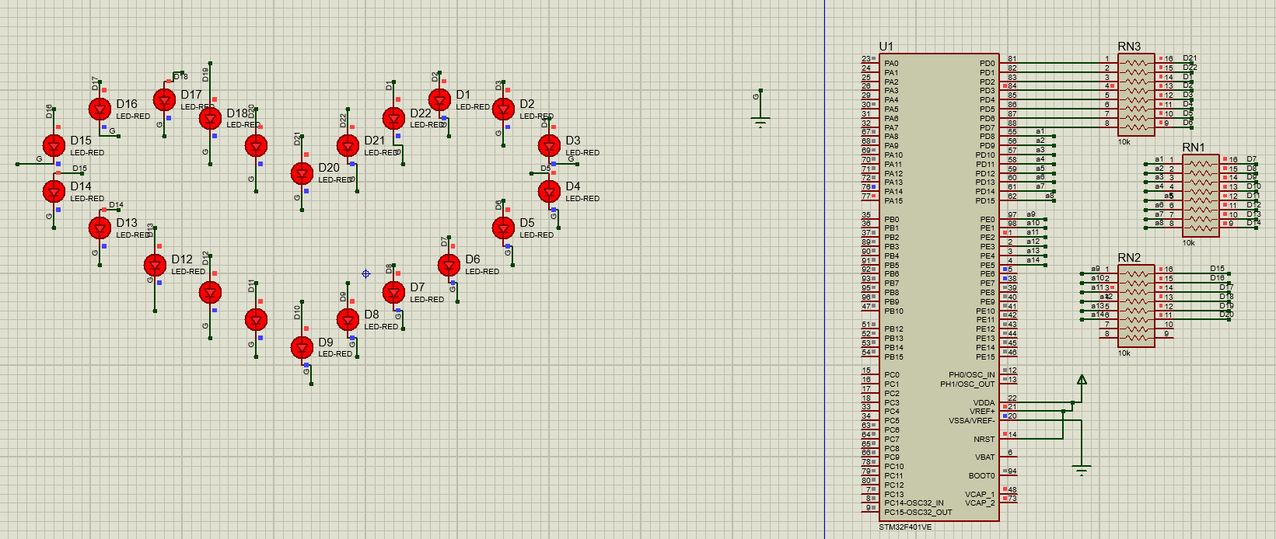

Figure 9 Sơ đồ thiết kế

## 3.Đặc điểm linh kiện:

* 22 Led-Red
* 3 mạch RES16DIPIS
* Chip STM32F401VE

## 4.Code:

*#include "main.h"*

*void SystemClock_Config(void);*

*static void MX_GPIO_Init(void);*

*void SANGLED();*

*void TATLED();*

*void NHAPNHAY();*

*void NHAPNHAY3();*

*void NHAPNHA();*

*int main(void)*

*{*

*HAL_Init();*

*SystemClock_Config();*

*MX_GPIO_Init();*

*while (1)*

*{*

*SANGLED();*

*HAL_Delay(1000);*

*TATLED();*

*HAL_Delay(1000);*

*NHAPNHAY();*

*HAL_Delay(500);*

*NHAPNHAY();*

*NHAPNHAY3();*

*NHAPNHA();*

*}*

*}*

*void TATLED()*

*{*

*SANGLED();*

*HAL_GPIO_WritePin (GPIOD, GPIO_PIN_0, GPIO_PIN_RESET);*

*HAL_GPIO_WritePin (GPIOD, GPIO_PIN_1, GPIO_PIN_RESET);*

*HAL_GPIO_WritePin (GPIOD, GPIO_PIN_2, GPIO_PIN_RESET);*

*HAL_GPIO_WritePin (GPIOD, GPIO_PIN_3, GPIO_PIN_RESET);*

*HAL_GPIO_WritePin (GPIOD, GPIO_PIN_4, GPIO_PIN_RESET);*

*HAL_GPIO_WritePin (GPIOD, GPIO_PIN_5, GPIO_PIN_RESET);*

*HAL_GPIO_WritePin (GPIOD, GPIO_PIN_6, GPIO_PIN_RESET);*

*HAL_GPIO_WritePin (GPIOD, GPIO_PIN_7, GPIO_PIN_RESET);*

*HAL_GPIO_WritePin (GPIOD, GPIO_PIN_8, GPIO_PIN_RESET);*

*HAL_GPIO_WritePin (GPIOD, GPIO_PIN_9, GPIO_PIN_RESET);*

*HAL_GPIO_WritePin (GPIOD, GPIO_PIN_10, GPIO_PIN_RESET);*

*HAL_GPIO_WritePin (GPIOD, GPIO_PIN_11, GPIO_PIN_RESET);*

*HAL_GPIO_WritePin (GPIOD, GPIO_PIN_12, GPIO_PIN_RESET);*

*HAL_GPIO_WritePin (GPIOD, GPIO_PIN_13, GPIO_PIN_RESET);*

*HAL_GPIO_WritePin (GPIOD, GPIO_PIN_14, GPIO_PIN_RESET);*

*HAL_GPIO_WritePin (GPIOD, GPIO_PIN_15, GPIO_PIN_RESET);*

*HAL_GPIO_WritePin (GPIOE, GPIO_PIN_0, GPIO_PIN_RESET);*

*HAL_GPIO_WritePin (GPIOE, GPIO_PIN_1, GPIO_PIN_RESET);*

*HAL_GPIO_WritePin (GPIOE, GPIO_PIN_2, GPIO_PIN_RESET);*

*HAL_GPIO_WritePin (GPIOE, GPIO_PIN_3, GPIO_PIN_RESET);*

*HAL_GPIO_WritePin (GPIOE, GPIO_PIN_4, GPIO_PIN_RESET);*

*HAL_GPIO_WritePin (GPIOE, GPIO_PIN_5, GPIO_PIN_RESET);*

*}*

*void SANGLED()*

*{*

*HAL_GPIO_WritePin (GPIOD, GPIO_PIN_0, GPIO_PIN_SET);*

*HAL_GPIO_WritePin (GPIOD, GPIO_PIN_1, GPIO_PIN_SET);*

*HAL_GPIO_WritePin (GPIOD, GPIO_PIN_2, GPIO_PIN_SET);*

*HAL_GPIO_WritePin (GPIOD, GPIO_PIN_3, GPIO_PIN_SET);*

*HAL_GPIO_WritePin (GPIOD, GPIO_PIN_4, GPIO_PIN_SET);*

*HAL_GPIO_WritePin (GPIOD, GPIO_PIN_5, GPIO_PIN_SET);*

*HAL_GPIO_WritePin (GPIOD, GPIO_PIN_6, GPIO_PIN_SET);*

*HAL_GPIO_WritePin (GPIOD, GPIO_PIN_7, GPIO_PIN_SET);*

*HAL_GPIO_WritePin (GPIOD, GPIO_PIN_8, GPIO_PIN_SET);*

*HAL_GPIO_WritePin (GPIOD, GPIO_PIN_9, GPIO_PIN_SET);*

*HAL_GPIO_WritePin (GPIOD, GPIO_PIN_10, GPIO_PIN_SET);*

*HAL_GPIO_WritePin (GPIOD, GPIO_PIN_11, GPIO_PIN_SET);*

*HAL_GPIO_WritePin (GPIOD, GPIO_PIN_12, GPIO_PIN_SET);*

*HAL_GPIO_WritePin (GPIOD, GPIO_PIN_13, GPIO_PIN_SET);*

*HAL_GPIO_WritePin (GPIOD, GPIO_PIN_14, GPIO_PIN_SET);*

*HAL_GPIO_WritePin (GPIOD, GPIO_PIN_15, GPIO_PIN_SET);*

*HAL_GPIO_WritePin (GPIOE, GPIO_PIN_0, GPIO_PIN_SET);*

*HAL_GPIO_WritePin (GPIOE, GPIO_PIN_1, GPIO_PIN_SET);*

*HAL_GPIO_WritePin (GPIOE, GPIO_PIN_2, GPIO_PIN_SET);*

*HAL_GPIO_WritePin (GPIOE, GPIO_PIN_3, GPIO_PIN_SET);*

*HAL_GPIO_WritePin (GPIOE, GPIO_PIN_4, GPIO_PIN_SET);*

*HAL_GPIO_WritePin (GPIOE, GPIO_PIN_5, GPIO_PIN_SET);*

*}*

*void NHAPNHAY()*

*{*

*TATLED();*

*HAL_GPIO_WritePin (GPIOD, GPIO_PIN_0, GPIO_PIN_RESET);*

*HAL_Delay(100);*

*HAL_GPIO_WritePin (GPIOD, GPIO_PIN_1, GPIO_PIN_SET);*

*HAL_Delay(100);*

*HAL_GPIO_WritePin (GPIOD, GPIO_PIN_2, GPIO_PIN_RESET);*

*HAL_Delay(100);*

*HAL_GPIO_WritePin (GPIOD, GPIO_PIN_3, GPIO_PIN_SET);*

*HAL_Delay(100);*

*HAL_GPIO_WritePin (GPIOD, GPIO_PIN_4, GPIO_PIN_RESET);*

*HAL_Delay(100);*

*HAL_GPIO_WritePin (GPIOD, GPIO_PIN_5, GPIO_PIN_SET);*

*HAL_Delay(100);*

*HAL_GPIO_WritePin (GPIOD, GPIO_PIN_6, GPIO_PIN_RESET);*

*HAL_Delay(100);*

*HAL_GPIO_WritePin (GPIOD, GPIO_PIN_7, GPIO_PIN_SET);*

*HAL_Delay(100);*

*HAL_GPIO_WritePin (GPIOD, GPIO_PIN_8, GPIO_PIN_RESET);*

*HAL_Delay(100);*

*HAL_GPIO_WritePin (GPIOD, GPIO_PIN_9, GPIO_PIN_SET);*

*HAL_Delay(100);*

*HAL_GPIO_WritePin (GPIOD, GPIO_PIN_10, GPIO_PIN_RESET);*

*HAL_Delay(100);*

*HAL_GPIO_WritePin (GPIOD, GPIO_PIN_11, GPIO_PIN_SET);*

*HAL_Delay(100);*

*HAL_GPIO_WritePin (GPIOD, GPIO_PIN_12, GPIO_PIN_RESET);*

*HAL_Delay(100);*

*HAL_GPIO_WritePin (GPIOD, GPIO_PIN_13, GPIO_PIN_SET);*

*HAL_Delay(100);*

*HAL_GPIO_WritePin (GPIOD, GPIO_PIN_14, GPIO_PIN_RESET);*

*HAL_Delay(100);*

*HAL_GPIO_WritePin (GPIOD, GPIO_PIN_15, GPIO_PIN_SET);*

*HAL_Delay(100);*

*HAL_GPIO_WritePin (GPIOE, GPIO_PIN_0, GPIO_PIN_RESET);*

*HAL_Delay(100);*

*HAL_GPIO_WritePin (GPIOE, GPIO_PIN_1, GPIO_PIN_SET);*

*HAL_Delay(100);*

*HAL_GPIO_WritePin (GPIOE, GPIO_PIN_2, GPIO_PIN_RESET);*

*HAL_Delay(100);*

*HAL_GPIO_WritePin (GPIOE, GPIO_PIN_3, GPIO_PIN_SET);*

*HAL_Delay(100);*

*HAL_GPIO_WritePin (GPIOE, GPIO_PIN_4, GPIO_PIN_RESET);*

*HAL_Delay(100);*

*HAL_GPIO_WritePin (GPIOE, GPIO_PIN_5, GPIO_PIN_SET);*

*HAL_Delay(100);*

*}*

*void NHAPNHAY3()*

*{*

*TATLED();*

*HAL_GPIO_WritePin (GPIOD, GPIO_PIN_0, GPIO_PIN_SET);*

*HAL_Delay(1000);*

*HAL_GPIO_WritePin (GPIOD, GPIO_PIN_0, GPIO_PIN_RESET);*

*HAL_Delay(1000);*

*HAL_GPIO_WritePin (GPIOD, GPIO_PIN_1, GPIO_PIN_SET);*

*HAL_Delay(1000);*

*HAL_GPIO_WritePin (GPIOD, GPIO_PIN_1, GPIO_PIN_RESET);*

*HAL_Delay(1000);*

*HAL_GPIO_WritePin (GPIOD, GPIO_PIN_2, GPIO_PIN_SET);*

*HAL_Delay(1000);*

*HAL_GPIO_WritePin (GPIOD, GPIO_PIN_2, GPIO_PIN_RESET);*

*HAL_Delay(1000);*

*HAL_GPIO_WritePin (GPIOD, GPIO_PIN_3, GPIO_PIN_SET);*

*HAL_Delay(100);*

*HAL_GPIO_WritePin (GPIOD, GPIO_PIN_3, GPIO_PIN_RESET);*

*HAL_GPIO_WritePin (GPIOD, GPIO_PIN_4, GPIO_PIN_SET);*

*HAL_Delay(100);*

*HAL_GPIO_WritePin (GPIOD, GPIO_PIN_4, GPIO_PIN_RESET);*

*HAL_GPIO_WritePin (GPIOD, GPIO_PIN_5, GPIO_PIN_RESET);*

*HAL_Delay(100);*

*HAL_GPIO_WritePin (GPIOD, GPIO_PIN_6, GPIO_PIN_RESET);*

*HAL_Delay(100);*

*HAL_GPIO_WritePin (GPIOD, GPIO_PIN_7, GPIO_PIN_SET);*

*HAL_Delay(100);*

*HAL_GPIO_WritePin (GPIOD, GPIO_PIN_8, GPIO_PIN_SET);*

*HAL_Delay(100);*

*HAL_GPIO_WritePin (GPIOD, GPIO_PIN_9, GPIO_PIN_SET);*

*HAL_Delay(100);*

*HAL_GPIO_WritePin (GPIOD, GPIO_PIN_10, GPIO_PIN_RESET);*

*HAL_Delay(100);*

*HAL_GPIO_WritePin (GPIOD, GPIO_PIN_11, GPIO_PIN_RESET);*

*HAL_Delay(100);*

*HAL_GPIO_WritePin (GPIOD, GPIO_PIN_12, GPIO_PIN_RESET);*

*HAL_Delay(100);*

*HAL_GPIO_WritePin (GPIOD, GPIO_PIN_13, GPIO_PIN_SET);*

*HAL_Delay(100);*

*HAL_GPIO_WritePin (GPIOD, GPIO_PIN_14, GPIO_PIN_SET);*

*HAL_Delay(100);*

*HAL_GPIO_WritePin (GPIOD, GPIO_PIN_15, GPIO_PIN_SET);*

*HAL_Delay(100);*

*HAL_GPIO_WritePin (GPIOE, GPIO_PIN_0, GPIO_PIN_RESET);*

*HAL_Delay(100);*

*HAL_GPIO_WritePin (GPIOE, GPIO_PIN_1, GPIO_PIN_RESET);*

*HAL_Delay(100);*

*HAL_GPIO_WritePin (GPIOE, GPIO_PIN_2, GPIO_PIN_RESET);*

*HAL_Delay(100);*

*HAL_GPIO_WritePin (GPIOE, GPIO_PIN_3, GPIO_PIN_SET);*

*HAL_Delay(100);*

*HAL_GPIO_WritePin (GPIOE, GPIO_PIN_4, GPIO_PIN_SET);*

*HAL_Delay(100);*

*HAL_GPIO_WritePin (GPIOE, GPIO_PIN_5, GPIO_PIN_SET);*

*HAL_Delay(100);*

*}*

*void NHAPNHA()*

*{*

*TATLED();*

*HAL_GPIO_WritePin (GPIOD, GPIO_PIN_0, GPIO_PIN_SET);*

*HAL_Delay(100);*

*HAL_GPIO_WritePin (GPIOD, GPIO_PIN_0, GPIO_PIN_RESET);*

*HAL_Delay(100);*

*HAL_GPIO_WritePin (GPIOD, GPIO_PIN_0, GPIO_PIN_SET);*

*HAL_GPIO_WritePin (GPIOD, GPIO_PIN_1, GPIO_PIN_SET);*

*HAL_Delay(100);*

*HAL_GPIO_WritePin (GPIOD, GPIO_PIN_1, GPIO_PIN_RESET);*

*HAL_Delay(100);*

*HAL_GPIO_WritePin (GPIOD, GPIO_PIN_1, GPIO_PIN_SET);*

*HAL_GPIO_WritePin (GPIOD, GPIO_PIN_2, GPIO_PIN_SET);*

*HAL_Delay(100);*

*HAL_GPIO_WritePin (GPIOD, GPIO_PIN_2, GPIO_PIN_RESET);*

*HAL_Delay(100);*

*HAL_GPIO_WritePin (GPIOD, GPIO_PIN_2, GPIO_PIN_SET);*

*HAL_GPIO_WritePin (GPIOD, GPIO_PIN_3, GPIO_PIN_SET);*

*HAL_Delay(100);*

*HAL_GPIO_WritePin (GPIOD, GPIO_PIN_3, GPIO_PIN_RESET);*

*HAL_Delay(100);*

*HAL_GPIO_WritePin (GPIOD, GPIO_PIN_3, GPIO_PIN_SET);*

*HAL_GPIO_WritePin (GPIOD, GPIO_PIN_4, GPIO_PIN_SET);*

*HAL_Delay(100);*

*HAL_GPIO_WritePin (GPIOD, GPIO_PIN_4, GPIO_PIN_RESET);*

*HAL_Delay(100);*

*HAL_GPIO_WritePin (GPIOD, GPIO_PIN_4, GPIO_PIN_SET);*

*HAL_GPIO_WritePin (GPIOD, GPIO_PIN_5, GPIO_PIN_SET);*

*HAL_Delay(100);*

*HAL_GPIO_WritePin (GPIOD, GPIO_PIN_5, GPIO_PIN_RESET);*

*HAL_Delay(100);*

*HAL_GPIO_WritePin (GPIOD, GPIO_PIN_5, GPIO_PIN_SET);*

*HAL_GPIO_WritePin (GPIOD, GPIO_PIN_6, GPIO_PIN_SET);*

*HAL_Delay(100);*

*HAL_GPIO_WritePin (GPIOD, GPIO_PIN_6, GPIO_PIN_RESET);*

*HAL_Delay(100);*

*HAL_GPIO_WritePin (GPIOD, GPIO_PIN_6, GPIO_PIN_SET);*

*HAL_GPIO_WritePin (GPIOD, GPIO_PIN_7, GPIO_PIN_SET);*

*HAL_Delay(100);*

*HAL_GPIO_WritePin (GPIOD, GPIO_PIN_7, GPIO_PIN_RESET);*

*HAL_Delay(100);*

*HAL_GPIO_WritePin (GPIOD, GPIO_PIN_7, GPIO_PIN_SET);*

*HAL_GPIO_WritePin (GPIOD, GPIO_PIN_8, GPIO_PIN_SET);*

*HAL_Delay(100);*

*HAL_GPIO_WritePin (GPIOD, GPIO_PIN_8, GPIO_PIN_RESET);*

*HAL_Delay(100);*

*HAL_GPIO_WritePin (GPIOD, GPIO_PIN_8, GPIO_PIN_SET);*

*HAL_GPIO_WritePin (GPIOD, GPIO_PIN_9, GPIO_PIN_SET);*

*HAL_Delay(100);*

*HAL_GPIO_WritePin (GPIOD, GPIO_PIN_9, GPIO_PIN_RESET);*

*HAL_Delay(100);*

*HAL_GPIO_WritePin (GPIOD, GPIO_PIN_9, GPIO_PIN_SET);*

*HAL_GPIO_WritePin (GPIOD, GPIO_PIN_10, GPIO_PIN_SET);*

*HAL_Delay(100);*

*HAL_GPIO_WritePin (GPIOD, GPIO_PIN_10, GPIO_PIN_RESET);*

*HAL_Delay(100);*

*HAL_GPIO_WritePin (GPIOD, GPIO_PIN_10, GPIO_PIN_SET);*

*HAL_GPIO_WritePin (GPIOD, GPIO_PIN_11, GPIO_PIN_SET);*

*HAL_Delay(100);*

*HAL_GPIO_WritePin (GPIOD, GPIO_PIN_11, GPIO_PIN_RESET);*

*HAL_Delay(100);*

*HAL_GPIO_WritePin (GPIOD, GPIO_PIN_11, GPIO_PIN_SET);*

*HAL_GPIO_WritePin (GPIOD, GPIO_PIN_12, GPIO_PIN_SET);*

*HAL_Delay(100);*

*HAL_GPIO_WritePin (GPIOD, GPIO_PIN_12, GPIO_PIN_RESET);*

*HAL_Delay(100);*

*HAL_GPIO_WritePin (GPIOD, GPIO_PIN_12, GPIO_PIN_SET);*

*HAL_GPIO_WritePin (GPIOD, GPIO_PIN_13, GPIO_PIN_SET);*

*HAL_Delay(100);*

*HAL_GPIO_WritePin (GPIOD, GPIO_PIN_13, GPIO_PIN_RESET);*

*HAL_Delay(100);*

*HAL_GPIO_WritePin (GPIOD, GPIO_PIN_13, GPIO_PIN_SET);*

*HAL_GPIO_WritePin (GPIOD, GPIO_PIN_14, GPIO_PIN_SET);*

*HAL_Delay(100);*

*HAL_GPIO_WritePin (GPIOD, GPIO_PIN_14, GPIO_PIN_RESET);*

*HAL_Delay(100);*

*HAL_GPIO_WritePin (GPIOD, GPIO_PIN_14, GPIO_PIN_SET);*

*HAL_GPIO_WritePin (GPIOD, GPIO_PIN_15, GPIO_PIN_SET);*

*HAL_Delay(100);*

*HAL_GPIO_WritePin (GPIOD, GPIO_PIN_15, GPIO_PIN_RESET);*

*HAL_Delay(100);*

*HAL_GPIO_WritePin (GPIOD, GPIO_PIN_15, GPIO_PIN_SET);*

*HAL_GPIO_WritePin (GPIOE, GPIO_PIN_0, GPIO_PIN_SET);*

*HAL_Delay(100);*

*HAL_GPIO_WritePin (GPIOE, GPIO_PIN_0, GPIO_PIN_RESET);*

*HAL_Delay(100);*

*HAL_GPIO_WritePin (GPIOE, GPIO_PIN_0, GPIO_PIN_SET);*

*HAL_GPIO_WritePin (GPIOE, GPIO_PIN_1, GPIO_PIN_SET);*

*HAL_Delay(100);*

*HAL_GPIO_WritePin (GPIOE, GPIO_PIN_1, GPIO_PIN_RESET);*

*HAL_Delay(100);*

*HAL_GPIO_WritePin (GPIOE, GPIO_PIN_1, GPIO_PIN_SET);*

*HAL_GPIO_WritePin (GPIOE, GPIO_PIN_2, GPIO_PIN_SET);*

*HAL_Delay(100);*

*HAL_GPIO_WritePin (GPIOE, GPIO_PIN_2, GPIO_PIN_RESET);*

*HAL_Delay(100);*

*HAL_GPIO_WritePin (GPIOE, GPIO_PIN_2, GPIO_PIN_SET);*

*HAL_GPIO_WritePin (GPIOE, GPIO_PIN_3, GPIO_PIN_SET);*

*HAL_Delay(100);*

*HAL_GPIO_WritePin (GPIOE, GPIO_PIN_3, GPIO_PIN_RESET);*

*HAL_Delay(100);*

*HAL_GPIO_WritePin (GPIOE, GPIO_PIN_3, GPIO_PIN_SET);*

*HAL_GPIO_WritePin (GPIOE, GPIO_PIN_4, GPIO_PIN_SET);*

*HAL_Delay(100);*

*HAL_GPIO_WritePin (GPIOE, GPIO_PIN_4, GPIO_PIN_RESET);*

*HAL_Delay(100);*

*HAL_GPIO_WritePin (GPIOE, GPIO_PIN_4, GPIO_PIN_SET);*

*HAL_GPIO_WritePin (GPIOE, GPIO_PIN_5, GPIO_PIN_SET);*

*HAL_Delay(100);*

*HAL_GPIO_WritePin (GPIOE, GPIO_PIN_5, GPIO_PIN_RESET);*

*HAL_Delay(100);*

*HAL_GPIO_WritePin (GPIOE, GPIO_PIN_5, GPIO_PIN_SET);*

*SANGLED();*

*HAL_Delay(100);*

*TATLED();*

*HAL_Delay(500);*

*SANGLED ();*

*HAL_Delay(500);*

*TATLED();*

*HAL_Delay(500);*

*SANGLED ();*

*HAL_Delay(500);*

*TATLED();*

*HAL_Delay(500);*

*SANGLED ();*

*}*

*/\*\**

*\* @brief System Clock Configuration*

*\* @retval None*

*\*/*

*void SystemClock_Config(void)*

*{*

*RCC_OscInitTypeDef RCC_OscInitStruct = {0};*

*RCC_ClkInitTypeDef RCC_ClkInitStruct = {0};*

*__HAL_RCC_PWR_CLK_ENABLE();*

*__HAL_PWR_VOLTAGESCALING_CONFIG(PWR_REGULATOR_VOLTAGE_SCALE2);*

*RCC_OscInitStruct.OscillatorType = RCC_OSCILLATORTYPE_HSI;*

*RCC_OscInitStruct.HSIState = RCC_HSI_ON;*

*RCC_OscInitStruct.HSICalibrationValue = RCC_HSICALIBRATION_DEFAULT;*

*RCC_OscInitStruct.PLL.PLLState = RCC_PLL_NONE;*

*if (HAL_RCC_OscConfig(&RCC_OscInitStruct) != HAL_OK)*

*{*

*Error_Handler();*

*}*

*/** Initializes the CPU, AHB and APB buses clocks*

*\*/*

*RCC_ClkInitStruct.ClockType = RCC_CLOCKTYPE_HCLK|RCC_CLOCKTYPE_SYSCLK*

*|RCC_CLOCKTYPE_PCLK1|RCC_CLOCKTYPE_PCLK2;*

*RCC_ClkInitStruct.SYSCLKSource = RCC_SYSCLKSOURCE_HSI;*

*RCC_ClkInitStruct.AHBCLKDivider = RCC_SYSCLK_DIV1;*

*RCC_ClkInitStruct.APB1CLKDivider = RCC_HCLK_DIV1;*

*RCC_ClkInitStruct.APB2CLKDivider = RCC_HCLK_DIV1;*

*if (HAL_RCC_ClockConfig(&RCC_ClkInitStruct, FLASH_LATENCY_0) != HAL_OK)*

*{*

*Error_Handler();*

*}*

*}*

*/\*\**

*\* @brief GPIO Initialization Function*

*\* @param None*

*\* @retval None*

*\*/*

*static void MX_GPIO_Init(void)*

*{*

*GPIO_InitTypeDef GPIO_InitStruct = {0};*

*/* GPIO Ports Clock Enable */*

*__HAL_RCC_GPIOE_CLK_ENABLE();*

*__HAL_RCC_GPIOD_CLK_ENABLE();*

*/*Configure GPIO pin Output Level */*

*HAL_GPIO_WritePin(GPIOE, GPIO_PIN_2|GPIO_PIN_3|GPIO_PIN_4|GPIO_PIN_5*

*|GPIO_PIN_6|GPIO_PIN_7|GPIO_PIN_0|GPIO_PIN_1, GPIO_PIN_RESET);*

*/*Configure GPIO pin Output Level */*

*HAL_GPIO_WritePin(GPIOD, GPIO_PIN_8|GPIO_PIN_9|GPIO_PIN_10|GPIO_PIN_11*

*|GPIO_PIN_12|GPIO_PIN_13|GPIO_PIN_14|GPIO_PIN_15*

*|GPIO_PIN_0|GPIO_PIN_1|GPIO_PIN_2|GPIO_PIN_3*

*|GPIO_PIN_4|GPIO_PIN_5|GPIO_PIN_6|GPIO_PIN_7, GPIO_PIN_RESET);*

*/*Configure GPIO pins : PE2 PE3 PE4 PE5*

*PE6 PE7 PE0 PE1 */*

*GPIO_InitStruct.Pin = GPIO_PIN_2|GPIO_PIN_3|GPIO_PIN_4|GPIO_PIN_5*

*|GPIO_PIN_6|GPIO_PIN_7|GPIO_PIN_0|GPIO_PIN_1;*

*GPIO_InitStruct.Mode = GPIO_MODE_OUTPUT_PP;*

*GPIO_InitStruct.Pull = GPIO_NOPULL;*

*GPIO_InitStruct.Speed = GPIO_SPEED_FREQ_LOW;*

*HAL_GPIO_Init(GPIOE, &GPIO_InitStruct);*

*/*Configure GPIO pins : PD8 PD9 PD10 PD11*

*PD12 PD13 PD14 PD15*

*PD0 PD1 PD2 PD3*

*PD4 PD5 PD6 PD7 */*

*GPIO_InitStruct.Pin = GPIO_PIN_8|GPIO_PIN_9|GPIO_PIN_10|GPIO_PIN_11*

*|GPIO_PIN_12|GPIO_PIN_13|GPIO_PIN_14|GPIO_PIN_15*

*|GPIO_PIN_0|GPIO_PIN_1|GPIO_PIN_2|GPIO_PIN_3*

*|GPIO_PIN_4|GPIO_PIN_5|GPIO_PIN_6|GPIO_PIN_7;*

*GPIO_InitStruct.Mode = GPIO_MODE_OUTPUT_PP;*

*GPIO_InitStruct.Pull = GPIO_NOPULL;*

*GPIO_InitStruct.Speed = GPIO_SPEED_FREQ_LOW;*

*HAL_GPIO_Init(GPIOD, &GPIO_InitStruct);*

*}*

*void Error_Handler(void)*

*{*

*__disable_irq();*

*while (1)*

*{}*

*}*

*#ifdef USE_FULL_ASSERT*

*#endif*

**Mục lục**

**Bài TMP36 đo led** 2

1.Mô tả: 2

2.Sơ đồ thiết kế: 2

3.Đặc điểm linh kiện: 2

4.Code: 2

**Bài led bật tắt** 3

1.Mô tả: 3

2.Sơ đồ thiết kế: 3

3.Đặc điểm linh kiện: 3

4.Code: 3

**Bài led 7 đoạn** 4

1.Mô tả**:** 4

2.Sơ đồ thiết kế: 4

3.Đặt điểm linh kiện: 5

4.Code : 5

**Bài 8 led nhấp nháy** 9

1.Mô tả**:** 9

2.Sơ đồ thiết kế: 9

3.Đặc điểm linh kiện: 9

4.Code: 9

**Bài led ma trận** 11

1.Môi tả : 11

2.Sơ đồ thiết kế : 11

3.Đặc điểm linh kiện: 11

4.Code : 11

**Bài điều khiển motor bằng IC L1293D** 13

1.Mô tả : 13

2.Sơ đồ thiết kế: 13

3.Đặc điểm linh kiện: 13

4.Code: 13

**Bài nháy led 7 đoạn (0.0->9.9)** 18

1.Mô tả: 18

2.Sơ đồ kết nối: 18

3.Đặc điểm linh kiện: 18

4. Code: 18

**Bài đọc giá trị độ sáng và hiện ra LCD** 23

1.Mô tả: 23

2.Sơ đồ kết nối: 23

3.Đặc điểm linh kiện: 23

4. Code: 23

**Bài chip STM32F401CB nháy 4 led** 25

1.Mô tả: 25

2.Sơ đồ thiết kế: 25

3.Đặc điểm linh kiện: 25

4.Code: 25

**Bài chip STM32F401VE sáng led trái tim (22led)** 28

1.Mô tả: 28

2.Sơ đồ thiết kế 28

3.Đặc điểm linh kiện: 28

4.Code: 28