**Deploy applications on Azure AKS**

**1.** **Prerequisites** 2

**2.** **Setup Infrastructure with Terraform** 2

**2.1.** **Log in to Azure CLI** 2

**2.2.** **Initialize the module** 2

**2.3.** **Verify the terraform plan** 3

**3.** **Setup Azure DevOps pipelines** 3

**4.** **AKS Setup** 6

**5.** **Monitoring with Prometheus and Grafana** 6

1. **Prerequisites**

* Azure Subscription, Azure DevOps account
* Azure CLI
* Docker
* Kubectl
* Terraform
* Helm

1. **Setup Infrastructure with Terraform**

## **Log in to Azure CLI**

* Log in to your azure CLI using your terminal and execute: az login or az login –use-device-code.

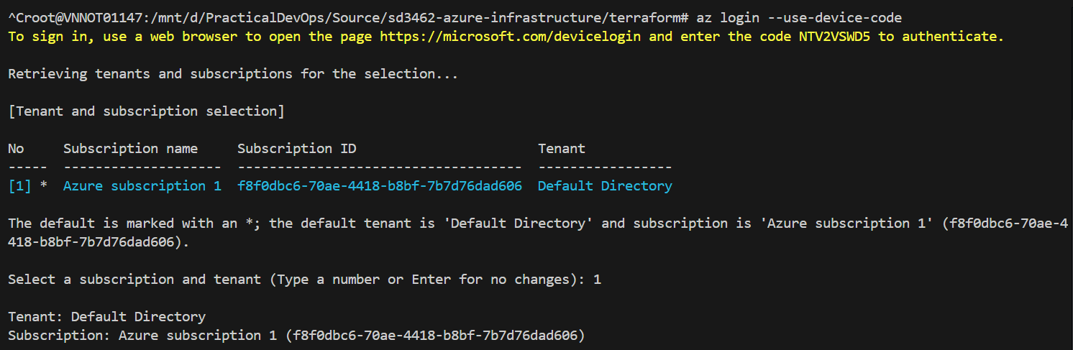

## **Initialize the module**

* Move to the **“/terraform”** directory to perform commands.
* Run the command terraform init to initializing the backend.

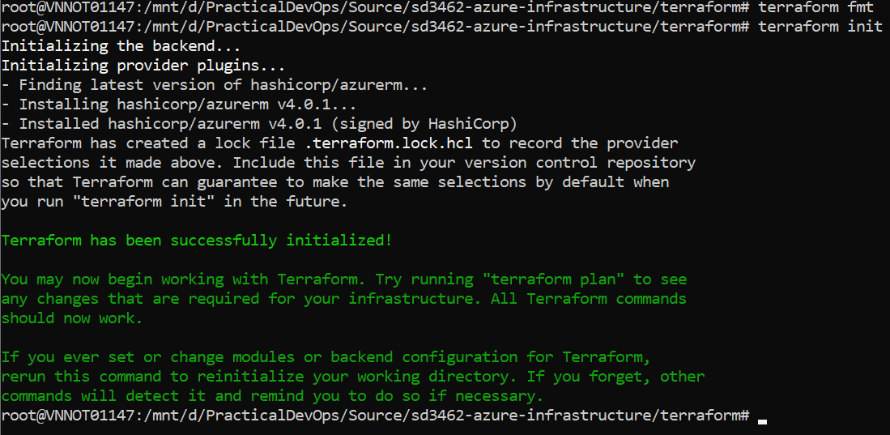

* After successfully initializing, run terraform validate to check whether the configuration is valid to ensure no issue when applying the terraform plan.
* Run terraform plan to apply the execution plan.

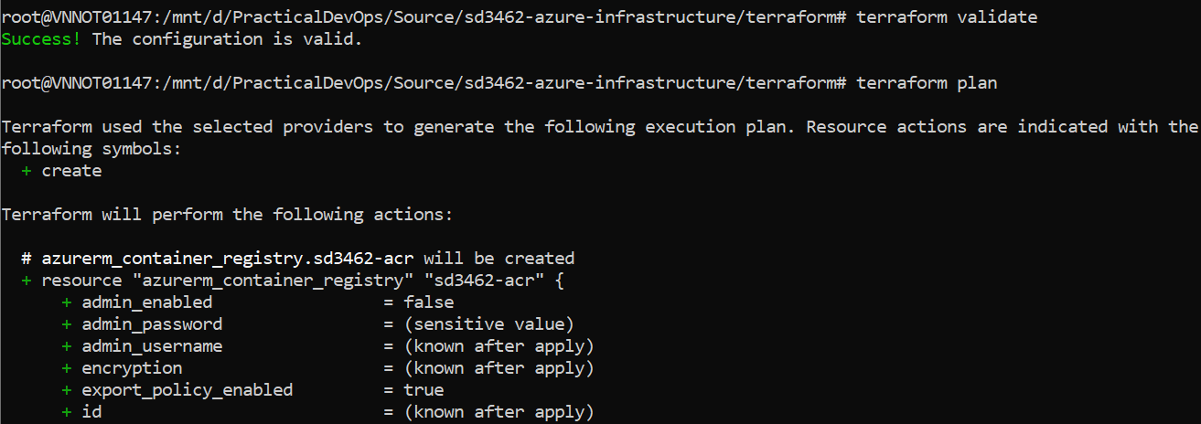

* Run terraform apply to create all the resource.

## **Verify the terraform plan**

1. **Setup Azure DevOps pipelines**

* Go to project settings > service connections and click “create service connection”.

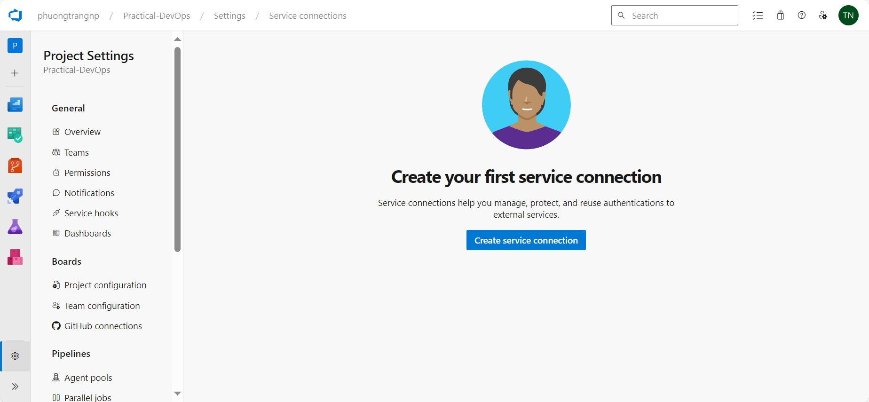

* Choose a service or connection type: **Docker Registry** then click “Next”.
* At create popup, select **Service Principle** authentication type, your subscription and container registry then click save.

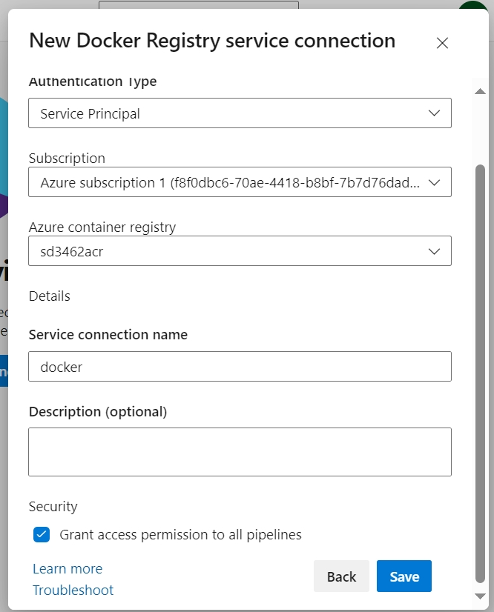

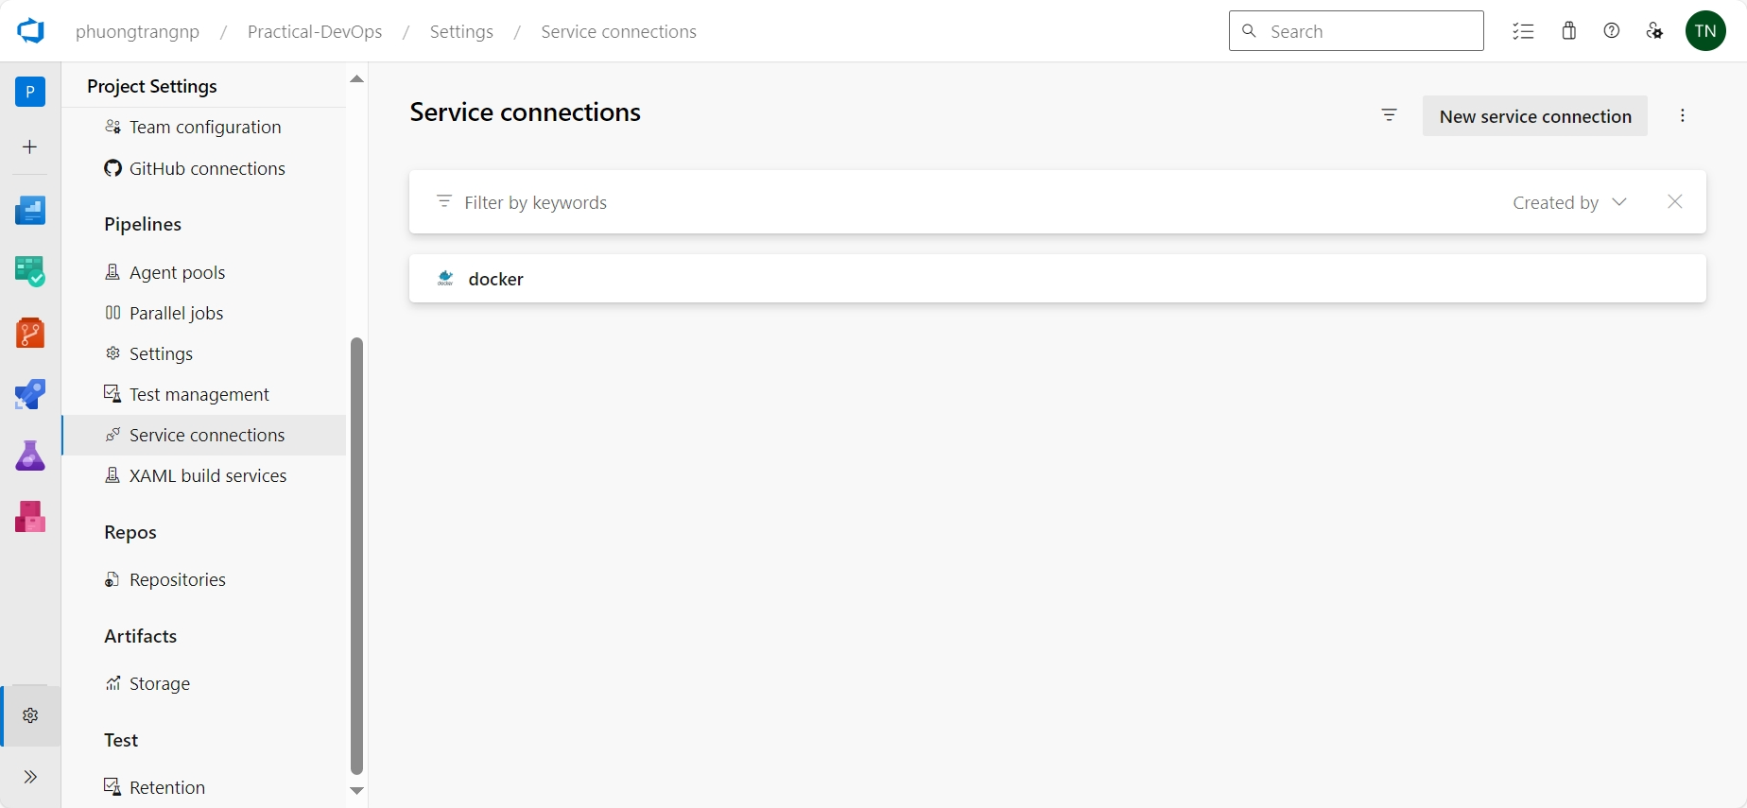

* Back to **Repo Page**, select **Set up build.** At **Configure** section choose Docker (Build and push an image to ACR) then fill the configuration to create a pipeline.

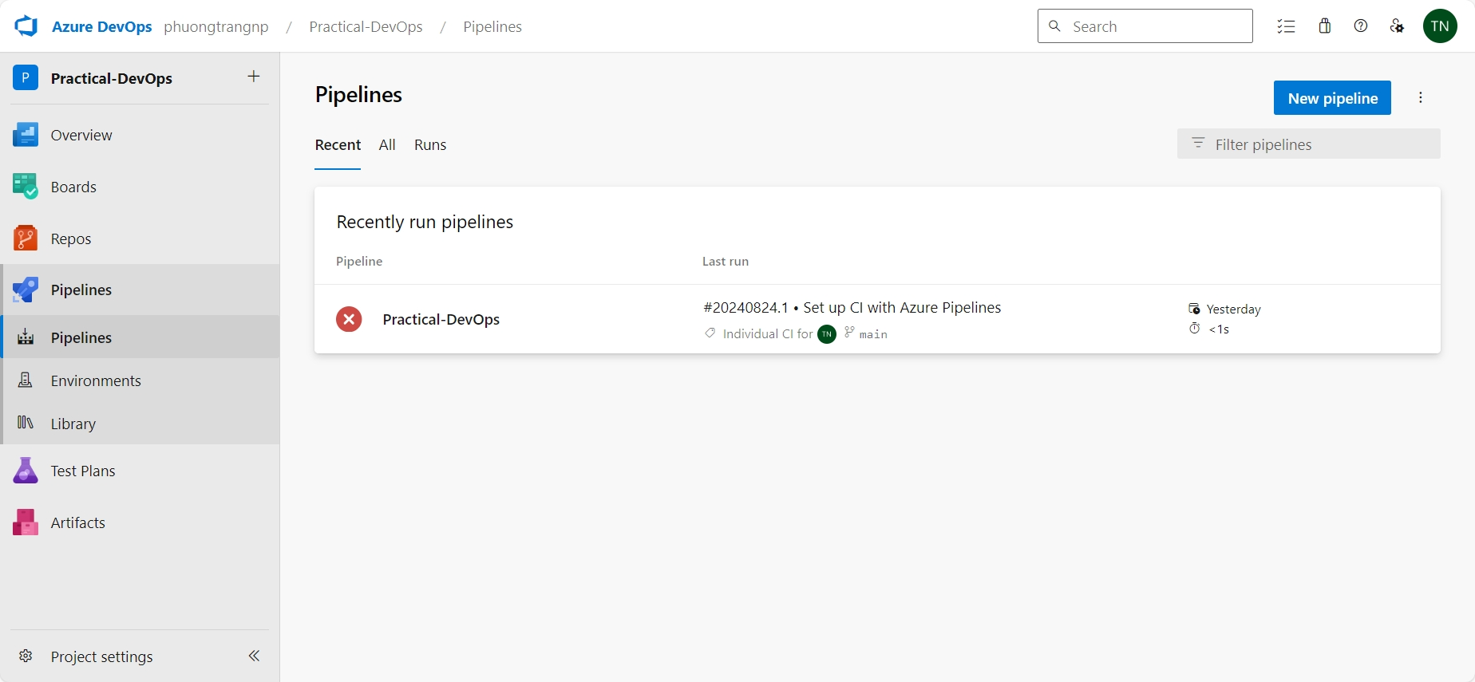

1. **AKS Setup**
2. **Monitoring with Prometheus and Grafana**