Contents

**1.** **Provision AWS resources** 2

1. **Provision AWS resources**

* Execute all commands from “./sd3462_aws_infrastructure/terraform” folder.
* AWS credentials need to be configured using the “aws configure” command. After the configuration is successful, your account will be listed below.

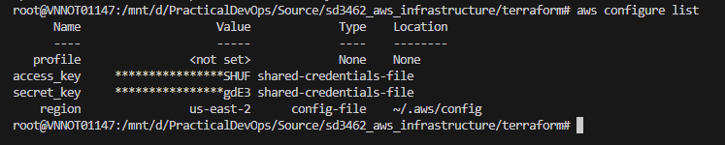

* Create the s3 bucket to store the “tfsate” file by command.

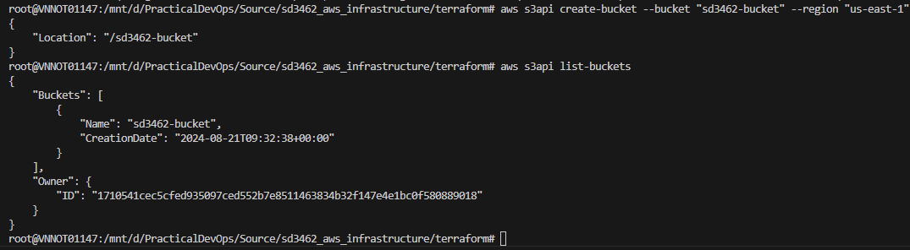

* Initialize the terraform module use “terraform init” and retrieve the “terraform plan”. Using commands below:
  + terraform init -backend-config "key=${tfstate_file_name}" -backend-config "bucket=${tfstate_bucket_name}" -backend-config "region=us-east-2"
  + terraform plan -var-file="dev.tfvars"

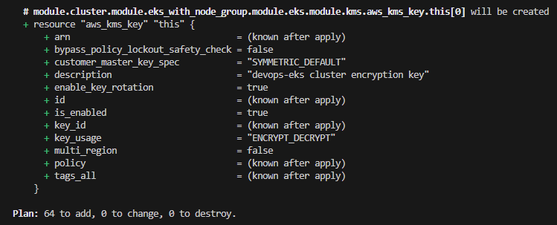

* Apply the terraform (use command: terraform apply -var-file="dev.tfvars") and wait for the resources to be created.

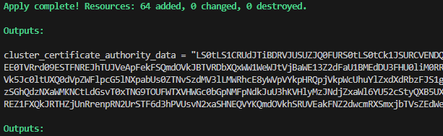

* Check status of cluster and validate “kubectl config” master node.

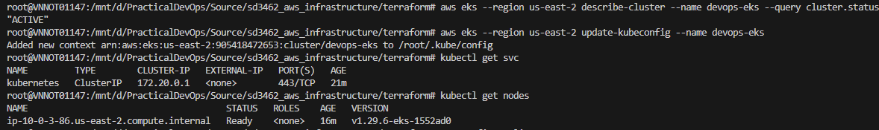

**Verify on AWS**

* S3 bucket

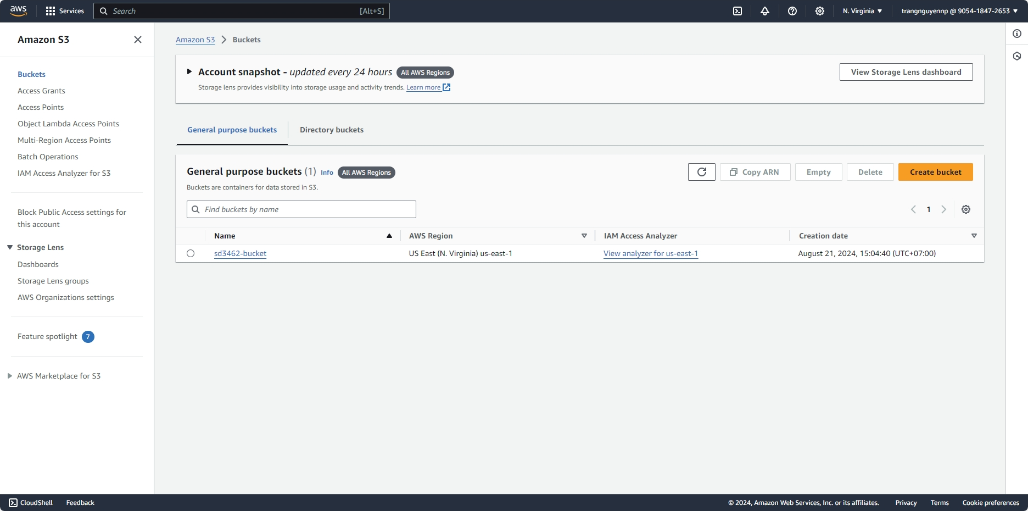

* Virtual private cloud.

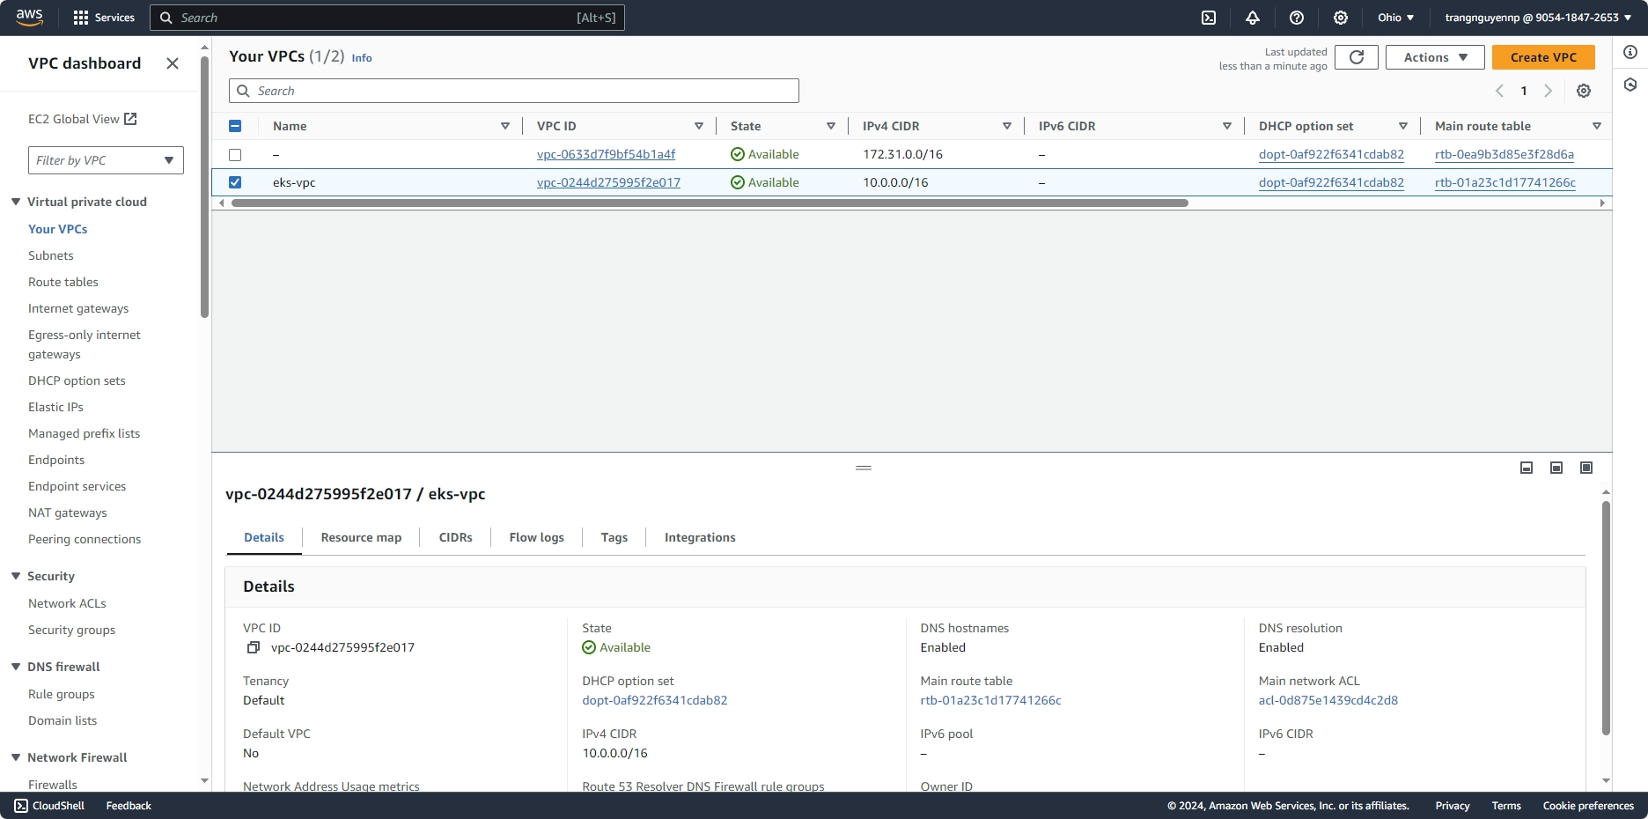

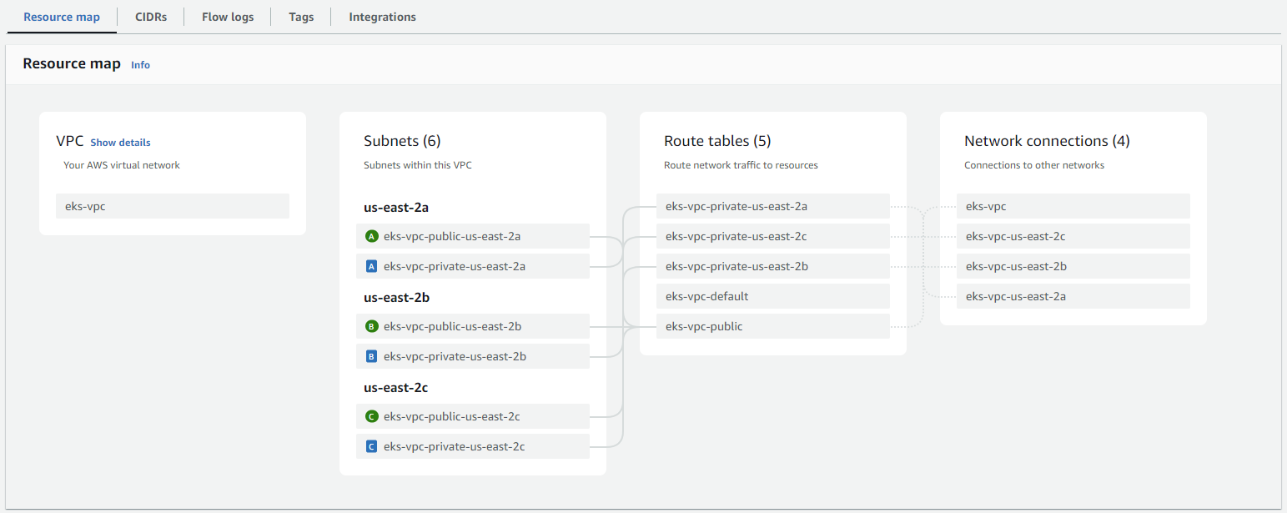

* EKS Cluster with OIDC Provider

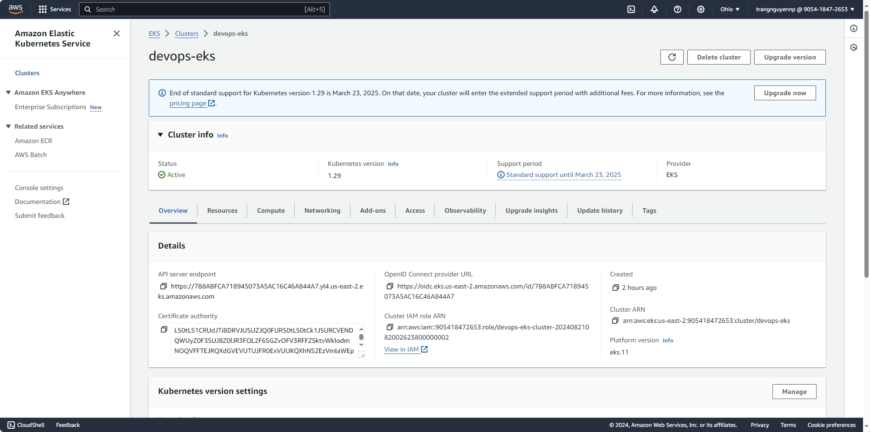

* EKS Managed AddOns

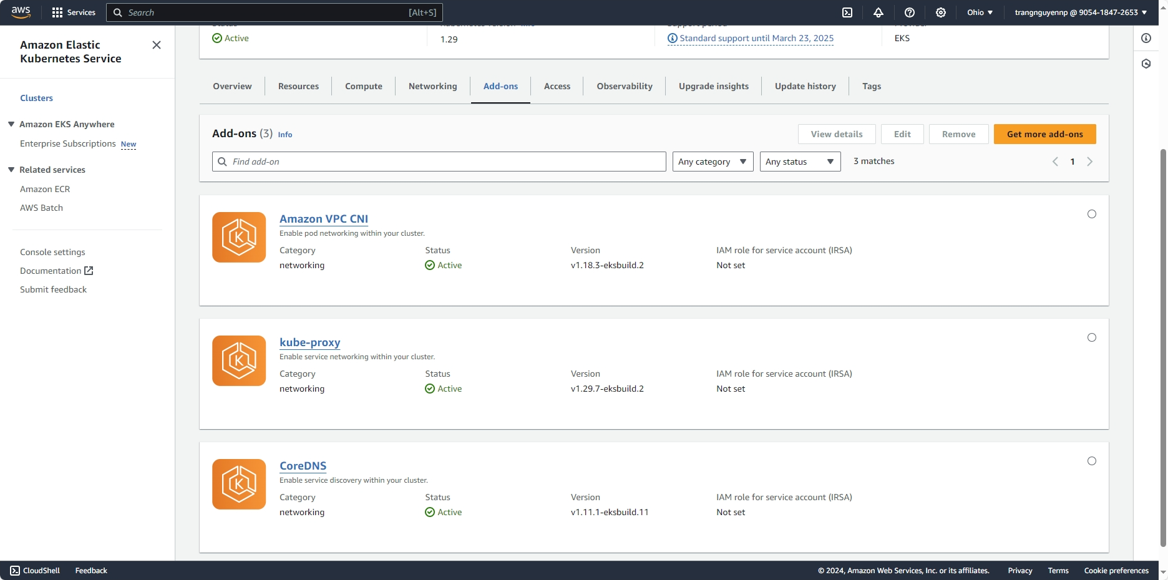

* EKS Managed node group

