1. **New Project**
   1. New Maven Project
   2. Add Pom.xml dependency

<dependency>

<groupId>org.apache.spark</groupId>

<artifactId>spark-core_2.10</artifactId>

<version>1.6.2</version>

</dependency>

1. **Code**
   1. Create spark Config and context

SparkConf conf = **new** SparkConf();

conf.set("spark.executor.cores", "1");

conf.set("spark.cores.max", "2");

JavaSparkContext sc = **new** JavaSparkContext(conf);

1. **Build**
   1. Move to Project’s folder 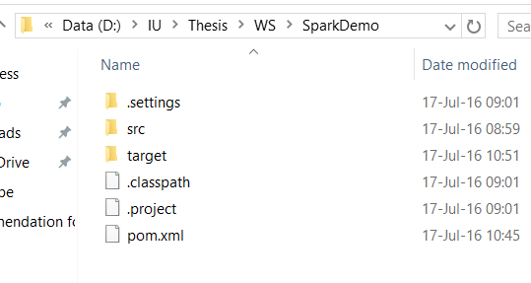
   2. Open cmd, point to project folder

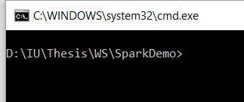

* 1. Type “mvn package” -> Enter 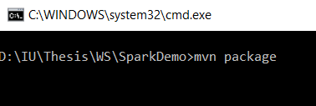
  2. Build Done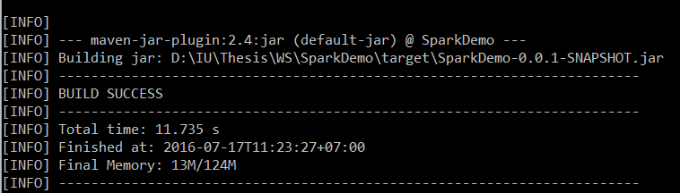

1. **Run**
   1. Copy jar file (the file that was created in build step) 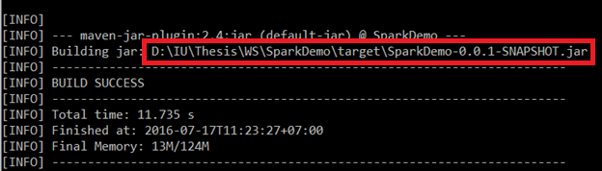
   2. Use Spark-submit command to run

./spark-submit --total-executor-cores 2 /home/hduser/SparkDemo-0.0.1-SNAPSHOT.jar

Cd $SPARK_HOME

Cd bin

Appendix:

Config maven:

1. Extract maven binary

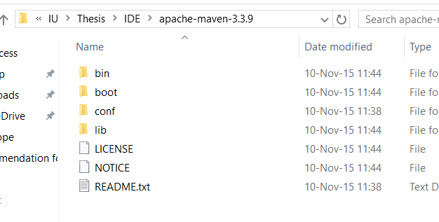

1. Add maven bin folder to PATH variable

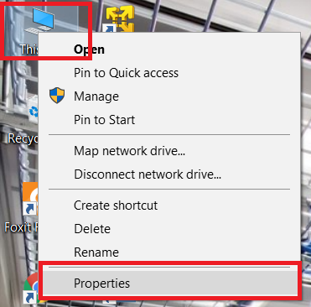

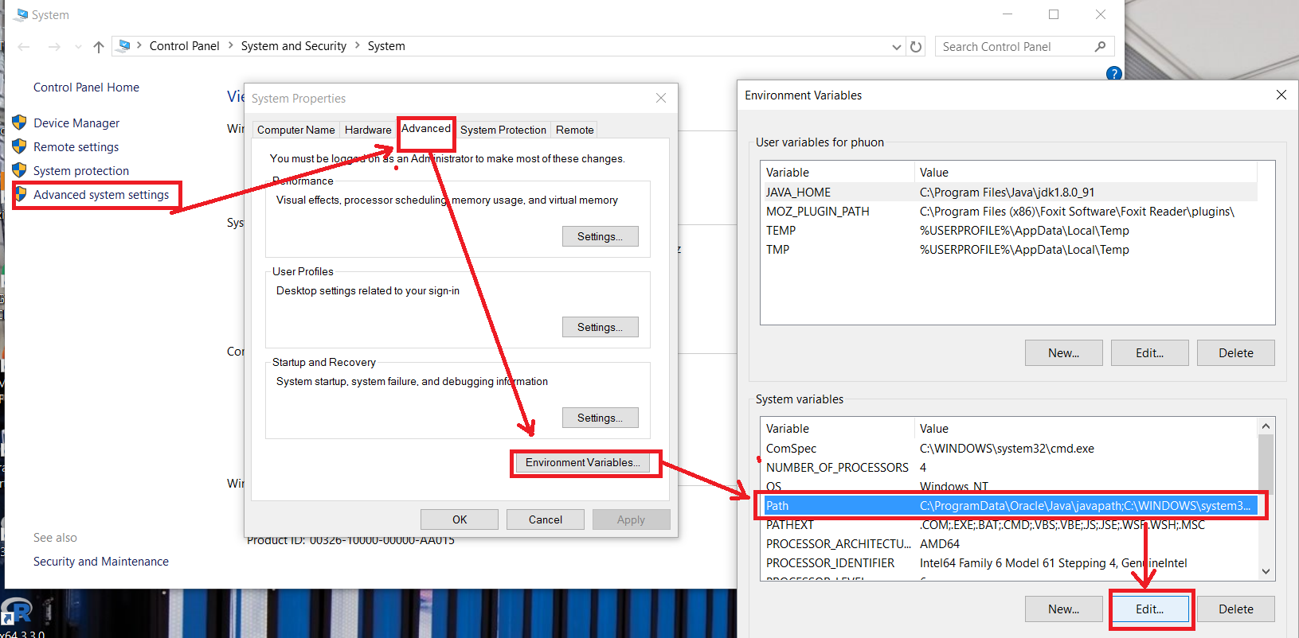

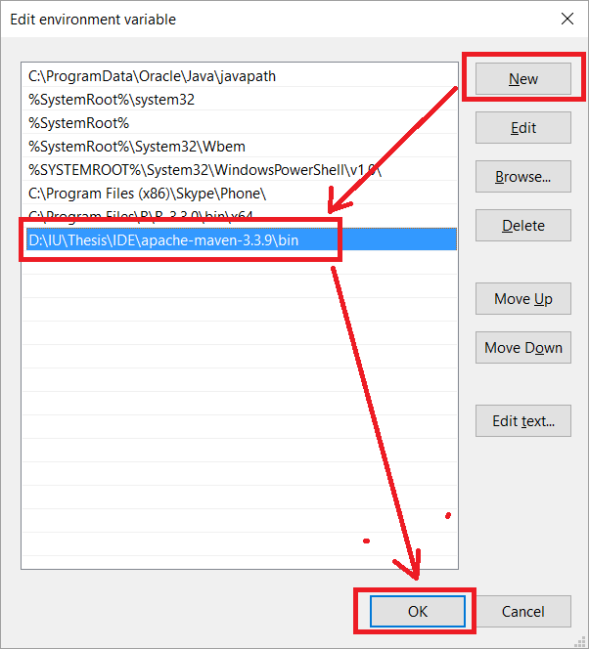

1. Using cmd to test
   1. Open cmd and type “mvn =version”

