SEW 23.9.2025
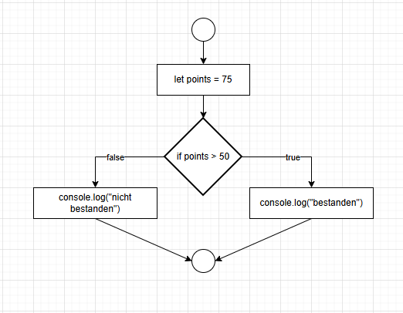
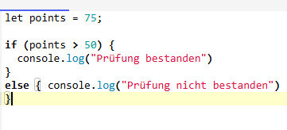
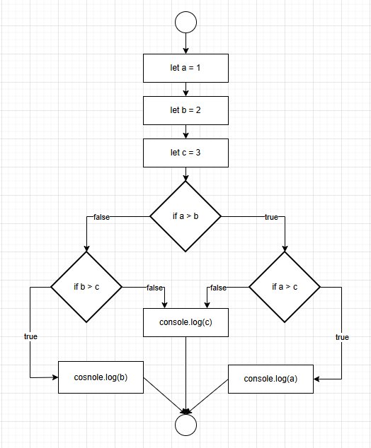
let a = 1
let b = 2
let c = 3

if (a>b) {
if (a>c) {
console.log(a)
} else {
console.log(c)
}
} else {
if (b>c) {
console.log(b)
} else {
console.log(c)
}
}

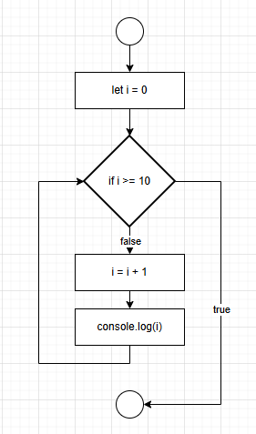
for (let i = 1; i <= 10; i++) {
console.log(i);
}

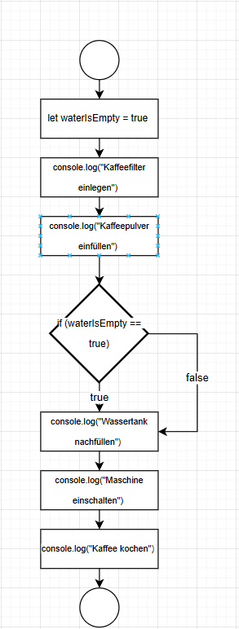
let waterIsEmpty = true
console.log("Kaffeefilter einlegen")
console.log("Kaffeepulver einfüllen")
if (waterIsEmpty == true) {
console.log("Wassertank nachfüllen")
}
console.log("Maschine einschalten")
console.log("Kaffee kochen")

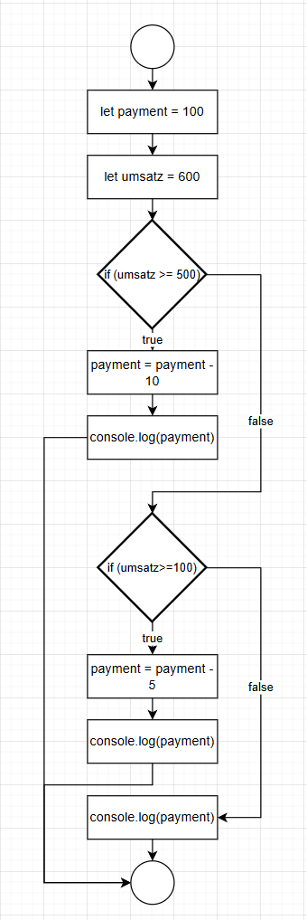
let payment = 100
let umsatz = 600
if (umsatz >= 500) {
payment = payment - 10
console.log(payment)
} else {
if (umsatz >= 100) {
payment = payment - 5
console.log(payment)
} else {
console.log(payment)
}

