Machine Learning Case Study
Comprehensive Study and Viva Guide
Classification | Regression | Clustering | Streamlit Inference Application
Prepared from the source notebooks, preprocessing package, exported artifacts, results, tests, and application code

How to Use This Guide
This document is a case-study preparation guide, not merely a code summary. It explains what the project does, why each decision was made, how to defend the results, what the important files contain, and what an instructor may ask during an evaluation.
- Read Chapters 1–4 before demonstrating the project.
- Read the algorithm chapters to prepare theory and equations.
- Use the results tables to answer model-selection questions with evidence.
- Use the viva questions at the end for rehearsal; answer in the context of this repository, not only from textbook definitions.

Executive Summary
The repository is an end-to-end machine-learning case study containing three analytical tracks. The classification track predicts whether a bank transaction is genuine or fraudulent. The regression track predicts the critical temperature of a superconducting material in Kelvin. The clustering track segments airline customers without using satisfaction during fitting or cluster selection. A Streamlit application provides read-only exploration and inference using already-trained pipelines.
Track | Dataset / target | Learning type | Headline result
Classification | Fraud Detection Bank Dataset; targets (0 = Genuine, 1 = Fraud) | Supervised binary classification | Gradient Boosting: 93.08% accuracy, 0.9760 ROC-AUC
Regression | UCI Superconductivity; critical_temp in K | Supervised regression | Random Forest: R² 0.9208, RMSE 9.6585 K
Clustering | Airplane Customer Satisfaction; no target used for fitting | Unsupervised segmentation | K-Means k=3 selected by elbow plus supporting evidence

1. Repository Architecture and File Map
Location | Purpose
data/raw/ | Original fraud, superconductivity, and airline data files.
data/processed/ | Persisted train/test matrices and clustering data used by analysis and tests.
src/preprocessing/ | Reusable cleaning, feature-selection, feature-engineering, and scaling logic.
src/*/*.ipynb | Exploratory analysis, algorithm benchmarking, evaluation, plots, and written interpretation.
models/classification/ and models/regression/ | Serialized fitted pipelines and metadata.json.
results/ | CSV summaries, text reports, confusion matrices, curves, profiles, and other figures.
scripts/ | Artifact export and regression figure reproduction scripts.
app/core/ | Path resolution, metadata validation, schema construction, artifact loading, inference, and figures.
app/pages/ | Streamlit pages for overview, tracks, comparisons, and visualizations.
tests/ | Schema, artifact, inference, result-loading, and no-training integrity tests.

The central engineering principle is separation of concerns: notebooks train and evaluate; export scripts serialize deployable pipelines; the app only loads and applies them. This prevents accidental retraining and reduces train–serve skew.

2. End-to-End Workflow
- Load the raw data and inspect shape, types, missing values, duplicates, distributions, correlations, and target balance.
- Clean the data using the shared preprocessing functions. Remove identifiers, constants, duplicate columns, duplicate rows, or highly correlated features where appropriate.
- Split into training and hold-out test sets using random_state=42. Classification uses stratification; regression uses a standard random split.
- Fit transformations only on the training data. Classification uses selected log1p transforms and StandardScaler. Regression adds a ratio feature and StandardScaler.
- Fit several algorithms representing linear, probabilistic, distance-based, tree-based, ensemble, kernel, and neural approaches.
- Evaluate on untouched test data using metrics appropriate to the task. Classification records accuracy, precision, recall, weighted F1, ROC-AUC, and confusion matrices. Regression records R², RMSE, MAE, and five-fold CV R².
- Compare models, identify a champion, and export fitted preprocessing-plus-model pipelines with joblib and a metadata file.
- Use the Streamlit app to validate raw inputs, apply the serialized pipeline, compare predictions, and display persisted evaluation artifacts.
raw input -> cleaning -> train/test split -> fitted preprocessing -> model -> test metrics -> serialized pipeline -> Streamlit inference

3. Reproducibility and Data Leakage Controls
Reproducibility is enforced with random_state = 42 throughout the project. The classification split is 80/20 and stratified so the fraud proportion is preserved. The classification dataset contains 16,234 training rows and 4,059 test rows after cleaning. Regression also uses a 20% hold-out test set.
The most important leakage control is fitting transformations on training data only. StandardScaler learns its mean and standard deviation from X_train, then transforms X_test and future inputs using those frozen values. Selecting skewed columns is also performed from the training frame. The persisted pipeline stores these fitted steps, so inference does not recompute statistics from user data.
- Never fit a scaler on the complete dataset before splitting.
- Never select features using the test target or use satisfaction to choose customer clusters.
- Never interpret a test-set score as a guarantee for arbitrary future data.
- The GUI explicitly rejects target columns and validates required feature names, numeric types, missing values, and ordering.

4. Preprocessing Implementation

4.1 Classification preprocessing
The function load_fraud_clean removes the first unnamed row identifier, drops constant columns, detects exact duplicate feature columns by transposing the feature matrix, and removes duplicate rows. The metadata records 15 constant columns, one duplicate column (col_7), and 175 duplicate rows removed. Ninety-six model features remain.
Selected non-negative, non-binary skewed columns receive log1p(x) = log(1+x). This compresses large positive values and reduces right skew without changing zero values into an invalid logarithm. StandardScaler then produces features with approximately zero mean and unit variance on the training set.

4.2 Regression preprocessing
The superconductivity data loses 66 duplicate rows. Features with absolute pairwise correlation above 0.95 are removed to reduce redundancy and instability. Twenty-three highly correlated features are recorded in metadata. A domain-inspired feature thermal_to_mass_ratio is added as a ratio of thermal conductivity to mass-related information with a small epsilon in the denominator to avoid division by zero. The resulting feature space contains 58 features and is standardized.

4.3 Why pipelines matter
classification_preprocessor and regression_preprocessor return scikit-learn Pipeline objects. The model exporter places preprocessing and the estimator in one serialized object. At inference, raw feature values go directly into pipeline.predict. This makes the deployed behavior match the training behavior and is safer than manually repeating transformations in the UI.

5. Classification Track: Fraud Detection
The target column is targets, with 0 representing Genuine and 1 representing Fraud. Fraud detection is not just an accuracy problem: false negatives allow fraud to pass, while false positives create investigation cost. Therefore precision, recall, F1, ROC-AUC, and the confusion matrix must be discussed together.
Model | Accuracy | Precision | Recall | Weighted F1 | ROC-AUC
Gradient Boosting | 0.9308 | 0.8833 | 0.8513 | 0.9304 | 0.9760
SVM (RBF) | 0.9256 | 0.8886 | 0.8225 | 0.9247 | 0.9687
Random Forest | 0.9219 | 0.9103 | 0.7825 | 0.9199 | 0.9675
Bagging (Decision Tree) | 0.9214 | 0.8527 | 0.8504 | 0.9214 | 0.9694
Logistic Regression | 0.9177 | 0.8786 | 0.8002 | 0.9164 | 0.9580
Decision Tree | 0.9165 | 0.8447 | 0.8392 | 0.9164 | 0.9505
KNN | 0.9103 | 0.8511 | 0.8020 | 0.9095 | 0.9508
MLP Neural Network | 0.9093 | 0.8365 | 0.8178 | 0.9090 | 0.9470
AdaBoost | 0.8810 | 0.8603 | 0.6580 | 0.8755 | 0.9188
Gaussian Naive Bayes | 0.5627 | 0.3713 | 0.9368 | 0.5744 | 0.8655

Gradient Boosting is the champion because it provides the best overall hold-out accuracy, weighted F1, and ROC-AUC. Gaussian Naive Bayes has unusually high recall but very poor precision and accuracy: it catches most fraud but flags many genuine transactions. This is a useful example of why one metric is insufficient.

5.1 Classification algorithms to explain
Algorithm | Core idea | Strength | Caution
Logistic Regression | Models log-odds as a linear function of features. | Fast and interpretable; coefficients become odds ratios. | Cannot represent complex nonlinear boundaries without feature engineering.
KNN | Predicts from the majority class among nearest points. | Simple, non-parametric, useful local baseline. | Sensitive to scaling, noisy dimensions, k, and inference cost.
Gaussian NB | Uses Bayes rule with class-conditional Gaussian feature distributions. | Very fast and produces probabilities. | Conditional independence assumption is unrealistic when features correlate.
Decision Tree | Recursively chooses impurity-reducing splits. | Interpretable nonlinear rules. | Deep trees overfit; depth control is essential.
RBF SVM | Maximizes margin using K(x,x') = exp(-gamma ||x-x'||²). | Strong nonlinear classifier in scaled spaces. | Scaling is essential; support-vector inference can be expensive.
Random Forest | Averages many randomized decision trees. | Stable nonlinear model and feature importance. | Less interpretable than one tree; may favor certain feature types.
AdaBoost | Sequentially focuses on previously misclassified examples. | Can turn weak learners into a strong classifier. | Sensitive to noisy or mislabeled observations.
Gradient Boosting | Builds additive trees that correct previous residual errors. | Excellent tabular-data performance. | Sequential training and tuning are more expensive.
Bagging | Fits independent bootstrapped base estimators and averages them. | Reduces variance. | Does not reduce bias as directly as boosting.
MLP | Learns layered nonlinear transformations with backpropagation. | Flexible function approximator. | Needs scaling, tuning, sufficient data, and careful regularization.

5.2 Metrics and confusion matrix
For fraud as the positive class: TP means fraud correctly detected, TN means genuine correctly accepted, FP means genuine incorrectly flagged, and FN means fraud missed.
accuracy = (TP + TN) / (TP + TN + FP + FN)
precision = TP / (TP + FP) recall = TP / (TP + FN)
F1 = 2 * precision * recall / (precision + recall)
ROC-AUC summarizes ranking quality across classification thresholds. It is threshold-independent, but it does not directly state the operational cost of a false positive or false negative. In a real fraud system, the decision threshold should be selected using business costs, not automatically fixed at 0.5.

5.3 Logistic-regression interpretation
The classifier models log(P(fraud)/(1-P(fraud))) = beta_0 + beta_1 x_1 + ... + beta_p x_p. Since inputs are standardized, exp(beta_i) is the multiplicative change in fraud odds for a one-standard-deviation increase in feature i, holding other features fixed. This is association, not proof of causation.
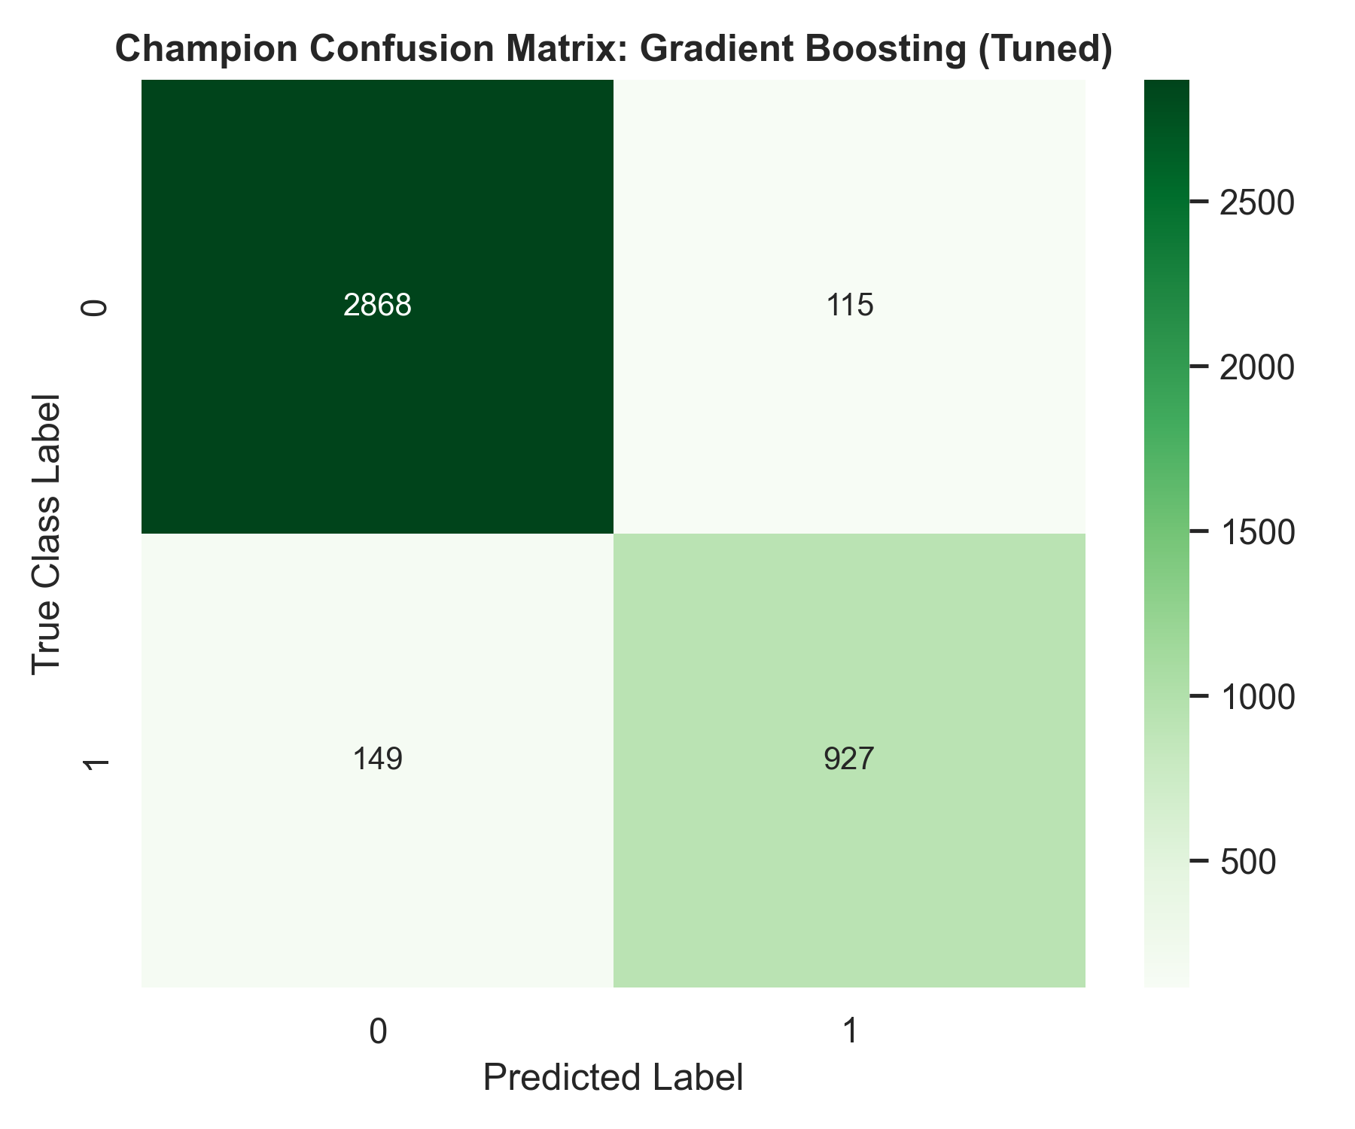
Persisted confusion matrix for the selected classification model.

6. Regression Track: Superconductivity
The regression target is critical_temp, measured in Kelvin. The task estimates a continuous physical quantity, so a prediction error is naturally expressed in Kelvin. The exported pipelines clip predictions below zero because negative absolute temperature is physically invalid in this modeling context.
Model | Test R² | RMSE (K) | MAE (K) | 5-fold CV R²
Random Forest | 0.9208 | 9.6585 | 5.6209 | 0.9166
Gradient Boosting | 0.9193 | 9.7493 | 5.7310 | 0.9133
KNN | 0.9074 | 10.4421 | 5.6114 | 0.8986
Decision Tree | 0.8783 | 11.9706 | 6.3475 | 0.8663
SVR | 0.8495 | 13.3105 | 7.6703 | 0.8437
Polynomial Regression (degree 2) | 0.8411 | 13.6758 | 9.0168 | 0.8096
ElasticNet | 0.7154 | 18.3039 | 13.5486 | 0.7085
Ridge | 0.7154 | 18.3038 | 13.5485 | 0.7085
Linear Regression | 0.7153 | 18.3067 | 13.5481 | 0.7085
Lasso | 0.7153 | 18.3080 | 13.5539 | 0.7083

Random Forest is the preferred regression model by test R², RMSE, and cross-validated R². Gradient Boosting is a close second. The close agreement between test R² and five-fold CV R² is reassuring: the result is not obviously dependent on one lucky split.

6.1 Regression metrics
R² = 1 - sum((y_i - yhat_i)^2) / sum((y_i - y_bar)^2)
RMSE = sqrt(mean((y_i - yhat_i)^2))
MAE = mean(abs(y_i - yhat_i))
R² measures variance explained relative to predicting the mean. RMSE penalizes large errors more strongly than MAE. MAE is easier to interpret as a typical absolute Kelvin error. A model can have a slightly lower MAE but a higher RMSE if it usually performs well yet makes a few large mistakes.

6.2 Regression diagnostics
- Actual-versus-predicted plot: points near the diagonal indicate accurate predictions; systematic curvature or spread indicates bias or heteroscedasticity.
- Residual plot: residuals should be centered around zero without a visible pattern. A funnel shape suggests non-constant variance.
- Feature-importance plot: tree importance is predictive importance, not causality. Correlated features can share or distort importance.
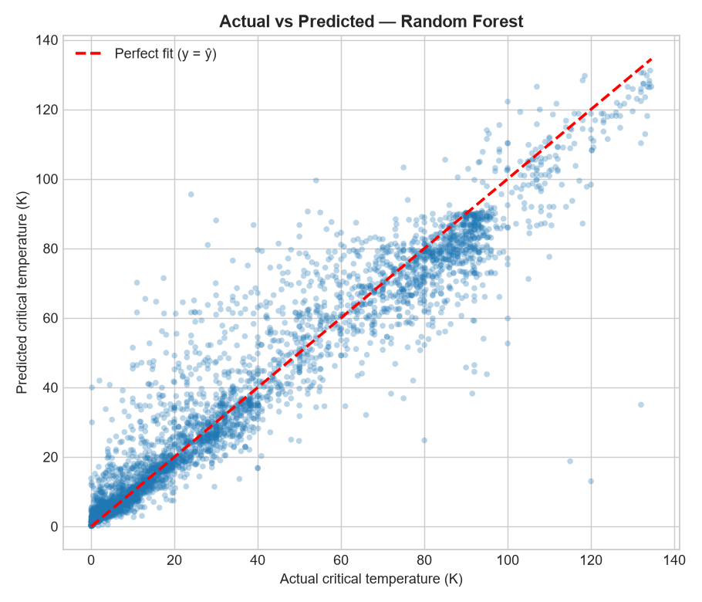
Persisted actual-versus-predicted diagnostic.

7. Clustering Track: Airline Customer Segmentation
Clustering is unsupervised: there is no target used to fit the customer groups. The official K-Means model is fitted on all 103,904 rows with 23 post-encoding features. Candidate values k=2 through k=10 are compared. Internal metrics are evaluated on the same fixed 10,000-row sample for comparability, while inertia is computed on the full-data model.
Evidence | Observed result | Interpretation
Elbow | Largest marginal inertia improvement at k=3 | Supports a simple three-segment solution.
Silhouette | Best at k=2 (0.1232); k=3 = 0.1108 | Separation is weak and k=2 is slightly better.
Davies-Bouldin | Best at k=7 (2.1377); k=3 = 2.7456 | Metrics disagree; k=3 is not the DB optimum.
Calinski-Harabasz | Best at k=2 (1426.4); k=3 = 1088.5 | Again favors k=2 but does not invalidate k=3.
Cluster balance for k=3 | 30.17%, 42.01%, 27.82% | No tiny or degenerate cluster.

The documented selection of k=3 is a judgment based on elbow evidence, near-optimal separation, balanced sizes, simplicity, and interpretability. The report explicitly acknowledges that the indices disagree and that the segments overlap. This is stronger scientific communication than silently reporting only the metric that favors the chosen k.
Satisfaction is used only post hoc. Cluster 1 has a 74.36% satisfaction rate, compared with 25.40% for cluster 0 and 15.93% for cluster 2. The association is strong (Cramer's V = 0.5379), but satisfaction did not influence fitting, k selection, or internal metrics. Therefore the correct wording is 'clusters are associated with satisfaction,' not 'the clustering predicts satisfaction.'

7.1 Clustering theory
inertia = sum over clusters and points of ||x_i - centroid_cluster(i)||^2
K-Means alternates between assigning each point to its nearest centroid and recomputing centroids until convergence. Standardization matters because a high-scale feature can otherwise dominate Euclidean distance. PCA and t-SNE projections are visualization tools, not proof that the original high-dimensional clusters are well separated.

7.2 Agglomerative clustering
The repository also contains agglomerative clustering comparisons across linkage choices and diagnostic plots. Agglomerative clustering begins with one cluster per observation and repeatedly merges clusters according to a linkage criterion. Single linkage can create chaining; complete linkage emphasizes the farthest pair; average linkage averages pair distances; Ward linkage minimizes the increase in within-cluster variance and is usually paired with Euclidean distance.
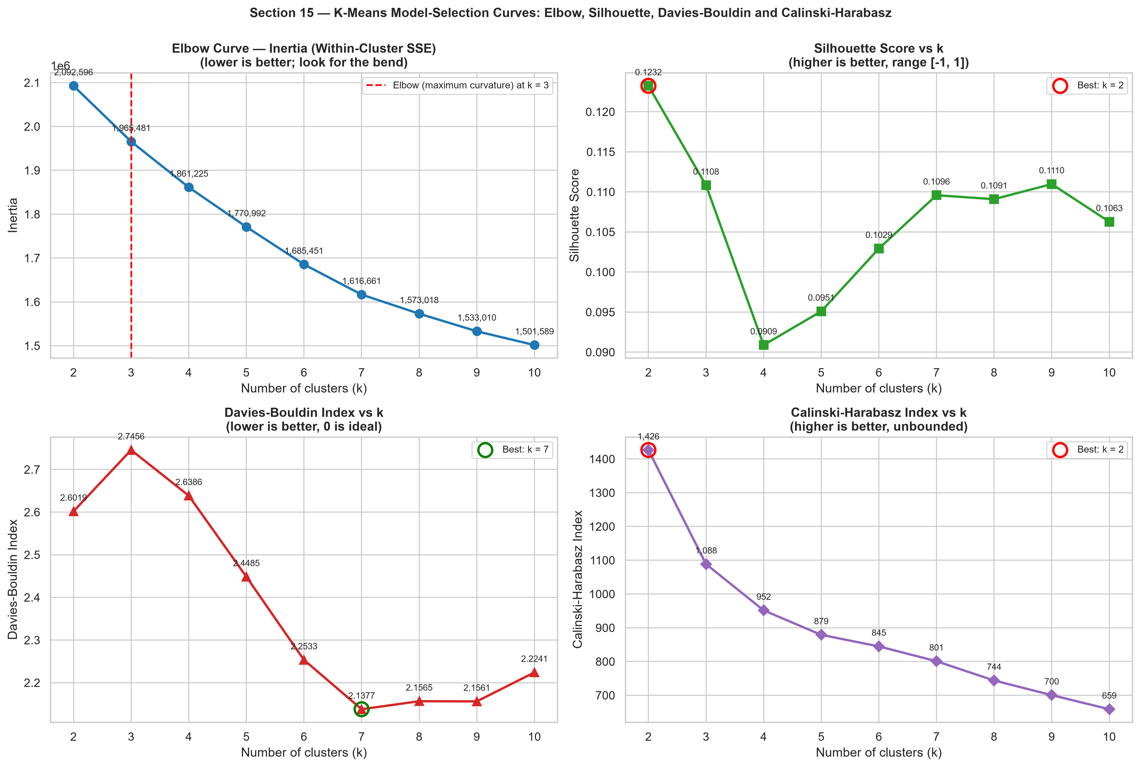
K-Means selection curves for candidate cluster counts.

8. Streamlit Application and Deployment Design
Run the application from the repository root with `streamlit run app/main.py`. The entry point adds the app and repository directories to sys.path, loads the shared UI helpers, and exposes pages for overview, classification, regression, clustering, model comparison, and visualizations.

8.1 Application data flow
- paths.py resolves paths relative to the repository rather than depending on the current working directory.
- metadata.py loads and validates metadata.json, ensuring the track, target, feature names, and model entries exist.
- schemas.py builds feature specifications and derives median defaults from raw data for convenient example inputs.
- loaders.py reads metadata, CSV results, text reports, and joblib pipelines; Streamlit caching avoids repeated disk work.
- inference.py sends the same raw frame through every selected persisted model and returns predictions or explicit per-model errors.
- ui.py validates manual and uploaded CSV inputs, rejects targets, reorders columns, caps uploaded batches at 5,000 rows, and displays comparisons.
The app distinguishes native class probabilities from decision scores. For SVM, decision_function output is a margin and is never mislabeled as probability. Regression outputs are labeled in Kelvin. The metrics shown in the app are persisted hold-out metrics, not metrics recomputed from the user's input.

8.2 Why the app must not train
Training inside a web request would be slow, nondeterministic, difficult to audit, and potentially leak user data into the model. The test suite explicitly scans the app for fit(), fit_transform(), GridSearchCV, notebook execution, subprocess calls, and similar training behavior.

9. Testing and Quality Assurance
Test area | What it protects
Schema structure | Target, feature names, counts, defaults, and metadata agreement.
Validation | Missing columns, target leakage, extra columns, non-numeric values, and blanks.
Inference | Every listed model runs, predictions have correct shape, probabilities are valid, and regression values are finite/non-negative.
Artifact integrity | Every metadata artifact exists, loads with joblib, predicts, and reproduces stored metrics.
Result loading | Saved images are non-trivial and CSV/text outputs are readable.
No-training guard | Importing app modules does not fit estimators or execute notebooks.

The strongest test is metrics_match_reported_values: it reconstructs the raw split and verifies that each serialized pipeline reproduces the metric stored in metadata to within 1e-6. That catches mismatched feature order, missing preprocessing, accidental refitting, and stale metadata.
pytest -q

10. Limitations and Responsible Interpretation
- The fraud data uses anonymized-looking feature names, so domain explanations of individual columns are limited.
- A random split may not represent temporal drift. A production fraud system should use time-aware validation and monitor drift.
- Accuracy and ROC-AUC do not encode the asymmetric financial cost of fraud errors.
- Clustering separation indices are modest and the PCA plot shows overlap; segments should be treated as useful summaries, not natural immutable categories.
- Post-hoc satisfaction association is not causal evidence and does not mean cluster assignment causes satisfaction.
- Tree feature importance is not causality and can be unstable with correlated inputs.
- The models are benchmark artifacts, not automatically production-ready systems. Calibration, threshold selection, fairness analysis, monitoring, retraining policy, and security controls would be required.
- Joblib artifacts should only be loaded from trusted sources because serialized Python objects can execute code during deserialization.

11. Practical Demonstration Script
- Start by showing the repository map and identifying raw data, notebooks, models, results, app, and tests.
- Open the classification results and explain why Gradient Boosting is selected without claiming it is universally best.
- Demonstrate that the classification app accepts raw feature values and runs every saved model.
- Explain why SVM shows a decision score rather than a probability.
- Demonstrate CSV validation by removing a required column or adding the target column.
- Show the regression comparison and explain R², RMSE, MAE, and the Kelvin unit.
- Show the clustering report and explicitly discuss the disagreement among silhouette, Davies-Bouldin, Calinski-Harabasz, and elbow evidence.
- Run the test suite and point out the test that verifies stored metrics against regenerated predictions.

12. Instructor / Viva Questions with Model Answers
Q: Why did you use train/test split?
A: To estimate generalization on data not used to fit model parameters. The test set is held out until final evaluation.
Q: Why stratify classification?
A: Fraud is the minority/positive class. Stratification preserves approximately the same class proportions in train and test.
Q: Why scale features?
A: Distance-based, margin-based, and gradient-based models are sensitive to feature magnitude. Scaling puts features on a comparable numerical scale.
Q: Why use log1p?
A: For non-negative skewed variables, log1p compresses extreme values while safely handling zeros because log1p(0)=0.
Q: What is data leakage here?
A: Using information from the test set or future records when fitting preprocessing, selecting features, tuning, or choosing clusters. The pipeline design avoids this for supervised tracks.
Q: Why is Gaussian NB recall high but precision low?
A: Its assumptions lead it to classify many observations as fraud. It catches most positives but generates many false alarms.
Q: Why is ROC-AUC useful?
A: It measures how well the model ranks positives above negatives across thresholds, useful before choosing an operating threshold.
Q: Why is Gradient Boosting the classification champion?
A: It has the strongest combination of accuracy, weighted F1, and ROC-AUC in the persisted hold-out benchmark.
Q: Why is Random Forest the regression champion?
A: It has the highest test R², lowest RMSE among the listed models, and strong five-fold CV R².
Q: What does R² = 0.9208 mean?
A: Relative to predicting the mean target, the model explains about 92.08% of target variance on this test split; it does not mean every prediction is 92% correct.
Q: RMSE versus MAE?
A: RMSE penalizes large errors more strongly; MAE is the average absolute error and is easier to communicate as a typical error.
Q: Why add thermal_to_mass_ratio?
A: It encodes a potentially meaningful relationship between physical quantities and gives the model a derived interaction-like signal.
Q: Why remove highly correlated regression features?
A: To reduce redundancy, multicollinearity, noise, and computational burden; the 0.95 threshold is a modeling choice, not a universal law.
Q: Why choose k=3 when silhouette favors k=2?
A: Selection balances elbow evidence, near-optimal internal metrics, balanced cluster sizes, simplicity, and interpretability. The disagreement is documented.
Q: Did satisfaction influence clustering?
A: No. It was excluded from fitting and selection and only analyzed afterward as an external association.
Q: What does Cramer's V = 0.5379 indicate?
A: A substantial association between cluster label and satisfaction category, not causation and not a model accuracy.
Q: Why does the app not retrain?
A: It is an inference and exploration layer. Retraining in the UI would harm reproducibility, latency, auditability, and leakage control.
Q: How does the app prevent wrong feature order?
A: The schema validates names and feature_matrix reorders the frame to metadata order before inference.
Q: Why are SVM margins not called probabilities?
A: decision_function returns signed distance/margin-like scores, not calibrated values in [0,1].
Q: How would you improve the project for production?
A: Use time-based validation for fraud, cost-sensitive thresholding, calibration, drift monitoring, model registry/versioning, secure artifact loading, fairness checks, and automated deployment tests.
Q: What is the most important test?
A: The metric reproduction test, because it proves the serialized pipeline and metadata correspond to the intended preprocessing and evaluation split.

13. Final Revision Checklist
- Can I draw the raw-data-to-inference pipeline without looking at the code?
- Can I explain why preprocessing is fitted only on training data?
- Can I define TP, TN, FP, FN and connect them to fraud risk?
- Can I justify Gradient Boosting and Random Forest using the actual tables?
- Can I explain R², RMSE, MAE, silhouette, Davies-Bouldin, and Calinski-Harabasz?
- Can I defend k=3 while admitting that internal metrics disagree?
- Can I explain why satisfaction is post hoc and not a clustering input?
- Can I demonstrate that the app loads artifacts and never trains?
- Can I describe at least three limitations and three production improvements?

Appendix A: Important Commands
cd D:\Studies\projects\Machine-Learning-CaseStudy
pip install -r requirements.txt
streamlit run app\main.py
pytest -q
python scripts\export_regression_figures.py

Appendix B: Key Technical Vocabulary
Term | Meaning in this project
Estimator | A scikit-learn object that learns a predictive relationship from data.
Pipeline | Ordered preprocessing and model steps applied consistently at fit and predict time.
Hold-out test set | Data reserved for final evaluation and not used to fit parameters.
Cross-validation | Repeated train/validation partitions used to estimate stability.
Hyperparameter | A configuration chosen before or outside model fitting, such as tree depth or k.
Calibration | Agreement between predicted probabilities and observed event frequencies.
Data drift | Change in input distributions over time.
Concept drift | Change in the relationship between inputs and target over time.
Post-hoc analysis | Analysis performed after the primary model has been fitted or selected.
Feature importance | A model-specific measure of predictive contribution, not causal effect.

Evaluation Metrics and Viva Masterclass
This chapter consolidates the machine-learning topics most likely to be tested in a case-study evaluation. For every metric or method, be prepared to state its definition, formula or intuition, whether higher or lower is better, what failure mode it reveals, and how it is used in this repository.

A. Classification Evaluation

A.1 Confusion matrix and threshold metrics
For this project, Fraud is the positive class (1) and Genuine is the negative class (0). A confusion matrix contains true positives (TP: fraud detected), true negatives (TN: genuine accepted), false positives (FP: genuine flagged), and false negatives (FN: fraud missed). Every threshold-based classification metric is derived from these four counts.
Metric | Formula | Best direction | Viva interpretation
Accuracy | (TP + TN) / total | Higher | Overall fraction correct; can mislead with class imbalance.
Precision / PPV | TP / (TP + FP) | Higher | When the system flags fraud, how often is it actually fraud?
Recall / Sensitivity / TPR | TP / (TP + FN) | Higher | What proportion of all fraud is detected?
Specificity / TNR | TN / (TN + FP) | Higher | What proportion of genuine transactions is accepted?
FPR | FP / (FP + TN) = 1 - specificity | Lower | Rate of genuine transactions incorrectly flagged.
FNR | FN / (FN + TP) = 1 - recall | Lower | Rate of fraud missed by the detector.
F1 score | 2PR / (P + R) | Higher | Harmonic mean; high only when precision and recall are both high.
Balanced accuracy | (TPR + TNR) / 2 | Higher | Useful when class frequencies are unequal.

The harmonic mean makes F1 punish an extreme imbalance between precision and recall. In this project Gaussian Naive Bayes has high recall (0.9368) but low precision (0.3713), demonstrating that catching almost every fraud case can produce too many false alarms.

A.2 ROC curve and ROC-AUC
The Receiver Operating Characteristic (ROC) curve plots True Positive Rate (recall) on the vertical axis against False Positive Rate on the horizontal axis as the classification threshold changes. Each threshold produces one confusion matrix. A perfect classifier reaches the top-left corner; random ranking follows the diagonal.
TPR(threshold) = TP / (TP + FN)
FPR(threshold) = FP / (FP + TN)
ROC-AUC is the area under this curve. It is the probability that a randomly selected positive receives a higher score than a randomly selected negative. AUC = 0.5 is random ranking; AUC = 1.0 is perfect ranking. The project's Gradient Boosting model has ROC-AUC 0.9760, the highest consolidated result.
- ROC-AUC is threshold-independent, while precision, recall, and accuracy depend on a threshold.
- ROC-AUC can look optimistic when negatives greatly outnumber positives; inspect a Precision-Recall curve as well.
- The SVM's decision_function is a ranking margin, not a calibrated probability. The application correctly labels it as a decision score.

A.3 Precision-Recall curve, average precision, and calibration
A Precision-Recall curve plots precision against recall for changing thresholds. It is especially informative when the positive class is rare because it focuses on the quality of positive predictions. Average Precision summarizes the precision-recall curve. A probability is calibrated when predictions near 0.8 correspond to roughly 80% observed positives; a high ROC-AUC does not guarantee calibration.
If fraud has a much higher business cost than manual review, the operating threshold should be chosen using expected cost, capacity, and acceptable false negative rate rather than automatically using 0.5.
expected_cost = cost_FP * FP + cost_FN * FN + cost_review * reviews

A.4 Cross-validation, stratification, and GridSearchCV
K-fold cross-validation partitions the training data into K folds. Each fold is used once as validation data while the other K-1 folds are used for training. The scores are averaged and their standard deviation indicates variability. The test set must remain untouched until the final evaluation.
5-fold CV: train on folds 2-5, validate on 1; repeat with validation folds 2, 3, 4, and 5
This project uses five-fold stratified cross-validation for the classification champion and five-fold CV R² for regression comparisons. StratifiedKFold preserves class proportions in each classification fold. For clustering, ordinary supervised cross-validation is not directly applicable because there is no target; internal cluster validation is used instead.
GridSearchCV is an exhaustive, systematic search over a user-specified grid of hyperparameter values. For each combination, it performs the chosen cross-validation procedure, selects the combination with the best scoring metric, refits the winning estimator on all available training data, and then the untouched test set is used once for final reporting.
GridSearchCV(estimator, param_grid, cv=StratifiedKFold(5), scoring='roc_auc', refit=True)
Term | Meaning | Example in this case study
Parameter | Value learned from data during fit. | Logistic coefficients or tree split thresholds.
Hyperparameter | Chosen before fitting; controls model behavior. | k in KNN, max_depth, C, n_estimators, learning_rate.
Grid | Candidate values searched. | KNN k in [3, 5, 7, 9, 11].
Scoring | Objective used to rank candidates. | ROC-AUC for classification; R² or negative RMSE for regression.
Nested CV | Outer CV estimates performance; inner CV tunes hyperparameters. | Preferred when an unbiased tuned-model estimate is required.

A common viva trap is to call the test set a validation set. The validation folds inside CV are for selection and tuning; the test set is for final unbiased assessment. Repeatedly checking the test score and changing the model also causes indirect test leakage.

A.5 Hyperparameter tuning and fine tuning
Fine tuning means systematically improving a model by selecting hyperparameters and sometimes changing the feature representation, threshold, class weights, or regularization. It is not the same as changing learned coefficients by hand.
Model | Important hyperparameters | Effect to explain
Logistic Regression | C, penalty, solver, class_weight, max_iter | C is inverse regularization strength; lower C means stronger regularization.
KNN | n_neighbors, metric, p, weights | Small k is flexible/noisy; large k is smoother/high-bias.
Decision Tree | max_depth, min_samples_leaf, criterion | Depth and leaf size control variance and overfitting.
SVM | C, kernel, gamma | C penalizes errors; gamma controls RBF locality; scaling is essential.
Random Forest | n_estimators, max_depth, max_features, min_samples_leaf | More trees reduce variance; depth and feature subsampling affect complexity.
Boosting | n_estimators, learning_rate, max_depth, subsample | Small learning rate usually needs more estimators; depth controls weak-learner complexity.
MLP | hidden_layer_sizes, alpha, learning_rate_init, max_iter | Controls capacity, regularization, optimization, and convergence.

A good tuning answer includes a search space, a selection metric, a validation scheme, a leakage-control statement, and a final hold-out comparison. Never select hyperparameters because they produce the best test score after repeated experimentation.

B. Regression Evaluation

B.1 Core metrics
Metric | Formula / meaning | Best direction | Important caveat
R² | 1 - SSE/SST | Higher | Can be negative; does not equal percentage prediction accuracy.
Adjusted R² | Penalizes unnecessary predictors | Higher | Useful for linear models; not a universal tree-model score.
MAE | Mean absolute error | Lower | Robust and directly interpretable in Kelvin here.
MSE | Mean squared error | Lower | Units are squared; strongly penalizes outliers.
RMSE | sqrt(MSE) | Lower | Same units as target; emphasizes large errors.
MAPE | Mean absolute percentage error | Lower | Unstable or undefined when actual values are zero/near zero.
CV R² | Mean R² across validation folds | Higher | Also report standard deviation to communicate stability.

For this project, RMSE is measured in Kelvin and is 9.6585 K for Random Forest. MAE is 5.6209 K, meaning the average absolute error is about 5.62 K on the reported test set. RMSE is larger than MAE because larger errors receive extra weight.

B.2 Residual analysis and assumptions
A residual is e_i = y_i - yhat_i. A strong regression evaluation does not stop at R². Plot residuals against predictions and important features. Good residuals are approximately centered around zero, show no systematic curve, have roughly constant spread, and are not dominated by a few outliers.
Pattern | Likely meaning | Possible response
Curved residual pattern | Nonlinearity not captured | Add nonlinear features, trees, splines, or transformations.
Funnel-shaped spread | Heteroscedasticity | Transform target/features, use weighted/robust methods, or model variance.
Large isolated residuals | Outliers, data errors, or rare regime | Investigate; do not delete automatically.
Residuals mostly positive/negative | Systematic bias | Revisit features, intercept, target transformation, or model class.
Train score much better than test | Overfitting/high variance | Regularize, simplify, add data, or tune with CV.

The physical non-negative clipping in the exported regression pipelines is a domain constraint. It prevents impossible negative Kelvin predictions, but it does not replace validation of model quality or guarantee physical accuracy.

B.3 Bias, variance, regularization, and model selection
High bias means the model is too simple and underfits; high variance means it fits training noise and generalizes poorly. The bias-variance trade-off explains why a deeper tree can lower training error while increasing test error. Ridge adds an L2 penalty, Lasso adds an L1 penalty that can set coefficients to zero, and ElasticNet combines both.
Ridge objective = SSE + alpha * sum(beta_i^2)
Lasso objective = SSE + alpha * sum(abs(beta_i))
Feature scaling is particularly important before regularized linear models because the penalty acts on coefficient magnitude. Without scaling, a feature's units can determine how strongly it is penalized.

C. Clustering Evaluation

C.1 Inertia and the elbow method
K-Means inertia is the within-cluster sum of squared distances from each point to its assigned centroid. It always decreases or stays constant as k increases, so the minimum inertia alone would select an unnecessarily large k. The elbow method looks for a point where additional clusters produce diminishing returns. This repository identifies k=3 from the largest marginal inertia improvement.
inertia(k) = sum_i ||x_i - centroid_of_assigned_cluster||^2
Inertia is scale-dependent and cannot be compared meaningfully across differently scaled datasets. It is an optimization objective, not a direct measure of business usefulness or external validity.

C.2 Silhouette score
For point i, a(i) is its average distance to points in its own cluster and b(i) is the smallest average distance to another cluster. The silhouette is:
s(i) = (b(i) - a(i)) / max(a(i), b(i))
The score ranges from -1 to 1. Values near 1 indicate a point is much closer to its own cluster, values near 0 indicate overlapping or boundary points, and negative values suggest possible misassignment. The project reports k=3 silhouette 0.1108, so separation is modest rather than sharply distinct.

C.3 Davies-Bouldin index
The Davies-Bouldin (DB) index compares within-cluster scatter to between-cluster separation. For each cluster, it finds the most similar other cluster and then averages these worst-case ratios. Lower is better: compact clusters far apart produce a smaller DB index. The project's best candidate by DB is k=7, not k=3, which is why metric disagreement must be reported.

C.4 Calinski-Harabasz index
The Calinski-Harabasz (CH) index is the ratio of between-cluster dispersion to within-cluster dispersion, adjusted by the number of clusters and observations. Higher is better. It often favors compact, well-separated solutions and, in this sweep, favors k=2. It should not be interpreted as an absolute supervised accuracy score.

C.5 Cluster validation and post-hoc analysis
Internal validation uses only the features and cluster assignments: inertia, silhouette, DB, CH, cluster sizes, and stability. External or post-hoc analysis uses a variable not used to fit or choose the clusters, such as satisfaction, to interpret whether the segments are useful.
Post-hoc means after the primary clustering decision. In this case satisfaction is compared across the final clusters only after k=3 is selected. The chi-square test asks whether cluster membership and satisfaction category are independent; Cramer's V measures association strength. A tiny p-value does not prove a large or causal effect, which is why both p-value and effect size are reported.
Cramer's V = sqrt(chi2 / (n * min(number_of_rows-1, number_of_columns-1)))
- Correct claim: satisfaction is strongly associated with the discovered segments.
- Incorrect claim: the clusters cause satisfaction or constitute a satisfaction predictor.
- Leakage warning: including satisfaction before clustering would turn the analysis into target-informed segmentation.

C.6 PCA, t-SNE, scaling, and linkage follow-ups
Topic | Evaluation answer
Feature scaling | Required for distance-based K-Means and agglomerative clustering so large-unit variables do not dominate.
PCA | Linear dimensionality reduction used for visualization or denoising; components maximize variance, not cluster separation necessarily.
t-SNE | Nonlinear visualization that preserves local neighborhoods; sensitive to settings and not a proof of global cluster structure.
Agglomerative clustering | Bottom-up merging method; linkage choices define how cluster distance is measured.
Ward linkage | Merges to minimize the increase in within-cluster squared error; usually paired with Euclidean distance.
Cluster stability | Repeat with different samples/seeds and compare assignments, for example with adjusted Rand index.
Degenerate clusters | Very tiny clusters may indicate outliers, an unsuitable k, or an unstable solution.

D. High-Frequency Cross-Track Viva Questions
Q: Why is the test set not used in GridSearchCV?
A: Repeated selection on the test set makes it part of model development and causes optimistic generalization estimates.
Q: What is the difference between an estimator and a hyperparameter?
A: An estimator learns parameters such as coefficients or tree splits; hyperparameters such as C, k, depth, or number of trees are selected outside that fitting process.
Q: Why is a pipeline safer than separate preprocessing code?
A: It stores the fitted transformation and estimator together, preserves feature order, and applies exactly the same steps to new data.
Q: Why can models disagree on the best metric?
A: Metrics reward different behavior: recall prioritizes missed positives, precision penalizes false alarms, RMSE emphasizes large regression errors, and clustering indices use different geometric criteria.
Q: What does a low silhouette mean here?
A: Customer segments overlap substantially in the chosen feature space; the clusters can still be useful summaries, but they are not sharply separated natural groups.
Q: Why report both a mean CV score and its standard deviation?
A: The mean estimates expected performance across folds; the standard deviation indicates sensitivity to the particular split.
Q: What is overfitting in hyperparameter tuning?
A: Choosing a complex configuration that performs well on validation observations but captures noise and fails on unseen data.
Q: How would you handle class imbalance?
A: Use stratification, inspect class-specific metrics, consider class weights or resampling within each training fold, tune the threshold, and report PR-AUC.
Q: Why is accuracy insufficient for fraud?
A: It can hide poor fraud recall when genuine transactions dominate. The cost of FN and FP is asymmetric.
Q: Why can a model have high R² and still be operationally poor?
A: Errors may be unacceptable for a particular range, the model may be biased, or the test distribution may not represent deployment.
Q: Why can inertia not determine the final k by itself?
A: It monotonically decreases with k, so it rewards adding clusters and needs an elbow or other validation evidence.
Q: What is post-hoc analysis?
A: An interpretation or association analysis performed after model fitting/selection that must not retroactively influence the selection claim.

E. Evaluation Answer Framework
When asked to defend a result, use this five-part structure: (1) define the method or metric, (2) explain why it matches the task, (3) quote the project's actual result, (4) acknowledge a limitation or competing metric, and (5) state what you would do next in production.
- Define: for example, ROC-AUC is the area under the TPR-versus-FPR curve.
- Apply: it is useful for ranking fraud risk across thresholds.
- Evidence: Gradient Boosting achieved ROC-AUC 0.9760 in this case study.
- Caveat: ROC-AUC does not choose the operational threshold or reflect review cost.
- Next step: inspect PR-AUC, calibrate probabilities, and select a threshold using fraud costs.

