*Use case diagram*

**Name – Ma Phyo Zin Mar**

**Case Study1**:

**Task1**

*Requirement Definition (RD)*

* *Admin/Sta*ff registers
* *Sale record*
* *Customer Id*
* *Type of shoe*
* *Daily order*
* *Price*
* *Stock*

**Task2**

*Data Requirements*

* Login(Admin & Staff)
* Product detail
* Customer detail
* Order
* Record
* Receipt

**Task3**

*Functional Requirements*

The system must provide following functionalities.

* Keeping record of admission of customers
* Keeping the record of product and daily sell
* Storing the feedback given by the customer
* Keeping details about the product it is delivered or not
* System can add, update and delete stock
* System can view all the service records
* System can update password**(admin & staff**)

**Task4**

*Non –Functional Requirements*

* The system can save stock into the database.
* The system can support all the PC
* The system can create the backup database file after every transaction
* Stock should be added after end of sales per day
* The system can use easily
* Data integrity
* Only admin can change secure access of confidential data
* User name and password are encrypted

**Task5**

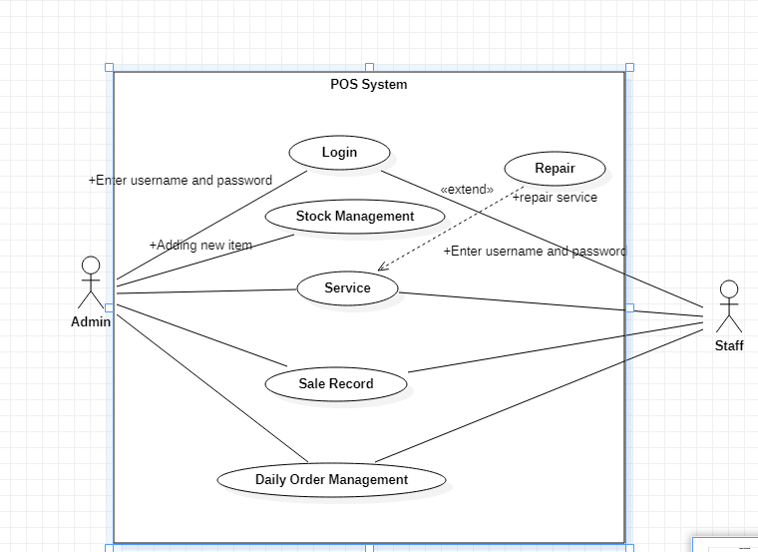

**Case2**

**Task1**

*Requirement Definition*

* Facebook account
* Record
* Sender address
* Receiver address
* Delivery fee
* Payment
* Profit
* Staff salary

**Task2**

*Data Requirement*

* Username and password
* Date
* Address
* User detail
* Payment method(cash or bank)

**Task3**

*Functional Requirement*

* System can restrict location
* Customer can select fee to order
* Review the order before submitting
* Payment (There are many type of secure billing such as credit card, prepaid as after delivery as account(eg. Kpay Account)
* The system can collect customer’s order
* Calculating delivery fee ,daily profit and additional profit
* The system can pay staff’s salary
* The system can update and delete staff’s detail.
* The system can update password (Admin)
* Calculating bus cost

**Task4**

*Non-Functional requirement*

* The system can save order into the database
* The system can support all the Pc
* The system can create a backup database file after every transaction
* Password and bank account are encrypted in the database
* Only admin can change password ,staff details and customer details
* Data integrity
* Security and safety

**Task5**

*Use case diagram*

