**University Of Computer Studies**

**(Hinthada)**

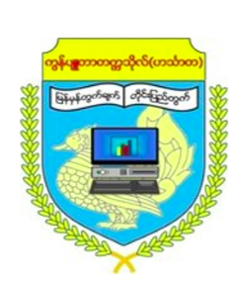

**Department of English**

**English Presentation**

***Submitted by***

1. ***1 CST - 6 Ma Khaing May Soe***
2. ***1 CST - 8 Ma Swe Zin Win***
3. ***1 CST - 10 Ma Yoon Thiri Kyaw***
4. ***1 CST - 21 Ma Myat Ei Hlaing***
5. ***1 CST - 24 Ma Yoon Wati Myo***
6. ***1 CST - 44 Ma Thin Thin Han***