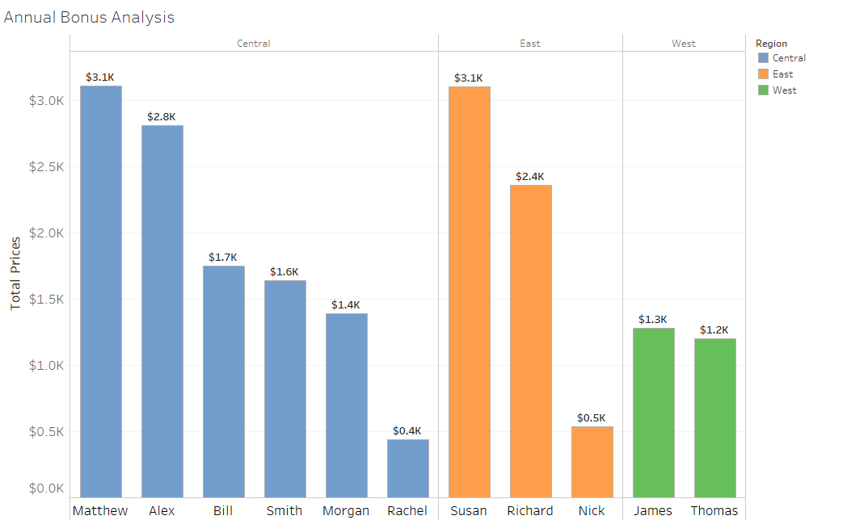

**Copy Data:**

Region Rep Total Prices

Central Alex 2,812.19

Central Bill 1,749.87

Central Matthew 3,109.44

Central Morgan 1,387.77

Central Rachel 438.37

Central Smith 1,641.43

East Nick 536.75

East Richard 2,363.04

East Susan 3,102.3

West James 1,283.61

West Thomas 1,203.11