Vivek Patel
In class 09 Form part 1
Mobile App Development
https://github.com/Phyvlik/in_class_09_signup_app_part1
Critical Thinking Questions
Question 1: Why StatefulWidget instead of StatelessWidget?

SignupPage uses StatefulWidget because it manages data that changes over time. The avatar selection, text field values, and form validation results all update while the user interacts with the screen. StatefulWidget provides a setState() method that tells Flutter to rebuild the UI when that data changes. StatelessWidget has no setState() and cannot rebuild itself, so it is only suitable for content that never changes. For example, when the user taps a different avatar emoji, setState() updates the selected avatar and redraws the picker with the new selection highlighted. If SignupPage were a StatelessWidget, tapping a different avatar would do nothing visually because there would be no mechanism to trigger a rebuild.

Question 2: The role of GlobalKey<FormState>()

A GlobalKey gives a widget a unique identity that persists across the entire widget tree and across rebuilds. The _formKey acts like a remote control for the Form widget. Even though the Sign Up button sits outside the Form in the widget tree, it can reach into the Form and call .validate() on it using the key. Without a global key, there would be no way to trigger validation from a button that is separate from the Form. The problem it solves is cross-widget communication. Instead of passing callbacks up and down the tree manually, the GlobalKey gives any part of the code direct access to the FormState, which coordinates validation across every TextFormField inside it with a single call.

Question 3: The Flutter Widget Tree and the Family Metaphor

Every Flutter UI is a tree of widgets where each widget has a single responsibility. Using the family metaphor, MyApp is the Great-Grandparent, acting as the entry point that never changes and whose only job is to hand control to MaterialApp. MaterialApp is the Grandparent that sets the global design language including colors, typography, and navigation rules, which every widget below it inherits. Scaffold is the Parent that provides the physical structure of a page including the AppBar and the scrollable body area, without knowing or caring what lives inside it. Form is the Child that holds all the input fields and handles validation logic, without knowing anything about layout or navigation. The TextFormField widgets are the Grandchildren, each with one job: collect one piece of user input and validate it. This reflects encapsulation because each widget hides its internal behavior from the others, and it reflects separation of concerns because layout, theming, navigation, and validation are each handled by a different widget independently, making each one easier to test and maintain.

Question 4: Email Validation Weaknesses and Improved Code

The current check using value.contains('@') is weak because it accepts strings like "@" with nothing before or after it, "a@" with no domain, "a@b" with no top-level domain, and even "@@@@" which contains the symbol but is not a valid email. A more robust approach uses a regular expression that enforces the full structure of a real email address. The improved validator would check that there is a local part before the @, a valid domain after it, and a top-level domain of at least two characters. The improved code would be written as follows: first check if the value is null or empty and return an error if so, then define a RegExp using the pattern r'^[a-zA-Z0-9._%+-]+@[a-zA-Z0-9.-]+.[a-zA-Z]{2,}$', and if the value does not match that pattern return 'Please enter a valid email address', otherwise return null to indicate the field passed validation.

Question 5: Limitations of SnackBar and Alternatives

A SnackBar auto-dismisses after a few seconds, so a distracted user may miss it entirely. It does not block interaction, meaning the user can immediately re-tap Sign Up before reading the message. It also provides no persistent confirmation that signup was successful and offers no way to display next steps or additional information. A better alternative for account creation is navigating to a new screen, which is what this app does. This gives the user a dedicated and persistent success state they must actively leave, clearly signaling that something important happened. An Alert Dialog is another option that blocks all interaction until dismissed, making it impossible to miss. An inline success banner that stays visible inside the form without auto-dismissing is also more reliable than a SnackBar for important feedback.

Question 6: TextEditingController Disposal

TextEditingController allocates memory and attaches listeners that track every keystroke in a text field. When a StatefulWidget is removed from the tree, Flutter calls dispose() on its State object. If the controllers are not manually disposed inside that method, they remain in memory with their listeners still active even though the widget no longer exists. This causes a memory leak. Each time the user navigates away from the screen without disposal, a new set of controllers accumulates in memory while the old ones are never released. In a large or long-running app this degrades performance over time and can eventually cause crashes. Calling .dispose() on each controller inside the widget's dispose() method releases those resources immediately when the widget leaves the tree.

Question 7: Flutter Navigation Stack

Flutter's Navigator works like a stack of cards where screens are pushed on top and popped off to go back. Before tapping Sign Up, the stack contains only SignupPage at the top. After Navigator.push() runs with a MaterialPageRoute to WelcomeScreen, WelcomeScreen is placed on top of the stack and becomes the visible screen, while SignupPage is preserved directly underneath it. When the user taps the back arrow in the AppBar, Navigator.pop() removes WelcomeScreen from the top of the stack and SignupPage becomes visible again exactly as the user left it. MaterialPageRoute provides the slide-in transition animation automatically. The entire stack is managed by the Navigator widget that is built into MaterialApp, so no additional setup is required to get basic push and pop navigation working.

Question 8: Password Security Beyond obscureText

On the client side, a production app should enforce a strong password policy using a validator that requires a minimum length, at least one uppercase letter, one number, and one special character. A show and hide toggle should be added so users can verify what they typed before submitting. The password field should also be cleared from memory immediately after the form is submitted and the app should prevent the operating system from caching or suggesting the password through autofill in sensitive contexts. On the server side, passwords must never be stored in plain text and should be hashed using a slow algorithm like bcrypt or Argon2 before being saved to a database. All network requests must use HTTPS and TLS so the password is encrypted in transit and cannot be intercepted. Rate limiting and account lockout should be implemented after a set number of failed login attempts to prevent brute force attacks. Multi-factor authentication adds another verification layer, and short-lived session tokens using JWT or OAuth should be issued after login rather than re-sending credentials with each request.

Question 9: Flutter Form vs. Other Frameworks

Compared to React with hooks, Flutter's form handling has several notable differences. In React, each input is typically a controlled component where useState tracks the value and an onChange handler updates it on every keystroke, which requires more wiring per field. Flutter's validator callback keeps the validation logic co-located with the field itself, making it easier to read and maintain. The Form widget's ability to coordinate all fields with a single .validate() call through the GlobalKey is also more convenient than validating each field separately in React. Flutter requires no external libraries for basic form handling, whereas React developers often reach for libraries like Formik or React Hook Form for the same level of built-in validation support. On the downside, Flutter requires more boilerplate than React hooks for simple forms, and TextEditingController must be manually created and disposed, which React handles automatically through its virtual DOM. Asynchronous validation such as checking whether an email is already registered also requires extra work in Flutter, while libraries like React Hook Form support it more natively.

Question 10: Code Quality Improvements

The first improvement would be to extract widgets into separate files. WelcomeScreen, the avatar picker, and the individual form fields are complex enough to warrant their own files under a lib/widgets folder. Keeping everything in main.dart makes the file grow unmanageably as the app scales and makes it harder for multiple developers to work on the codebase simultaneously. The second improvement would be to replace the inline validator lambdas with named functions in a dedicated validators.dart file. Functions like validateEmail, validatePassword, and validateName would be reusable across any form in the app, independently unit-testable, and far easier to update in one place when requirements change. Mixing business logic directly into widget build methods violates separation of concerns. The third improvement would be to use const constructors wherever possible. Many widgets in the current code such as SizedBox, Text labels, and InputDecoration could be declared const, which tells Flutter to cache those widgets and skip rebuilding them on every setState call. This improves rendering performance and signals to other developers that those values will never change at runtime, making the code easier to reason about.

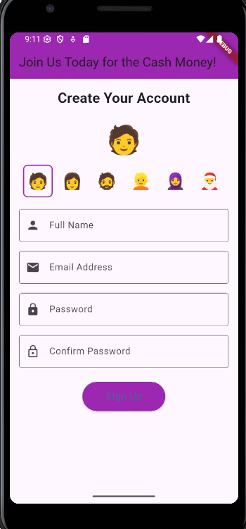
‘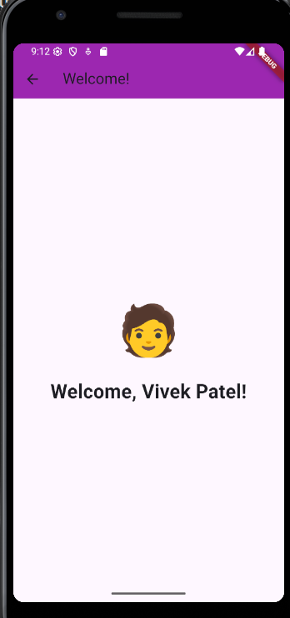

Validation – invalid password
