BMP280 and the Pi

Tom Aarts
taarts1@gmail.com
Pi4j ID taartspi
July 11, 2023

Opening
This document explains connecting an Adafruit BMP280 to a Raspberry Pi
Use a BMP280 data-sheet as reference. Example https://www.digikey.com/htmldatasheets/production/2394371/0/0/1/BMP280-Datasheet.pdf

Table of Contents
Opening 2
Adafruit BMP280 3
Simple Direct Connections 4
I2C Header Pin/Colors – Pi 40 pin connector 5
SPI Header Pin/Colors – Pi 40 pin connector 5
Direct Pi Connection 6
Power on Pi to Validate Device Visible 7
Pi command i2cdetect -y 1 7
Prototype Board 8
Socket 9
Completed Board 9
Wiring to Pi GPIO 40 Pin Connector 10
3.3v from GPIO to a common point on the board. 10
Ground GPIO to common point on the board 11
I2C from GPIO to the board 12
Wiring within the board 13
Result 16

Adafruit BMP280
After soldering the pins to the PCB you could use female-female jumpers to connect directly to the Pi GPIO pins. I choose to make a simple socket-ed PCB. I can later use this board to attach other chips, up to a 28 pin ICs

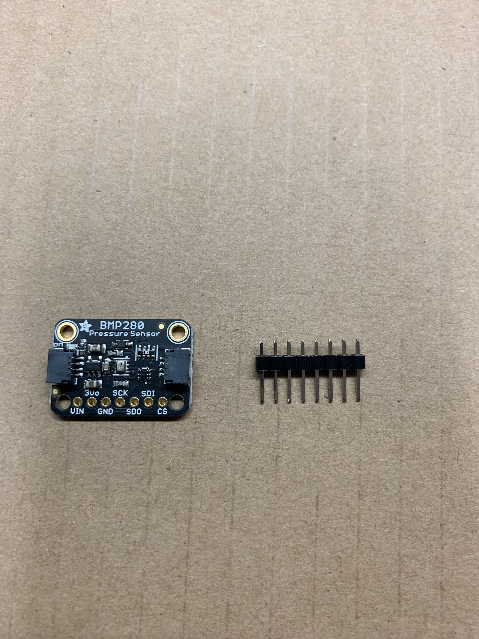

Simple Direct Connections
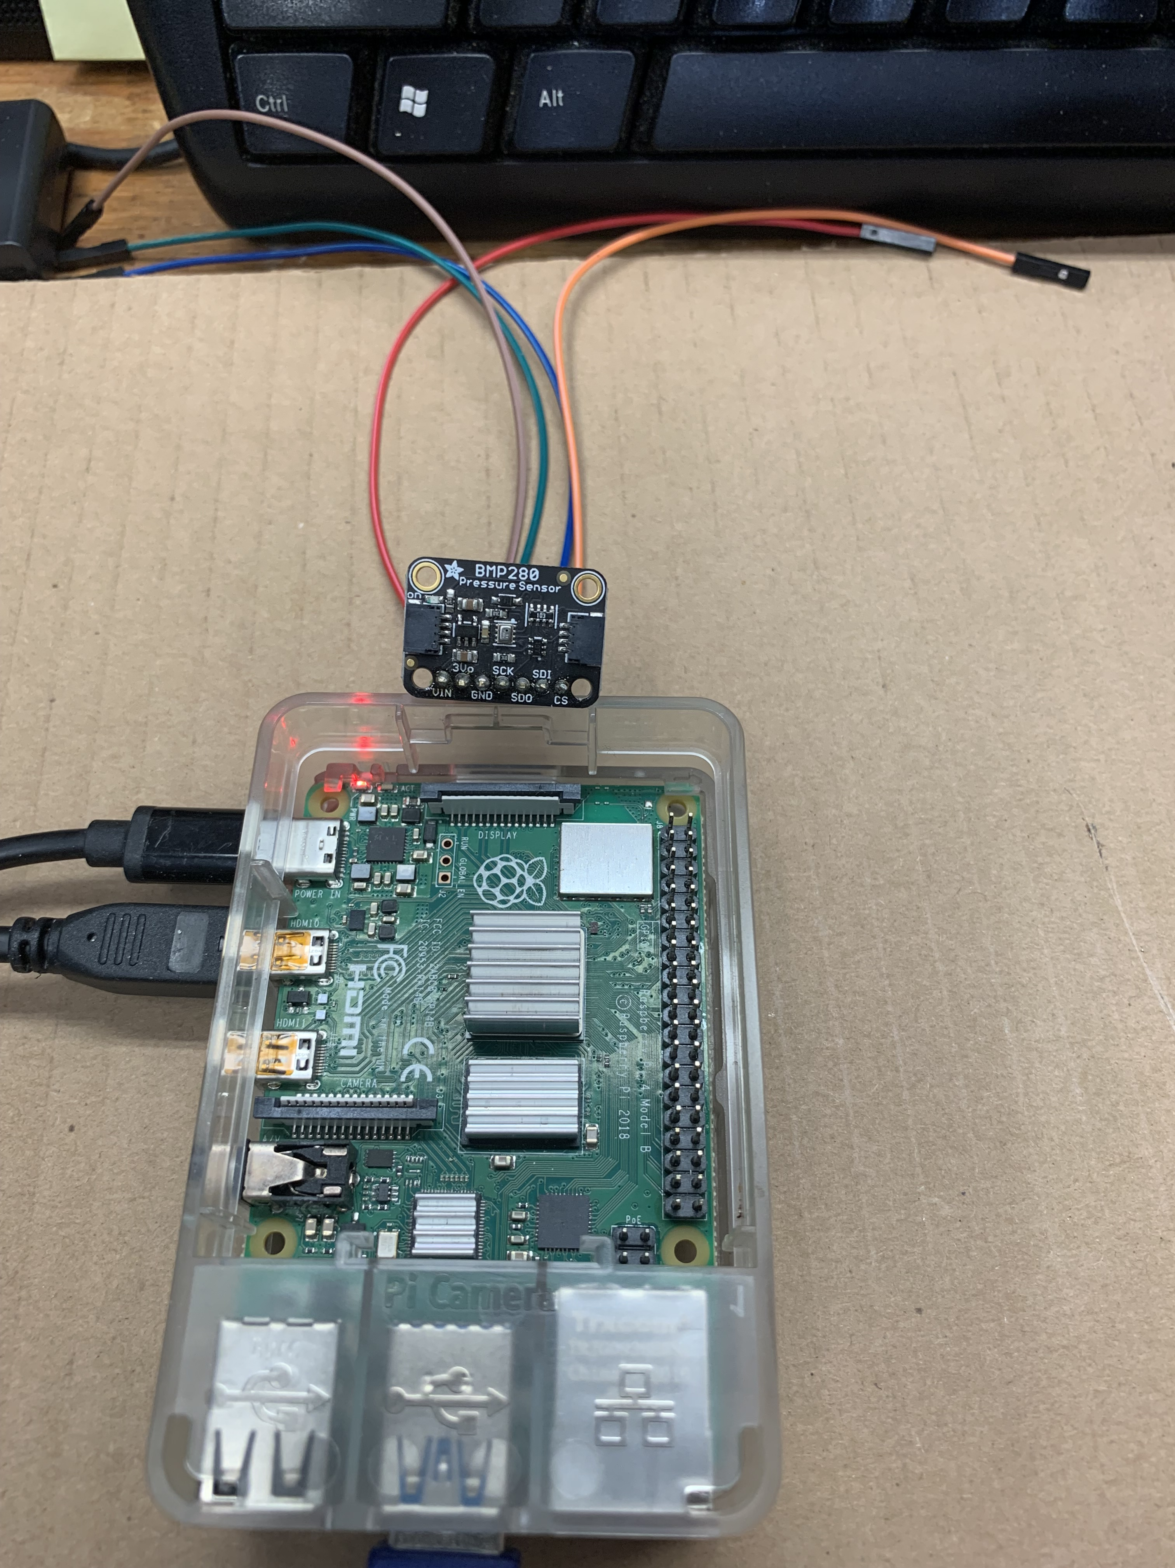
You can directly connect this BMP280 to the Pi 40 pin connector. This provides a fast means to validate hardware and use of the Pi4j code and supporting Java device code.

Solder the header to the circuit board and connect wires as follows.

I2C Header Pin/Colors – Pi 40 pin connector

Pi pin1 3.3v to Red Vin
N/C 3v
Pi pin6 Gnd to Brown Gnd
Pi pin5 SCL to Green SCK
N/C yellow SDO
Pi pin3 SDA to Blue SDI
Pi pin17 3.3v to Orange CS

SPI Header Pin/Colors – Pi 40 pin connector

Pi p19 MOSI BMP SDI Blue
Pi p21 MISO BMP SDO Yellow
Pi p23 SCLK BMP SCK Green
Pi p40 GPIO21 BMP CS Orange
Pi Gnd BMP GND Brown
Pi 3.3 BMP Vin Red

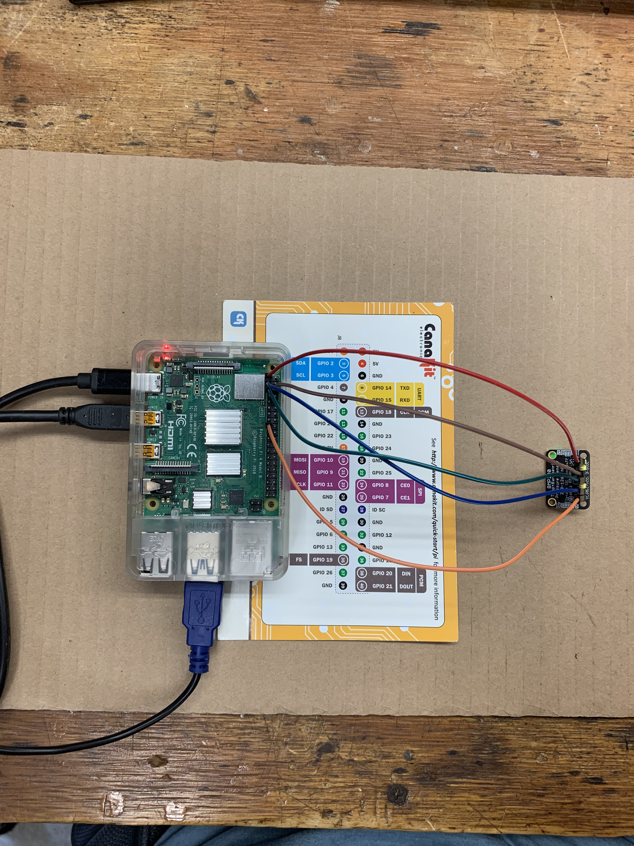
Direct Pi Connection

Power on Pi to Validate Device Visible

Pi command i2cdetect -y 1
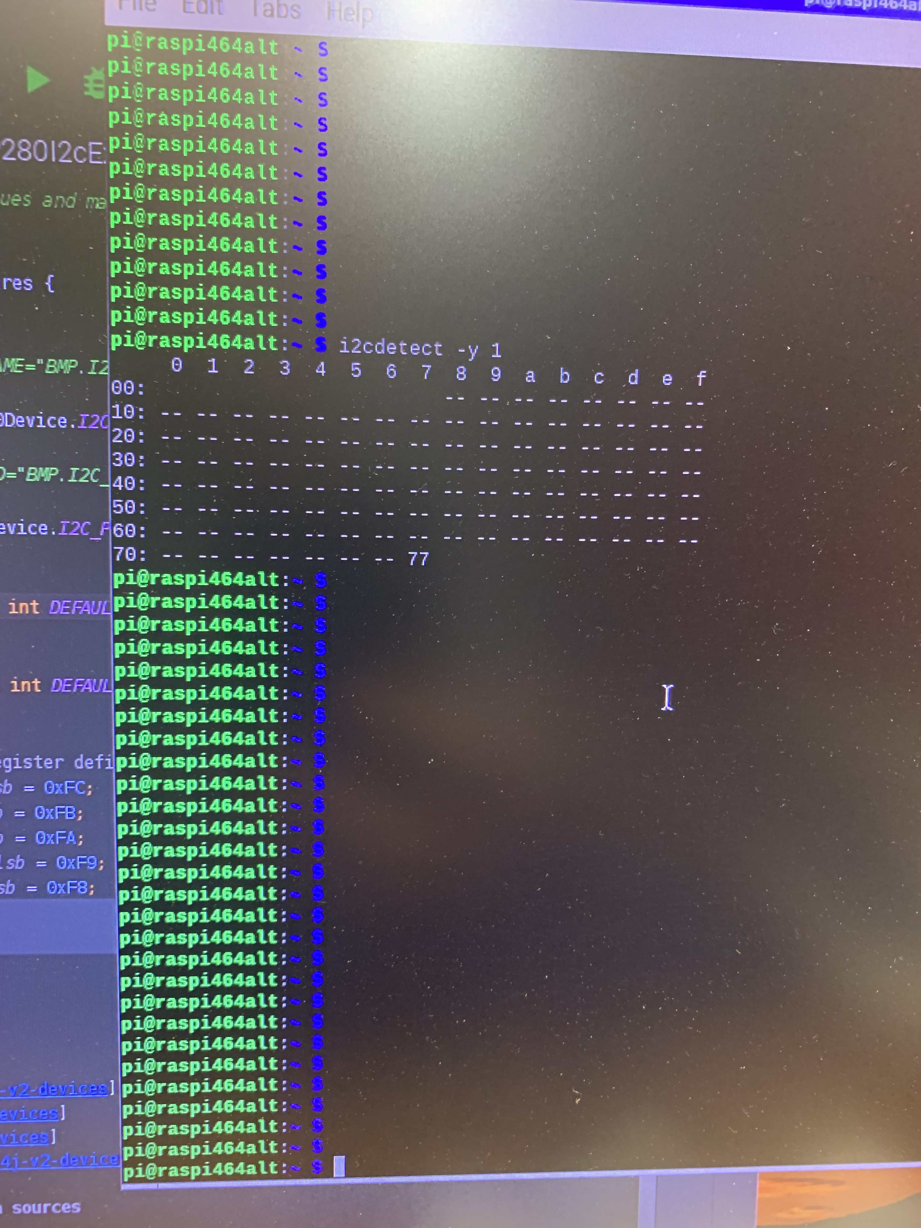

Prototype Board
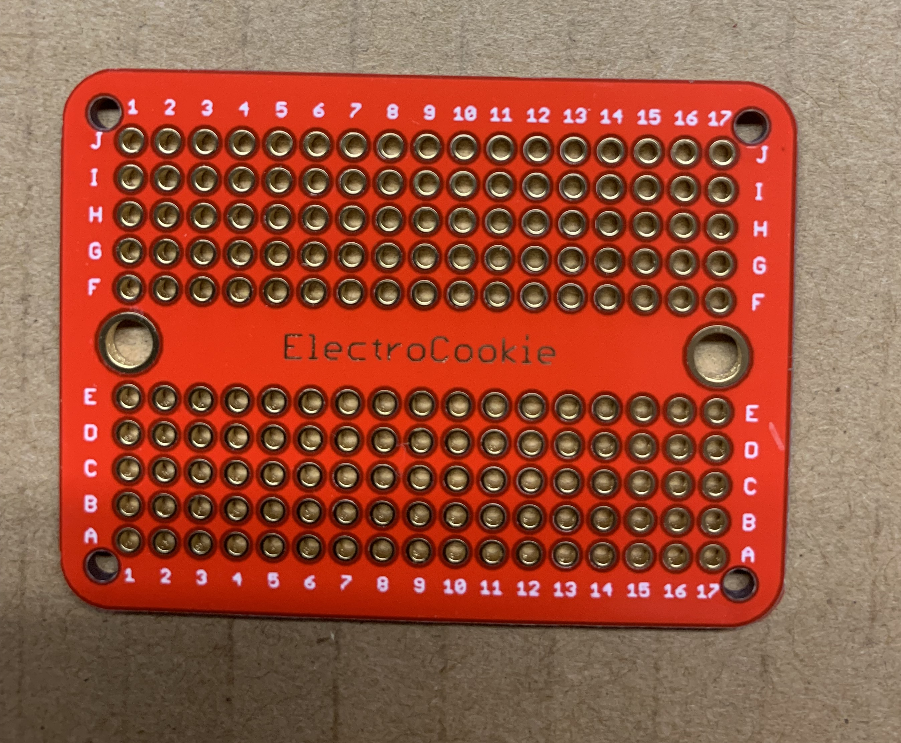
If you intend to work with other chips building a prototype board is worth the time. These are steps to build and connect such a board. Once built you can plug in various chips, most importantly socketed chips.

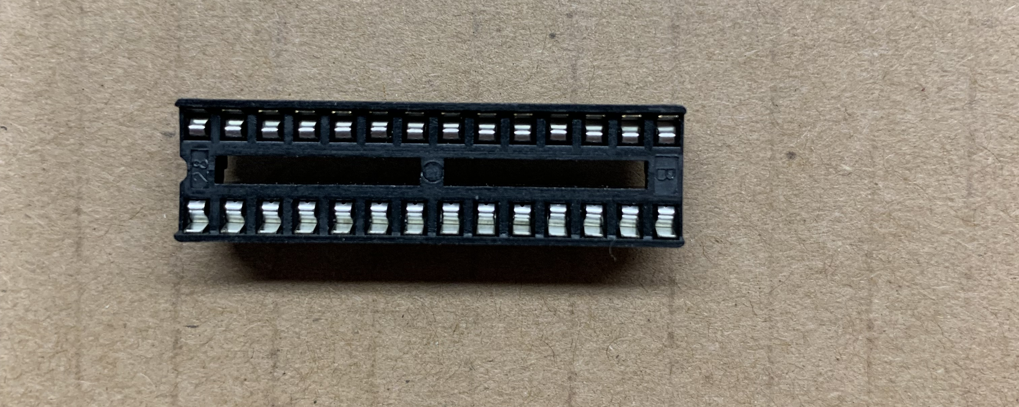
Socket

Completed Board
The board includes a pin for each of the sockets 28 connections. In addition pins will provide a common connection for 3,3v 5v and ground.

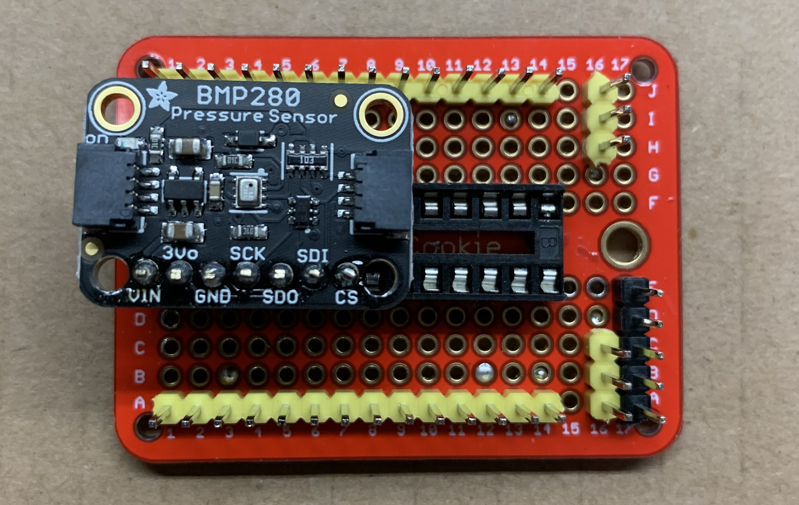

Wiring to Pi GPIO 40 Pin Connector

3.3v from GPIO to a common point on the board.
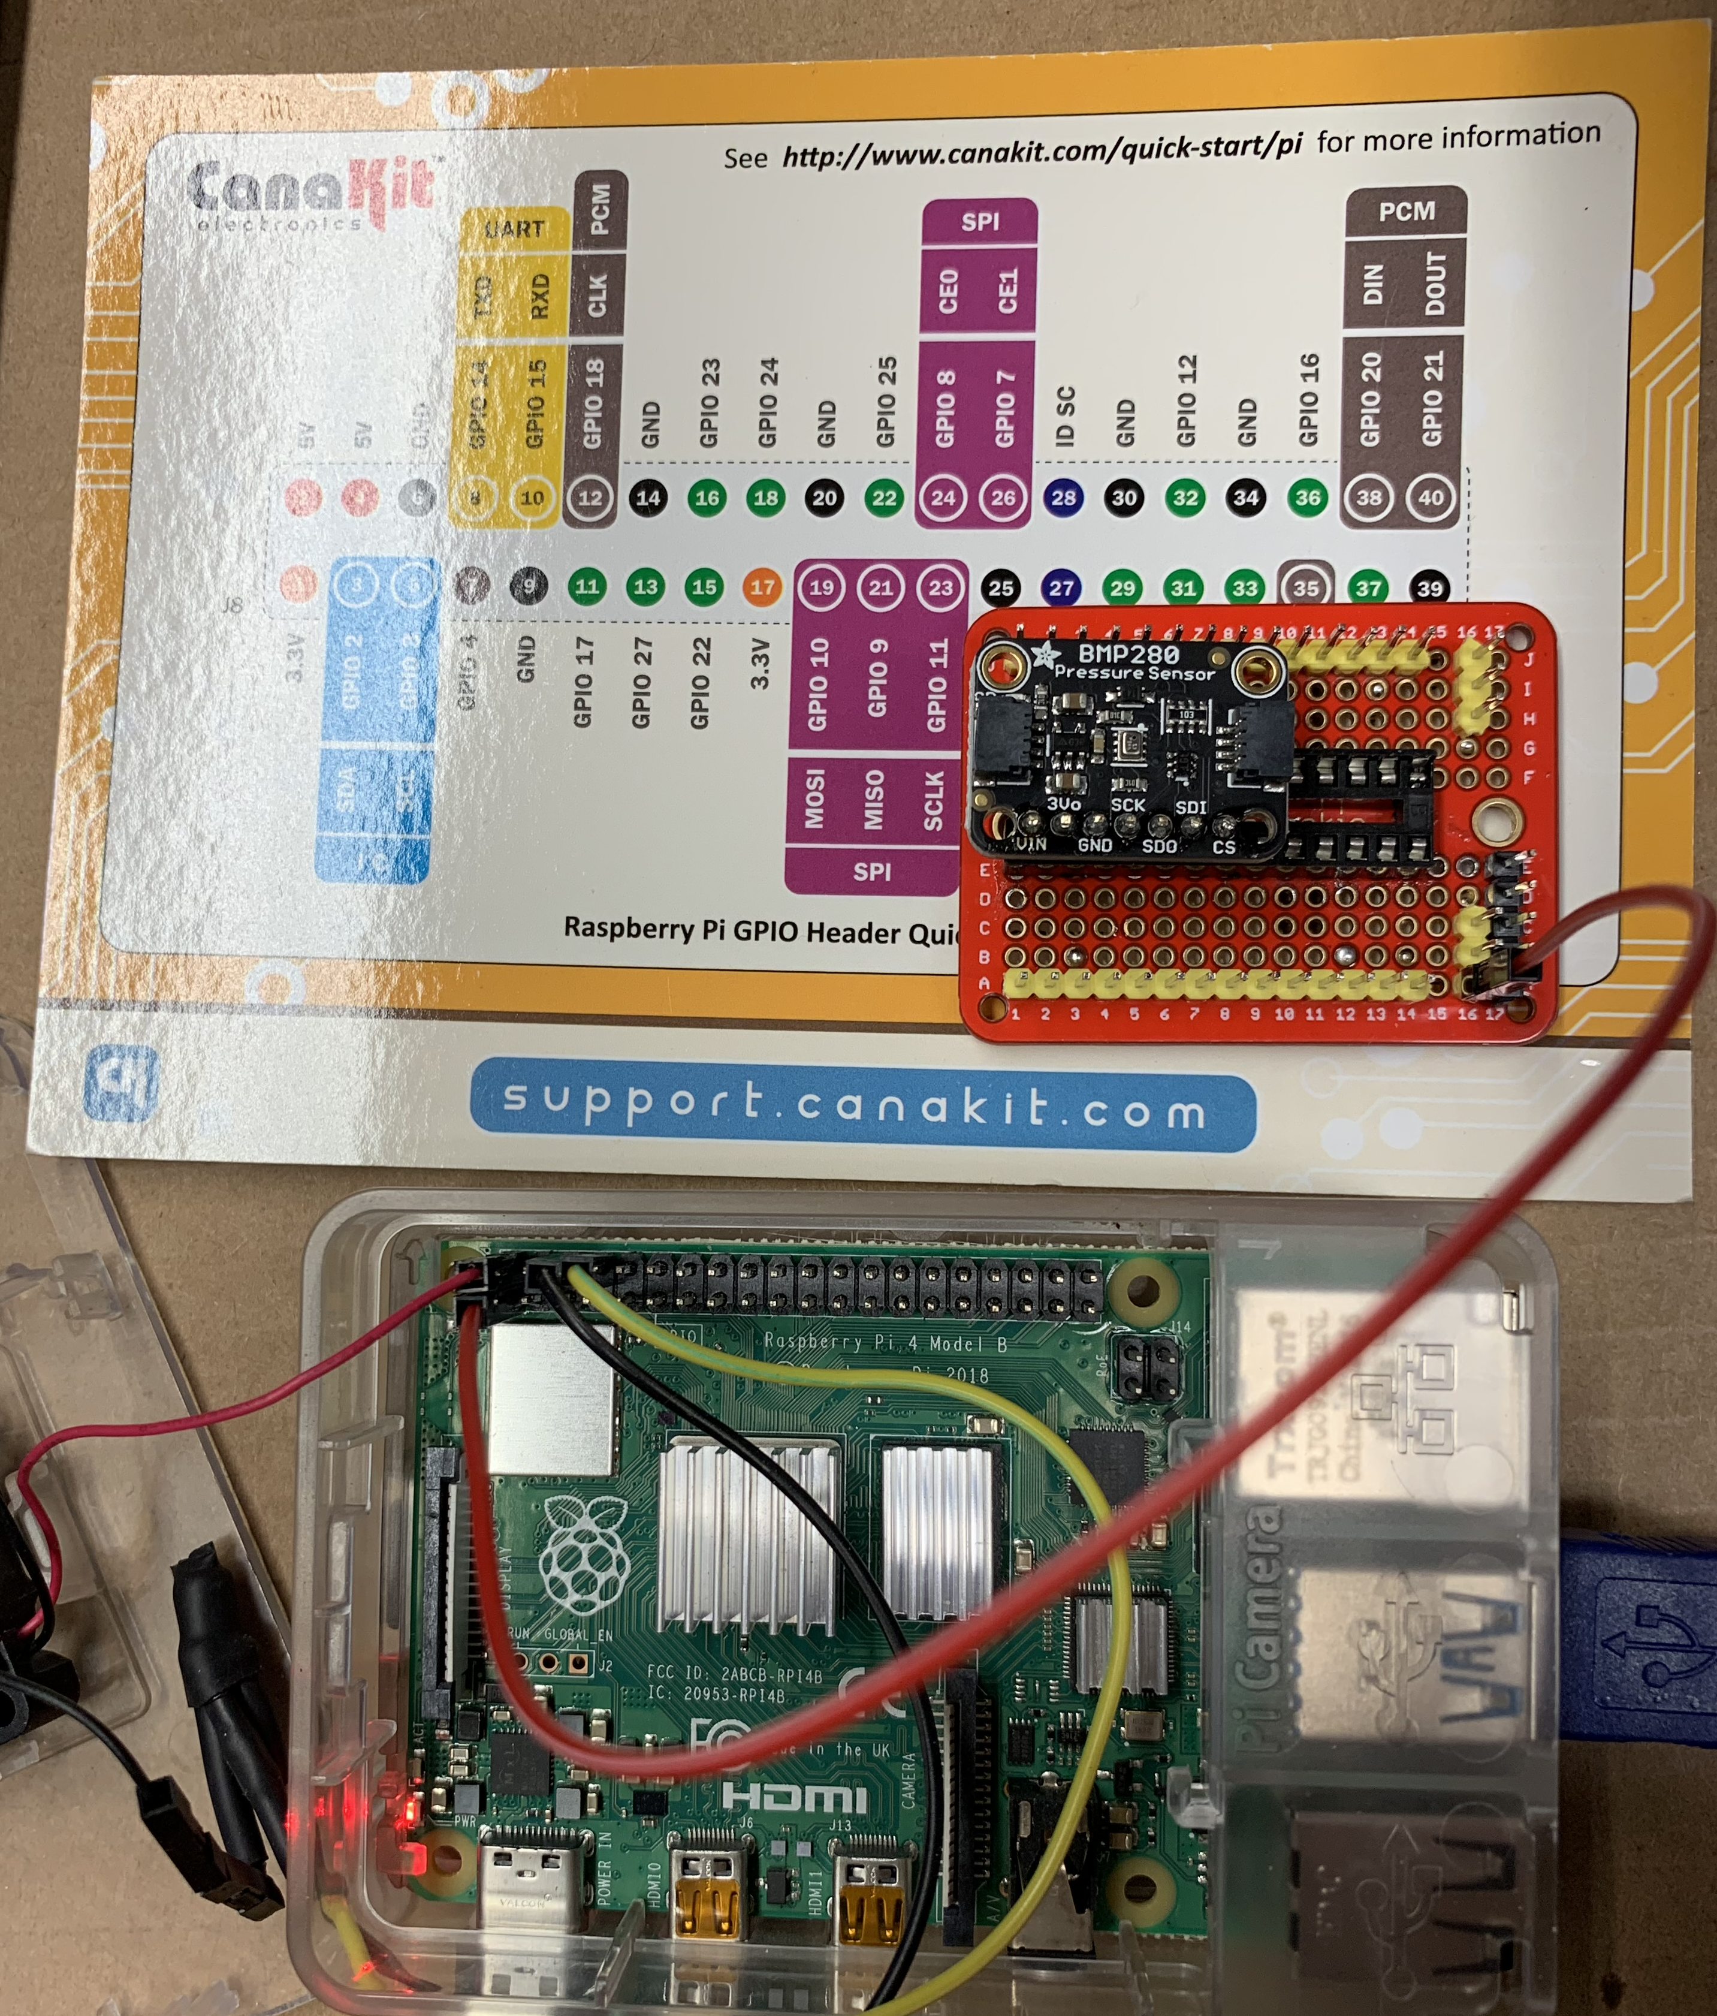

Ground GPIO to common point on the board

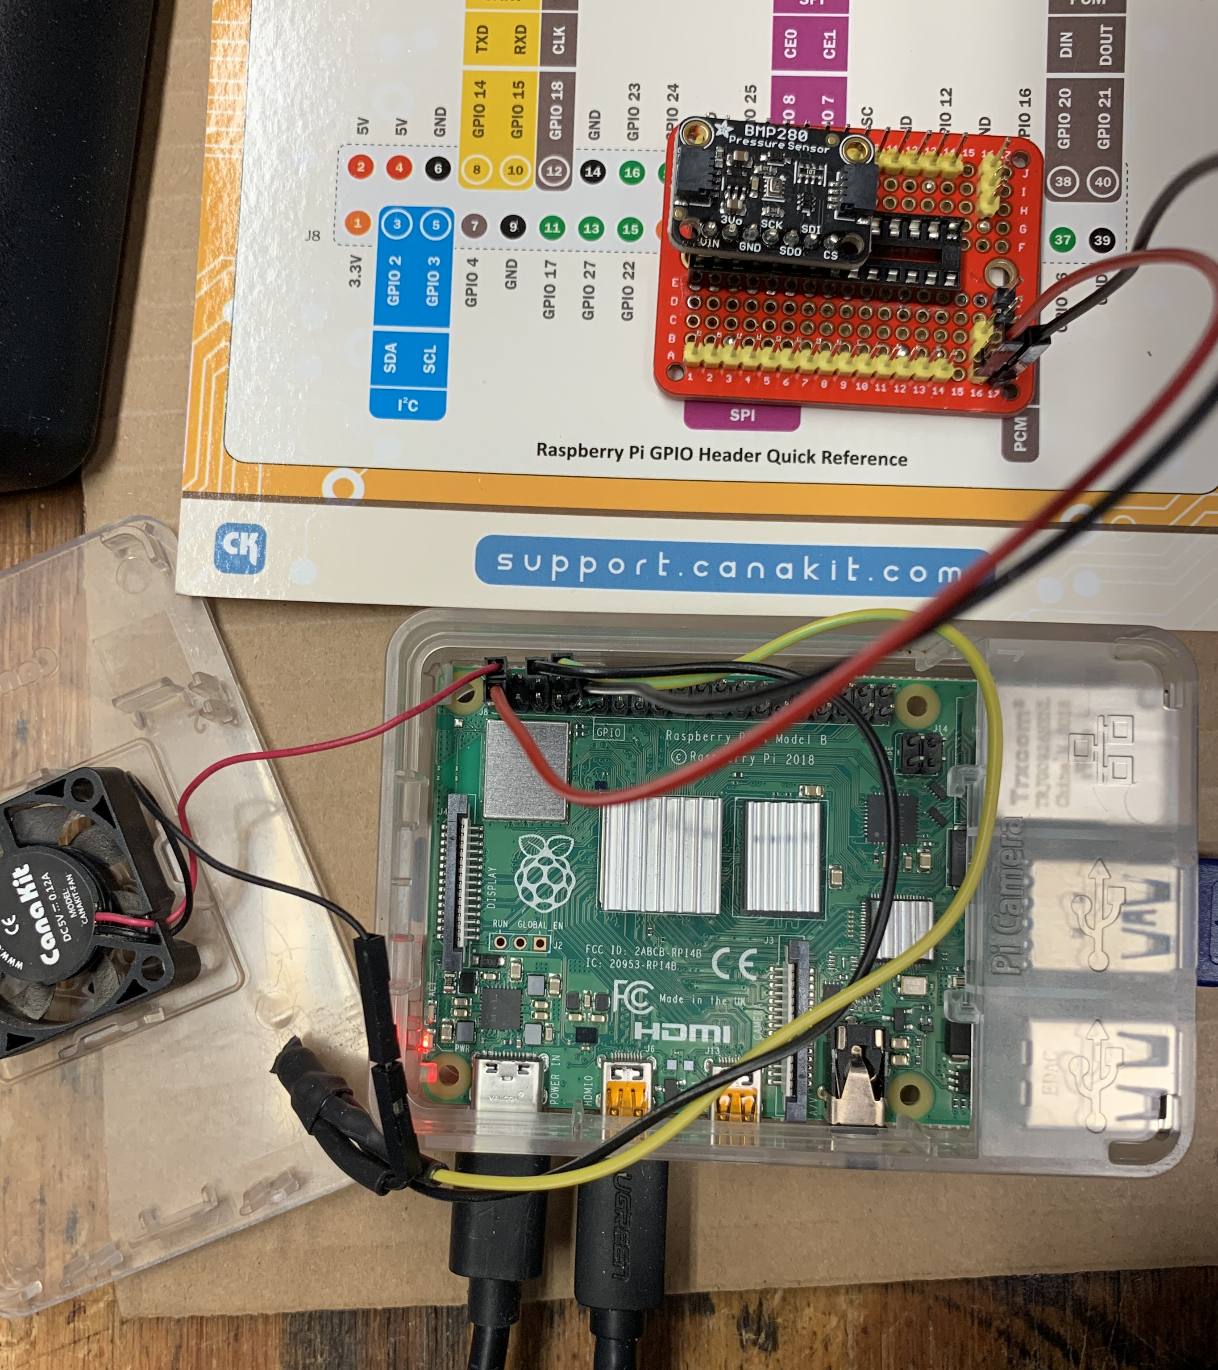

I2C from GPIO to the board
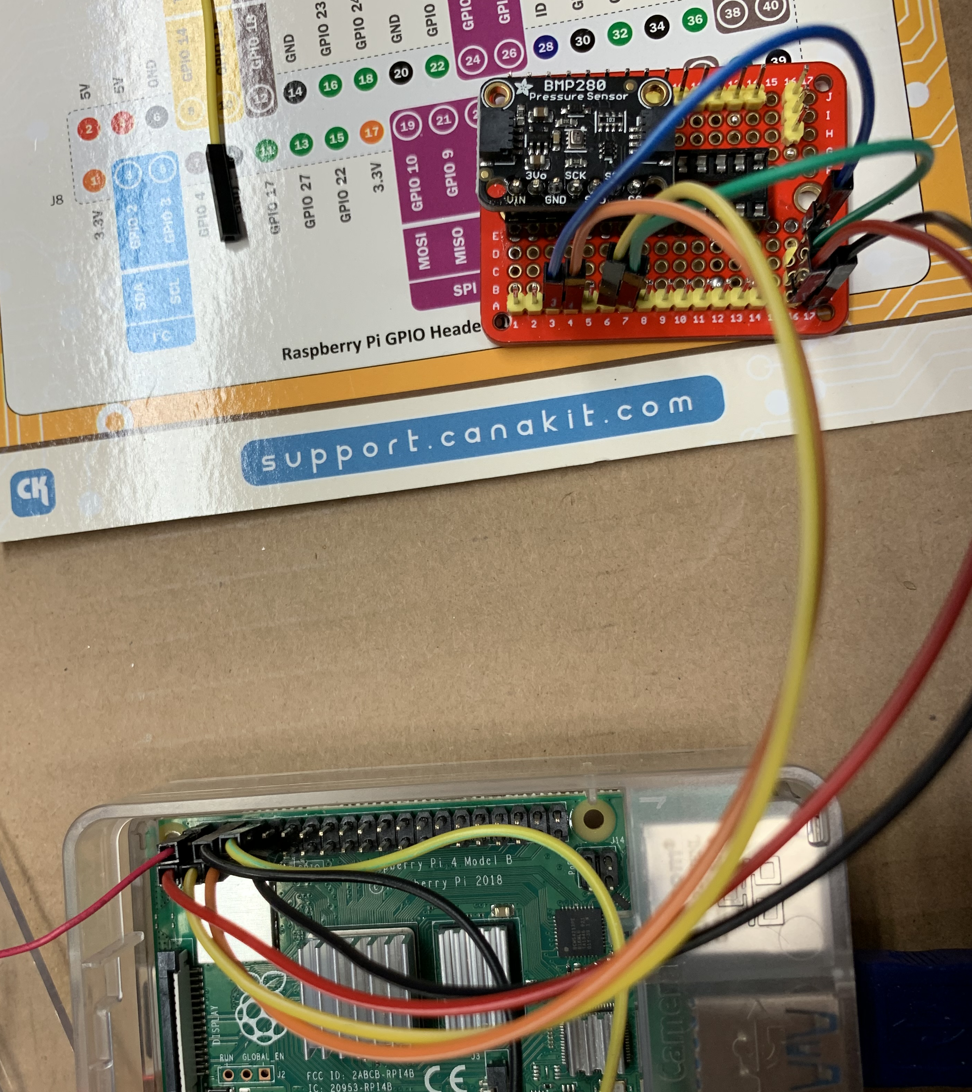

Wiring within the board
At this point the 3.3v and ground are connected from the Pi to the board. In addition the I2C SDA and SCL are connected from the Pi to the BMP280 pins. Remaining connections are within the board and they connect BMP280 pins to 3.3v or ground.
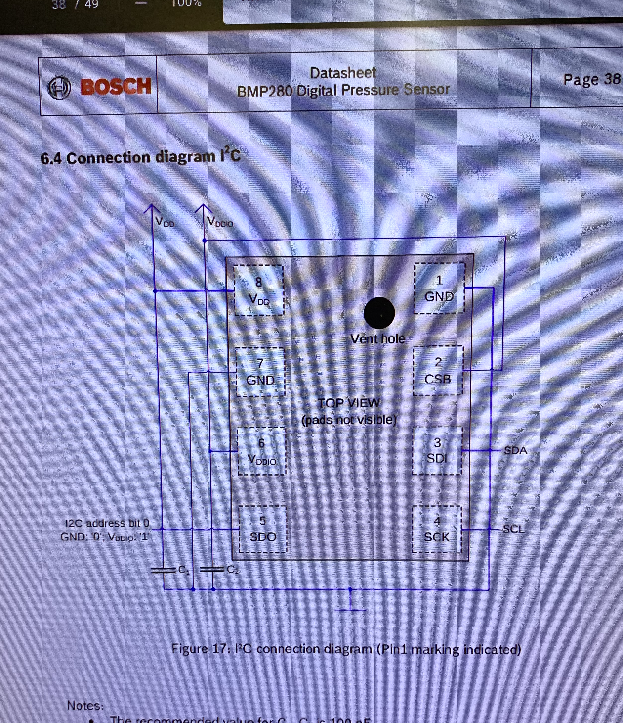
Final Connections
The BMP280 pins:

- vin I 3.3V
- 3v connects to 3v bus on the board.
- GND N/C
- SCK connects SCL on the Pi gpio connector
- SDO connects to ground bus on the board. Sets i2c device address 0x76
- SDI connects to SDA on the Pi gpio connector
- CS connects to 3.3v bus on the board. Enables i2c interface *

* CS must be energized with 3.3v before OR at the same time as the 3v pin to correctly enable the I2C interface.

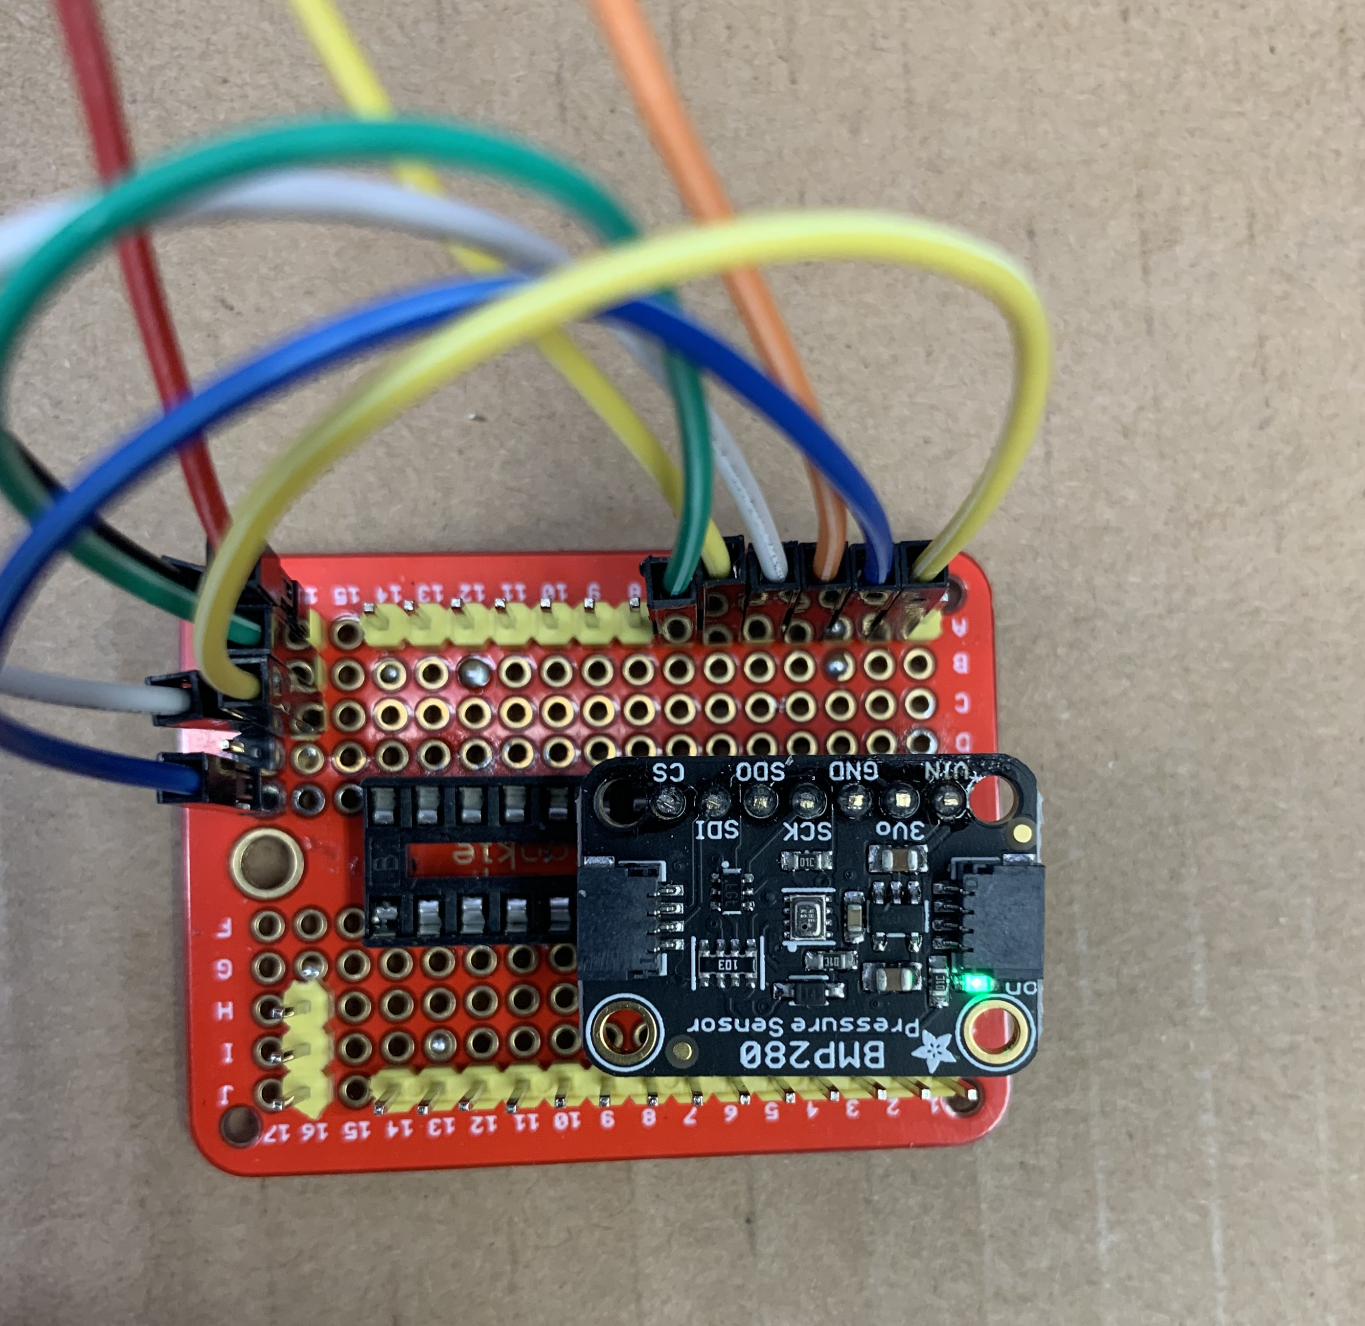

Result
If properly connected and energized:

