|  |  |
| --- | --- |
|  | Multi Objective Optimization |
|  |  |
|  | Final Project  ME 5511  Pranav Pishawikar |

**Introduction**

Multi Objective optimization is a field of optimum design that deals with the simultaneous optimization of more than one objective functions.

Multi objective optimization is applied in various fields of science, engineering and statistics that require the optimization of specific objective functions when there is a trade-off between different conflicting goals. Minimizing the price of a flight ticket while also minimizing the travel time, and maximizing performance whilst minimizing fuel consumption and maximizing the interior space in a vehicle are examples of such multi objective optimization problems with two and three goals, respectively. In practical, there can be more than three objectives.

For a [nontrivial](https://en.wikipedia.org/wiki/Nontrivial) problem in multi objective optimization, there can exist no single solution that is the best possible result for all the objectives. In such a scenario, the objective functions are said to conflict with each other. There exists a (possibly infinite) number of Pareto optimal (also called [nondominated](https://en.wikipedia.org/wiki/Maxima_of_a_point_set" \o "Maxima of a point set), [Pareto efficient](https://en.wikipedia.org/wiki/Pareto_efficient) or noninferior) solution.

The definition of a Pareto optimal solution is as follows: If for a particular solution of a multi objective optimisation problem, none of the objective functions can be improved in value without degrading some of the other objective values, the solution is called Pareto optimal. In general, Pareto optimal solutions may be a set of individual solutions, a continuous set of solutions or even a zone with optimal values.

In multi objective analysis, without supplemental [subjective](https://en.wikipedia.org/wiki/Subjectivity) information such as preferences or weighted distributions, all Pareto optimal solutions are considered equally good. However, with these sorts of problems, a certain human component is required in the decision making and choosing of the best possible solution.

Literature review reveals a verity in the different methods imposed to effectively solve and analyse such problems and the results vary significantly through each approach. The goal may be to find a representative set of Pareto optimal solutions, and/or quantify the trade-offs in satisfying the different objectives, and/or finding a single solution that satisfies the subjective preferences of a human decision maker (DM).

**1.0 Problem statement**

In the design of an industrial heater, it is desired to find the best size for the manufacturing of a heating element that is well optimized in three criteria:

1. Heating performance
2. Cost of production
3. Speed of production

The maximum allowable size of the heating element is 10 units and the smallest size element that can be produced is 1 unit. Also, due to the nature of the manufacturing process, size may be varied only in multiples of 0.5 (1, 1.5, 2, 2.5, 3, …, 9.5,11)

The heating performance of the element is dependent on the size of the element. Although heating capacity is directly proportional to the size of the heater, it was found that in practical application, within the size constraints previously imposed, heating performance is closer to the polynomial function:

$$H=x-0.003 x^{3}$$

Where H is the heating performance, and x is the size of the element

The Cost of production is determined by two aspects:

Cost of Material

$$C_{m}=0.125 x$$

And the cost of manufacture

$$C_{p}=0.5+1.2\log\left(x\right)$$

The number of elements that can be produced per minute is given by

$$N=1+5/x$$

The objective is to maximize the heating performance, minimize the cost of production and to increase number of elements being produced. All three objectives have equal prioritization.

**2.0 Solution**

**2.1 Standardizing the Optimization Problem**

Let us start by defining our problem as a standard optimization problem.

Here, we want to write each optimization function as a minimization problem

* + 1. **Heating performance**

Maximize

$$H=x-0.003 x^{3}$$

Or Minimize

* + 1. **Cost of production**

Minimize

* + 1. **Speed of production**

Maximize

$$N=1+5/x$$

Or Minimize

$$N=-1-5/x$$

**2.1.4 Thus our problem becomes:**

Minimize

$$f_{1}=-x+0.003 x^{3}$$

$$f_{2}=0.5+1.2\log\left(x\right)+0.125 x$$

$$f_{3}=-1-5/x$$

Such that

$$x∈[1, 1.5, 2, 2.5, 3, 3.5, 4, 4.5, 5, 5.5, 6, 6.5, 7, 7.5, 8, 8.5, 9, 9.5, 10, 10.5, 11]$$

**2.2 Finding Pareto Optimal Solutions**

Let us begin by finding the Non-dominated solutions, or Pareto optimal solutions for each of these optimization problems individually.

* + 1. **Heating performance:**

To minimize $f_{1}$,

$$∇f_{1}=-1+0.009{ x}^{2}=0$$

$$or x=\sqrt{\frac{1}{0.009}}=10.54$$

To verify that this is indeed a minimum, second order optimality condition yields

$$0.018x=0.1897$$

which is greater than zero

Checking at the nearest feasible points,

$$f_{1}\left(10.5\right)=-7.027$$

$$f_{1}\left(11\right)=-7.007$$

Thus, **x=10.5** is a Non-dominated solution.

This is also verified through the MATLAB extensive solver code shown in Section 3.2.1

* + 1. **Cost of production:**

This cannot be analyzed just using first order and second order conditions.

Thus, to minimize, we analyze using the extensive solver in MATLAB shown in Section 3.2.2 to find **x = 1** and

* + 1. **Speed of production:**

Again, using the extensive solver in MATLAB as shown in Section 3.2.3

It is found that the Non-dominated solution or Pareto optimal solution is **x = 1**

And

* 1. **Using Global Criterion Method to solve the Optimization problem**

Minimize

$$\sum_{k=1}^{3}{\frac{{f_{k}\left(x^{*}\right)-f}_{k}\left(x\right)}{f_{k}\left(x^{*}\right)}}$$

Here, since every function shares equal priority, weights of each of the functions are one.

Thus, we want to minimize

$$f=\frac{-7.027+x-0.003 x^{3}}{-7.027}-\frac{0.625-0.5-1.2\log\left(x\right)-0.125 x}{0.625}+\frac{-6+1+5/x}{-6}$$

As observed, the function value is least at **x=1** with **f=0.8581**

## 3.0 MATLAB code and Plots

## Contents

* 3.1 Initialization
* 3.2.1 Heating capacity
* 3.2.2 Production cost
* 3.2.3 Speed of production
* 3.3 Global criteria Optimal calculation
* 3.4 Graph plotting

clear all

clc

## 3.1 Initialization

x=1:0.5:11;

## 3.2.1 Heating capacity

i1=1;

while i1<22

f1=-x(i1)+0.003*x(i1)^3;

if i1==1

g1=f1;

k1=1;

else

if g1>f1

g1=f1;

k1=i1;

end

end

i1=i1+1;

end

fprintf('\nNon-dominated solution for Heating capacity: x= %f\nValue of function at x*=%f\n',x(k1),g1)

Non-dominated solution for Heating capacity: x= 10.500000

Value of function at x*=-7.027125

## 3.2.2 Production cost

i2=1;

while i2<22

f2=0.5+1.2*log(x(i2))+0.125*x(i2);

if i2==1

g2=f2;

k2=1;

else

if g2>f2

g2=f2;

k2=i2;

end

end

i2=i2+1;

end

fprintf('\nNon-dominated solution for Cost of production: x= %f\nValue of function at x*=%f\n',x(k2),g2)

Non-dominated solution for Cost of production: x= 1.000000

Value of function at x*=0.625000

## 3.2.3 Speed of production

i3=1;

while i3<22

f3=-1-5/x(i3);

if i3==1

g3=f3;

k3=1;

else

if g3>f3

g3=f3;

k3=i3;

end

end

i3=i3+1;

end

fprintf('\nNon-dominated solution for maximum production: x= %f\nValue of function at x*=%f\n',x(k3),g3)

Non-dominated solution for maximum production: x= 1.000000

Value of function at x*=-6.000000

## 3.3 Global criteria Optimal calculation

i=1;

while i<22

f=((-7.027+x(i)-0.003*x(i)^3)/(-7.027))-((0.625-0.5-1.21*log(x(i))-0.125*x(i))/0.625)+((-6+1+5/x(i))/(-6));

if i==1

g=f;

k=1;

else

if g>f

g=f;

k=i;

end

end

i=i+1;

end

fprintf('\nCalculated Optimal Solution: x= %f\n',x(k))

Calculated Optimal Solution: x= 1.000000

## 3.4 Graph plotting

graph1=-x+0.003.*x.^3;

graph2=0.5+1.2*log(x)+0.125.*x;

graph3=-1-5./x;

graph=((-7.027+x-0.003*x.^3)/(-7.027))-((0.625-0.5-1.21*log(x)-0.125*x)/0.625)+((-6+1+5./x)/(-6));

hold on

plot(x,graph1,'Displayname','f1');

plot(x,graph2,'Displayname','f2');

plot(x,graph3,'Displayname','f3');

legend show

xlabel 'size of element'

ylabel 'Objective functions'

legend('Heating Capacity *(-1)','Material Cost','Speed of Production *(-1)')

figure

plot (x,graph);

xlabel 'size of element'

ylabel 'Deviation from optimal'

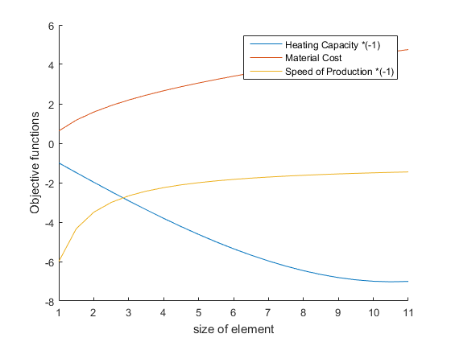

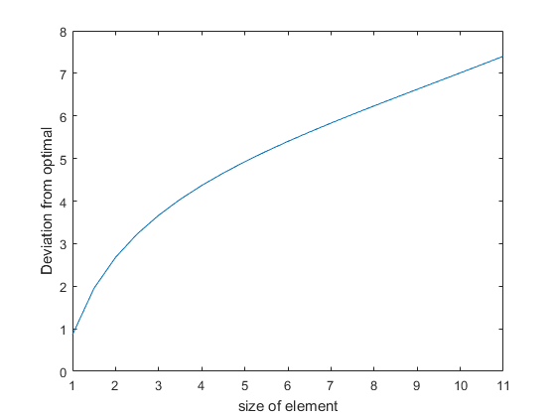

[Published with MATLAB® R2015b](http://www.mathworks.com/products/matlab/)

1. **Conclusion**

Although it is clear from the above result that x=1 will yield the optimum value as both speed of production and cost of production are small, it is easy to see that by adding weights to the same global function the optimum may easily change.

In a real world scenario for example, although the speed of production may be cheap for a smaller heating element, the market demand may lean more toward bigger heating elements. In that case, there is no point in producing high quantities of smaller elements as they may not sell. The speed of production may thus have an insignificant weight compared to the heating capacity.

Similarly, cost of production may also be insignificant if the profit margins on the larger heating elements are higher.

Thus it is easy to see that although a component of guesswork and judgment may be needed in deciding what functions to prioritize in a multi objective analysis, good market survey and proper understanding of the needs can prove this to be a very effective tool.