To password-protect the editor:

Goto <https://console.eu-gb.bluemix.net/dashboard/apps/>

Do **not** click on the link below ROUTE

Instead click on the name of your app below NAME

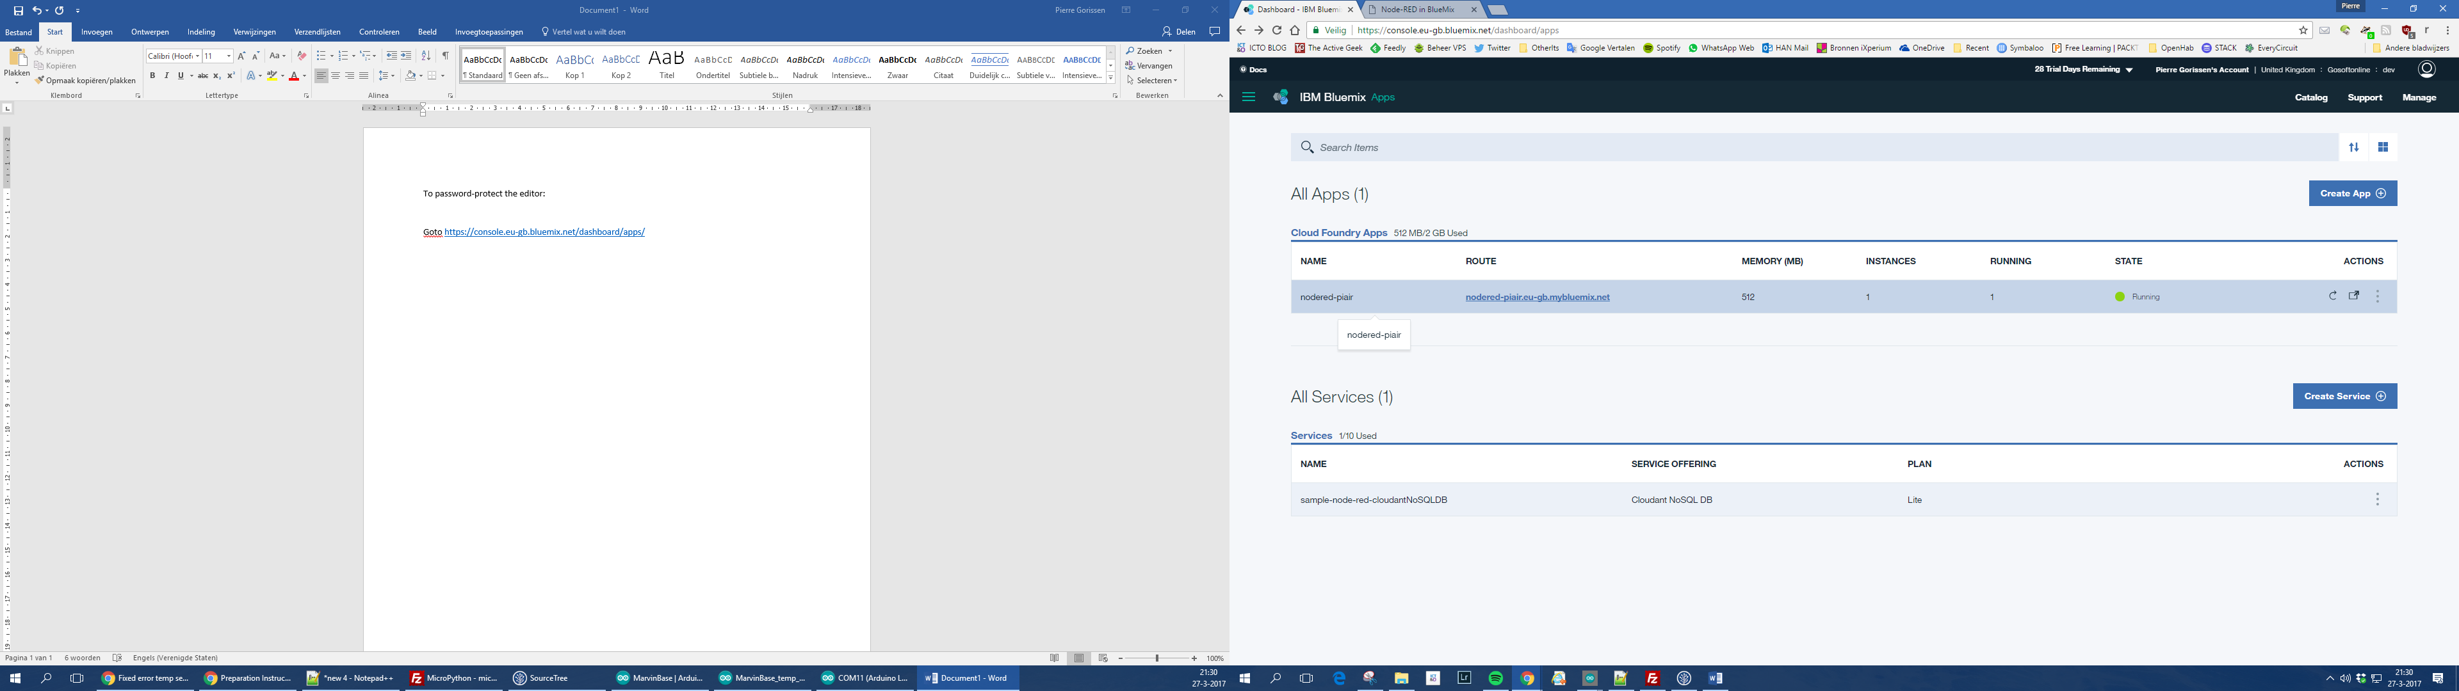

That will bring you to the Overview page for you App

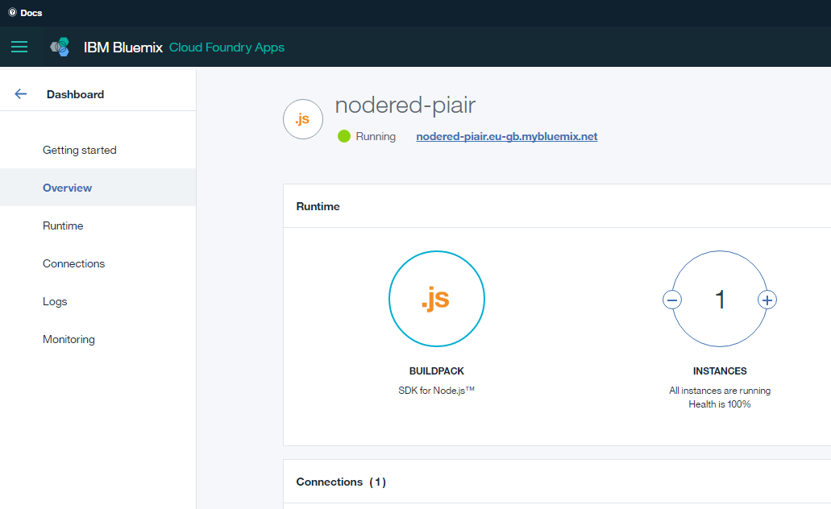

Click on “Runtime” in the menu on the left

Then select Environment variables

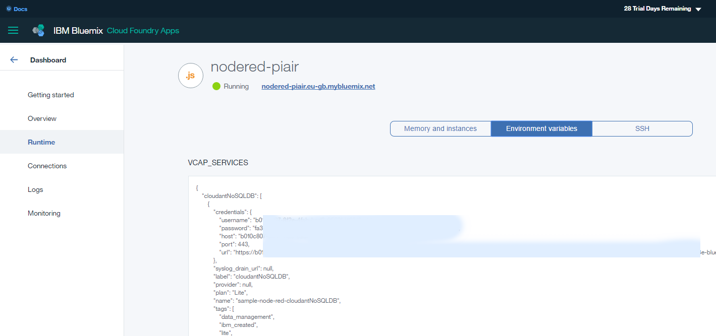

Scroll down to “User defined”

Add the following user-defined variables:

* NODE_RED_USERNAME - the username to secure the editor with
* NODE_RED_PASSWORD - the password to secure the editor with

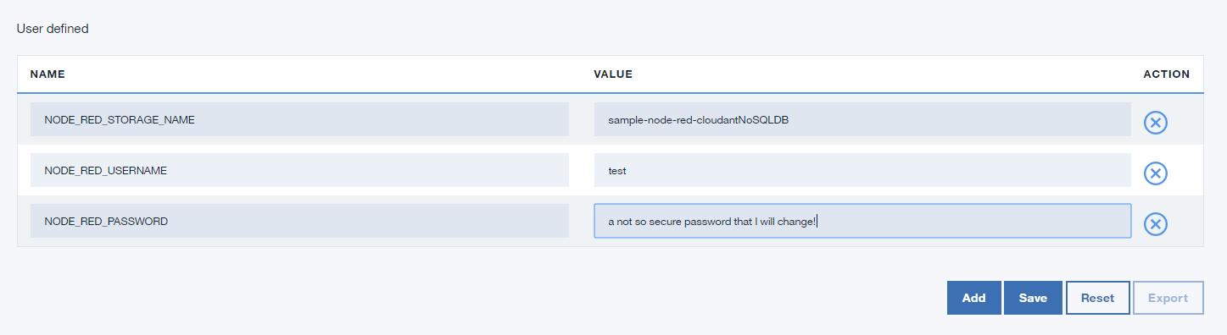

Click “Save”

Use the button on the top right side of the page to restart the App

Done. The editor is now secured by a username and password.

