**理想高通滤波**

**1、代码实现：**

# 理想高通滤波实现

import numpy as np

import cv2

from matplotlib import pyplot as plt

plt.rcParams['font.sans-serif']=['SimHei']

plt.rcParams['axes.unicode_minus'] = False

I = cv2.imread('../image/1.png')

cv2.imshow('original',I)

(r,g,b) = cv2.split(I)

I = cv2.merge([b,g,r])

J = np.double(cv2.cvtColor(I,cv2.COLOR_RGB2GRAY))

D1 = 30

D2 = 60

D3 = 160

Fuv = np.fft.fftshift(np.fft.fft2(J))

print('Fuv',Fuv)

print(I.shape)

m,n = I.shape[0],I.shape[1]

xo = np.floor(m/2)

yo = np.floor(n/2)

h1 = np.zeros((m,n))

h2 = np.zeros((m,n))

h3 = np.zeros((m,n))

for i in range(m):

for j in range(n):

D = np.sqrt((i-xo)**2+(j-yo)**2)

if D>=D1:

h1[i,j]=1

else:

h1[i,j]=0

if D>=D2:

h2[i,j]=1

else:

h2[i,j]=0

if D>=D3:

h3[i,j]=1

else:

h3[i,j]=0

Guv1 = h1*Fuv

Guv2 = h2*Fuv

Guv3 = h3*Fuv

g1 = np.fft.ifftshift(Guv1)

g1 = np.uint8(np.real(np.fft.ifft2(g1)))

print('g1',g1)

g2 = np.fft.ifftshift(Guv2)

g2 = np.uint8(np.real(np.fft.ifft2(g2)))

print('g2',g2)

g3 = np.fft.ifftshift(Guv3)

g3 = np.uint8(np.real(np.fft.ifft2(g3)))

print('g3',g3)

plt.subplot(2,2,1),plt.imshow(I),plt.title('原图像')

plt.subplot(2,2,2),plt.imshow(g1),plt.title('D0=30')

plt.subplot(2,2,3),plt.imshow(g2),plt.title('D0=60')

plt.subplot(2,2,4),plt.imshow(g3),plt.title('D0=160')

plt.show()

**2、实验结果：**

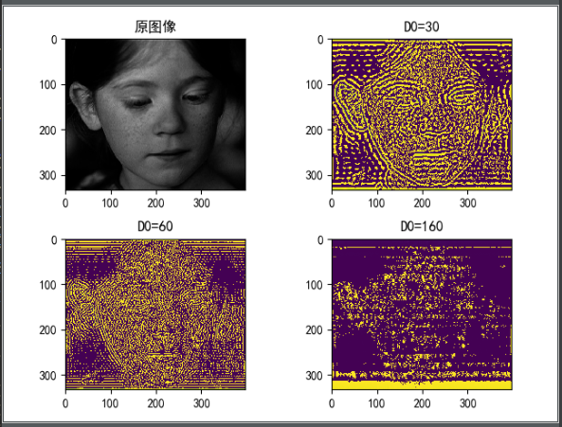

不同大小滤波下的图像变化