**高斯滤波**

**1、代码实现：**

# 高斯滤波

from skimage import data,filters

import matplotlib.pyplot as plt

img = data.astronaut()

edges1 = filters.gaussian_filter(img,sigma=0.4) #sigma=0.4

edges2 = filters.gaussian_filter(img,sigma=5) #sigma=5

plt.figure('gaussian',figsize=(8,8))

plt.subplot(121)

plt.imshow(edges1,plt.cm.gray)

plt.subplot(122)

plt.imshow(edges2,plt.cm.gray)

plt.show()

**2、实验结果：**

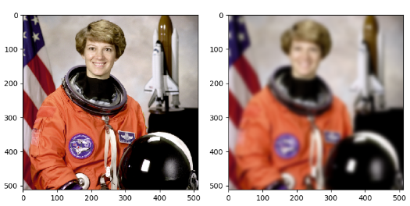

高斯滤波sigma=0.4和sigma=5后图片